**PRECISION PUBLIC HEALTH OPT 2 CORE**

**PROJECT LEAD: Julie Johnson, Pharm.D BUDGET JUSTIFICATION:**

##### SENIOR/KEY PERSONNEL

**Pearson, Thomas, MD, MPH, PhD, Precision Public Health Program Director (1.2 calendar months):** Dr. Pearson serves as Project Lead for Translational Workforce Development (TWD) Program and Principal Investigator of the KL2 component of the CTSI. As Chair of the TWD Directorate, Dr. Pearson is responsible for ensuring the KL2 Program achieves its goals and aims, with oversight of Professional Development, Mentor Development, Education Development and Evaluation Programs, as well as the TL1, TRACTS, KL2, and Research Professional Programs. Dr. Pearson will oversee the four Working Groups and seven programs which carry out the education, training and career development functions of the CTSI. Dr. Pearson will also serve as interim Director of the Diversity and Inclusion work group to promote recruitment, selection, supervision and career development of the KL2 program. Dr. Pearson also directs the K-to-R Boot Camp. Dr. Pearson is a CTSI Executive Committee Member. Dr. Pearson will serve as Convener of the Precision Public Health initiative, which develops an infrastructure to support the identification, description, and intervention of geographically clustered subpopulations with disparately high burdens of disease.

**Cavallari, Larisa, Pharm.D, Faculty, Associate Director of the Precision Health Program (1.2 calendar months):** Dr. Cavallari is the Associate Director of the CTSI’s Precision Health Program and has a major leadership role in the planning and execution of the program’s initiatives. Dr. Cavallari has substantial experience in genomic medicine implementation both at UF and at her previous institution. Dr. Cavallari is very aware of the complexity of genomic medicine implementation, the various personnel who must be committed to the effort and the types of data to be collected to document the program.

**Johnson, Julie, Pharm.D, Precision Health Co-Chair, CTSI Governing Board Member, (0.6 calendar months):** Dr. Johnson will co-chair the CTSI Precision Health Pilot Committee. Dr. Johnson is an expert in clinical pharmacology and pharmacogenomics, with particular focus on the pharmacogenomics of cardiovascular drugs. Dr. Johnson has an extensive record of funding and publication in pharmacogenomics. Dr. Johnson has led multiple large multidisciplinary research groups including the Pharmacogenomic Evaluation of Antihypertensive Responses (PEAR) group, the International Warfarin Pharmacogenetics Consortium, among others. Dr. Johnson was inaugural chair of the new NHGRI genomic medicine implementation network called IGNITE and is PI of a genomic medicine implementation grant, focused on pharmacogenomics, in that network. Dr. Johnson was recently awarded a T32 in genomic medicine as an MPI, evidence of her strength in and commitment to training. Dr. Johnson has an extensive track record of training the next generation of scientists, including undergraduate students, graduate students (13 awarded PhD as chair of PhD committee), and postdoctoral trainees (25 total), with four active PhD (n=1) or postdoctoral (n=3) trainees currently in my laboratory. Most of her PhD and post-doctoral trainees have pursued research careers in academia. Former trainees include numerous tenured faculty, full professors, a department chair, the Director of the Office of Clinical Pharmacology, Center for Drug Evaluation and Research (CDER), US Food and Drug Administration (FDA) and the Associate Director for Genomics and Targeted Therapy, CDER, FDA. In the last 10 years, her trainees (pre-doc and post-doc) have authored 53 first-author publications as part of their training, some of which are highlighted under publications. In the same timeframe they have won 10 national awards for their abstracts or publications. Dr. Johnson was elected to the National Academy of Medicine (formally called Institute of Medicine) in 2014, and was a Thomson-Reuters (now Clarivate Analytics) Highly Cited Scientist in 2015, 2016 and 2017 for being among the top 1% of cited scientists in pharmacology and toxicology.

**Rasmussen, Sonja, MD, MS, Precision Public Health Co-Lead (1.2 calendar months):** Dr. Rasmussen will provide overall direction and leadership for the CTSI Precision Health program. Dr. Rasmussen will contribute

1.2 calendar months to administrative leadership and will be overseeing the coordination of precision medicine and precision public health teams; including ongoing operations management, building stakeholder priorities,

helping to organize pilot projects, and implementation and dissemination of program output. Dr. Rasmussen will oversee development and implementation of a dissemination strategy for the initiative to disseminate strategy for the CTSI Public Health initiative. Dr. Rasmussen is uniquely qualified for this role, given her years of leadership in the public health domain for the Centers for Disease Control and Prevention and her training in pediatrics and genetics.

##### OTHER PERSONNEL

**Elsey, Amanda, MHA, PMP Assistant Director (1.2 calendar months):** Ms. Elsey serves as Assistant Director of the CTSI’s Personalized Medicine Program. Ms. Elsey joined the College of Pharmacy as the manager of the CTSI-led UF Health Personalized Medicine Program (PMP) in August 2011. In less than a year, the UF and UF Health Shands Hospital officially launched the PMP’s first clinical pharmacogenetic implementation. Ms. Elsey’s responsibilities include the planning, development, organization, coordination and management of all activities of the PMP. Ms. Elsey facilitates all the key elements of the program, coordinates with faculty and staff throughout the health system and communicates regularly with faculty leaders to ensure the success of the program. The PMP has since launched two additional clinical implementations, all in different patient care settings, with more than 1,400 patients receiving a clinical pharmacogenetic test. In addition to her recent work with PMP, Ms. Elsey brings in a background in clinical research coordination, health administration, exercise sciences and patient care services.

### CTR Core H: Precision Health Specific Aims

A centerpiece of our transition from infrastructure to impact will be incorporating our prior optional function in clinical metabolomics into a broader Precision Health Initiative that capitalizes on significant momentum emerging in three complementary areas — metabolomics, genomic medicine, and precision public health — and leverages our hub’s strengths in informatics, population datasets, community engagement, and communication science to lay the groundwork for novel integration of risk assessments at the individual and community levels to better understand and mitigate health risks and disparities. We developed foundational programs in parallel during our first two CTSA cycles, and the third cycle will allow us to bring them together to explore and test innovative methodologies and integrative models of precision medicine and precision public health (Figure 1).

The NIH All of Us Program describes precision medicine as an “approach for disease prevention and treatment that takes into account individual differences in lifestyle, environment, and biology.”1 Two CTSI programs in molecular medicine, “a branch of medicine that develops ways to diagnose and treat disease by understanding the way genes, proteins, and other cellular molecules work,”2 have laid important groundwork for incorporating biological risk factors in precision medicine. The CTSI Personalized Medicine Program has successfully implemented clinical pharmacogenomics and demonstrated improved patient outcomes. The Southeast Center for Integrated Metabolomics is advancing the critical first steps toward clinical metabolomics by developing technologies and building chemical libraries. In addition to biological factors, precision medicine considers lifestyle and environmental factors, with increasing recognition of “place” — where people live, learn, work, and play — as influencing a wide range of health risks and outcomes. In collaboration with its partners, the CTSI created the OneFlorida Data Trust with geospatial, electronic health record, and claims data for 15M patients, a unique resource for considering social determinants of health3 — environmental, social, and economic factors — in the context of precision medicine. While precision medicine considers lifestyle, environmental and biological factors at the individual level, precision public health considers them at a population level. The Director of the Office of Public Health Genomics at the Centers for Diseases Control and Prevention defined precision in the context of public health as “improving the ability to prevent disease, promote health, and reduce health disparities in populations by: 1) applying emerging methods and technologies for measuring disease, pathogens, exposures, behaviors, and susceptibility in populations; 2) developing policies and targeted implementation programs to improve health.”4

The CTSI will advance precision medicine and precision public health in collaboration with the OneFlorida Clinical Research Consortium, statewide partners including FSU, and CTSA investigators through three aims:

**Aim 1**: Evolve the Personalized Medicine Program into a Precision Medicine Program by expanding beyond

pharmacogenomics and leveraging

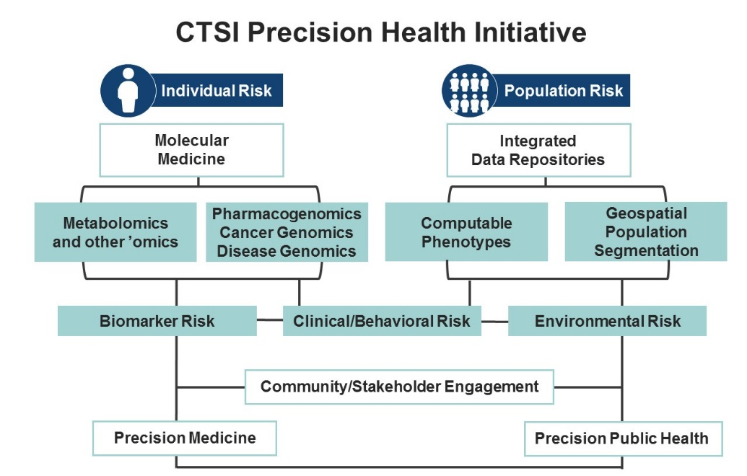

*Figure 1: CTSI Precision Health Initiative*

molecular medicine infrastructure to pave the way for integration of additional individual-level data to enhance precision of preventive interventions, diagnostic tools, and treatment decisions in clinical settings.

**Aim 2:** Create a Precision Public Health Program to develop resources and tools for the identification and characterization of population-level risk factors to identify communities at high risk for adverse health outcomes.

**Aim 3:** Implement a Precision Health Initiative to organize resources and training, foster

multidisciplinary team science, and support pilot projects aligned with stakeholder priorities to explore and develop integrative models of precision medicine and precision public health.

### CTR Core H: Precision Health

The Precision Health Initiative will be led by a strong and unique constellation of expertise: Julie A. Johnson, PharmD, Dean of the UF College of Pharmacy and Director of the CTSI Personalized Medicine Program; Sonja Rasmussen, MD, a pediatrician, clinical geneticist, and public health expert; and Thomas A. Pearson, MD, MPH, PhD, Director of the new Precision Public Health Program and CTSI’s Translational Workforce Development Program. Dr. Johnson is an expert in clinical pharmacology and pharmacogenomics, elected to the National Academy of Medicine in 2014. Prior to joining UF in July 2018, Dr. Rasmussen served as a public health leader at the CDC, including as Deputy Director for Infectious Diseases and Director of the Division of Public Health Information Dissemination. Dr. Pearson, an expert in cardiovascular epidemiology, has published extensively on cardiovascular disease prevention at the patient, health system, community, and public policy levels. The Precision Health Initiative will engage UF, FSU, OneFlorida, and CTSA investigators, as well as Florida public health agencies, to develop integrative models for precision medicine and precision public health.

**Significance and Innovation.** High-quality genomic discovery research constitutes the pipeline for translation of genomic medicine to produce new treatment and prevention modalities. Increasingly large datasets allow combinations of genomics and other ’omics-level data — such as metabolomics, transcriptomics, proteomics, and methylomics — to identify and mitigate health risks. Yet, studies of common diseases have not explained a significant portion of disease risk due to either inherited or environmental sources. Many studies have identified interaction between behavioral factors and genetic polymorphisms, enhancing our ability to identify subsets at high risk for poor health outcomes. Other studies of epigenetic factors have identified mechanisms by which environmental factors modify genetic factors to increase disease risk. However, many datasets lack the power to test large numbers of biological traits interacting with human behaviors and socio-environmental factors for their impact on human health. Further, complex methodological, societal, and implementation challenges hinder progress. Few, if any, programs have linked available individual genomic, metabolomic, behavioral, community, and environmental data.5 With geospatial, electronic health record, and claims data for 15M patients, the OneFlorida Data Trust is fast becoming a nucleus for developing precision health capabilities. The Precision Public Health Program has organized faculty with expertise in geography, demography, informatics, biostatistics, clinical decision analysis, and communication, creating opportunities to identify places with high or low risk that can be further characterized by state and local databases in terms of demographic, social, and economic factors. Communication with high-risk communities is essential to not only further understand the nature of their risk but also to assemble and implement clinical services, population interventions, or both. The novel eventual goal is to combine individual-level data and community-level data to improve risk assessment at both levels. To our knowledge, no studies like this have been planned and activated with adequate study design, statistical power, and analysis to test hypotheses related to the role of environmental/community factors in defining individual risk for poor health outcomes.

**PROGRESS REPORT: August 15, 2015–May 25, 2018**

As a component of its 2009 CTSA, the CTSI invested in developing, integrating, and expanding access to UF’s unique resources for global and targeted metabolomics, which include nationally recognized experts and facilities for mass spectrometry and nuclear magnetic resonance. CTSI support enabled UF investigators to compete successfully in 2013 for a $9.3M NIH grant to establish the Southeast Center for Integrated Metabolomics (SECIM), one of six regional centers funded by the NIH Common Fund to catalyze metabolomics research in the US. SECIM partners include the National High Magnetic Field Laboratory, which is headquartered at FSU and has satellite facilities at UF. To accelerate SECIM’s translational impact, our 2015 CTSA included an optional function in clinical metabolomics. Led by Richard A. Yost, PhD, Professor of Chemistry, and Timothy Garrett, PhD, Associate Professor of Pathology, Immunology and Laboratory Medicine, SECIM advanced the critical first steps in translation by developing technology for metabolomic and lipidomic tissue analysis and building chemical libraries that can enable improved diagnosis from excised tissues. Progress is highlighted below and further demonstrated by 49 publications since 2015 (see Overall Progress Report Publication List). Over the next five years, the CTSI will build on this work through an expanded Precision Health Initiative that capitalizes on significant scientific momentum emerging in three complementary areas: metabolomics, genomic medicine, and precision public health.

**2015-19 Aims at a Glance Highlights of Progress (33 months into 44-month project period)**

Clinical Metabolomics Aim 1: • Validated a quantitative method for 6 tryptophan metabolites combined with untargeted

CAP-certified and CLIA-licensed profiling in the same injection for clinical analysis in lupus, cancer, microbiome, delirium studies

|  |
| --- |
| laboratory for global • Validated a combined quantitative/qualitative assay for amino acids and 400 additional metabolomics of clinical samples metabolites using liquid chromatography-high resolution mass spectrometry for reference  range development and inter-laboratory studies   * Automated lipids processing with development of open-source tools (see Table 3) * Developed automated pipeline for quality control, data analysis, and metabolite identification in metabolomics and lipidomics to enable translation of analytical methods to multiple clinical labs |
| Clinical Metabolomics Aim 2: • Partnered with Prosilia to apply FlowProbe tech to melanoma samples for cancer diagnostics Ambient mass spectrometric • Developed first-ever approach to analyze excised tissue for rapid chemical signatures using an imaging and magnetic resonance adaptation of the FlowProbe source  metabolomics methods for tissue • Recruited new faculty member with expertise in protein approaches to imaging mass pathology in surgery spectrometry (starts Fall 2018) |
| **Changes for 2019-24 Aims:** Transitioned to three new aims as part of a larger Precision Health Initiative to develop methods, data resources, and integrative models for precision medicine and precision public health. |

**Aim 1: Evolve the Personalized Medicine Program into a Precision Medicine Program.** Translating genomics and metabolomics for use in the clinical environment is a highly collaborative and multidisciplinary endeavor. Through learning health system pathways (see Overall), CTSI programs partner with UF Health to move the testing, policies, procedures, equipment, and analytical tools used for ’omics research into the clinical environment, and then collaborate with OneFlorida partners to adapt clinical implementation strategies for other health care settings. Our first CTSA enabled creation of SECIM and the Personalized Medicine Program, and both programs demonstrated national leadership over the last five years as part of the NIH Common Fund Metabolomics Consortium and NHGRI’s Implementing Genomics in Practice network (IGNITE), respectively.

The CTSA-supported Precision Health Initiative (Aim 3) will allow us to expand into precision medicine, while also supporting dissemination and expanded access to the considerable resources developed by each program to date. The Precision Medicine and SECIM teams will provide consultation and collaboration for investigators and trainees to develop precision health pilot applications. The following sections delineate the programmatic, clinical, and database resources that will be available to investigators through the pilot program.

**Metabolomics:** SECIM’s success has allowed it to transition to a new institutional center beginning in 2019, with its own cost-recovery and sustainability model. SECIM will continue its work toward a long-term vision of routine implementation of metabolomics techniques in clinical care. Reference range development using global metabolomics will proceed with the method developed during the current project period, working closely with UF Health Pathology Laboratories, which has invested in the development of metabolic screening and is collaborating with SECIM to extend its expertise to include global metabolomics in clinical diagnostics. Analysis of larger sample sets will commence in areas such as diabetes, delirium, and prostate cancer diagnostics. In collaboration with the CTSI, SECIM will share samples, analytical methods, and statistical methods with OneFlorida, CTSA, and other collaborators to improve the use of metabolomics in diagnosis and assessment of treatment efficacy. Dr. Garrett will provide support and guidance to investigators who want to develop precision health pilot applications involving metabolomics (Aim 3).

**Pharmacogenomics:** The Personalized Medicine Program was established in 2011 with support from a CTSA admin supplement to advance the clinical implementation of genomic medicine, with an initial focus on overcoming barriers to the use of pharmacogenetic information as a routine part of clinical care. In 2013, the program became one of the first three groups funded to join IGNITE, with Dr. Johnson serving as inaugural chair of the national Steering Committee and principal investigator of a well-scored IGNITE 2 application (funding decision expected Summer 2018). The program’s groundbreaking work showed improved outcomes of CYP2C19-guided clopidogrel therapy in post coronary angioplasty patients, now published6, 7 and implemented by several US medical

centers.8 The program further leveraged the clinical infrastructure it developed at UF Health to implement TPMT-guided thiopurine therapies for pediatric cancers and inflammatory bowel disease, IL28B-guided interferon-alpha therapies for hepatitis C, CYP2D6-guided pain management, CYP2D6/CYP2C19- guided antidepressant therapy, and CYP2C19-guided proton pump

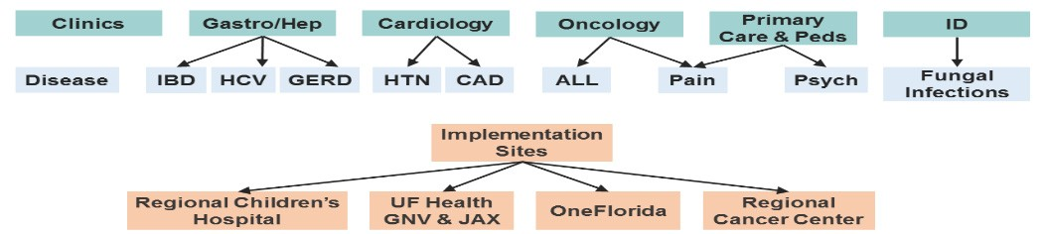

*Figure 2: Precision Medicine Program clinical implementation projects*

inhibitor therapy (Figure 2).9 In 2018-19, a CTSI translational pilot is supporting a pragmatic trial of genotype-

guided pain management for patients undergoing arthroplasty surgery at UF Health. The pilot seeks to validate pre-emptive genotyping and develop outcome measures for opioid use, clinical decision support, and pain control for a national clinical trial to help address the significant burden of pain and opioid use in the US. Expanding beyond UF Health, the program partnered with FSU and OneFlorida to study CYP2D6-guided pain management at two family medicine practices in Orlando10 and is conducting a trial at UF Health Jacksonville to study the effectiveness of point-of-care pharmacogenetics testing to guide clopidogrel therapy for heart stent patients (>1,200 enrolled).11

**Precision Medicine:** In 2018, the Personalized Medicine Program will begin to expand its focus beyond pharmacogenomics as part of a new genomic medicine T32 institutional training grant (T32HG008958) funded by NHGRI and developed in collaboration with the Translational Workforce Development Program. Dr.

Johnson and Dr. Pearson are multi-PIs on this postdoctoral program, which is designed to train fellows for at least two years in the theory and practice of genomic medicine in the areas of pharmacogenomics, cancer genomics, and disease susceptibility genetics/genomics. The inclusion of clinical rotations and emphasis on recruitment of clinicians assures the program will be highly translational and supportive of the Precision Health Initiative. Larisa Cavallari, PharmD, Associate Director of the Personalized Medicine Program, also leads the UF College of Pharmacy’s Center for Pharmacogenomics, and program faculty lead national and international research consortia including Pharmacogenetic Evaluations of Antihypertensive Reponses, International Consortium for Antihypertensive Pharmacogenomic Studies, Warfarin Pharmacogenetics Consortium, Clinical Pharmacogenetics Implementation, and NCI Match.

As we expand into precision medicine, our approach will take into account not only the patient, provider, clinic, and institution levels affecting clinical decision making but also the community context from which patients come,12 and thus will be renamed the Precision Medicine Program. We will engage the Learning Health System Program and OneFlorida to identify opportunities for the implementation of genomic, biomarker, behavioral, and social determinants of health profiles within their settings.13 Further, we will explore the integration of multisource data and will engage special populations, with opportunities to build on past and future projects. For example, Precision Medicine and SECIM faculty recently integrated metabolomic and genomic profiles of hydrochlorothiazide-treated patients to identify novel genetic markers associated with hydrochlorothiazide blood pressure response.14 To develop precision medicine approaches for community settings, a CTSI translational pilot recruited rural practices at UF and FSU to pilot a personalized algorithmic hypertension management approach that incorporates age, race, ethnicity, biomarker, and treatment to improve health outcomes and care delivery processes, particularly for African Americans who have a disproportionate burden related to hypertension.15 At FSU, a new Health Sciences Big Data Analytics Institute is in development to promote integration of health data analytics, ’omics (metabolomics, genomics, proteomics), and neuroimaging data in collaboration with the FSU College of Medicine Translational Science Laboratory, which supports high-end genomic, proteomic, and metabolomic analyses.

**Aim 2: Create a Precision Public Health Program.** Precision public health is a relatively new concept that parallels precision medicine but at the population level.16, 17 Its emergence recognizes that “more accurate methods for measuring disease, pathogens, exposures, behaviors, and susceptibility could also allow better assessment of population health and development of policies and targeted programs for preventing disease.”16 The recent convergence of CTSI programs involving data repositories, community- based participatory research, big data science, communication science, and public health data resources, paired with our strong partnership with the state’s Department of Health and Medicaid Program (see Letters), has created fertile ground for developing a Precision Public

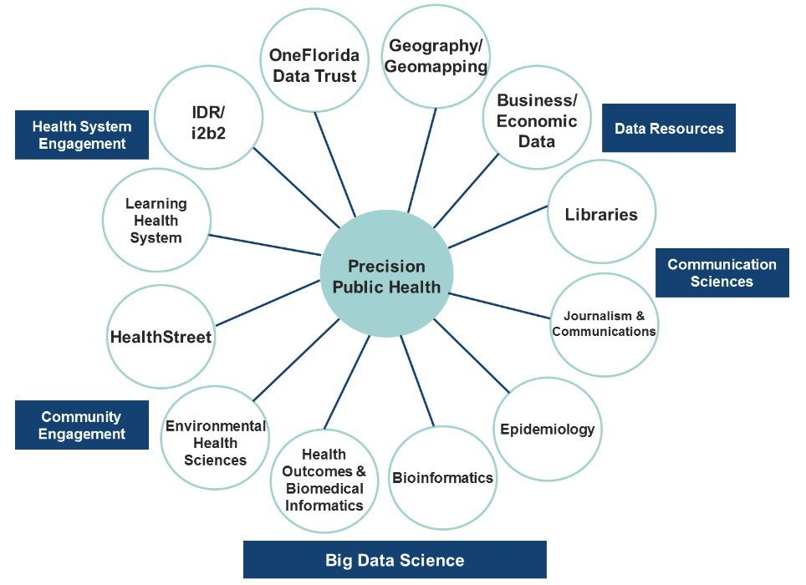

*Figure 3: Precision Public Health interaction with CTSA hub programs*

Health Program. In 2017, as an outcome of a CTSI planning retreat and Steering Committee workgroup, the CTSI funded a demonstration project to organize expertise and resources for precision public health projects (Figure 3). In June 2017, the workgroup invited Muin Khoury, MD, PhD, founding director of the CDC Office of Public Health Genomics, to give the CTSI Research Day keynote address and participate in a workshop focused on developing precision public health capacity at UF. This led to creation of a Precision Public Health Program as part of the Precision Health Initiative, with Dr. Khoury serving on our External Advisory Committee (see Letter in Overall).

The goal of precision public health is “providing the right intervention to the right population at the right time16,” which requires expanded data resources to identify the right community. The Diffusion of Innovation Theory describes health disparities and subsequent excess morbidity and mortality as a consequence of some communities lagging in their uptake of new ideas and services, thereby being left behind when new drug therapies or other health advances become available.18, 19 This leaves non-random clusters of “late adopter” individuals or communities with high disease burden. These communities can be linked using geospatial methods with community characteristics to better describe the disease disparity, the factors likely contributing to it, and the possible implementation strategies most likely to remove the disparity.20

Led by Dr. Pearson, the program organized personnel, data, and other resources in five areas (Table 1). The

Precision Public Health team includes environmental epidemiologists, biostatisticians, bioinformaticists, and geographers. In collaboration with the UF Health Science Center Library, we created a Precision Public Health LibGuide21 in preparation to develop a precision public health component of the searchable data commons to be developed by the Biomedical Informatics Program. The LibGuide catalogs federal-, state-, and local-level data resources, including the geospatial level for each source and type of data; the population and location specified; and type of data. Data

*Table 1: Building blocks of a Precision Public Health Program available at UF*

resources include agricultural, clinical data, demographic, environmental, health statistics, health services statistics, community health resources, housing, and legal/law enforcement and crime data (see Facilities). In addition, the OneFlorida Data Trust is an excellent example of one of our extensive health record datasets with geocoding information down to the neighborhood level. To augment data sources available for precision public health and other research projects, UF and FSU faculty collaborated on a highly scored National Science Foundation (NSF) proposal to establish a Florida Research Data Center, which would be the first federal statistical research data center in the state and uniquely focused on human health (funding decision expected summer 2018).

|  |
| --- |
| Health-related data collection with geospatial information, combined with stakeholder engagement to identify health topics critical to them, to segment and define high-risk subpopulations |
| Communication science expertise to develop and deliver multimedia messages for prevention or intervention, which are sensitive to language, health literacy and culture of the target audiences |
| Community engagement resources to organize and mobilize members of target stakeholders to participate in planning and implementation of risk reduction programs |
| Development of personal health programs as required to reduce risk of poor health outcomes |
| Environmental change (air, food, water, housing) through community engagement, leadership development and policy change |

Precision public health involves linkage and layering of multisource data to identify and characterize a population segment at high risk for poor health outcomes. For example, boys and girls in rural areas may be at high risk for not receiving the HPV vaccine, which in turn can increase their risk for HPV-related cancers in adulthood.22 Linking and layering immunization registry, electronic health record, and census data can allow scientists, clinicians, and public health programs to more effectively target their outreach within rural communities to improve vaccination rates with the goal of ultimately preventing HPV-related cancers.

Key components of this process include development of valid, sensitive, and specific computable phenotypes (see Informatics) with spatiotemporal linkages, or environment-wide association studies (EWAS) to find novel associations between health outcomes such as morbidity, mortality, and quality of life and environmental/social factors.23, 24, 25 For example, the Precision Public Health team is facilitating an EWAS of pregnancy-related high blood pressure, supported by an American Heart Association career award, and the Network Science team is collaborating on a study of the association of polymorphisms, perceptions of unfair treatment, and personal networks with hypertension among African Americans in Tallahassee26 as part of an NSF-funded project that builds on an early CTSI pilot.

Once communities that could potentially benefit from a public health intervention are identified, we will work closely with the Translational Communication Program to assess community knowledge and attitudes about

the risks identified. In precision public health, careful messaging related to risk should be sensitive to language and culture and use multiple media channels to inform community members of their risks and opportunities to reduce them. Our citizen scientists will bring personal and community perspectives into project development and implementation, and our community engagement programs can address health issues in place and time. For example, we can work with HealthStreet community health workers or IFAS Extension agents to mobilize community participation and implement interventions that address health priorities in our catchment area.

The Precision Public Health Program presents an opportunity to extend the CTSI’s learning health system approach to develop learning health communities. The program’s goal is to develop key infrastructure to support development of precision public health pilot projects by offering expert consultation, design studios, seminars, and short courses. Development will co-occur as part of the pilot program and collaborative activities in Aim 3, with areas of special interest including local, state, and national stakeholder priorities such as opioid/substance abuse, hypertension, and obesity.

**Aim 3. Implement a Precision Health Initiative to explore and develop integrative models of precision medicine and precision public health.** Isaac Kohane identified nine issues facing the successful implementation of precision

medicine.27 The implementation of precision public health shares corresponding issues (Table 2). Environment-wide association studies, for example, share many methodologies and assumptions with genome-wide association studies and can identify environment-disease associations from large numbers of exposures of potential significance. The parallel nature of issues facing precision medicine and precision public health were echoed during

*Table 2: Parallel issues facing Precision Medicine and Precision Public Health*

**Kohane, I. (2015). *Science 349*:37-38(11).**

|  |  |  |
| --- | --- | --- |
|  | **Precision Medicine** | **Precision Public Health** |
| **Linkage** | Individual data | Population surveillance data |
| **Blurred boundaries** | Individual data sharing, verification | Community data sharing, verification |
| **Popular support** | Disease advocacy | Community advocacy |
| **’omics writ large** | Lifetime individual risk | Long-term community risk |
| **Perpetual updating** | Individual risk databank | Community risk databank |
| **Computation** | Clinical decision support | Community policy support |
| **Affordability** | Cost of evaluation | Cost of risk assessment |
| **Representation** | Patient diversity | Community diversity |
| **Education** | Public/patients/health system | Public/communities/policy makers |

the CTSI’s Fall 2017 Advanced Data Capabilities and Methods Development roundtables. In the context of identifying advanced data capabilities and methods needed to advance each area, several themes emerged, including methodologies for semantics to address data integration challenges; application of deep learning and artificial intelligence; de-identification and standardization of data; common statistical designs for better comparison and automation of experimental approaches; privacy, ethics, and re-identification risks; guidelines for how to release data and add noise; and data visualization approaches to bridge the translational gulf between researchers and practitioners.

The Precision Health Initiative will administer an annual pilot competition in which investigators will have available to them the expertise, resources, and tools described in Aims 1 and 2 to develop precision medicine and precision public health pilot projects (Table 3). Drs. Johnson and Pearson will co-chair a Precision Health Pilot Committee, and their ongoing collaboration as multi-PIs on the genomic medicine T32 will ensure optimal coordination of training opportunities, as well as an opportunity for Precision Medicine Program lessons learned to inform the development and implementation of selected pilots. Dr. Rasmussen will oversee development and implementation of a dissemination strategy for the initiative, including a monthly forum in which faculty and students can share methods, results, and case studies and engage with experts across multiple programs, including Informatics, BERD, Regulatory Science, and Network Science. A project manager will manage activities and events and coordinate the pilot program. Terra Bradley, PhD, will coordinate FSU participation.

The learning health system concept of “think globally, act locally” will inform development of precision health pilots to foster the use of linked individual- and community-level data to develop precision health methodologies and interventions aligned with stakeholder priorities (Figure 4). Pilot awards of up to $50,000 each will be provided for a total of three to four awards per year. A pilot applicant workshop will be offered in collaboration with the Translational Workforce Development Program. Selection criteria will include qualifications to carry out the proposed work; innovation, significance, and feasibility; likelihood of development into an externally funded project; use of CTSI resources. Proposals from early-stage investigators, multidisciplinary teams, and teams from distant campuses and partners will be encouraged, and each project

must incorporate at least one trainee for a mentored research experience. Successful applicants will present results at the monthly forum, contribute to the data commons, and submit a final report.

**Milestones:** Year 1: Launch monthly forums, with option for remote participation. As part of the OneFlorida annual stakeholder meeting, host a summit with the Community Advisory Board, Florida Department of Health, and Florida Agency for Health Care Administration to identify stakeholder and scientific priorities for the initiative. Launch precision health pilot program open to UF and FSU investigators. Year 2: Expand pilot opportunity to OneFlorida.

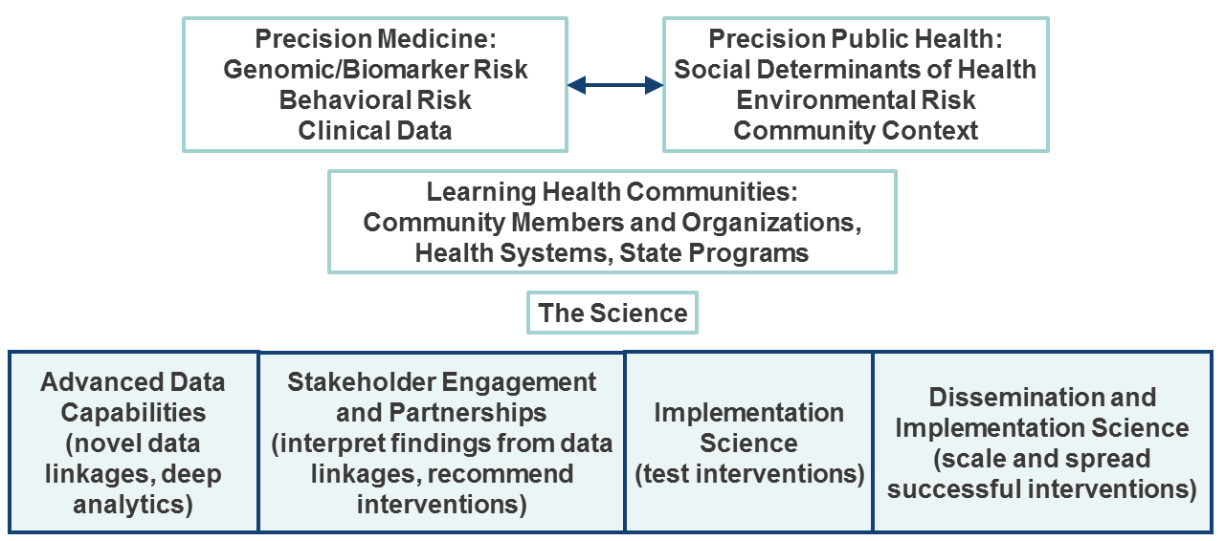

*Figure 4: Precision Health Pilot Program*

Incorporate precision health collaboration event as part of OneFlorida annual stakeholder meeting. Years 3-4: Continue annual pilot opportunity, manage and facilitate ongoing pilots. Explore a network-informed pilot intervention to advance precision health. Year 5: Disseminate results and facilitate translation of promising approaches through OneFlorida and CTSA consortia, including national CTSA funding mechanisms.

**Evaluation:** We will partner with the CTSI Evaluation team to develop, collect, and report metrics for CTSI evaluation and CTSA Common Metrics purposes. Metrics will include event participation and satisfaction; program and pilot awardee publications and grants; and development and use of methods, tools, and other resources. Indicators of impact related to stakeholder priorities identified in Year 1 and aspects of precision medicine and precision public health on Table 2 will be developed, as will case studies of integrative projects.

*Table 3: Examples of CTSI resources for Precision Health Initiative*

|  |  |  |  |
| --- | --- | --- | --- |
| **CTSI Program Resources** | **Southeast Center for Integrated Metabolomics** | **Precision Medicine Program** | **Precision Public Health Program** |
| **Tools and Techniques** | Clinical metabolomics:   * IE-Omics R script (automates iterative exclusion experiments for Thermo instruments)28 * LipidMatch software,29 LipidMatch Quant feature table, LipidPioneer interactive exact mass template,30 LipidQC method validation tool31 * SECIMTools (python tools for quality control metrics, visualization techniques, statistical analysis and adv classification methods, adv variable selection tools)32 * Blank feature filtering technique33 | IGNITE Toolbox website:34   * Implementing genomics in practice: evidence overviews, operational elements, clinical decision support and EHR integration, regulatory and process issues, reimbursement and coding for genetic testing, resources for patients and providers, workflow examples, data collection, implementation metrics * Researching genomics in practice: sample consent forms, surveys, data dictionaries, collaborative agmts, impl science resources | Precision Public Health LibGuide:35   * Data science resources * Data by jurisdiction, topic * Statistical reports * Raw datasets * Tools and training * Data repositories * News and events * Videos, presentations, articles   **Future:**   * Publish Your Data for Impact data commons initiative (see Informatics) |
| **Training and Education** | * Galaxy Training * SECIM Workshop and Symposium * American Society for Mass Spectrometry Asilomar Conference: Impact of Metabolomics in Translational and Clinical Research (2017) | * Precision Med continuing educ, annual conf (CME/CPE accredited) * Pharmacogenetics Pharmacy Residency (ASHP accredited) * Precision Med 9-credit online grad certificate (2018; 9-course curric) * Genomic Medicine Postdoc (T32) | **Future:**   * Pilot workshops * Consultation service * Training grants |
| **Precision Health Initiative: Monthly Forum/Studios, Pilots, Data Commons, Precision Health Summit** | | | |

##### CTR Core H2: Precision Health Core References References

1 https://allofus.nih.gov/about/about-all-us-research-program

2 [https://www.cancer.gov/publications/dictionaries/cancer-terms/def/molecular-medicin](http://www.cancer.gov/publications/dictionaries/cancer-terms/def/molecular-medicine)e

3 Centers for Disease Control. Social Determinants of Health. ht[tps://www.cdc.gov/socialdeterminants/](http://www.cdc.gov/socialdeterminants/) accessed April 27, 2018.

4 Precision Public Health and Precision Medicine: Two Peas in a Pod [https://blogs.cdc.gov/genomics/2015/03/02/precision-public/]

37 Khoury MJ. No Shortcuts on the Long Road to Evidence-Based Genomic Medicine. JAMA. 2017 Jul 4;318(1):27-28. doi: 10.1001/jama.2017.6315. PubMed PMID: 28570728.

7 Cavallari LH, Lee CR, Beitelshees AL, Cooper-DeHoff RM, Johnson JA, et. al IGNITE Network. Multisite Investigation of Outcomes With Implementation of CYP2C19 Genotype-Guided Antiplatelet Therapy After Percutaneous Coronary Intervention. JACC Cardiovasc Interv. 2018 Jan 22;11(2):181-191. doi: 10.1016/j.jcin.2017.07.022. Epub 2017 Nov 1. PubMed PMID: 29102571; PubMed Central PMCID: PMC5775044.

8 Weitzel KW, Elsey AR, Langaee TY, et. al. Clinical pharmacogenetics implementation: approaches, successes, and challenges. Am J Med Genet C Semin Med Genet. 2014 Mar;166C(1):56-67. doi: 10.1002/ajmg.c.31390. Epub 2014 Mar 10. PubMed PMID: 24616371; PubMed Central PMCID: PMC4076109.

9 Empey PE, Stevenson JM, Tuteja S, Weitzel KW, et. al. ; IGNITE Network. Multisite Investigation of Strategies for the Implementation of CYP2C19 Genotype-Guided Antiplatelet Therapy. Clin Pharmacol Ther. 2017 Dec 26. doi: 10.1002/cpt.1006. [Epub ahead of print] PubMed PMID: 29280137.

10 Cavallari LH, Weitzel KW, Elsey AR, Liu X, Mosley SA, Smith DM, Staley BJ, Winterstein AG, Mathews CA, Franchi F, Rollini F, Angiolillo DJ, Starostik P, Clare-Salzler MJ, Nelson DR, Johnson JA. Institutional profile: University of Florida Health Personalized Medicine Program. Pharmacogenomics. 2017 Apr;18(5):421-426. doi: 10.2217/pgs-2017-0028. Epub 2017 Mar 27. Review. PubMed PMID: 28346068; PubMed Central PMCID: PMC5558508.

11 Smith DM, Weitzel KW, Cavallari LH, Elsey AR, Schmidt SO. Clinical application of pharmacogenetics in pain management. Per Med. 2018 Mar;15(2):117-126. doi: 10.2217/pme-2017-0032. Epub 2018 Jan 31.

PubMed PMID: 29714124.

11 Cavallari LH, Franchi F, Rollini F, Been L, Rivas A, Agarwal M, Smith DM, Newsom K, Gong Y, Elsey AR, Starostik P, Johnson JA, Angiolillo DJ. Clinical implementation of rapid CYP2C19 genotyping to guide antiplatelet therapy after percutaneous coronary intervention. J Transl Med. 2018 Apr 11;16(1):92. doi: 10.1186/s12967-018-1469-8. PMID: 29642909. PMCID: PMC5896099.

13 Chan WV, Pearson TA, Bennett GC, et. al. ACC/AHA Special Report: Clinical Practice Guideline Implementation Strategies: A Summary of Systematic Reviews by the NHLBI Implementation Science Work Group: A Report of the American College of Cardiology/American Heart Association Task Force on Clinical Practice Guidelines. J Am Coll Cardiol. 2017 Feb 28;69(8):1076-1092. doi: 10.1016/j.jacc.2016.11.004. Epub 2017 Jan 26. PubMed PMID: 28132746.

12 Roberts MC, Kennedy AE, Chambers DA, Khoury MJ. The current state of implementation science in genomic medicine: opportunities for improvement. Genet Med. 2017 Aug;19(8):858-863. doi: 10.1038/gim.2016.210. Epub 2017 Jan 12. Review. PubMed PMID: 28079898.

14 Shahin MH, Gong Y, McDonough CW, Rotroff DM, Beitelshees AL, Garrett TJ, Gums JG, Motsinger-Reif A, Chapman AB, Turner ST, Boerwinkle E, Frye RF, Fiehn O, Cooper-DeHoff RM, Kaddurah-Daouk R, Johnson JA. A Genetic Response Score for Hydrochlorothiazide Use: Insights From Genomics and Metabolomics

Integration. Hypertension. 2016 Sep;68(3):621-9. doi: 10.1161/HYPERTENSIONAHA.116.07328. Epub 2016 Jul 5. PubMed PMID: 27381900; PubMed Central PMCID: PMC4982802.

15 OPTImizing Precision of Hypertension Care to Maximize Blood Pressure Control Pilot (OPTI-BP Pilot): NCT02814552.

16 Khoury MJ, Iademarco MF, Riley WT. Precision Public Health for the Era of Precision Medicine. Am J Prev Med. 2016 Mar;50(3):398-401. doi: 10.1016/j.amepre.2015.08.031. Epub 2015 Nov 4. Review. PubMed PMID: 26547538; PubMed Central PMCID: PMC4915347.

17 Khoury MJ, Galea S. Will Precision Medicine Improve Population Health? JAMA. 2016 Oct 4;316(13):1357- 1358. doi: 10.1001/jama.2016.12260. PubMed PMID: 27541310..

19 Rogers EM, Shoemacher EF. Communication of Innovation. New York, NY: Free Press; 1971; 99-134, 175- 196.

20 Pearson TA. Education and income: double-edged swords in the epidemiologic transition of cardiovascular disease. Ethn Dis. 2003 Summer;13(2 Suppl 2):S158-63. PubMed PMID: 13677431.

21 <http://guides.uflib.ufl.edu/precision> public health

22 Vogel NP, Appel SJ, Winker G. Improving HPV vaccination rates among young males in rural areas of the United States. Nurse Pract. 2018 Jan 15;43(1):1-6. doi: 10.1097/01.NPR.0000527572.74477.a5. PubMed PMID: 29240623.

24 Patel CJ, Ioannidis JP. Studying the elusive environment in large scale. JAMA. 2014 Jun 4;311(21):2173-4. doi: 10.1001/jama.2014.4129. PubMed PMID: 24893084; PubMed Central PMCID: PMC4110965.

25 McGinnis DP, Brownstein JS, Patel CJ. Environment-Wide Association Study of Blood Pressure in the National Health and Nutrition Examination Survey (1999-2012). Sci Rep. 2016 Jul 26;6:30373. doi: 10.1038/srep30373. PubMed PMID: 27457472; PubMed Central PMCID: PMC4960597.

26 Patel, Chirag J., Mark R. Cullen, John PA Ioannidis, and Atul J. Butte. "Systematic evaluation of environmental factors: persistent pollutants and nutrients correlated with serum lipid levels." International journal of epidemiology 41, no. 3 (2012): 828-843.

27 Fuller, K. C., Mccarty, C., Vacca, R., Gravlee, C. C., Boulter, A. C., & Mulligan, C. J. (2016, March). Association of ACE, TPA, and WNK1 Alu polymorphisms, perceptions of unfair treatment, and personal networks with hypertension in African Americans. In AMERICAN JOURNAL OF PHYSICAL ANTHROPOLOGY (Vol. 159, pp. 149-149). 111 RIVER ST, HOBOKEN 07030-5774, NJ USA: WILEY-BLACKWELL.

28 Kohane IS. HEALTH CARE POLICY. Ten things we have to do to achieve precision medicine. Science. 2015 Jul 3;349(6243):37-8. doi: 10.1126/science.aab1328. Epub 2015 Jul 2. PubMed PMID: 26138968.

29 Koelmel JP, Kroeger NM, Gill EL, Ulmer CZ, Bowden JA, Patterson RE, Yost RA, Garrett TJ. Expanding Lipidome Coverage Using LC-MS/MS Data-Dependent Acquisition with Automated Exclusion List Generation. J Am Soc Mass Spectrom. 2017 May;28(5):908-917. doi: 10.1007/s13361-017-1608-0. Epub 2017 Mar 6.

PubMed PMID: 28265968; PubMed Central PMCID: PMC5408749.

30Koelmel JP, Kroeger NM, Ulmer CZ, Bowden JA, Patterson RE, Cochran JA, Beecher CWW, Garrett TJ,

Yost RA. LipidMatch: an automated workflow for rule-based lipid identification using untargeted high-resolution tandem mass spectrometry data. BMC Bioinformatics. 2017 Jul 10;18(1):331. doi: 10.1186/s12859-017-1744-

1. PubMed PMID: 28693421; PubMed Central PMCID: PMC5504796.

31Ulmer CZ, Koelmel JP, Ragland JM, Garrett TJ, Bowden JA. LipidPioneer : A Comprehensive User- Generated Exact Mass Template for Lipidomics. J Am Soc Mass Spectrom. 2017 Mar;28(3):562-565. doi: 10.1007/s13361-016-1579-6. Epub 2017 Jan 10. PubMed PMID: 28074328; PubMed Central PMCID: PMC5557379..

*32* Ulmer CZ, Ragland JM, Koelmel JP, Heckert A, Jones CM, Garrett TJ, Yost RA, Bowden JA. LipidQC: Method Validation Tool for Visual Comparison to SRM 1950 Using NIST Interlaboratory Comparison Exercise Lipid Consensus Mean Estimate Values. Anal Chem. 2017 Dec 19;89(24):13069-13073. doi: 10.1021/acs.analchem.7b04042. Epub 2017 Dec 1. PubMed PMID: 29148710.

33 Kirpich AS, Ibarra M, Moskalenko O, Fear JM, Gerken J, Mi X, Ashrafi A, Morse AM, McIntyre LM. SECIMTools: a suite of metabolomics data analysis tools. BMC Bioinformatics. 2018 Apr 20;19(1):151. doi: 10.1186/s12859-018-2134-1. PubMed PMID: 29678131; PubMed Central PMCID: PMC5910624.

34 Patterson, R. E., Kirpich, A. S., Koelmel, J. P., Kalavalapalli, S., Morse, A. M., Cusi, K., ... & Yost, R. A. (2017). Improved experimental data processing for UHPLC–HRMS/MS lipidomics applied to nonalcoholic fatty liver disease. Metabolomics, 13(11), 142.

35 https://ignite-genomics.org/

36 <http://guides.uflib.ufl.edu/precisionpublichealth>