Precision Health Optional Function

DRAFT 03/20/18

**Introduction**

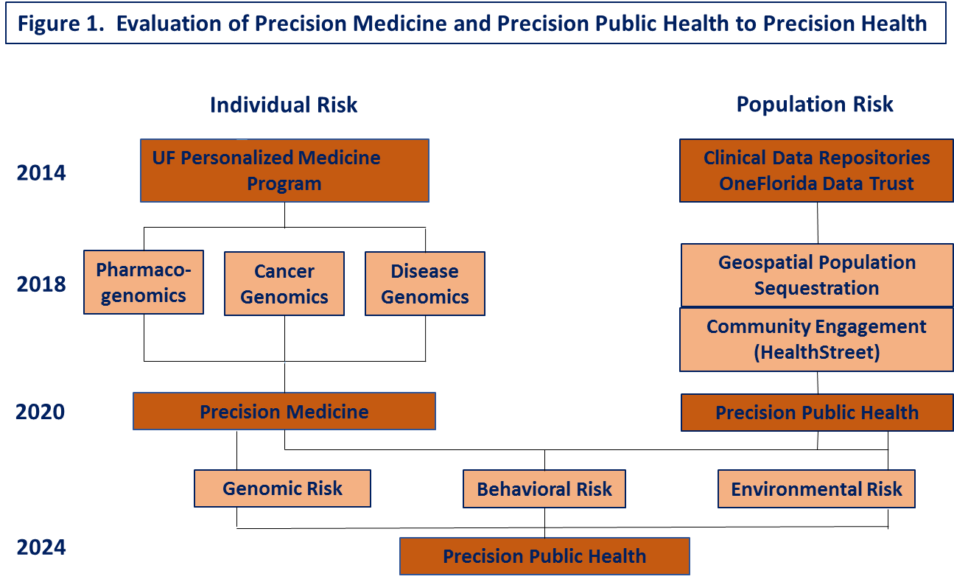 The Precision Health Optional Function constitutes the logical next step in the continued evolution of the UF CTSA’s Personalized Medicine Program (Figure 1), which has up to now focused on the barriers to the use of genomic information in health care services and the continued development of the evidence-base for the healthcare benefits of genomic medicine approaches. We propose to develop pharmacogenomics, cancer genomic, and disease susceptibility genomics as well as other individual-level data to better define the risks that guide diagnostic algorithms, prognostic prediction, and effective and safe treatments, as called for in the Precision Medicine Initiative (1). “The right dose of the right treatment in the right patient at the right time” has emerged as the Precision Medicine goal. A second UF CTSA initiative has recently begun development in Precision Public Health (2). Driven by expanding clinical databases, research networks using electronic health records, and increasing geospatial data on individuals’ places of residency, there is an increasing recognition of “place” as a significant contributor to the risk of populations and the individuals who reside in them. Geospatial factors including environmental, social, and economic factors, inform and enhance community-wide interventions as a complement to individual care. “The right intervention in the right place at the right time” becomes the goal of Precision Public Health (2). This Optional Function recognizes that the eventual goal is the comprehensive assessment of individual risk using both individual and population data applied to either clinical regimens, public health interventions, or both to provide the best and most precise intervention. The congregation of Precision Medicine and Precision Public Health then yields the Precision Health Optional Function proposed for the next period of funding (Figure 1).

**Significance and Innovation**

High quality genomic discovery research constitutes the pipeline for translation of genomic medicine to new treatment and prevention modalities. Increasingly large datasets allow combinations of genes and gene-gene interactions to identify additional risk and opportunities to mitigate that risk. Yet, studies of many common diseases have not explained a significant portion disease risk due to either inherited or non-genetic (environmental) sources. Many studies have identified interaction between behavioral factors and genetic polymorphisms, greatly enhancing our ability to identify high-risk subsets. Other studies of epigenetic factors have identified mechanisms by which environmental factors modify genetic factors to increase disease risk. However, many datasets lack the power to test large numbers of genetic and epigenetic traits interacting with human behaviors and/or socio-environmental factors for their impact on human health. The Precision Health Optional Function proposes to take advantage of three large, well-established programs within the UF CTSA and demonstrate interaction and synergism through comingling the disciplines and datasets (Figure 1). The Personalized Medicine Program has successfully functioned at the intersection of human genomics and the UF HSC clinical programs. It has been an Optional Function of the UF CTSA Program since 2014 and has fully integrated into the CTSA including sponsorship of KL2 Scholars, a newly funded Institutional Training Grant from NHGRI (Program for Applied Research and Development in Genomic Medicine), a Certificate Program in Genomic Medicine for Clinical-Scientists, and important contributions to UF Health clinical programs. The OneFlorida Data Trust, at the same time, has continued to enroll and make data available to faculty and students, now including 15.4 million Florida residents enrolled. Of these, 69% of residents have geospatial data on place of residence down to the level of 10 postboxes. This provides a nationally unique data resource to identify high-risk subpopulations. The HealthStreet Program is a major part of the UF CTSA’s Community Engagement Function, with faculty and staff with strong expertise in community-based participatory research, research subject recruitment, data collection and management, and other population health skills.

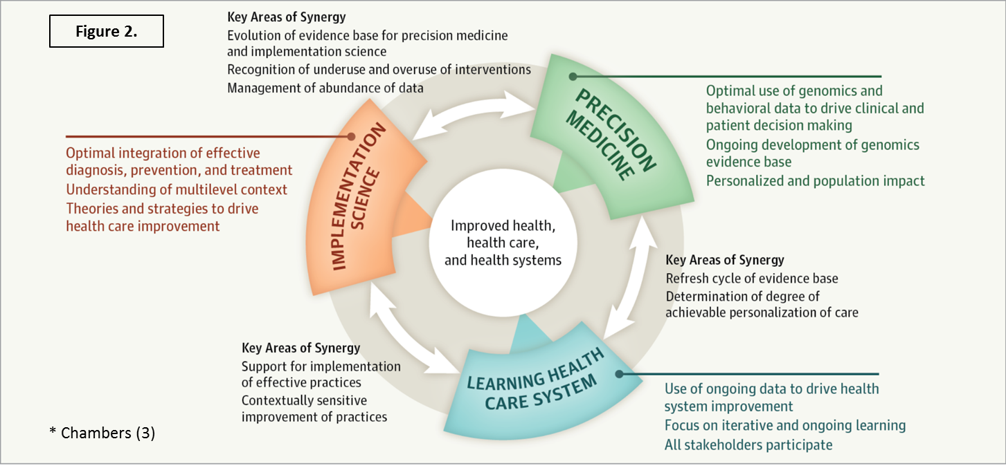A critical part of the Precision Health Optional Function then is the continued implementation and dissemination of the Precision Medicine Program, including its synergy and integration with UF Health as a Learning Health System and Implementation Science as the means to effectively adopt the use of genomic and behavioral profiles at multiple levels of our healthcare system (Figure 2) (3). An innovative aspect of the approach proposed here is to take into account not only the patient, provider, clinic, and institution of levels affecting clinical decision making, but also the community context from which the patients come (4).

Innovative aspects of the Precision Health Function include the One Florida Data Trust being the only state-based PCORNet site with availability of geospatial data on most of its subjects. The addition of faculty in geography, demography, informatics, biostatistics, clinical decision analysis, and communication to the Precision Public Health Team creates the opportunity to identify places with high or low risk that can be further characterized by state and local databases in terms of demographic, social and economic factors, etc. A second innovation is the assembly of methodologic expertise at the UF CTSA to link and layer these population databases with other data on environmental, economic, sociodemographic, and many other variables. Environment-wide Association Studies (EWAS) share many methodologies and assumptions with Genomic-wide Association Studies (GWAS) (5-7). EWAS can identify environment-disease associations from large numbers of exposures of potential significance. The novel eventual goal is to combine genomic/behavioral data in individuals with environmental/ behavioral data at the community level to provide improved risk assessment at both levels or “precision epidemiology” (8). Third, the communication with these high-risk communities would be essential to not only further understand the nature of their risk but also to assemble clinical services, population interventions, or both. To our knowledge, no studies like this have been planned and activated with adequate study design, statistical power, and analysis to test hypotheses related to environmental/community factors’ role in defining individuals’ risk for poor health outcomes.

Specific Aim 1: Evolve the successful Personalized Medicine Program as a focus of the 2015-CTSA renewal into a Precision Medicine Program through use of individual-level data to guide diagnosis, prognosis, and treatment. The University of Florida has been a leader in both genomic medicine discovery and its implementation in three areas: Pharmacogenomics, Cancer Genomics, and Disease Susceptibility Genetics/Genomics. Each of these use genetic/genomic markers to better characterize an individual’s risk. Pharmacogenomics has great potential to significantly impact an individual’s current care. The UF Center for Pharmacogenomics was established in 2001 in the College of Pharmacy. Center faculty now lead national research groups on Pharmacogenetic Evaluations of Antihypertensive Reponses, an International Consortium for Antihypertensive Pharmacogenomic Studies, the Warfarin Pharmacogenetics Consortium and the Clinical Pharmacogenetics Implementation Consortium. The UF Health Personalized Medicine Program (PMP) was established in 2011 under the leadership of Dr. Julie Johnson to establish UF as a leader in clinical implementation of genomic medicine, specifically by overcoming barriers to the use of genomic information in the healthcare system. This Center was one of the inaugural research groups funded for NHGRI’s genomic medicine implementation network, IGNITE, with Dr. Johnson as Chair of its Steering Committee. This has resulted in the groundbreaking investigations of CYP2C19 genotype-guided clopidogrel therapy in post coronary angioplasty patients, now published and implemented by several U.S. medical centers. Additional PMP programs include TPMT-guided thiopurine therapies for pediatric cancers and inflammatory bowel disease, IL28B genotype-guided interferon-alpha therapies hepatitis C, CVP2D6-guided pain management in chronic pain of cancer, CYP2D6/CYP2C19-guided antidepressant therapy (SSRI’s and tricyclic antidepressants), 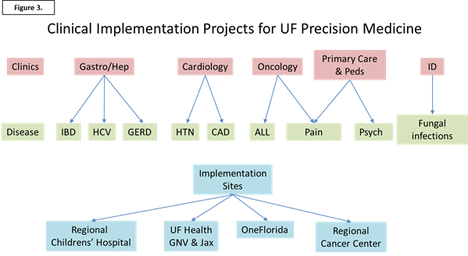and CYP2C19-guided proton pump inhibitor therapy. Several additional studies of ondansetron therapy and voriconazole therapy are getting underway. The goals for the next funding period is to continue to describe the utility of pharmacogenomics markers in additional fields of clinical practice and to expand and implement these advances beyond the UF HSC (Figure 3).

The Cancer Genomics program partners with the UF Health Cancer Center to use tumor genomic data to refine diagnoses and prognoses and to select individualized therapies for cancer patients. The UF Health Precision Cancer Care Program emphasizes comprehensive molecular profiling of somatic mutations and amplifications in a variety of solid tumors to predict drug responses, progression, etc. Tumor and blood samples for patients who are molecular profiled are added to the CTSI’s Integrated Data Repository. The plan for the Precision Cancer Care Program includes the evaluation of molecular profiling in diagnostic, prognostic, and therapeutic aspects of cancer care and their incorporation into care protocols for those found to be efficacious and cost effective. This Program is an excellent example of CTSA-Cancer Center collaboration at UF.

The Disease Susceptibility Genetics/Genomics Program is part of the UF Medical Genetics Program supported by a Molecular and Cytogenetics Laboratory and Medical Genetics Clinic in Department of Pediatrics. The Medical Genetics Program hosts two nationally recognized Centers of Excellence. The UF Health Center for Pediatric Neuromuscular and Rare Diseases cares for patients with monogenic disorders of the neuromuscular system as well as a variety of storage diseases, cardiomyopathies, cystic fibrosis, etc. The Turner Syndrome Center of Excellence provides comprehensive genetic diagnosis and care to girls and women as the only such center in the Southeast U.S.

In 2018, UF Colleges of Pharmacy and Medicine initiated an Institutional Training Grant (T32) with funding by NHGRI entitled: “Program for Applied Research and Development in Genomic Medicine” (PARADIGM). Dr. Julie Johnson, Director of the UF Health Personalized Medicine Program and Dr. Thomas Pearson, Director of the Precision Public Health Initiative and CTSA Translational Workforce Development Program are MPI’s on this postdoctoral program to train postdoctoral fellows for at least two years in the theory and practice of Genomic Medicine. A didactic curriculum, career development program, mentored research experience, on annual Precision Medicine Symposium, and a supervised clinical experience borrow heavily from and integrate well with the UF CTSA Translational Workforce Development Program. The inclusion of clinical rotations and emphasis on recruitment of clinicians as PARADIGM fellows assures this training program to be highly translational and supportive of this proposed Precision Health Optional Function.

The milestones of productivity for the Precision Medicine Program include federal and private sector grants applied for and obtained in the three foci, publications in precision medicine which cite support from the CTSA Programs, and postdoctoral fellows’ recruitment, acquisition of funding, and publication of manuscripts in Precision Medicine.

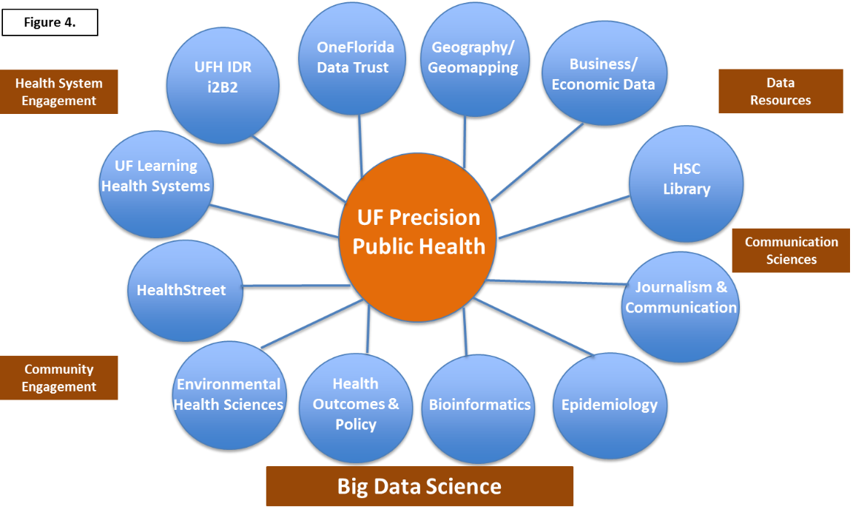Specific Aim 2: To establish a Precision Public Health Program which uses geospatial methods to identify populations at high risk and the characteristics of those subpopulations which contribute to that risk. Precision Public Health is a relatively new concept which parallels Precision Medicine but at the population level (2,9). Its emergence is due to “More accurate methods for measuring disease, pathogens, exposures, behaviors, and susceptibility could also allow better assessment of population health and development of policies and targeted programs for preventing disease (2).” UF CTSA is in a strong position to develop a Precision Public Health Program, due to a large number of UF programs with data repositories, community participation research, big data science, communication sciences, and public health data resources (Figure 4). A UF Precision Public Health Working Group of eleven Faculty and Senior Staff was convened in 2017 from the organizations identified on Figure 4 to establish an infrastructure for investigators and trainees to more easily develop and carry out Precision Public Health Initiatives at the UF CTSA Program.

One requirement to implement “the right intervention in the right community at the right time” is to use expanded data resources to identify that “right community”. The Diffusion of Innovation Theory (10,11) describes health disparities and subsequent excess morbidity and mortality as a consequence of some communities lagging in their uptake of new ideas and services, thereby being left behind when new drug therapies or other health advances become available. This leaves non-random clusters of “late adopter” individuals or communities with high disease burden. These communities can be linked using geospatial methods with community characteristics to better describe the disease disparity, the factors likely contributing to it, and the possible implementation strategies most likely to remove the disparity (11).

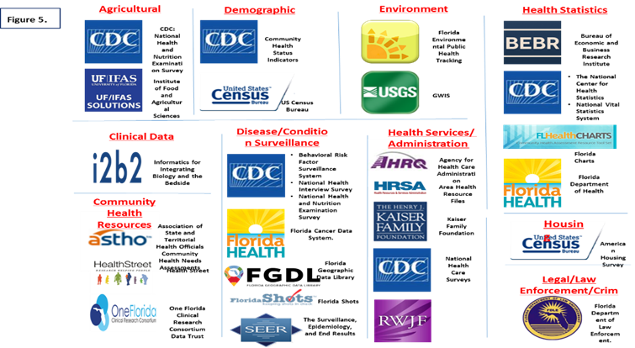 The UF CTSA Precision Public Health Initiative has organized personnel, data, and other resources in five areas (Table 1). First, we have succeeded in assembly of a remarkable constellation of datasets relevant to health of residents of the State of Florida. These have been organized for ease of data sharing by the staff of the UF Health Science Center Library i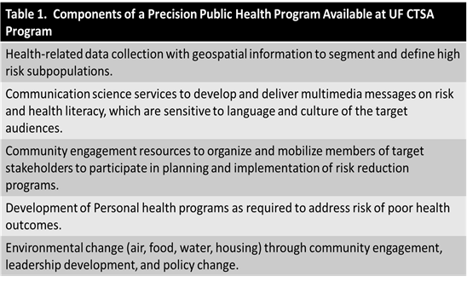nto a publically accessible PPH Library Guide (http://guides.uflib.ufl.edu/precision public health) (Figure 5). This Lib Guide has federal, state, and local-level data resources with the geospatial level for each source and type of data, the population and location specified, and type of data (agricultural, clinical data, demographic, environmental, health statistics, health services statistics, community health resources, housing, and legal/law enforcement and crime data identified. A primary use of these data is the identification and characterization of a high-risk population segment through data linkage and layering. The OneFlorida Data Trust is an excellent example of one of our extensive health record datasets with geocoding information down to the neighborhood level. The CTSA Precision Public Health team includes environmental epidemiologists, biostatisticians, bioinformaticists, and geographers who can develop computerizable phenotypes which are valid, sensitive, and specific, and have spatiotemporal linkages with the multisource data from the LibGuide. One new method would be the Environment-wide Association Study (EWAS) to find novel associations between health outcomes and environmental/social factors (5-7). The UF Precision Public Health Program is currently performing an EWAS of pregnancy-related high blood pressure supported by an American Heart Association career award grant to Dr. Hui Hu.

The UF CTSA will work closely with the UF College of Journalism and Communication to enhance community knowledge and attitudes on risks identified. In Precision Public Health, careful messaging related to risk should be sensitive to language and culture and use multiple media channels to inform the community members of their risks and opportunities to reduce them. The UF CTSA Community Engagement Function, HealthStreet, will be called on to address the health issues in place and time, and to organize and mobilize community participation to implement a solution. UF Health could then consider population health programs as part of their commitment as a Learning Health System. Other physical, legal, or legislative efforts could also be activated to address environmental factors linked to the localized disease burden.

The Precision Public Health Initiative’s goal is to have an infrastructure to support PPH programs in place by 2020. For the next period of funding, the continued development will be stimulated by a pilot study program which trainees and faculty could receive funds to perform population segmentation, carry out an EWAS, or design on implementation science study using the Precision Public Health infrastructure (Table 1). The milestones for the Precision Public Health Program will be the utilization of the OneFlorida Data Trust and LibGuide for purposes of Geomapping disease, the grants submitted and awarded using PPH infrastructure, the number of publications on PPH per year, and the number of PPH Programs involving community engagement, individual healthcare programs, or community-wide initiatives in environmental change and policy, as listed in Table 1.

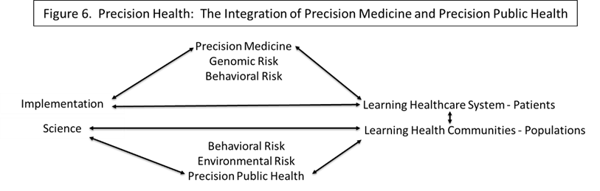Specific Aim 3. To develop the expertise, databases, and methods to integrate Precision Medicine and Precision Public Health Programs to allow a more comprehensive estimation of risks of individuals and communities to guide more tailored and effective programs of risk reduction. Few, if any programs are currently active in which individual genomic, metabolomic, and behavioral data can be linked by place of residence to community traits and environmental factors. The lack of population-wide genomic data, for example, has been identified as a barrier to precision public health (3,12). Precision Health can then be conceptualized as multiple, interacting layers of an implementation strategy (Figure 6). Genomic and behavioral determinants of individual health are now joined with behavioral and environmental determinants at the population level to inform both Learning Health Care Systems as well as Learning Health Communities. The other connection is through implementation science programs which tailor individual or community intervention based on the risk information collected.

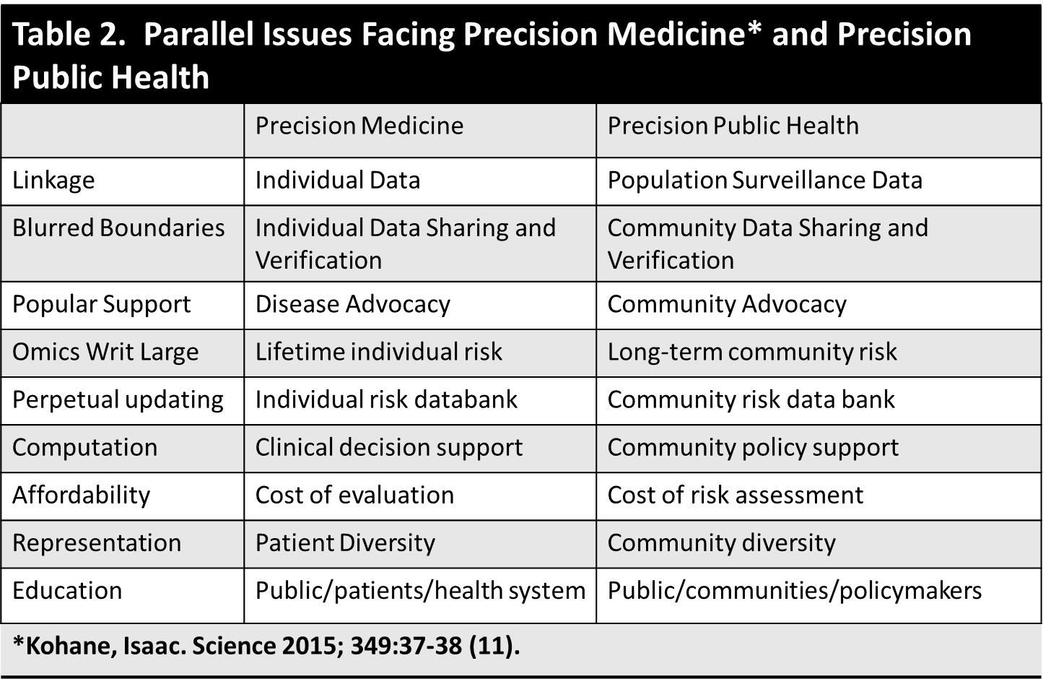 As with the Precision Medicine Specific Aims, the goal of the Precision Health Program is to identify barriers to integration of Precision Medicine and Precision Public Health Programs. Isaac Kohane identified nine issues facing the successful implementation of precision medicine (11) (Table 2). Implementation of Precision Public Health shares most of these issues. CTSA programs are in place to address both, as identified for Precision Public Health. Proposed for the next funding period will be multiple pilot/seed projects which aim to implement integrated Precision projects within the UF CTSA.

The milestones for the Precision Health Program are the aggregate number of grants submitted or awarded in all three areas (Precision Medicine, Precision Public Health, and Precision Health), as well as publications in these fields. Moreover, metrics tied to aspects of Precision Medicine and Precision Public Health on Table 2 will be developed. Of particular interest will be case-studies of those programs which fully integrate Precision Medicine components into Precision Public Health programs.

References

1. Collins FS, Varmus H. A new initiative on precision medicine. N Engl J Med 2015;372:793-795.
2. Khoury MJ, Iademarco MF, Riley WT. Precision public health for the era of precision medicine. Am J Prev Med 2016; 50:398-401.
3. Roberts MC, Kennedy AF, Chambers DA, Khoury MJ. The current state of implementation science in genomic medicine: opportunities for improvement. Genet Med doi:10:1038/gim.2016.210.
4. Chan W, Pearson T, et al. ACC/AHA Special Report: Clinical Practice Guideline Implementation Strategies: A Summary of Systematic Reviews by the NHLBI Implementation Science Work Group. J Am Coll Cardiol. 2017 Feb 28;69(8): 1076-1092. Doi:10.1016/j.jacc.2016.11.004.
5. Patel CJ, Ioannidis JP. Studying the elusive environment in large scale. JAMA 2014;311:2173-2174. Doi:10.1001/jama.2014.4129.
6. McGinnis DP, Brownstein JS, Patel CJ. Environment-wide association study of blood pressure in the National Health and Nutrition Examination Survey (1999 – 2012). Scientific Reports (6:30373) doi:10.1038/srep 30373.
7. Patel CJ, et al. Systematic evaluation of environmental factors: persistent pollutants and nutrients connected with serum lipid levels. Int J Epidemiol 2012;41:828-843.
8. Blanco C, Compton WM, Grant BF. Trend precision epidemiology. JAMA Psychiatry 2016; 73:1008-9.
9. Khoury MJ, Galea S. Will precision medicine improve population health? JAMA 2016;316:1357-1358.
10. Rogers EM, Shoemacher EF. Communication of Innovation. New York, NY: Free Press; 1971; 99-134, 175-196.
11. Pearson TA. Education and Income: Double-Edged Swords in the Epidemiologic Transition of Cardiovascular Disease. 2003;13(Suppl 2): S2-158-S2-163.
12. Khoury MJ. No shortcuts on the long road to evidence-based genomic medicine. JAMA 2017;318:27-29.
13. Kohane I. Ten things we have to do to achieve precision medicine. Science 2015; 349:37-38.