Consistent format:

Set in Tabby Cat Kenippy's hut where StatCat lectures DataDog on the follies of impatience and poor planning.

Each incident opens with StatCat and DataDog setting up story. These pages are told in DataStory format, single horizontal panel set ups (reusing backgrounds, shots and panels)

All stories told within Sunday comics style format (though altered and based on side to side dimensions established in the DataStories, though these "flashbacks" or "stories" are all longer on the up and down axis to fit in more panels.)

Story closes and we return to the hut where they discuss the moral of the story.

Learning event.

Return to hut to set up next story.

The main story is housed within the Star Wars satire universe.

All the flashbacks/stories are told in different styles.

Alway returning to Tabby Cat Keniipy's Star Wars hut.

STAR WARS/FLASH GORDON/BUCK ROGERS ITERATION:

Chapter 1:

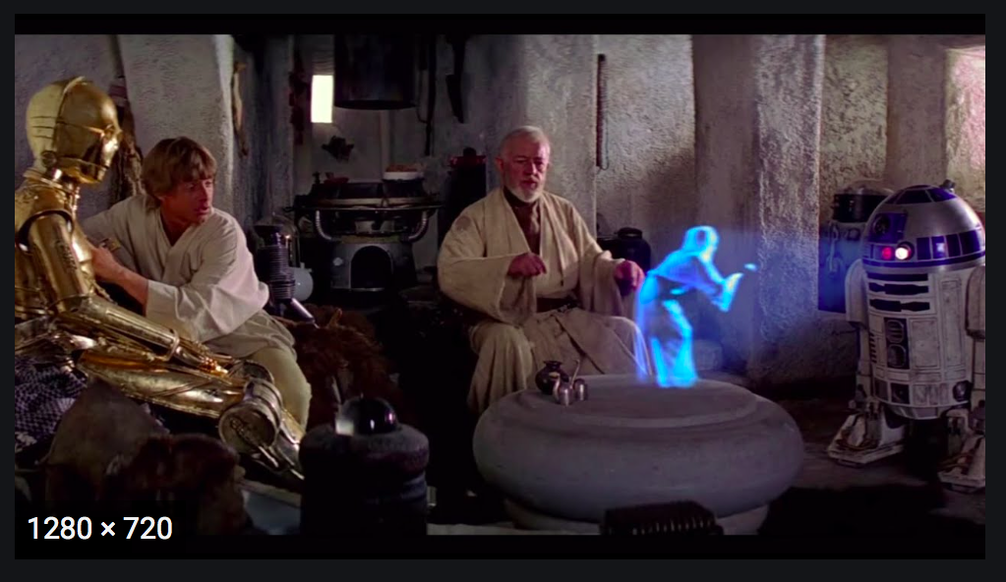

Opening scene: "Fluke/Klute Dogwalker" (DataDog) sits in a corner in Tabby Cat Kenippy's comfy cave-hut, drinking a blue gravy martini, playing 3D chess with an A.I. robot. She takes a sip, and StatCat comes roaring in making horrible sounds, wearing a robe and hood.

She spits a bit of her martini on the chess set.

**StatCat: “**DataDog! Enough with that video game! I just narrowly escaped the dastardly Beachpeople to bring the most wondrous news! The Rebel Institutes for Cat and Dog Health is offering 500,000 cybergold splunker grants to study the impact of canned food vs dry kibble on cat and dog lives!” He raves, holding a yellowed flyer over his head.

**DataDog:** [wiping martini off her costume] “Wow! That sounds right up your alley, StatCat! And a great way to learn more about your own immortality (or lack of)”

**StatCat:** “Immortality?! As long as I take regular baths in Illudium Phosdex all 8 lives are secured--though it would have been nine had it not been for that unfortunate weekend in Toledo, don’t ya know! But I would be remiss to pass up an opportunity to learn more about the best nutrition units I should be consuming… and just think, flavor issues aside, of all the cat and dog lives that could be saved!” He raves, arm dramatically raised overhead, pointing to the stars.

DataDog leaps up and poses, her bone becoming a light saber.

**DataDog**: A life and death kibble kerfuffle!. So, when is the grant proposal due?

**StatCat**: "Tonight at midnight! We must get started right away. The future wellness of rebel canine and felines is at stake! And put that thing down, it drains the batteries! Uh… here…

(He hands the clipping from the journal to DataDog, who sheathes her bone.)

**StatCat:** This looks like a job for you, young Klute! I'm too old to run off on another idealistic paperwork crusade... and I need a nap, a Cosmic Catnap, don't ya know!

DataDog furiously types away at the computer while StatCat has a shocked look on his face.

Next frame shows the progression into nighttime.

**DataDog:** “Finished! And with 2 hours before the Beachpeople rise to spare! Let me go ahead and deliver this to the Moss Isley Brother's spaceport…”

**StatCat:** DataDog! Don’t you think I should look it over before you submit it? You wrote it quite quickly….and did you write a data management plan? Most grants require those when applying.”

**DataDog:** “Data management plan? Of course I wrote a DMP! It’s an interstellar DMP. Here, let me print it out for you on the Uni-vac 4,000 so you can witness the best data management planning you’ve ever seen!" Data Dog kicks at an old rusty computer in the corner. "Now, while you review this, I’m going to treat myself to another martini.”

With DataDog in the background gathering materials from the cave's Bar, StatCat holds the DMP in his hands with a suspicious look on his face on his face, brow furrowed.

**StatCat:** “This DMP is only 2 sentences…. young Klute."

DataDog appears unphased, and continues to craft her martini.

**DataDog:** [without looking up] “Yes, I thought that I had perhaps made it too long as well.”

**StatCat:** “And it's all stored on your iBone…."

**DataDog:** “I paid for the 3 year protection plan…."

**StatCat: “**DataDog, you need to take this more seriously! A DMP should be 2 pages of content and include so much more detail than you have here! and you can't trust that doohickey as the only storage..."

**StatCat:** “But... but... but the 3 year protection plan... and... and I was headed to Kashi station to pimp out my power converters!

The next frame shows StatCat standing in front of a chalkboard with a ruler he uses to point to the board.

**StatCat: "**A DMP should address each aspect of your data throughout your research project - and you have to convince the funders that you are going to take care of this data!"

**DataDog:** “That protection plan cost me 30 bucks!"

The board has the following points:

1. Finding/Collecting the data

2. Who can access the data

3. How will you store it?

4. What file formats will you use?

5. What analyses will you use?

6. What filenaming schemes will you use?

7. Will you use metadata? Which standards?

8. And funder-specific requirements!

Next frame returns to DataDog and Statcat standing around the Uni-Cativac.

**DataDog:** “But how can I make the perfect Martini, pimp out my power converters and write a new DMP in time? [wipes sweat off brow] *Sigh*, this whole process is making me want a double."

**StatCat:** “Easy on the gravy there."

**DataDog:** “What could go wrong? That's the best iBone and--"

**StatCat:** “Yes, yes I know, the best iBone and protection plan money can buy. Drink up young pup... and let me tell you some stories... what could go wrong indeed!" Statcat pauses, stares at the viewer and says, "You think by now she'd know what could go wrong."

"WE'LL BE RIGHT BACK!"

**1st story:** (formatted like a Sunday comic, but vertical in nature based on our consistent format, perhaps running same width but 3 or 4 up) Set in the world of "Wizards."

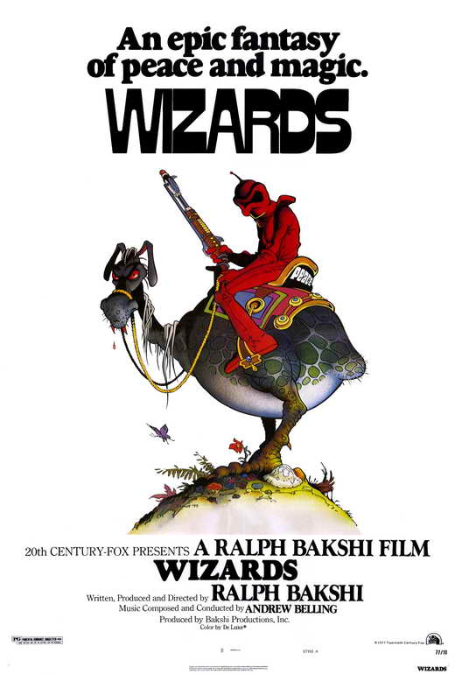

**President Of the Elves:** "Quickly now! Take this floppy disc to the forbidden zone! It has the recipe for our new data flavored marshmallow cereal, 'Floppy Bits.' Don't let it fall into the hands of the BurglarBot.

Data Dog takes off on her two legged mount.

StatCat as a "BurglarBot" ("Peace") charges out of the bushes to steal the floppy disc.

Chase ensues, shots are fired.

**DataDog**: Ha, silly BurglarBot... floppy discs are for elves!"

Mid gloat, DataDog, falls into a hole, the floppy disc (in true cartoon form), hovers in the air over the pit, StatCat leaps across the hole and snags it, running off... the data lost forever.

Final panel, they sit around making copies of the floppy disc... "Don't let your marshmallow recipe data get lost or stolen... buy one ACME floppy disc... get one free!"

**"AND NOW BACK TO OUR SHOW"**

**CUT BACK TO HUT:**

**StatCat:** ...Aaaaand... the moral of the story is..."

**DataDog:** Watch out for potholes!

**StatCat:** You have a lot to learn young Deadeye. Make sure you set clear boundaries around who should, and shouldn’t have access to your data. Make sure the data is saved in secure locations, and in your DMP, document these access regulations!

LEARNING EVENT (Open-form field)

Want to avoid having your data stolen or accessed by the wrong folks unlike DataDog and StatCat? Fill out the following interactive exercise as you write your DMP:

- Who will be the main data steward (lead all the activities around the data)?

- What happens if a member of the research team leaves? Do they lose access to the data?

- Who will be handling the operational (day-to-day) data management?

- How will you ensure that the DMP is being followed in regards to data security and backups?

**StatCat:**

Did I ever tell you about the time I rushed and failed to follow my DMP? You were but an eager underclassman, still wet behind her puppy ears. I was working for the Evil Committee then. Thought they'd revoke my grant and I'd lose my tenure. Ah yes... a long time ago... in a university far far away...

**Cut to 2nd Story:**

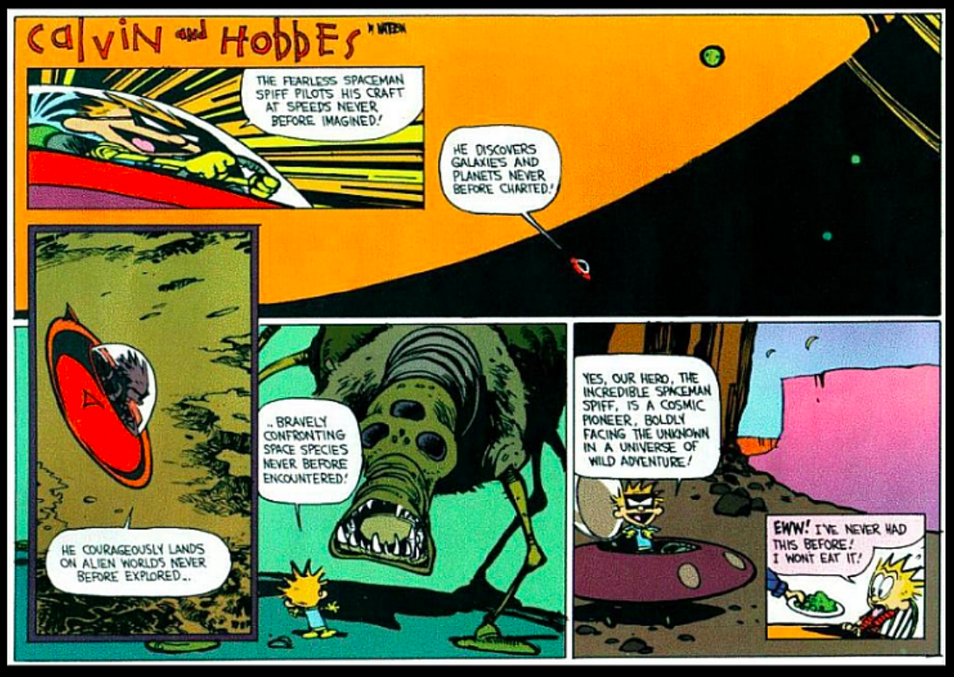

StatCat working for the "Evil Committee" doing his DMP work sloppily and impatiently from within a highly guarded prison cell set up like an office. Bloated queen bee-like ant creatures loom over his shoulder and watch in from computer screens, barking orders.

**StatCat:** That oughta satisfy the National Committee For Cat & Dog Health.

Turns it in, marched under guard.

A moment later, gets called into a hearing at Empire U., fearing being fired, losing his grant or being strangled by Dart Nadir, the big slimy worm queen of the committee.

Last(ish) panel, StatCat walking past a young DataDog, a young prisoner in the next cell, dripping with tar and covered in feathers (or seen sitting at his desk in a slouch).

**StatCat:** "All things considered... I got off easy, don't ya know."

**CUT BACK TO HUT:**

**StatCat:** And the moral of the story, young Dogwalker?

**DataDog:** Committees suck!

**StatCat:** True, my impetuous ward, but... you should make sure that you are doing what you say you will do in the DMP – if plans change, update your DMP!

**LEARNING EVENT:**

Don’t end up like StatCat! Treat your DMP like a valued part of the research team!

**MC Question**

Which of the following best characterizes the role of your data management plan throughout a project?

A. Generally, you should create a DMP only as a formality at the beginning of a project. It is not usually consulted after the project starts.

B. Your DMP should be created as early as possible in the research process, and be treated as a living document. As your research progresses, you should update your DMP as needed to reflect any changes in your data process.

C. A DMP is insufficient to be used as a roadmap/blueprint for your research process, and therefore does not play a significant role in research once the project has started

D. Most funding agencies don’t expect you to follow your DMP – they are simply requesting one for legal reasons.

* Potential for DataDen appendix here – talking through each scenario and the nuances of each option (i.e. some are more correct than others but there’s true elements in each question)

**CUT BACK TO THE HUT:**

**DataDog:** OK, OK, I get it, I'm never going to make it to Kashi Station.

DataDog gets up to go.

**StatCat:** But we aren't through yet, impetuous Young Deadeye!

**DataDog:** Stop nagging - I get the point. I'm not afraid!

StatCat looks at the viewer/Datadog.

**StatCat:** You will be... you will be!

**Cut To 3rd story:**



**DataDog:** What are we going to do, DataGhost? They're gaining on us!

**StatCat:** They'll never catch us Pup! Not so long as I have my power bracers!

**DataDog:** They'd better not, DataGhost, we have the only Zoidbot with plans for the Rebel Committee Dissolution Laser Cannon!

Their ship is blown to smithereens by "The Committee."

Final shot of StatCat and DataDog floating through space, clinging to a bit of debris while bits of the robot floats by.

**StatCat:** Just goes to show, don't ya know!

**CUT BACK TO HUT:**

**StatCat:** Sometimes even the best tech fails, young Dogwaker. It’s a good idea to follow the 3-2-1 technique for backing up your data: make sure you have at least three copies, in two different storage formats, with one copy saved in the cloud!

**LEARNING EVENT (Open-form question):**

Turns out, “The Committee” exists all around us in the form of natural disasters, hardware failures, data corruption, etc. But, you can plan ahead for the possibility of these occurrences in your DMP! Fill out the following interactive exercise as you write your DMP:

1. Looking at what you and your research team currently have access to, discuss how you will try to follow the 3-2-1 technique for your data storage. Where will your three copies live? What are the two different storage formats? Where in the cloud will one of these copies be saved?

+ another learning event at discretion of instructor that is MC – OR **drawing/network/diagramming activity**

**StatCat:** And remember the "Gibbering Monster Mob Incident?"

**DataDog:** Uh oh! That!

**StatCat:** Uh Oh, indeed.

**Cut to 4th story:**

THIS STORY NEEDS A LOT OF WORK AND RETHINKING!

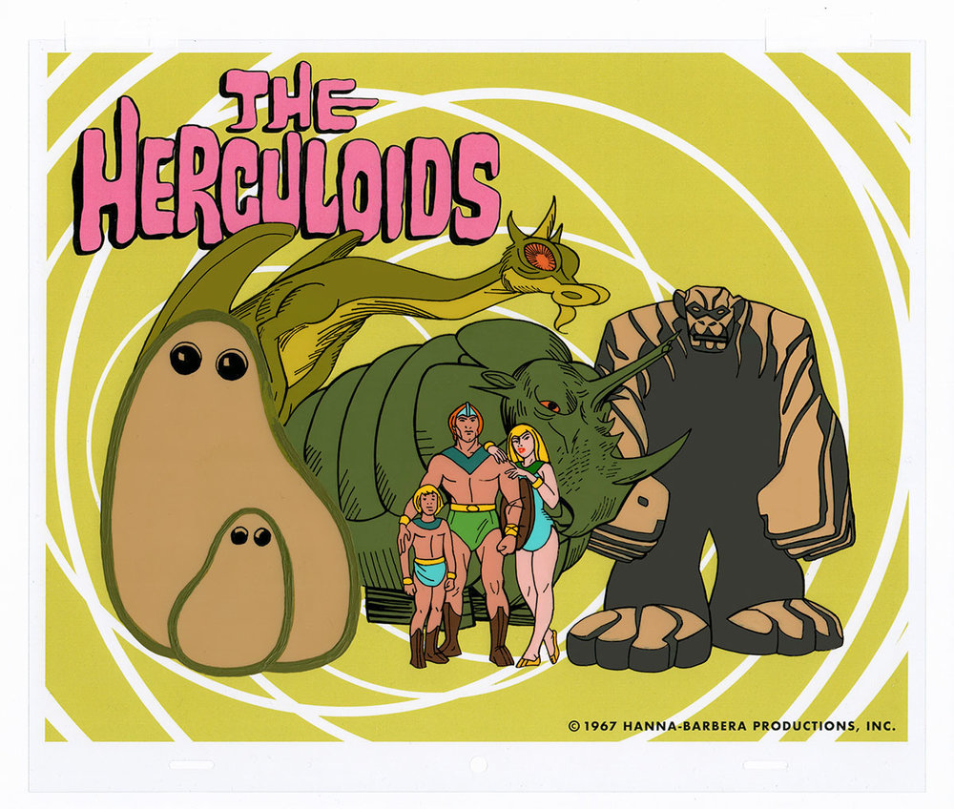

Scene: StatCat an DataDog stand on a plateau in a barbaric world with a mob of monsters behind them.

**StatCat:** We've safely lead the mutaloids of Snafu 7 to Axebeak of the Worblers, the secrets of the Mutaloids will finally be made available to the Worblers, and Snafu 7 will be unified as one, this long horrible intergalactic battle resolved! It has been a long dangerous jouney.

Insert flashback panels of Mutaloids, DataDog and StatCat battling monsters along the way with narration snippets "We battled the Flying Monkey People of the Monkey Butt Hills..." etc.

They arrive at the gate and are greeted by Axebeak, when StatCat proudly brings forth his mob of mutants with their information, they begin spitting out a babble of noise in numerous languages no one can decipher. Everything that comes of of their mouths is in different fonts and all looks like lousy filenames.

Statcat stands among them, with his pencil and clipboard.

**StatCat:** Right, so this is Unk from Rigel 9, and he speaks Dargonogog... no wait... was that Onk from Liger 8 speaking Darcolian... no wait... he's over there... right... THAT'S Dargonozzle from... or...

Next scene, StatCat and DataDog tied to the wall in a dungeon.

**StatCat:** Guess we shoulda brought a translator.

**DataDog:** Or taken better notes.

**StatCat:** Who knew?

“StatCat 1.csv”, “file-3.csv”, “this file has data.csv”, “cat food 4.csv”, etc.]

LEARNING EVENT

**[Learning experience/panel – “Make sure you use a consistent filenaming scheme in your research, making sure that your filenames are recognizable and give important context about what is in the file. Taking the time to use consistent and helpful filenames now will save you time later by making it easier and quicker to navigate your files!”]**

DataDog and StatCat have certainly found themselves in a pickle! You can avoid ending up in a similar situation like this by sticking with filenaming conventions that accurately describe the contents of your files, and include these conventions in your DMP. Take the MC questions below to help come up with ideas for good filenames!

MC Questions

Which of the following are considered good elements to include in a filename?

A. Underscores

B. Spaces

C. Special Characters

Which of the filenames below would be the most helpful for understanding what kind of data is in the file?

A. file_final.csv

B. dataset1_trees.csv

C. StatCat_experiment1_survey2_quant_analysis_results_2020_02_03_final.csv

D. StatCat_exp1_20200203_v3.csv

*Opportunity for DataDen here – analogy is choosing how to name a new room in the DataDen and the conversation around it – how do you choose a name?

UNFINISHED FROM HERE DOWN...

5th story:  FLASH

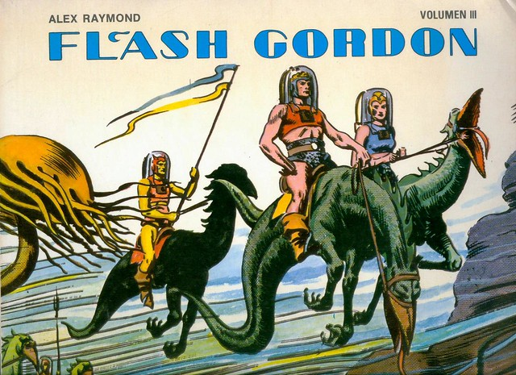

[StatCat ends up getting sued and put on trial in front of a grand jury because he broke into cats’ homes and surveyed what cat food they were eating (lesson - make sure you have the right approval to collect data ethically]

Perhaps we could set this in a Jabba the Hut-like situation, being led through his cavernous danger-filled lair, in which they being brought in chains before this terrifying alien and he reads them the riot act.

LEARNING EVENT

It’s never a good idea to break into cat’s homes without prior authorization! The same goes for your own data collection process – in your DMP, you want to make it clear how you plan to collect/use data in an ethical manner. In the reflective space below, describe the resources at your institution for data ethics, such as your Institutional Review Board (IRB), data ethics/information security offices, libraries, etc.

1. What support does your institution offer for education, advice, and infrastructure for data ethics?

2. How will you reflect these resources in your DMP? *Does your institution offer RCR training?

THIS ONE IS NOT YET VERY GOOD AND NEEDS WORK.

FINAL panel, the two of them back in Obi-Wan's hut... DataDog looks terrified by all these possible disasters. She packs up and starts out the door.

StatCat: "Hey... what's up young Klute?"

DataDog: The heck with all this... I'm goin' back to the moisture farm!"

StatCat: "May the Nip be with you."

**[Final learning experience/panel – “It is always worth it to take the time to plan out your steps for data management in a research project through a DMP! It is just as important as your data collection, analysis, and visualization, and should be taken seriously!”]**

LEARNING EVENT

As much as DataDog would like to think about literally anything other than a DMP, StatCat knows the importance of the document having gone through many regrettable experiences! In the reflective space below, expand on how you will commit to ensuring your DMP is being treated as a valuable tool in your research. What are three steps you can take each day to support this?