EE450: Sample Exercises
These are sample problems from other textbooks (These textbooks are posted on our side in the Reference folder). No solutions are available but will be happy to check your work during office hours
1)
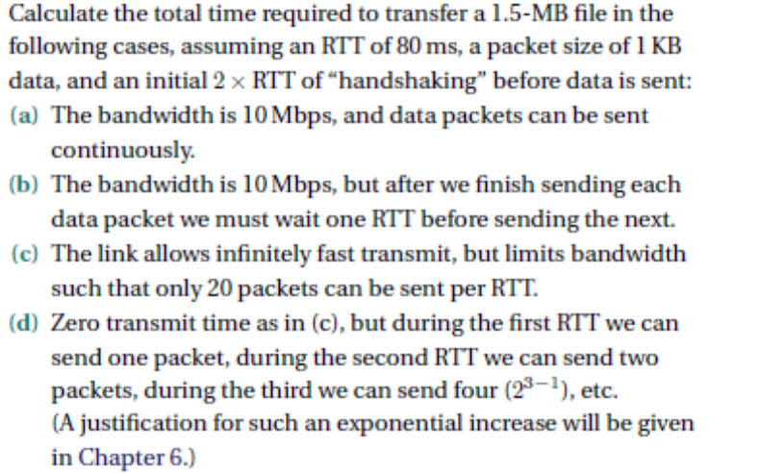
2)
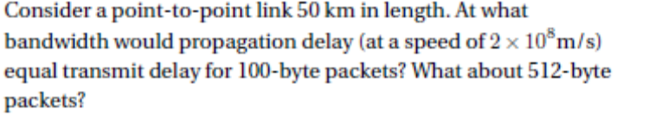
3)
4)
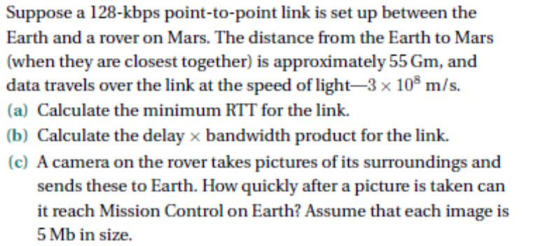
5)
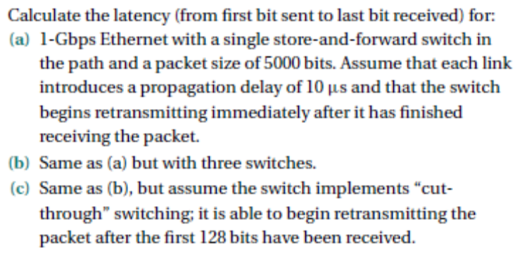
6)
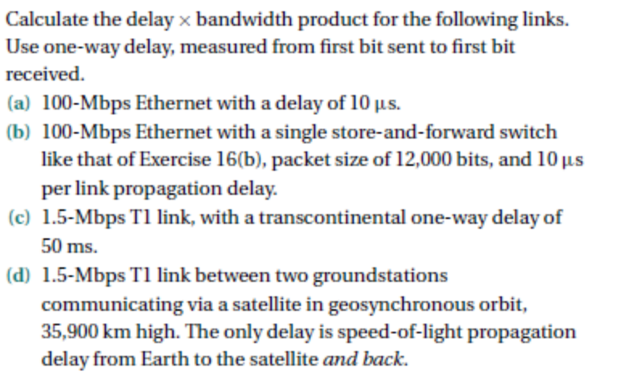
7)
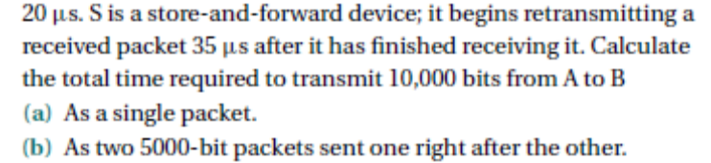
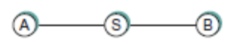

8)
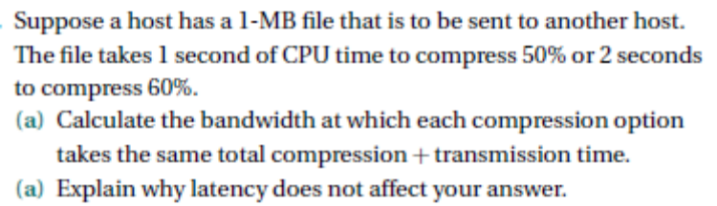
9)
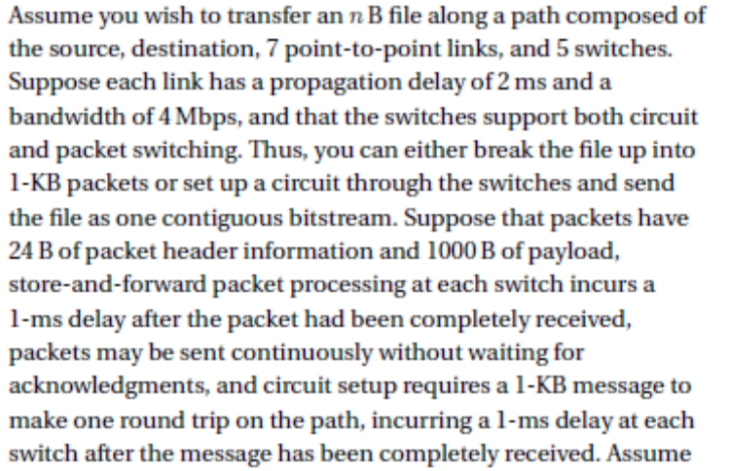
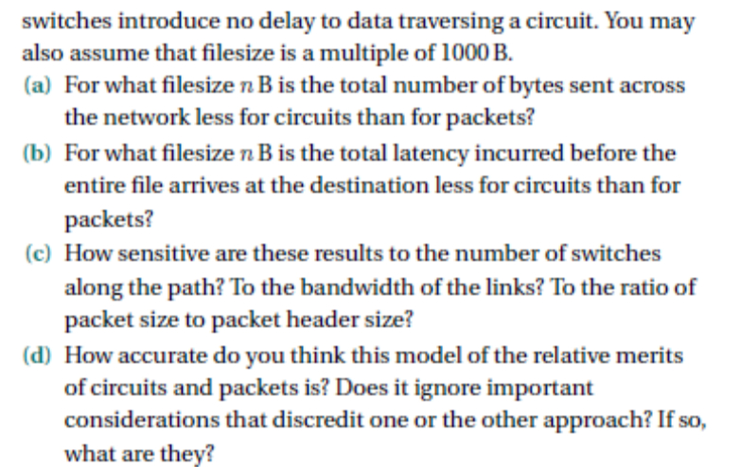
Typo in problem. It should be 6 switches

10)
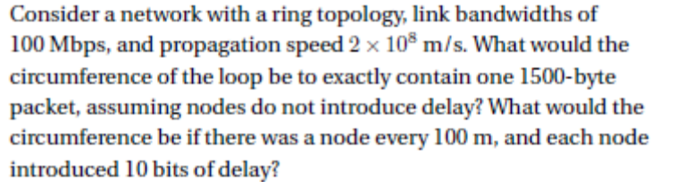
11)
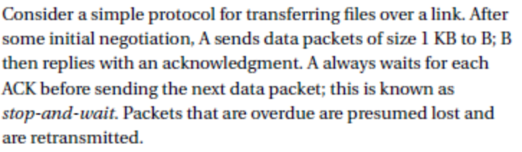
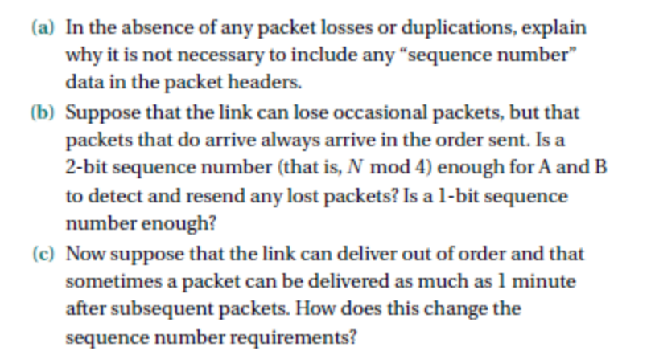
12)
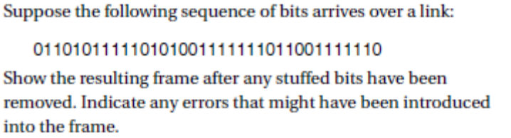

13)
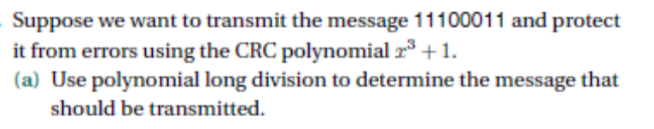
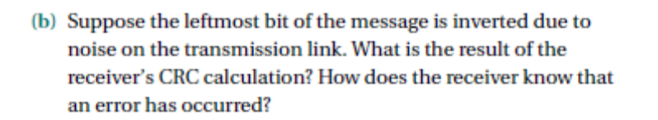
14)
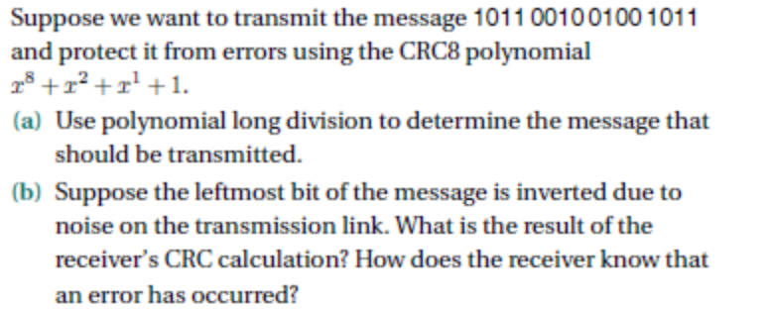
15)
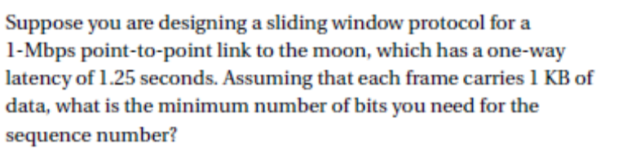
16)
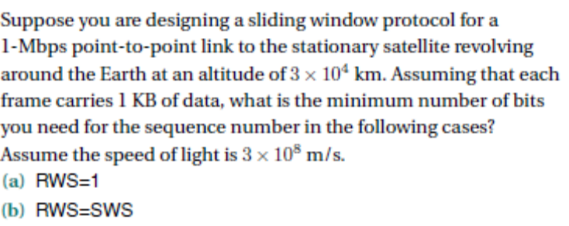

17)
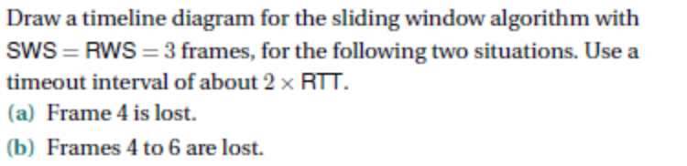
18)
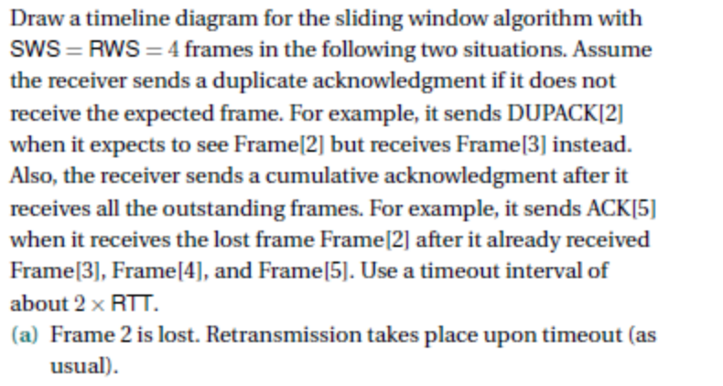
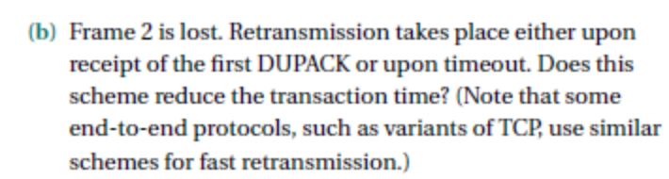
19)
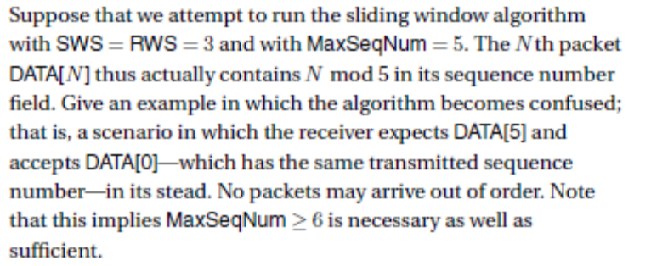

20)
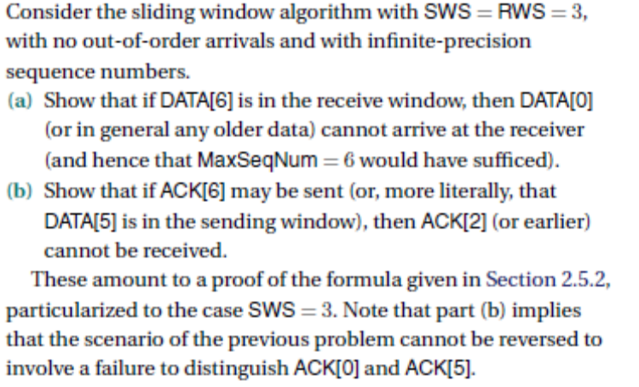
21)
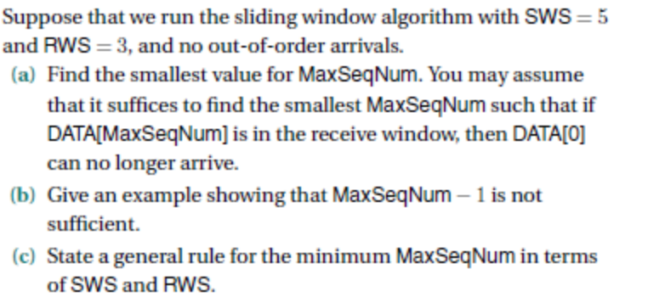
22)
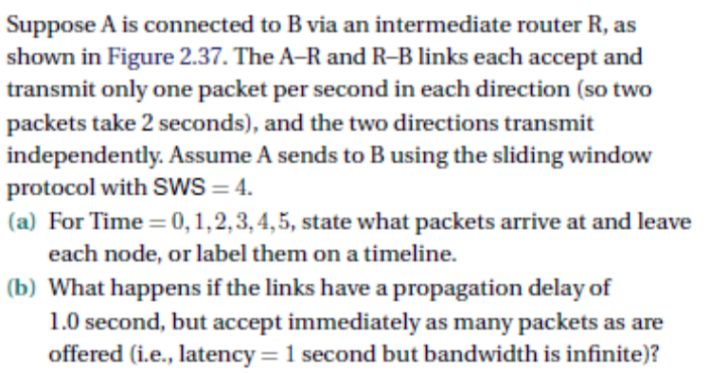


23)
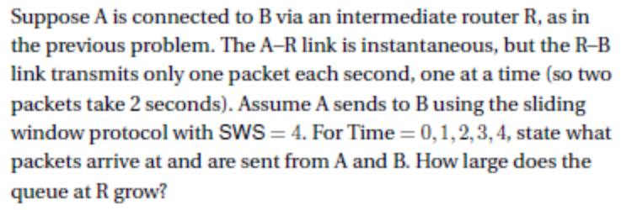
24)
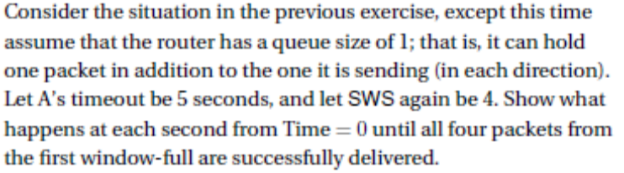
Note: Problems 1 through 24 were taken from the reference Text by Peterson and Davie (Posted)
25)
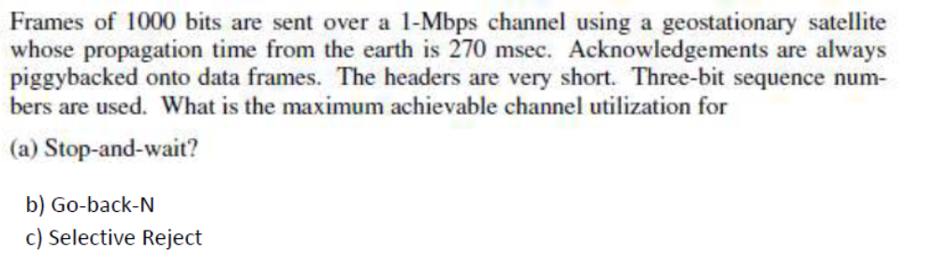
26)
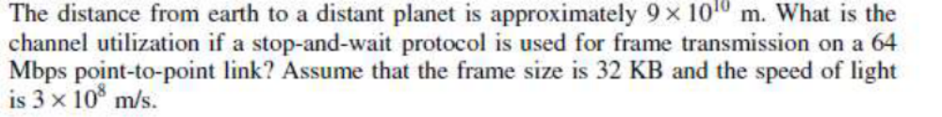

27)
28)
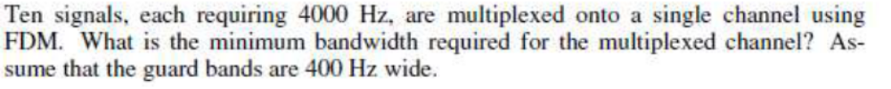
29)
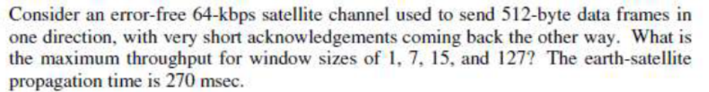
30)
Note: a T1 line has a rate of 1.5Mbps
31)
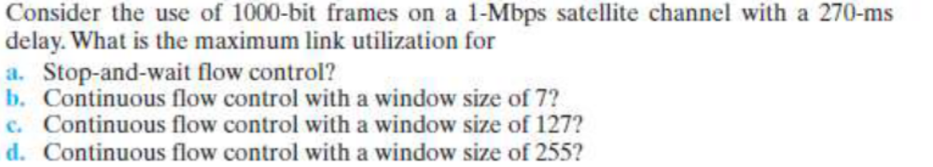
32)
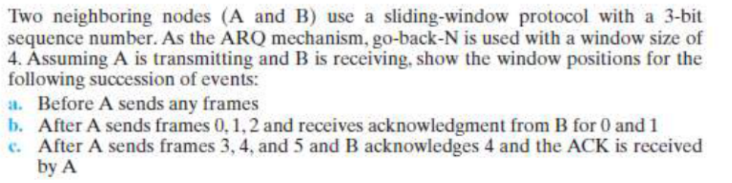
33)
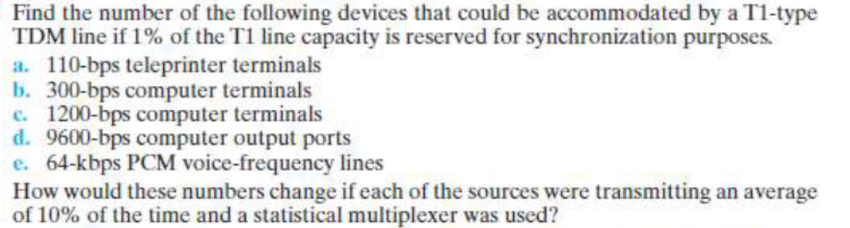
34)
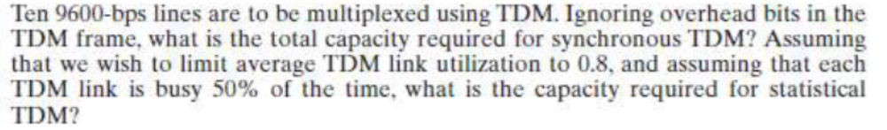
35)
