System Architecture Document
Security Questionnaire MVP1
  - Demo-first architecture for a 15-day build and a 60-90 second demo flow

Document version | v0.1
Status | Draft / demo-ready working version
Date | March 11, 2026
Authoring basis | Derived from sad.mvp1.md and aligned to full sad.md

Table of Contents
1. Purpose and document scope
2. Architecture summary
3. Design principles and assumptions
4. System context and logical architecture
5. Component architecture
6. Data flow and API surfaces
7. Runtime flow
8. Data model and storage
9. Security, reliability, and operational constraints
10. Build plan for the 15-day MVP1
11. Risks, tradeoffs, and deferred capabilities
12. Acceptance criteria
Appendix A. Mermaid diagram
Appendix B. Version history

Version History
Version | Date | Author | Summary of change
0.1 | 2026-03-11 | OpenAI / ChatGPT | Initial readable MVP1 architecture document created from the MVP1 SAD and tailored for demo use.

1. Purpose and document scope
This document describes the MVP1 system architecture for the Security Questionnaire solution.
MVP1 is intentionally designed as a demo-first implementation: a narrow, repeatable end-to-end flow that can be built in 15 days and demonstrated in roughly 60 to 90 seconds during a demo. It does not attempt to represent the full production architecture.
• Primary objective: show that the system can generate evidence-bound draft answers with visible citations in under 90 seconds.
• Primary audience: demo, collaborators, and a development partner building the first working version.
• In scope: one intake path, a four-step agent flow, one single-page UI, one export path, and a small curated knowledge base.
• Out of scope: review queue, risk scoring workflow, authentication, multi-tenant controls, full audit persistence, and broad format support.

2. Architecture summary
MVP1 uses a simple sequential pipeline. A user pastes or uploads a small demo questionnaire containing 3 to 5 questions. The backend parses the questions, retrieves supporting evidence from a fixed demo knowledge base, drafts answers using only that evidence, attaches claim-level citations, displays the results, and exports them into one deliverable file.
Design choice | MVP1 decision
Architecture pattern | Single-page web flow + one backend processing path
Agent model | Sequential agents: Ingestion -> Retrieval -> Drafting -> Citation
Knowledge base | Curated fixed demo KB with 5-10 evidence chunks
Storage | In-memory state or SQLite
Performance target | Pipeline under 60 seconds for 3-5 questions
Demo output | Results view plus one export file

3. Design principles and assumptions
• Demo-first: every design decision serves the single live demo path rather than broader platform completeness.
• Evidence is the differentiator: the product claim is not just speed, but speed with traceable evidence.
• Deterministic inputs: the questionnaire and knowledge base are fixed and rehearsed so the demo is reliable.
• Minimal moving parts: no unnecessary services, no optional workflow branches in the critical path, and no heavy document parsing.
• Fast operator recovery: any failure should produce a clear message rather than silent failure.

Assumptions:
- The demo runs in a controlled setting.
- The initial questionnaire is limited to 3 to 5 questions.
- The demo knowledge base is deliberately small and aligned to those questions.
- One export format is enough for MVP1.
- The backend may be Python-based and invoked directly by the UI or through a lightweight API layer.

4. System context and logical architecture
At a high level, the system has four zones:
- the presenter-facing UI,
- the backend orchestration layer,
- the curated demo knowledge base,
- and minimal persistence.
The backend owns the complete pipeline. The knowledge base supplies evidence. Persistence is optional and exists only to support result handling or export.
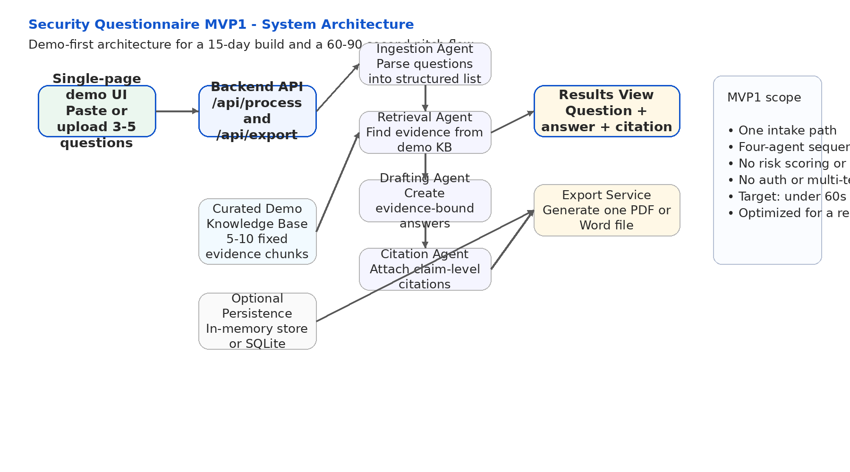
  - Figure 2. Logical architecture for MVP1
The architecture above intentionally excludes review queue logic and risk-routing because those features help a production workflow but do not increase the proof value of the demo.

5. Component architecture

5.1 Single-page demo UI
The frontend is a single screen with four visible states: input, processing, results, and export. The UI must keep the story obvious. The user either pastes 3 to 5 questions or uploads one lightweight demo file, clicks Process, watches short progress text, reviews answers with citations, and exports the result.

5.2 Backend API
The backend exposes a small surface area. At minimum, one endpoint processes the questionnaire and one endpoint exports the results. The processing endpoint returns a structured payload that the UI can render directly.

5.3 Ingestion agent
The ingestion agent converts pasted or uploaded content into a structured list of questions. It should normalize basic formatting, assign identifiers, and carry any lightweight metadata needed by downstream steps.

5.4 Retrieval agent
The retrieval agent queries the demo knowledge base and returns the most relevant evidence chunks for each question. For MVP1, the retrieval logic should optimize for deterministic quality rather than broad recall.

5.5 Drafting agent
The drafting agent creates the response text using only the retrieved evidence. It should avoid unsupported claims and keep answers concise enough for a clear demo.

5.6 Citation agent
The citation agent attaches claim-level references to the answer. Each answer should visibly include at least one citation or explicitly indicate that supporting evidence was not found.

5.7 Knowledge base
The knowledge base is a curated set of 5 to 10 evidence chunks, such as a policy excerpt, certification statement, or control narrative. Each chunk should include a document identifier, section label, and evidence text.

5.8 Minimal persistence
Persistent storage is optional. In-memory storage is acceptable for the shortest build path. SQLite is acceptable if the team needs a simple place to store results, demo metadata, or export content.
Component | Responsibility | Required for demo | Notes
UI | Capture input, show progress, display answers and citations, trigger export | Yes | Single page only
Processing API | Run the sequential pipeline and return structured results | Yes | Keep endpoint count minimal
Demo KB | Provide fixed evidence chunks | Yes | Preloaded for repeatability
SQLite or in-memory store | Hold transient state or export data | Optional | Choose the fastest path

6. Data flow and API surfaces
The processing sequence is linear and synchronous from the perspective of the demo.
• Step 1: The UI submits pasted text or a small demo file to the processing endpoint.
• Step 2: The ingestion agent extracts a structured question list.
• Step 3: The retrieval agent fetches evidence chunks from the curated knowledge base.
• Step 4: The drafting agent writes answers constrained to that evidence.
• Step 5: The citation agent attaches document, section, and snippet references.
• Step 6: The backend returns a structured result set to the UI.
• Step 7: The export endpoint creates one document containing questions, answers, and citations.
Endpoint | Purpose | Response
POST /api/process | Accept questionnaire input and run the full MVP1 pipeline | Structured JSON with question, answer, and citation array
POST /api/export | Generate one export document from the processed results | Downloadable file or file path/URL

7. Runtime flow
The runtime flow below reflects the intended presenter journey. The system should be tuned to make each transition visible and fast.
Stage | User sees | Target duration | Notes
Input | Paste questions or upload one demo file | 5-10s | Use a prepared questionnaire for consistency
Processing | Parsing, finding evidence, drafting answers, attaching citations | 45-60s | Progress text should reassure the audience
Results | Question + answer + citation visible for each item | 15-20s | Highlight that every claim ties back to a source
Export | One-click document generation | 5-10s | The file proves portability and readiness

8. Data model and storage
MVP1 does not require a production-grade schema. A lightweight structured payload is sufficient. The recommended logical model is shown below.
Entity | Core fields
Question | question_id, question_text, optional domain_tag
Evidence chunk | document_name, section, snippet, score
Answer result | question_id, answer_text, citations[]
Export payload | question list, answer list, citation list, generation timestamp

9. Security, reliability, and operational constraints
MVP1 deliberately relaxes many production concerns, but a few controls still matter.
• Do not train on customer content. Even for a demo, inputs should be treated as transient working data.
• Keep secrets in environment variables and out of source files.
• Validate input shape and file size to avoid trivial failures during the demo.
• Fail clearly when parsing or retrieval cannot complete.
• Keep logs lightweight and focused on debugging the demo path.
Deferred controls. Authentication, role-based access, tenant isolation, full audit logging, and enterprise-grade monitoring are intentionally deferred to the full MVP.

10. Build plan for the 15-day MVP1
The build should proceed in the shortest dependency order so the end-to-end demo path works as early as possible.
Days | Focus | Outcome
1-2 | Project setup and config | Working repo, environment, and baseline app shell
3-4 | Curated demo knowledge base | 5-10 evidence chunks and retrieval utility
5-6 | Ingestion flow | Paste or file intake converted to structured questions
7-9 | Retrieval, drafting, and citation pipeline | One processing endpoint returning complete results
10-11 | Frontend flow | Single-page demo UI with progress and results
12 | Export | One document format generated from results
13 | End-to-end rehearsal | Timing, UX, and error handling tuned
14-15 | Buffer and polish | Demo hardening and local run instructions

11. Risks, tradeoffs, and deferred capabilities
The main tradeoff is intentional narrowness. MVP1 is optimized for clarity and reliability, not breadth.
Risk or tradeoff | Impact | Mitigation / posture
Tiny fixed knowledge base | May look less production-ready | Frame MVP1 as the wedge, not the full platform
No review queue or risk router | Less enterprise depth in the demo | Present them as the next build step after proof of value
Single intake path | Limited generality | Use a prepared questionnaire that matches the knowledge base
Local or minimal deployment | Less operational polish | Prioritize demo stability over cloud complexity

12. Acceptance criteria
• A presenter can run one prepared scenario from input to export in about 60 to 90 seconds.
• The processing pipeline completes in under 60 seconds for 3 to 5 questions.
• Every answer shown in the results view includes at least one citation or a visible no-evidence flag.
• The export document includes questions, answers, and citations.
• The demo path runs without crashes or silent failures.

Appendix A. Version history
Version | Date | Owner | Notes
0.1 | 2026-03-11 | ChatGPT | Initial architecture document with rendered diagram and Mermaid source

