VBB
VETERANS MEMORIAL MEDICAL CENTER BLOOD BANK
Selected screenshot:
- Login page / Security
- Type your username and password
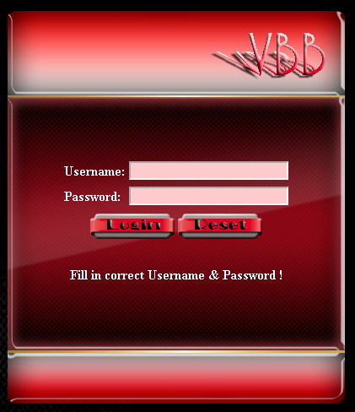

Homepage
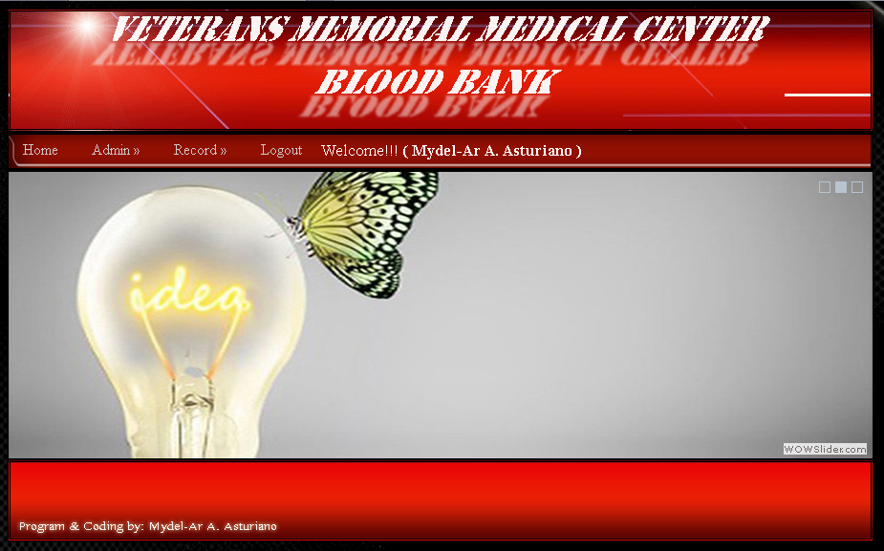
IT - Account
- Add User

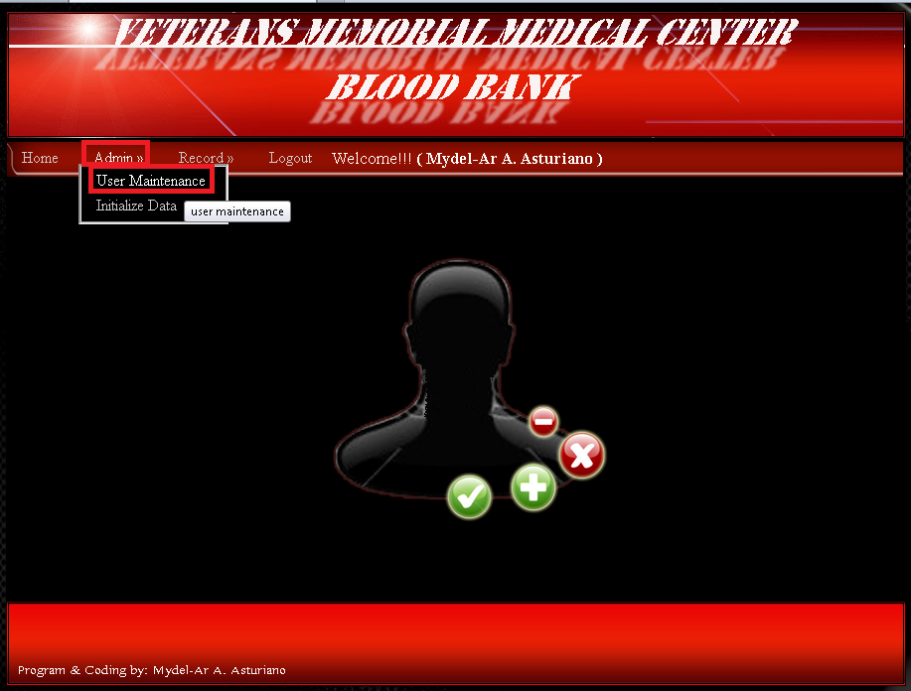

- Sample Valid Entry for Add User
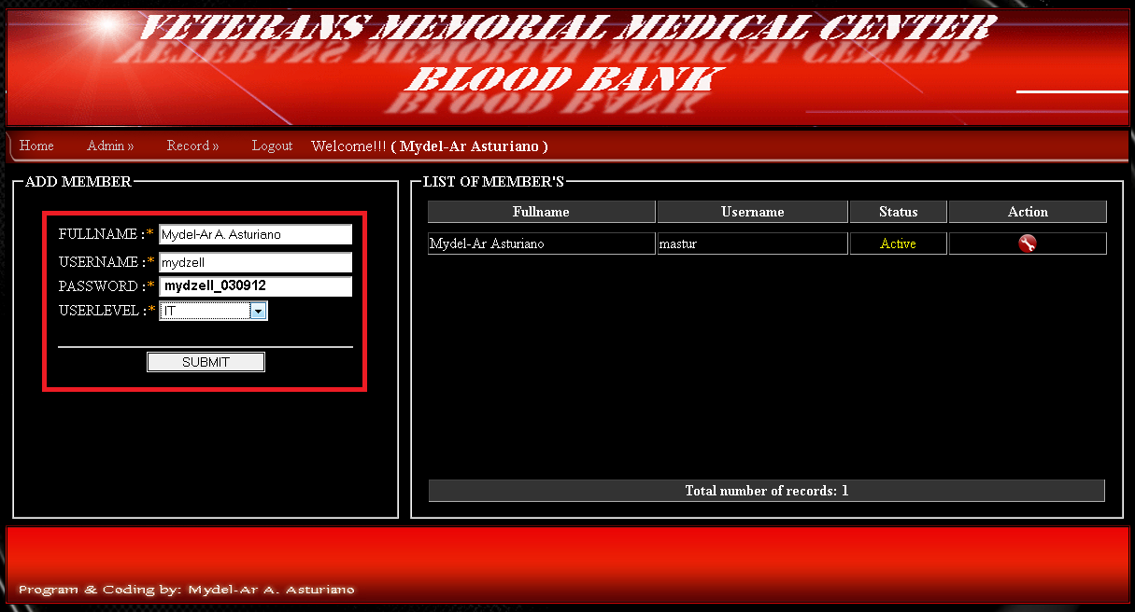

Staff – Account
- Add Patient

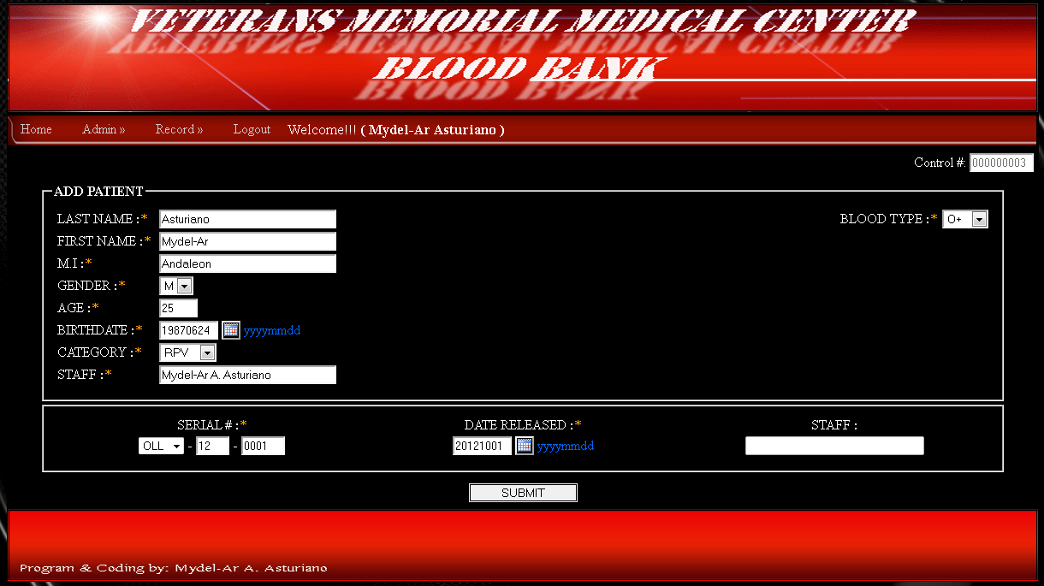

- Sample Print out

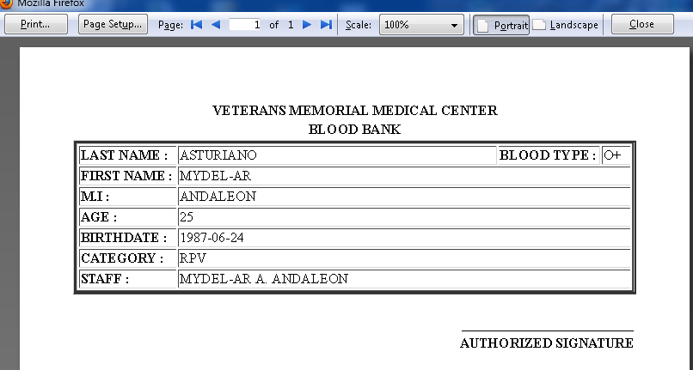

End
Thank you

Programmer:
Mydel-Ar A. Asturiano

