- OLIC (ORACLE LOADING INTEGRITY CHECK)
- Check the text files not loaded in Oracle
- Check daily, weekly and monthly.
- Recreate the text files.
- Correct invalid contents of text files.
- Create supplier master text files.
- Create customer master text files.
Screenshot:
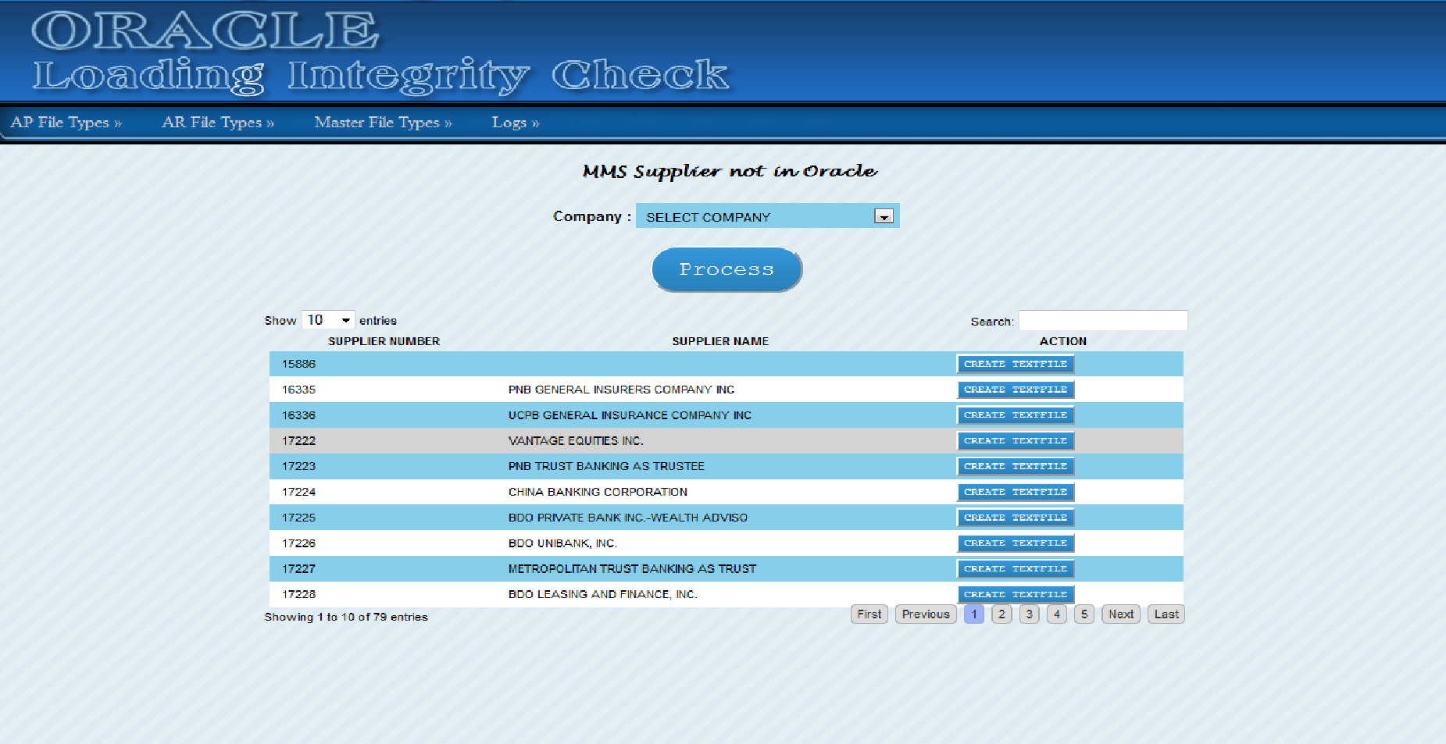

- ORS (ORACLE REPORTING SYSTEM)
- Report that relates to oracle database and in house program, Generate report for departments.
- IT Department, Cash Management Department, Leasing Department, Financial Department, Payables Department, Merchandising Department, Supply Chain Department, Audit Department, Payroll Department, Accounting Department, Hr Department
- Oracle Active and Inactive users
- Next Day Term Invoices
- Return to vendor invoices with check number.
- Invoice Status, Paid or Unpaid, Validated or Unvalidated.
- Concessionare invoices upload or unuploaded to oracle.
- Setup of tenants.
- ATUB uploaded to oracle, branches bill electricity and water invoices.
- Vendor Trial Balance, Get the Paid, Outstanding Current and Outstanding Due for Vendor, Get the payables,deductibles and net, compute also the aging.
- Customer Trial Balance, Get the Paid, Outstanding Current and Outstanding Due for Customer, Get the payables,deductibles and net, compute also the aging.
- Manpower Billing
- Etc.
Screen shot:
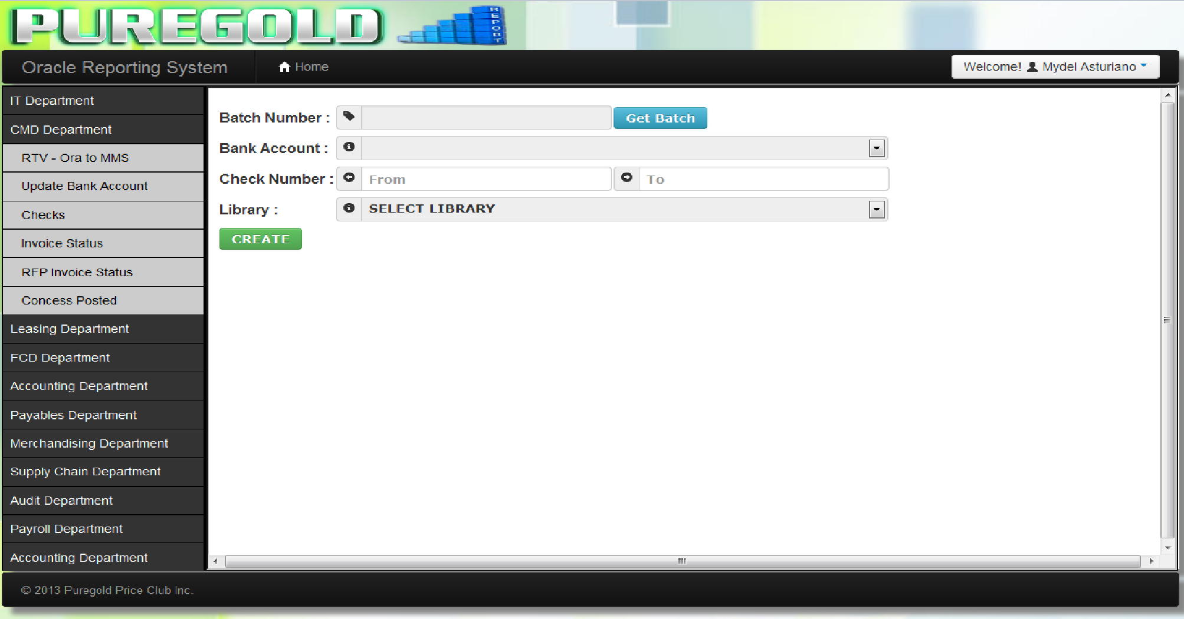

- AR SYSTEM (ACCOUNTS RECEIVABLE SYSTEM)
- Create a text files for auto balancing of AR and GL in Oracle.
Screenshot:
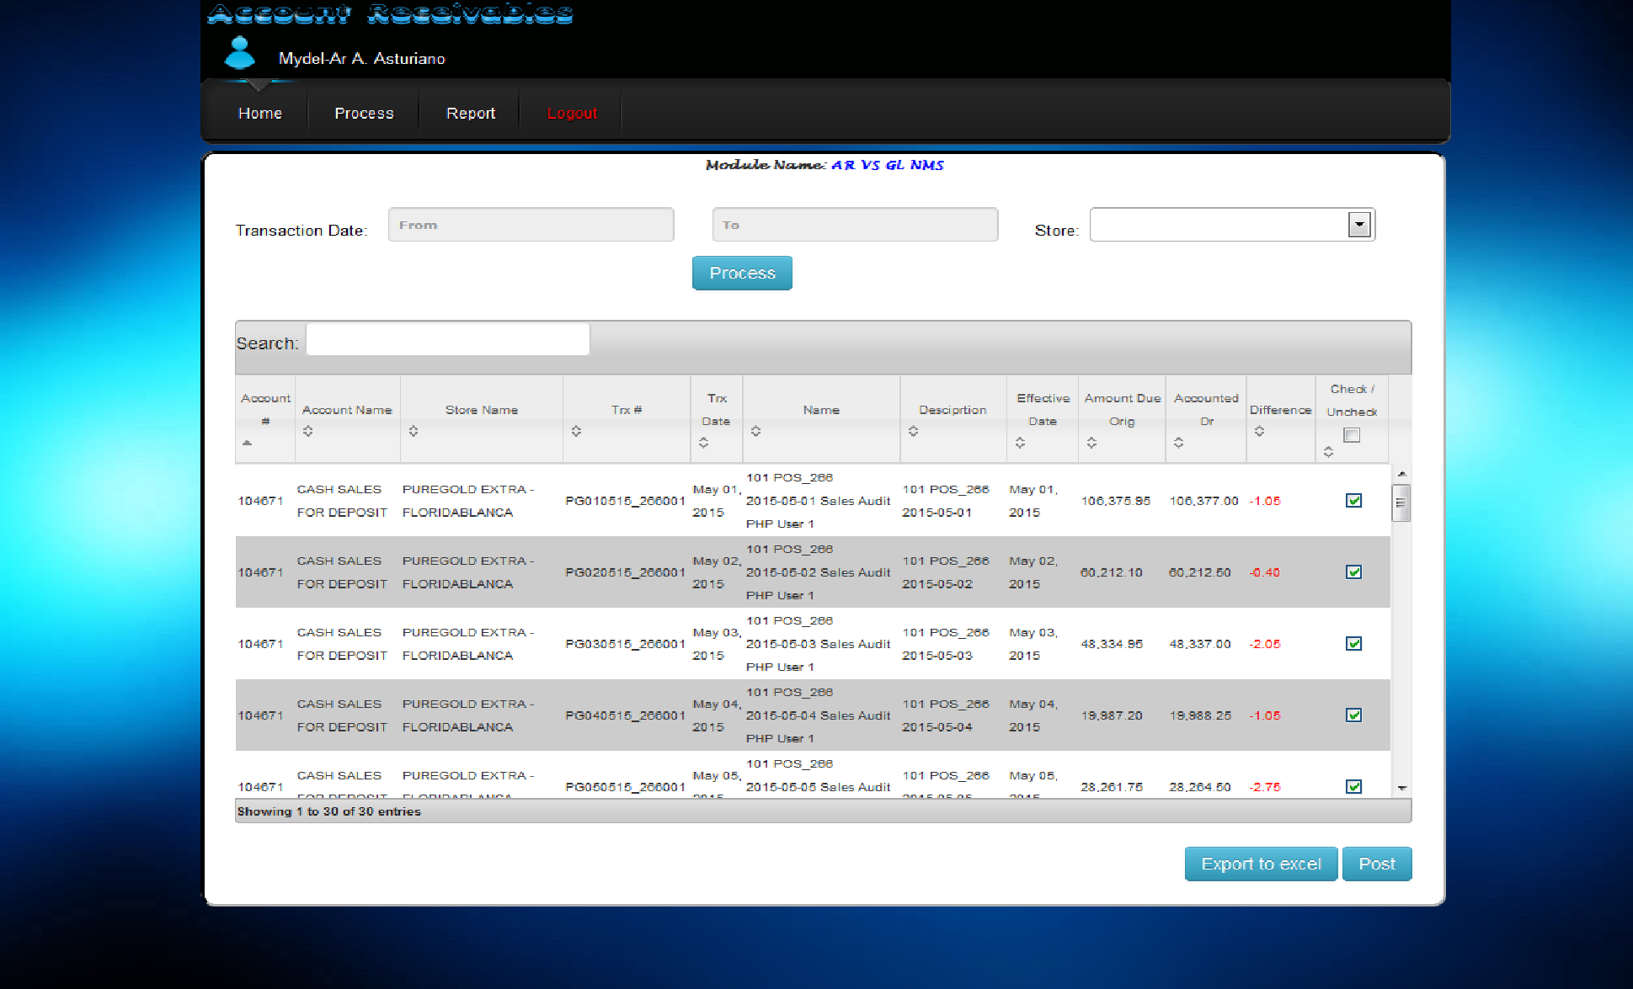

- SIS98 UPDATES
- Upload text files on FTP server for Puregold branches weighing scale change price updates
- Organized text files per branch folder.
Screenshot:
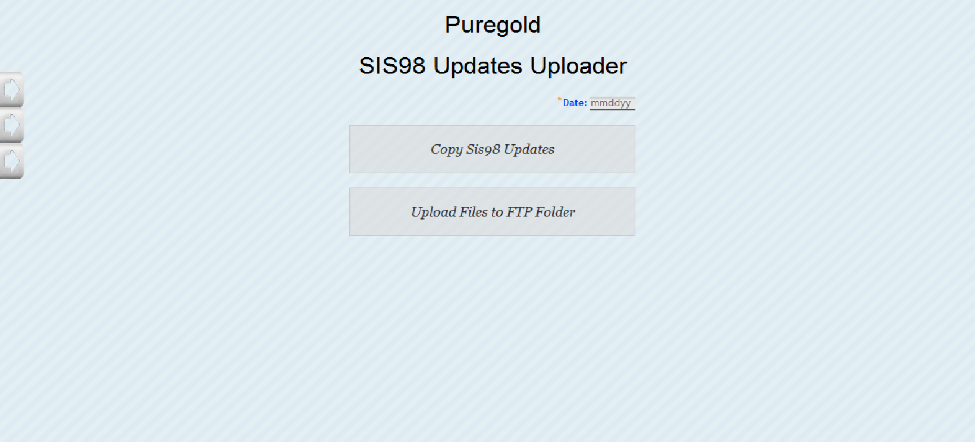

- CRM FTP CHECK FILE
- Download the text files of Perks Points and Aling Puring Points from FTP server per branch folder.
- Load to CRM outsourced program.
Screenshot:
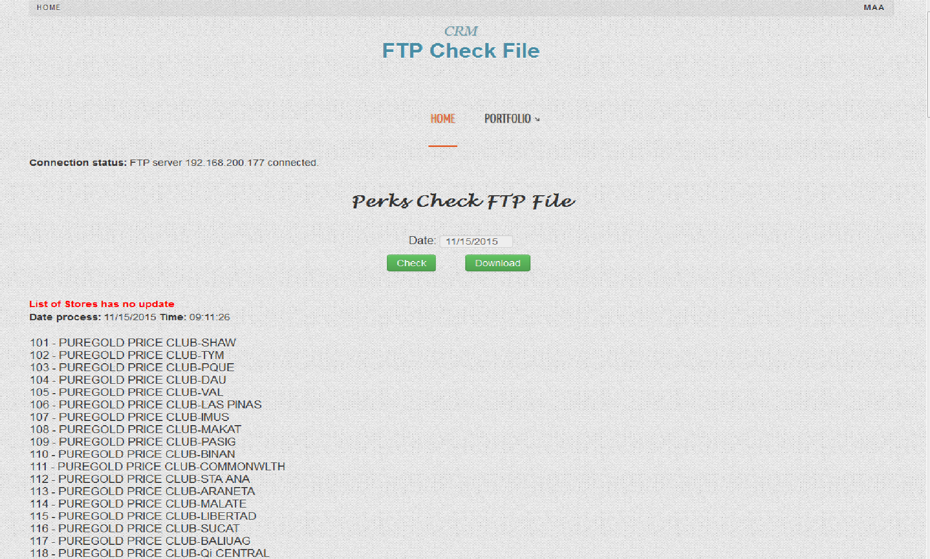

- GENERATE CSV
- Create csv text files for ARC-BI outsourced program.
- Create text file for Puregold Website for the Perks Points and Aling Puring Points online inquiry.

Screenshot:
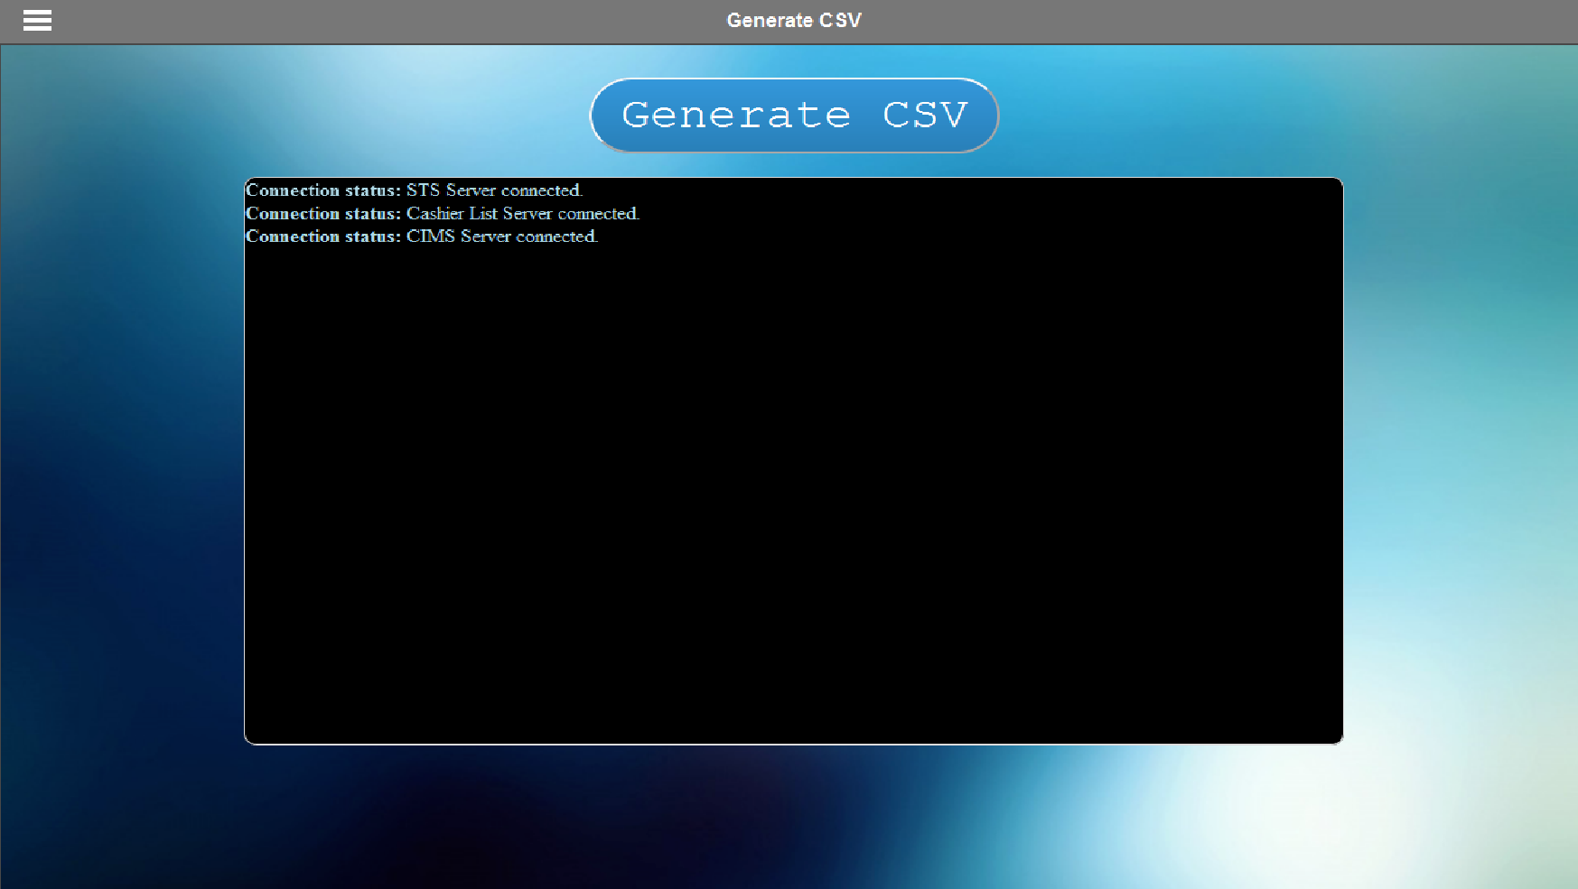
- KIOSK PRICE VERIFIER
- Product price checker.
- Perks points inquiry
- Aling Puring points inquiry.
Screenshot:
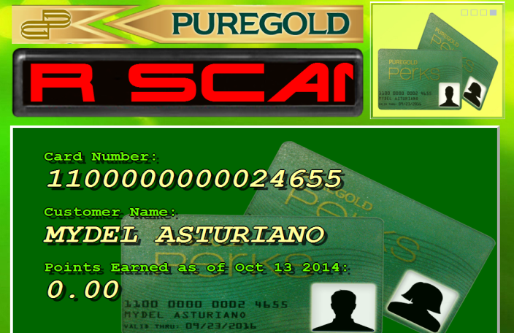

- STS PROGRAM
- Supplier transaction system.
Screenshot:
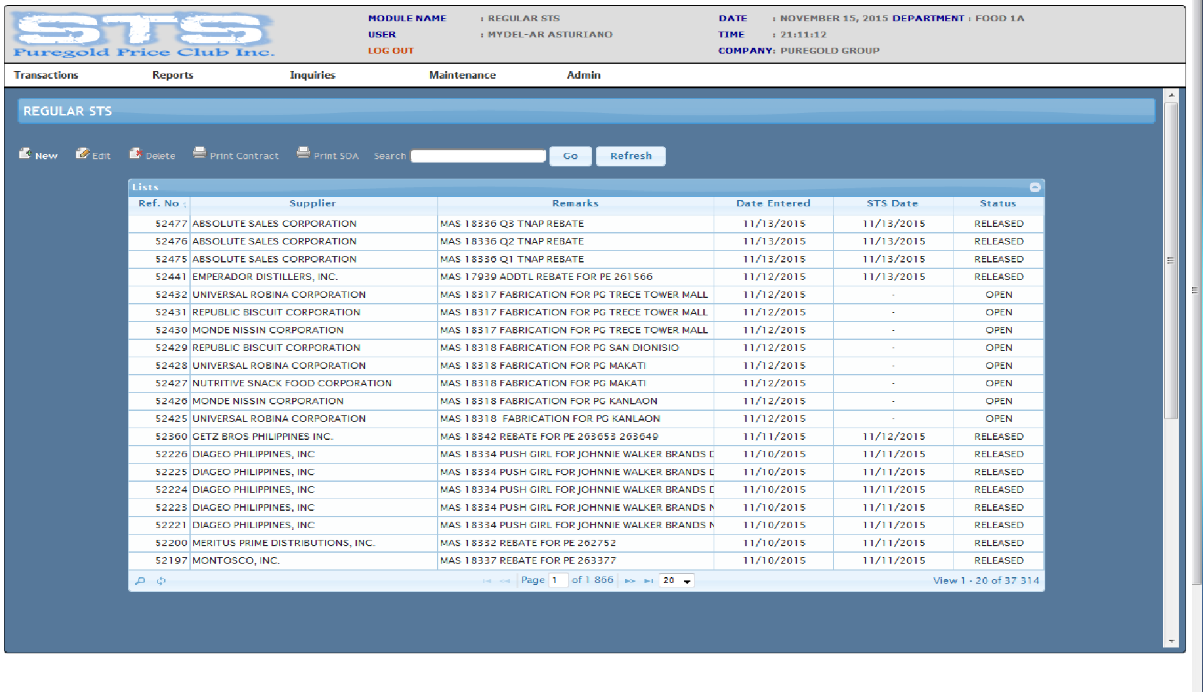

- PG UST REDEMPTION
- Use the UST coupon for purchasing items.
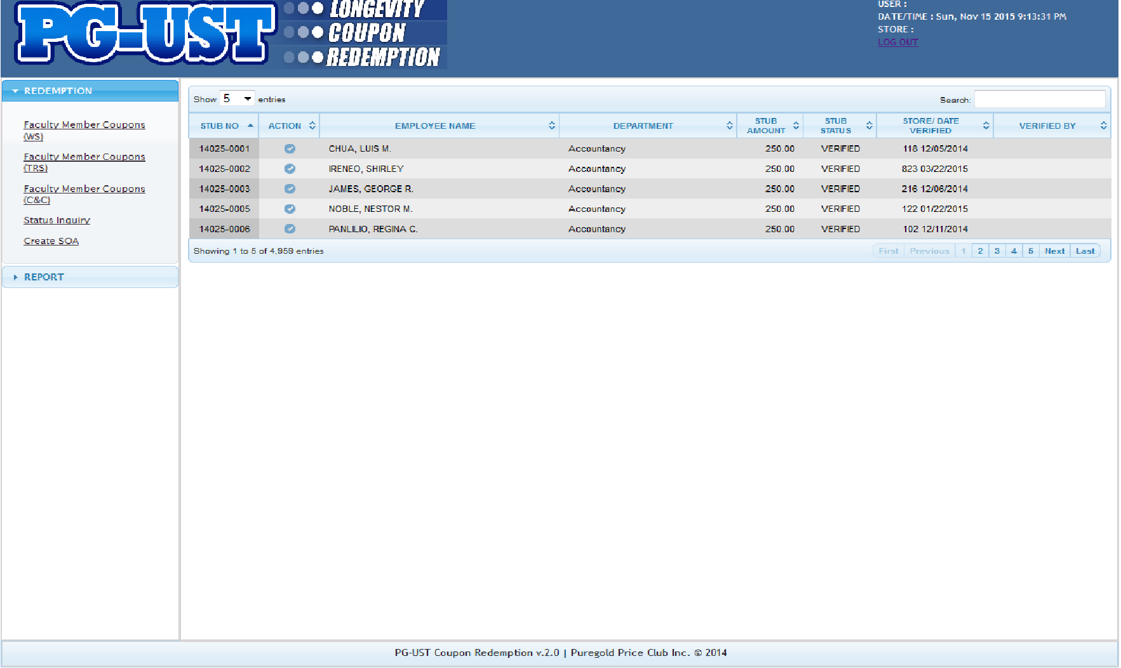
- WTC BUS REGISTRATION
- Registration of customer for WTC (World Trade Center) events.
- The program used per puregold branch if the branch is part of the event for their customers to register on the program and to have a free bus ride going to the World Trade Center.
- The program creates a text files then upload on FTP and there’s a program used in WTC to download the text files and feed the text files for the copy of registered customers in the branch.
- Count the number of customers with companion for reference in WTC.
Sreenshot:

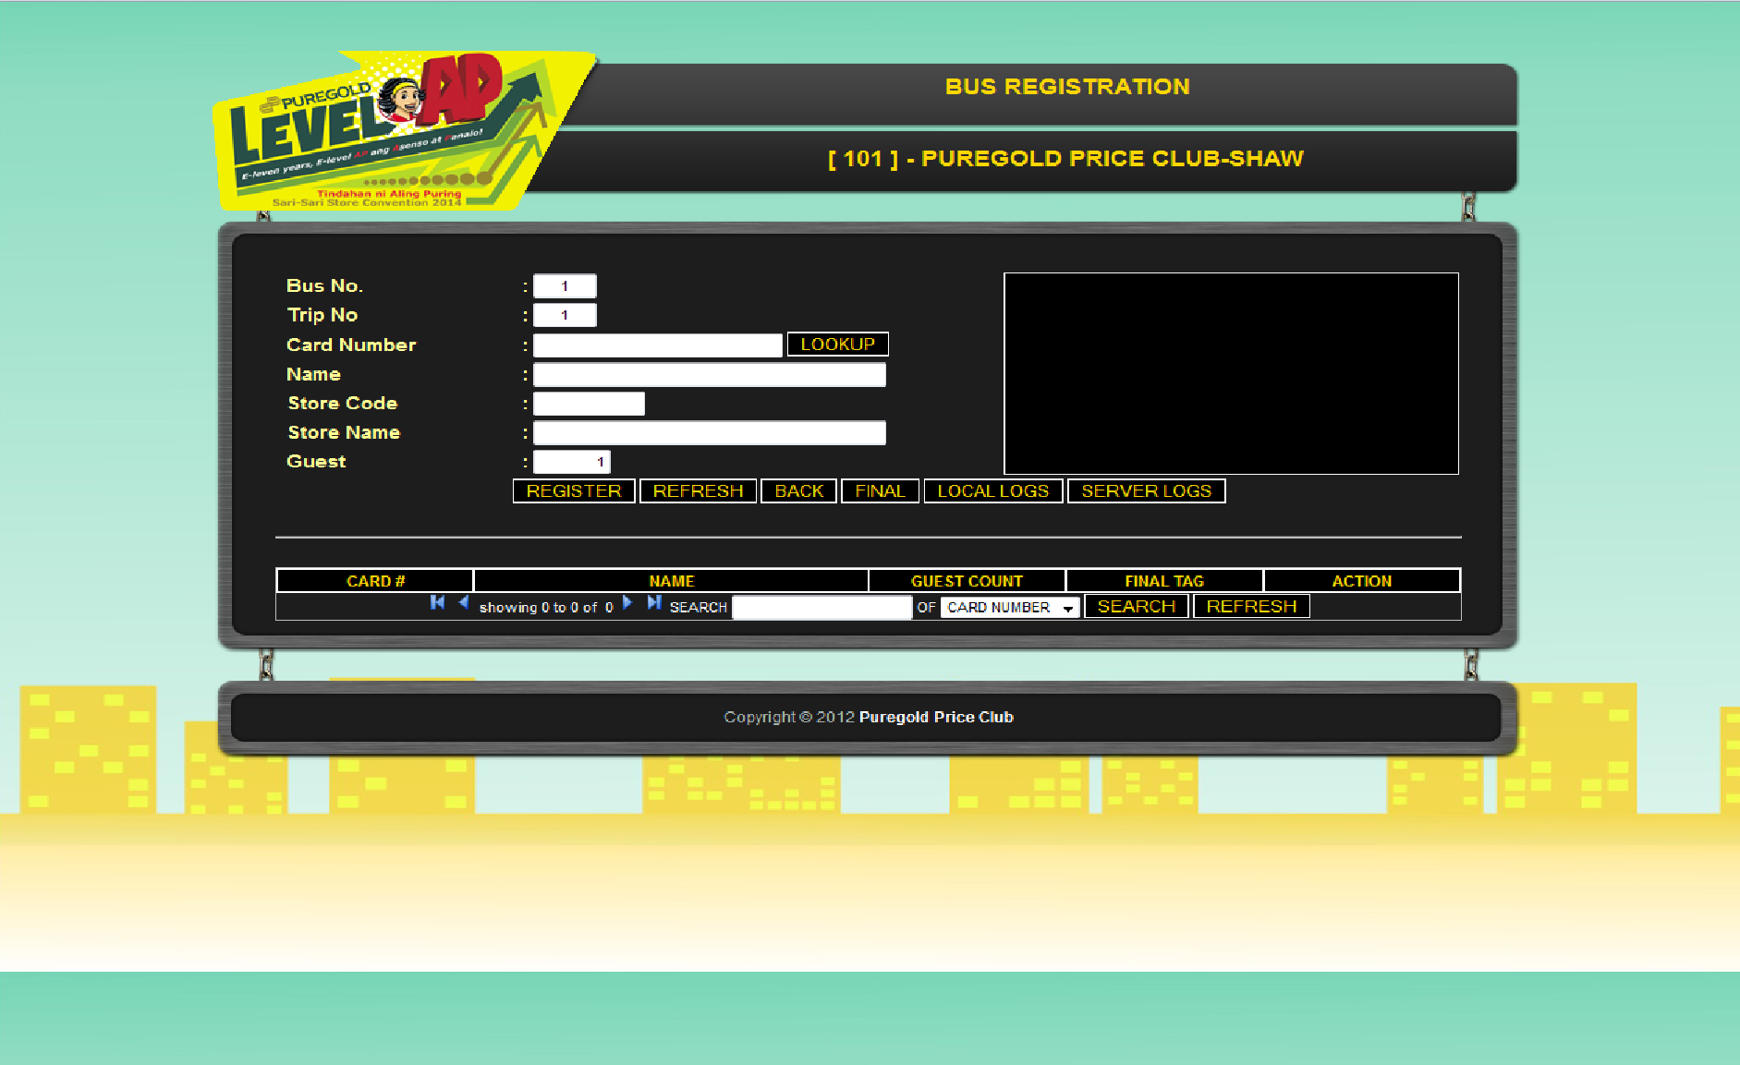
• Data8 vs CRM
- Report that will check the customer transaction if loaded to CRM program or remain only in the CRM Staging due to error of loading.
Screenshot:
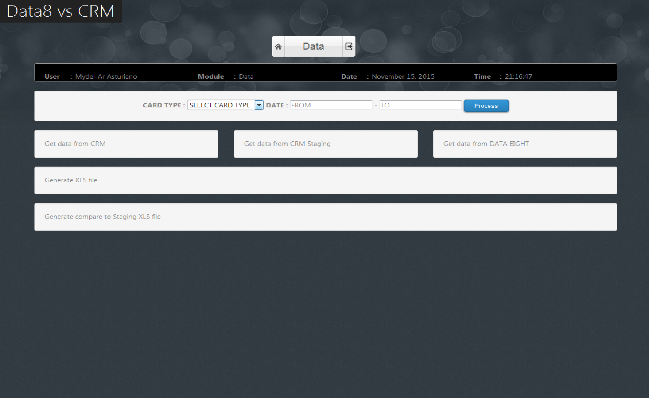

• SAWT - Summary of Alpha list Withholding Tax.
- To reduce / eliminate the time for accounting to manage and reconcile WHT certificates vs GL and to be able to send BIR data file for Withholding Tax certificates.
Screenshot:
