VBB User’s Manual
VETERANS MEMORIAL MEDICAL CENTER BLOOD BANK

Open browser, required (MOZILLA FIREFOX)
Type on the browser:
http://127.0.0.1/veterans or http://localhost/veterans

- Login page / Security
- Type your username and password
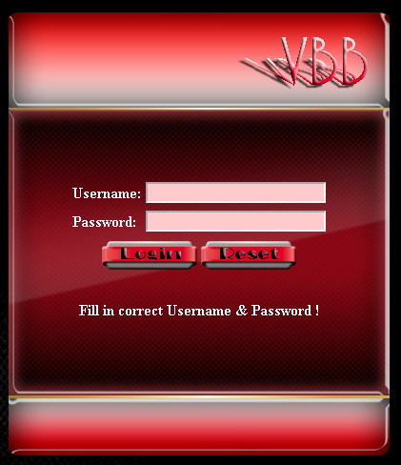

Homepage
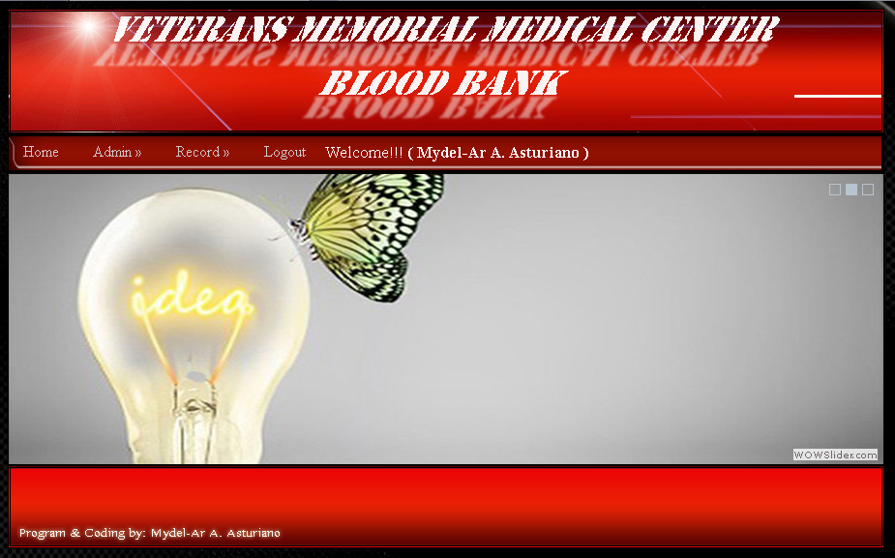
IT - Account
- Add User

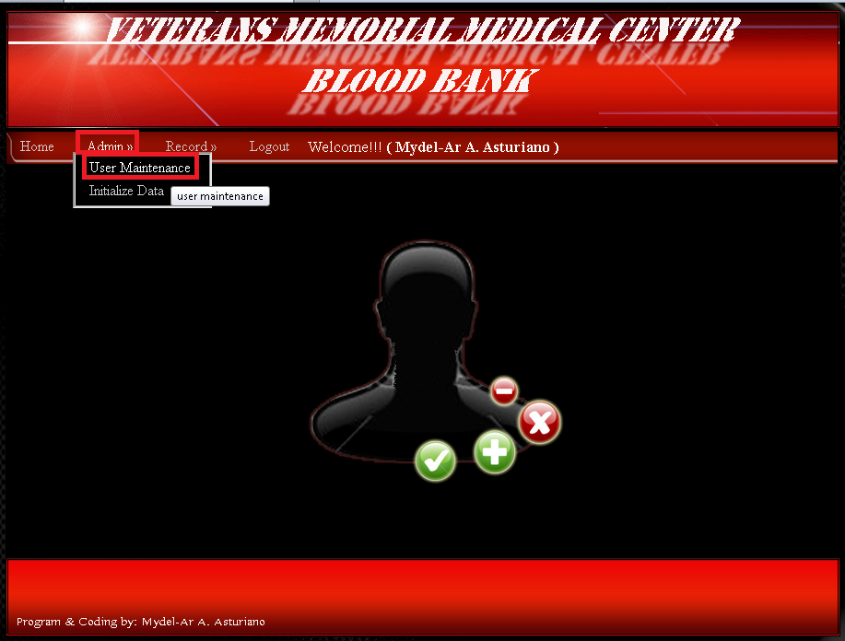

- Sample Valid Entry for Add User
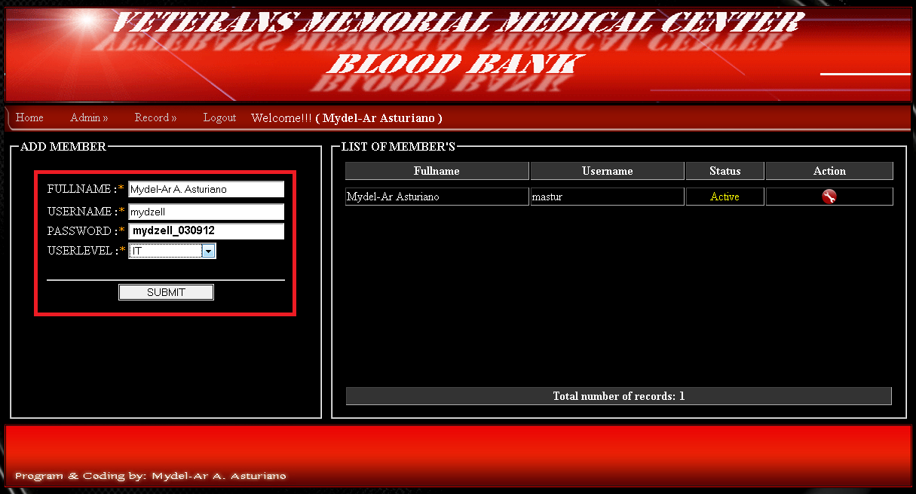

- Edit User
- Click encircle icon

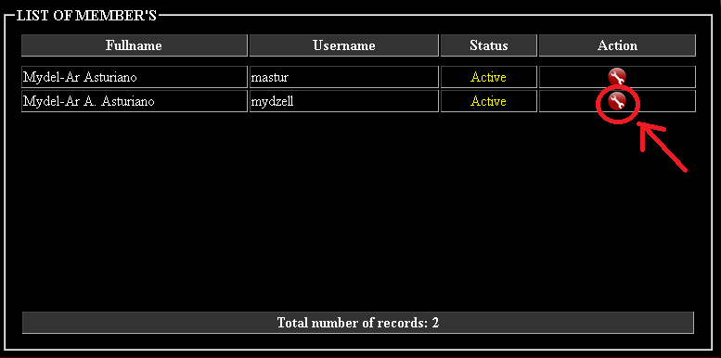

- Another window will appear

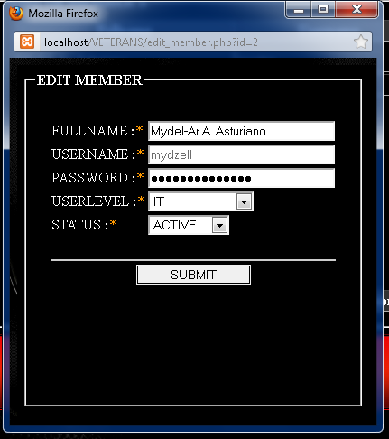

Staff – Account
- Add Patient

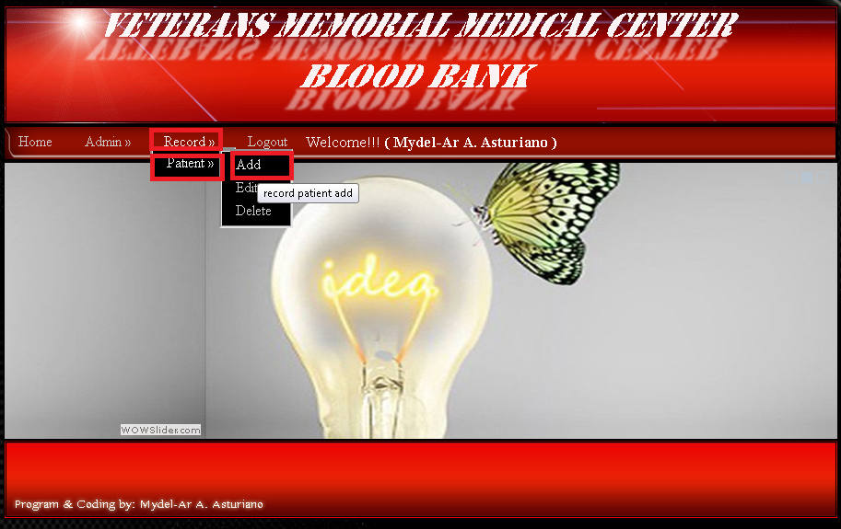

- Sample Valid Entry
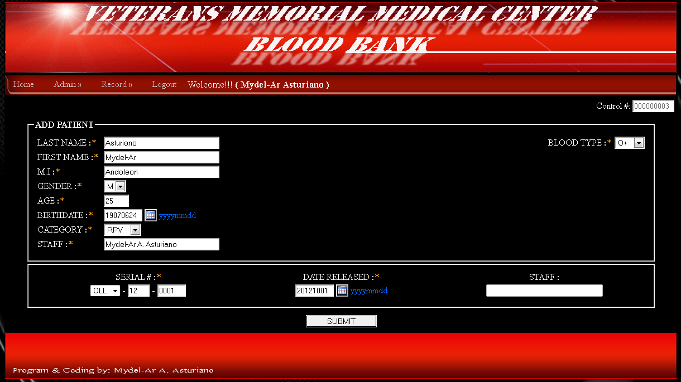

- Check the encoded patient
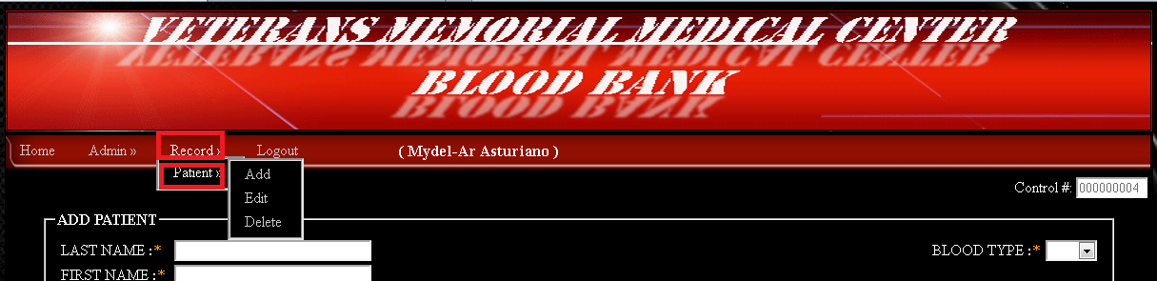
- Print the encoded patient - information only.
- Click the encircle color green icon

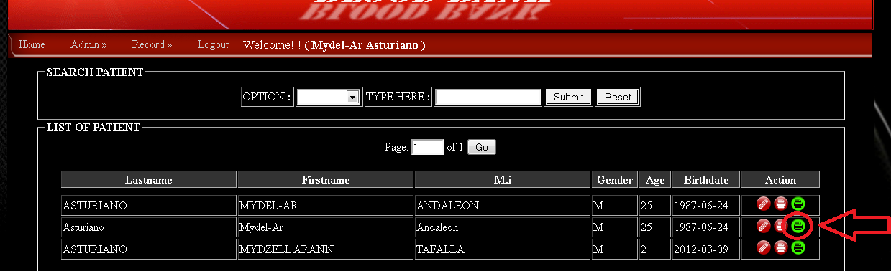

- Print the encoded patient - detailed
- Click the encircle color red icon

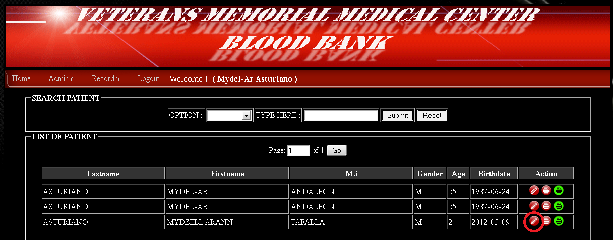

- Click File -> Page Setup

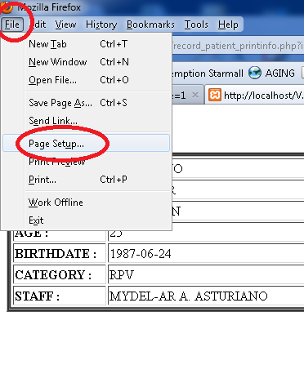
- Go to Margins & Header/Footer Tab
- Edit all the red encircle
- Click OK

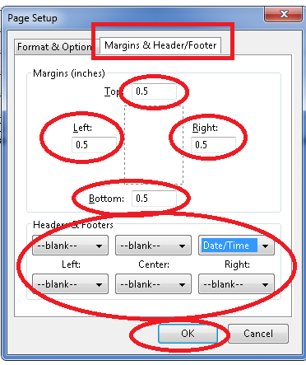

- Print Preview

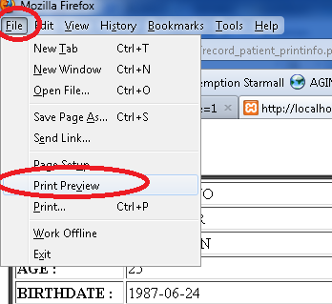

- Print to printer

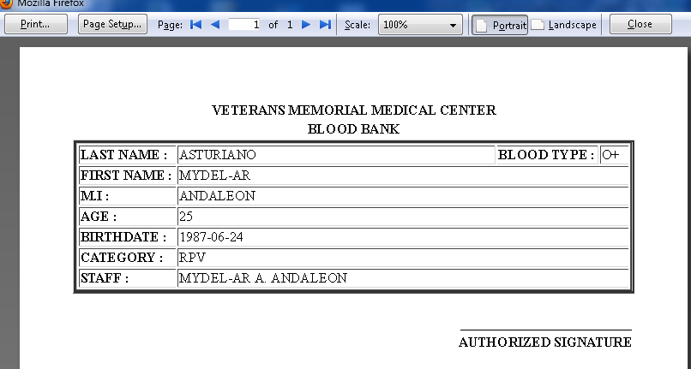

- Update the encoded patient
- Click encircle icon

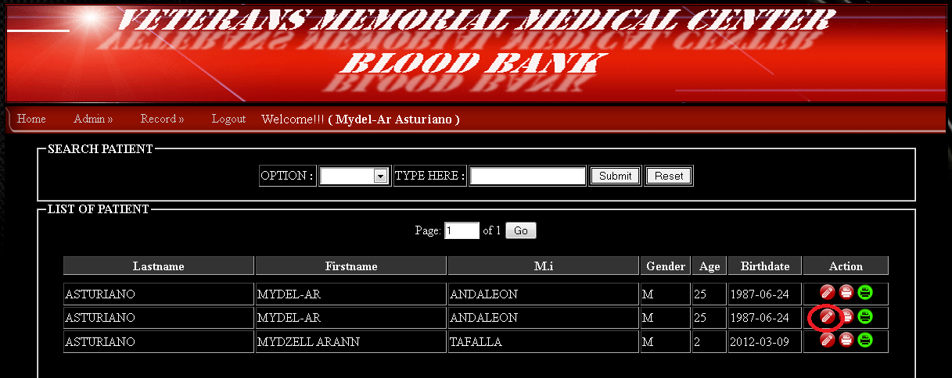

- Sample valid entry

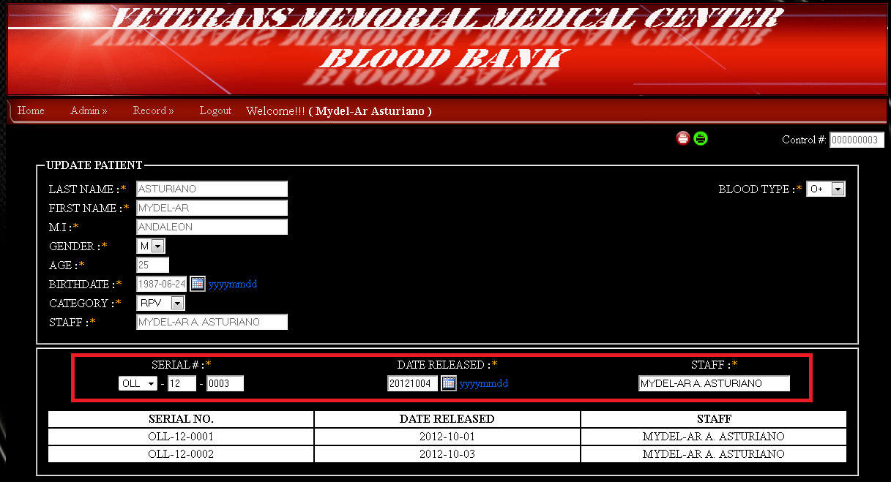

- Updated entry will inserted additional row

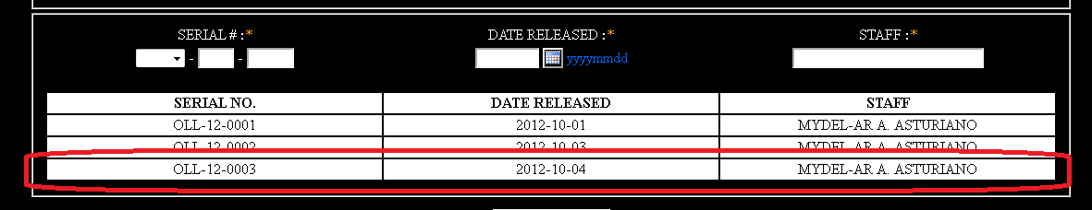

- Update patient module had a print button if you want to print

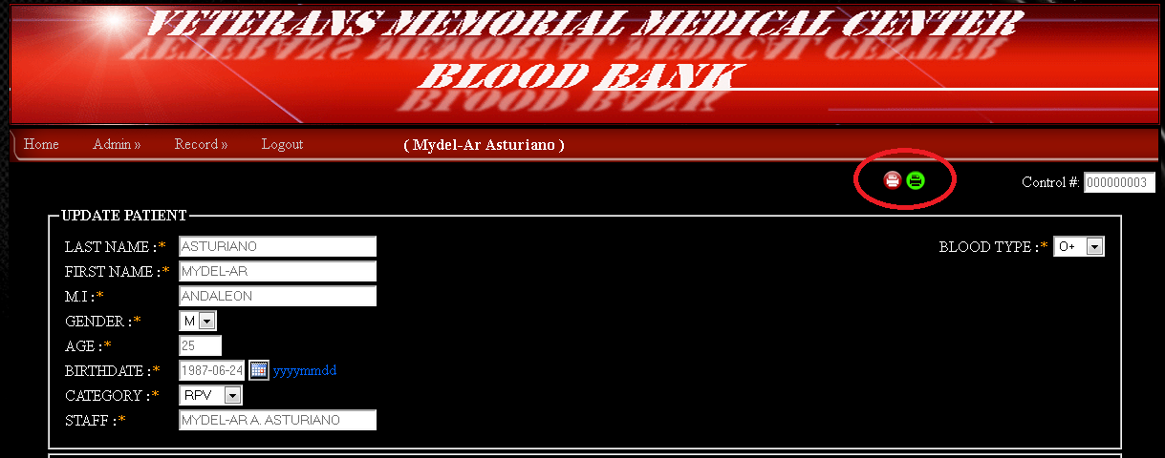

Supervisor – Account
- Edit patient

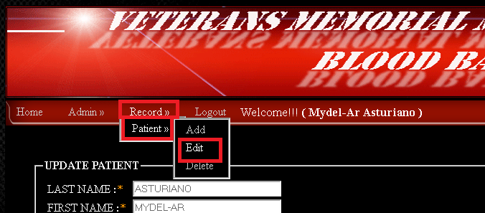

- Use search engine

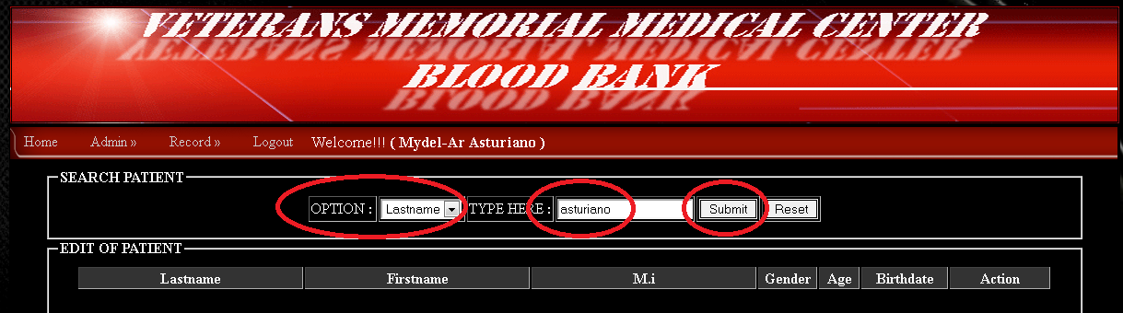

- Click encircle icon

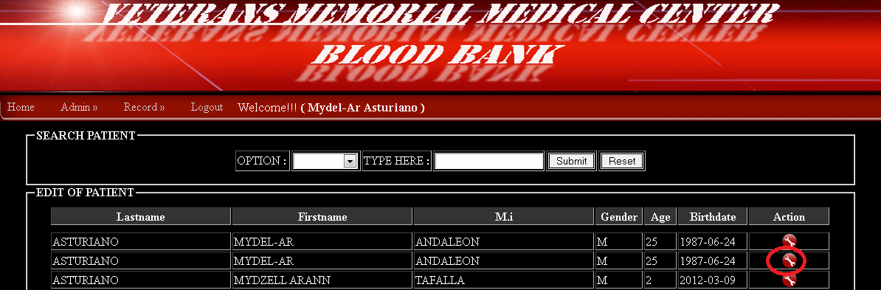

- All fields are editable except encircle in red

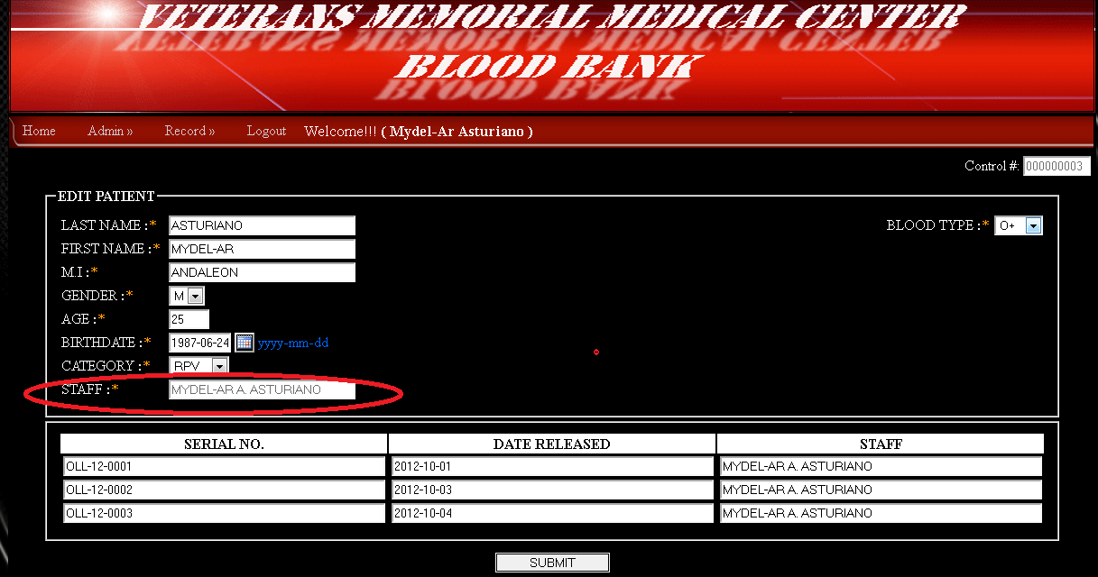

- Delete the patient

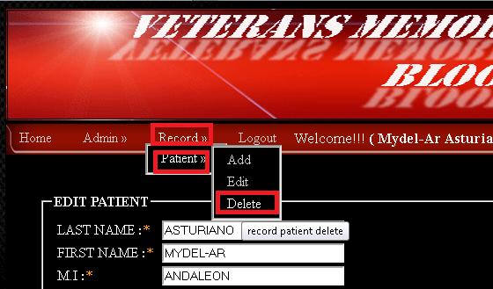

Use search engine

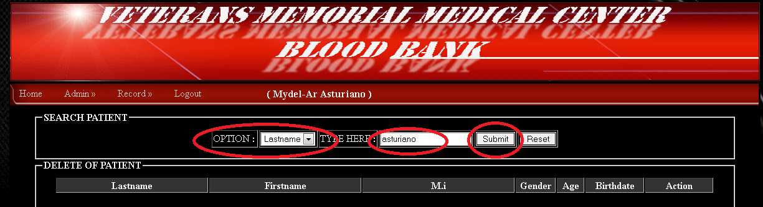

Click the encircle icon

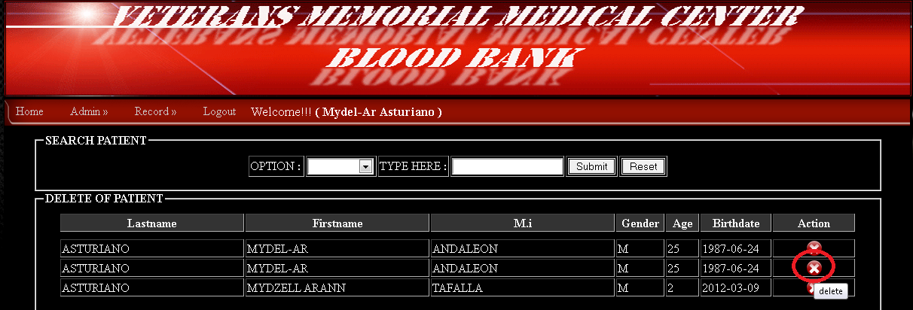

Click yes to delete or no for not delete

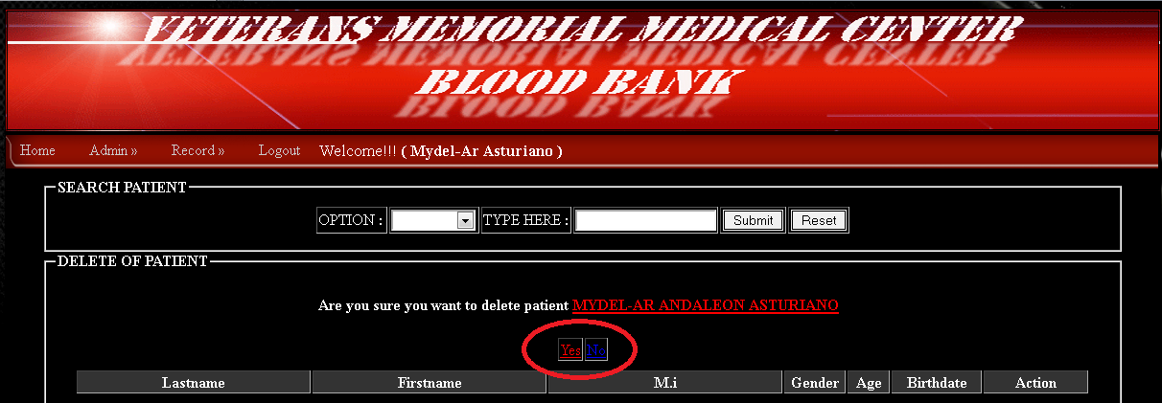

End
Thank you

Programmer:
Mydel-Ar A. Asturiano

