**LOGIN PAGE**

Instruction:

* Input username is required
* Input password is required
* Account exist is required

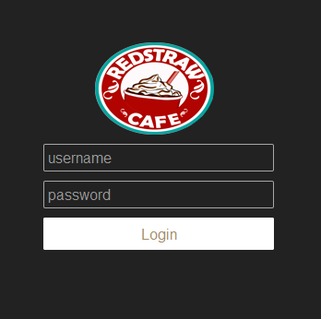

* Message prompt if username is blank.

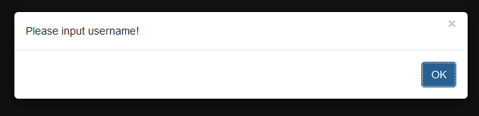

* Message prompt if password is blank.

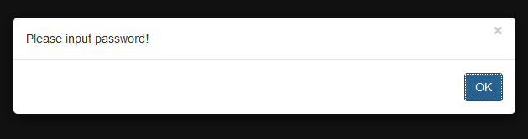

* Message prompt if username and password is invalid.

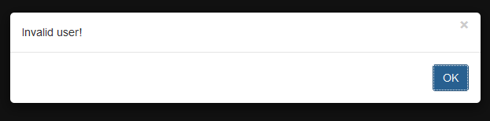

**USER MAINTENANCE**

* Select User Maintenance

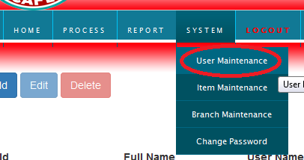

**ADD USER**

* Click Add button

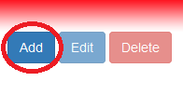

* Input fullname is required
* Input username is required
* Input group name is required

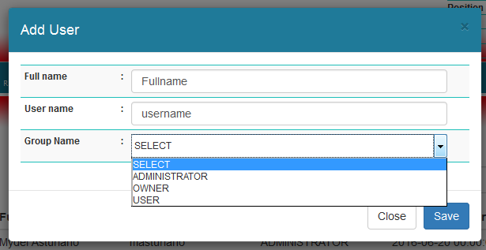

**EDIT USER**

* Click the target user



* Click Edit button

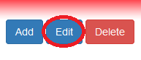

* User id is not editable
* Username is not editable
* Fullname is editable
* Group code is editable
* User status is editable
* Click Save Changes button to save the changes

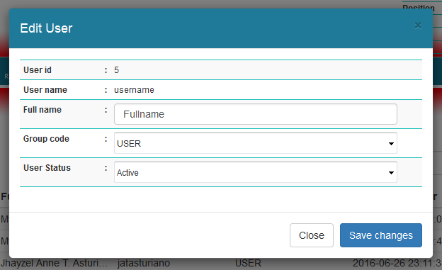

**DELETE USER**

* Click the target user



* Click Delete button

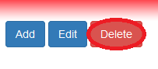

* Click Save Changes button to delete the user.

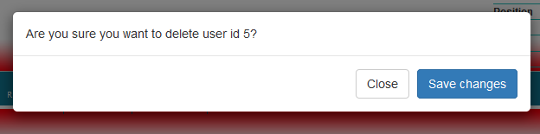

**ITEM MAINTENANCE**

* Select Item Maintenance

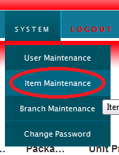

**ADD ITEM**

* Select Group Name (Ingredients,Non-food,Equipments)
* Input Description
* Input Packaging
* Input Unit Price
* Input Rel Price
* Input Fran Price
* Input No. of Item
* Input Lower Limit
* Click Save button to save the changes

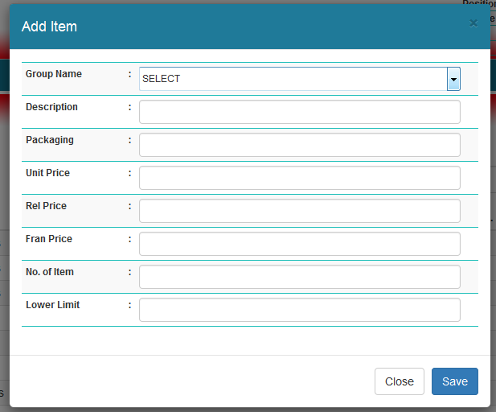

**EDIT ITEM**

* Click the target user



* Click Edit button



* Item id is not editable
* Select Group Name (Ingredients,Non-food,Equipments)
* Edit Description
* Edit Packaging
* Edit Unit Price
* Edit Rel Price
* Edit Fran Price
* Edit No. of Item
* Edit Lower Limit
* Click Save button to save the changes

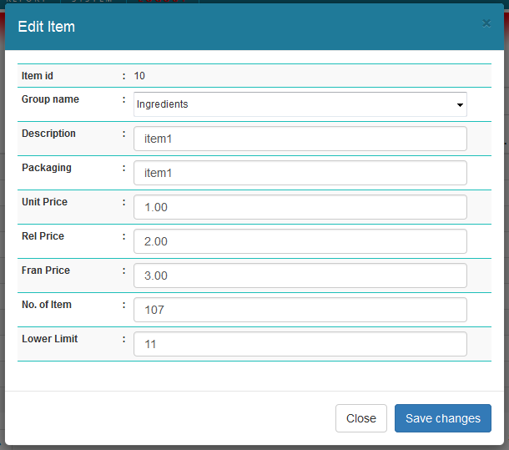

**DELETE ITEM**

* Click the target user



* Click Delete button



* Click Save Changes button to delete the item.

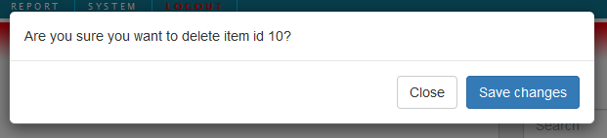

**BRANCH MAINTENANCE**

* Select Branch Maintenance

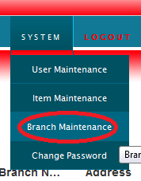

**ADD BRANCH**

* Input Branch No (e.g “D03” Letter is acceptable )
* Input Branch Name
* Input Address
* Input Owner
* Input Mobile No.
* Input Tel No.
* Click Save button to save the changes

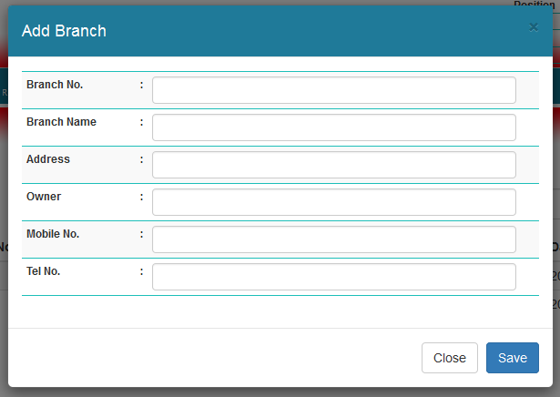

**EDIT BRANCH**

* Click the target branch



* Click Edit button

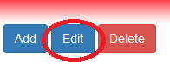

* Branch id is not editable
* Edit Branch No (e.g “D03” Letter is acceptable )
* Edit Branch Name
* Edit Address
* Edit Owner
* Edit Mobile No.
* Edit Tel No.
* Click Save changes button to save the changes

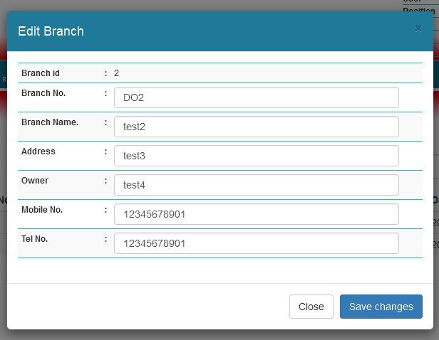

**DELETE BRANCH**

* Click the target branch



* Click Delete button



* Click Save Changes button to delete the branch.

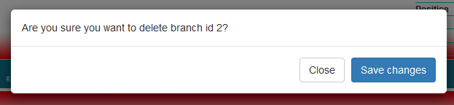

**CHANGE PASSWORD**

* Select Change Password

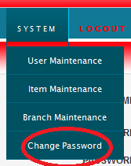

* Input new password is required
* Input confirm password is required
* New password and confirm password must be the same
* Click Save button to save the changes

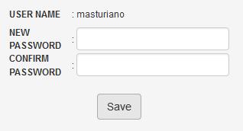

**ADD STOCK**

* Select Add Stock

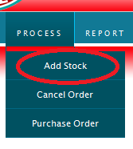

* Click the targer item



* Click Add button



* Input Additional No. of Item
* Click Save changes

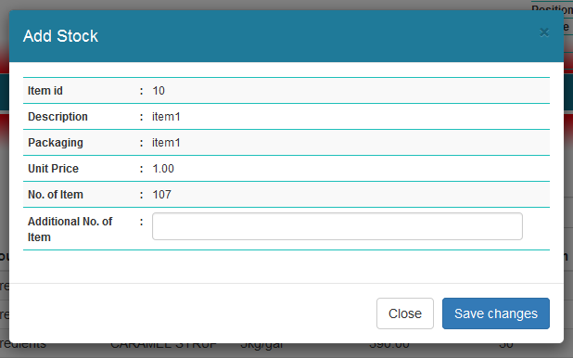

**PURCHASE ORDER**

* Select Purchase Order

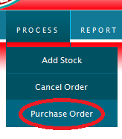

* Select Buyer
* Click Create

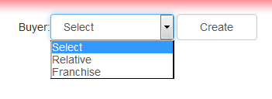

**CREATE HEADER**

* Select Branch Name
* Order No. automatically created
* Branch No. automatically display
* Owner automatically display
* Input Delivery Charge
* Input Previous Balance
* Click Save

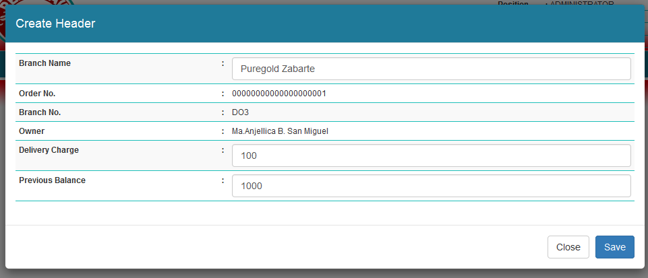

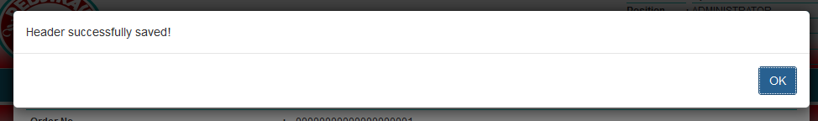

**CREATE DETAILS**

**Note:** Multiple items can add

* Select Item Description
* Order No. automatically created
* Branch No. automatically display
* Owner automatically display
* Input Delivery Charge
* Input Previous Balance
* Click Save

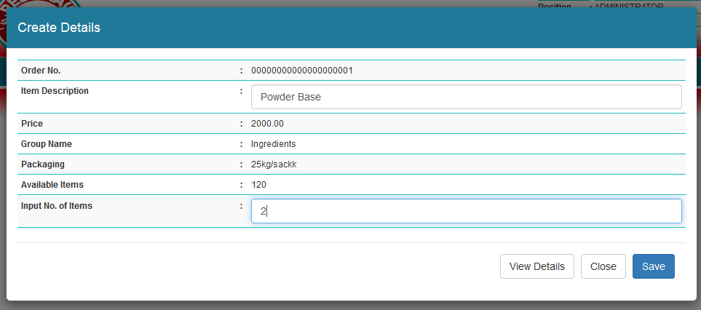

* Click View Details to see the list of added items

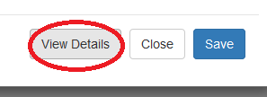

* Click Print if you are finish on adding an item.
* Note: Click final will finish the ordering

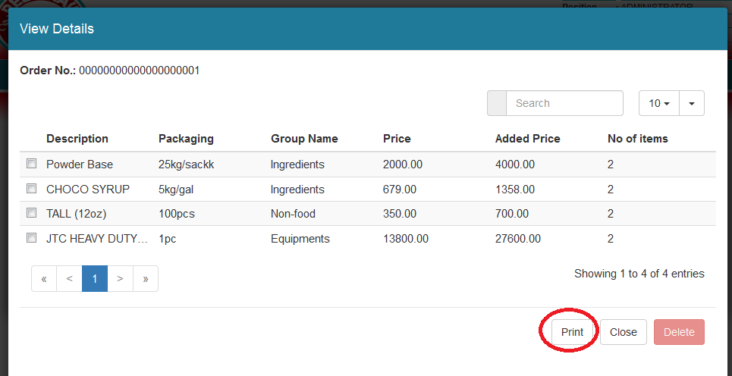

* Pdf file will prompt
* Click ok

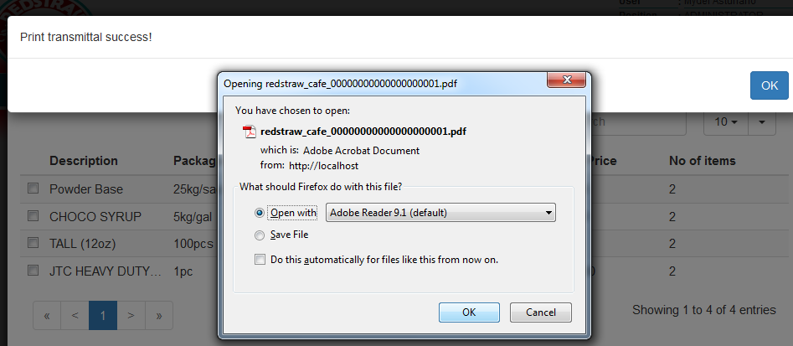

* Sample output of pdf

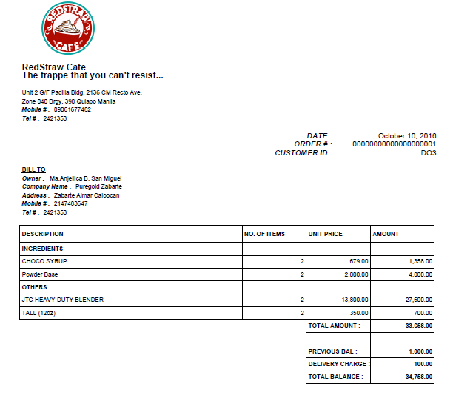

**CANCEL ORDER**

* Select Cancel Order

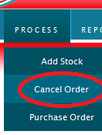

* Input Order No.
* Order No. must be 20 digits
* Click Cancel

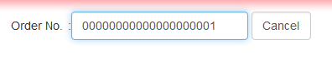

* Order number must be exist

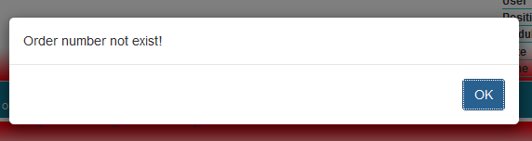

* Click Yes

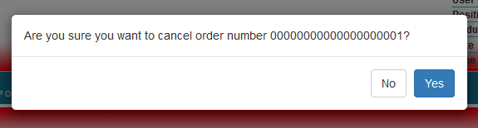

**REPORTS**

**AVAILABLE STOCKS**

* Select Available Stocks

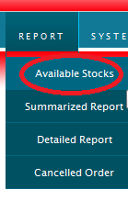

* Select Item Group (Equipments,Ingredients,Non-Food)
* Click Print Excel Button

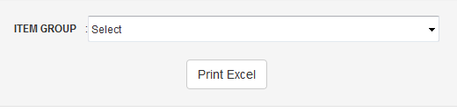

**SUMMARIZED REPORT**

* Select Summarized Report

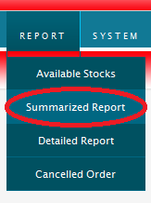

* Select Date Enter From and To
* Click Print Excel

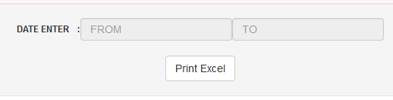

**DETAILED REPORT**

* **Select Detailed Report**

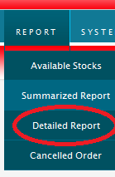

* Select Date Enter From and To
* Click Print Excel

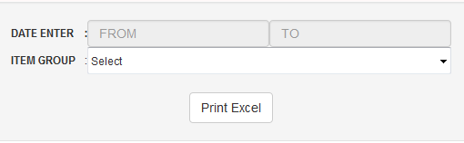

**CANCEL ORDER REPORT**

* Select Cancelled Order

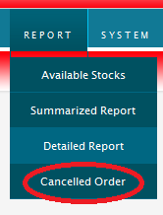

* Select Date Enter From and To
* Click Print Excel

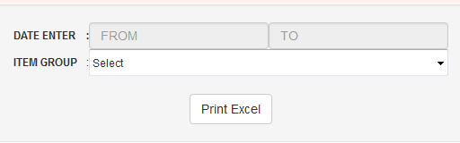

**REPRINT ORDER NO.**

* Select Reprint Order

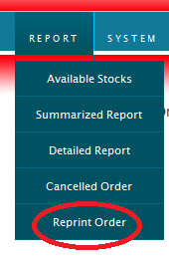

* Input Order No.
* Order No. must be 20 digits
* Click Reprint

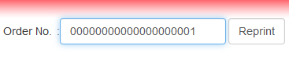

**LOGOUT**

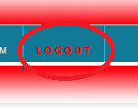

**END**