ID: 132073

### Name: Dipeshkumar M Parekh

#### SBA Final Task management

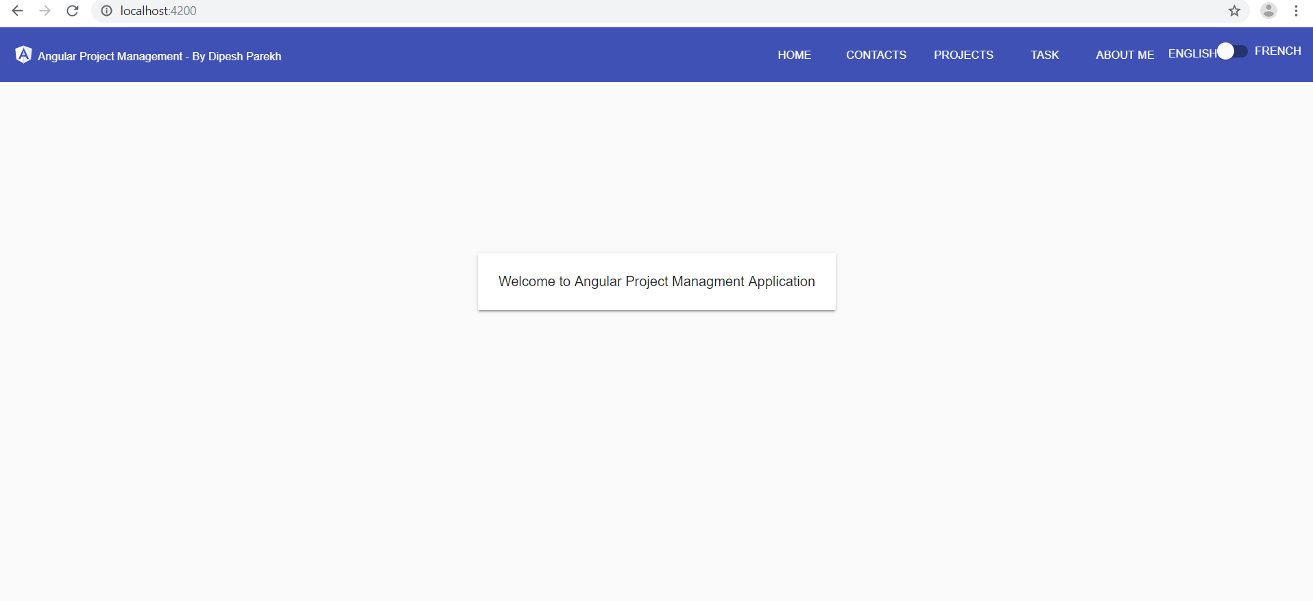

Technology: Angular, material, .Net Webapi, Entity framework, Rest service.

# Setup:

Run DB script.

After that copy webapi folder and replace connection string with correct connection string.

Create a folder and copy angular code.

Run npm install

Run ng build

Run ng serve

To set production: use production environment

# PRODUCTION VS NON PRODUCTION

This project build on two DB option. If you are setting production configuration then it will run real SQL server and use rest api to manage all operation. Else it set to false then it will run under in memory api.

# Angular Code:

Highlights

* Used In memory api for quick solution
* Used Material design for desktop, mobile and tablet compatible
* Used Language service for multi-language support
* Used Logger to log angular error and module loading
* Used Filters, custom controls and loading functionality
* Used services and module for features loading
* Used multi form and stepper
* SCSS for styling and website
* Implemented Notification bar for every operation success and fail.
* Routes and Page not found routes also implemented
* Used custom paginator and pop for search controls
* Created dialog component for warning and search controls
* Single control for multi functionality (ADD /EDIT)

# .Net Code

Highlights

* Used UnitOfWork for generic and single transaction unit.
* Used Entity framework DB to entity
* Used Logger to log all the errors in Text files
* Used Nunit for controller and Service testing
* Created services for all operations

# Angular Code structure

|  |  |
| --- | --- |
|  | 1. Logger for logging 2. Main lay out 3. Nav bar for navigation bar on top 4. Toast for notification 5. Features (Task, project and contact) 6. Shared – shared component and filters 7. Environments for environment related config |
|  |  |

# .Net Code structure

|  |  |
| --- | --- |
|  | 1. Business entity – Transpose DB to custom entity 2. Business service for doing Crud operation and business logic 3. DataModel – Unit of work repository for individual CRUD operation through generic 4. Unit test project API controller and buisessService test. |

>

# Working Application Screenshot

## Welcome page

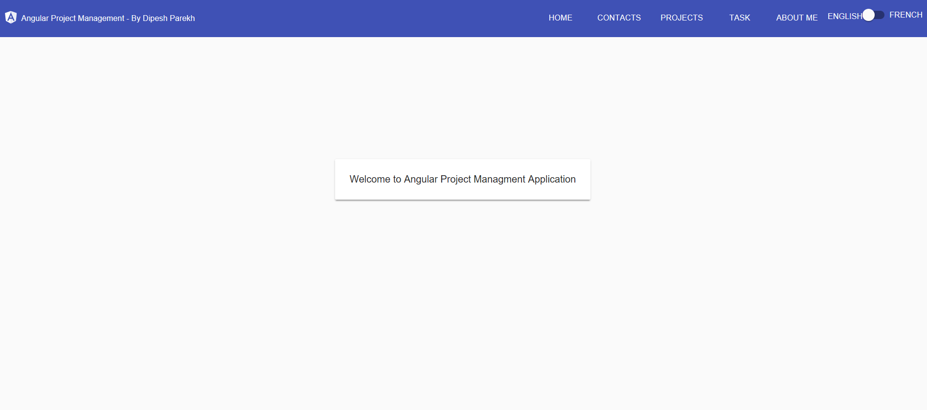

## Contact Page

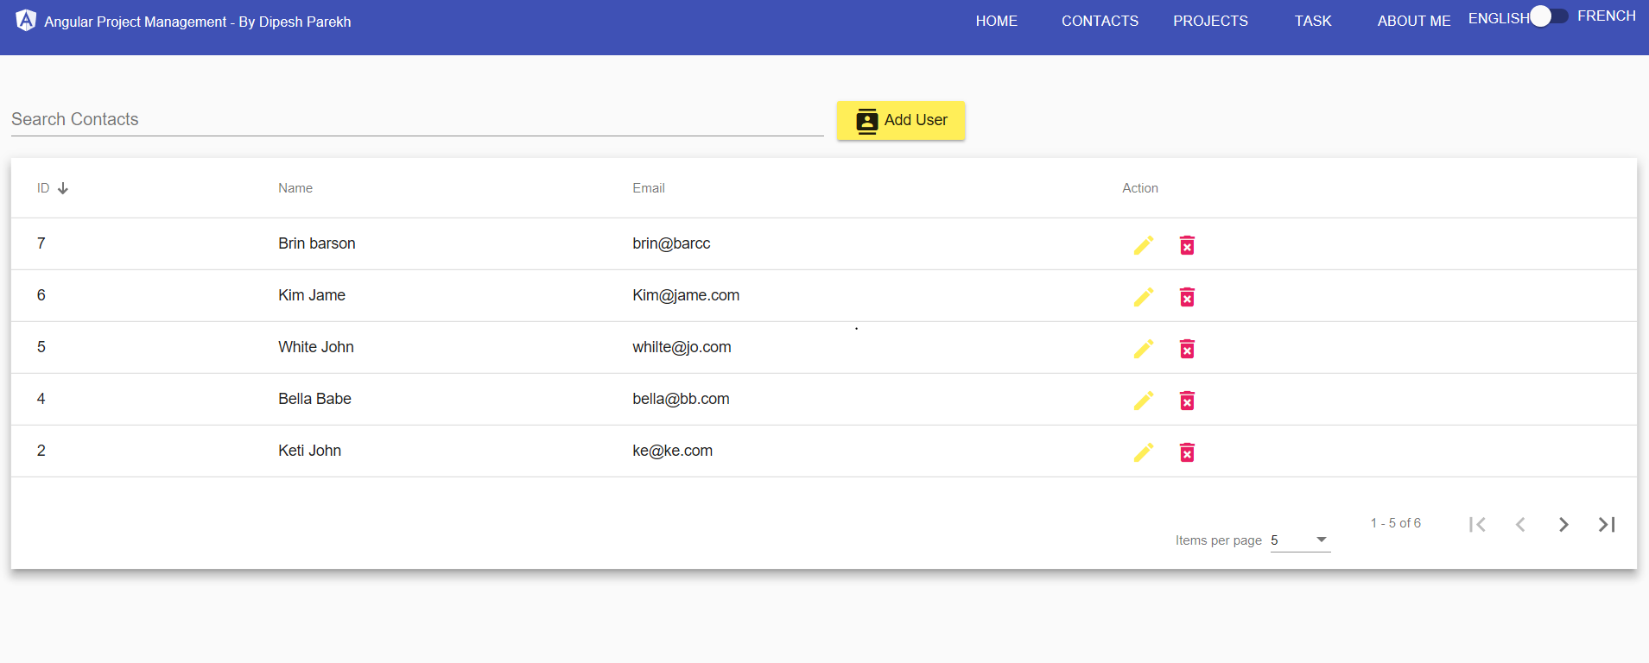

Search by Name email

Action Edit and Delete

Pager with option Items per page and pagination

Sorting on name , email and id.

Add User Button to add new contact

Notification bar -



Edit contact

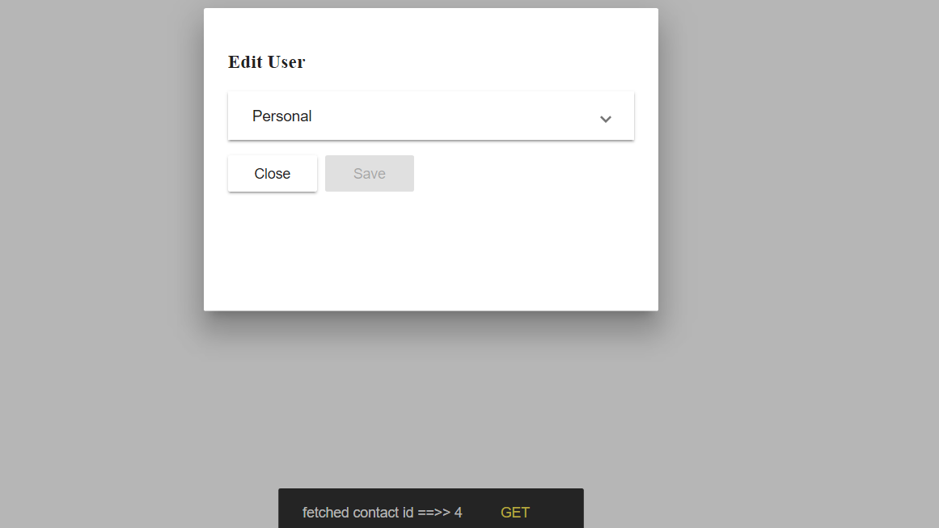

Stepper and Validation.

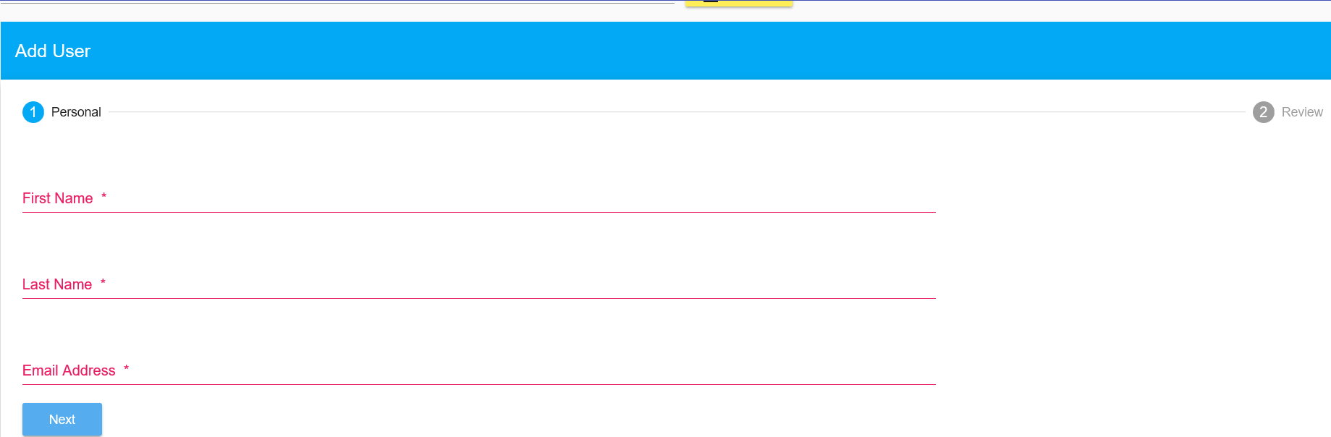

## Project Page

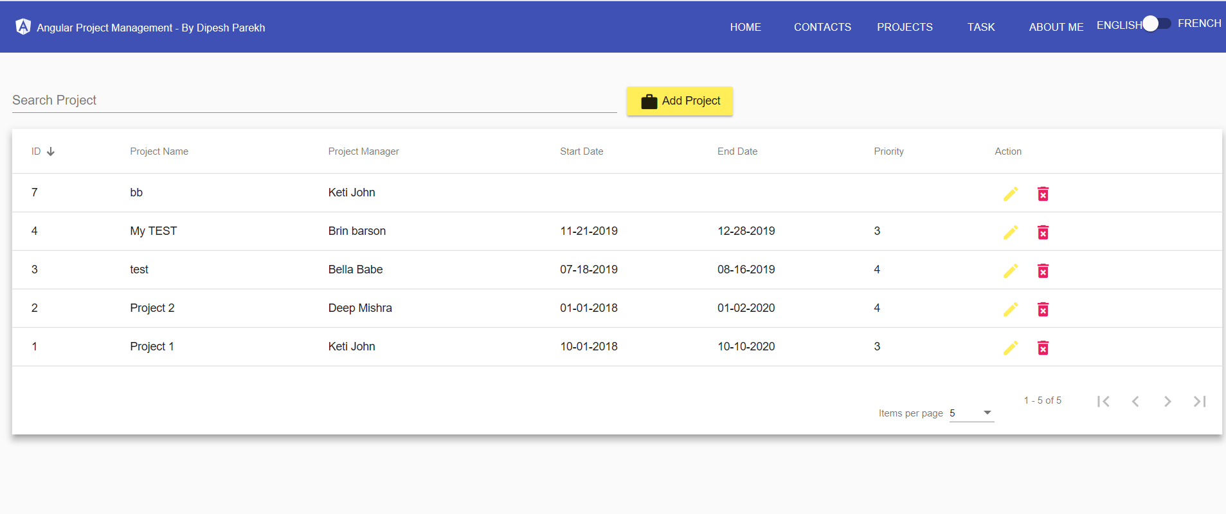

Search by Project Name email

Action Edit and Delete

Pager with option Items per page and pagination

Sorting on name, Project manager Priority.

Add Project Button to add new Project

Notification bar –

## Edit Project

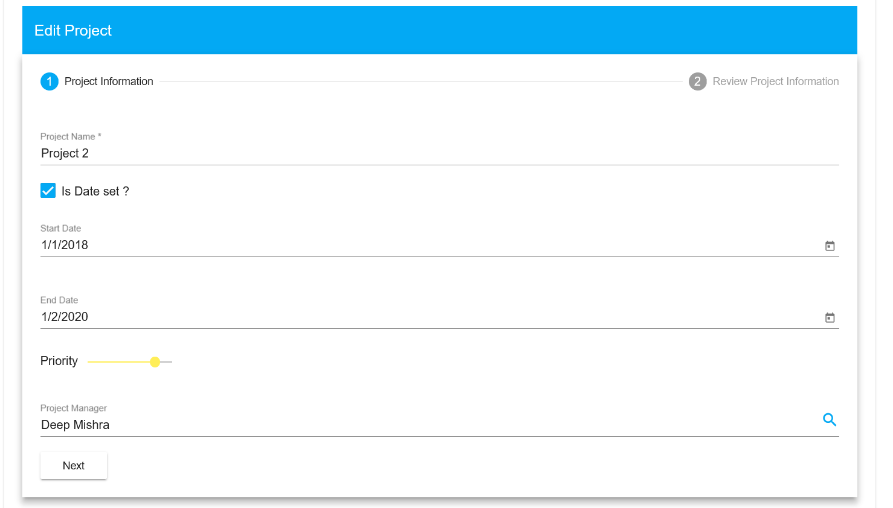

Same control used for add and edit

Mat slider is used for priority

And Stepper for multi form and review before submit data

## Task page

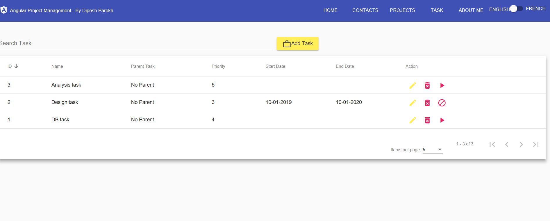

Search by task name.

Action Edit and Delete and suspend task

Pager with option Items per page and pagination

Sorting on name, Priority, date and parent task

Add task Button to add new task

Notification bar –

## Globalization

On top bar there is an option for English or French

All Label, notification such as save, fail, fetch and pager, grid will change to French

* Bottom notification change
* Add/Edit project button label changed
* Grid column header changed
* Pager changed.

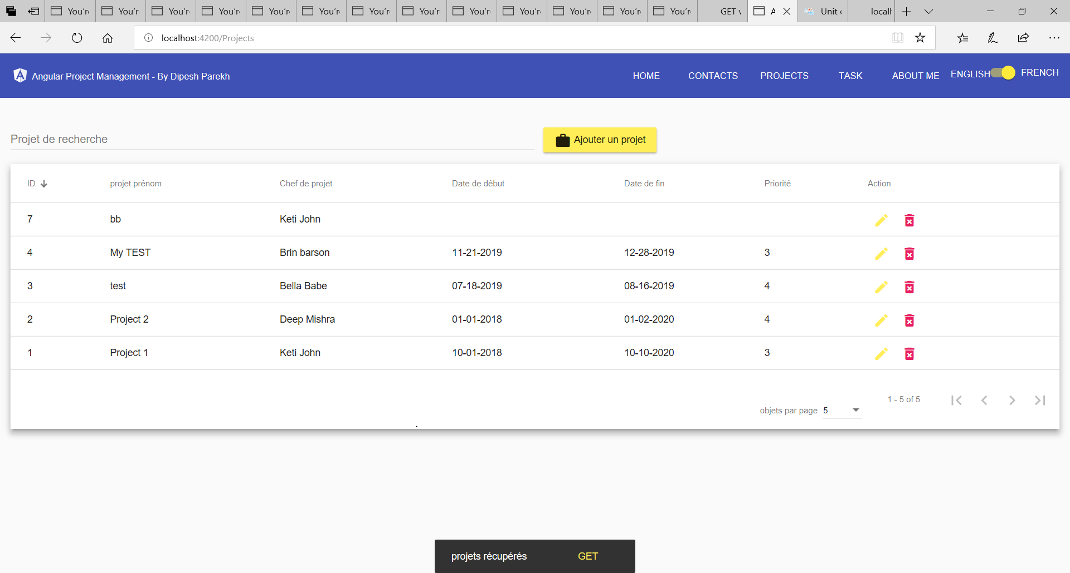

UNIT TEST and coverage report

