字体直链4.0（预览）
- 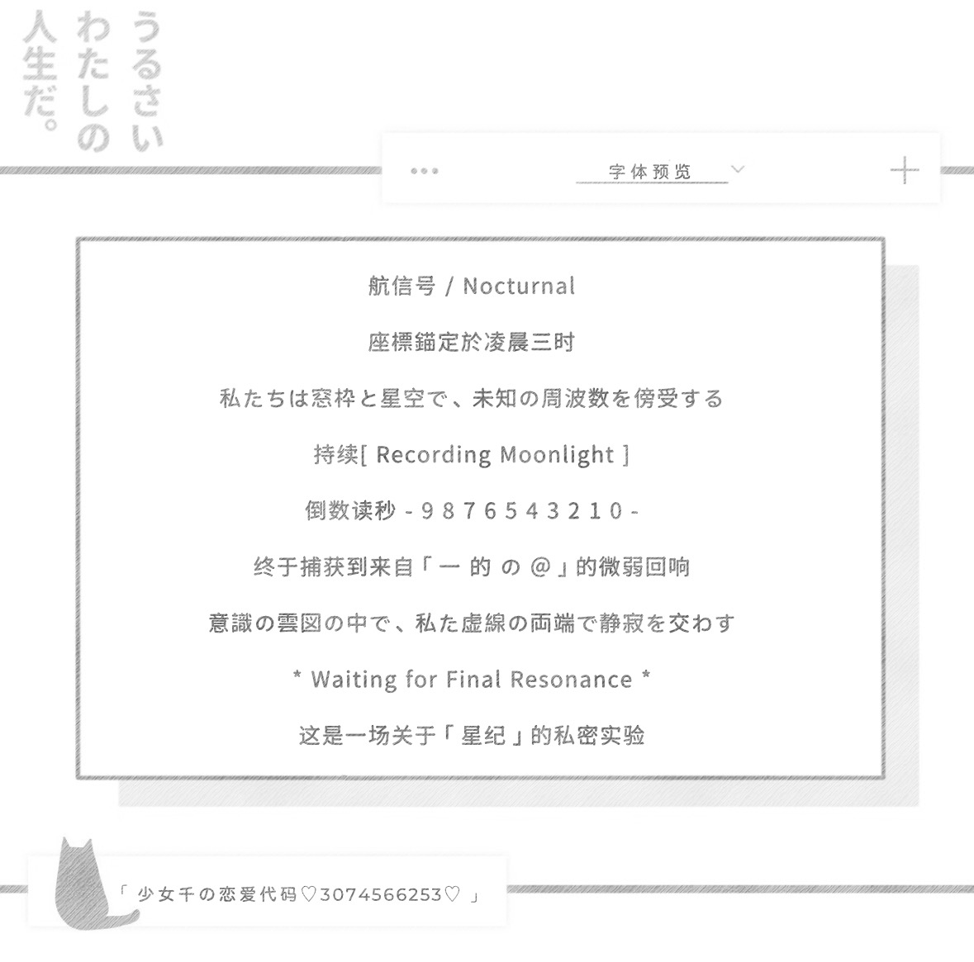
- 星纪
- https://nos.netease.com/ysf/1797b3a0640e60037d966077f6d9886c.ttf

- 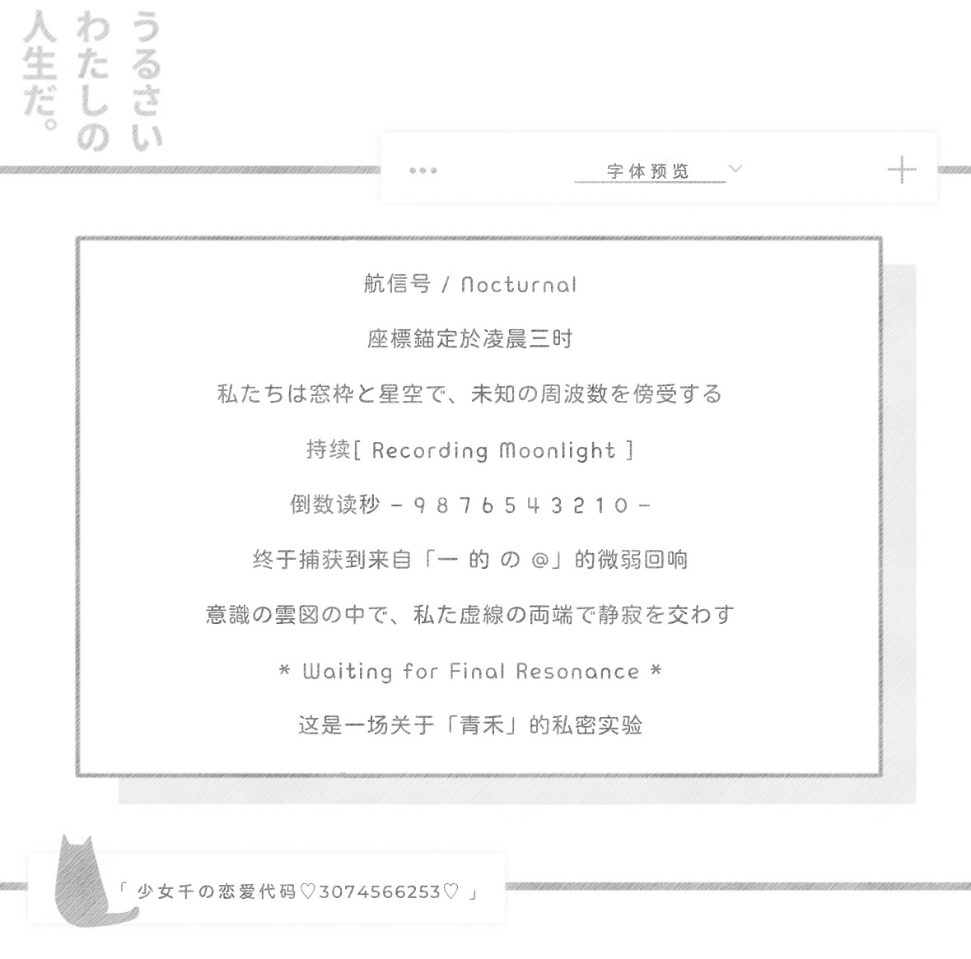
- 青禾
- https://nos.netease.com/ysf/5e0a4df77cd78b36b4db6f00fd0a0792.ttf

- 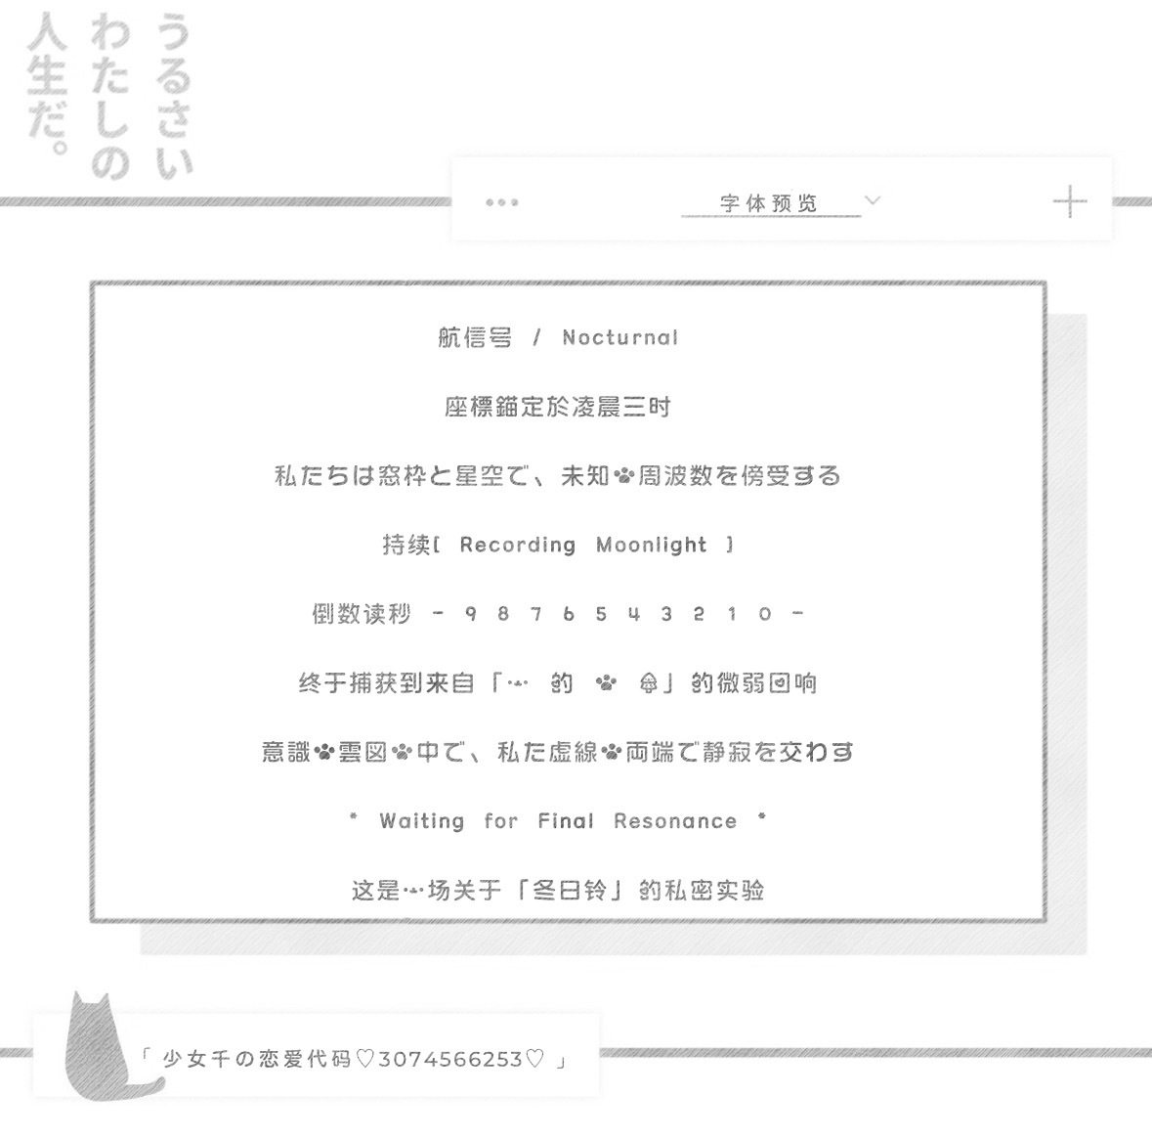
- 冬日铃
- https://nos.netease.com/ysf/66e3caf656adcd84fd31b58c5e7ad6c0.ttf

- 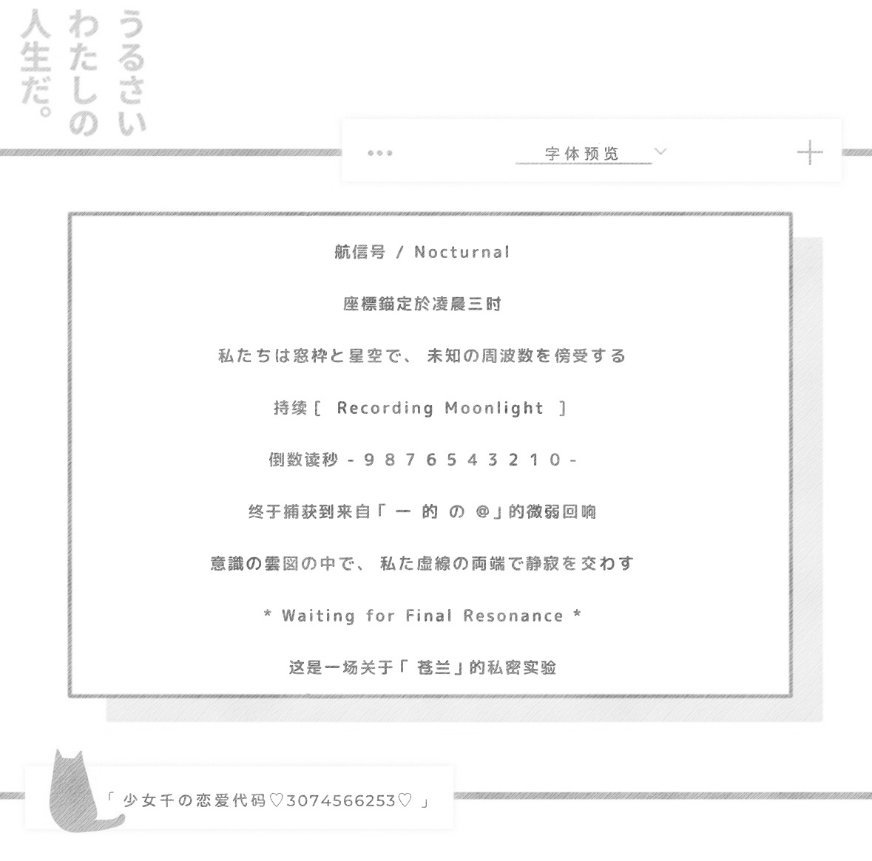
- 苍兰
- https://nos.netease.com/ysf/b3b010585918a283a09f243c85207972.ttf

- 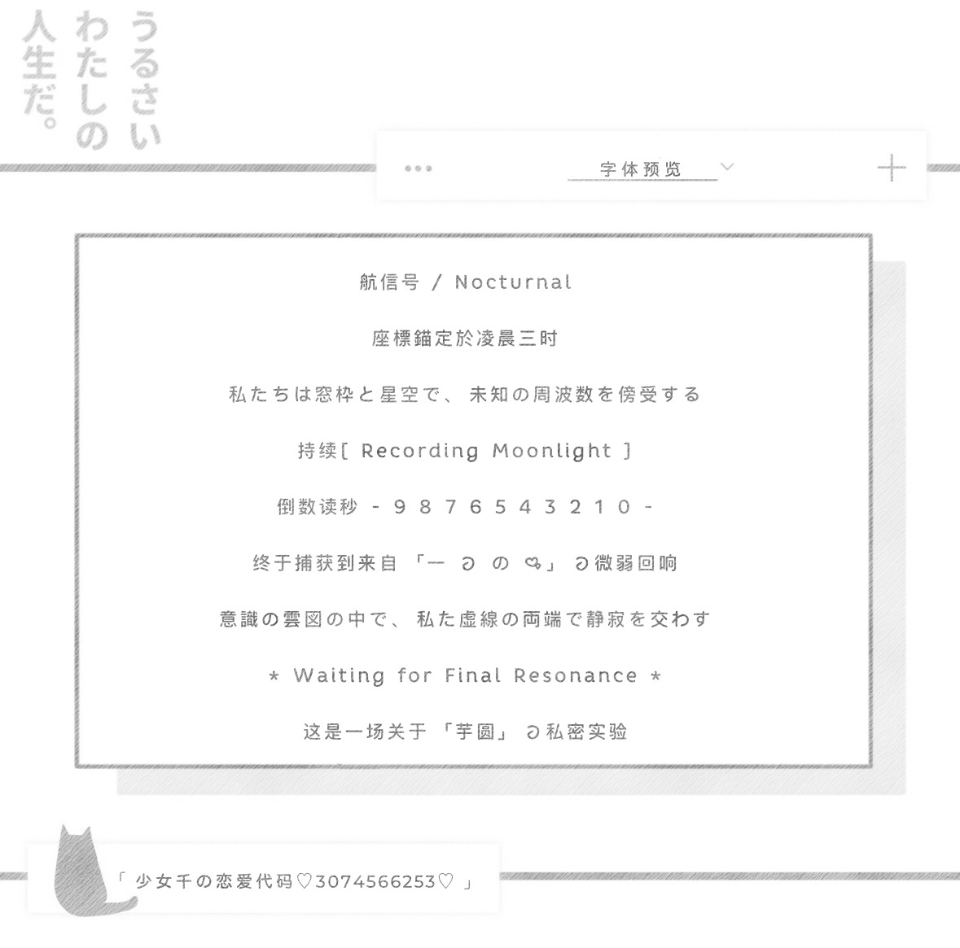
- 芋圆
- https://nos.netease.com/ysf/8c1ce5b83d3a2b5c1593dd204f37f876.ttf

- 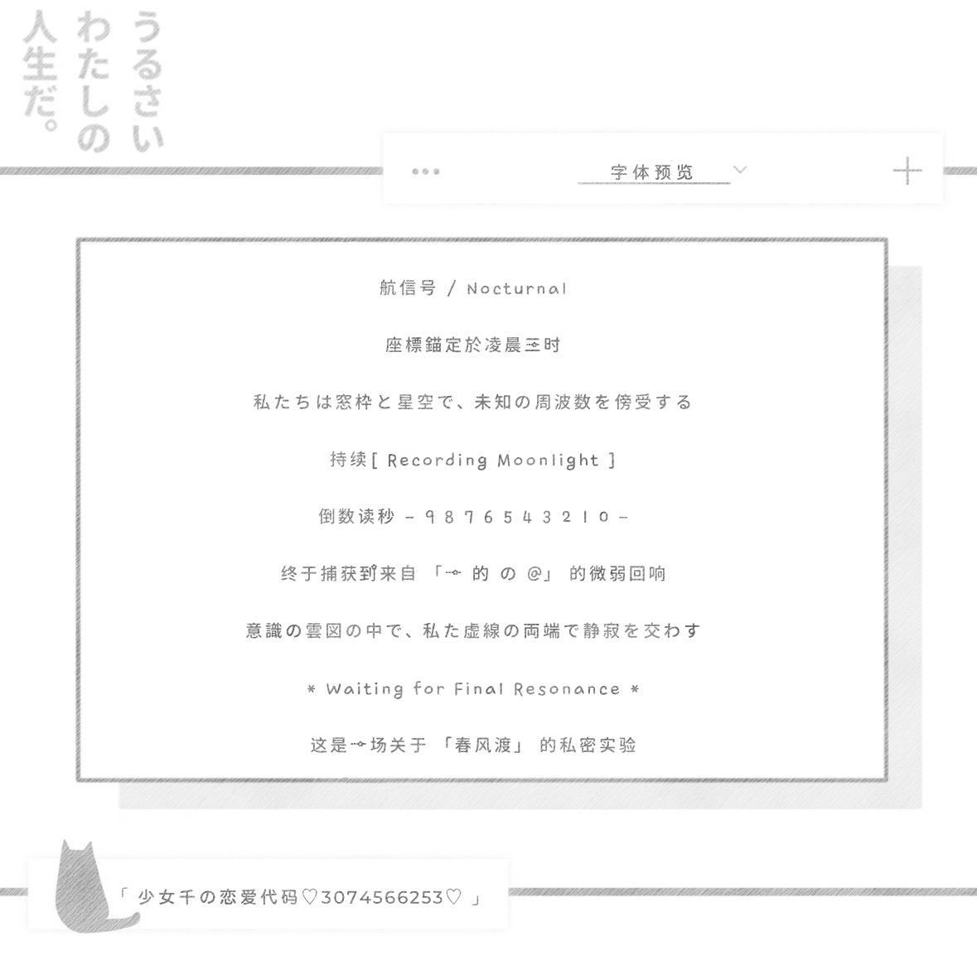
- 春风渡
- https://nos.netease.com/ysf/69ab48fd45b105b678c10745e7967e54.ttf

- 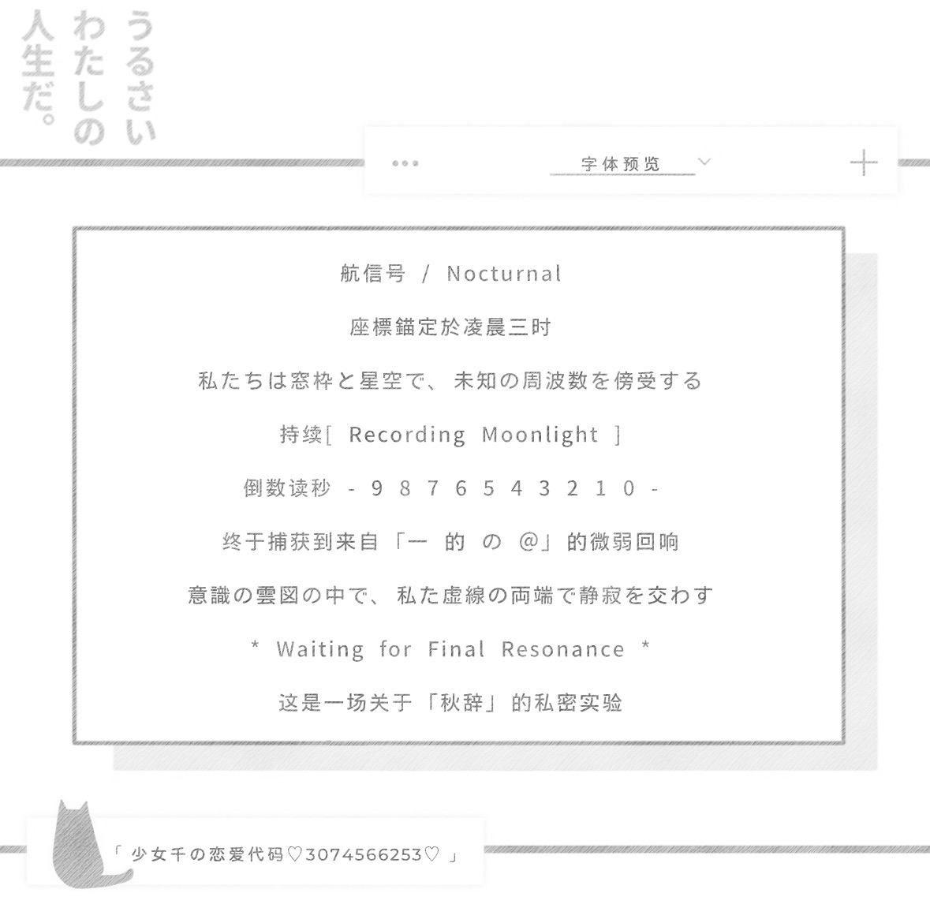
- 秋辞
- https://nos.netease.com/ysf/028b0c2914cf48d2712714a3ea3ce607.ttf
- 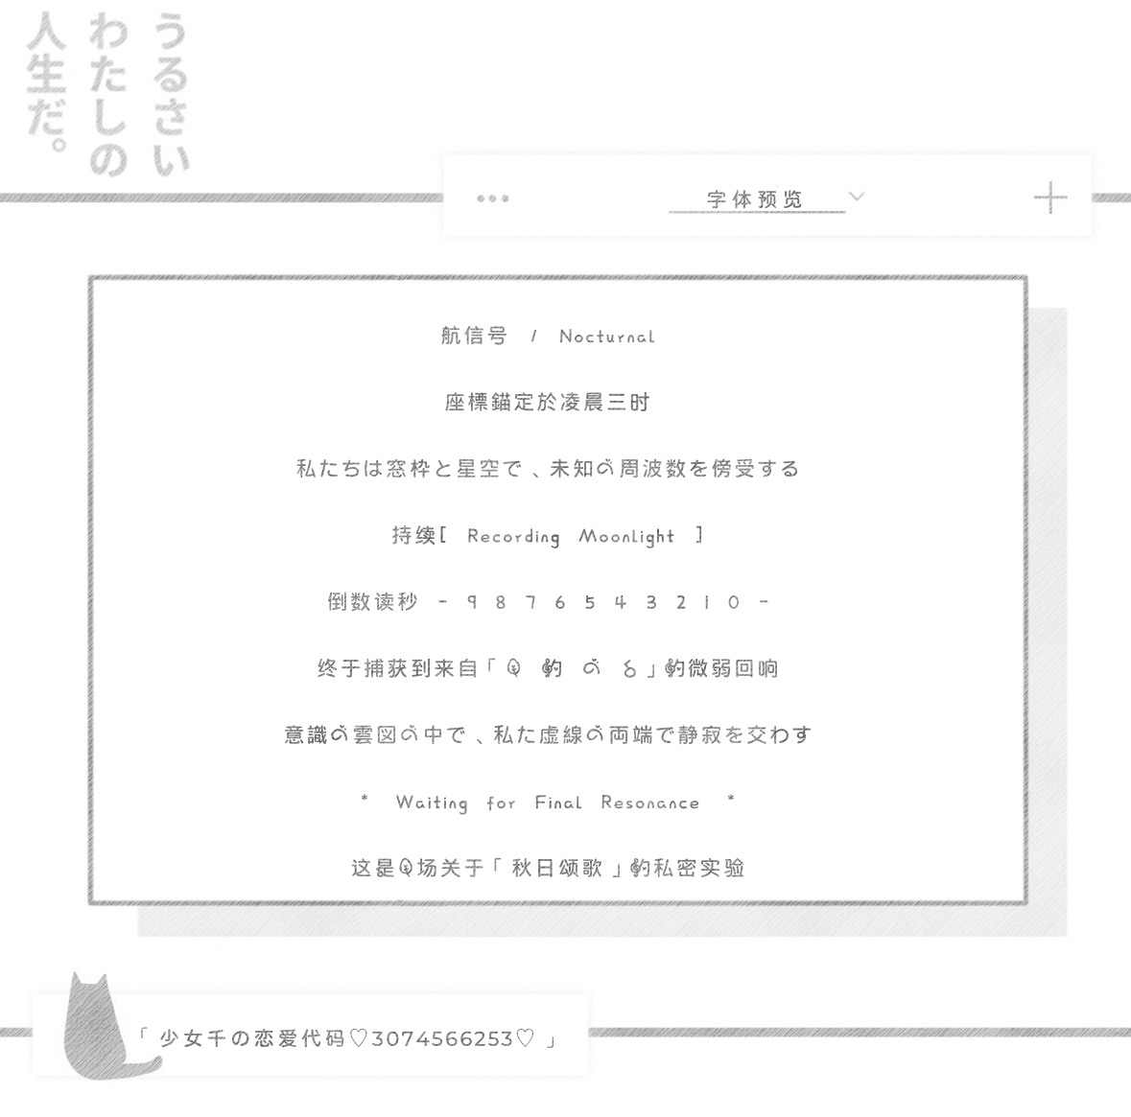
- 秋日颂歌
- https://nos.netease.com/ysf/346019090ce8418b92b48cfc410ebed1.ttf
- 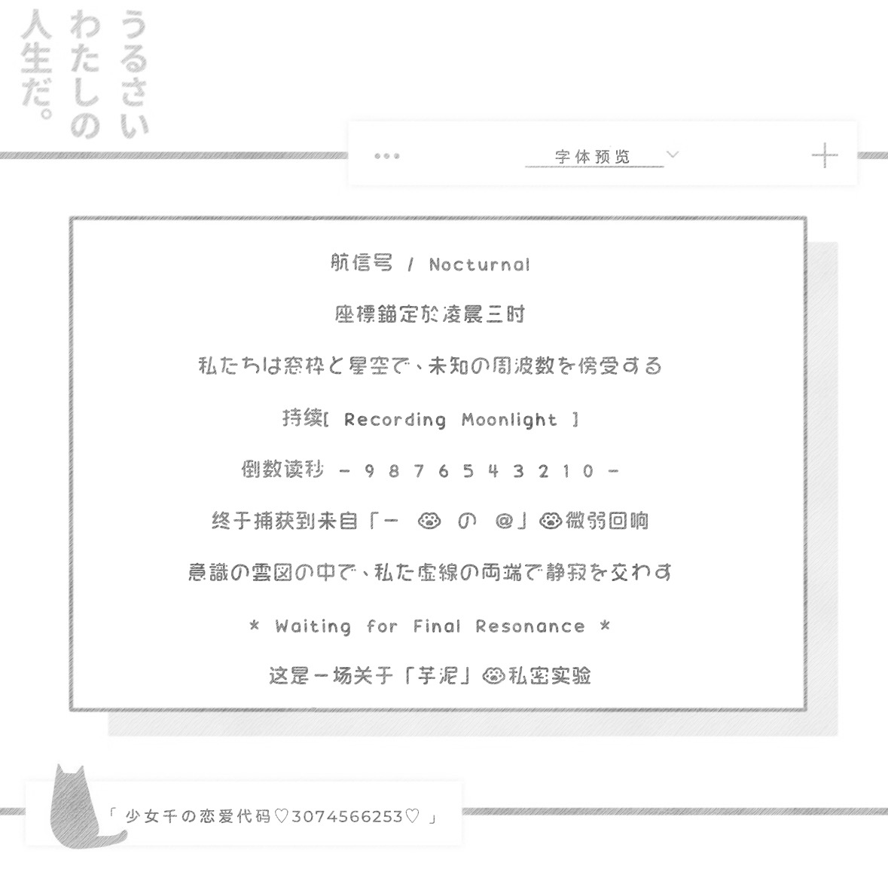
- 芋泥
- https://nos.netease.com/ysf/a2740374710f63fa57197466ab455d70.ttf
- 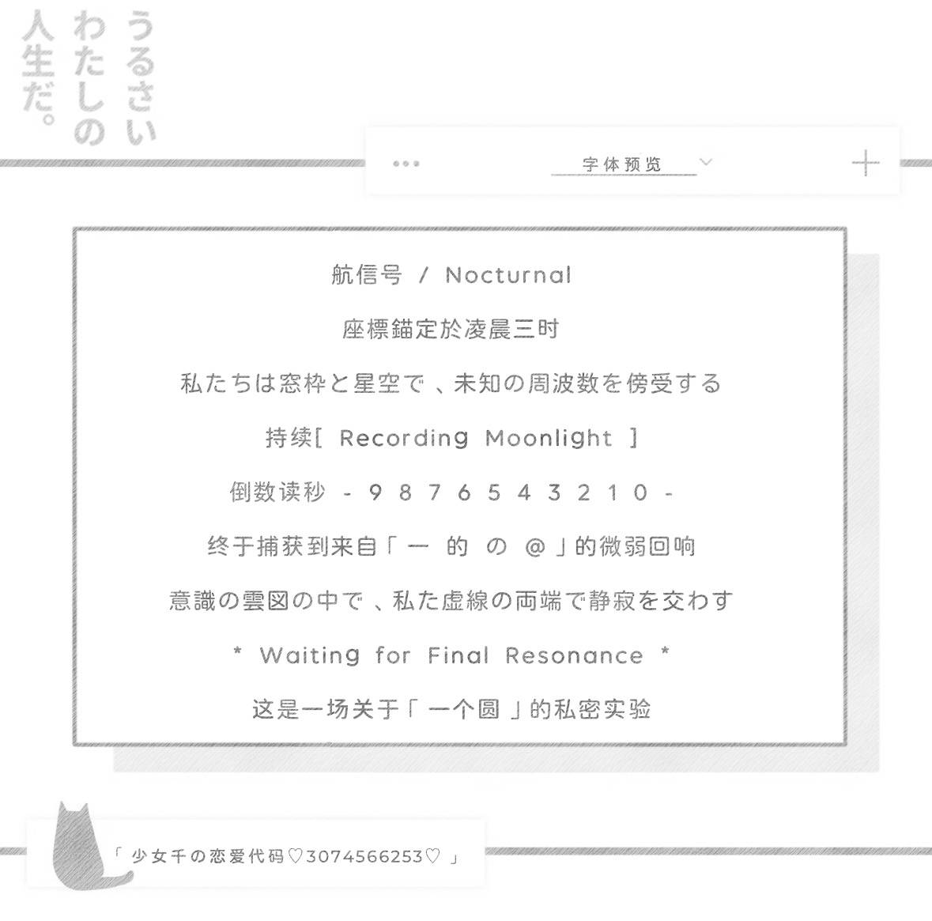
- 一个圆
- https://nos.netease.com/ysf/c2ec23c7ed59e87461a8426876516708.ttf

