Also, bad font color in buttons under each document. I have difficulty reading “more detail” in white on a grey button.

**I think you saying about this button? see snapshot:**

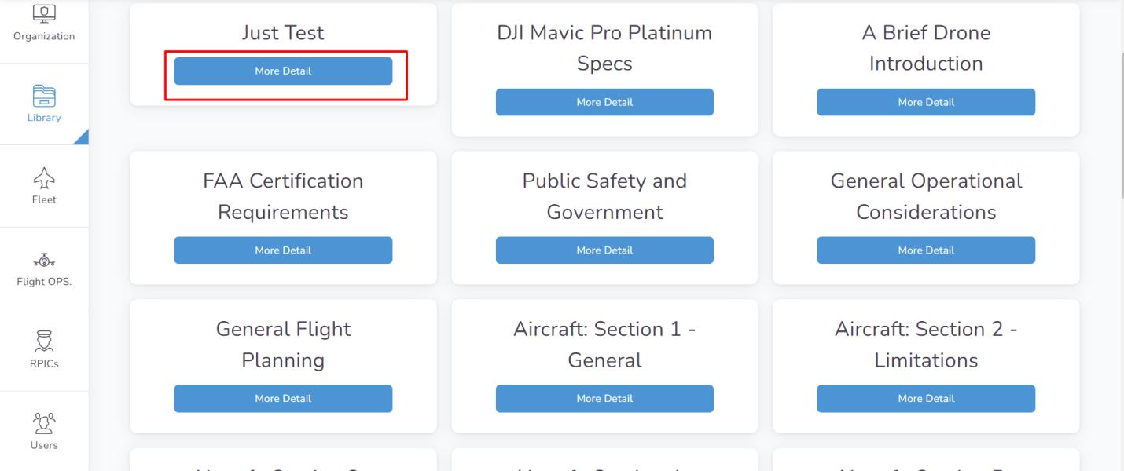

**Please explain below uncleared points, if possible attach screenshot**

Can we add check boxes or buttons next to a list of apps that should be downloaded and updated on tablets? This applies only if the equipment type is “tablet.” This list should be editable/customizable. Similar to this: Tablet has current: iOS v 10 and the following apps installed and updated: Autel, DJI Go, DJI GS Pro, B4UFly, Aloft, Airmap, Remote Pilot prepare, FAR AIM, Hazmat 2020, and My Drone Fleet Mobile

When creating a battery, the drop down was empty to assign the battery to a drone. But no drones were added before I tried to add this battery.