Nguyễn Hoàng Mỹ Dung - 23IT035
Step 1: Create a local git repository
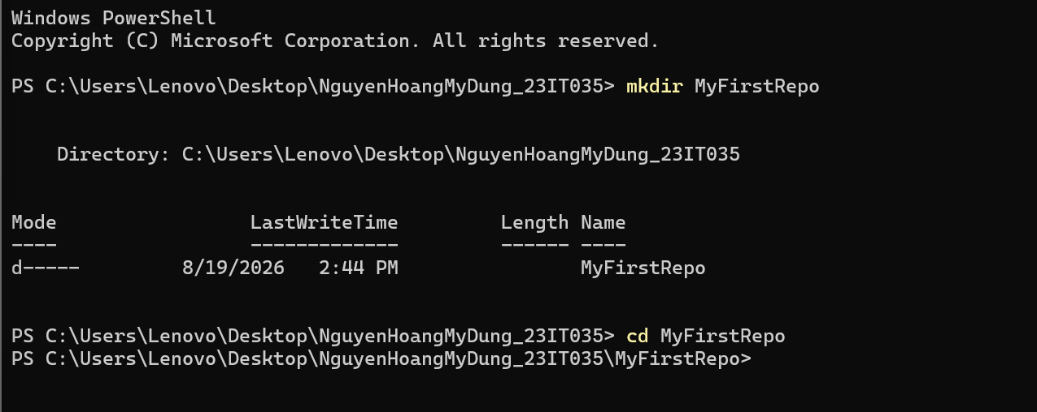
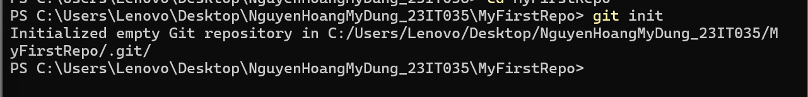

Step 2: Add a new file to the repo

