Growing Shade Use Report

17 March 2022

Table of Contents

1 Introduction 1

1.1 Presentations conducted 1

1.2 Application usage 2

1.2.1 Who is using the app? 2

1.2.2 How are people using the app? 3

1.2.3 How are pepole finding the app? 3

# 1 Introduction

**Growing Shade** is a tree canopy enhancement and preservation tool which combines *local stories* and an *interactive mapping tool*.

The groundwork for Growing Shade was laid with Thrive MSP 2040 which included outcomes of *sustainability* and *equity.* A partnership with The Nature Conservancy and Tree Trust was formed and a tree canopy tool was conceptualized in 2020(?). An advisory group was formed and a stakeholder survey was conducted in early 2021 to inform the project. Growing Shade was developed over the summer and fall of 2021. The project had a soft launch in November 2021 for the purposes of soliciting user feedback and beta testing the project. Growing Shade was refined in response to the feedback, and official launched late January 2022.

This summary is intended to inform how successful (or not) outreach efforts have been thus far, and may be useful in refining future efforts and continuing to promote usage of the application to inform a more sustainable and equitable future for the Twin Cities region.

## 1.1 Presentations conducted

Since January 1, 2022 Growing Shade has been presented to practitioners with a focus on foresters and planners. The focus of outreach efforts will switch to residents soon.

* Committee of the Whole (Feb 2, 2022)
* MN Shade Tree Advisory Committee (Feb 17, 2022; ~50 attendees)
* PlanIt Implementation Webinar (Feb 24, 2022; 70 registrants)
* MN Shade Tree Short Course (March 15, 2022; 106 participants attended the session)

## 1.2 Application usage

Since January 2022, Growing Shade has been accessed by 581 users (929 users since November 2021). This summary only looks at user data since January 2022. We don’t know exactly how accurate internet provider locations are (and some people use vpns so we can’t access the information), but this information may still be valuable! Note, all development traffic is run locally, so should not be contaminating these statistics.

### 1.2.1 Who is using the app?

Within the 7 county region, St. Paul and Minneapolis have the most users (Figure 1.1).

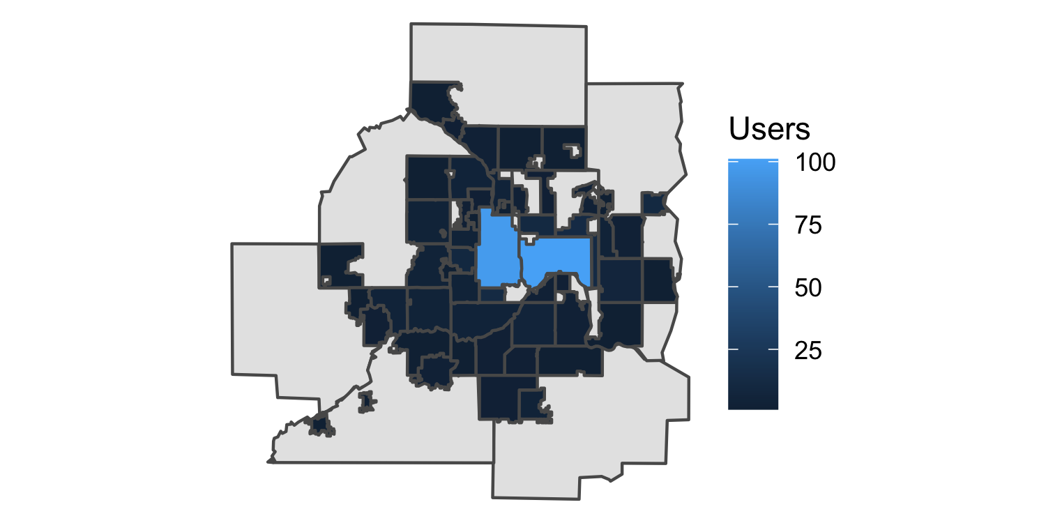

Figure 1.1: Average time that each user has spent engaged on the Growing Shade application.

But the east metro (esp. Maplewood) has the highest engagement where people have spent the most time on the application (Figure 1.2).

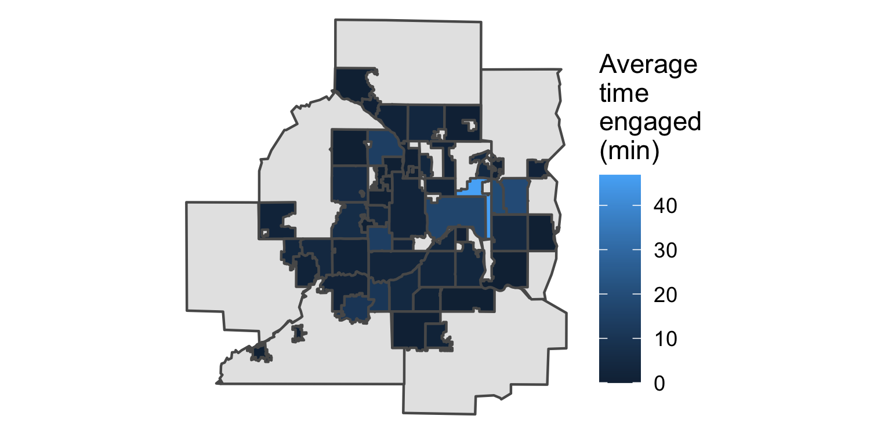

Figure 1.2: Average time that each user has spent engaged on the Growing Shade application.

While Growing Shade has a scope limited to the 7 county region, we do see engagement across the state (and also in neighboring states). Table 1.1 lists the other cities in Minnesota where more than one person has accessed Growing Shade.

**Table 1.1:** Other Minnesota cities where more than one person has accessed Growing Shade since January 2022.

| **City** | **Users** |
| --- | --- |
| Rush City | 7 |
| Rochester | 3 |
| Saint Francis | 3 |
| Bemidji | 2 |
| Duluth | 2 |
| Grand Rapids | 2 |
| Wheaton | 2 |

### 1.2.2 How are people using the app?

Most people are scrolling and clicking around the application. Since January 2022, there have been 30 file downloads.

### 1.2.3 How are pepole finding the app?

Since January 2022, new users have mostly accessed the application via the direct link (435 users; <https://metrotransitmn.shinyapps.io/growing-shade/>). A growing number of users (160) are accessing the application via a referral from metrocouncil.org. Other ways of accessing the application (socials like linkedin, facebook, youtube, teams are lower - it’s unclear if Twitter gets pulled out separately or if those users are part of the “direct link” users).

Just under 6% of users are accessing the application via a mobile platform.