Modern Voluntary Health Care System

The influence of gamification on the willingness of people to live healthy

57.1% of overall Austrian population is overweight

30% risk of being an overweight child in the US

47% of grownup Austrians smoke daily

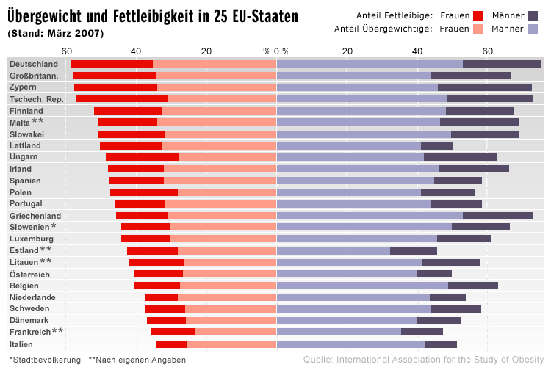

Key features

* Collect purchases from grocery store
* Track activities from sport platforms/apps (e.g. RunKeeper)
* Track health status with reports from medical checks
* Stay connected, challenge friends/other users
* Collect “points” to get discounts at partner stores or others gifts

Business benefits

* Targeted advertising for partners (promotions, stores, etc.)
* Online-store
* Reduce overall costs for health care

The project will lead to a new form of personal voluntary healthcare based on several pillars:

* *Technology*use today’s possibilities to support a healthier lifestyle
* *Ubiquitous Computing*integrate seamless into ones living day
* *Psychology*motivate user to stay in shape, especially by gamification
* *Security & Privacy*protect sensible data of health care system