Medical Integrated System (MIS)

Jihee Seon†, 1578168 and Myeong Jin Sim††, 1605028

SUMMARY We suggests the integrated medical service which connects four agents, hospital, pharmacy, insurance company, and patients as they sign in. Hospitals can write medical chart for patients, and as soon as they write charts, prescriptions corresponding to chart are automatically issued. So patients can check their prescriptions easily. Also, patients can send their prescriptions and receipts to pharmacy and insurance company where they want.

key words: medical system, hospital, patient, pharmacy, insurance company

1. Introduction

Medical area tries to be smarter, which means introducing many automation tools such as KIOSK. Existed medical system seems to

We propose a platform that connects hospital-pharmacy-insurance company-patients. Our web application users are hospitals, pharmacies, insurance companies, and patients.

MIS serves broad functionalities with coverage of every medical related user. The service interconnects lots of isolated services of hospital, patient, pharmacy, and insurance company. Internal hospital system which was composed of cramped, boring medical chart, will be shown as greater display with support of MIS. It also provides interface when writing medical chart, no need to write detailed instructions. The hospital system which was closed and independent will be now connected to patients, and furthermore pharmacy and insurance. Patients can view medical documents with indirect approach to medical chart and other records in the hospital. Insurance company and pharmacy can indirectly deal with the documents by transaction from patients. In other words, if a hospital issues medical documents such as prescriptions, medical certificates, and receipts, pharmacies and patients can receive them in real time through web applications. In addition, if the patient wants to claim medical expenses on insurance company, the patient simply sends relevant documents to the insurance company. Thus, the existing insurance process can be simplified.

2. Related works

Current KIOSKs in big general hospital

C Currently, KIOSK has propagated large general hospitals in priority, which indicates introduction of unmanned technology in medical area. KIOSK is stationary touch-screen info-terminal, especially for hospital, helps to schedule appointment with doctor or print prescriptions out or sends electronic prescription to pharmacy. It was expected to reduce burden of hospital staff and patients’ waiting time. Contrary to expectations, there are quite lots of complaints filed by medical actors. First, patients who are unfamiliar to deal with unmanned stationary machine complains for the early timeout of the device. Since it is for public service, there has time limits when using the service, which makes patients feel hard and isolated. Not only for patient, but also for pharmacy, there are some problems to be posed. In case of issuing electronic prescriptions, patients select the pharmacy where they want to send their prescriptions. However, dozns of patients take drugs at other pharmacies, not taking drugs at a pharmacy they selected. So pharmacies have said to have trouble in correcting computer errors about prescriptions. Also, there is a problem with the fee. Pharmacies have to pay about 300 won per case just they are displayed in Kiosk. Many pharmacies have complaints about this system, but they inevitably forced to join in Kiosk because of rate of prescriptions.

3. Implementation

[1] overcomes limits of stationary service

Earlier, there were some problems of KIOSK by the elders or people who have slow reaction due to early time out. Our service can be provided in mobile environment, which more people are familiar with rather than big stationary machine.

[2] not makes dependency relationship between medical actors, but real integration of the actors

**4. System design**

**4.1 Usecase diagram**

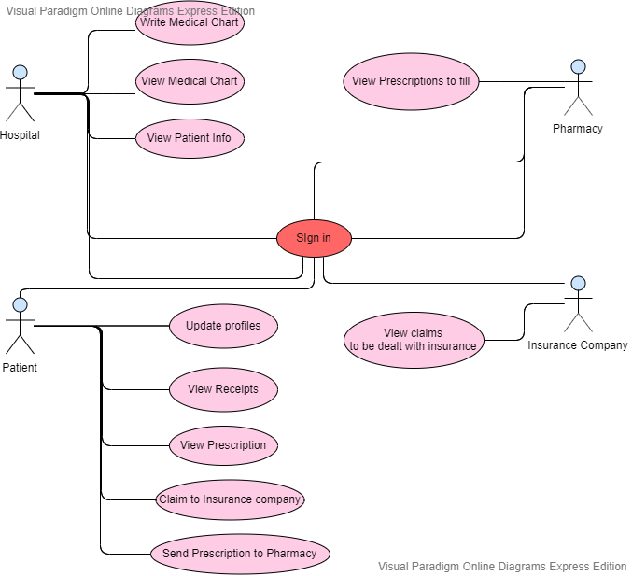

Our project suggests the integrated medical service which connects four agents, hospital, pharmacy, insurance company, and patients as they sign in.

The functionalities for each users are showed as below.

i. Hospital

a. Write Medical Chart

- When the doctor types only the patient’s diagnosis on the display, database system internally searches for the mapped medical treatment and prescriptive guide, and registers the according DB, which makes doctor not to give instructions of every patients.

b. View Medical Chart

- default setting : chart ordered by recent date and time

- optional : Doctor can search the record with the date and patient.

c. View Patient

- Doctor can view the profile information with medical records.

ii. Patient

a. Update Profile

- Patients can update their profile information to sign in.

b. View Receipts

- Patient can view medical expenses in the format of receipt.

c. Send Receipts to Insurance company

Patient can send the receipts to insurance company directly in order to deal with insurance.

※ Currently, patients should print out and shoot all the receipts. Then they should install the specific application of the insurance company to claim, and send all the photos using application. MIS simplicates this complex process, which ensures convenience of patient.

d. View Prescription

- Patient can view prescription, which enables to check the information of the pill.

e. Send Prescription

- Patient can send the prescription to pharmacy they want.

※ Currently, only the big general hospital such as university hospital provides similar functionality using big stationary device established in the hospital. The service does not cover the regular hospital, and there’s timeout limit of picking the pharmacy, which makes hard patients to select appropriate pharmacy. Our functionality can cover all the patients within the mobile environment who signs in.

iii. Pharmacy

a. View prescriptions to fill

- Pharmacy can view prescription sent by patient into the format of chart, in the real-time.

iv. Insurance Company

a. View claims to be dealt with

- Insurance company can view receipts sent from the patient.

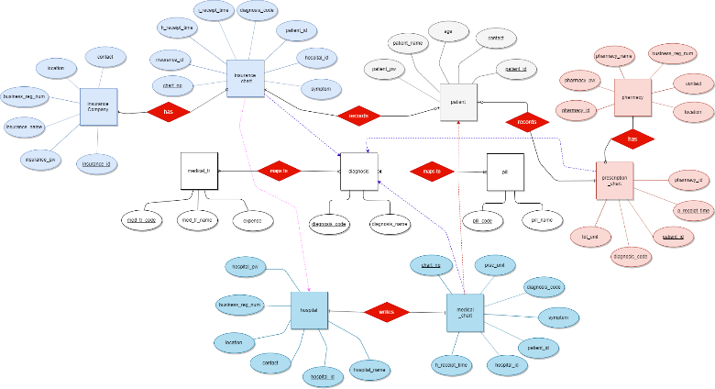**4.2 Entity Relationship Diagram (ERD)**

The system is composed of 12 tables, that can be classified into four types.

1. User information  
   : hospital, patient, pharmacy, insurance company  
   - All the tables store individual information for each party to sign in.
2. Chart tables  
   : hospital_chart, pharmacy_chart, insurance_chart  
   - All the tables store only diagnosis_code and get needed information by approaching mapping tables.
3. Entity tables related with the process of hospital : diagnosis, medical_tr, pill  
   - The way doctor handles to diagnosis is divided into medical treatment and prescriptions. The table here is related to the process of hospital.
4. Mapping tables : med_tr_guide, prescription_guide (marked as ‘maps to’ in ER)  
   - With only diagnosis_code of patients, every chart tables can approach more than one medical treatments or prescription information by mapping tables.

Every chart tables have patient information, which implies dependency relationship. Especially, unlike medical chart which doctor writes, insurance chart and prescription chart is automatically written when patient sends receipts or prescriptions. Hence, the relation can be expressed as more than dependency relation, which is marked as ‘has’ relationship with patient table.

Another relationship needs to be checked is ‘maps’ relation ship between diagnosis table and med_tr table or pill table. Insurance chart table needs what medical treatments that were served, and prescription table needs on what pills to be prepared. Instead of getting all the redundant information, they can access med_tr_guide table or prescription_guide table which implements ‘maps’ relation with only diagnosis_code. This prevents from waste of memory.

5. Conclusion

[1] Reduced patient's waiting time for prescriptions

Patients can send the prescription to any pharmacy they want as soon as they are prescribed at the hospital. Latency reduction is expected as transmission is possible prior to arrival at the pharmacy.

[2] Reduced preparation time for pharmacy

Pharmacists can check the prescriptions sent to them in real time and prescriptions are sorted by reception time, so they increase efficiency.

6. References

[1] problem of KIOSK

<http://m.dailypharm.com/newsView.html?ID=254259>