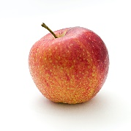

${Title}

公告單位: ${Source} 申請人${Apply}

${Content}

|  |  |
| --- | --- |
| 問題 | 回答 |

#ExportDetail[

|  |  |
| --- | --- |
| **${column1}**  #column2[  (${question})  ${description}  ]. | #column3[   1. (${name})${ans}   ]. |

]