# Assignment 1 – Database

## Task 1, Chat Activity

### Explain the main purpose of the following tables.

- **mdl_chat**

The main purpose of mdl_chat is to show any active/inactive chats throughout all the courses. The chats are given an id and the courseid is also shown.

-**mdl_chat_users**

The main purpose of mdl_chat_users is to show which users have been active in the open chats. In the table we can see the chatid, from mdl_chat. We can also see the userid from mdl_user.

-**mdl_chat_messages**

The main purpose of mdl_chat_messages is to display all chat activity(messages); this includes any messages sent and received via the chat. The chatid is seen from mdl_chat, along with the userid from mdl_user.

### b) Explain the purpose of the following fields.

- **issystem (chat_messages table)**

The issystem is a Boolean value, 0 being negative(false) and 1 being positive(true). In the case of the issystem it is telling us whether the chat is being activated or deactivated. Whenever a user clicks on the chat it considered as a 1, or whenever the chat is exited. However, any communication is considered 0.

- **IP (chat_users table)**

The IP, or also known as the IP address stands for Internet protocol. The purpose of having the IP address in the chat_users table helps to correctly identify the device that is being used in communication. It is merely another form of identification.

### c) Draw an ERD for Chat (concept)

- Include course, user, chat, chat_users, and chat_messages (leaving out chat_messages_current).

- Add primary keys, foreign keys {use (PK), (FK) notation to flag these}, and cardinalities in your ERD.

## Task 2 Write SQL statements.

### Show the ids of all users subscribed to a particular forum (e.g., forum id 2; use any forum value that is applicable to your course site).

SELECT *FROM mdl_forum_discussion_subs where forum = 2

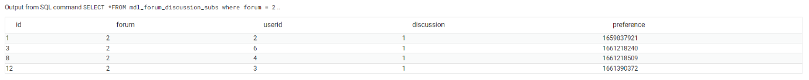

### b) Show the ids, usernames of all users subscribed to all forums belonging to a particular course (e.g., course id 2). Present your query results in the alphabetical order of usernames.

### c) Show the names of all forums that have some sort of HTML (tags) stored in their Intro field. Also include intro field in your query results.

SELECT id, discussion, userid, subject, message FROM mdl_forum_posts

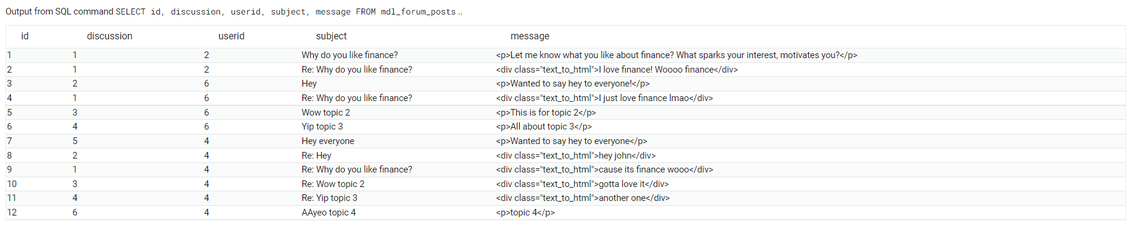

### d) Find out the total number of posts across all the forum discussions on a single course (give answer only for one course and not across all courses; should result in a numeric value).

select count(mdl_forum_posts.id) from mdl_forum_posts

join mdl_forum on mdl_forum_posts.discussion = mdl_forum.id

where course = 2



### e) Show the ids, usernames of all users who posted on forum discussions belonging to a particular course (e.g., course id 2). If a user has posted multiple times their details should be presented only one (e.g., a teacher will post many times, but their details should appear only once).