**Bangwe**

Descriptives

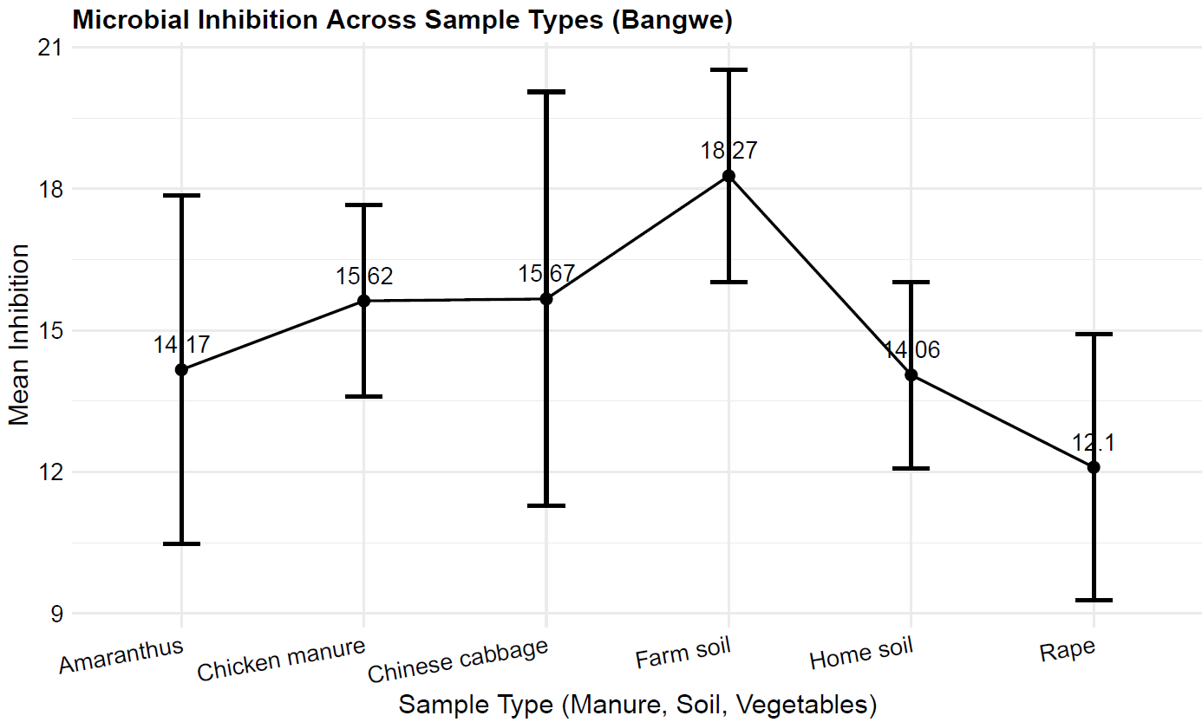

**Inferential**

We carried out 2-way ANOVA To see if there is an interaction effect between **the antibiotic** and the **sample** on inhibition.

Table 1: Test Results

| Source of Variation | Degrees of Freedom | sumsq | meansq | F-Statistic | P-Value*1* |
| --- | --- | --- | --- | --- | --- |
| Antibiotic | 8 | 2766.7356 | 345.84195 | 15.087065 | < 0.001 *** |
| Sample | 5 | 121.3563 | 24.27126 | 1.058814 | 0.405 |
| Antibiotic: Sample | 27 | 1192.8932 | 44.18123 | 1.927369 | 0.049 * |
| Residuals | 26 | 596.0000 | 22.92308 |  |  |
| *1*Significance codes: *** p < 0.001; ** p < 0.01; * p < 0.05 | | | | | |

According to the table above, there is a not a strong interaction effect between Antibiotics and The different sample types (p=0.049). Table shows that there might be a pattern from manure to soil to vegetables. Then we carry out a Post-Hoc Test (TurkeyHSD) to see where the differences actually lies.

We start with Antibiotics and then the interacti

Here re the antibiotics

| Comparison | Difference | Lower_CI | Upper_CI | Adjusted_p_value*1* |
| --- | --- | --- | --- | --- |
| CIP-SXT | 15.545455 | 8.4847027 | 22.6062064 | < 0.001 *** |
| TGC-SXT | 9.555556 | 2.1306114 | 16.9804997 | 0.005 ** |
| CTX-SXT | 11.400000 | 4.1730901 | 18.6269099 | < 0.001 *** |
| AMP-CIP | -17.945455 | -25.0062064 | -10.8847027 | < 0.001 *** |
| GM-CIP | -13.545455 | -20.2909615 | -6.7999476 | < 0.001 *** |
| AMP-TGC | -11.955556 | -19.3804997 | -4.5306114 | < 0.001 *** |
| GM-TGC | -7.555556 | -14.6813848 | -0.4297263 | 0.032 * |
| AMP-CTX | -13.800000 | -21.0269099 | -6.5730901 | < 0.001 *** |
| GM-CTX | -9.400000 | -16.3192395 | -2.4807605 | 0.003 ** |
| MEM-AMP | 17.400000 | 0.4513939 | 34.3486061 | 0.041 * |
| *1*Significance codes: *** p < 0.001; ** p < 0.01; * p < 0.05 | | | | |

**Key Findings (row 1):**

* **Statistical Significance**: The difference in resistance levels between CIP (Ciprofloxacin) and SXT (Sulfamethoxazole-Trimethoprim) is statistically significant, with a highly significant adjusted p-value of less than 0.001.
* **Effectiveness**: CIP is shown to be more effective than SXT, with a mean difference of 15.55, indicating that patients treated with CIP experience significantly higher levels of inhibition against the target microorganisms.

**Clinical Implications:**

* **Antibiotic Selection**: The results suggest that healthcare providers should prefer CIP over SXT for treating infections where both antibiotics are applicable, particularly in cases where resistance is a concern.
* **Guideline Influence**: This finding may impact clinical guidelines and decision-making processes regarding empirical antibiotic therapy.

**Public Health Considerations:**

* **Resistance Management**: Understanding the effectiveness of different antibiotics helps inform strategies to combat antibiotic resistance, potentially leading to improved patient outcomes and reduced treatment failures.

**Future Research Directions:**

* Further studies could investigate the mechanisms underlying the observed differences in efficacy and assess whether these patterns hold across various microbial strains or infection types.

**The interaction**

| Comparison | Difference | Lower_CI | Upper_CI | Adjusted_p_value*1* |
| --- | --- | --- | --- | --- |
| SXT:Home soil-CIP:Chicken manure | -18.66667 | -36.43339 | -0.8999456 | 0.03 * |
| AMP:Home soil-CIP:Chicken manure | -18.33333 | -36.10005 | -0.5666123 | 0.037 * |
| GM:Home soil-CIP:Chicken manure | -18.33333 | -36.10005 | -0.5666123 | 0.037 * |
| SXT:Home soil-CIP:Farm soil | -20.00000 | -39.86380 | -0.1362020 | 0.047 * |
| *1*Significance codes: *** p < 0.001; ** p < 0.01; * p < 0.05 | | | | |

Interpretation of Each Comparison (only first row)

**SXT:Home soil - CIP:Chicken manure**

This indicates that the mean microbial presence or resistance in Home soil with SXT is significantly lower than that in Chicken manure with CIP by approximately 18.67 units. Confidence Interval: (-36.43, -0.90). The difference is statistically significant as the CI is below 0, with a P- value of P<0.05

**NB; The remaining rows are interpreted in a similar pattern**

**Chigumula**

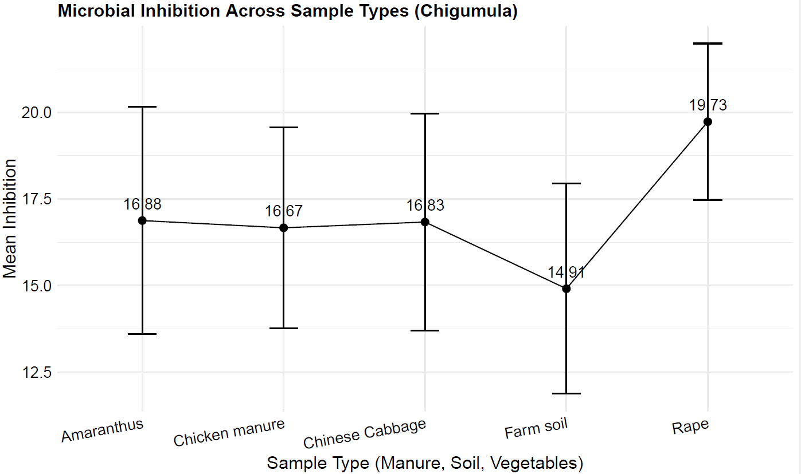

**Then Anova**

Table : Test Results

| Source of Variation | Degrees of Freedom | sumsq | meansq | F-Statistic | P-Value*1* |
| --- | --- | --- | --- | --- | --- |
| Antibiotic | 8 | 3044.6540 | 380.58175 | 7.5910758 | < 0.001 *** |
| Sample | 4 | 150.7892 | 37.69731 | 0.7519097 | 0.571 |
| Antibiotic:samples | 27 | 1686.3901 | 62.45889 | 1.2458038 | 0.329 |
| Residuals | 16 | 802.1667 | 50.13542 |  |  |
| *1*Significance codes: *** p < 0.001; ** p < 0.01; * p < 0.05 | | | | | |

The interacion is not significant, only antibiotics are, then we do test and show only the significant microbes

| Comparison | Difference | Lower_CI | Upper_CI | Adjusted_p_value*1* |
| --- | --- | --- | --- | --- |
| CIP-SXT | 18.63492 | 5.940818 | 31.329023 | 0.002 ** |
| CRO-SXT | 17.65714 | 2.907929 | 32.406357 | 0.013 * |
| AMP-CIP | -17.27778 | -30.553588 | -4.001968 | 0.006 ** |
| GM-CIP | -13.47778 | -25.051361 | -1.904195 | 0.016 * |
| VAN-CIP | -26.77778 | -46.468986 | -7.086569 | 0.004 ** |
| VAN-TGC | -21.66667 | -42.233463 | -1.099870 | 0.035 * |
| CRO-AMP | 16.30000 | 1.047256 | 31.552744 | 0.032 * |
| VAN-CRO | -25.80000 | -46.874695 | -4.725305 | 0.011 * |
| *1*Significance codes: *** p < 0.001; ** p < 0.01; * p < 0.05 | | | | |

**Significant Comparisons**:

**CIP-SXT**: The difference is 18.63, with a confidence interval from 5.94 to 31.33, and an adjusted p-value of 0.002, indicating a significant difference in resistance levels between these two antibiotics.

**Practical Implication**: This suggests that when treating infections, CIP may be more effective than SXT, guiding clinicians in antibiotic selection.

**Mpemba**

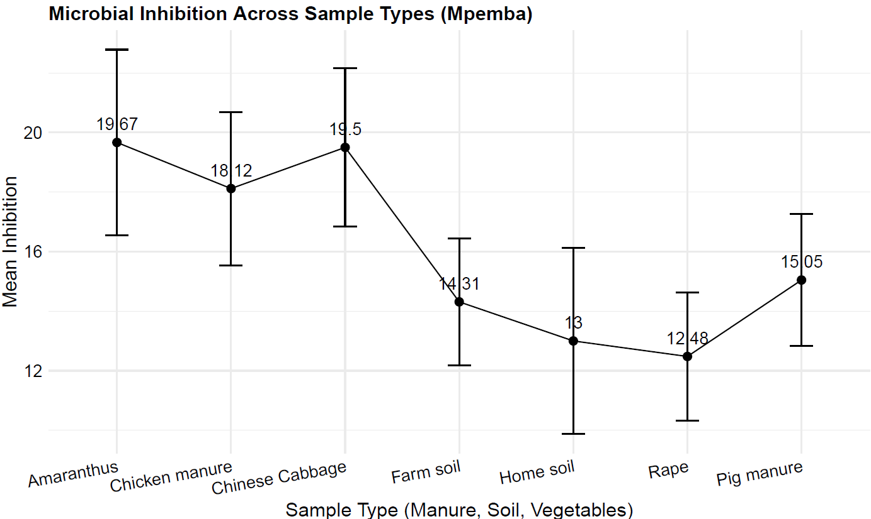

**I will start with 2 way ANOVA**

| Source of Variation | Degrees of Freedom | sumsq | meansq | F-Statistic | P-Value*1* |
| --- | --- | --- | --- | --- | --- |
| Antibiotic | 9 | 5471.4255 | 607.93617 | 16.451650 | < 0.001 *** |
| Item | 6 | 523.4729 | 87.24548 | 2.360992 | 0.045 * |
| Antibiotic:sample | 40 | 2246.7585 | 56.16896 | 1.520015 | 0.085 |
| Residuals | 46 | 1699.8333 | 36.95290 |  |  |
| *1*Significance codes: *** p < 0.001; ** p < 0.01; * p < 0.05 | | | | | |

I see significance in 1. Antibiotics and 2 Interction, so I start to show Antibiotics

| Comparison | Difference | Lower_CI | Upper_CI | Adjusted_p_value*1* |
| --- | --- | --- | --- | --- |
| CIP-SXT | 17.633333 | 10.570695 | 24.6959713 | < 0.001 *** |
| TGC-SXT | 10.355556 | 1.837694 | 18.8734174 | 0.007 ** |
| CTX-SXT | 13.883333 | 6.059178 | 21.7074891 | < 0.001 *** |
| AMP-CIP | -18.277778 | -26.525162 | -10.0303935 | < 0.001 *** |
| GM-CIP | -14.333333 | -21.067294 | -7.5993723 | < 0.001 *** |
| ATM-CIP | -12.119048 | -21.117682 | -3.1204136 | 0.002 ** |
| CRO-CIP | -9.458333 | -18.042483 | -0.8741836 | 0.02 * |
| VAN-CIP | -25.833333 | -36.045891 | -15.6207757 | < 0.001 *** |
| AMP-TGC | -11.000000 | -20.523259 | -1.4767409 | 0.012 * |
| VAN-TGC | -18.555556 | -29.823628 | -7.2874835 | < 0.001 *** |
| AMP-CTX | -14.527778 | -23.435971 | -5.6195846 | < 0.001 *** |
| GM-CTX | -10.583333 | -18.112131 | -3.0545360 | 0.001 ** |
| VAN-CTX | -22.083333 | -32.836607 | -11.3300598 | < 0.001 *** |
| VAN-GM | -11.500000 | -21.712558 | -1.2874424 | 0.016 * |
| VAN-MEM | -24.000000 | -46.130054 | -1.8699457 | 0.024 * |
| VAN-ATM | -13.714286 | -25.543297 | -1.8852741 | 0.012 * |
| VAN-CRO | -16.375000 | -27.891845 | -4.8581546 | < 0.001 *** |
| *1*Significance codes: *** p < 0.001; ** p < 0.01; * p < 0.05 | | | | |

**Eample results:**

The comparison between Tigecycline (TGC) and Sulfamethoxazole-Trimethoprim (SXT) reveals a statistically significant difference in resistance levels, with a mean difference of 10.36 (95% CI: 1.84 to 18.87) and an adjusted p-value of 0.007. This indicates that TGC is significantly more effective than SXT in inhibiting microbial growth. The confidence interval does not include zero, further confirming the significance of the result.

**Discussion**

The results suggest that TGC is a better option than SXT for treating infections where both antibiotics are viable choices, particularly in cases where resistance is a concern. This finding has clinical implications, as it highlights the superior efficacy of TGC, which could influence treatment guidelines and antibiotic selection. From a public health perspective, prioritizing the use of TGC over SXT in appropriate scenarios could help mitigate resistance development and improve patient outcomes. Further research is needed to explore whether this pattern holds across different microbial strains and infection types, ensuring broader applicability of these findings.

**Then the interaction**

| Comparison | Difference | Lower_CI | Upper_CI | Adjusted_p_value*1* |
| --- | --- | --- | --- | --- |
| CIP:Chicken manure-SXT:Chicken manure | 25.00000 | 0.24509436 | 49.7549056 | 0.044 * |
| CIP:Pig manure-SXT:Chicken manure | 23.50000 | 0.01543447 | 46.9845655 | 0.05 * |
| SXT:Home soil-CIP:Chicken manure | -25.00000 | -49.75490564 | -0.2450944 | 0.044 * |
| GM:Rape-CIP:Chicken manure | -21.25000 | -41.96144001 | -0.5385600 | 0.037 * |
| ATM:Rape-CIP:Chicken manure | -24.66667 | -46.80812739 | -2.5252059 | 0.012 * |
| VAN:Rape-CIP:Chicken manure | -28.00000 | -52.75490564 | -3.2450944 | 0.01 ** |
| SXT:Pig manure-CIP:Chicken manure | -22.25000 | -42.96144001 | -1.5385600 | 0.02 * |
| VAN:Rape-CIP:Farm soil | -25.00000 | -49.75490564 | -0.2450944 | 0.044 * |
| CIP:Pig manure-SXT:Home soil | 23.50000 | 0.01543447 | 46.9845655 | 0.05 * |
| ATM:Rape-CIP:Rape | -21.16667 | -41.87810668 | -0.4552267 | 0.038 * |
| VAN:Rape-CIP:Rape | -24.50000 | -47.98456553 | -1.0154345 | 0.03 * |
| CIP:Pig manure-GM:Rape | 19.75000 | 0.57493254 | 38.9250675 | 0.035 * |
| CIP:Pig manure-ATM:Rape | 23.16667 | 2.45522665 | 43.8781067 | 0.011 * |
| CIP:Pig manure-VAN:Rape | 26.50000 | 3.01543447 | 49.9845655 | 0.01 ** |
| CIP:Pig manure-SXT:Pig manure | 20.75000 | 1.57493254 | 39.9250675 | 0.018 * |
| *1*Significance codes: *** p < 0.001; ** p < 0.01; * p < 0.05 | | | | |

Explanation as other farms:

Chileka 1

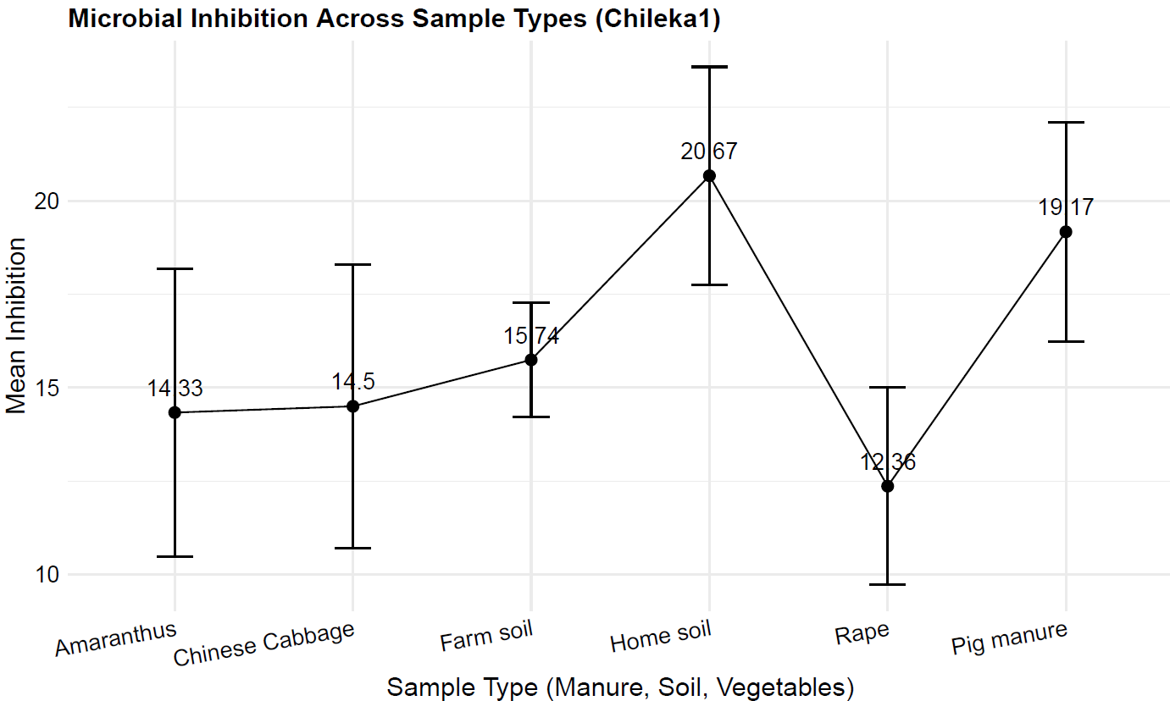

ANOVA

| Source of Variation | Degrees of Freedom | sumsq | meansq | F-Statistic | P-Value*1* |
| --- | --- | --- | --- | --- | --- |
| Antibiotic | 8 | 2720.1013 | 340.01267 | 4.5401900 | < 0.001 *** |
| Samle | 5 | 735.6603 | 147.13206 | 1.9646548 | 0.108 |
| Antibiotic:Sample | 33 | 1124.8611 | 34.08670 | 0.4551598 | 0.987 |
| Residuals | 35 | 2621.1333 | 74.88952 |  |  |
| *1*Significance codes: *** p < 0.001; ** p < 0.01; * p < 0.05 | | | | | |

**Then Post-hoc (TurkeyHSD) on Antibiotic**

| Comparison | Difference | Lower_CI | Upper_CI | Adjusted_p_value*1* |
| --- | --- | --- | --- | --- |
| CIP-SXT | 14.10714 | 2.862921 | 25.3513649 | 0.006 ** |
| AMP-CIP | -18.60714 | -31.274899 | -5.9393863 | < 0.001 *** |
| GM-CIP | -11.57143 | -22.374528 | -0.7683295 | 0.028 * |
| *1*Significance codes: *** p < 0.001; ** p < 0.01; * p < 0.05 | | | | |

**Chileka2**

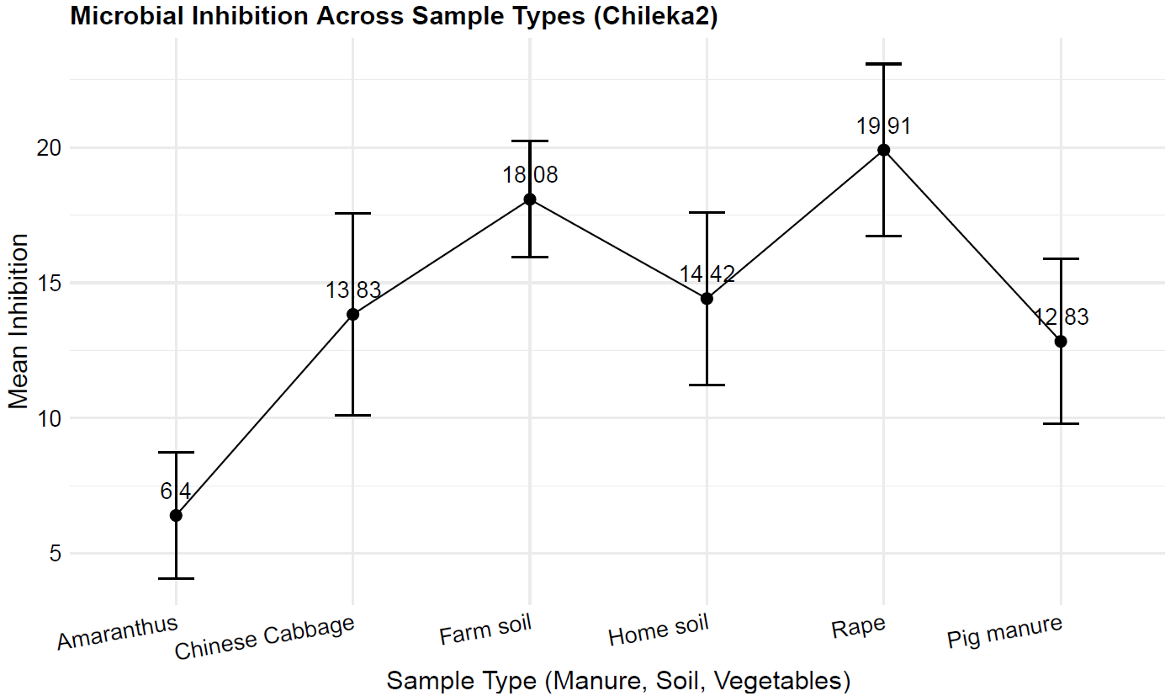

**ANOVA**

| Source of Variation | Degrees of Freedom | sumsq | meansq | F-Statistic | P-Value*1* |
| --- | --- | --- | --- | --- | --- |
| antibiotic | 8 | 3188.2766 | 398.53458 | 5.5601870 | 0.001 ** |
| Item | 5 | 634.2214 | 126.84429 | 1.7696782 | 0.173 |
| antibiotic:item | 32 | 1328.5575 | 41.51742 | 0.5792336 | 0.911 |
| Residuals | 17 | 1218.5000 | 71.67647 |  |  |
| *1*Significance codes: *** p < 0.001; ** p < 0.01; * p < 0.05 | | | | | |

| Comparison | Difference | Lower_CI | Upper_CI | Adjusted_p_value*1* |
| --- | --- | --- | --- | --- |
| CIP-SXT | 19.08889 | 5.361314 | 32.816463 | 0.003 ** |
| CTX-SXT | 17.38889 | 1.642281 | 33.135497 | 0.024 * |
| AMP-CIP | -18.86667 | -34.295129 | -3.438205 | 0.011 * |
| VAN-CIP | -25.20000 | -48.342693 | -2.057307 | 0.027 * |
| *1*Significance codes: *** p < 0.001; ** p < 0.01; * p < 0.05 | | | | |

**Now, I m combining these**

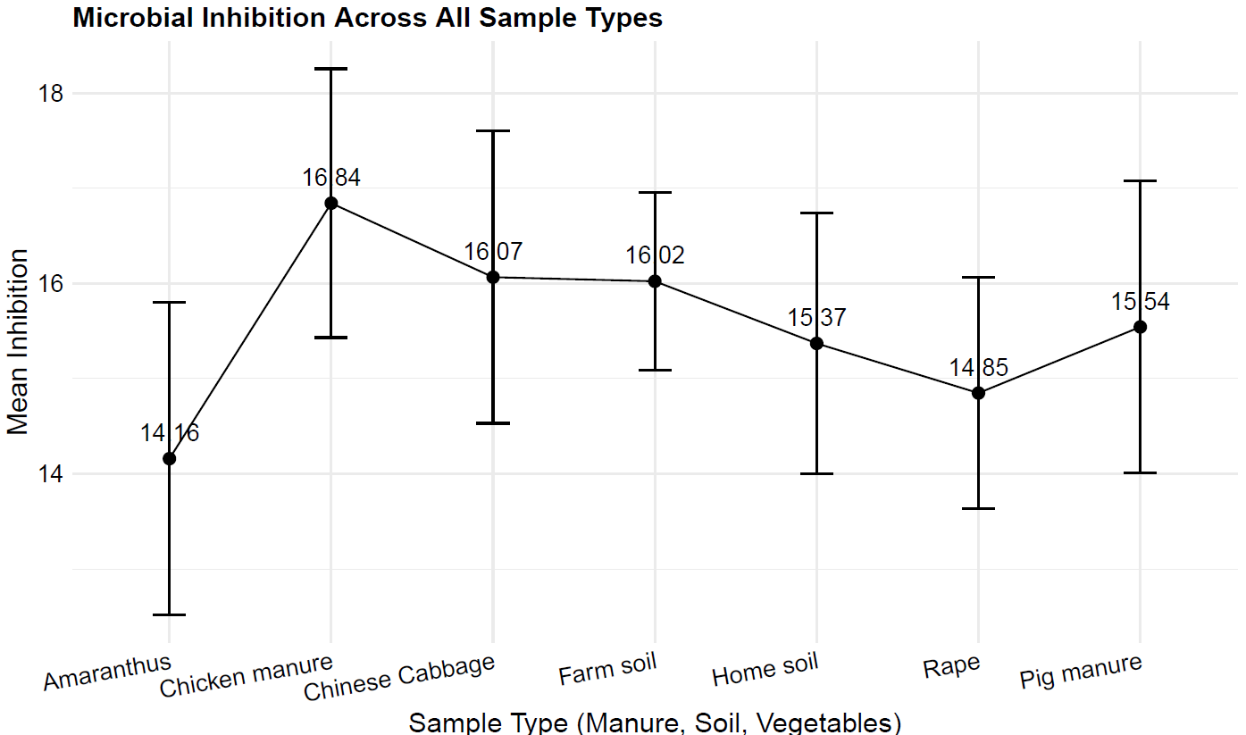

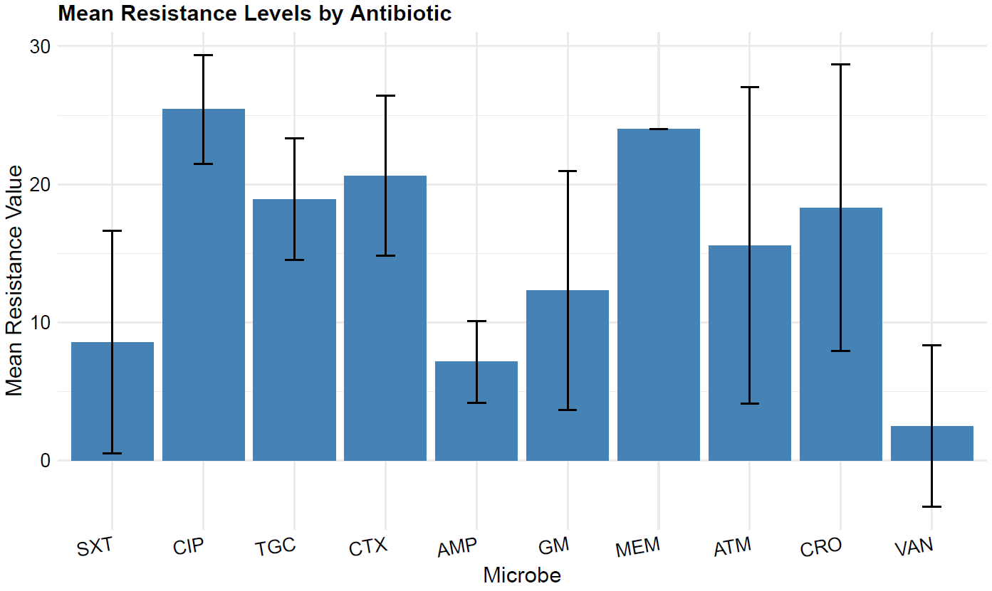

**The effectiveness is tracked for Ecoli and Klebsella**

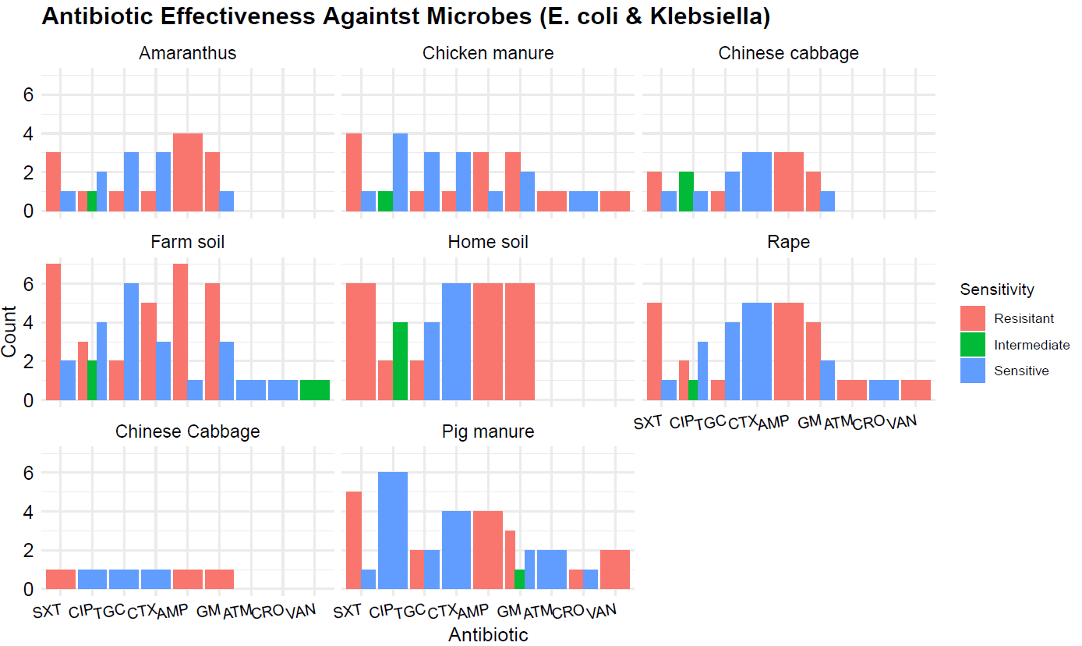

Table : Mean Inhibition of Microbes by Antibiotic Treatment

|  | Antibiotic Treatment | | |
| --- | --- | --- | --- |
| Microbe | Antibiotic | Mean Inhibition | Resistance Status |
| E. coli | SXT | 10.14 | R |
| E. coli | CIP | 27.50 | I |
| E. coli | TGC | 20.20 | S |
| E. coli | CTX | 16.90 | S |
| E. coli | AMP | 9.20 | R |
| E. coli | GM | 15.71 | R |
| E. coli | ATM | 20.00 | S |
| E. coli | CRO | 20.50 | S |
| E. coli | VAN | 3.50 | I |
| Acinetobacter junni | SXT | 20.00 | S |
| Acinetobacter junni | CIP | 26.00 | I |
| Acinetobacter junni | GM | 20.00 | R |
| Acinetobacter junni | MEM | 24.00 | S |
| Klebsiella pneumoniae | SXT | 8.08 | R |
| Klebsiella pneumoniae | CIP | 23.54 | I |
| Klebsiella pneumoniae | TGC | 19.48 | R |
| Klebsiella pneumoniae | CTX | 22.72 | S |
| Klebsiella pneumoniae | AMP | 6.28 | R |
| Klebsiella pneumoniae | GM | 8.65 | R |
| Klebsiella pneumoniae | ATM | 10.00 | R |
| Klebsiella pneumoniae | CRO | 29.00 | S |
| Klebsiella pneumoniae | VAN | 0.00 | R |
| Serratia odoniferia | CIP | 26.50 | S |
| Serratia odoniferia | CTX | 20.50 | R |
| Serratia odoniferia | GM | 21.50 | S |
| Serratia odoniferia | ATM | 24.00 | S |
| Serratia odoniferia | CRO | 12.50 | R |
| Pasteurella Spp | SXT | 4.00 | R |
| Pasteurella Spp | CIP | 25.00 | S |
| Pasteurella Spp | AMP | 7.00 | R |
| Pasteurella Spp | GM | 4.20 | R |
| Pasteurella Spp | ATM | 12.60 | R |
| Pasteurella Spp | CRO | 24.40 | S |
| Pasteurella Spp | VAN | 0.00 | R |
| Acinetobacter Spp | SXT | 0.00 | R |
| Acinetobacter Spp | CIP | 23.50 | S |
| Acinetobacter Spp | GM | 22.00 | S |
| Acinetobacter Spp | ATM | 23.50 | S |
| Acinetobacter Spp | CRO | 7.00 | I |
| Acinetobacter Spp | VAN | 0.00 | R |
| Raoultella ornitholytica | SXT | 6.00 | R |
| Raoultella ornitholytica | CIP | 25.00 | S |
| Raoultella ornitholytica | TGC | 18.00 | S |
| Raoultella ornitholytica | CTX | 23.00 | S |
| Raoultella ornitholytica | AMP | 9.00 | R |
| Raoultella ornitholytica | GM | 20.00 | S |
| Pseudomonas Spp | CIP | 26.00 | S |
| Pseudomonas Spp | CTX | 19.00 | R |
| Pseudomonas Spp | GM | 25.00 | S |
| Pseudomonas Spp | ATM | 0.00 | R |
| Pseudomonas Spp | CRO | 18.00 | I |
| Erwinia Spp | CIP | 30.00 | S |
| Erwinia Spp | TGC | 20.00 | S |
| Erwinia Spp | GM | 20.00 | S |
| Erwinia Spp | ATM | 19.00 | S |
| Erwinia Spp | CRO | 25.00 | S |
| Pseudomonas luteola | CIP | 25.00 | S |
| Pseudomonas luteola | CTX | 22.00 | S |
| Pseudomonas luteola | GM | 23.00 | S |
| Pseudomonas luteola | ATM | 24.00 | S |
| Pseudomonas luteola | CRO | 15.00 | I |
| Xanthomonas maltophilia | SXT | 12.00 | R |
| Xanthomonas maltophilia | CIP | 26.00 | S |
| Xanthomonas maltophilia | TGC | 11.50 | R |
| Xanthomonas maltophilia | GM | 21.50 | S |
| Xanthomonas maltophilia | ATM | 16.00 | R |
| Xanthomonas maltophilia | CRO | 12.00 | R |
| Stenotrophomonas | SXT | 33.00 | S |
| Stenotrophomonas | CIP | 32.00 | S |
| Stenotrophomonas | GM | 30.00 | S |
| Stenotrophomonas | ATM | 27.00 | S |
| Stenotrophomonas | CRO | 27.00 | S |
| Stenotrophomonas | VAN | 16.00 | R |
| Pseudomonas cepacian | SXT | 0.00 | R |
| Pseudomonas cepacian | CIP | 22.67 | R |
| Pseudomonas cepacian | CTX | 16.00 | R |
| Pseudomonas cepacian | GM | 0.00 | R |
| Pseudomonas cepacian | ATM | 0.00 | R |
| Pseudomonas cepacia | CRO | 16.33 | S |
| Pseudomonas cepacia | VAN | 0.00 | R |
| Stenotrophomonas maltophilia | SXT | 0.00 | R |
| Stenotrophomonas maltophilia | CIP | 29.00 | S |
| Stenotrophomonas maltophilia | TGC | 7.00 | R |
| Stenotrophomonas maltophilia | GM | 26.00 | S |
| Stenotrophomonas maltophilia | ATM | 0.00 | R |
| Stenotrophomonas maltophilia | CRO | 18.00 | S |
| Pseudomonas aeruginosa | CIP | 39.00 | S |
| Pseudomonas aeruginosa | CTX | 18.00 | R |
| Pseudomonas aeruginosa | GM | 28.00 | S |
| Pseudomonas aeruginosa | ATM | 30.00 | S |
| Pseudomonas aeruginosa | CRO | 22.00 | S |
| Yersinia pestis | CIP | 25.00 | S |
| Yersinia pestis | CTX | 15.00 | S |
| Yersinia pestis | GM | 5.00 | R |
| Yersinia pestis | CRO | 0.00 | R |
| Salmonella choleraesuis | SXT | 0.00 | R |
| Salmonella choleraesuis | CIP | 28.00 | S |
| Salmonella choleraesuis | GM | 0.00 | R |
| Salmonella choleraesuis | ATM | 25.00 | S |
| Salmonella choleraesuis | CRO | 24.00 | S |
| Salmonella choleraesuis | VAN | 0.00 | R |
| Acinetobacter pitii | SXT | 11.00 | R |
| Acinetobacter pitii | CIP | 24.00 | I |
| Acinetobacter pitii | GM | 7.00 | R |
| Acinetobacter pitii | MEM | 24.00 | S |

ANOVA

| Source of Variation | Degrees of Freedom | sumsq | meansq | F-Statistic | P-Value*1* |
| --- | --- | --- | --- | --- | --- |
| Antibiotic | 9 | 16030.6706 | 1781.18562 | 36.3139358 | < 0.001 *** |
| Sample | 6 | 192.4315 | 32.07191 | 0.6538664 | 0.687 |
| Antibiotic:Sample | 46 | 2823.4995 | 61.38042 | 1.2513939 | 0.139 |
| Residuals | 308 | 15107.2903 | 49.04964 |  |  |
| *1*Significance codes: *** p < 0.001; ** p < 0.01; * p < 0.05 | | | | | |

**Then Turkey HSD**

| Comparison | Difference | Lower_CI | Upper_CI | Adjusted_p_value*1* |
| --- | --- | --- | --- | --- |
| CIP-SXT | 16.853317 | 12.6776214 | 21.0290128 | < 0.001 *** |
| TGC-SXT | 10.358962 | 5.6839017 | 15.0340229 | < 0.001 *** |
| CTX-SXT | 12.047599 | 7.4952523 | 16.5999450 | < 0.001 *** |
| ATM-SXT | 7.010885 | 1.6664400 | 12.3553307 | 0.002 ** |
| CRO-SXT | 9.730259 | 4.4526293 | 15.0078878 | < 0.001 *** |
| TGC-CIP | -6.494355 | -11.0211198 | -1.9675899 | < 0.001 *** |
| CTX-CIP | -4.805718 | -9.2056351 | -0.4058018 | 0.02 * |
| AMP-CIP | -18.265509 | -22.8274137 | -13.7036036 | < 0.001 *** |
| GM-CIP | -13.111663 | -17.0741056 | -9.1492194 | < 0.001 *** |
| ATM-CIP | -9.842432 | -15.0576504 | -4.6272131 | < 0.001 *** |
| CRO-CIP | -7.123059 | -12.2697837 | -1.9763334 | < 0.001 *** |
| VAN-CIP | -22.919355 | -29.9588756 | -15.8798341 | < 0.001 *** |
| AMP-TGC | -11.771154 | -16.7941743 | -6.7481334 | < 0.001 *** |
| GM-TGC | -6.617308 | -11.1029194 | -2.1316960 | < 0.001 *** |
| VAN-TGC | -16.425000 | -23.7717414 | -9.0782586 | < 0.001 *** |
| AMP-CTX | -13.459790 | -18.3688024 | -8.5507781 | < 0.001 *** |
| GM-CTX | -8.305944 | -12.6635097 | -3.9483784 | < 0.001 *** |
| VAN-CTX | -18.113636 | -25.3829056 | -10.8443671 | < 0.001 *** |
| GM-AMP | 5.153846 | 0.6327745 | 9.6749178 | 0.012 * |
| MEM-AMP | 16.846154 | 0.6631801 | 33.0291276 | 0.034 * |
| ATM-AMP | 8.423077 | 2.7717374 | 14.0744165 | < 0.001 *** |
| CRO-AMP | 11.142450 | 5.5542560 | 16.7306443 | < 0.001 *** |
| CRO-GM | 5.988604 | 0.8780374 | 11.0991706 | 0.008 ** |
| VAN-GM | -9.807692 | -16.8208203 | -2.7945643 | < 0.001 *** |
| VAN-MEM | -21.500000 | -38.5479475 | -4.4520525 | 0.003 ** |
| VAN-ATM | -13.076923 | -20.8667571 | -5.2870891 | < 0.001 *** |
| VAN-CRO | -15.796296 | -23.5404417 | -8.0521509 | < 0.001 *** |
| *1*Significance codes: *** p < 0.001; ** p < 0.01; * p < 0.05 | | | | |

Comparison of each sample across all the farms does not yield significant difference, this means that the data is indeed true reflection