Curriculum vitae

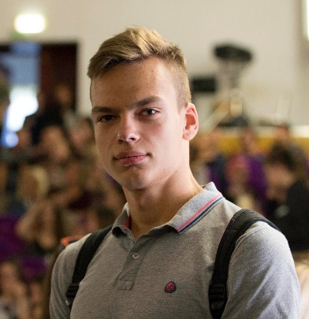

|  |  |
| --- | --- |
| Personal details | |
| First and Last name | Andrey Egorov |
| Date of birth | 19.10.1999 |
| Country of citizenship | Belarus |
| Permanent address | 12 Alibegova Street, #87 |
| Address of residence | 12 Alibegova Street, #87 |
| Marital status | Unmarried |
| Ready for business trips (Yes/No) | No |

|  |  |  |  |  |  |  |
| --- | --- | --- | --- | --- | --- | --- |
| Contact information | | | | | | |
| Landline phone number | |  | | | | |
| Mobile phone number | | +375293960675 | | | | |
| E-mail | | andrey.egorov.minsk@gmail.com | | | | |
| Skype | | a_tbi_kto_2014 | | | | |
| LinkedIn.com | | https://www.linkedin.com/in/andrey-egorov-414b241b6/ | | | | |
| Other social networks | | t.me/myfosse | | | | |
| Education | | | | | | |
| Name of educational institution | | BSU | | | | |
| Period of study (from/to) | | 2017-2021 | | Form of study (Full-time / remote) | | Full-time |
| Average score | | 7.4 | | Form of study(Free / paid) | | Free |
| Faculty | | FAMCS | | | | |
| Specialty | | Mathematician – System Programmer | | | | |
| Additional education**(Certificates, courses, seminars, trainings, internships, etc.)** | | | | | | |
| IBA Courses “System Multiplatform Programming” – 2020  Netcracker EC “Back-end Development (Java)” - 2021 | | | | | | |
| Foreign languages | | | | | | |
|  | Level | | | | | | |
| English | Intermediate | | | | | | |
| Professional skills (technologies and programming languages) | | | | | | |
| **Programming languages and technologies** | Level | | | | | |
| Junior | | Middle | | Senior | |
| **Java Core** | + | |  | |  | |
| **Spring** | + | |  | |  | |
| **MySQL\Oracle SQL\PostgreSQL** | + | |  | |  | |
| **HTML** | + | |  | |  | |
| **JSP** | + | |  | |  | |
| **XML** | + | |  | |  | |
| Additional information | | | | | | | | |
| Hobbies: basketball and volleyball.  Personal qualities: sociable, honest, hard-working.  Have programming experience with: C++, TypeScript (Angular), Android Java development. | | | | | | | | |