

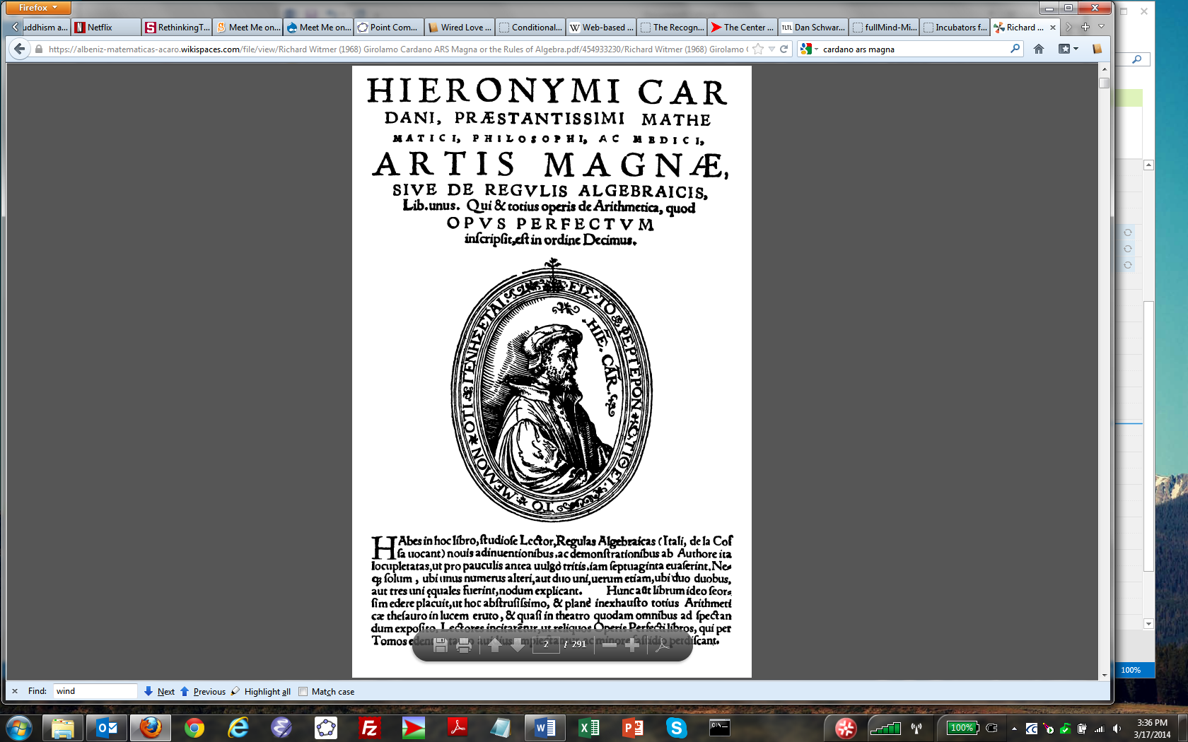

***THE GREAT ART'***

*or*

*The Rules of Algebra*

*by*

*GIROLAMO CARDANO*

*Outstanding Mathematician, Philosopher and Physician*

*In One Book, Being the Tenth in Order of the Whole*

*Work on Arithmetic Which is called the* Perfect Work

In this book, learned reader, you have the rules of algebra (in Italian,

tho rules of the coss 2). It is so replete with new discoveries and demonstrations

by the author - more than seventy of them - that its forerunners

[are] of little account or, in the vernacular, are washed out.

It unties the knot not only where one term is equal to another or two

to one but also where two are equal to two or three to one. 31t is a

pleasure, therefore, to publish this book separately so that, this most

abstruse and unsurpassed treasury of the entire [subject of] arithmetic

being brought to light and, as in a theater, exposed 4 to the sight of all,

its readers may be encouraged and will all the more readily embrace

and with the less aversion study thoroughly the remaining books of

the Perfect Work which will be published volume by volume.3

1 The original title page was omitted in 1663.

2 "Coss" and its variants were familiar terms for algebra in fifteenth-century and

sixteenth-century Italian, German, and English. See David Eugene Smith, *History* ~r

*Mathematics* (Boston, 1923-1925), I, 320, 328; II, 392.

3 In lieu of this passage 1570 has the following:

It is a pleasure, therefore, to publish this book anew partly so that, this most abstruse

and clearly unsurpassed treasury of the entire [subject of] arithmetic being brought to

light and, as in a theater, exposed' to the sight of all, its readers may be encouraged

and will all the more readily embrace and with the less aversion study thoroughly the

remaining books of the Perfect Work and partly because it has recently been revised

and enlarged by the author.

• 1545 has *exposito;* 1570 has *opposito ..*

