**Assignment-1:**

User ‘**asdasa**’ is not present in the system. System is validating username & password at a time(from /etc/passwd). After validation it didn’t find the user, so it is showing ‘**Access Denied**’.

**Assignment-2:**

1. Password has been changed successfully. But before changing it, system is taking confirmation by asking ‘**Current password**’. Only after verifying current password, OS is resetting to new password.

1. OS is not resetting the password to **1234** or **abcd**, because minimum 8 characters should be provided as a password.

1. OS will not allow any account without password. After 3retries we get shell prompt.

**Assignment-3:**

1. It is listing all the files and directories under **/** . Blue color indicates **directories**, Skyblue color indicates **Link files.**



1. It is home directory for all users. Whenever userid is created, then homedirectory for that user will be created in **/home** directory with his username.(i.e., For **suresh** account -> **/home/suresh**)

1. After providing **‘cd ..’** cursor is going to previous directory(one step back) i.e., **/**



1. As that directory is not present, we are getting ‘**No such file or directory**’ error.

1. As my account ‘**suresh**’ is not having any permission(rwx), OS is not allowing me to enter into **/root** directory.

**Assignment-4:**

1. In this **/etc** directory, many files and directories are present. Observed that it is having configuration files like **sysctl.conf, vconsole.conf, yum.conf, resolv,conf, rsyslog.conf** etc.,

1. Observed these hidden files(**.pwd.lock, .updated**) are displayed after executing **ls -al** command.

1. **‘ls -i’** is showing inode number of each file.

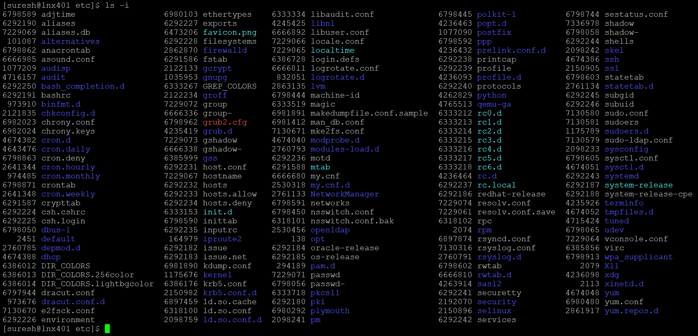

1. **‘ls -lrt’** is showing all files in ascending order(w.r.t date) with latest updated files at last.

**Assignment-5:**

1. After restarting the linux box.

1. After moving to **/var** directory:

