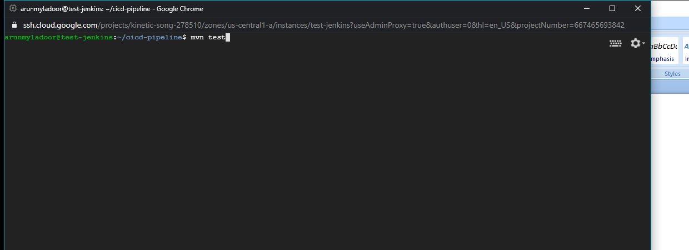

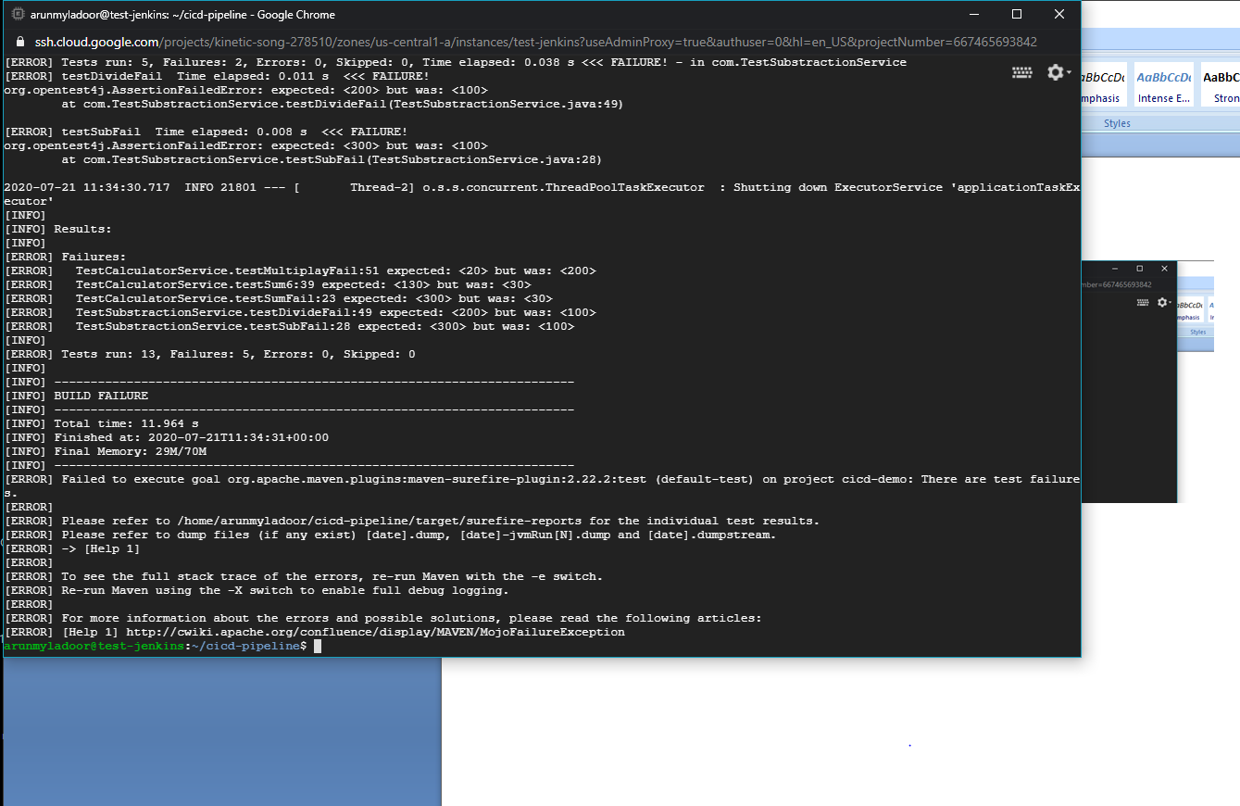

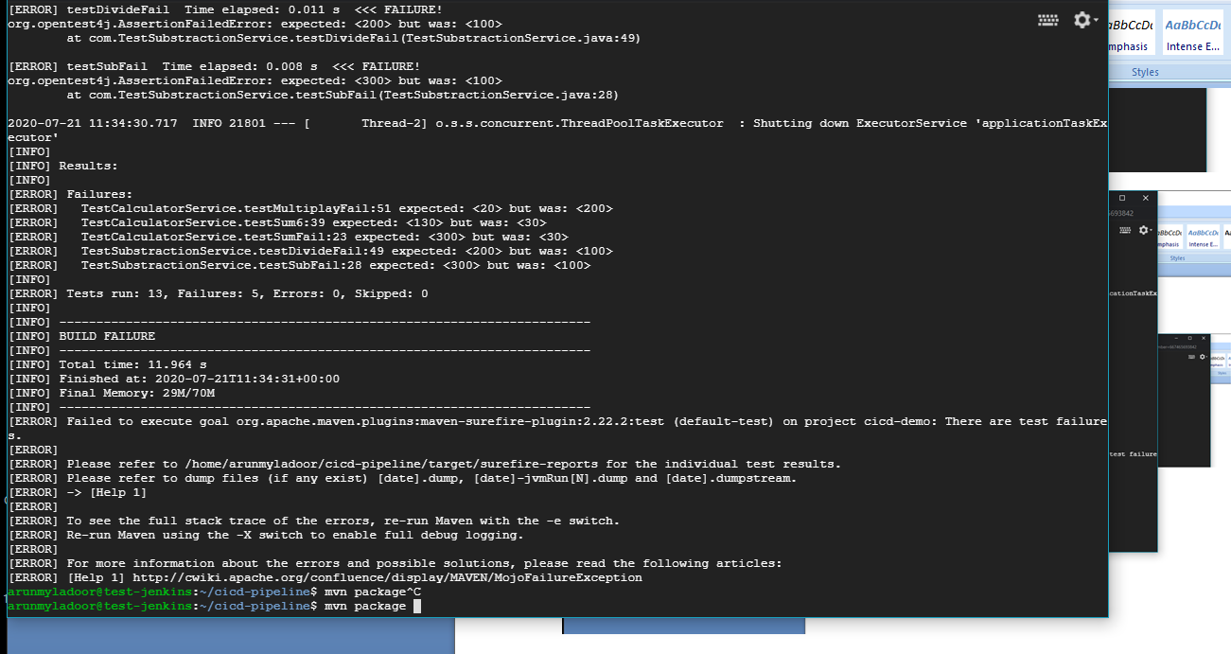

arunmyladoor@test-jenkins:~/cicd-pipeline$ mvn package

[INFO] Scanning for projects...

[INFO]

[INFO] ------------------------------------------------------------------------

1:36:41.173 [main] DEBUG org.springframework.test.context.BootstrapUtils - Instantiating TestContextBootstrapper for test class [co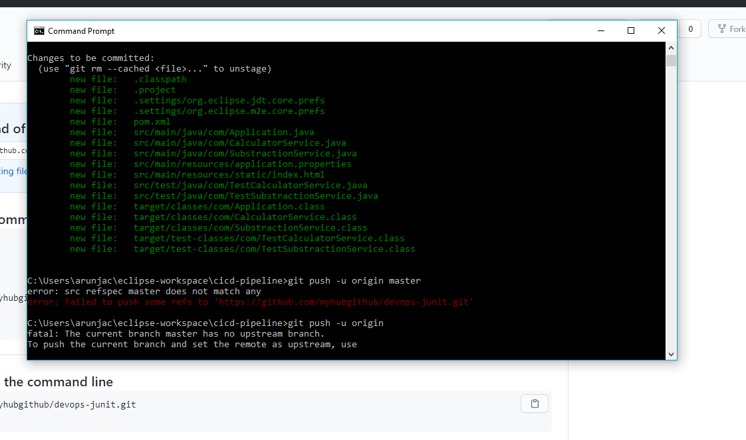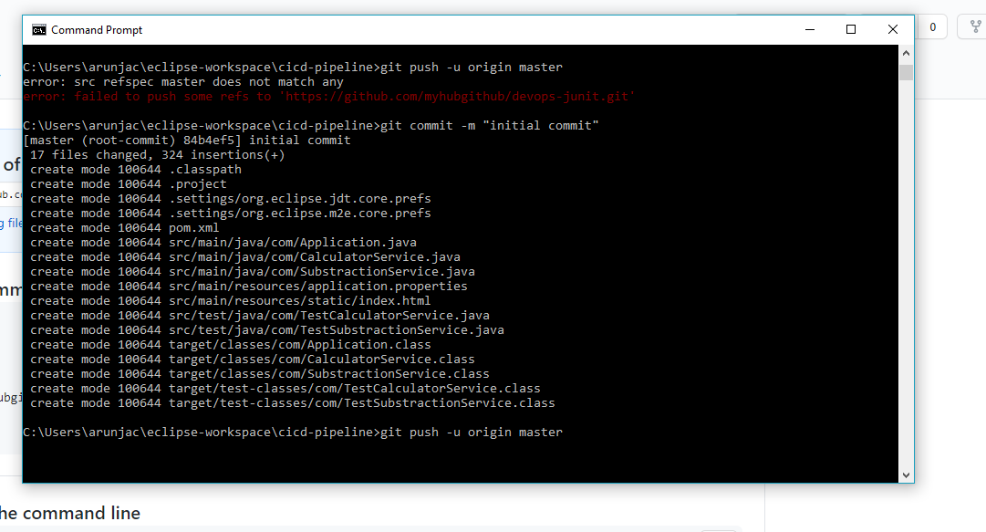

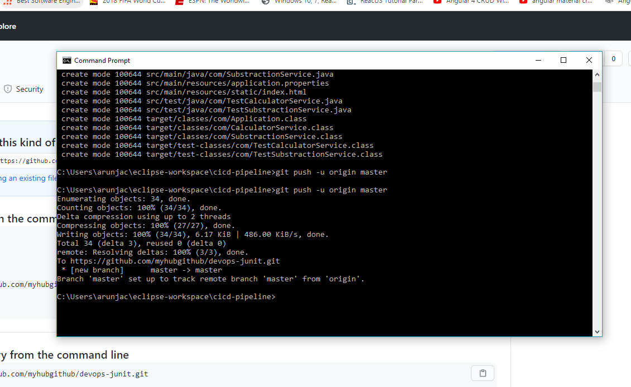m.TestCalculatorService] from class [org.springframework.boot.test.context.SpringBootTestContextBootstrapper]11:36:41.198 [main] INFO org.springframework.boot.test.context.SpringBootTestContextBootstrapper - Neither @ContextConfiguration nor @ContextHierarchy found for test class [com.TestCalculatorService], using SpringBootContextLoader

[INFO] Scanning for projects...[INFO] [INFO] ------------------------------------------------------------------------[INFO] Building cicd-demo 0.0.1-SNAPSHOT[INFO] ------------------------------------------------------------------------[INFO] [INFO] --- maven-resources-plugin:3.1.0:resources (default-resources) @ cicd-demo ---[INFO] Using 'UTF-8' encoding to copy filtered resources.[INFO] Copying 1 resource[INFO] Copying 1 resource[INFO] [INFO] --- maven-compiler-plugin:3.8.1:compile (default-compile) @ cicd-demo ---[INFO] Changes detected - recompiling the module