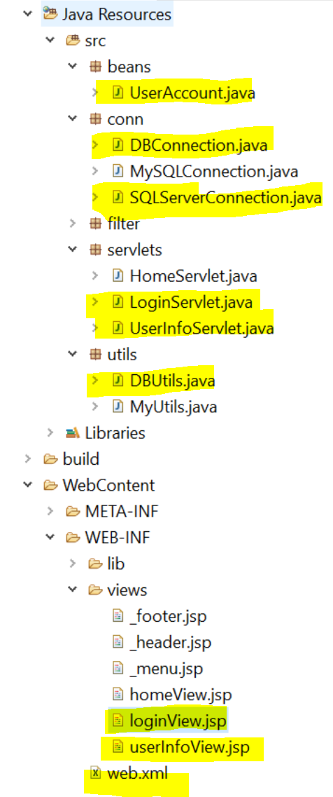

**Web.xml**

**LoginView.jsp**

**UserInfoView.jsp**

**LoginServlet.java**

**DBUtils.java**

**UserAccount.java**

**MyUtils.java**

**DBConnection.java**

**SQLServerConnection.java**

