https://developer.mozilla.org/en-US/docs/Web/Media/Formats/Audio_codecs
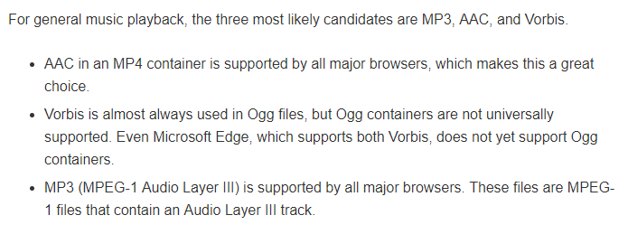

http://www.differencebetween.net/technology/difference-between-aac-and-m4a/
