D365 Design Studio
Functional guide: the complete feature set, end to end
A browser-based design tool for Dynamics 365 functional consultants and business analysts. It shows the design as a Dynamics 365 app, and reads and writes the Excel design workbook that the deployment engine uses to build the solution.

Item | Detail
Audience | Business analysts, functional leads, and anyone reviewing or signing off a design
Version covered | Studio release built 14 October 2026 (single file: D365-Design-Studio.html)
Screenshots | Taken from the built-in sample workbook ("Sample Fund CRM"), which contains no client data
Companion | CRMMetadataDeploy engine (reads the same workbook and builds it in Dataverse)

Contents
1 What the Studio is
2 Getting started and the top bar
3 Browsing the app and designing views
4 The form designer
5 Business process flows
6 Command-bar buttons
7 Preview and View as
8 Check design, Notes and Migration
9 Security roles
10 Organisation: business units and teams
11 Scripts
12 Documents
13 Compare versions
14 AI design: from a process description to a design
15 Saving, undo and the workbook
16 Working with the engine, and current limits
A Appendix A. Screenshot guide

1. What the Studio is
The Studio lets a business analyst design a Dynamics 365 application visually, with the look and behaviour of the Unified Interface, instead of filling an Excel template cell by cell. The analyst works on screen. The Studio writes the result back into the same Excel workbook. The deployment engine then builds exactly what the workbook says.

1.1 How it fits together
Step | Who / what | What happens
1. Design | Business analyst in the Studio | Opens the workbook, designs tables, fields, forms, views, flows, roles, organisation, scripts and documents. Checks the design and records notes.
2. Save | Studio | Save to Excel downloads the updated workbook. Only the sheets that were changed are altered; every other sheet is kept as it was.
3. Validate | Engine (CRMMetadataDeploy) | The validate action reads the workbook and reports errors and warnings before anything is built.
4. Build | Engine | Deploy, views and org actions create tables, columns, choices, views, business units and teams in Dataverse. A dry run is available first.
5. Review | BA and consultant | Compare versions shows what changed between two copies of the workbook, with a Word change list for the client.

1.2 Principles
- The workbook is the single source of truth. Nothing is stored on a server. The engine never writes the workbook; only the Studio does.
- Everything stays in your browser. Opening a workbook does not upload it. The only optional network call is the AI feature, and it has a no-key copy-and-paste mode.
- Every change can be undone. Undo and Redo (Ctrl+Z / Ctrl+Y) cover every edit, including bulk changes from AI design.
- Design first, build later. Several features record intent for the developer (default values, validation rules, scripts, documents) without building it yet.
- The Studio is honest about what it checks. Check design lists what would break the build and what is worth a look, and each item jumps to the place to fix it.

2. Getting started

2.1 Open the tool
Double-click D365-Design-Studio.html in Chrome or Edge. It is one self-contained file and needs no installation. The start screen offers two ways in.
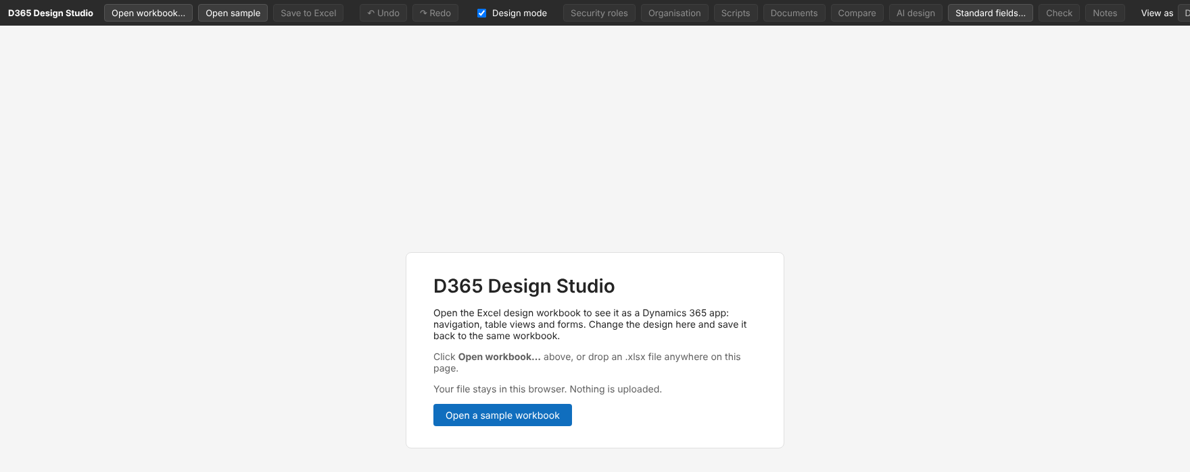
Figure 1. Start screen. Open workbook… or drop an .xlsx on the page; Open sample loads the built-in example.
- Click Open workbook… (or drag the .xlsx onto the page).
- Or click Open a sample workbook to explore with invented data.
- Work in Design mode (on by default). Untick it to see the app exactly as a user would.
- Click Save to Excel when done. A dot on the button shows there are unsaved changes.

2.2 The top bar
The dark bar at the top holds every tool. The blue bar below it is the app itself, as users will see it.
Button | What it does
Open workbook… / Open sample | Loads an Excel design workbook, or the built-in sample.
Save to Excel | Downloads the updated workbook. Only changed sheets are altered.
Undo / Redo | Steps back and forward through every edit.
Design mode | On: all design controls visible. Off: preview, looks like the live app.
Security roles | Privilege grid, field security, navigation and AI draft for each role (section 9).
Organisation | Business units and teams, and the roles each team holds (section 10).
Scripts | Web resources and form scripts (section 11).
Documents | Word / PDF templates produced from a record (section 12).
Compare | What changed between two versions of the workbook (section 13).
AI design | Describe a process; the AI proposes tables, fields and a process flow (section 14).
Standard fields… | Loads a list of standard Dynamics fields, so standard columns are reused rather than recreated (section 4.4).
Check / Notes / Migration | Review panel on the right (section 8).
View as | Redraws the app as a chosen role would see it (section 7.2).

3. Browsing the app and designing views

3.1 The app shell
Once a workbook is open, the Studio draws a Dynamics 365 app: app name, search bar, left navigation with groups and pages, a command bar and a list of records. The list shows one sample record built from each field's Example column, so the analyst sees realistic data without any database.
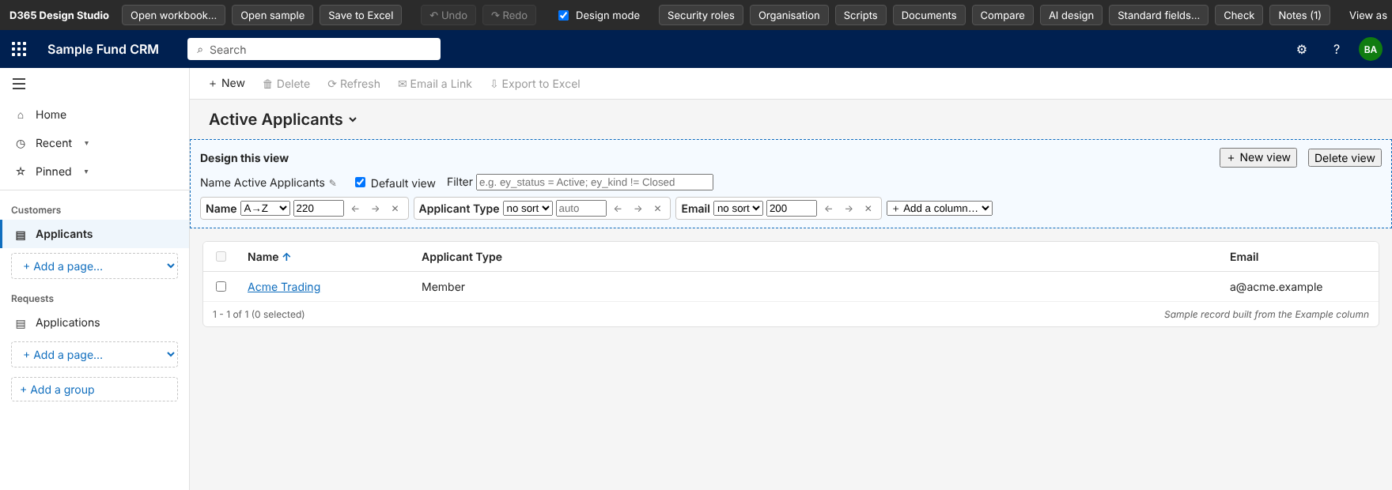
Figure 2. The app shell. Navigation on the left, command bar on top, view designer (dotted blue box) above the list.

Navigation (sitemap) design
- Rename a group or page with the pencil icon; reorder with the ↑ / ↓ arrows; remove with ✕.
- Add a page with + Add a page… (choose any table), and a group with + Add a group.
- Each change is saved to the Sitemap sheet of the workbook.

3.2 Views
Every table has one or more views, chosen from the view picker beside the title. In design mode a dotted panel shows what the BA can change.
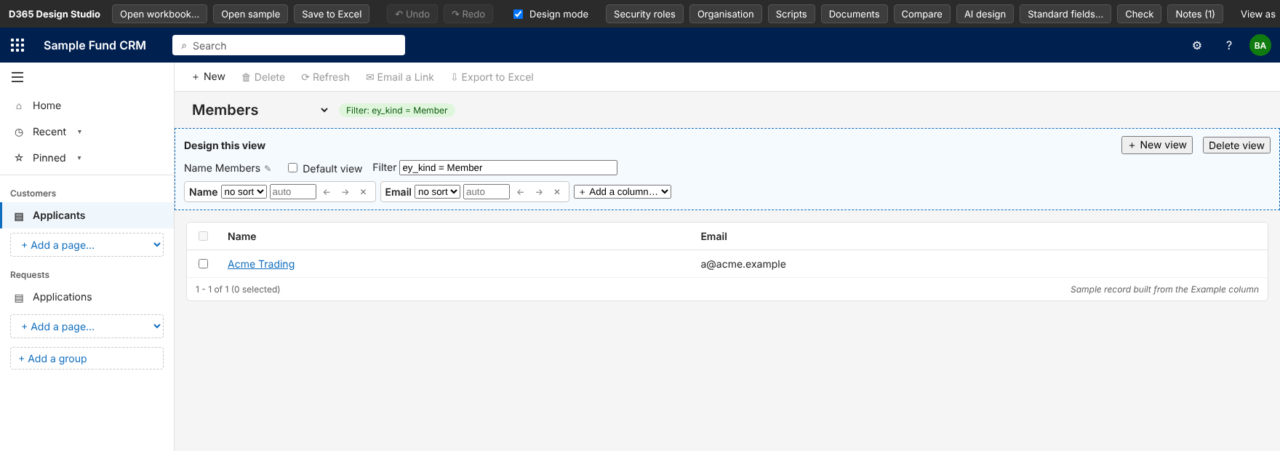
Figure 3. A second view (Members) with its filter shown as a green chip beside the title.
Control | Purpose
Name | Rename the view.
Default view | Tick to make this the view users land on.
Filter | A short rule such as ey_status = Active; ey_kind != Closed. The list and the Excel sheet use it.
Column boxes | Per column: sort (none, A→Z, Z→A), width, and ← → arrows to reorder; ✕ removes.
+ Add a column… | Adds any column of the table, including system columns: Created On, Created By, Owner, Modified On, Modified By.
+ New view / Delete view | Create a named view or remove one.

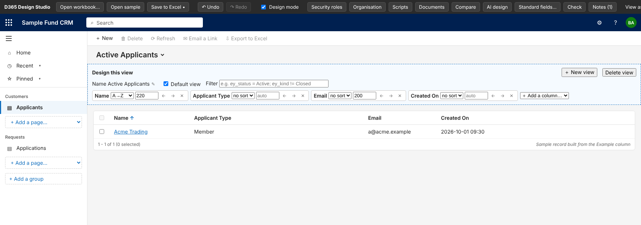
Figure 4. Adding Created On to the default view. It appears at once in the list.
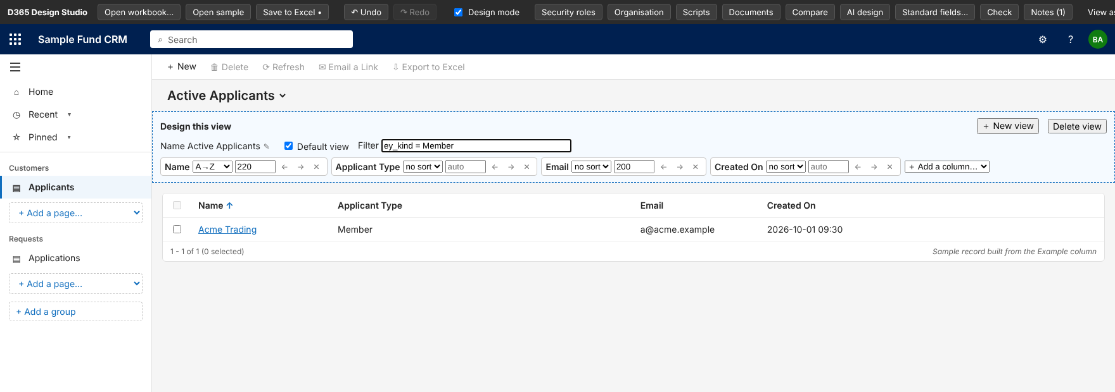
Figure 5. Typing a filter in the view designer. Views are saved to the Views sheet.

3.3 Adding a new table
A business analyst can add a table without any Excel work. In design mode, click + New table under the navigation. It sits above + Add a group.
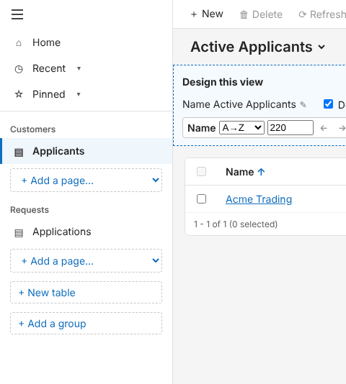
Figure 6. The + New table button in the navigation (design mode).
A small form opens. Only the display name is required.
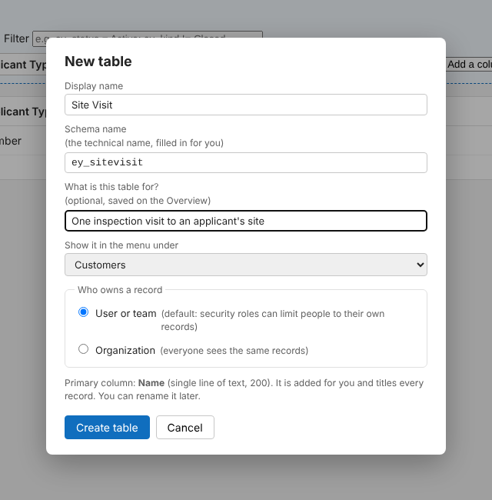
Figure 7. New table dialog. The schema name (ey_sitevisit) filled itself in from the display name.
Field | What it does
Display name | The name users see, for example Site Visit. It must not match an existing table.
Schema name | Filled in for you: the publisher prefix plus the name in lower case without spaces (ey_sitevisit). If it is already taken, a number is added. Type in the box to change it; Reset returns to the suggestion. Maximum 50 characters including the prefix.
What is this table for? | Optional. Saved as the purpose on the Overview sheet and in the table sheet title.
Show it in the menu under | Pick one of the current group names, or choose A new group… and type a name. This is also written to the Block column of the Overview.
Who owns a record | User or team is selected by default. Organization is the other choice.
Primary column | Always Name (single line of text, 200 characters, marked as the record title). It is added for you and can be renamed later.

Create table adds everything in one step, and the new table opens on its form so fields can be added straight away.
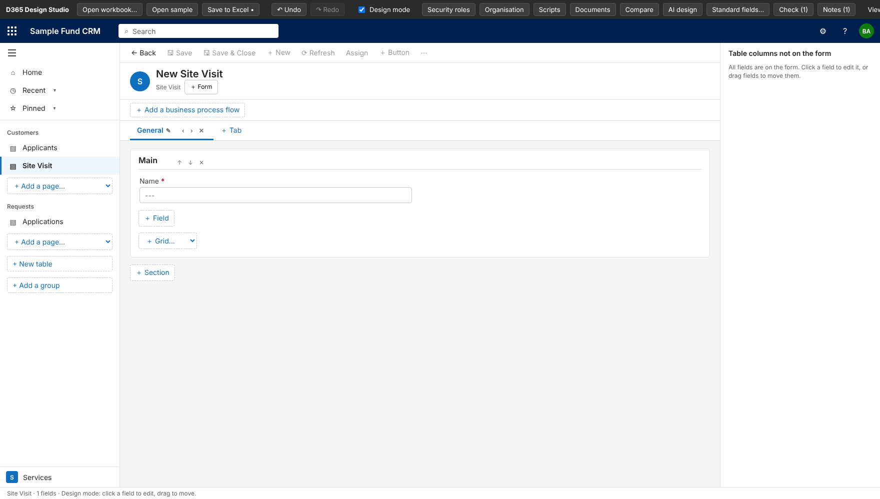
Figure 8. The new table opens on its form with the Name primary column, and appears in the navigation.
- What is created: a table sheet (title, Type, Block, Grain, Schema name and Ownership lines, then the field table with the Name column), a row on the Overview sheet, and a menu item. The worksheet itself is written when you press Save to Excel.
- Undo: one Undo removes the table, its Overview row and its menu item together.
- Checks: the dialog refuses a duplicate display name, a duplicate or invalid schema name, and a schema name without the publisher prefix, and says why in plain words.
- Check design: a new table is flagged "No role can read Site Visit" until you give a role Read access on the Security roles screen. This is expected; it stops a table nobody can open from reaching the build.

Ownership: User or team, or Organization
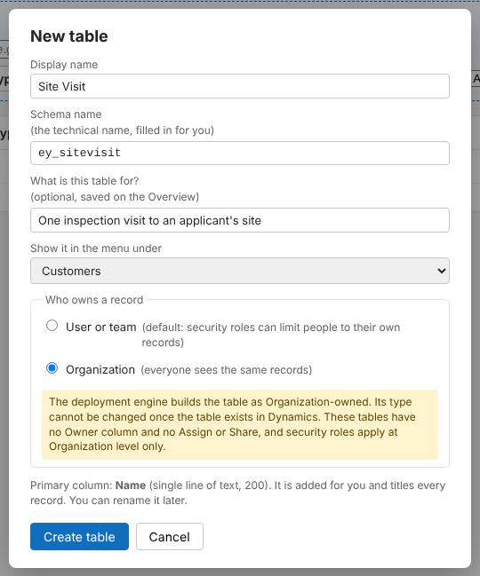
Figure 9. Choosing Organization shows what the engine does and the limits of an organization-owned table.
User or team is the Dataverse default and lets security roles limit people to their own records. Organization means every record is shared by everyone. The choice is saved on the Ownership line of the table sheet. A sheet without that line is read as User or team.
Engine The deployment engine reads the Ownership line and builds an Organization table as Organization-owned. The type cannot be changed once the table exists in Dynamics, so decide before the first deployment. These tables have no Owner column, Assign or Share, and security roles apply at Organization level only. The engine warns about an owner field, owner-based views and privileges below Organization level.
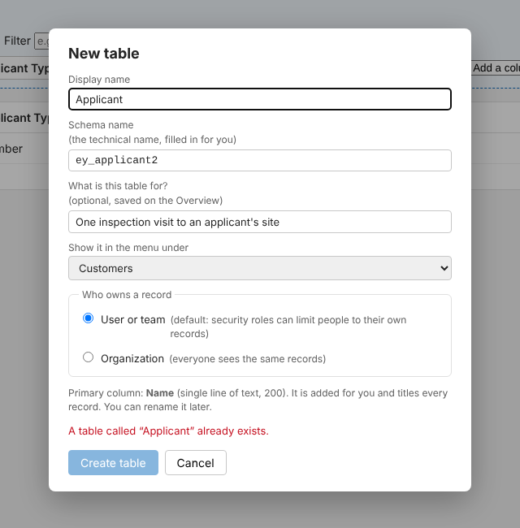
Figure 10. Entering a name that already exists: the message appears and Create table stays disabled.

4. The form designer
Click a record in the list to open its main form. The form is built from tabs, sections and fields, exactly as in Dynamics 365. In design mode every part is editable.
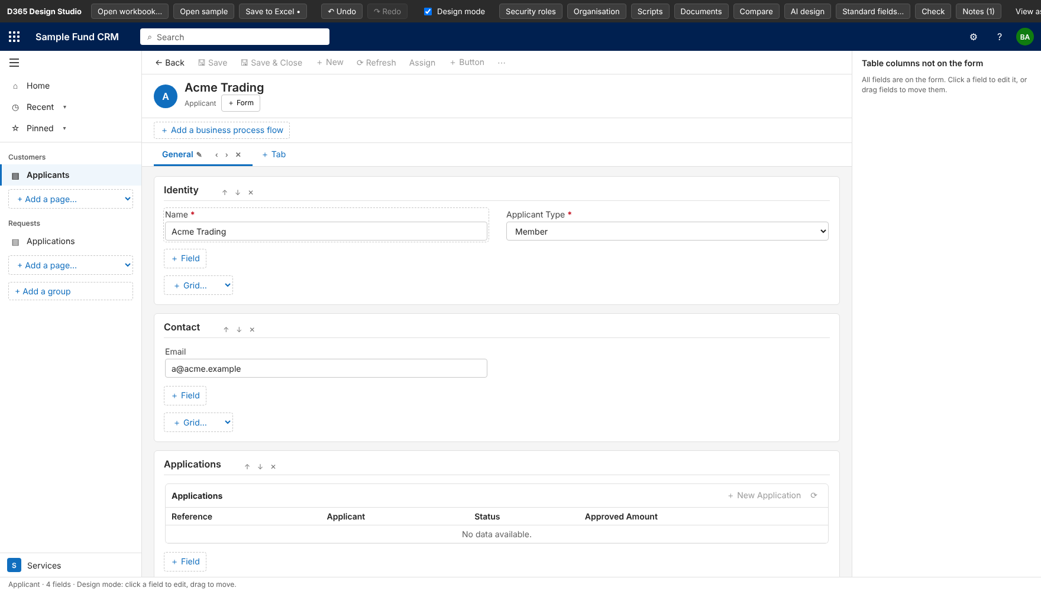
Figure 11. A form in design mode: tabs (General), sections (Identity, Contact, Applications) and fields. The right panel lists table columns not yet on the form.

4.1 Tabs, sections and fields
- Tabs: click the pencil to rename, ‹ › to reorder, ✕ to remove, + Tab to add.
- Sections: rename by clicking the title; drag by the title or use ↑ ↓ to reorder (drag onto a tab to move it to that tab); ✕ removes; + Section adds one.
- Fields: drag a field to another section or position. + Field adds a new field to that section.
- Table columns not on the form: the right-hand panel lists columns that exist but are not placed. Drag one onto the form, or click it to edit.
- Grids: use + Grid… in a section to add a related-records grid for any table (shown as Applications above).

4.2 Field properties
Click any field to open its properties on the right.
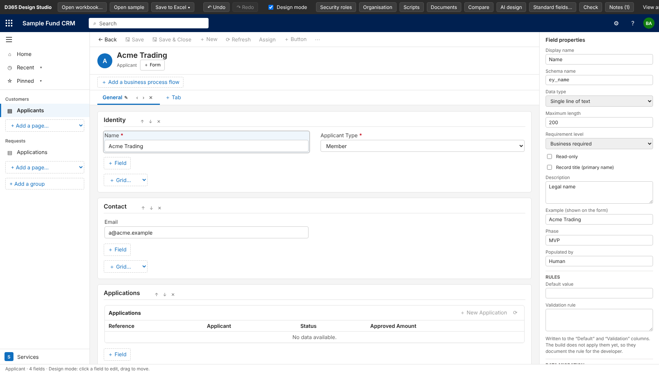
Figure 12. Field properties for Name: type, length, requirement level, record title, description, example value, and the migration fields at the bottom.
Property | What it means
Display name / Schema name | The label users see, and the technical name. A new field fills its schema name itself from the display name (publisher prefix + name).
Data type | Single line of text, multiple lines, whole number, decimal, currency, date only, date and time, Yes/No, Choice, Choices (multi-select), Lookup, Subgrid, Autonumber, Email, Phone, Owner.
Maximum length | For text types.
Requirement level | Optional, Business required, or System required. Required fields show a red star.
Read-only | Users cannot edit the field.
Record title (primary name) | Tick on the one text or autonumber column that names each record. Only one per table.
Description / Example | Description is saved for the developer. Example is the value shown in the sample record.
Default value / Validation rule | Recorded for the developer. The build does not apply them yet.
Legacy field / Migration notes | Where the data comes from in the old CRM (section 8.3).
Remove from form / Delete field | Remove keeps the column in the table (OnForm = Removed). Delete removes its row from the workbook.

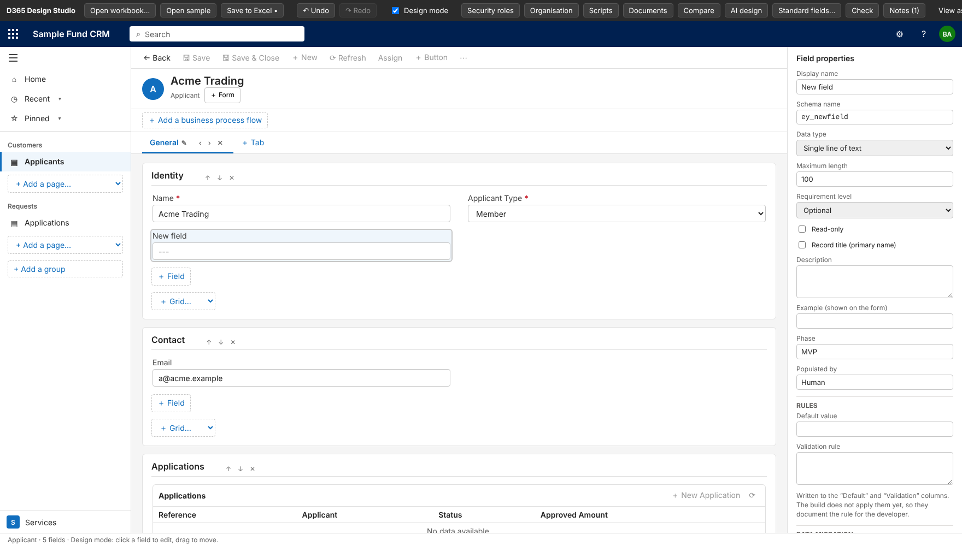
Figure 13. A new field added to the Identity section. Its schema name (ey_newfield) was generated automatically.

4.3 Several forms per table
Under the record title, + Form adds another main form that starts as a copy of the current one. Name it, press Enter, and switch between forms from the same place. Each form has its own tabs, sections and fields, saved in the Form column of the workbook.
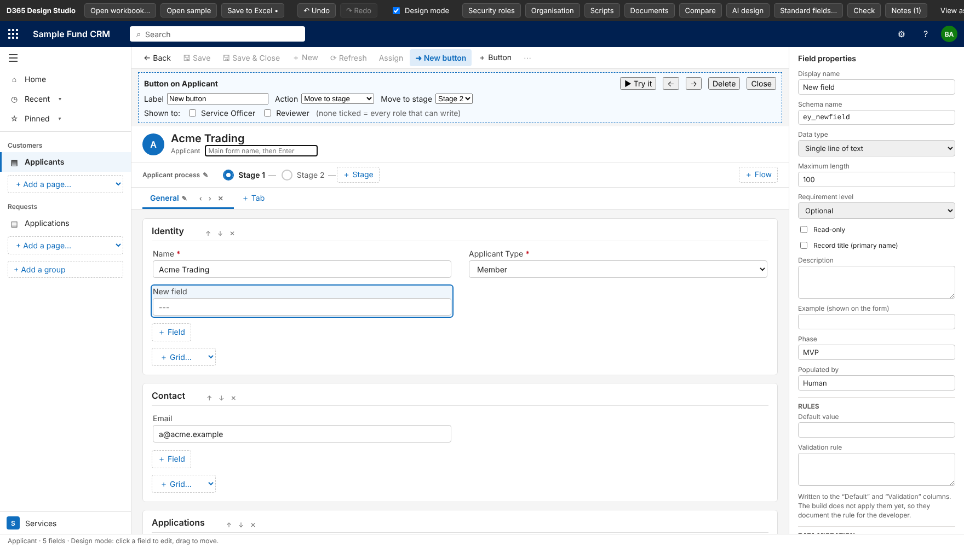
Figure 14. Naming a new form (the box under the record title). The command-bar button editor is open above.

4.4 Standard fields first
On a standard Dynamics table (Account, Contact and so on), Standard fields… offers the columns Dynamics already has, with the ones on the standard form listed first. This avoids creating a duplicate of something that exists. The list comes from a small file exported from your environment by the ExportStandardFields tool (see docs/STANDARD_FIELDS.md). The custom tables in the sample workbook do not need it, so it is not illustrated here.

4.5 Controlling the layout: tabs, sections and fields
In design mode, the gear icon next to a tab or a section opens its layout settings. A field has the same settings in the right-hand panel, under On the form.
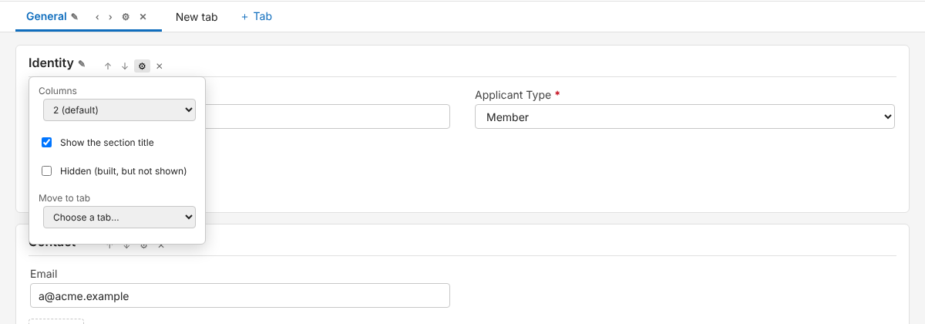
Figure 15. The gear menu of a section: columns, section title, hidden, and Move to tab.
Setting | What it does
Move a section to another tab | Drag the section title onto a tab, or use Move to tab in its gear menu. If the other tab already has a section with the same name, the fields join it. The section's settings move with it.
Move a field to another tab | Drag the field onto a tab. It lands in the first section of that tab. Drag it onto a field to place it before that field.
Merge tabs | In the tab's gear menu, Merge this tab into… moves every section across. One Undo reverses it.
Columns (section) | 1, 2, 3 or 4 columns. Two is the default and is not written to the workbook.
Show the section title (section) | Untick to hide the title. In design mode the title stays visible but struck through, so you can still select it.
Hidden (tab, section, field) | The item is built on the form but not shown. While designing it appears dimmed with a "hidden" badge. In Preview it disappears.
Full width (field) | The field spans the whole width of its section, whatever the column count. Multi-line fields and grids are already full width.
Show the label (field) | Untick to show the field without its label.

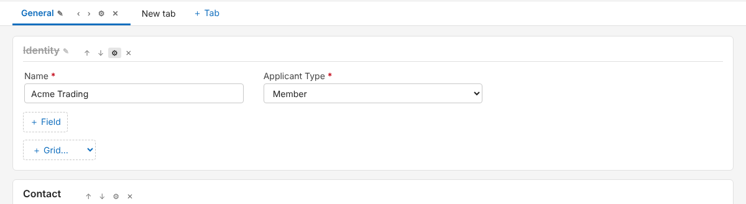
Figure 16. A section set to three columns with its title hidden (struck through while designing). Preview shows no title.
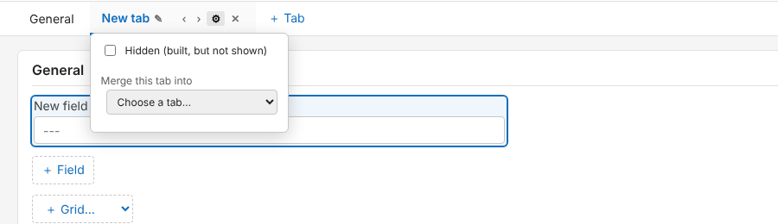
Figure 17. The gear menu of a tab: Hidden, and Merge this tab into another tab.
Figure 18. A hidden tab, shown dimmed with a "hidden" badge. It does not appear in Preview.
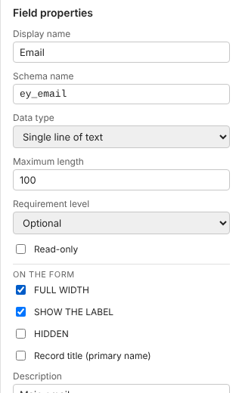
Figure 19. Field properties: Full width, Show the label and Hidden, under On the form.
Where it is saved Which tab and section a field is in, and the order of tabs, sections and fields, are saved in the table sheet, as before. Columns, hidden, label and full-width settings are saved in a new optional Form Layout sheet (Excel format, section 6.16). The engine reads that sheet when it builds the form, and a workbook without the sheet builds exactly as before. This has been checked offline on a real form, not yet in a live deployment. One limit: a field that is already on a live form is not moved when its tab or section changes in the workbook. Details are in docs/ENGINE_FORM_LAYOUT.md.

5. Business process flows
A business process flow is the stage bar across the top of a form. Click a stage to see its steps. In design mode the BA builds the flow directly on the form.
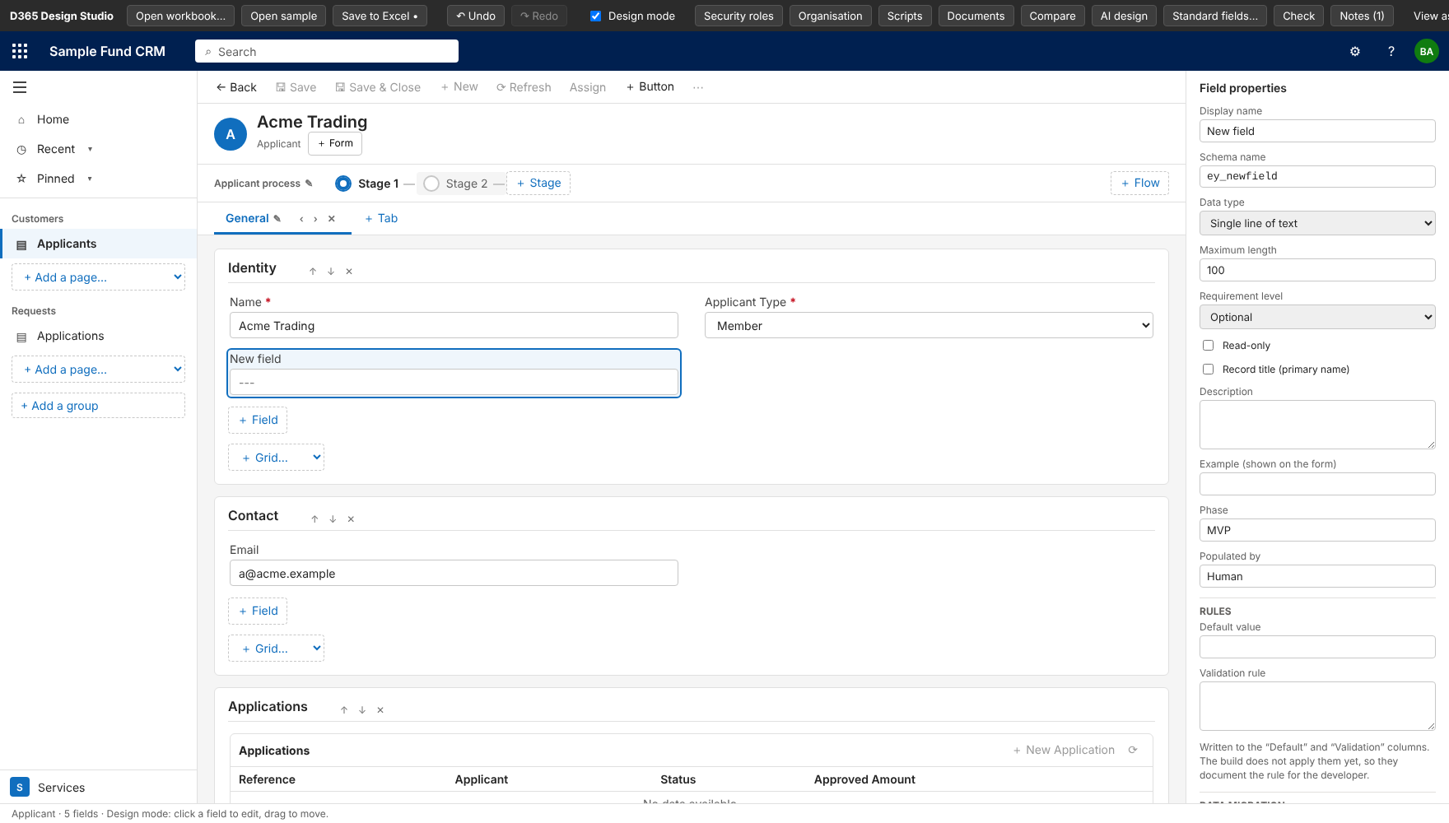
Figure 20. A flow with two stages. + Stage adds another, + Flow adds a second flow, and the right panel edits the selected stage.
- Click + Add a business process flow to create one, then + Stage to add stages.
- Select a stage to rename it, move it earlier or later, or delete it. Delete flow removes the whole flow.
- Add steps from a field: each step is a field the user fills in before leaving the stage. Tick Required where the process cannot move on without it.
- A stage with no steps is kept in the workbook as an empty stage.
- Flows are saved to the Process Flows sheet.

6. Command-bar buttons
The command bar above a form holds the standard buttons (Save, Save & Close, New, Refresh, Assign, Share). In design mode the BA can add stage buttons that move the record to a chosen stage.
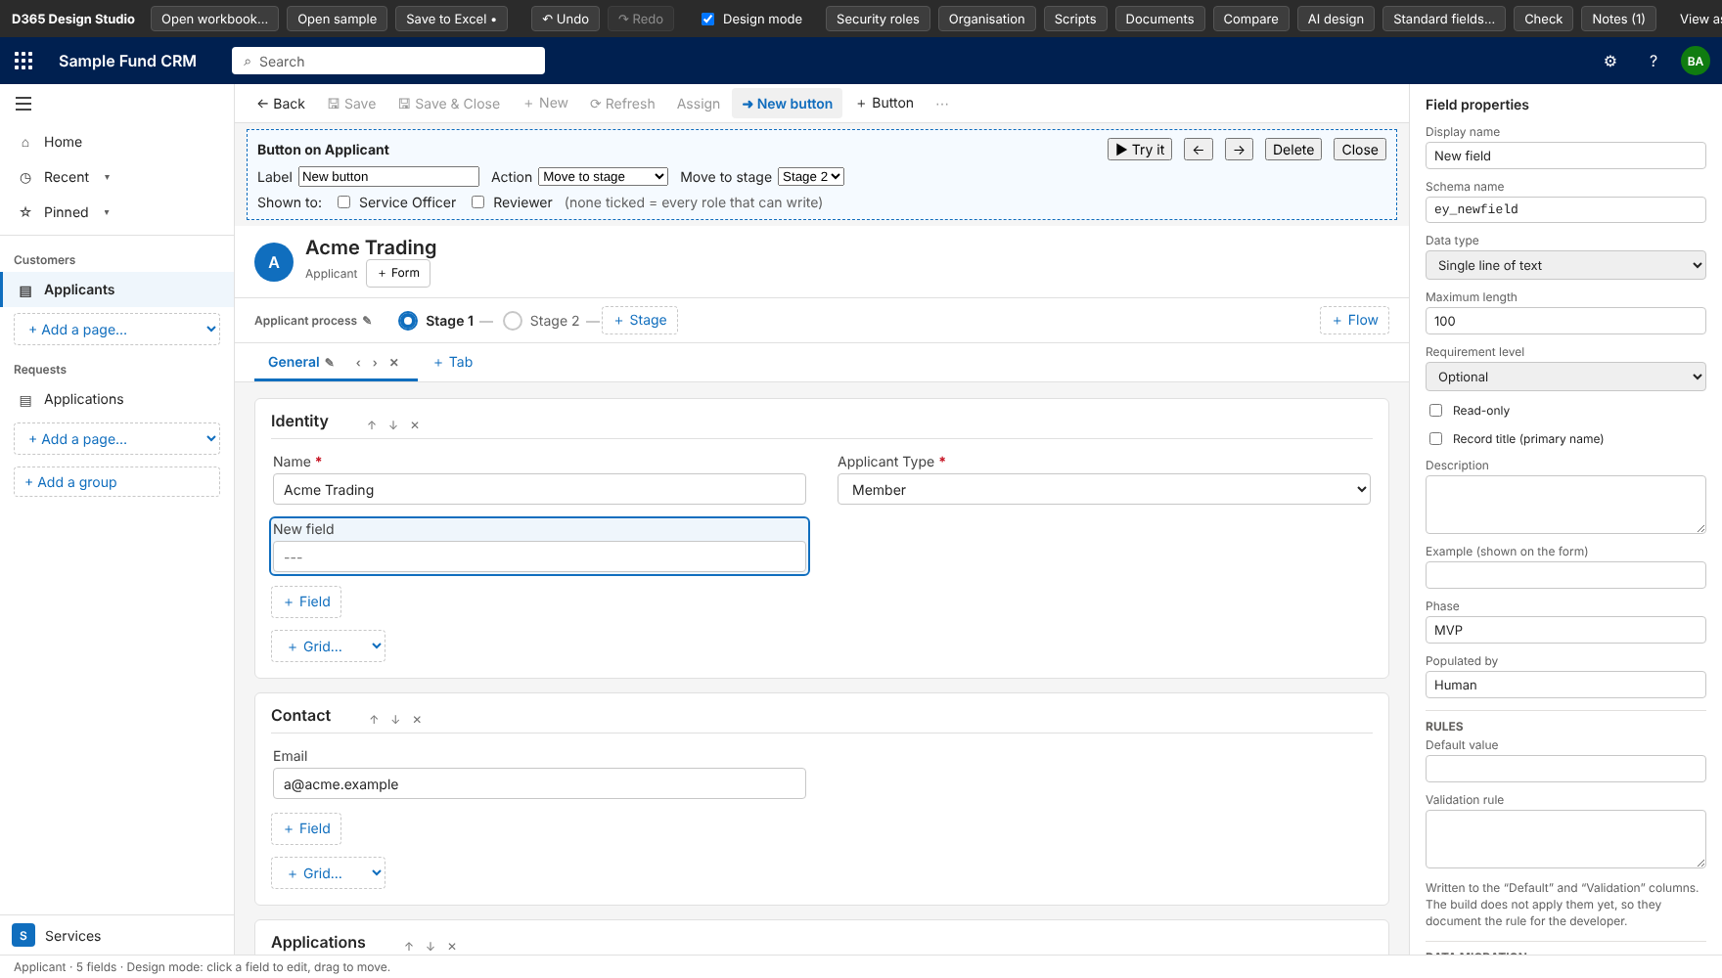
Figure 21. Editing a stage button: label, action (Move to stage), target stage and the roles who see it.
Setting | Meaning
Label | The text on the button.
Action / Move to stage | Moves the record to the chosen stage, optionally setting a field first.
Shown to | Tick roles to limit who sees it. None ticked means every role that can write.
Try it | Test the button on the sample record. A banner explains what happened.

Buttons are saved to the Command Bar sheet. In the stage flyout of a flow, Move here does the same by hand.

7. Preview and View as

7.1 Preview
Untick Design mode to hide every design control. The app looks and behaves like the final product, which is the right view for a client walkthrough.
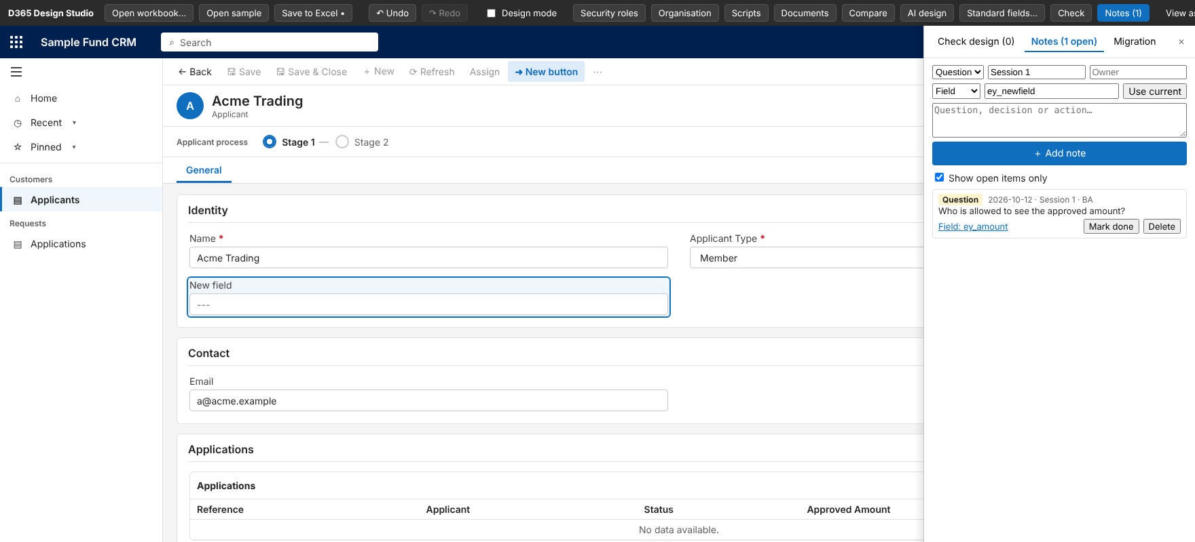
Figure 22. Preview: no design controls, just the app.
In Preview the BA can type or pick values on a form to walk a client through a journey. These sample values are held only while the page is open: they are never written to the workbook and the engine never sees them. They also appear in the list (the footer says so), and the form title follows the record title. The Reset sample data button on the top bar forgets them, and so does opening another workbook. Refreshing the page also clears them.
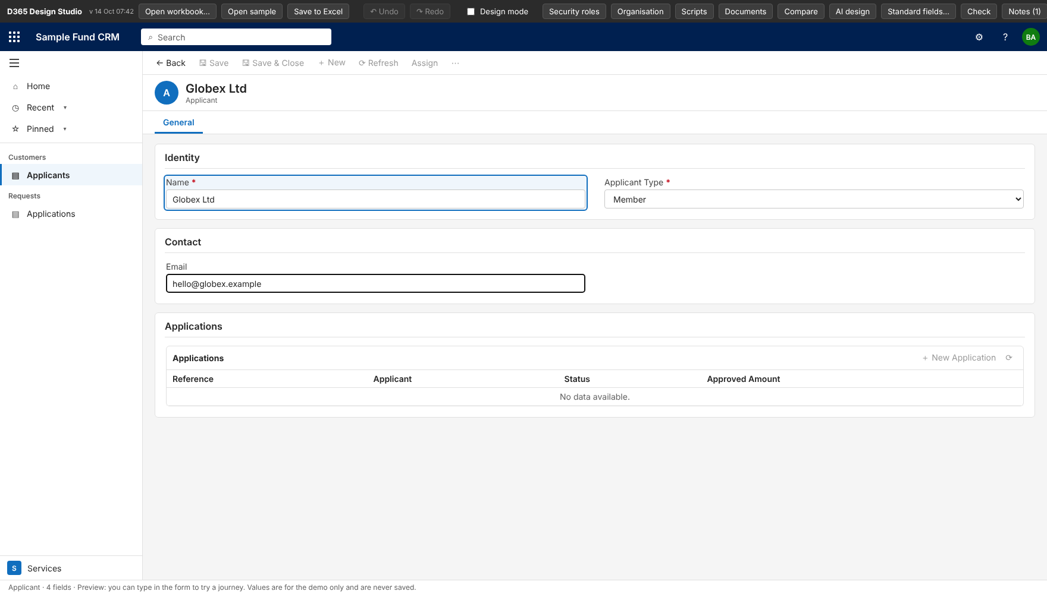
Figure 23. Preview with typed sample values: the title follows the Name field and Reset sample data (2) appears on the top bar.

7.2 View as a role
Pick a role in View as on the top bar. The Studio redraws the whole app as that user would see it, from the role's privileges.
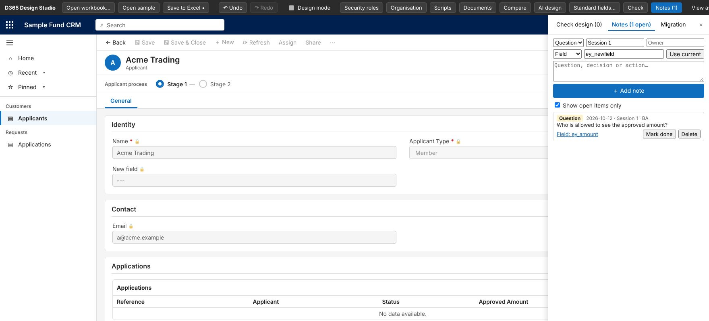
Figure 24. View as "Reviewer": read-only fields show a lock, buttons the role lacks are hidden, navigation is limited.
- Navigation shows only the areas the role is allowed to open.
- Buttons appear only if the role has the matching privilege: New (Create), Delete, Assign, Share, Save (Write).
- Fields restricted by field security show as hidden or read-only.
- The list shows only the records the role's Read scope allows.
- Pick Designer (all access) to return to the full view.

8. Check design, Notes and Migration
Three tabs in the right-hand review panel help the BA keep the design clean and the project organised.

8.1 Check design
One click lists what would break the build and what is worth a look. Each item can be clicked to jump to it.
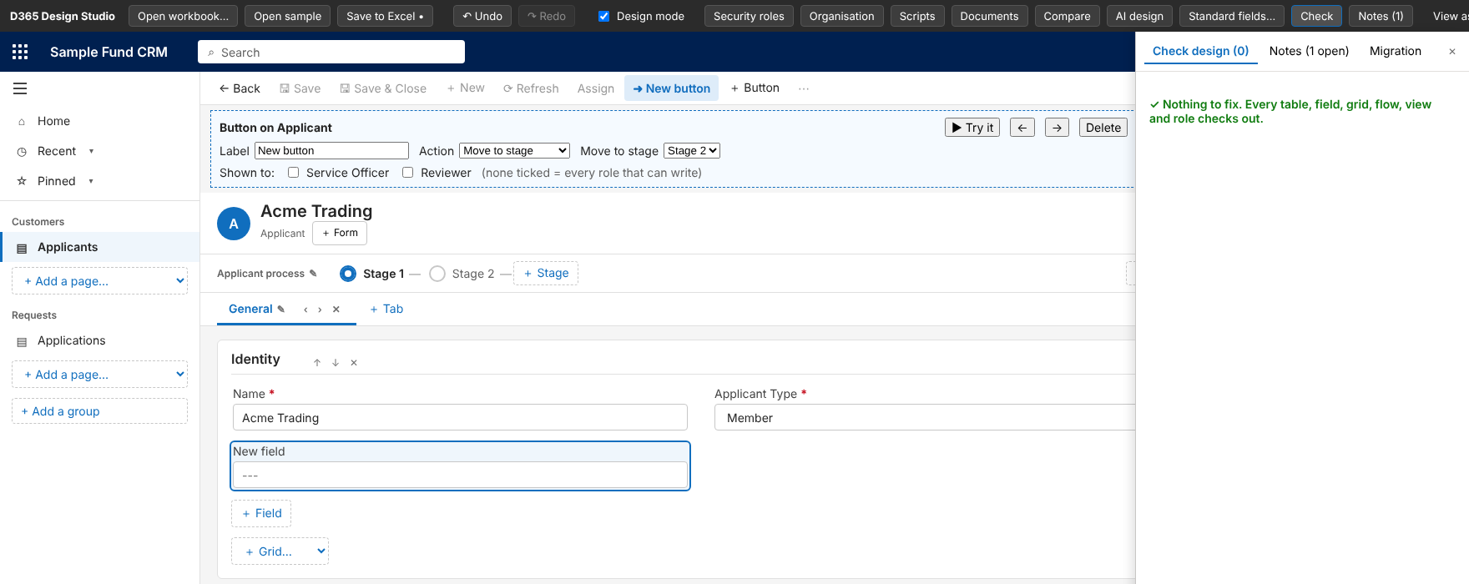
Figure 25. Check design: green when nothing needs fixing.
Kind | Examples
Errors (would break the build) | A choice field with no options, a grid that points to a missing table, duplicate or invalid schema names, a lookup that does not say what it looks up, a navigation page or flow that points at a missing table, a stage button aimed at a missing stage, two columns marked as the record title.
Warnings (worth a look) | A table nobody can read, a table missing from the menu, a view column that does not exist, a role that names a missing table or field, a lookup to a table with no sheet (fine if it is a standard Dynamics table).

8.2 Notes
Log questions, decisions and actions during a session, attached to a table or a field, and tick them off. Notes are saved to a Notes sheet that the engine ignores, so the workshop record travels with the workbook.
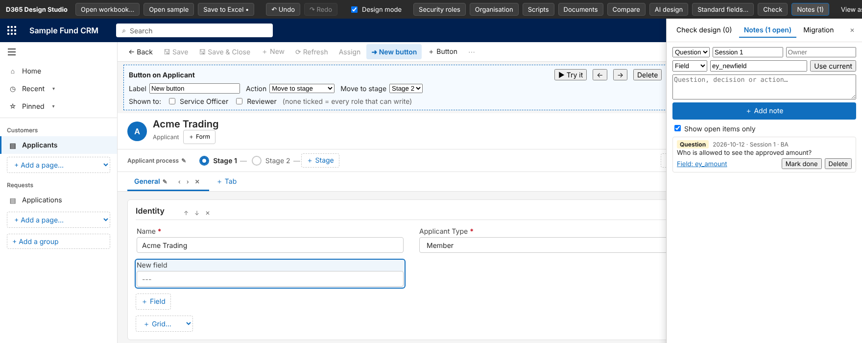
Figure 26. Notes panel: type (Question, Decision, Action), session, owner, target table or field, and the open-items filter.

8.3 Data migration mapping
Each field has a Legacy field and Migration notes box. The Migration tab shows how many fields are mapped per table, so migration progress is visible. They are saved as two extra columns on the table sheet, which the engine ignores.
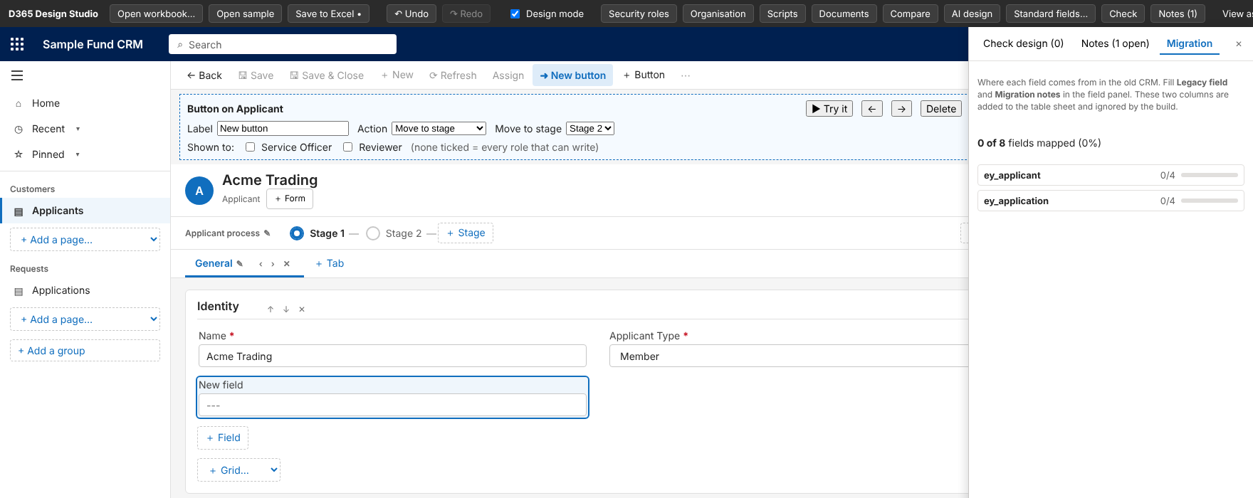
Figure 27. Migration tab: fields mapped per table and overall percentage.

9. Security roles
The Security roles screen defines what each role can do, see and open. It uses the same circles Dynamics 365 uses: none, own records (User), Business Unit, Parent-Child BU, and Organization.

9.1 Table privileges
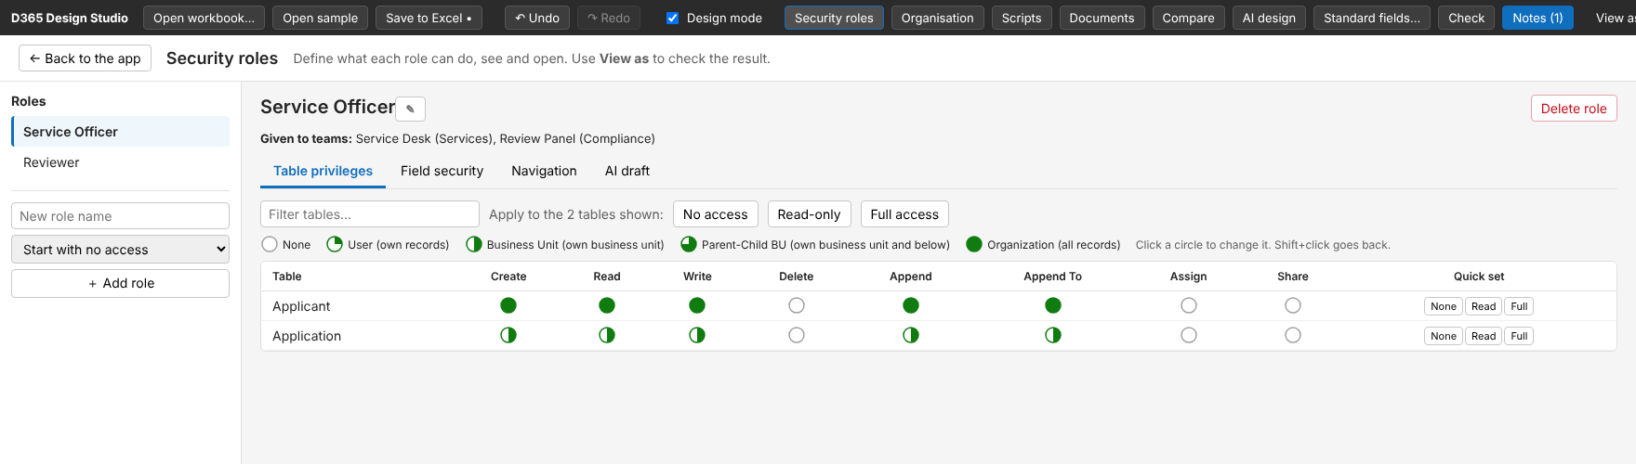
Figure 28. Table privileges grid for Service Officer. Click a circle to change the scope; Shift+click goes back.
- Rows are tables; columns are Create, Read, Write, Delete, Append, Append To, Assign, Share.
- Quick set per table: None, Read, Full. Apply to the shown tables: No access, Read-only, Full access.
- Create a role with + Add role and choose how it starts: no access, read-only on all tables, or full access.
- "Given to teams" under the title shows which teams hold the role.

9.2 Field security
Choose a table, then set each field to Editable, Read-only or Hidden for the role. Fields not listed stay editable. Dynamics secures a whole column and uses profiles, so the build gives each role in the workbook its own profile.
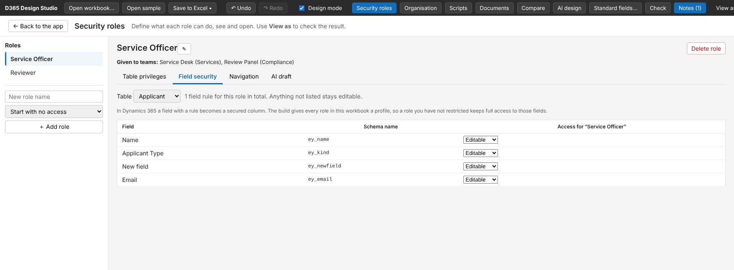
Figure 29. Field security for the Applicant table.

9.3 Navigation
Tick Limit this role to the areas ticked below, then tick the areas the role may open. These limits shape View as and are saved to the Role Navigation sheet.
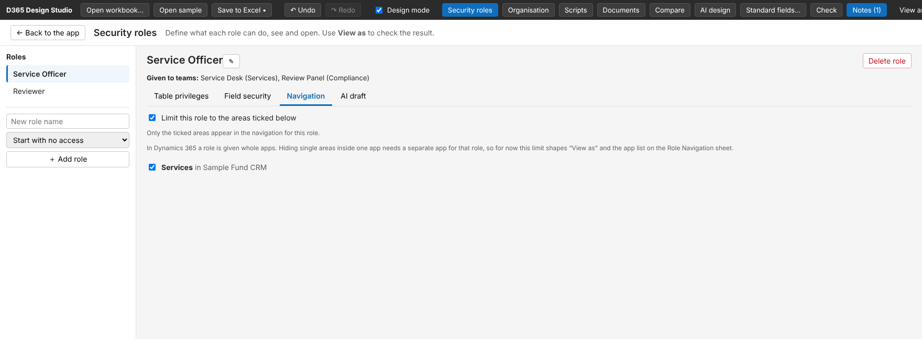
Figure 30. Navigation limits per role.

9.4 AI draft for roles (optional)
Describe the department in plain words and the AI proposes table privileges and field restrictions. The BA reviews, unticks anything they disagree with, and presses Apply. Undo reverses it. It needs the BA's own Anthropic API key, which is kept only in the browser. By default only the description and table names are sent; table purposes and field names are opt-in, and a "What is sent" box shows the exact text.
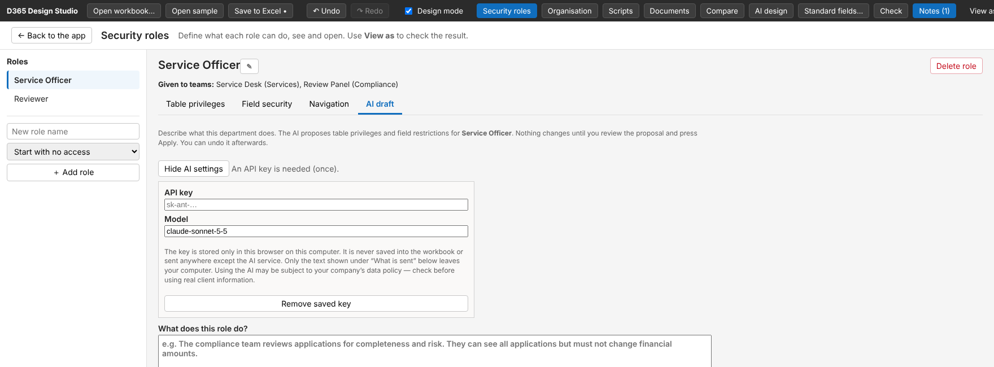
Figure 31. AI draft tab: key settings, description box and the privacy note.
Note The role sheets written are Security Roles, Role Field Rules and Role Navigation. The Studio works fully without the AI feature.

10. Organisation: business units and teams
Business units decide what "Business Unit" and "Parent-Child" mean in a security role. Teams hold the roles. The Organisation screen shows both as a tree.
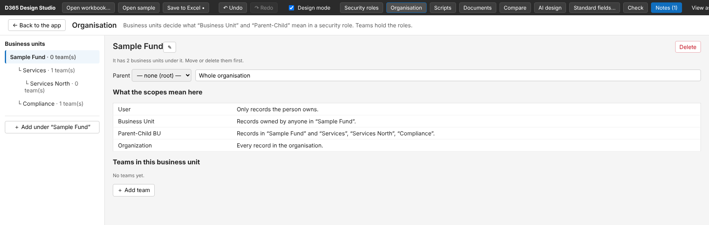
Figure 32. Business unit tree with the plain-words table "What the scopes mean here".
- Add a unit under any unit; rename, move (parent) or delete it. Deleting needs the unit to be empty first.
- The "What the scopes mean here" table updates as the tree changes, so the BA can explain each scope to the client in concrete terms.
- Add teams to a unit with + Add team. Each team has a name, a type (Owner or Access) and a business unit.
- Tick the roles each team holds. The Roles screen then shows which teams hold each role.
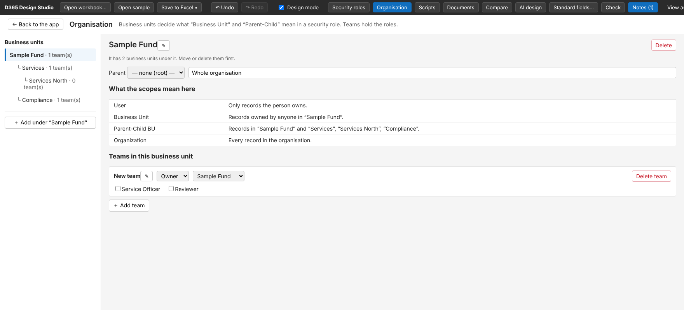
Figure 33. A new team with its type, business unit and role tick boxes.
Rule Access teams share individual records and cannot hold security roles in Dataverse. The Studio shows a note instead of the role boxes, and the engine skips roles on Access teams. Choose Owner if the team needs roles.
Saved to the Business Units and Teams sheets, which the engine uses to create them in Dataverse (org action, dry run available).

11. Scripts
Scripts record which JavaScript files the solution publishes and which function runs on which form event. They edit the Web Resources and Form Scripts sheets.
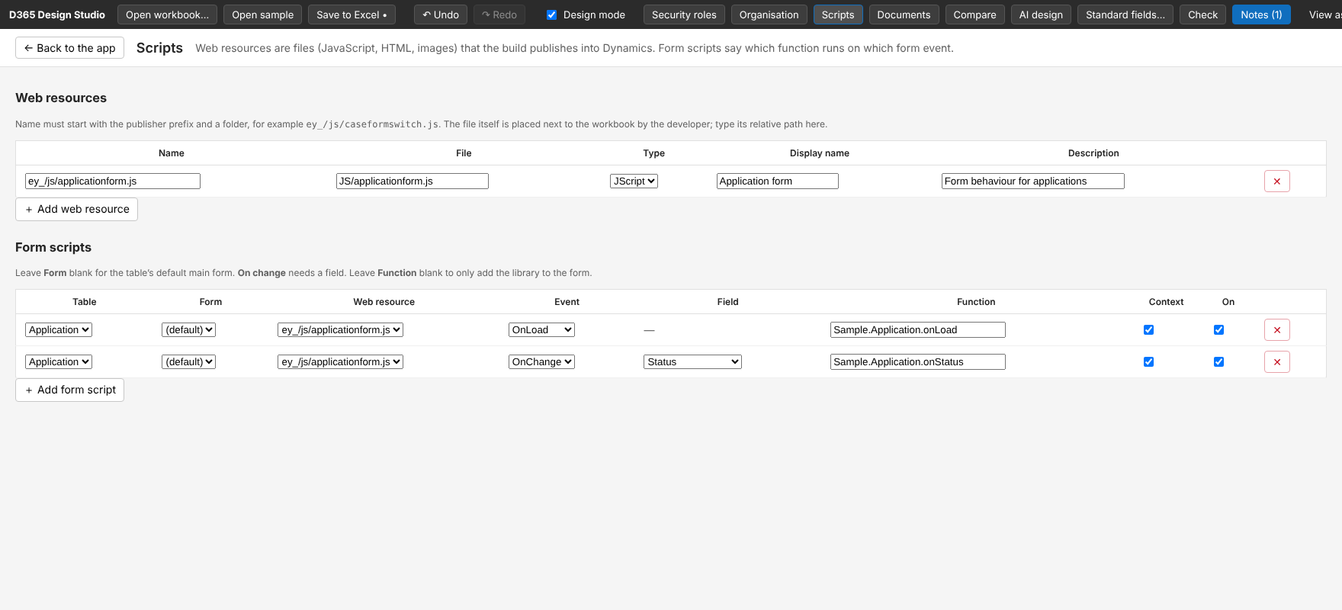
Figure 34. Web resources (top) and form scripts (bottom).
- Web resources: name (publisher prefix and folder), file path next to the workbook, type, display name and description.
- Form scripts: table, form (blank = default main form), web resource, event (OnLoad, OnChange…), field (for OnChange), function name, pass execution context, enabled.
- Leave Function blank to add only the library to the form.

12. Documents
Documents are the Word or PDF letters, certificates and summaries Dynamics will produce from a record. The BA designs the content; each section is built from lines.
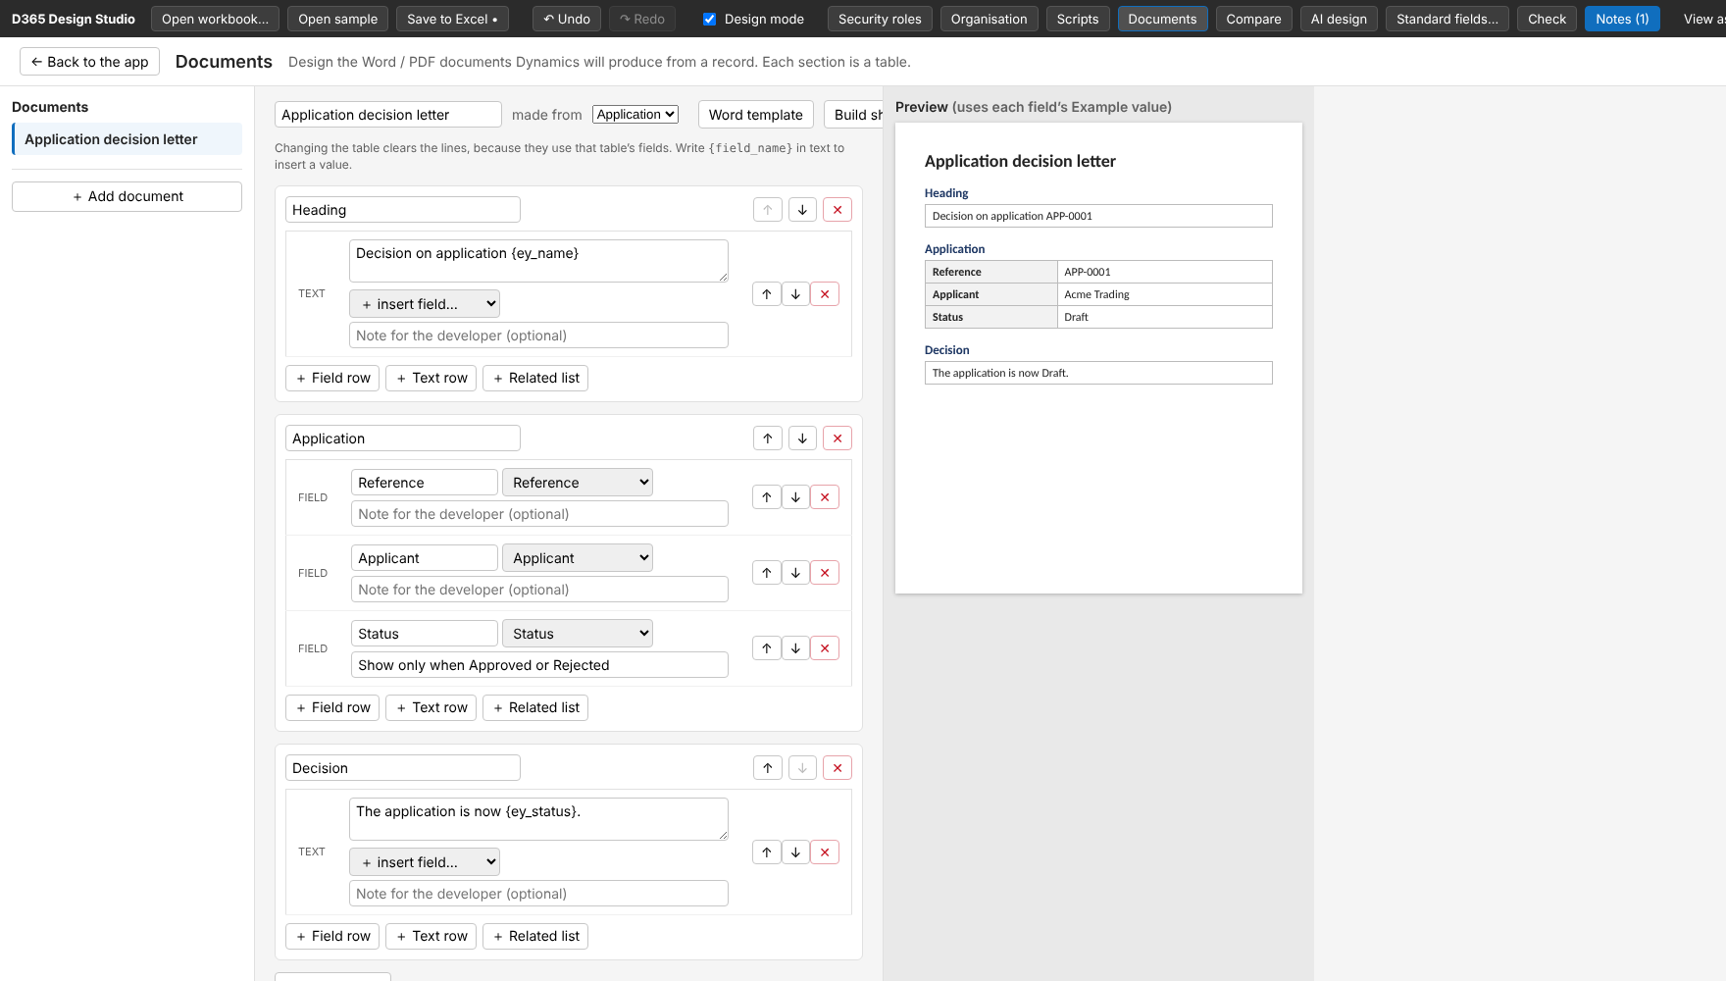
Figure 35. A document design with live preview on the right (uses each field's Example value).
Line type | Use
Text row | Free text. Write {field_name} to insert a value, or use the insert field… list.
Field row | A label plus a field from the chosen table.
Related list | A small table of child records, with chosen columns.

- made from selects the table. Changing it clears the lines, because they use that table's fields.
- Note for the developer is saved with each line (for example, "Show only when Approved or Rejected").
- Word template exports a .docx with a content control for every field. Build sheet exports a short Word sheet for the developer.

13. Compare versions
Keep a copy of the workbook before each working session, then compare to show the client exactly what changed. Nothing is edited.
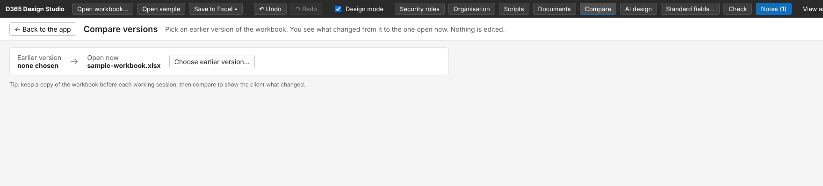
Figure 36. Compare starts with the open workbook and asks for an earlier version.
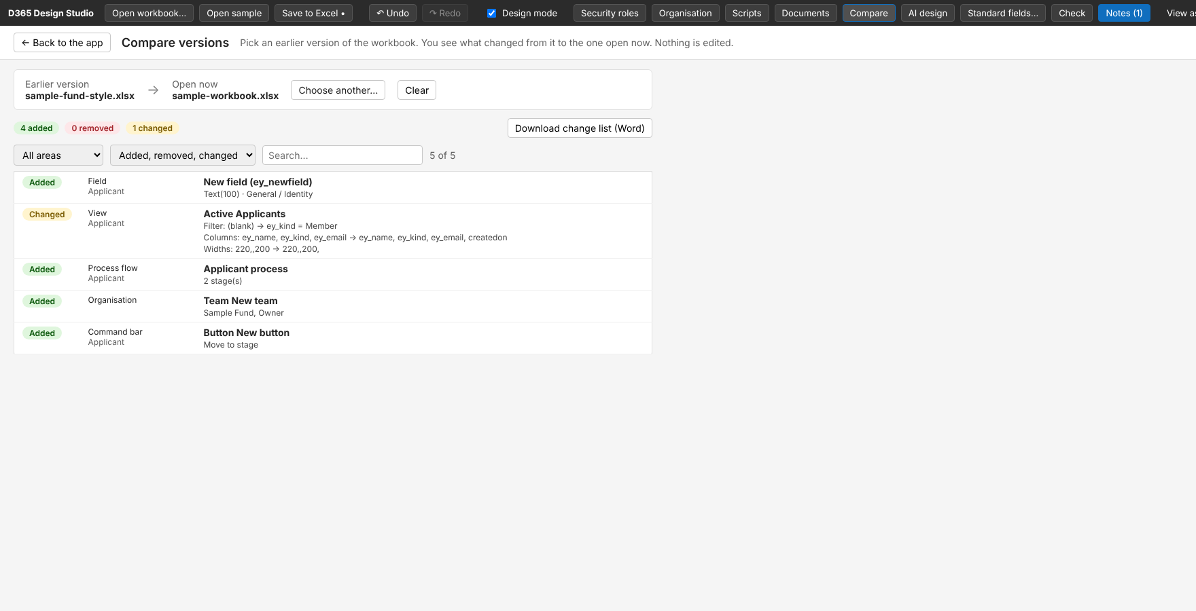
Figure 37. Result after changes: 4 added, 0 removed, 1 changed. Filter by area or search.
- Click Choose earlier version… and pick the older .xlsx.
- The summary counts added, removed and changed items across tables, fields, views, forms, flows, roles, organisation and buttons.
- Filter by area and by Added, Removed or Changed; search by name.
- Download change list (Word) produces a client-ready .docx of all changes.
- Details such as old to new filters, column lists and widths are shown on the changed rows.

14. AI design: from a process description to a design
The BA pastes a workshop note or requirement, and the AI proposes a data model and then a process flow. The AI only adds; it never changes or removes anything already in the design. The BA ticks what to keep and applies it as one undoable step.

14.1 Two ways to use it
Mode | How it works
Copy and paste (default, no key) | The Studio builds a prompt. The BA copies it into Claude, Copilot or any chat they already have, then pastes the reply back. The reply goes through the same checks as the direct mode.
Direct (needs an API key) | The Studio calls the Anthropic API from the browser. The key is kept only in the browser.

14.2 Step by step
- Open AI design and write or paste the process description. It is kept in the browser, so the BA can come back to it.
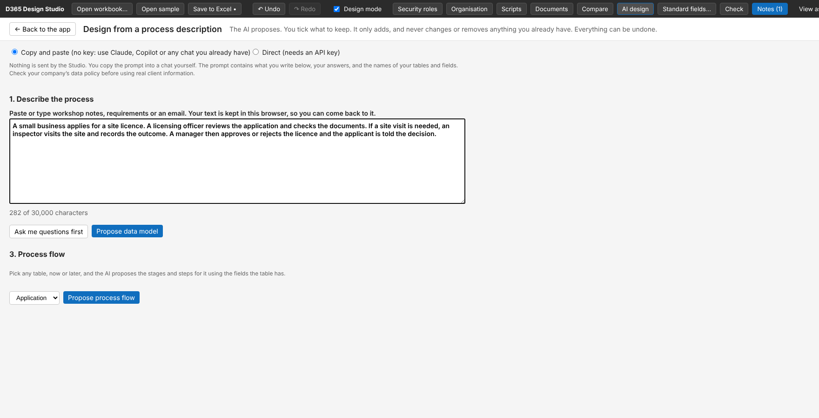
Figure 38. Step 1: describe the process. The character counter allows up to 30,000.
- Optional: Ask me questions first. The AI asks up to six short questions about what the description leaves open. Answers are included in the next prompt.
- Click Propose data model. In copy-and-paste mode a panel gives the prompt and a box for the reply.
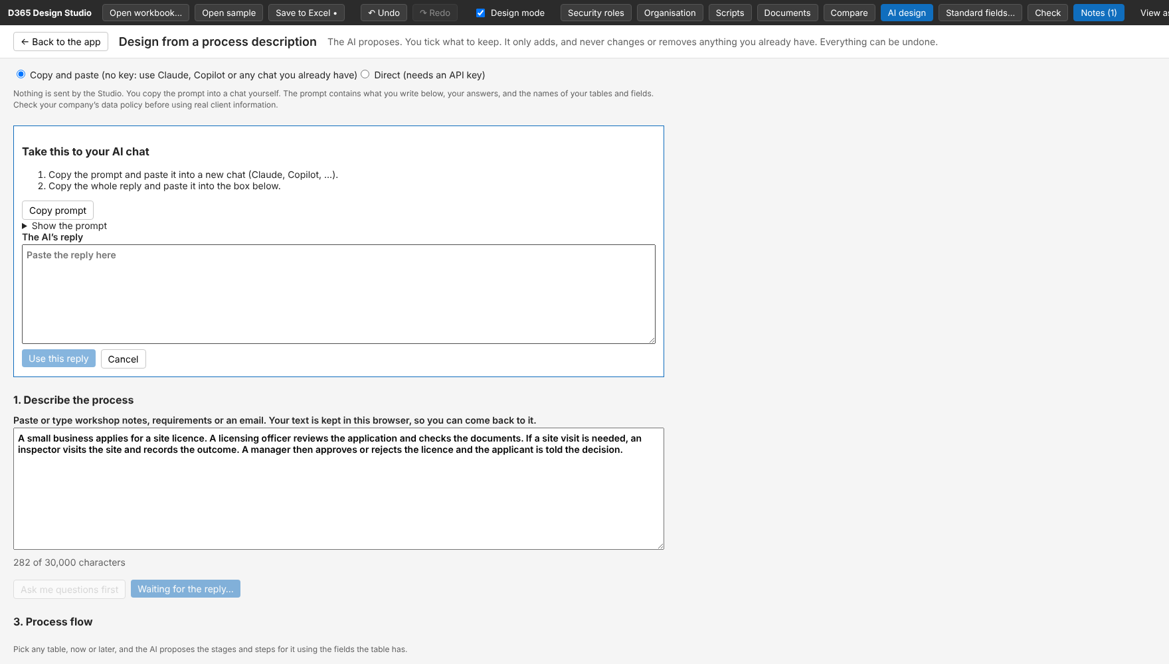
Figure 39. Step 3: Copy prompt, run it in your AI chat, paste the whole reply and press Use this reply.
- Review the proposal. New tables and the new fields of existing tables are listed with the reason for each. Untick anything you disagree with.
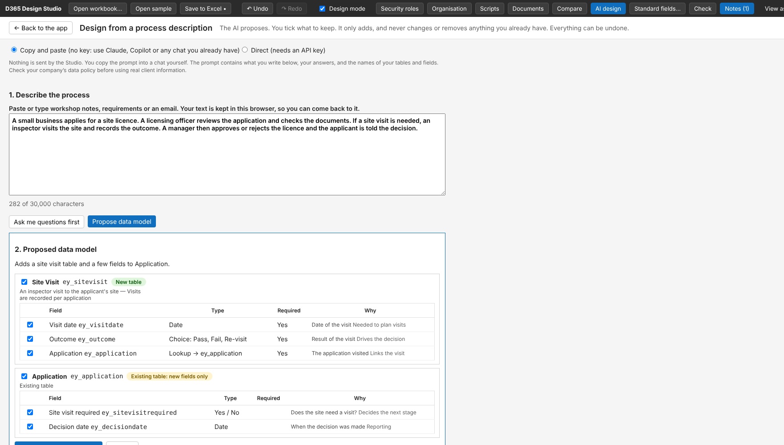
Figure 40. Review: a new table (Site Visit) and new fields on an existing table (Application, "new fields only").
- Click Add selected to the design. The tables are created, added to the Overview and the navigation, and the result is checked automatically.
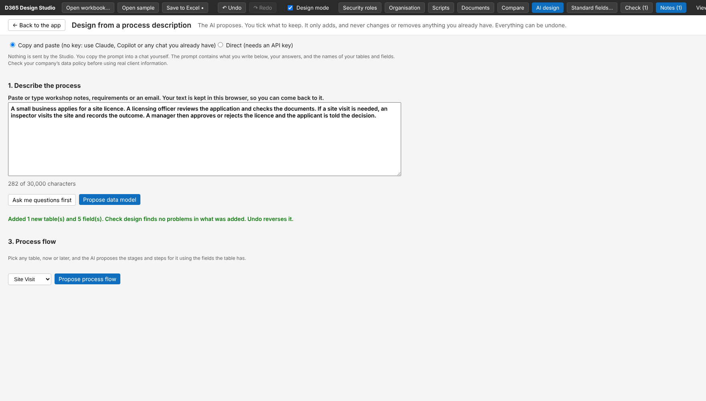
Figure 41. Applied: "Added 1 new table(s) and 5 field(s). Check design finds no problems." Undo reverses it.
- Process flow: pick any table and click Propose process flow. Review the stages and steps and add the flow.
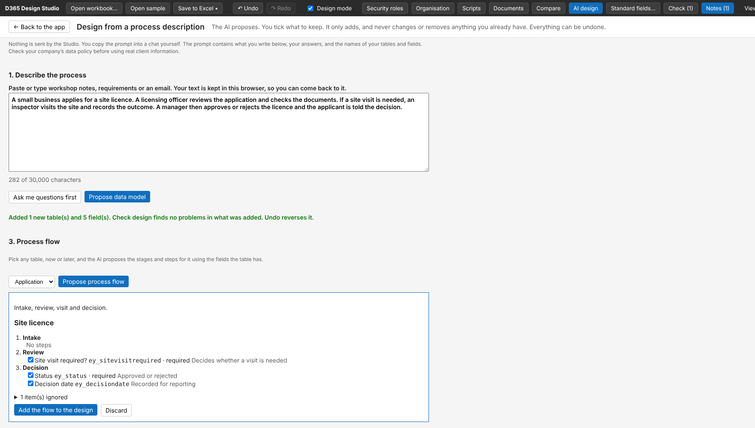
Figure 42. Flow review: stages, steps, required flags and reasons. Items that name a field not on the table are listed as ignored.
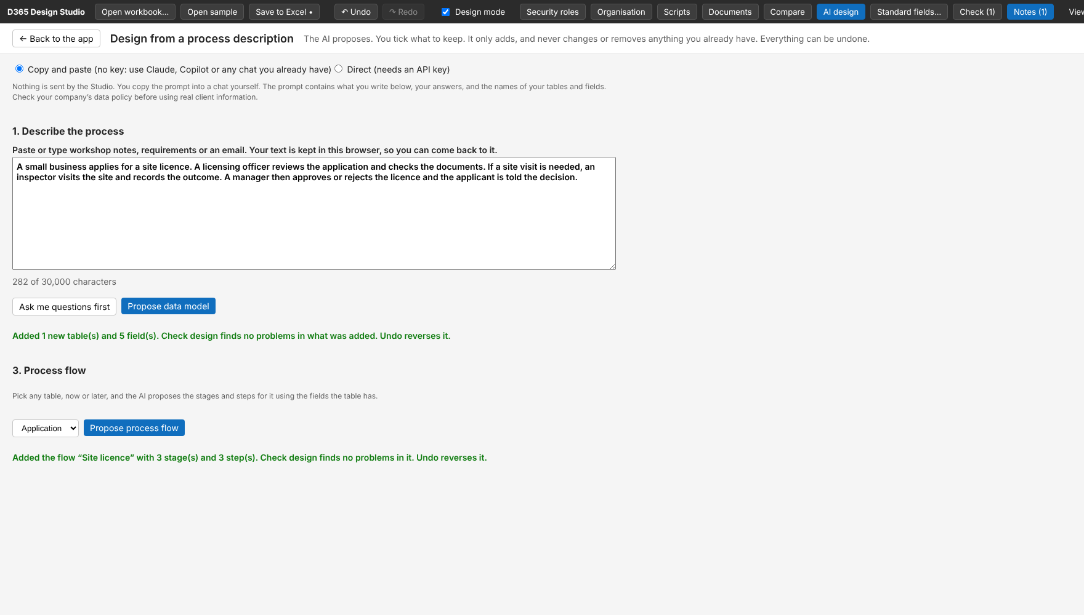
Figure 43. The flow is added to the design as one undoable step.

14.3 Safeguards
- The reply must be valid JSON that matches the Studio's format. Unknown items are dropped and listed under "item(s) ignored".
- Schema names are lower case and carry the publisher prefix. Lookup targets must exist, be in the proposal, or be a standard table.
- Limits per proposal: 12 new tables, 40 fields per table, 8 stages, 8 steps per stage.
- Only your description, answers and the table (and optionally field) names are sent; nothing is uploaded unless you copy or send it yourself.
Data policy Check your company's policy before pasting real client information into any AI chat.

15. Saving, undo and the workbook
- Save to Excel downloads the workbook. It writes only the cells that changed and leaves every other sheet and style as it was, so the workbook remains safe to use with the engine.
- New tables created in the Studio get a worksheet (header block, field header row, a primary name field), an Overview row and a sitemap entry when saved.
- Choice fields add rows to an Option Sets sheet, which is created if missing.
- Undo and Redo work across the whole session, including AI changes.

15.1 Workbook sheets the Studio reads and writes
Sheet | Content
Overview | One row per table: display name, schema name, block, purpose.
One sheet per table | Header block (title, Type, Block, Grain, Schema name, Ownership), then one row per field: names, type, length, requirement, form placement (tab, section, order, form), description, example, phase, populated by, default, validation, legacy field, migration notes.
Option Sets | Choice values for choice fields.
Sitemap | Navigation groups and pages.
Views | Named views, columns, widths, sort, filter, default flag.
Process Flows | Flows, stages and steps.
Command Bar | Form buttons.
Security Roles / Role Field Rules / Role Navigation | Table privileges, field restrictions and navigation limits per role.
Business Units / Teams | Organisation tree, teams, team type and roles.
Web Resources / Form Scripts | Scripts and the events that run them.
Documents | Document templates and their lines.
Notes | Workshop questions, decisions and actions.
Form Layout | Optional. Section columns, hidden tabs, sections and fields, label visibility and full-width fields.

The full layout is defined in docs/EXCEL_FORMAT.md in the Studio repository. That document is the contract for both the Studio and the engine.

16. Working with the engine, and current limits

16.1 After the design: building it
- validate: reads the workbook and reports errors and warnings. Fix errors in the Studio, save, validate again.
- deploy with --dryrun true: shows what would be created. Then run for real against a non-production environment first.
- views: creates or updates the views. The second run should report existing views as UPDATED.
- org: creates business units and teams (dry run is the default).
- Check in make.powerapps.com and the admin center, then compare against the design.

16.2 Current limits
- Default value and validation rule are recorded for the developer; the build does not apply them yet.
- AI design only adds. It does not edit or remove existing items.
- AI design has been tested with simulated replies. Real replies from Claude or Copilot may need small prompt tuning.
- Table settings such as display name and ownership are not editable yet for existing tables.
- Ownership: the engine reads the Ownership row and creates an Organization-owned table as such. The type cannot be changed once the table exists in Dynamics. The engine warns when an Organization-owned table has an owner field, owner-based views, or privileges below Organization level.
- Form Layout settings (columns, hidden, labels, full width) are read by the engine and checked offline on a real form, but not yet in a live deployment. Moving a section or field to another tab changes the Tab, Section and row order, and takes effect for fields that are not yet on the live form. A field already on a live form is not moved.
- The Studio does not connect to Dynamics. Everything is read from and written to the workbook.
- Sample values typed in Preview are for the demo only. They are not saved anywhere, and Documents previews still use each field's Example value.

Appendix A. Screenshot guide
Use this appendix to retake the screenshots with your own project, for example for a client handover pack. The images in this guide were taken in Chrome at 1760 × 1000 pixels from the built-in sample.
Fig. | Screen | How to reproduce it
1 | Start screen | Open the HTML file with no workbook.
2 | App shell and list | Open the sample. Tables are in the left navigation; the first page opens its default view.
3–5 | View designer | Open the view picker for a second view; add a column with + Add a column…; type a filter.
6–10 | New table | In design mode click + New table under the navigation. Type a display name; choose Organization to see the note about organization-owned tables; type an existing name to see the error.
11–13 | Form and properties | Click a record. Click a field to open properties. Click + Field in a section.
15–19 | Layout settings | Add a second tab with + Tab. Click the gear icon next to a section or tab. Click a field and look under On the form.
14 | New form | Click + Form under the record title.
20 | Process flow | Click + Add a business process flow, then + Stage. Select a stage to see the right-hand panel.
21 | Command button | Click + Button on the command bar.
25–27 | Check, Notes, Migration | Click Check, then the Notes and Migration tabs of the panel.
23 | Typed sample values | Untick Design mode, type in a field, and note Reset sample data on the top bar.
22–24 | Preview and View as | Untick Design mode. Choose a role in View as.
28–31 | Security roles | Open Security roles. Click each tab.
32–33 | Organisation | Open Organisation. Click + Add team.
34 | Scripts | Open Scripts.
35 | Documents | Open Documents. The preview is on the right.
36–37 | Compare | Open Compare. Choose an earlier version of the workbook.
38–43 | AI design | Open AI design, type a description, then Propose data model. Paste a reply, apply, then Propose process flow.

Tips for good screenshots
- Use a window about 1700 pixels wide so the whole top bar is visible. Zoom the browser to 100%.
- Use the sample or invented data. Never include real client names, people or amounts in a document that leaves the team.
- Set Design mode on for design screens and off for the preview and View as screens.
- Crop to the part of the screen that matters; keep the caption short and say what to look at.
- Retake a screenshot whenever the Studio changes visibly, so the guide matches the tool.

