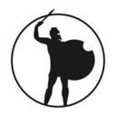

**IRONCOIN WHITEPAPER**

09.05.2018 #2.0



Proposed and made by

# Kowai - Story teller

Head of the Faceless Men

Free city of Braavos

# History

The Iron Bank was established before the apocalypse dawned on ancient Valyria, when Braavos was not yet concurred by the Valyrian Empire. Its founders were affluent craftsmen and traders. The name ‘Iron Bank’ originates form the vault in which the account holders paved their possessions, which happened to be a diminished iron mine. Furthermore, the bank’s sole entrance was heavily guarded by reinforced iron gates and bars, as well as human security guards. Since then, the bank has undergone radical transformation, but the vault still remains, acting as both a depository and a tourist attraction site.

What Does It Do?

The Iron Bank is perhaps the most powerful banking institution, with a client base covering both Essos and Westeros. Similar to other banks, this establishment finances their customer when they need capital to start a project. However, unlike its peers, the Iron Bank does not class its clients, and treats them equally regardless of their social status.

Why Is It Powerful?

Every city has its own bank, but none is as wealthy as the Iron Bank. In fact, the Iron Bank is richer than the combined worth of the eight other banks. This affluence makes the Iron Bank a huge influencer of the local politics, as Kings are obligated to honor the bank, lest they get overthrown.

## The IronCoin Symbol

The symbol on the IronCoin takes after the famous Titan of Braavos, a giant statue that is located on the on the Braavos harbor. The massive figurine is local landmark due to its conspicuous nature, standing well over 400 feet above the ground.

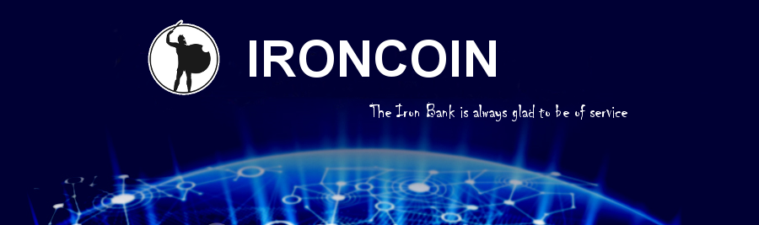

# Overview

We are pleased to be a community of enthusiastic fans of Game of Thrones. If you are reading those lines, the project we have is **getting the attention it deserved** and the time has come for us to join forces.

# Who we are

We are a **non-profit group of fans gathering under the Ironcoin**. We would like to use this coin as an anchor that will link the virtual Game of Throne world, to reality.

**What is a Ironcoin**

The Ironcoin is the real perfect match of the fantasy coin from the Iron-bank of Braavos. The main difference is, this coin is numeric ! Safe and tradable using the blockchain technology, it has the potential to be spent just like any other coin.

The Ironcoin only have the value we give him. In the time we are writing those line, it doesn’t have any, and our idea is to make the Ironcoin flourish in the same time as it’s community will grow.

**How will it’s value grow ?**

We are looking for a steady growth with quality relations with our community, we will encourage early adopter and to make it famous, we promote it on exchanges and website comparing cryptocurrencies.

Also the close link with our community will encourage them to spread the news about this opportunity. As the community will get bigger, so will our aspirations with the range of possibilities that will be offered to us…

Other cryptocurrencies similar to the fancoin Ironcoin had already great success, the Ironcoin will make no exception.

# Goals

Following our roadmap. We aim to reach some specific goals in the early age that is divided in 3 mains ideas but is still subject to evolution.

1. **Expansion** : Gather fans and promote got values around the ironcoin. Our goal is to expand the Game of thrones legacy beyond the wall of ice, further than the highest mountains, deeper than the sea. We want everyone to be aware and recognize the power of the ironbank. We give the richest queen the same open arms as the poorest boy.
2. **Acceptation** : Use the legitimacy of those fan to contact you and merge our power for a common goal.
3. **Developpement** : After being accepted, this coin could simply become a sort of pension funds for its Fans during generations and have such a greater meaning than just a company number. Users would feel like belonging to the story !

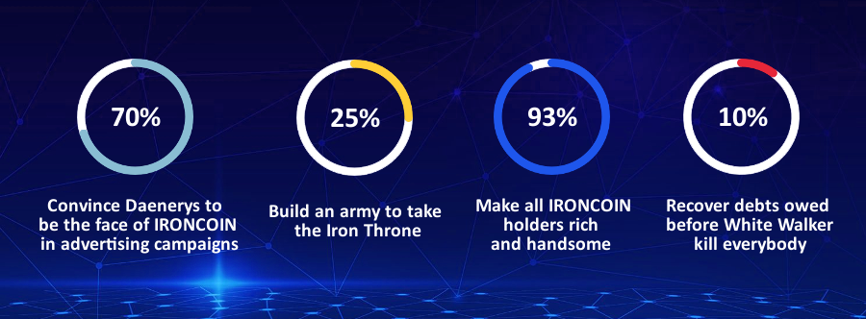

**Specifications**

*“roadmap that will meet citizen of Braavos enthusiasm”*

To reach those goals, we need an objective full of promises. And I have just what we need. It might sound crazy, but that’s our goal, we want to be number one and this is how we will do it.

## Epic stages

|  |  |  |
| --- | --- | --- |
| The Age of the first Men | The Great War | The White walker’s march |
| The Awakening of the dragon | - | - |

Each Milestones will have it’s own goals and promises to be explained in the next section. All those explained with some historical data from the IronBank, Westeros and the 7 Houses.

# Milestones

## I. < The Age of the first Men >

*In the Dawn Age of Westeros, before the coming of man and the raising of castles and cities, there were only the Children of the Forest.*" ―[Bran Stark](http://gameofthrones.wikia.com/wiki/Bran_Stark)

During this age the children of the forest are creating and gathering an anthic power. In this early age, great power are sleeping. Early adopters will enjoy Airdrop age. Our idea is to gather a community of enthusiastic people that will share our beliefs : Shadows are full of horrors and the Ironbank future is bright.

## II. < The Great War >

*“Though the object of being a Great Power is to be able to fight a Great War, the only way of remaining a Great Power is not to fight one.”*

[*― A.J.P. Taylor.*](https://www.goodreads.com/author/show/12831.A_J_P_Taylor)"

The Great War is the consequence of gathering such a power in a tiny space. The power only aim to be freed and this potential comes naturally with disasters and unprecedented opportunities. It’s now too late for be newcomers to be called “the First Men”, nevertheless this is the golden age for the Lannister. They founded their fortunes with wise investment they made at that time in the newly created Ironbank. During this age, we will ask all our community to promote a document suggesting George R.R Martin to recognize and accept to promote our coin.

## III. < The White walker’s march >

*“In that darkness the White Walkers came for the first time. They swept through cities and kingdoms, riding their dead horses, hunting with their packs of pale spiders big as hounds."* [*―Old Nan*](http://gameofthrones.wikia.com/wiki/Old_Nan)

The Great War is over, it left great scars in Westeros. Now that the first men almost disappeared, the territory is divided by the very famous 7 houses that HODL the power. All those houses had what seemed like a never ending conflict and war and the IronBank thanks to its supply of Ironcoin kept the power balanced helping unlucky houses to survive the great war and maintain their influence over their enemies.

This conflicts ended because of the arrival of a greatest enemy. The battle of life against death, the battle that started with the moves of the white walkers heading south : Winter is coming. The Ironbank will again need to use it’s influence to unite all the houses to fight this greatest enemy.

## IV. < The Awakening of the dragon >

*“Valar Morghulis.*" ― [Faceless Storyteller](http://gameofthrones.wikia.com/wiki/Bran_Stark)

The north can’t hold the white-walker anymore. Winter is here, the bank has been betrayed by the Lannisters ( they pretended to have plenty of gold in their mine ), thus couldn’t unify the main houses using the influence of it’s precious ironcoin. They kept fighting.

Only one hope remains, gather what is left of the Ancien Power : the children of the forest, the house Strack and the prophecy that claim the rise of a new Queen - The Mother of Dragons - Queen of unsullied.

# Requirement for each ages

## The Age of the first Men

**Distribute coins** : Airdrop, Contests, Rewards,

**Strong community** : Twitter event, challenge,

**Social media** : Twitter, Reddit, Telegram,

**Website 1.0** : English, Non-profit, Fan-based,

Explaining that our community want our coin to be recognised

**Expend** : More and more exchanges.

## The Great War

**All coin distributed**

**Strong community** : Monthly report, keep community practices

**Website upgrade** : New look, all multi languages.

**Expend** : More and more exchanges.

## The White walker’s march

**All coin distributed**

**Strong community** : Monthly report, keep community practices **Network upgrade** : Change the Erc20 token to more effective ones.

**Expend** : More and more exchanges.

The Awakening of the dragon

**When the** **Ironcoin get out of ETH blockchain for it’s own.**

# Distribution of coins

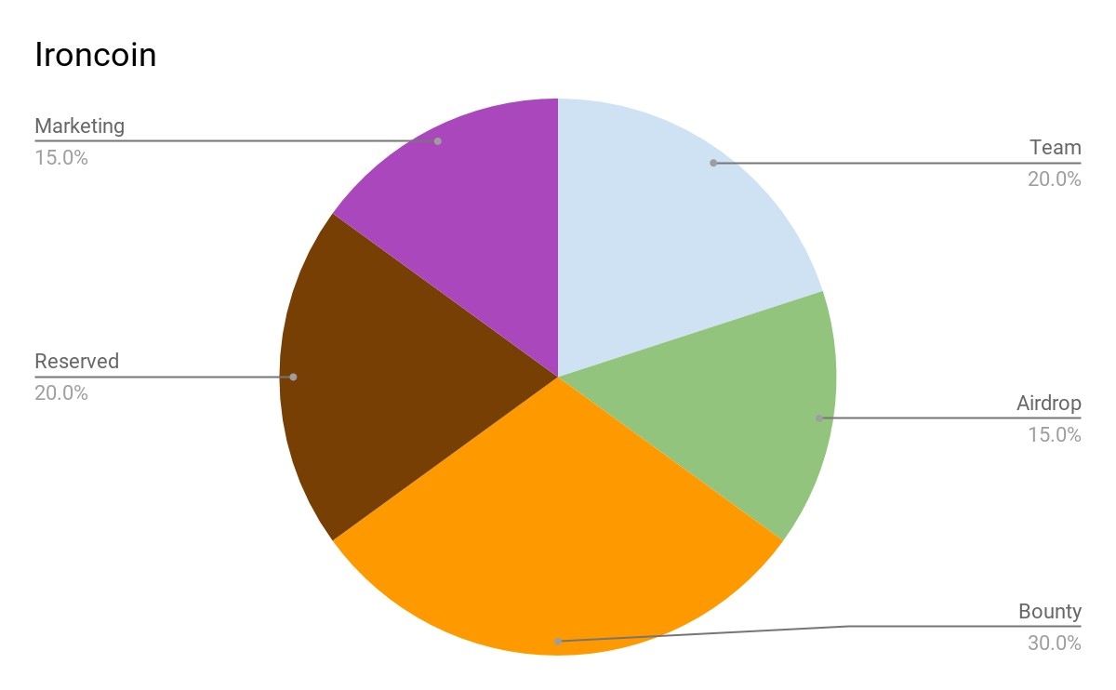

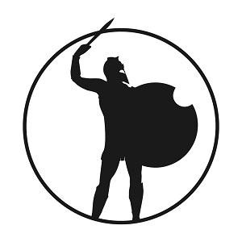

**Contract Address :**

0x1f21d8395655fb262251897df7cb3c9358bec6a2

*Do not send ether to this address. This is the token itself*

**Symbol :** IRC

**Decimals :** 8