Mini Project Report
Of
CLOUD COMPUTING AND DEVOPS LAB [CSE 3130]
AUTO-SCALING AND SELF-HEALING
CLOUD-NATIVE APPLICATION
USING KUBERNETES, DOCKER, TERRAFORM AND AWS
Student Task Manager
SUBMITTED BY
Myisha Siddiqui | Manan Bhasin | Rishabh Raj
Registration numbers: Myisha Siddiqui — 240905560; Manan Bhasin — 240905492; Rishabh Raj — 240905420
Under the Guidance of
Dr. Anup Bhat B — Assistant Professor
Dr. Sangeetha T S — Assistant Professor-Senior Scale
Dr. Hirdesh Varshney — Assistant Professor
July–November 2026
SCHOOL OF COMPUTER ENGINEERING
Manipal Institute of Technology, Manipal
25 October 2026
CERTIFICATE
This is to certify that the project titled “Auto-Scaling and Self-Healing Cloud-Native Application using Kubernetes, Docker, Terraform and AWS: Student Task Manager” is a record of the bona fide work done by Myisha Siddiqui, Manan Bhasin, and Rishabh Raj, submitted in partial fulfilment of the requirements for the award of the Degree of Bachelor of Technology (B.Tech.) in the School of Computer Engineering of Manipal Institute of Technology, Manipal, Karnataka, a constituent institute of Manipal Academy of Higher Education, during the academic year 2026–2027.
Student registration numbers: Myisha Siddiqui — 240905560; Manan Bhasin — 240905492; Rishabh Raj — 240905420.
Name and Signature of Examiners
______________________________________________ Date: ______________
Dr. Anup Bhat B
______________________________________________ Date: ______________
Dr. Sangeetha T S
______________________________________________ Date: ______________
Dr. Hirdesh Varshney
TABLE OF CONTENTS
Abstract
CHAPTER 1: INTRODUCTION
CHAPTER 2: METHODOLOGY
CHAPTER 3: RESULT ANALYSIS
CHAPTER 4: CONCLUSION
REFERENCES
ABSTRACT
This mini project implements a cloud-hosted Student Task Manager and uses it to demonstrate container delivery, infrastructure as code, Kubernetes pod autoscaling, recovery, and monitoring. The browser dashboard and REST API are delivered by a Java 21 Spring Boot application; task records are stored in MySQL on a private Amazon RDS instance. Docker packages the service, Amazon ECR stores its image, and Terraform provisions the AWS network, EC2 host, database, registry, and access configuration. A single EC2 instance in Sydney runs K3s. Kubernetes exposes the API through a NodePort Service, monitors application health, and uses a Horizontal Pod Autoscaler (HPA) to adjust the API pod count between one and two based on CPU utilization.
The live demonstration verified browser/API operation, a bounded read-only load test, HPA scale-up and scale-down, Deployment replacement after pod deletion, and container restart after a controlled liveness-probe failure. Prometheus, kube-state-metrics, and Grafana were deployed privately in the cluster. The load run completed 5,699 requests at approximately 43.7 requests per second with no failed requests and a p95 response time of 403.98 ms. The evidence supports pod-level elasticity and recovery on the demonstration host; it does not establish EC2 host failover or multi-node high availability.
Keywords: Kubernetes, K3s, Docker, Terraform, AWS, HPA, self-healing, Prometheus, Grafana, MySQL.
CHAPTER 1
INTRODUCTION
1.1 Background
Cloud-native applications package services into containers and use an orchestration platform to place, monitor, and replace those containers. This project applies that approach to a small student task application. A browser dashboard sends task requests to a REST API. The API persists tasks in MySQL, while Kubernetes manages the application pods and routes requests to ready instances. Docker provides a repeatable application image, Terraform describes the cloud resources, and AWS supplies compute, database, and image registry services [1], [2], [3], [5].
1.2 Problem and motivation
A task service should remain usable when an application process or pod becomes unhealthy, and it should add application replicas when request load increases. Manually creating hosts and configuring application environments makes deployments harder to repeat. The project therefore combines infrastructure automation with Kubernetes health checks, declarative workload management, and CPU-based pod autoscaling. The prototype is intentionally small enough to deploy and inspect in a cloud lab.
1.3 Aim and objectives
The aim is to build and demonstrate a browser-accessible, cloud-native task manager and verify its deployment, scaling, recovery, and monitoring behavior.
Objective | How it is addressed | Evidence
Deliver a working task manager | Browser dashboard and REST API backed by MySQL | Live UI/API checks and task screenshots
Package the application consistently | Multi-stage Docker image stored in Amazon ECR | Dockerfile and deployed image
Automate cloud infrastructure | Terraform definitions for the AWS demo environment | GitHub Actions Terraform format/validation
Scale application capacity | Kubernetes HPA targets 60% CPU; bounds 1–2 replicas | 30-VU k6 run and HPA observations
Recover from pod/process failure | Deployment reconciliation and liveness/readiness probes | Replacement pod and restart evidence
Observe application and cluster | Prometheus, kube-state-metrics, Grafana dashboard | Targets, datasource and live query results
Table 1.1: Project objectives and corresponding verification evidence.
1.4 Scope and cloud features
The implemented application is a Student Task Manager. Its task operations include create, list, view, edit, status update, and delete. Task states are TODO, IN_PROGRESS, and DONE. The original planning concept referred to student records; during implementation the team adapted the application domain to task management while keeping the cloud deployment, scaling, and recovery goals.
• On-demand infrastructure: EC2, RDS, and ECR resources are defined for the AWS Sydney Region (ap-southeast-2).
• Resource pooling and managed networking: the VPC separates the public application host from private database subnets; database access is restricted to the application security group.
• Elasticity and measured service: Kubernetes can increase or reduce API pod replicas based on observed CPU utilization; Prometheus collects application and cluster metrics.
• Automation and repeatability: Terraform manages infrastructure configuration, while Kubernetes manifests describe the application and monitoring workloads.
1.5 Success criteria and limitations
Success is defined as a working deployed task interface, API connectivity to persistent MySQL storage, a repeatable container image, infrastructure validation, observable HPA behavior, and recovery from pod/process failure. The deployed cluster has one EC2 node and the HPA permits at most two application pods. These constraints make the project a lab demonstration rather than a high-availability production service.
CHAPTER 2
METHODOLOGY
The implementation follows a build–package–provision–deploy–observe workflow. The browser and API run in the same Spring Boot service. Task data is stored in RDS MySQL. Terraform creates the AWS foundation; Docker creates the application image; ECR stores the image; K3s schedules the application and monitoring workloads. The diagram summarizes the request path and the supporting deployment path.
Request and data path | Build and operations path
Browser dashboard  ↓  Kubernetes NodePort Service (30080)  ↓  Spring Boot API pod(s) in K3s  ↓  Private Amazon RDS MySQL | Source and tests → Docker image → Amazon ECR → K3s deployment  Terraform → VPC, EC2/K3s host, RDS, ECR, IAM and security rules  Actuator + kube-state-metrics → Prometheus → Grafana (private SSM tunnel)
Fig. 2.1: System architecture and build, deployment, and monitoring paths.
2.1 Application and request workflow
The dashboard is served from the Spring Boot application's static resources, so browser calls use the same origin as the REST API. The controller receives validated requests, the service layer applies task operations, and the repository uses Spring Data JPA to read and write MySQL records. The API exposes task endpoints under /api/tasks and health/metrics endpoints through Spring Boot Actuator. No authentication or per-user task ownership is implemented in this prototype.
2.2 Container build and image storage
The Dockerfile uses a multi-stage build. Maven and the Java 21 build image create the application artifact; a smaller Java 21 runtime image runs the packaged service. The runtime uses a non-root user. The built image is pushed to Amazon ECR and pulled by K3s using a Kubernetes image-pull secret. This separates build tooling from runtime and gives the cluster a versioned image source [1].
2.3 Infrastructure provisioning with Terraform
Terraform describes the AWS demo resources in ap-southeast-2: a VPC, public application subnet, private database subnets, routing, security groups, one EC2 K3s host, private RDS MySQL, an ECR repository, and IAM permissions for Systems Manager, image pulls, and database-secret access. The database accepts MySQL traffic only from the application host security group. The public SSH port is not opened; the host is administered through Systems Manager. Terraform provides a reviewable plan before changes are applied [2], [3].
2.4 Kubernetes deployment and health management
K3s runs as a single-node Kubernetes cluster on EC2. A Deployment maintains one baseline task-manager API pod and uses a rolling update strategy. The pod has CPU and memory requests/limits and runs as a non-root user with a read-only root filesystem. Startup, liveness, and readiness probes call Actuator health endpoints. The NodePort Service maps host port 30080 to application port 8080, and the database remains private [5].
2.5 Horizontal pod autoscaling
The autoscaling/v2 HPA observes average CPU utilization relative to the API container's CPU request. Its target is 60%, with a minimum of one and maximum of two replicas. A 180-second scale-down stabilization window reduces rapid oscillation after load falls. CPU requests are configured because utilization-based HPA calculations depend on resource requests [4]. The HPA changes pod count only; it does not add EC2 nodes or resize RDS.
2.6 Monitoring
Prometheus scrapes Spring Boot Actuator's Prometheus endpoint and kube-state-metrics at 15-second intervals. Grafana reads from Prometheus and presents six panels: request rate, 5xx response rate, mean request duration, ready versus desired API replicas, JVM heap, and process CPU. The monitoring services use private ClusterIP endpoints and are reached through an authorized Systems Manager port-forward. Prometheus retains up to six hours or 256 MB in temporary storage; Grafana's local database is also temporary [6]–[8].
2.7 Verification procedure
Verification combined application checks with controlled operational exercises. The browser UI and readiness endpoint were checked through an SSM tunnel. A bounded k6 script issued read-only GET requests to /api/tasks, ramping to a maximum of 30 virtual users. Kubernetes status and HPA metrics were observed during load and after it stopped. Separately, an API pod was deleted to observe Deployment reconciliation, and a controlled Java-process pause was used to exercise the liveness probe. Monitoring target health and selected PromQL values were checked after deployment. These exercises were run against the team's demo environment, not a production workload.
CHAPTER 3
RESULT ANALYSIS
This chapter reports results captured from the deployed Sydney demo environment on 25 October 2026. The UI screenshots show task interactions; the load, HPA, recovery, and monitoring figures are taken from the recorded demo evidence. The k6 workload was read-only and did not change task data.
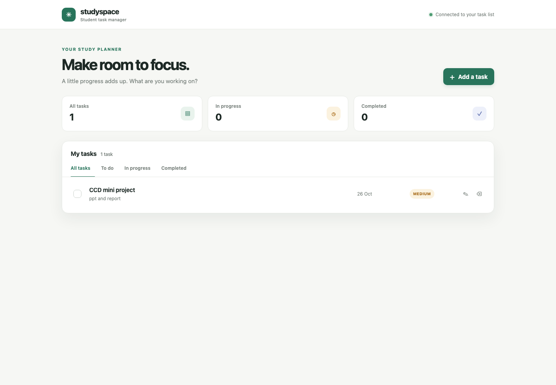
Fig. 3.1: Student Task Manager dashboard served by the deployed application.
The dashboard displays the saved task list and indicates that the API is connected. The app responds through the Kubernetes NodePort over a temporary SSM tunnel. The task-created and task-completed screenshots below record the user-facing interaction; the temporary evidence task was removed after capture, and the original task list was verified unchanged.
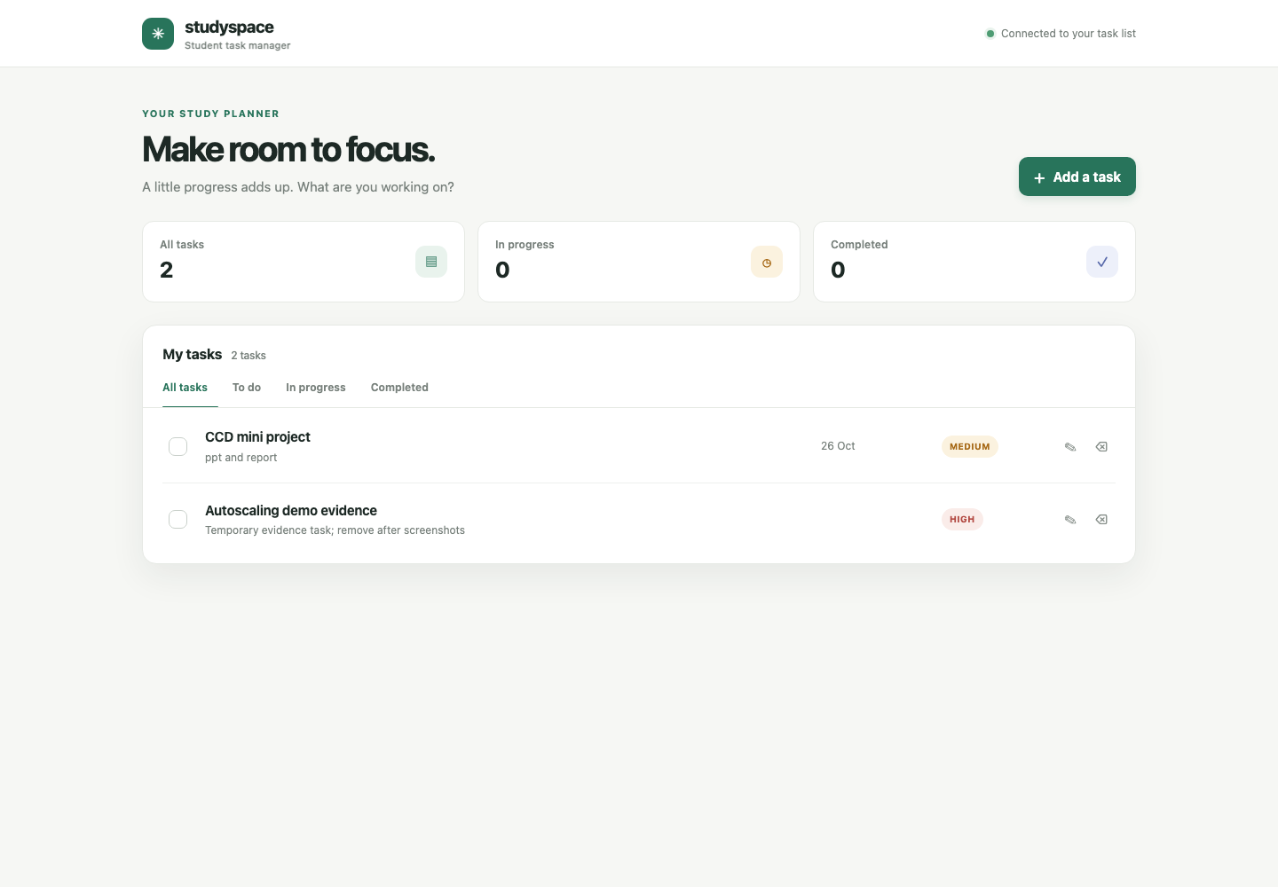  Fig. 3.2: Task created in the deployed app. | 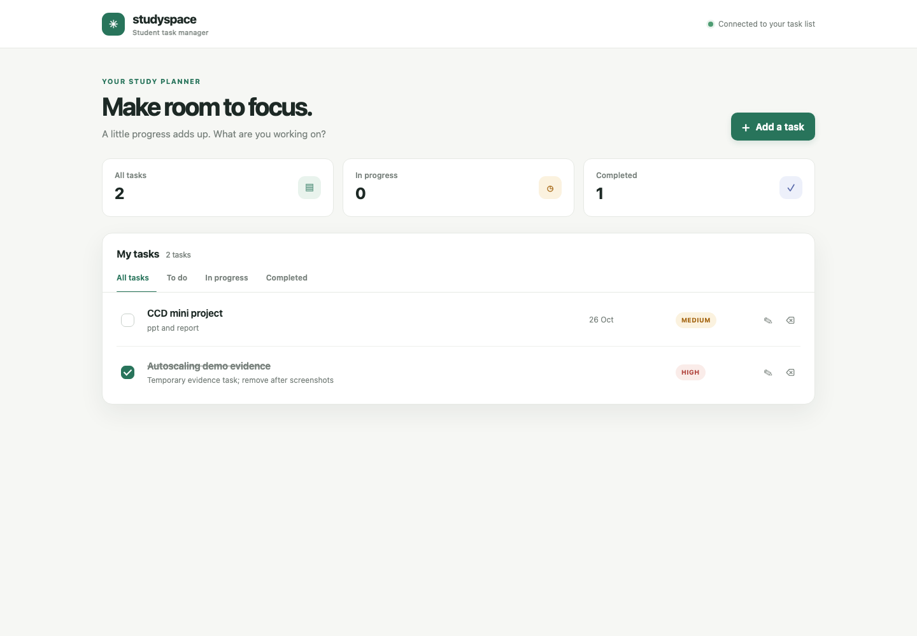  Fig. 3.3: Task marked complete in the deployed app.
The evidence task was created as ID 3, changed to DONE, and then deleted with HTTP 204. A final API read showed only the pre-existing task (ID 2).
3.1 Load-test results
The autoscaling workload ramped up over 20 seconds to 5 virtual users, over the next 30 seconds to 15 users, held at up to 30 users for 60 seconds, and ramped down over 20 seconds. It repeatedly requested the task list endpoint and checked for HTTP 200 JSON responses. The script limits the run to 30 VUs and defines thresholds of less than 1% failed requests and p95 below 1,500 ms.
Measure | Observed result | Interpretation
Maximum virtual users | 30 | Bounded concurrency for the demonstration
HTTP requests | 5,699 | Read-only GET /api/tasks requests
Request rate | Approximately 43.7 requests/second | Throughput during the recorded run
Failed requests | 0 (0.00%) | No request failures observed in this run
p95 response time | 403.98 ms | 95% of observed requests completed within this time
Table 3.1: Recorded results from the bounded k6 workload.
The result indicates that this deployment served the tested read-only workload without failed GET requests during the measured run. It does not characterize write throughput, long-duration stability, performance under database contention, or behavior with a larger cluster.
3.2 Autoscaling results
Phase | HPA / pod observation | Result
Before load | 1 replica; target CPU 60% | Baseline Deployment 1/1 Ready
During load | CPU reached 319% of the pod CPU request; desired replicas rose to 2 | Both API pods reached 1/1 Running
After load | After the 180-second stabilization period, replicas returned to 1 | Deployment returned to 1/1 Available
Table 3.2: HPA observations during and after the load run.
The HPA target is relative to the configured CPU request, not a percentage of the entire EC2 host's CPU. The observed peak of 319% therefore means the measured pod CPU was substantially above its request. The HPA successfully added one pod, but the configured maximum of two and the single-node cluster bound the experiment. Scale-down occurred after the configured stabilization delay.
3.3 Recovery and CI results
Exercise | Observed result | What it demonstrates
Delete an API pod | Deployment created a replacement pod; replacement reached 1/1 Running | Controller reconciliation restores desired pod count
Pause Java process | Liveness probe failed, container restart count became 1, readiness returned UP | Probe-driven container restart and recovery
GitHub Actions CI | Application test/package/container build and Terraform format/validation passed | Build and infrastructure configuration checks; no automatic AWS deploy
Table 3.3: Recovery exercises and continuous-integration checks.
The pod deletion test first encountered an expired ECR pull credential, so the replacement could not initially retrieve its image. After refreshing the pull secret, a replacement pod became ready. This is a practical operational limitation: ECR authorization tokens expire after 12 hours, and the demo currently needs a refresh before later image pulls. GitHub Actions validates and packages the project but does not yet publish the image to ECR or roll out a deployment. The recorded CI run is [9].
3.4 Monitoring results
Component / signal | Recorded observation
Prometheus targets | Application, kube-state-metrics, and Prometheus targets all UP
Grafana | Provisioned datasource health OK; six-panel operations dashboard loaded
Application request rate | 0.3719 requests/second over the queried 5-minute window
HTTP 5xx rate | 0 in the queried window
Mean request duration | 0.00893 seconds in the queried window
API / HPA replicas | 1 ready API replica; HPA current replica count 1
JVM heap / process CPU | 49,917,728 bytes / 0.0293 process CPU
Node and monitoring memory | EC2 node 6% CPU and 70% memory used; Grafana about 140 MiB
Table 3.4: Snapshot of live monitoring checks and Prometheus query results.
These values are a snapshot rather than a long-term performance profile. A Grafana PNG was not captured because the image-renderer endpoint was unavailable in this environment; the dashboard configuration, datasource health, panel response, Prometheus targets, and live queries were verified. Prometheus uses temporary storage with up to six hours of retention, and Grafana's local database is temporary. Consequently, monitoring history is not durable across pod replacement.
3.5 Analysis against objectives
The application, container, Terraform, and Kubernetes objectives were met for the current demonstration. The load run showed HPA scale-up and subsequent scale-down, while the deletion and liveness tests showed two distinct pod-level recovery mechanisms. Prometheus and Grafana provided application and Kubernetes signals that can be inspected during a demonstration. These observations support the project's learning objectives, but the single EC2 host remains a shared failure point. HPA pod scaling does not increase host capacity and cannot provide host-level fault tolerance.
3.6 Cost analysis
The Sydney on-demand model estimates about $47.31 per month before taxes, credits, and variable charges. It assumes 730 hours, one EC2 t3.small host, one public IPv4 address, one Single-AZ RDS MySQL db.t4g.micro instance, the configured 30 GB EC2 and 20 GB RDS gp3 volumes, one Secrets Manager secret, and 1 GB of ECR image storage.
Estimated monthly line items are EC2 compute $19.27; EC2 gp3 disk $2.88; public IPv4 $3.65; RDS compute $18.25; RDS gp3 storage $2.76; Secrets Manager $0.40; and assumed ECR storage $0.10. The calculation and assumptions are in COST_ANALYSIS.md; AWS pricing sources [11]–[15] are listed in References.
The HPA changes API pod count on the same fixed EC2 and RDS resources, so pod scale-up or scale-down has approximately $0 effect on these provisioned hourly charges. A hypothetical additional worker node used for 146 hours per month would have $3.85 compute cost versus $19.27 if kept on for 730 hours; the $15.42 difference is compute-only, projected, and not implemented.
This is a list-price model, not the AWS account bill. AWS CLI credentials were unavailable for Cost Explorer verification. The estimate excludes taxes, variable data transfer, backup/snapshot amounts beyond included allowances, any RDS CPU-credit surplus, and other account resources. Confirm current regional rates and free-plan eligibility in the AWS billing console and Pricing Calculator.
CHAPTER 4
CONCLUSION
The project delivered a browser-based Student Task Manager backed by MySQL and deployed it as a Docker container on Kubernetes running in AWS. Terraform defines the cloud foundation, Amazon ECR stores the application image, and Systems Manager provides administrative access without opening SSH. Kubernetes health probes and a Deployment maintain application pods, while a CPU-based HPA adjusts replicas from one to two. Prometheus, kube-state-metrics, and Grafana provide a private monitoring path for application and cluster behavior.
The recorded 30-VU read-only load run generated 5,699 successful requests at about 43.7 requests per second, with zero failures and a p95 latency of 403.98 ms. HPA increased the API deployment from one pod to two under CPU pressure and later returned it to one. A deleted pod was replaced after the ECR pull credential was refreshed, and a controlled process pause caused a liveness-probe restart followed by a healthy readiness result. Together these results demonstrate pod-level autoscaling and self-healing behavior for this lab deployment.
The main limitations are the single EC2 node, the HPA maximum of two pods, temporary Prometheus and Grafana storage, expiring ECR pull credentials, and the manual AWS release workflow prepared but awaiting OIDC role configuration in GitHub Actions. Authentication and per-student task ownership are also outside the current application scope. The experiments do not prove host-level availability, multi-node resilience, production security, or lower AWS costs from pod scaling; the underlying EC2 and RDS remain provisioned at fixed capacity.
Future work should add a multi-node cluster or managed Kubernetes option, configure and exercise the prepared manual image-publishing and deployment workflow, rotate ECR access automatically, persist monitoring data, and add authentication with per-user authorization. The team should also test write workloads, longer runs, database failure/recovery, and host-level disruption. Before any extended deployment, monitor the AWS bill and remove demonstration resources when they are no longer needed.
REFERENCES
[1] Docker, “What is a container?” Docker Documentation. [Online]. Available: https://docs.docker.com/get-started/docker-concepts/the-basics/what-is-a-container/. [Accessed: Oct. 25, 2026].
[2] HashiCorp, “What is Terraform?” Terraform Documentation. [Online]. Available: https://developer.hashicorp.com/terraform/intro. [Accessed: Oct. 25, 2026].
[3] Amazon Web Services, “Working with MySQL on Amazon RDS,” Amazon RDS User Guide. [Online]. Available: https://docs.aws.amazon.com/AmazonRDS/latest/UserGuide/CHAP_MySQL.html. [Accessed: Oct. 25, 2026].
[4] Kubernetes Authors, “Horizontal Pod Autoscaling,” Kubernetes Documentation. [Online]. Available: https://kubernetes.io/docs/concepts/workloads/autoscaling/horizontal-pod-autoscale/. [Accessed: Oct. 25, 2026].
[5] K3s, “Quick-Start Guide,” K3s Documentation. [Online]. Available: https://docs.k3s.io/quick-start. [Accessed: Oct. 25, 2026].
[6] Prometheus Authors, “Getting started,” Prometheus Documentation. [Online]. Available: https://prometheus.io/docs/introduction/first_steps/. [Accessed: Oct. 25, 2026].
[7] VMware, Inc., “Metrics,” Spring Boot Reference Documentation. [Online]. Available: https://docs.spring.io/spring-boot/reference/actuator/metrics.html. [Accessed: Oct. 25, 2026].
[8] Grafana Labs, “Dashboards,” Grafana Documentation. [Online]. Available: https://grafana.com/docs/grafana/latest/dashboards/. [Accessed: Oct. 25, 2026].
[9] Myishaa Siddiqui, “Student Task Manager: GitHub Actions run 33,” GitHub Actions, 2026. [Online]. Available: https://github.com/myishaa/student-task-manager/actions/runs/40094738509. [Accessed: Oct. 25, 2026].
[10] Myisha Siddiqui, Manan Bhasin, and Rishabh Raj, “Student Task Manager: implementation, manifests, and demo evidence,” project repository and internal test record, Oct. 2026.
[11] Amazon Web Services, “Amazon EC2 T3 Instances,” AWS. [Online]. Available: https://aws.amazon.com/ec2/instance-types/t3/. [Accessed: Oct. 25, 2026].
[12] Amazon Web Services, “Amazon RDS for MySQL Pricing,” AWS. [Online]. Available: https://aws.amazon.com/rds/mysql/pricing/. [Accessed: Oct. 25, 2026].
[13] Amazon Web Services, “Amazon EBS Pricing,” AWS. [Online]. Available: https://aws.amazon.com/ebs/pricing/. [Accessed: Oct. 25, 2026].
[14] Jeff Barr, “New – AWS Public IPv4 Address Charge + Public IP Insights,” AWS News Blog, Jul. 28, 2023. [Online]. Available: https://aws.amazon.com/blogs/aws/new-aws-public-ipv4-address-charge-public-ip-insights/. [Accessed: Oct. 25, 2026].
[15] Amazon Web Services, “Amazon ECR Pricing” and “AWS Secrets Manager Pricing,” AWS. [Online]. Available: https://aws.amazon.com/ecr/pricing/ and https://aws.amazon.com/secrets-manager/pricing/. [Accessed: Oct. 25, 2026].

