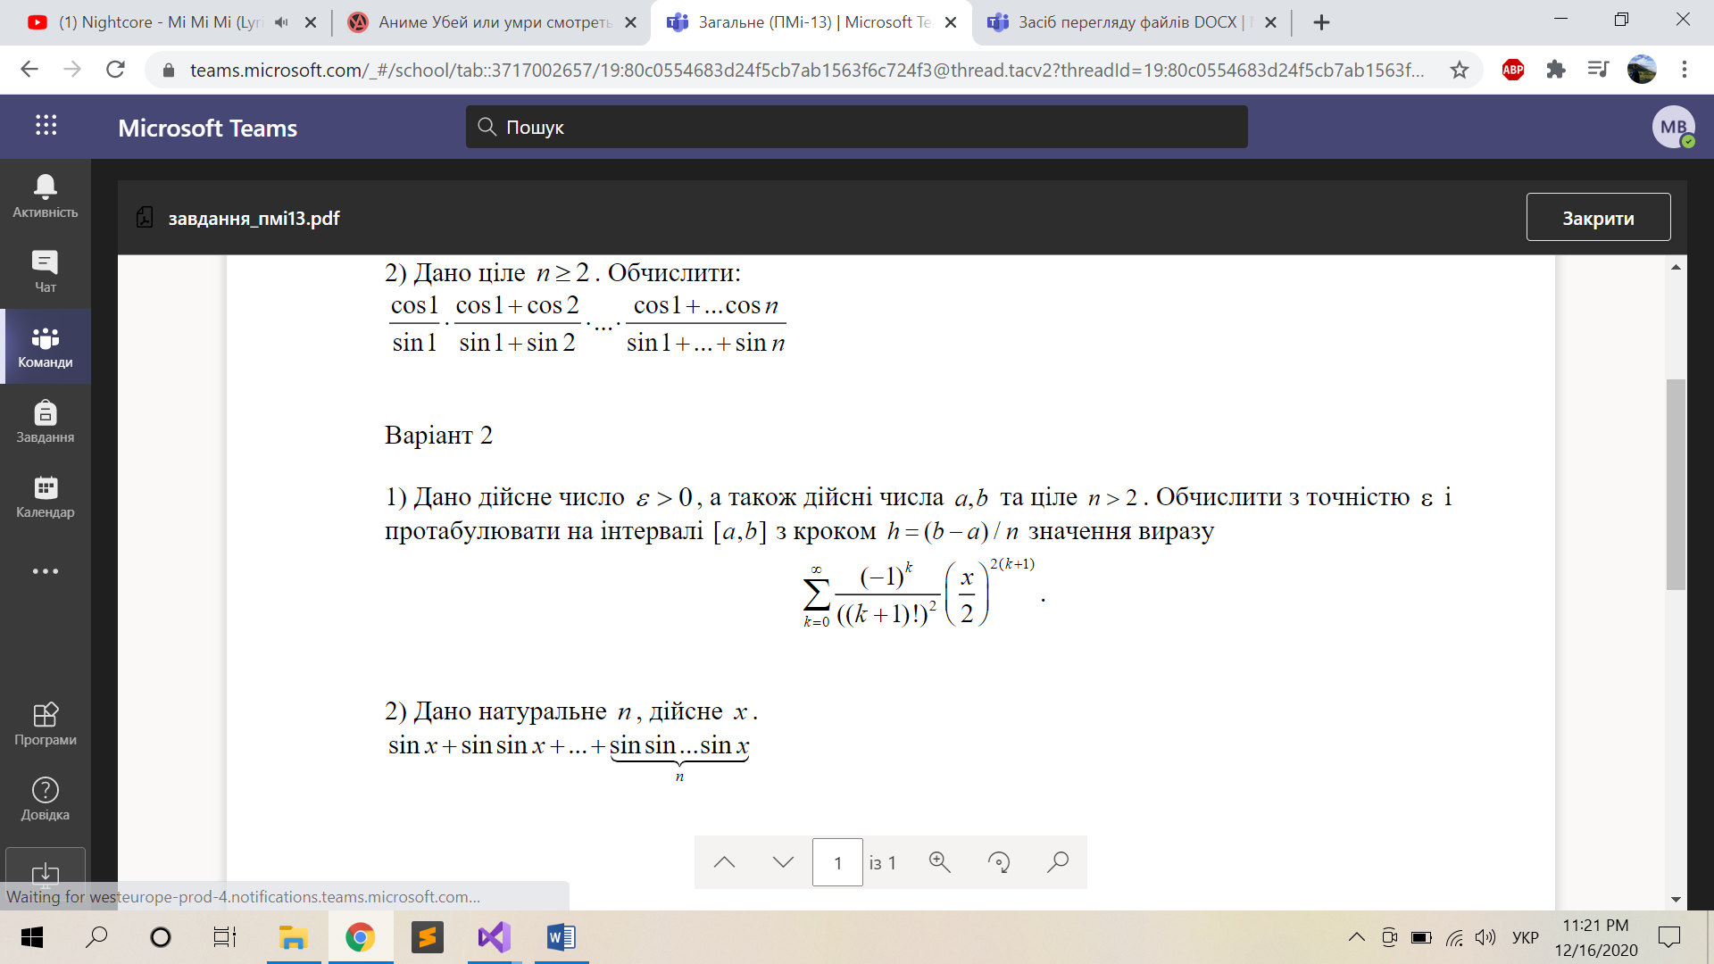

#include<iostream>

#include<cmath>

using namespace std;

int fact(int n) {

if (n == 0 || n == 1)

return 1;

return n \* fact(n - 1);

}

int main() {

double a, b, h, eps, sum = 0;

cout << "a ";

cin >> a;

cout << "b ";

cin >> b;

cout << "h ";

cin >> h;

cout << "eps ";

cin >> eps;

if (eps <= 0 || b < a) {

cout << "eps should be > 0" << endl

<< "a should be >= b";

return 0;

}

for (; a <= b; a += h) {

sum = 0;

for (int k = 1;; k++) {

sum += pow(-1, k + 1) / fact(2 \* k + 1) \* pow(a / 3, 2 \* k + 1);

if(abs(sum) < eps) {

cout << a << " " << sum << endl;

break;

}

}

}

}