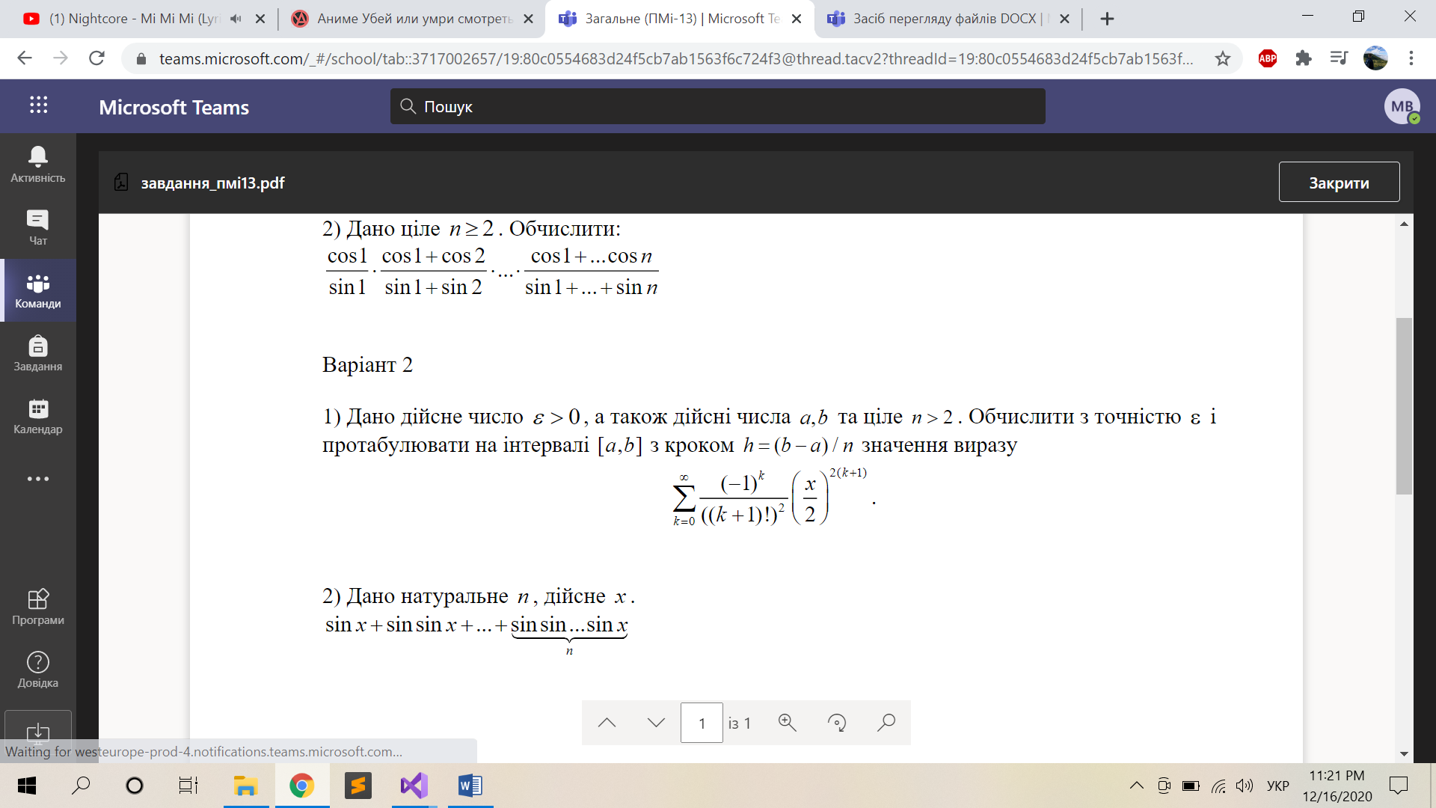

#include<iostream>
#include<cmath>

using namespace std;

int fact(int n) {
if (n == 0 || n == 1)
return 1;
return n * fact(n - 1);
}

int main() {

double a, b, h, eps, sum = 0;
cout << "a ";
cin >> a;
cout << "b ";
cin >> b;
cout << "h ";
cin >> h;
cout << "eps ";
cin >> eps;

if (eps <= 0 || b < a) {
cout << "eps should be > 0" << endl
<< "a should be >= b";
return 0;
}

for (; a <= b; a += h) {
sum = 0;
for (int k = 1;; k++) {

sum += pow(-1, k + 1) / fact(2 * k + 1) * pow(a / 3, 2 * k + 1);

if(abs(sum) < eps) {
cout << a << " " << sum << endl;
break;
}
}
}
}

