In August 2019, I with my friends took a break from routine and went on a week to the Carpathians. The purpose of our visit was to conquer some mountains and just to relax in wild environment, far away from civilization.

The first top we climbed was Pip-Ivan. Fortunately, the weather was good, so we were able to see breathtaking views across the whole Carpathians.

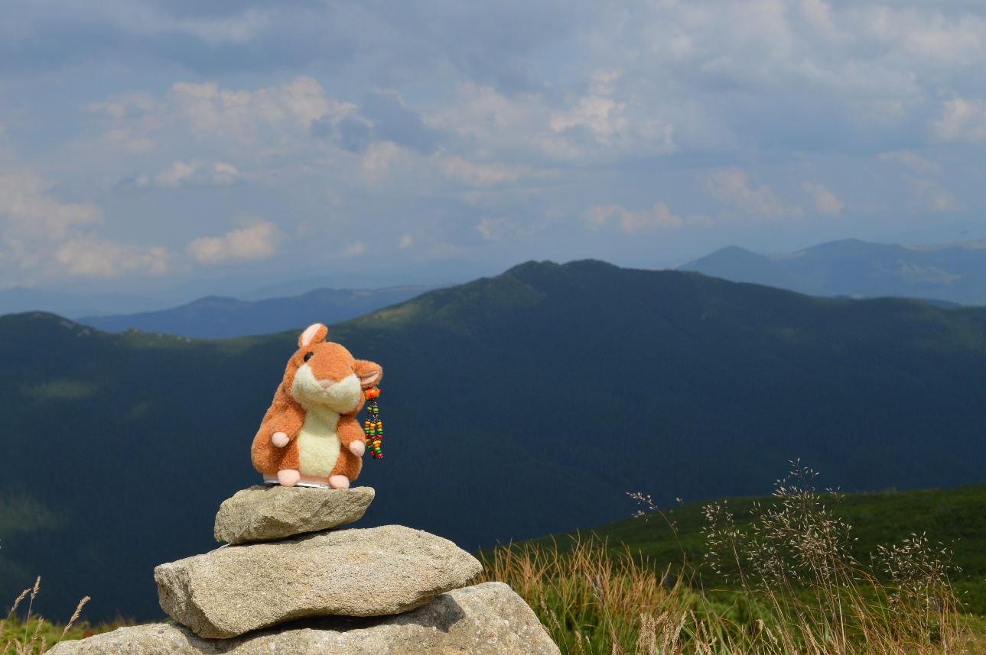

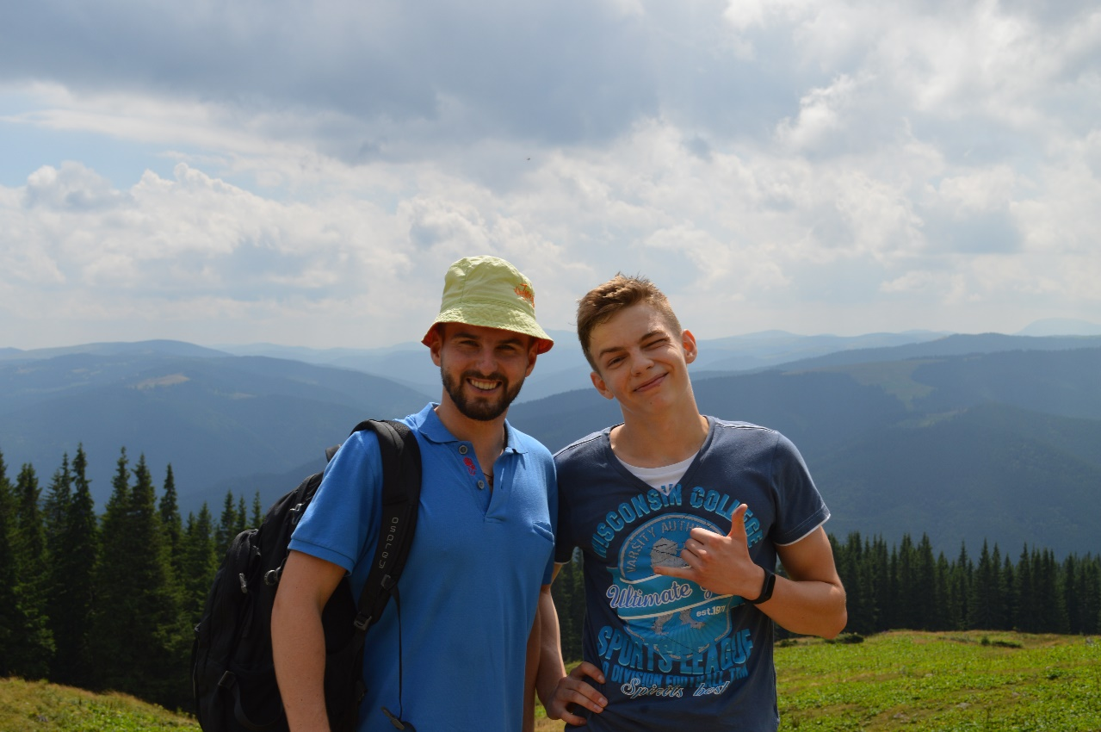

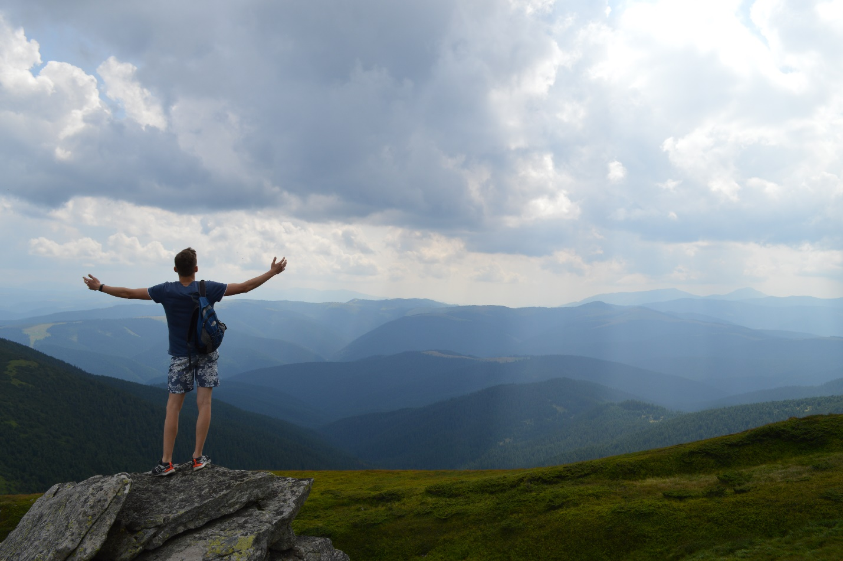

After some days of relax we decided, that previous journey was too easy and for the next challenge choose a one to a Petros. Waked up early we were ready for almost 40km journey in the mountains. Nevertheless, not all was as perfect as first time since there was a leafy fog on the top. Despite the fact that it was very long and exhausted we were very happy and satisfied.

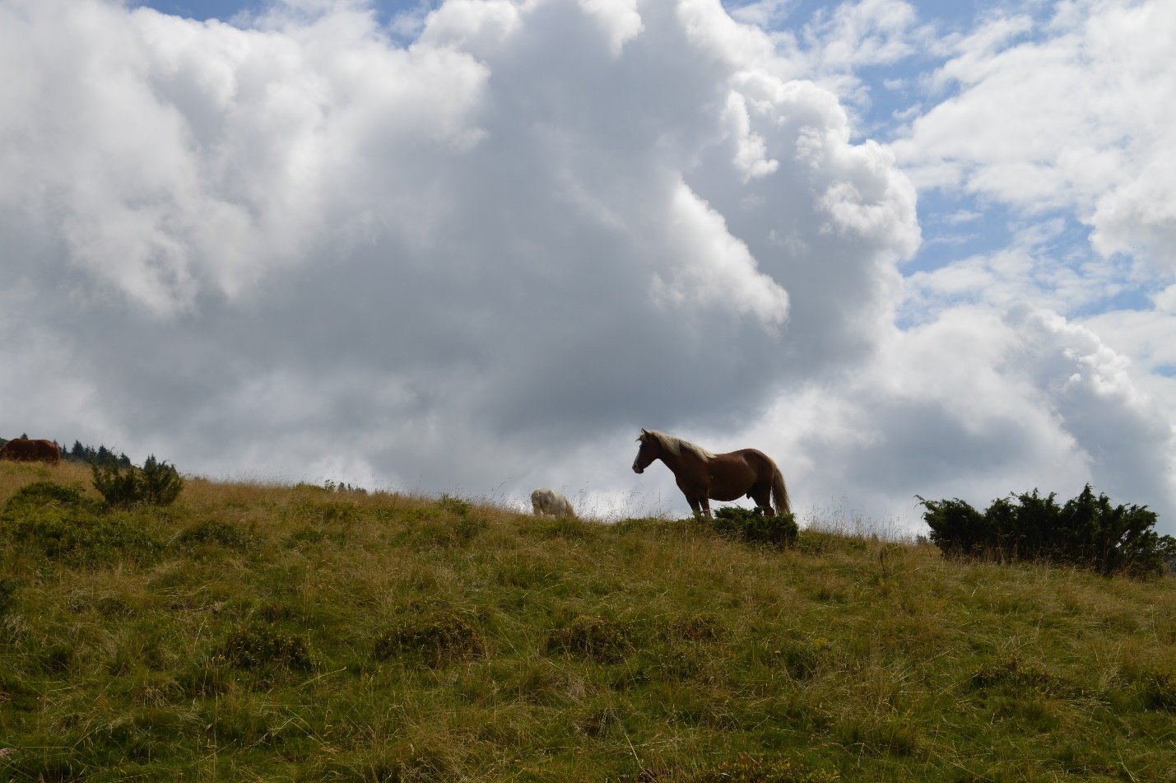

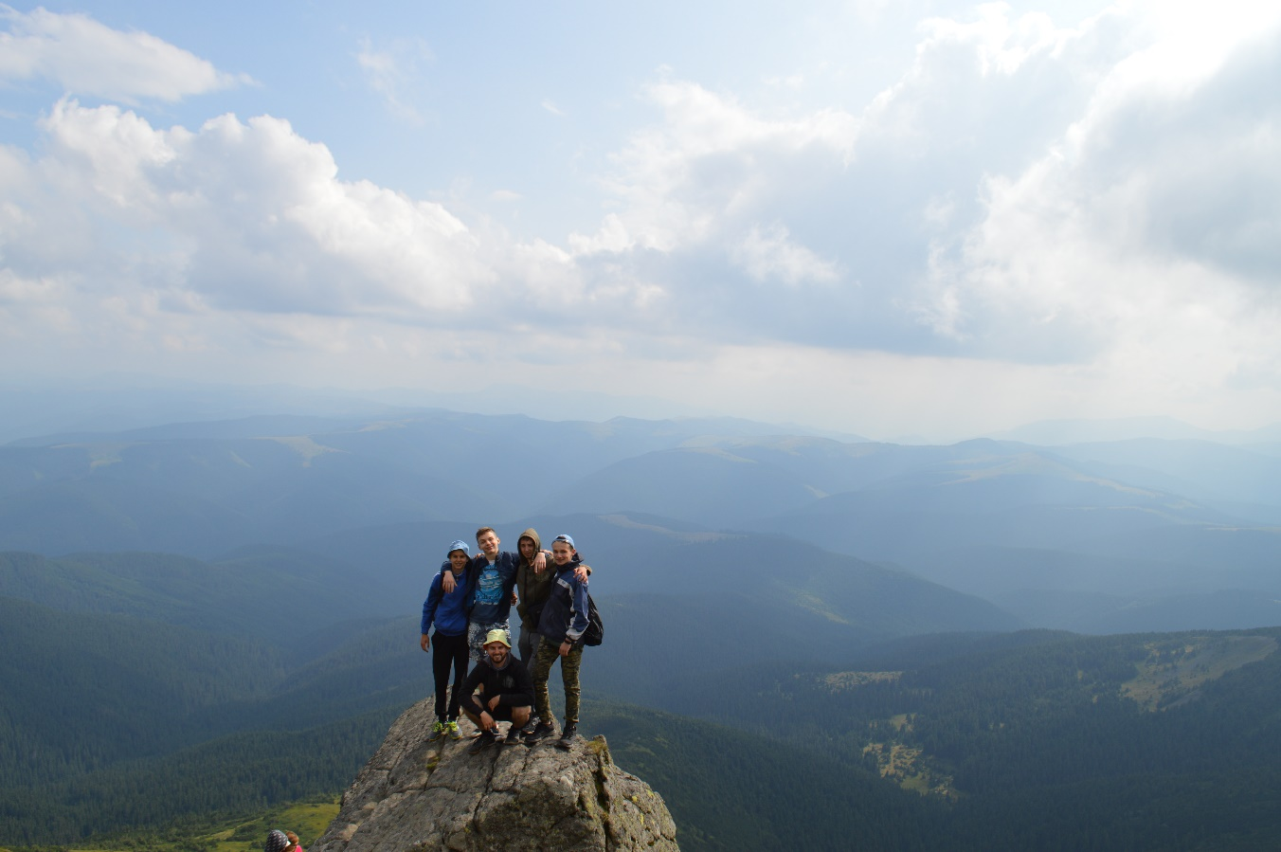

Without doubt, the trip was marvelous. From my point of view, everyone of us enjoyed our adventure. As for me, this trip was special, since I was here with my best friends. Frankly speaking every experience with they are special.