Oak at the Edge

Khanh Ton

Last updated 11/19/2024

## Results

Table A. Species codes

|  |  |  |
| --- | --- | --- |
| Species code | Scientific name | Common name |
| ABBA | *Abies balsamea* | Balsam fir |
| ACPE | *Acer pensylvanicum* | Striped maple |
| ACRU | *Acer rubrum* | Red maple |
| ACSA | *Acer saccharum* | Sugar maple |
| BEAL | *Betula alleghaniensis* | Yellow birch |
| BEPA | *Betula papyrifera* | Paper birch |
| BEPO | *Betula populifolia* | Gray birch |
| FAGR | *Fagus grandifolia* | American beech |
| FRAM | *Fraxinus americana* | White ash |
| OSVI | *Ostrya virginiana* | American hophornbeam |
| PIRU | *Picea rubens* | Red spruce |
| PIST | *Pinus strobus* | White pine |
| POGR | *Populus grandidentata* | Bigtooth aspen |
| POTR | *Populus tremuloides* | Quaking aspen |
| PRPE | *Prunus pensylvanica* | Pin cherry |
| PRSE | *Prunus serotina* | Black cherry |
| RUS | *Rubus spp.* | Brambles genus, including raspberries and blackberries |
| QURU | *Quercus rubra* | Northern red oak |
| TIAM | *Tilia americana* | American basswood |
| TSCA | *Tsuga canadensis* | Eastern hemlock |

### 

### Stand characterization

#### Understory competition

In burned stands, *Q. rubra* mainly competes with early successional seedlings e.g. *Rubus spp.*, *A. rubrum*, *B. alleghaniensis* and stump sprouts e.g. *F. grandifolia*.

*Figure 1. Stem density (per ha) of understory species in study stands*

#### Overstory composition

Burn stands have lower overstory basal areas than control stands. Pairs 5 and 6 stand out especially due to their clearcut treatment i.e. absence of mature trees of 20 cm and above in DBH. Their compositions are also the least diverse, consisting of *Prunus* (PRPE, PRSE), *Populus* (POGR, POTR), and *Betula spp.* (BEAL, BEPO, BEPA). The remaining stands have a significant presence of mature *Q. rubra* as well as *Acer* and *Betula* spp. of mid-ranged DBH classes. Additionally, Pair 1’s overstory composition includes a large basal area of high-DBH *Pinus strobus*.

Figure 2. Basal area (per ha) of overstory species in study stands by DBH size classes

### Oak seedling density and measurements

#### 2023 oak seedling density

Seedling density increased threefold in burned stands (2359+/-211 per ha) relative to control stands (778+/-121 per ha, p<0.001).

*Table B. Summarized statistics of 2023 oak seedling density per ha*

|  |  |  |  |  |  |  |
| --- | --- | --- | --- | --- | --- | --- |
| **Disturbance** | **min** | **max** | **median** | **mean** | **sd** | **se** |
| B | 0 | 17189 | 1146 | 2359 | 3045.723 | 211 |
| C | 0 | 12096 | 0 | 778 | 1637.060 | 121 |

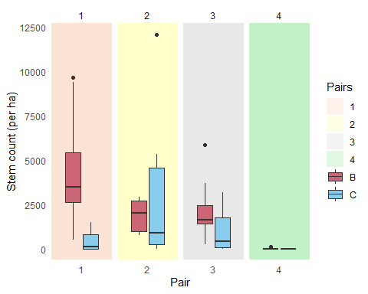

Figure 3. 2023 oak seedling density per ha of study stands

#### 2023 diameter at root collar (DRC, mm)

DRC was greater for seedlings in burned stands (4.6+/-0.3 mm) versus control stands (3.3+/-0.3 mm, p<0.01).

*Table C. Summarized statistics of 2023 oak seedling measurements*

|  |  |  |  |  |  |  |  |
| --- | --- | --- | --- | --- | --- | --- | --- |
| **Disturbance** | **Variable** | **min** | **max** | **median** | **mean** | **sd** | **se** |
| B | Height (cm) | 5.00 | 182.00 | 13.750 | 24.314 | 25.944 | 2.349 |
| B | DRC (mm) | 1.05 | 17.54 | 3.650 | 4.614 | 3.161 | 0.286 |
| B | Number of live branches | 1 | 18 | 2 | 3 | 3.119 | 0 |
| B | Number of dead branches | 0 | 35 | 2 | 3 | 4.969 | 1 |
| C | Height (cm) | 4.30 | 184.00 | 14.000 | 19.780 | 25.619 | 3.178 |
| C | DRC (mm) | 1.12 | 17.37 | 2.875 | 3.348 | 2.297 | 0.287 |
| C | Number of live branches | 1 | 4 | 1 | 1 | 0.585 | 0 |
| C | Number of dead branches | 0 | 7 | 1 | 1 | 1.402 | 0 |

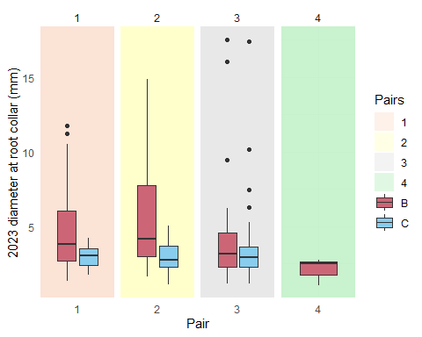

Figure 4. 2023 seedling DRCs by study stands

#### 2024 extension growth (cm)

Extension growth was greater for seedlings in burned stands (6.43+/-0.5 cm) versus control stand (2.6+/-0.4 cm, p<0.001).

*Table D. Summarized statistics of 2024 oak seedling measurements*

|  |  |  |  |  |  |  |  |
| --- | --- | --- | --- | --- | --- | --- | --- |
| **Disturbance** | **variable** | **min** | **max** | **median** | **mean** | **sd** | **se** |
| B | Height (cm) | 1.55 | 263.00 | 18.00 | 31.105 | 35.808 | 2.465 |
| B | Extension growth (cm) | 0.00 | 38.00 | 3.50 | 6.432 | 7.306 | 0.503 |
| B | DRC (mm) | 0.86 | 27.58 | 3.92 | 5.170 | 3.939 | 0.271 |
| B | Number of leaves | 2 | 100 | 8 | 16 | 20.540 | 1 |
| B | Number of live branches | 1 | 38 | 2 | 4 | 4.398 | 0 |
| B | Number of dead branches | 0 | 37 | 2 | 4 | 5.983 | 0 |
| C | Height (cm) | 6.00 | 225.00 | 15.00 | 21.414 | 29.999 | 2.773 |
| C | Extension growth (cm) | 0.00 | 40.30 | 1.60 | 2.622 | 4.190 | 0.387 |
| C | DRC (mm) | 1.44 | 22.55 | 2.85 | 3.530 | 2.937 | 0.272 |
| C | Number of leaves | 2 | 100 | 4 | 7 | 12.943 | 1 |
| C | Number of live branches | 0 | 31 | 1 | 2 | 2.986 | 0 |
| C | Number of dead branches | 0 | 25 | 2 | 2 | 3.265 | 0 |

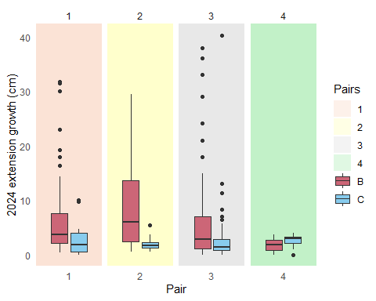

Figure 5. 2024 seedling extension growths by study stands

#### 2024 number of live branches

There were more live branches per seedling in the burned stands than the control stands, respectively 4+/-0 and 2+/-0 (p<0.001).

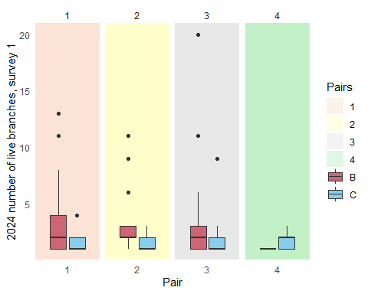

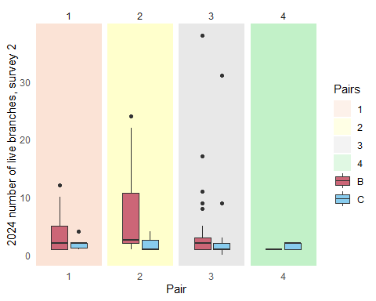

*Figure 7. 2024 number of live branches per seedling by study stands at the beginning of the summer (above) and at the end of the summer (below)*

#### 2024 number of leaves

Seedlings in burned stands sprouted more leaves (16+/-1) than in control stands (7+/-1, p<0.001).

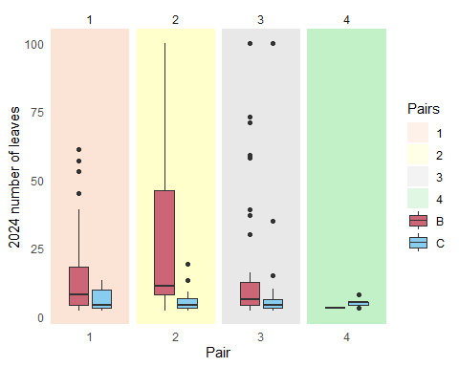

Figure 8. 2024 number of leaves per seedling by study stands

### Leaf Area Index (LAI)

Burned stands have lower LAI values (averaging 3.2+/-0.2) than control stands (5.4+/-0.2, p<0.001).

*Table E. Summarized statistics of LAI values*

|  |  |  |  |  |  |  |
| --- | --- | --- | --- | --- | --- | --- |
| **Disturbance** | **min** | **max** | **median** | **mean** | **sd** | **se** |
| B | 0 | 9.233 | 2.928 | 3.159 | 2.136 | 0.150 |
| C | 0 | 9.825 | 5.915 | 5.400 | 2.347 | 0.176 |

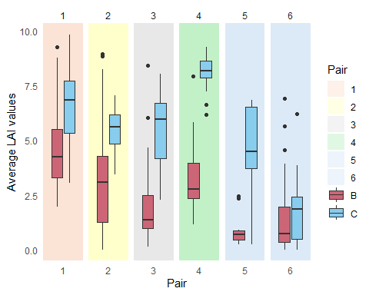

Figure 9. LAI values by study stands

## Citations

### R packages

[1] F. Aust. *citr: RStudio Add-in to Insert Markdown Citations*. R package version 0.3.2. 2019. <https://github.com/crsh/citr>.

[2] C. Boettiger. *knitcitations: Citations for Knitr Markdown Files*. R package version 1.0.12. 2021. <https://github.com/cboettig/knitcitations>.

[3] W. Chang, J. Cheng, J. Allaire, et al. *shiny: Web Application Framework for R*. R package version 1.9.1. 2024. <https://CRAN.R-project.org/package=shiny>.

[4] G. Grolemund and H. Wickham. “Dates and Times Made Easy with lubridate”. In: *Journal of Statistical Software* 40.3 (2011), pp. 1-25. <https://www.jstatsoft.org/v40/i03/>.

[5] K. Müller and H. Wickham. *tibble: Simple Data Frames*. R package version 3.2.1. 2023. <https://CRAN.R-project.org/package=tibble>.

[6] R Core Team. *R: A Language and Environment for Statistical Computing*. R Foundation for Statistical Computing. Vienna, Austria, 2022. <https://www.R-project.org/>.

[7] V. Spinu, G. Grolemund, and H. Wickham. *lubridate: Make Dealing with Dates a Little Easier*. R package version 1.9.3. 2023. <https://CRAN.R-project.org/package=lubridate>.

[8] H. Wickham. *forcats: Tools for Working with Categorical Variables (Factors)*. R package version 1.0.0. 2023. <https://CRAN.R-project.org/package=forcats>.

[9] H. Wickham. *ggplot2: Elegant Graphics for Data Analysis*. Springer-Verlag New York, 2016. ISBN: 978-3-319-24277-4. <https://ggplot2.tidyverse.org>.

[10] H. Wickham. *stringr: Simple, Consistent Wrappers for Common String Operations*. R package version 1.5.1. 2023. <https://CRAN.R-project.org/package=stringr>.

[11] H. Wickham. *tidyverse: Easily Install and Load the Tidyverse*. R package version 2.0.0. 2023. <https://CRAN.R-project.org/package=tidyverse>.

[12] H. Wickham, M. Averick, J. Bryan, et al. “Welcome to the tidyverse”. In: *Journal of Open Source Software* 4.43 (2019), p. 1686. DOI: 10.21105/joss.01686.

[13] H. Wickham, W. Chang, L. Henry, et al. *ggplot2: Create Elegant Data Visualisations Using the Grammar of Graphics*. R package version 3.5.1. 2024. <https://CRAN.R-project.org/package=ggplot2>.

[14] H. Wickham, R. François, L. Henry, et al. *dplyr: A Grammar of Data Manipulation*. R package version 1.1.4. 2023. <https://CRAN.R-project.org/package=dplyr>.

[15] H. Wickham and L. Henry. *purrr: Functional Programming Tools*. R package version 1.0.2. 2023. <https://CRAN.R-project.org/package=purrr>.

[16] H. Wickham, J. Hester, and J. Bryan. *readr: Read Rectangular Text Data*. R package version 2.1.5. 2024. <https://CRAN.R-project.org/package=readr>.

[17] H. Wickham, D. Vaughan, and M. Girlich. *tidyr: Tidy Messy Data*. R package version 1.3.1. 2024. <https://CRAN.R-project.org/package=tidyr>.

[18] Y. Xie. *Dynamic Documents with R and knitr*. 2nd. ISBN 978-1498716963. Boca Raton, Florida: Chapman and Hall/CRC, 2015. <https://yihui.org/knitr/>.

[19] Y. Xie. “knitr: A Comprehensive Tool for Reproducible Research in R”. In: *Implementing Reproducible Computational Research*. Ed. by V. Stodden, F. Leisch and R. D. Peng. ISBN 978-1466561595. Chapman and Hall/CRC, 2014.

[20] Y. Xie. *knitr: A General-Purpose Package for Dynamic Report Generation in R*. R package version 1.42. 2023. <https://yihui.org/knitr/>.

[21] Y. Xie. “TinyTeX: A lightweight, cross-platform, and easy-to-maintain LaTeX distribution based on TeX Live”. In: *TUGboat* 40.1 (2019), pp. 30-32. <https://tug.org/TUGboat/Contents/contents40-1.html>.

[22] Y. Xie. *tinytex: Helper Functions to Install and Maintain TeX Live, and Compile LaTeX Documents*. R package version 0.53. 2024. <https://github.com/rstudio/tinytex>.