**User’s Manual**

**ImaginEat**

**SummerTeam**

**Table of contents**

1. GENERAL INFORMATION 4

1.1 System overview 4

1.2 Organisation of the manual 4

2. SYSTEM SUMMARY 5

2.1 System configuration 5

2.2 User access levels 5

2.3 Contingencies 5

3. USING THE SYSTEM 6

3.1 Getting started 6

3.2 Main menu 7

3.3 Search results 8

3.4 Restaurant view 9

3.5 Menu view 10

3.6 Dish view 11

**Table of figures**

Figure 1 Main menu 7

Figure 2 Search results 8

Figure 3 Restaurant view 9

Figure 4 Menu view 10

Figure 5 Dish view 11

# **GENERAL INFORMATION**

General Information section explains in general terms the system and the purpose for which it is intended.

## System overview

ImaginEat is an application which allows finding and viewing information about restraurants and cafes, including their menus with prices, ingredients and 3D/AR meal models. The application requests geo-location for improved user experience. Its operational status is under development. ImaginEat operates on mobile devices with Android operating system.

## Organisation of the manual

The user’s manual consists of three sections: General Information, System Summary, and Using The Application.

General Information section explains in general terms the system and the purpose for which it is intended.

System Summary section provides a general overview of the system. The summary outlines the uses of the system’s hardware and software requirements, system’s configuration, user access levels and system’s behavior in case of any contingencies.

Using The System section provides a getting started tutorial, as well as description of system functions.

# SYSTEM SUMMARY

System Summary section provides a general overview of the system. The summary outlines the uses of the system’s hardware and software requirements, system’s configuration, user access levels and system’s behavior in case of any contingencies.

## System configuration

ImaginEat operates on mobile devices with Android operating system. It is compatible with Android 28 API and higher versions. The application requires connection to Internet in order to fetch data from database, internal GPS receiver in order to obtain coordinates automatically to order restaurants by proximity, as well as internal photo camera to view AR content. After installation on the device, Imagineat can be used immediately without any further configuration and/or registration.

## User access levels

Everyone can use application.

## Contingencies

In case of power outage data are not saved in internal memory of the operating device (except photos that are stored in external storage folder of the device). In case there is no Internet connection available data cannot be fetched to internal memory of the operating device.

# USING THE SYSTEM

Using The System section provides a getting started tutorial, as well as description of system functions.

## Getting started

User can download and install the application from Play Market or via apk-file distributed by developers team (if not yet available in Play Market). For specific instruction on how to install application on specific device refer to device’s manual.

## Main menu

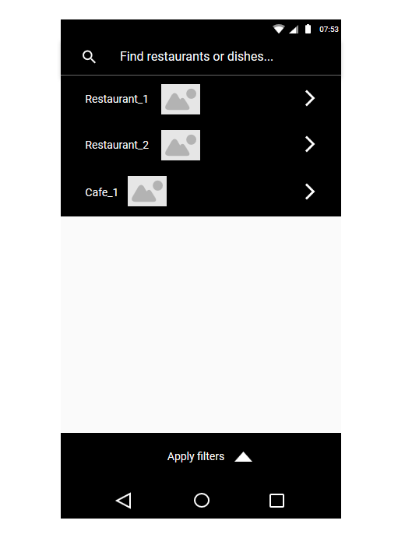

Figure 1 Main menu

Main menu contains a search bar, a list of closest restaurants (if geo-location was enabled by the user, random cafes and restaurants otherwise), and filters for more precise search.

## Search results

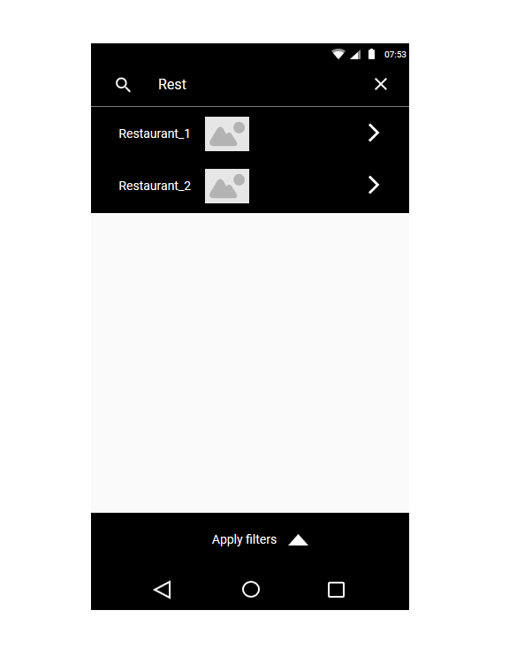

Figure 2 Search results

Search results can be seen upon typing anything in the search bar on the top. User can find this way restraunts, cafes, as well as the dishes in their menus. Tapping on one of them allows to go to Restaurant or Dish view respectively.

## Restaurant view

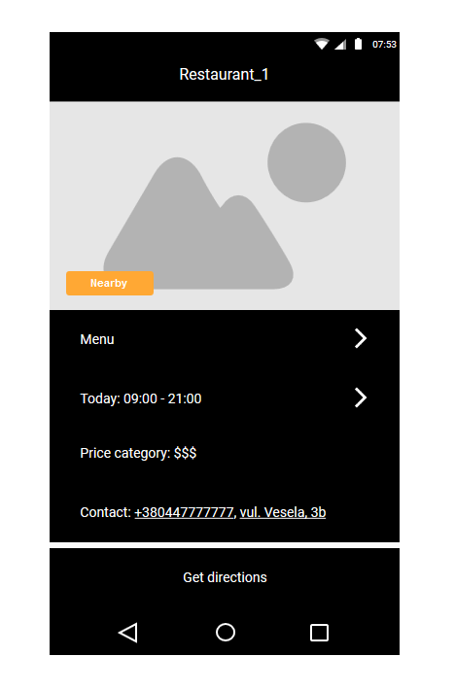

Figure 3 Restaurant view

Restaurant view allows user to see selected restaurants photo, opening and closing times, price category as well as contact information. User can go to Menu view from here.

## Menu view

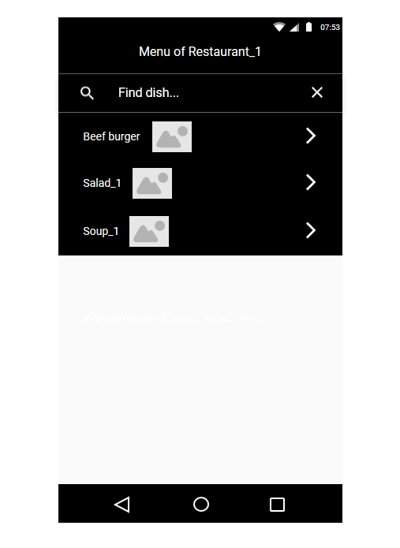

Figure 4 Menu view

In the menu view user can see all the dishes listed, find one of them by name and switch to dish view.

## Dish view

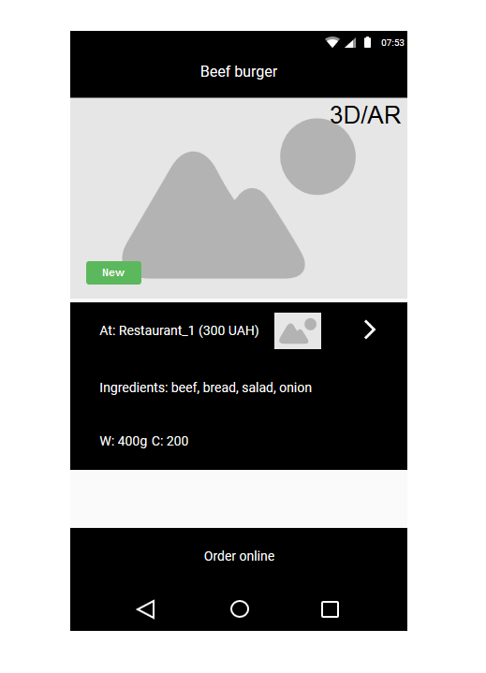

Figure 5 Dish view

Dish view allows user to see meal’s ingredients, weight, calories, 3D/AR model and go to Menu view of the restaurant serving viewed dish.