Using Docker for Developing 12 Factor Apps

Antifragility is a property of systems that increase in capability, resilience, or robustness as a result of stressors, shocks, volatility, noise, mistakes, faults, attacks, or failures. It is a concept developed by Professor Nassim Nicholas Taleb in his book, Antifragile :: Wiki (https://en.wikipedia.org/wiki/Antifragility)
A new common methodology has emerged with the purpose of providing an outline for building well structured and scalable applications. It’s called the “12-Factor App” methodology, and it’s about to change the way we approach the architecture of the next app. The 12-Factor App methodology is a list of 12 principles, each explaining the ideal way to handle a subset of your application.
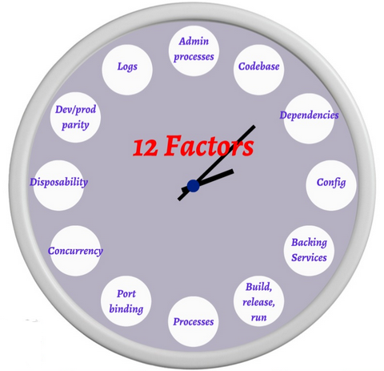

Using containers can be a great way to package, distribute, and run your
12 Factor application. Her comes the, Docker which is the most popular container solution. It initially built on top of LXC but now uses its own libcontainer. Dockerfile and docker-compose.yml are emerging standards for declaring everything about your service in the codebase: dependencies, environment, ports, multiple process types, and backing services.

I . Codebase : One codebase tracked in revision control, many deploys ( such as Git, Mercurial, or Subversion)
II. Dependencies — Explicitly declare and isolate dependencies : Docker images are built from explicit Dockerfile recipes and Docker containers are run as isolated environments.
III. Config — Store config in the environment : Docker-compose.yml has an environment hash where you explicitly define what environment variables will be set in a container. These can be default values or undefined values that will be inherited from the host at runtime. Additionally there is the Dockerfile ENV instruction and the `docker run — env=[]` and `docker run — env-file=[]` runtime options.
IV. Backing services : Treat backing services as attached resources: Docker containers share little to nothing with other containers and therefore should communicate with backing services over the network.docker-compose.yml has a links hash where you specify the other containerized services that your application depends on. `docker-compose up` will start these backing services first and set environment variables in the app container with network connection information. With these tools you can say that your application depends on a backing Postgres 9.4 and Redis 3.0 service and have your application connect to them via hostname and port information present in their environment.
V. Build, release, run – Strictly separate build and run stages
VI. Processes — Execute the app as one or more stateless processes : By default, Docker containers are shared nothing processes with ephemeral storage. docker-compose.yml defines a collection of services, each one with its own image or build recipe and command.With this tool you can say that your application has a both a web and worker process.
XII. Admin processes — Run admin/management tasks as one-off processes : Docker images are easily run as one-off processes.`docker run myapp CMD` will run an arbitrary command in the same environment as your web process.With this tool you can run an interactive bash prompt or run one-off `rake db:migrate` process against your development Postgres database.

