STUDY ABROAD

High-Fidelity UI Design Specification
  - Version 1.0 | 14 October 2026 | Review draft
Visual direction: Apple-inspired Minimalism × Liquid Glass × Iridescent Glass. This deliverable contains six polished static screen concepts plus implementation-oriented UI specifications. These are visual proposals, not tested or approved production screens.

01 Scope and decisions
- MVP countries: Sweden, Netherlands, Finland, France, Germany. Program-level information remains unpublished until individually verified.
- Guest can calculate a budget; authentication is required to save it. Checklist persistence also requires authentication.
- Official exchange-rate and cost sources with the agreed review cadence; every displayed financial datum needs source, timestamp, currency and freshness status.
- Reviewer publishing rights remain exactly as defined in the approved ACL; no additional Publisher role is assumed.
- Mobile prototypes must undergo prioritized usability testing before layout sign-off.

02 High-fidelity screen gallery

1. Home — desktop concept
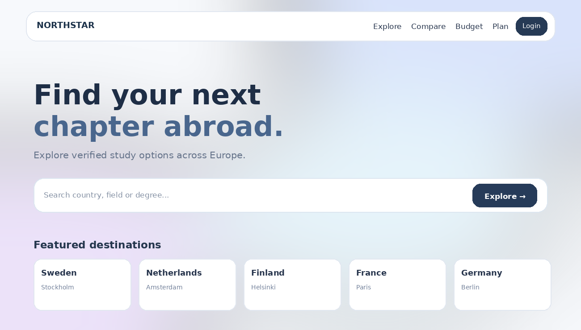
Visual mockup uses illustrative copy and placeholder values; it is not a claim about verified programs or tuition.

1. Home — mobile concept
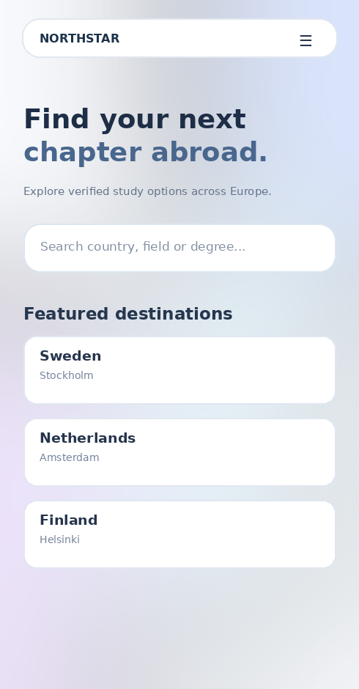

2. Explore — desktop concept
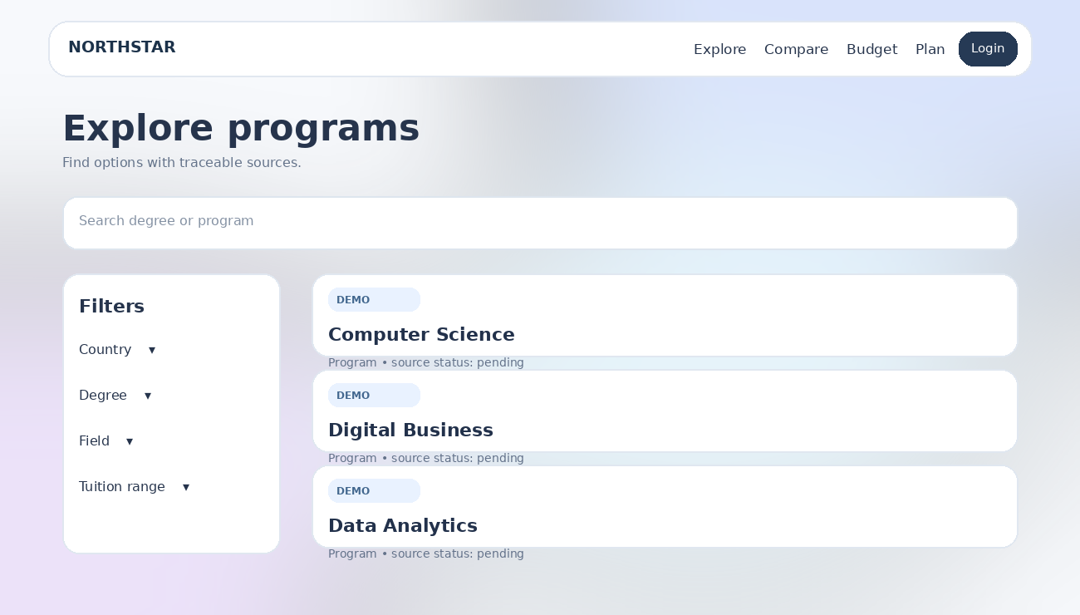
Visual mockup uses illustrative copy and placeholder values; it is not a claim about verified programs or tuition.

2. Explore — mobile concept
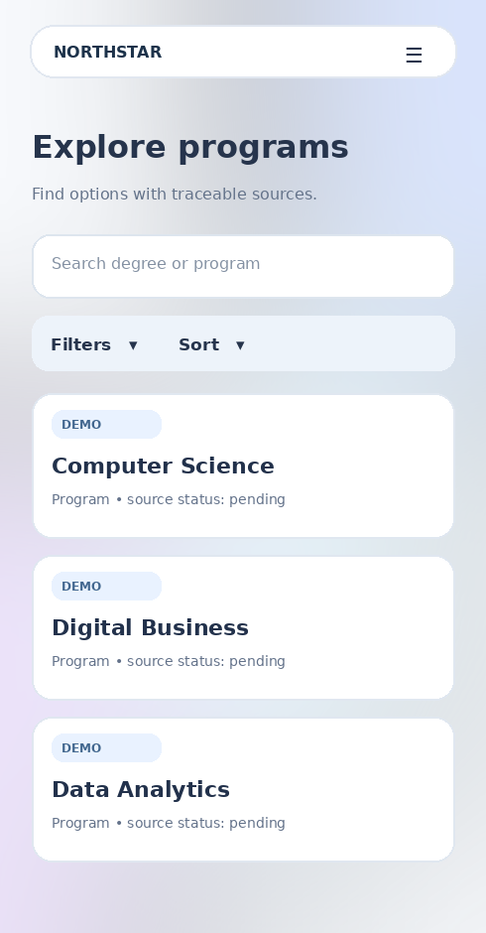

3. Budget — desktop concept
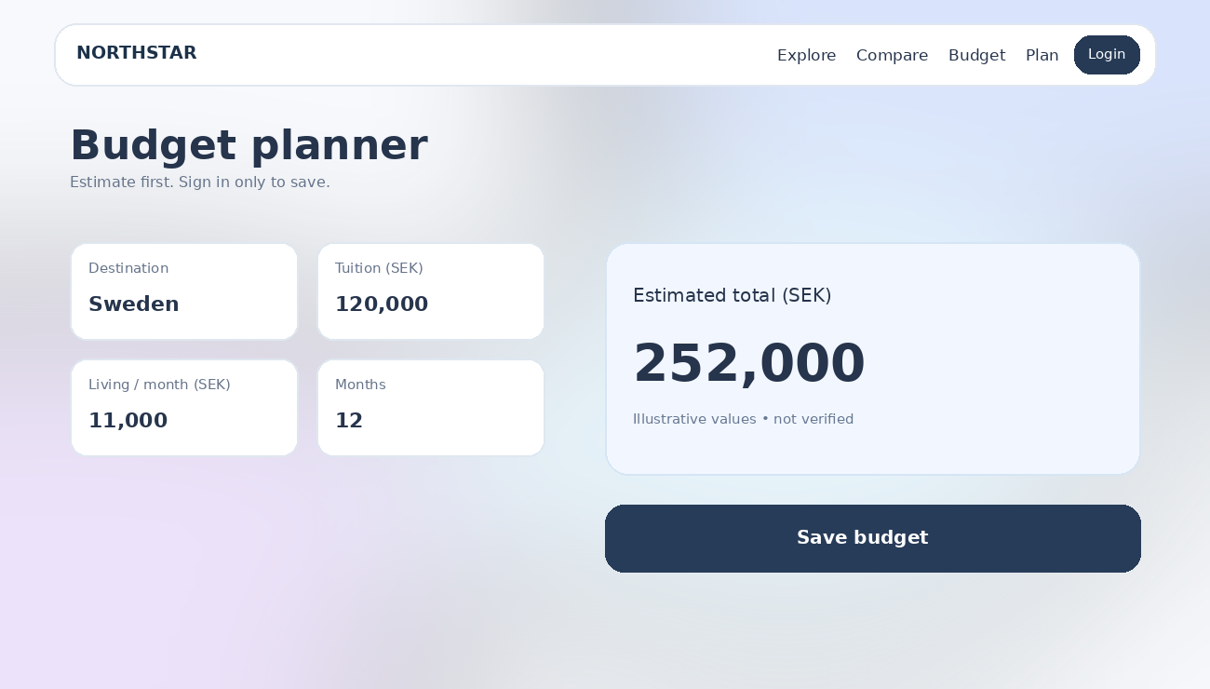
Visual mockup uses illustrative copy and placeholder values; it is not a claim about verified programs or tuition.

3. Budget — mobile concept
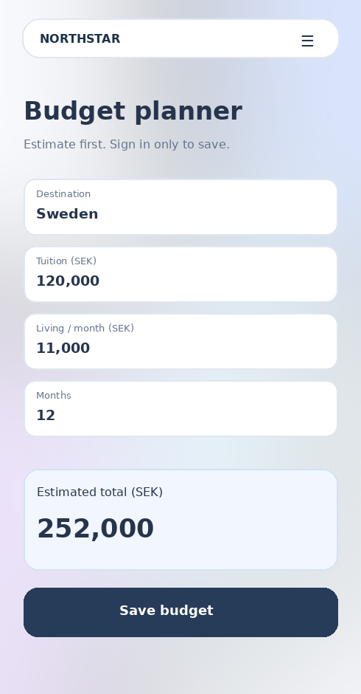

03 Screen inventory and visual behavior
Screen | UI / interaction contract
Home | Prominent search, five-country discovery, explicit trust signals; no fabricated verification badges.
Explore / Search | Keyword search; country/degree/field/tuition filters; sorting; loading/empty/error; only published records.
Country / Program detail | Program title, school, degree, requirements, tuition, source link, checked-at date and missing-data markers.
Compare | Maximum two programs; mobile stacked/side-by-side variants for testing; no inferred ranking or hidden gaps.
Budget Planner | Guest can calculate; sign-in gate only on Save; display local currency and VND with dated conversion and provenance.
Study Plan | Task creation, due date, status, edit, delete confirmation; saving requires sign-in; private by owner.
Report Issue | Page reference, issue category, description, optional evidence URL; validation and anti-spam feedback.
CMS Editorial | Draft, review, approve, publish, archive, audit trail; no self-approval; role-aware action availability.
Admin / Access | Role and scope visibility; step-up authentication for sensitive actions; no default private-plan access.

04 Visual tokens (proposed)
- Core: Snow #F8FAFC, Silver #E5E9F0, Ice Blue #DCECF8, Iridescent #C9C5F4, Ink #202B3D.
- Glass: translucent layers reserved for hero, navigation and floating controls; use solid surfaces for dense financial and policy data.
- Type: system UI / Aptos or platform-native fallback with Vietnamese glyph support; body >= 16px in implementation, readable line height.
- Spacing: 4px base scale; primary layout rhythm 8/16/24/32px. Radius: 12/16/24px tiers.
- States: default, hover, focus-visible, pressed, disabled, loading, success, error, empty and stale-data.
- Accessibility: target WCAG 2.2 AA; ensure contrast over variable glass backgrounds, keyboard focus, reduced motion and 44px touch targets where feasible.

05 Interaction and security handoff
- Guest presses Save Budget → sign-in prompt → return to previous draft; preservation mechanism and retention need engineering/privacy approval.
- All role checks happen server-side; hidden buttons are not authorization. Unauthorized access: 401/403/404 per approved ACL.
- Budget input validation: no negative amounts, explicit duration, currency units and rounding. Missing/stale FX blocks or clearly labels conversion according to product policy.
- Published content displays source evidence and verified-at timestamp. Unverified placeholder content must never masquerade as official data.
- Reviewer may publish only within ACL-defined scope and separation-of-duties checks; version conflicts show 409 resolution state.

06 Mobile usability test plan
- Tasks: find a program using filters; compare two programs; estimate a budget; attempt to save as guest; find source evidence.
- Prototype variants: compare side-by-side vs stacked; filter sheet vs inline; sign-in gate as modal vs routed page.
- Observe task completion, time, errors, comprehension and accessibility issues; do not lock responsive layout before findings are reviewed.
- Use a small formative round (approximately 5–8 participants) as a starting point; recruit across relevant applicant journeys.

07 Acceptance and open items
- Approved baseline: PRD v0.1, ACL v0.1, IA v1.0, User Flows v1.0, Wireframe v1.0, Design System v1.0 and UI readiness decisions.
- Open: verified program catalog and source URLs for each of five countries; exact FX authority and API; privacy retention for guest draft; identity/login solution; measurable performance targets.
- Sign-off gates: product owner review → visual QA → mobile usability tests → accessibility audit → developer handoff.
Status: Draft for review. Mockup data and labels are illustrative only.

