Do you know autofit setting in Tradovate chat?

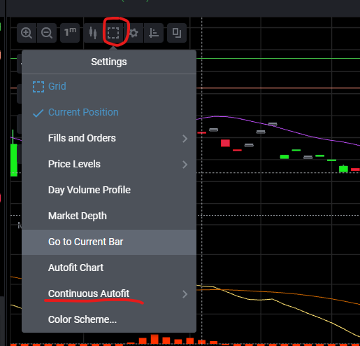

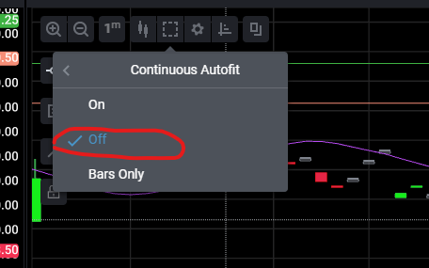

If you set continuous autofit into Off, you can disable autofit functionality of main chart.

But, for indicator (ex: macd), you can’t do like it.

I want to disable autofit functionality of macd indicator.

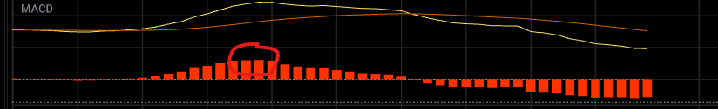

This is builtin macd indicator.

I tell you how to edit this indicator in Tradovate.

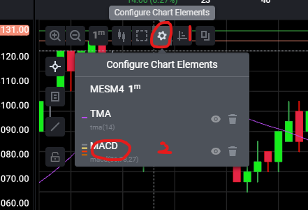

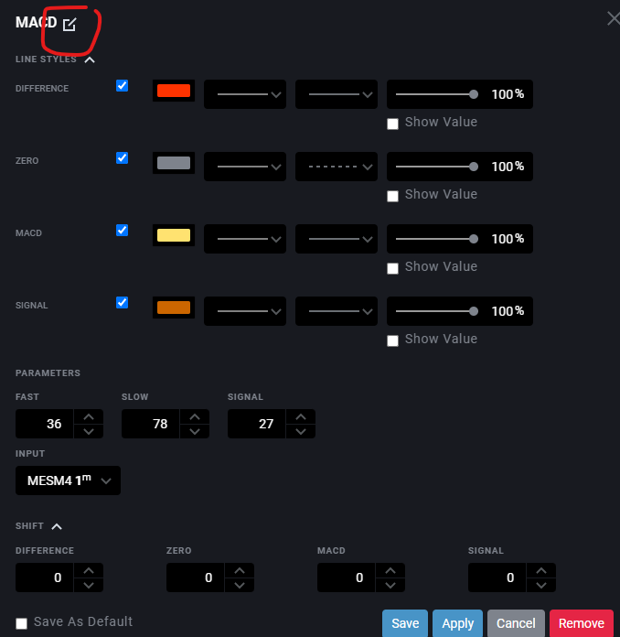

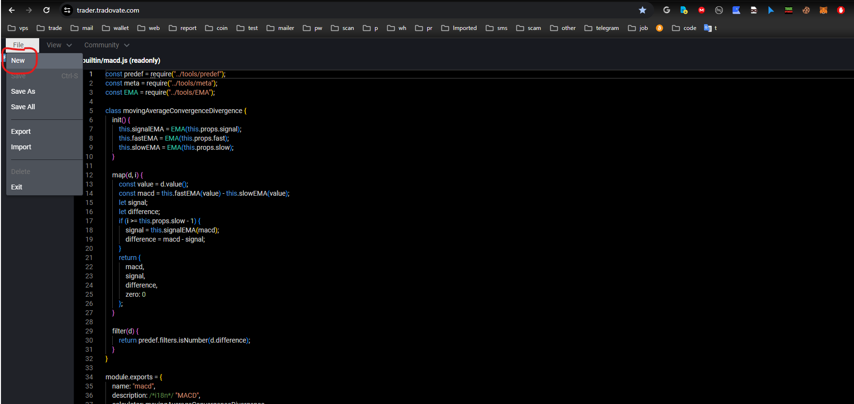

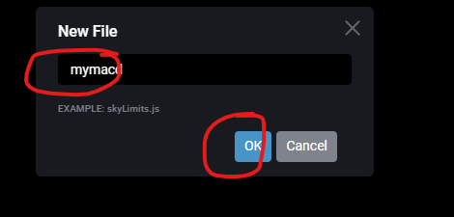

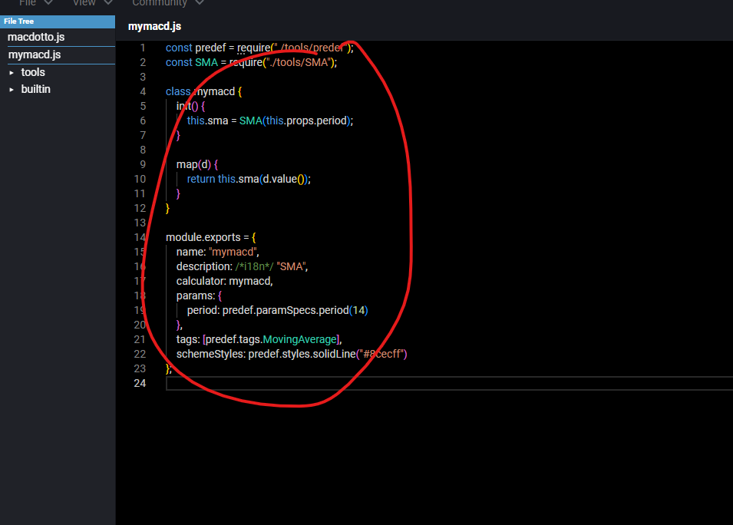

Copy the source code of macd here and save (ctrl +s)

You can edit the source code here.

And you can refer this manual.

<https://tradovate.github.io/custom-indicators>

time: 1 day

budget: $70