I have a Tradovate MACD indicator – YAZDANI-MACD.

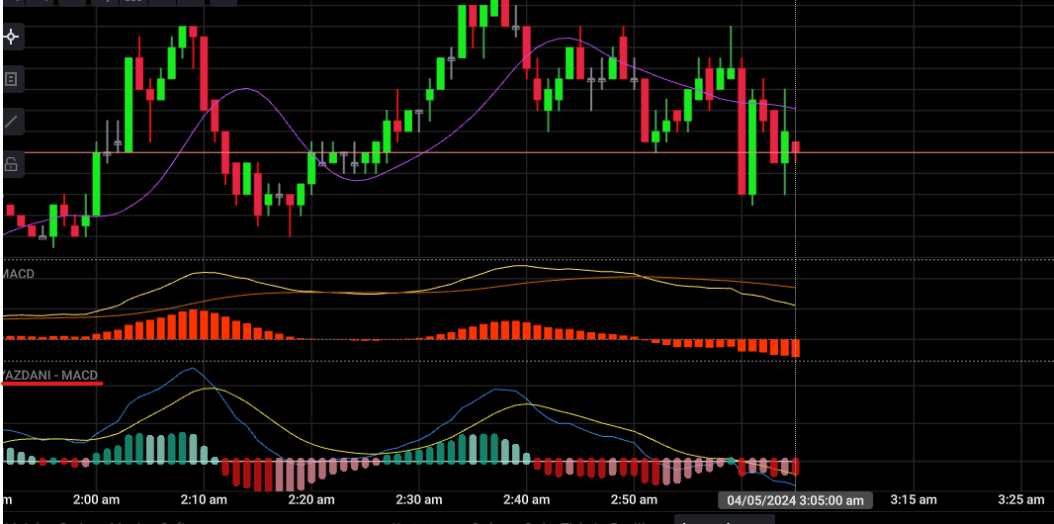

I am going to update this indicator.

This indicator has rounded candle in the histogram.

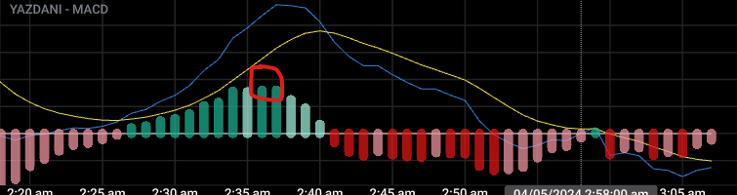

I want to change the rounded candle into flat candle like below picture.

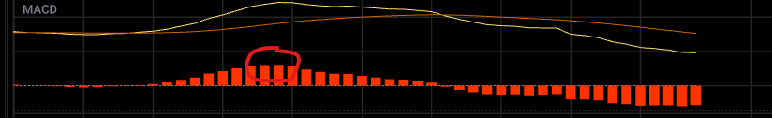

This is builtin macd indicator.

Here is source code of my indicator- YAZDANI-MACD.

<https://github.com/vicktor031003/Tradovate/blob/main/MACD%20With%20Histogram_Otto_Blink_MACD.js>

I tell you how to edit this indicator in Tradovate.

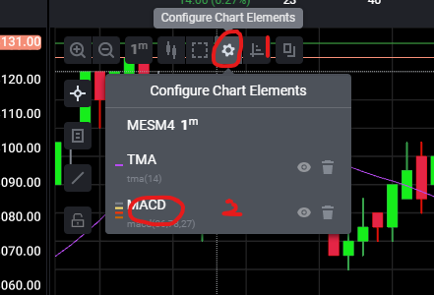

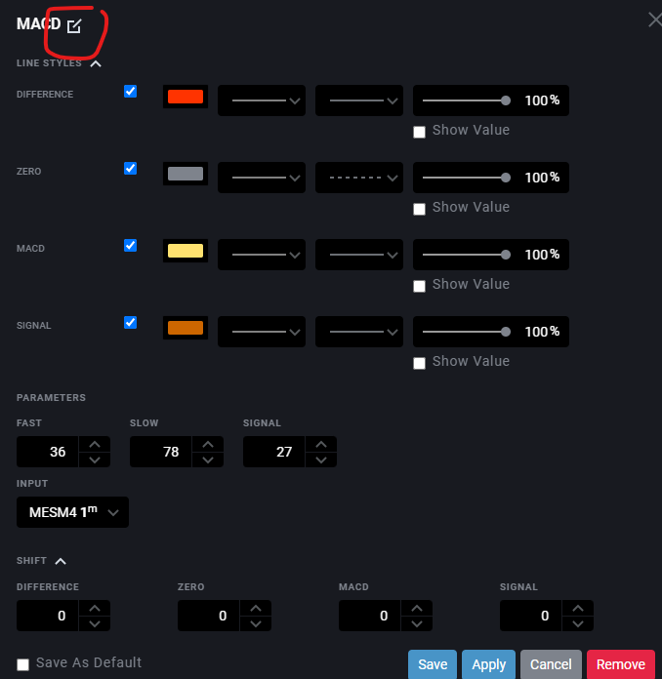

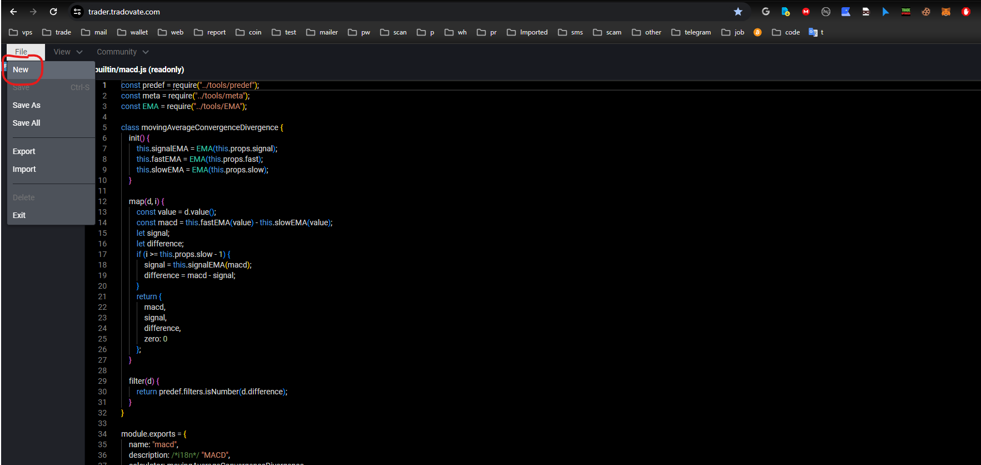

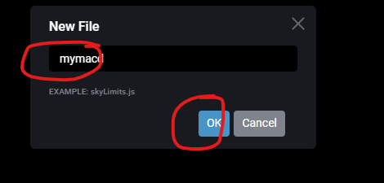

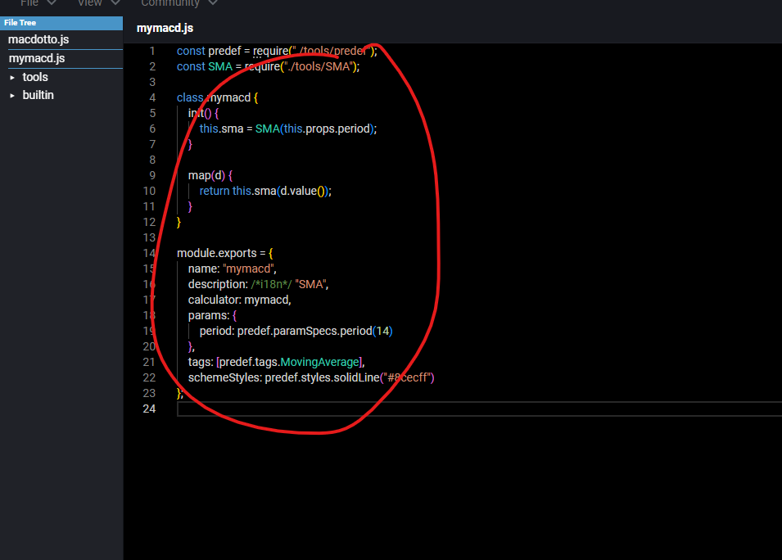

Copy the source code of my indicator here and save (ctrl +s)

You can edit the source code here.

And you can refer this manual.

https://tradovate.github.io/custom-indicators