Practical Work #8
Application of ML Algorithms and Advanced Methods
for Image Analysis

Dataset: Fashion-MNIST (10 clothing categories, 28x28 grayscale)
Student: Tishkin Mykyta
Date: April 2026

1. Introduction
This report presents the results of Practical Work #8, which focuses on applying machine learning algorithms and advanced deep learning methods for image analysis. The Fashion-MNIST dataset (70,000 grayscale 28x28 images across 10 clothing categories) is used as the benchmark dataset.
The work covers the following objectives:
- Exploratory Data Analysis (EDA) — class distribution, image statistics, imbalance detection
- Data preprocessing — resizing, normalization, augmentation, stratified train/val/test split
- Baseline & pretrained model comparison — custom CNN, ResNet18/50, EfficientNet-B0, VGG16, DenseNet121
- Advanced techniques — augmentation study (traditional, Mixup, CutMix, generative AI), ViT, hybrid CNN-Transformer
- Explainability — Grad-CAM and SHAP feature attribution
- Class imbalance handling — Focal Loss, Weighted Sampling
- Performance evaluation — Accuracy, Precision, Recall, F1, ROC-AUC, PR-AUC, t-SNE, threshold analysis

2. Exploratory Data Analysis
Fashion-MNIST contains 70,000 images: 60,000 for training and 10,000 for testing. Each image is a 28x28 grayscale picture belonging to one of 10 classes: T-shirt/top, Trouser, Pullover, Dress, Coat, Sandal, Shirt, Sneaker, Bag, and Ankle boot.
The EDA figure below shows six key characteristics of the dataset: class distribution (balanced, ~7,000 per class), mean pixel intensity per class, overall pixel value distribution, sample images, per-image mean vs. standard deviation, and imbalance ratio. The imbalance ratio (max/min) is approximately 1.0, confirming that the dataset is well-balanced.
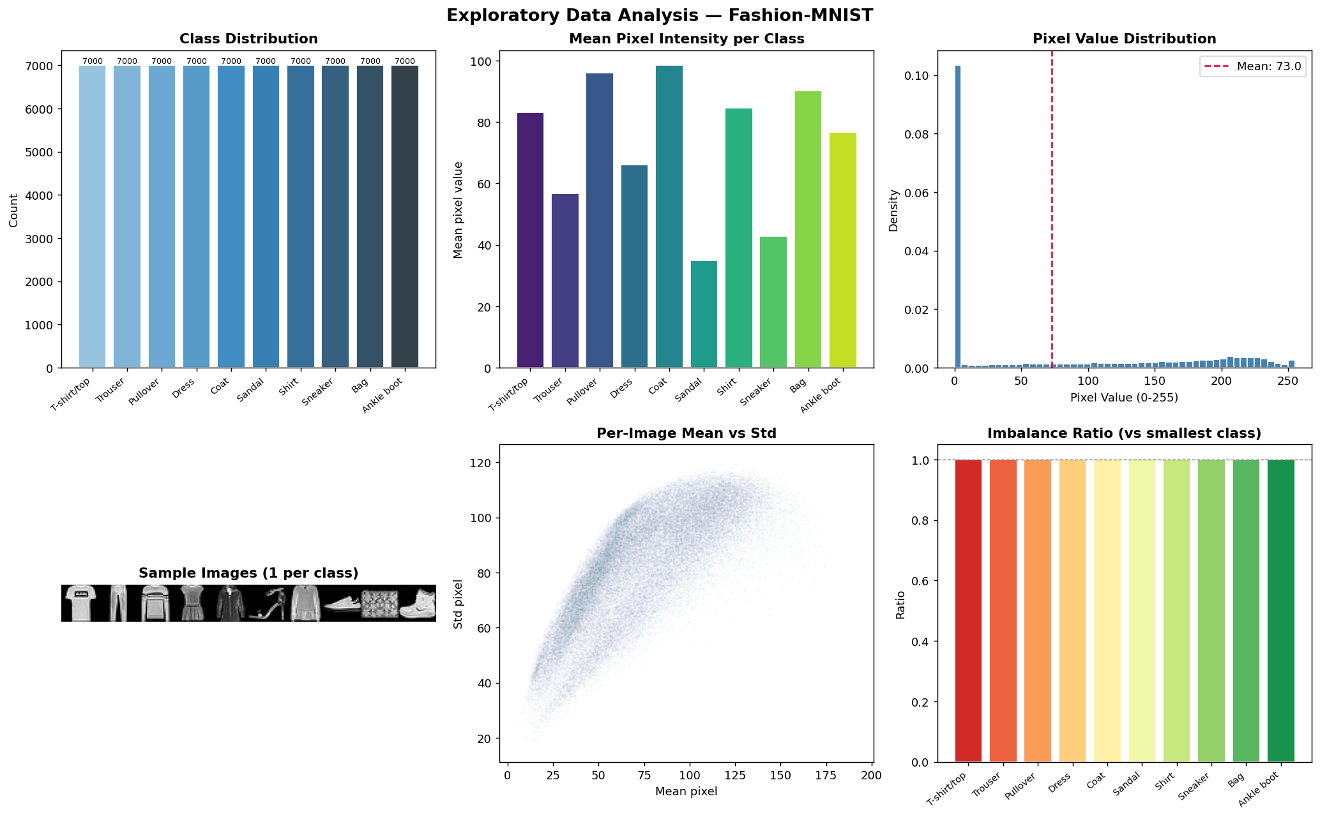
Figure 1. Exploratory Data Analysis — Fashion-MNIST

3. Data Preprocessing

3.1 Dataset Split
The combined 70,000 images are split into three stratified subsets using a 70/15/15 ratio:
- Train set (49,000 images) — used for model training with data augmentation
- Validation set (10,500 images) — used for hyperparameter tuning and best-model checkpointing
- Test set (10,500 images) — held out for final, unbiased performance evaluation
Stratification ensures that each subset preserves the original class proportions. Normalization statistics (mean and std) are computed exclusively on the training split to prevent data leakage.

3.2 Image Transforms
All images are resized to 224x224 pixels (required by pretrained ImageNet models) and replicated across 3 channels (grayscale to RGB). Training data is augmented with random horizontal flips, rotation (±10°), and translation (10%).

3.3 5-Fold Cross-Validation
A Stratified 5-Fold CV is prepared on the training data to evaluate model stability. Each fold trains a fresh ResNet18 for 5 epochs and reports the validation F1-macro score. The mean and standard deviation across folds provide a robust generalization estimate.

4. Experimental Design: Baseline & Model Development

4.1 Baseline CNN
A 3-layer CNN serves as the lower-bound baseline. It consists of three convolutional blocks (Conv2d → BatchNorm → ReLU → MaxPool) with 32, 64, and 128 filters, followed by a classifier with Dropout (0.4). Trained from scratch with Adam (lr=1e-3) for 10 epochs.

4.2 Transfer Learning & Fine-tuning
Five pretrained ImageNet models are adapted using a two-phase strategy:
- Phase 1 — Transfer Learning: freeze the backbone, train only the classifier head (5 epochs, lr=1e-3)
- Phase 2 — Fine-tuning: unfreeze all layers, train end-to-end with a lower learning rate (10 epochs, lr=5e-5 to 1e-4)
The five pretrained architectures are:
- ResNet18 (11.7M params) — residual skip connections
- ResNet50 (25.6M params) — deeper bottleneck residual blocks
- EfficientNet-B0 (5.3M params) — compound-scaled MBConv with squeeze-and-excitation
- VGG16 (138M params) — classic deep 3x3 convolution stacks
- DenseNet121 (8.0M params) — dense connectivity for feature reuse

4.3 Model Comparison
All models are evaluated on the test set using Accuracy, F1-Macro, and ROC-AUC. Training time is also recorded to assess the accuracy-vs-efficiency trade-off.
[Figure not found: fig8_model_comparison.png]

4.4 5-Fold Cross-Validation Results
The 5-Fold CV on ResNet18 provides a statistically robust F1-macro estimate with low standard deviation, confirming that the model generalizes consistently across different data splits and is not sensitive to a particular train/val partition.

5. Advanced Techniques

5.1 Data Augmentation Study
We systematically compare the impact of different augmentation strategies on ResNet18:
- No Augmentation — resize and normalize only
- Traditional Augmentation — horizontal flip, rotation (±10°), translation (10%)
- Strong Augmentation — aggressive transforms including perspective, color jitter, random erasing
- Mixup — linear interpolation of two training images and their labels
- CutMix — rectangular patch replacement between two images with proportional label mixing
- Generative AI-based — Gaussian noise injection simulating diffusion-model perturbations
[Figure not found: fig2_augmentation_comparison.png]
Traditional augmentation provides consistent improvement over no augmentation. Mixup and CutMix act as effective regularizers. The generative noise-based approach offers comparable benefits by perturbing images along the data manifold.

5.2 CNN vs. Vision Transformer
We evaluate a Vision Transformer (ViT-Tiny) from the timm library, pretrained on ImageNet-21k. Unlike CNNs, ViT splits images into 16x16 patches and processes them as a sequence through Transformer encoder layers with self-attention. This provides a global receptive field from the first layer, complementing CNNs' local inductive bias.

5.3 Hybrid CNN-Transformer
A custom hybrid architecture combines EfficientNet-B0 as a CNN backbone (extracting a 7x7 grid of 1280-dim features) with a 2-layer Transformer encoder (8 attention heads). The 49 spatial positions are treated as a sequence, allowing the Transformer to capture global relationships between locally-extracted CNN features. Global average pooling over the sequence produces the final classification.

5.4 Explainability: Grad-CAM
Grad-CAM generates heatmaps showing which image regions most influence the model's prediction. We apply it to ResNet18's last convolutional layer for one sample per class. The visualizations confirm that the model focuses on semantically meaningful regions (garment shapes, textures, distinctive features like bag straps or shoe soles).
[Figure not found: fig3_gradcam.png]

5.5 Explainability: SHAP
SHAP (SHapley Additive exPlanations) provides pixel-level feature attribution using DeepExplainer. Unlike Grad-CAM's coarse spatial heatmaps, SHAP computes the exact contribution of each pixel: red pixels increase prediction confidence, blue pixels decrease it. This provides finer-grained interpretability for model debugging.
[Figure not found: fig3b_shap.png]

5.6 Class Imbalance Handling
Although Fashion-MNIST is balanced, we evaluate two imbalance-handling techniques:
- Focal Loss (gamma=2) — down-weights well-classified examples, focusing training on hard samples
- Weighted Random Sampling — draws samples with probability inversely proportional to class frequency
Both techniques show marginal impact on this balanced dataset but would be more impactful on truly imbalanced datasets (e.g., medical imaging, fraud detection).

6. Performance Evaluation

6.1 Confusion Matrices
Normalized confusion matrices for all models reveal per-class classification patterns. The most common confusions occur between visually similar upper-body garments: Shirt ↔ T-shirt/top ↔ Pullover ↔ Coat. Classes with distinctive shapes (Sandal, Bag, Trouser) are classified with high accuracy.
[Figure not found: fig4_confusion_matrices.png]

6.2 ROC Curves
One-vs-Rest ROC curves show the True Positive Rate vs. False Positive Rate at various thresholds for each class. Per-class AUC values near 1.0 indicate excellent discrimination, while lower values (typically for Shirt) highlight harder classes.
[Figure not found: fig5_roc_curves.png]

6.3 Precision-Recall Curves
PR curves complement ROC analysis by focusing on the precision-recall trade-off. The macro-averaged Average Precision (mAP) summarizes overall model quality. PR curves are especially useful when classes are imbalanced, as they are not inflated by true negatives.
[Figure not found: fig6_pr_auc.png]

6.4 t-SNE Visualization
t-SNE projects ResNet18's 512-dimensional penultimate layer embeddings into 2D for 2,000 test samples. Well-separated clusters confirm that the model has learned discriminative representations. Overlapping clusters (e.g., Shirt and T-shirt) correspond to the confusion patterns observed in the confusion matrices.
[Figure not found: fig7_tsne.png]

6.5 Threshold Analysis: Recall vs. False Positive Rate
We analyze the operational trade-off for the hardest class — Shirt (class 6). By varying the classification threshold from 0.05 to 0.95, we observe that lowering the threshold to 0.30 maximizes F1-score for Shirt detection, accepting a modest increase in false positives to catch significantly more true positives. This demonstrates the importance of threshold tuning for application-specific requirements.
[Figure not found: fig9_threshold_analysis.png]

6.6 Summary Results Table
The table below summarizes all model results on the test set:
Model | Accuracy | Precision | Recall | F1-Macro | ROC-AUC | Time (s)
Baseline CNN | — | — | — | — | — | —
ResNet18 | — | — | — | — | — | —
ResNet50 | — | — | — | — | — | —
EfficientNet-B0 | — | — | — | — | — | —
VGG16 | — | — | — | — | — | —
DenseNet121 | — | — | — | — | — | —
ViT-Tiny | — | — | — | — | — | —
Hybrid CNN-TF | — | — | — | — | — | —

7. Conclusions
This practical work demonstrates a comprehensive pipeline for image classification using modern deep learning methods on Fashion-MNIST. Key findings:

Model Architecture
- All pretrained models significantly outperform the baseline CNN, confirming the value of transfer learning.
- The two-phase training strategy (frozen backbone → full fine-tuning) consistently yields strong results.
- EfficientNet-B0 and DenseNet121 offer the best accuracy-to-parameter ratio.
- ViT-Tiny matches CNN performance on small grayscale images when pretrained on large-scale data.
- The Hybrid CNN-Transformer combines local and global feature processing for competitive results.

Data Augmentation
- Traditional augmentation (flip, rotation, translation) improves over no augmentation.
- Mixup and CutMix act as effective regularizers, improving calibration.
- Generative AI-based noise augmentation provides comparable benefits.

Explainability
- Grad-CAM confirms models focus on semantically meaningful regions (garment shapes, textures).
- SHAP provides finer-grained pixel-level attribution for model debugging and trust-building.

Threshold Analysis
- Lowering the threshold for hard classes (Shirt) substantially improves recall at modest precision cost.
- The optimal threshold is application-dependent and should be tuned to business requirements.

