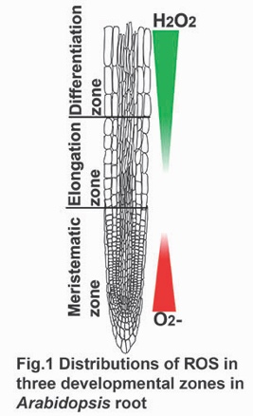 **ABRC home page**

The root is an essential plant organ that supports plants in the soil and obtains water and nutrients. The root apical meristem continually produces all cell types and controls root development throughout a plant's entire life. Therefore, how the root meristem controls root development and adapts to environmental conditions is important for understanding plant development.

*Arabidopsis* root developmental stages are simply divided into three developmental zones. The cells actively proliferate in the meristematic zone (Fig. 1) and then terminate cell division and initiate cell elongation in the elongation zone (Fig. 1). Finally, the cells become completely mature in the differentiation zone (Fig. 1). Recent findings have demonstrated that reactive oxygen species (ROS) function as signaling molecules to regulate plant development. In the *Arabidopsis* root, O2- and H2O2 are individually accumulated in the meristematic zone and the elongation and differentiation zones (Fig1. red and green)1,2. The sizes of the three developmental zones are regulated by the distributions of these two types of ROS1,2.

**1. Understanding of the regulation mechanism of ROS distributions at the specific root developmental zone under the RGF1 peptide signal.**

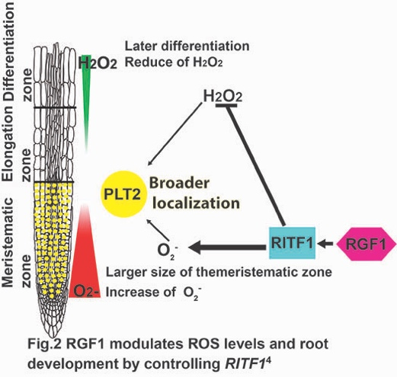 Stem cell niche and root meristem size are maintained by intercellular interactions and signaling networks of a peptide hormone, Root Meristem Growth Factor 1 (RGF1)3,4. How RGF1 regulates root meristem development is an essential question for understanding stem cell function. RGF1 controls root development by modulating ROS distributions along *Arabidopsis* root developmental zones (Fig2.). RGF1 induced the expression of the primary transcription factor (*RITF1*) expression within a short-time after RGF1 treatment in the meristematic zone (Fig2., blue). Then later, ROS distributions started to be altered at the boundary between the meristematic zone and the elongation zone, finally in the differentiation zone (Fig2. red and green). However, the underlying mechanism of how the RGF1 peptide controls ROS distribution along root developmental zones is still unclear.

RGF1 spatiotemporally controls ROS distribution along the root developmental zones by transcriptional and metabolic regulation. We hypothesize that ROS distributions are dynamically controlled by transcriptional and metabolic regulations in the three developmental zones through the RGF1-receptor pathway.To understand the dynamic change of gene expression by RGF1, we perform a multi-omics analysis of the specific developmental zone after RGF1 treatment.

2. **Understanding the spatial regulation mechanism of ROS distributions in the root developmental zone under abiotic stress.**

High-temperature stress is an agricultural problem in various places in the world. High temperature leads to an array of developmental, physiological, and biochemical changes in plants, which affect plant growth and development and cause significant damage to agricultural yield. Young seedlings are very susceptible to high-temperature stress. The root growth and development of young seedlings are greatly damaged by high-temperature stress. The seedlings are unable to access the water deep in the soil.

Under ambient conditions, plants are exposed to high-temperature stress for a long time and alter their physiology and morphology to adapt to the conditions. Root development is very responsive to high temperatures. Root alters the size of the developmental zones during adaptation to high temperatures. For example, the root adapts to optimum conditions and forms a larger meristematic zone because cells actively divide and produce more cells in the meristematic zone (Fig. 3, red in the left root). In contrast, under high-temperature stress conditions, root forms a smaller meristematic zone (Fig. 3, red in the right root). Fewer cells divide in the meristematic zone. Furthermore, the cells that initiated the differentiation earlier resulted in forming a larger differentiation zone. These result in forming a shorter root with a smaller meristematic zone (Fig. 3, red in the right root) and a larger differentiation zone under high-temperature conditions (Fig. 3, blue in the right root).

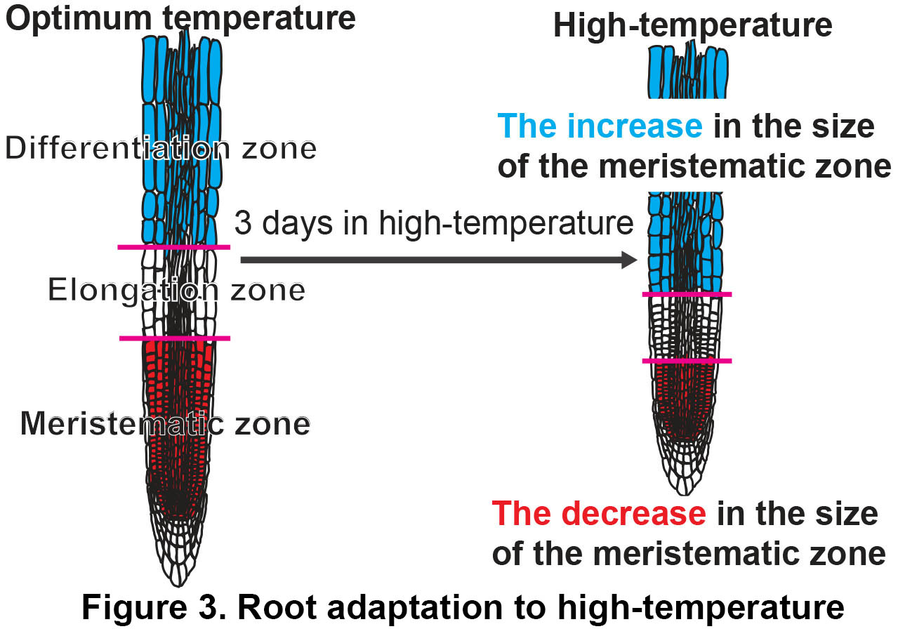

High-temperature adaptation in the root developmental zone is regulated by ROS signaling. The ROS signal is altered during adaptation to high-temperature stress. With long exposure (3 days) to high-temperature stress conditions, O2- is reduced in the meristematic zone during high-temperature adaptation. The timing of alteration of ROS correlates with root developmental zone size change. These suggest that the ROS signals in the specific developmental zones modulated root development during high-temperature adaptation. We aim to understand the ROS regulation mechanisms under abiotic stress in the specific root developmental zone.

1 Dunand, C., Crevecoeur, M. & Penel, C. Distribution of superoxide and hydrogen peroxide in Arabidopsis root and their influence on root development: possible interaction with peroxidases. *New Phytol* **174**, 332-341 (2007). <https://doi.org/10.1111/j.1469-8137.2007.01995.x>

2 Tsukagoshi, H., Busch, W. & Benfey, P. N. Transcriptional regulation of ROS controls transition from proliferation to differentiation in the root. *Cell* **143**, 606-616 (2010). <https://doi.org/10.1016/j.cell.2010.10.020>

3 Matsuzaki, Y., Ogawa-Ohnishi, M., Mori, A. & Matsubayashi, Y. Secreted peptide signals required for maintenance of root stem cell niche in Arabidopsis. *Science* **329**, 1065-1067 (2010). <https://doi.org/10.1126/science.1191132>

4 Yamada, M., Han, X. & Benfey, P. N. RGF1 controls root meristem size through ROS signalling. *Nature* **577**, 85-88 (2020). <https://doi.org/10.1038/s41586-019-1819-6>

**Research Focus in the lab home page**

**Understanding of the regulation mechanism of ROS distributions at the specific root developmental zone under the RGF1 peptide signal.**

The root is an essential plant organ that supports plants in the soil and obtains water and nutrients. The root apical meristem continually produces all cell types and controls root development throughout a plant's entire life. Therefore, how the root meristem controls root development and adapts to environmental conditions is important for understanding plant development.

*Arabidopsis* root developmental stages are simply divided into three developmental zones. The cells actively proliferate in the meristematic zone (Fig. 1) and then terminate cell division and initiate cell elongation in the elongation zone (Fig. 1). Finally, the cells become completely mature in the differentiation zone (Fig. 1). Recent findings have demonstrated that reactive oxygen species (ROS) function as signaling molecules to regulate plant development. In the *Arabidopsis* root, O2- and H2O2 are individually accumulated in the meristematic zone and the elongation and differentiation zones (Fig1. red and green)1,2. The sizes of the three developmental zones are regulated by the distributions of these two types of ROS1,2.

** Stem cell niche and root meristem size are maintained by intercellular interactions and signaling networks of a peptide hormone, Root Meristem Growth Factor 1 (RGF1)3,4. How RGF1 regulates root meristem development is an essential question for understanding stem cell function. RGF1 controls root development by modulating ROS distributions along *Arabidopsis* root developmental zones (Fig2.). RGF1 induced the expression of the primary transcription factor (*RITF1*) expression within a short-time after RGF1 treatment in the meristematic zone (Fig2., blue). Then later, ROS distributions started to be altered at the boundary between the meristematic zone and the elongation zone, finally in the differentiation zone (Fig2. red and green). However, the underlying mechanism of how the RGF1 peptide controls ROS distribution along root developmental zones is still unclear.

RGF1 spatiotemporally controls ROS distribution along the root developmental zones by transcriptional and metabolic regulation. We hypothesize that ROS distributions are dynamically controlled by transcriptional and metabolic regulations in the three developmental zones through the RGF1-receptor pathway.To understand the dynamic change of gene expression by RGF1, we perform a multi-omics analysis of the specific developmental zone after RGF1 treatment.

1 Dunand, C., Crevecoeur, M. & Penel, C. Distribution of superoxide and hydrogen peroxide in Arabidopsis root and their influence on root development: possible interaction with peroxidases. *New Phytol* **174**, 332-341 (2007). <https://doi.org/10.1111/j.1469-8137.2007.01995.x>

2 Tsukagoshi, H., Busch, W. & Benfey, P. N. Transcriptional regulation of ROS controls transition from proliferation to differentiation in the root. *Cell* **143**, 606-616 (2010). <https://doi.org/10.1016/j.cell.2010.10.020>

3 Matsuzaki, Y., Ogawa-Ohnishi, M., Mori, A. & Matsubayashi, Y. Secreted peptide signals required for maintenance of root stem cell niche in Arabidopsis. *Science* **329**, 1065-1067 (2010). <https://doi.org/10.1126/science.1191132>

4 Yamada, M., Han, X. & Benfey, P. N. RGF1 controls root meristem size through ROS signalling. *Nature* **577**, 85-88 (2020). <https://doi.org/10.1038/s41586-019-1819-6>

**Understanding the spatial regulation mechanism of ROS distributions in the root developmental zone under abiotic stress.**

High-temperature stress is an agricultural problem in various places in the world. High temperature leads to an array of developmental, physiological, and biochemical changes in plants, which affect plant growth and development and cause significant damage to agricultural yield. Young seedlings are very susceptible to high-temperature stress. The root growth and development of young seedlings are greatly damaged by high-temperature stress. The seedlings are unable to access the water deep in the soil.

Under ambient conditions, plants are exposed to high-temperature stress for a long time and alter their physiology and morphology to adapt to the conditions. Root development is very responsive to high temperatures. Root alters the size of the developmental zones during adaptation to high temperatures. For example, the root adapts to optimum conditions and forms a larger meristematic zone because cells actively divide and produce more cells in the meristematic zone (Fig. 3, red in the left root). In contrast, under high-temperature stress conditions, root forms a smaller meristematic zone (Fig. 3, red in the right root). Fewer cells divide in the meristematic zone. Furthermore, the cells that initiated the differentiation earlier resulted in forming a larger differentiation zone. These result in forming a shorter root with a smaller meristematic zone (Fig. 3, red in the right root) and a larger differentiation zone under high-temperature conditions (Fig. 3, blue in the right root).



High-temperature adaptation in the root developmental zone is regulated by ROS signaling. The ROS signal is altered during adaptation to high-temperature stress. With long exposure (3 days) to high-temperature stress conditions, O2- is reduced in the meristematic zone during high-temperature adaptation. The timing of alteration of ROS correlates with root developmental zone size change. These suggest that the ROS signals in the specific developmental zones modulated root development during high-temperature adaptation. We aim to understand the ROS regulation mechanisms under abiotic stress in the specific root developmental zone.