DC-DC CONVERTOR BOARD
TECHNICAL SPECIFICATION

TABLE OF CONTENTS
1 GENERAL 3
1.1 SYSTEM ARCHITECTURE 3
1.2 COMPONENT TECHNOLOGY 3
2 FUNCTIONAL OPERATION 4
2.1 Requirement Specification 4
2.2 DC-DC Converter Protection 4
2.3 BLOCK DIAGRAM 5
2.4 DESCRIPTION OF SIGNALS AND SYMBOLS 6
2.5 PWM SWITCHING CONTROLLER 6
2.6 POWER MOSFET DRIVER 6
2.7 HF TRANSFORMER 7
2.8 CURRENT SENSE 7
2.9 DC VOLTAGE SENSE 8
2.10 DC LOAD CUREENT SENSE 8
2.11 LCD DISPLAY-PARALLEL 9
2.11.1 LCD SERIAL 10
2.12 INVERTER/CHARGER PCBA INTERFACE 10
2.13 ELEVATOR CPU INTERFACE-PARALLEL 11
2.14 ELEVATOR CPU INTERFACE-SERIAL 12
2.15 NTC’s and FAN’s 13
2.16 +36V MONITORING 14
2.17 3-PHASE SENSING 14
2.18 MICROCONTROLLER SECTION 15
2.18.1 TIMERS 15
2.18.2 INTERNAL MEMORY 16
2.18.3 INTERNAL WATCHDOG 16
2.18.4 IO MAPPING(TBD) 16
2.19 MAIN CRYSTAL 18
2.20 CRYSTAL FOR RTC 18
2.21 JTAG INTERFACE 19
2.22 DEBUG -RS232 SERIAL INTERFACE 19
2.23 SD CARD INTERFACE 21
2.24 POWER SUPPLY 21
2.24.1 +12V POWER SUPPLY 22
2.24.2 +3.3V POWER SUPPLY 22
2.24.3 +3.3V POWER SUPPLY MODULE 23
2.24.4 POWER OK INDICATORS 23
3 INTERFACES 23
3.1 ELECTRICAL INTERFACE 23
3.2 MECHANICAL INTERFACE 31
3.2.1 PCB LAYOUT DRAWING 31
3.2.2 ALLOWED FIXING METHOD 32
3.3 USER INTERFACE 32
3.3.1 LED’S 32
3.3.2 KEYPAD SWITCHES 32
3.3.3 FUSES 33
3.3.4 PARAMETERS 33
3.4 DIAGNOSTICS 33
3.5 REQUIREMENTS FOR SOFTWARE 33
3.6 DESIGN FOR TESTABILITY (DFT) 33
3.7 INSTALLATION 33
3.8 MAINTENANCE 33
3.9 MANUFACTURING PROCESS 33
3.9.1 PCB STRUCTURE AND COMPONENT TECHNOLOGY 33
4 LAYOUT INSTRUCTIONS 35
4.1 SAFETY 35
4.2 CLEARANCES AND CREEPAGE DISTANCES 36
4.3 EMC 37
4.4 ENVIRONMENTAL REQUIREMENTS 37
4.5 RELIABILITY 37
4.6 PROTECTION CATEGORY 37
5 COMPATIBILITY 37
6 SECOND SOURCES 37
7 OTHER RELATED ANALYSIS AND TEST RESULTS 37
7.1 ANALYSIS RESULTS 37
7.2 TEST RESULTS 37
8 TECHNICAL DATA 38
9 APPROVALS AND VERSION HISTORY 38

GENERAL
SRS function is to drive the elevator to the nearest landing during power failure, SRS is designed such that it can replace EBD, ERD as whole unit. It can be interfaced with MX/NMX machine ( with LWD).
This document describes the technical specifications of the DC-DC convertor board(5KW) which is part of SRS system.

SYSTEM ARCHITECTURE

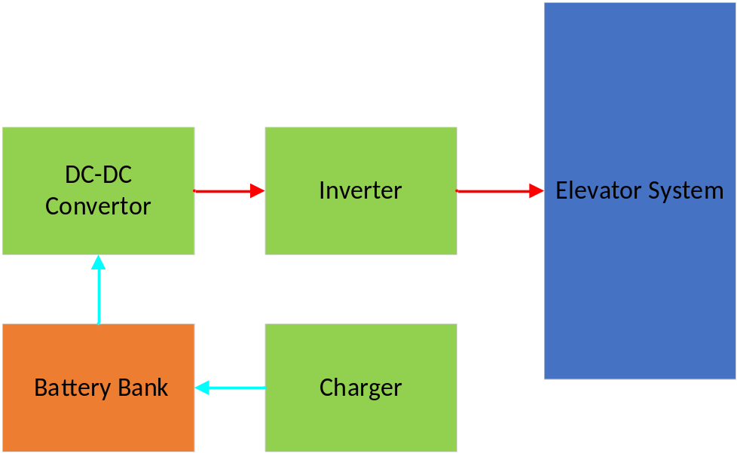
Figure 1:System Architecture

COMPONENT TECHNOLOGY
The component technology decided to use is specified in chapter Manufacturing process.

FUNCTIONAL OPERATION

Requirement Specification

Parameter | Value
Output power rating | 5KW
Output voltage | 380 VDC
Input voltage max | 42 V DC
Input voltage min | 36 VDC
Controller type | Digital
Communication interface | RS485,RS232
Board Size | 155MMX215MM

DC-DC Converter Protection
- Temperature compensation for charger.
- Output overload protection
- Battery overload and fire protection
- Battery charger short circuit protection
- Battery reverse polarity protection
- Thermal protection for Transformer & Power device’s
- Instantaneous over current protection for MOSFET’s

BLOCK DIAGRAM
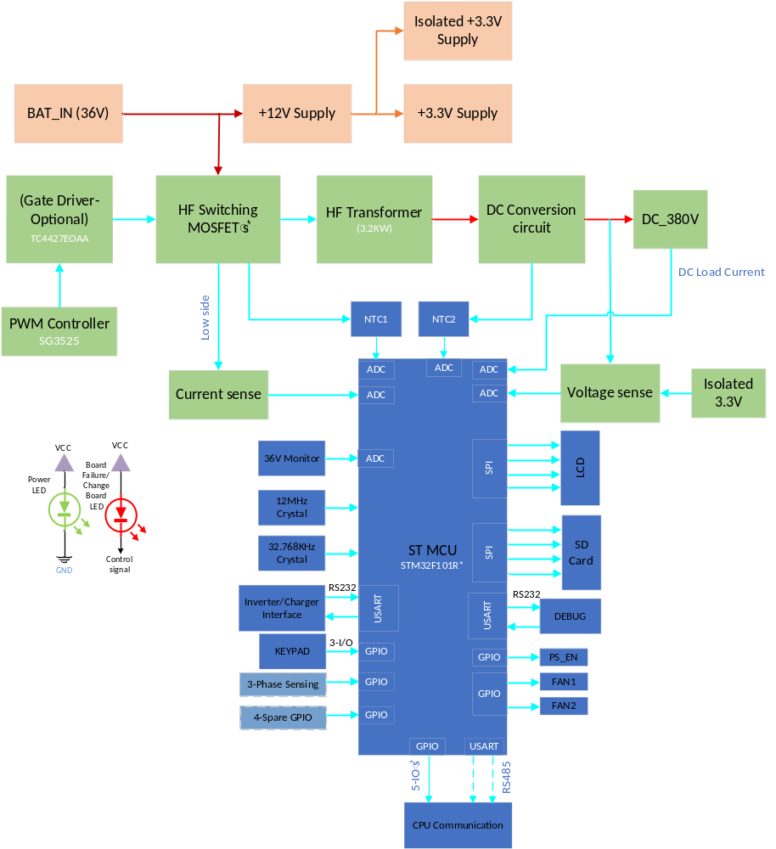

Figure 2:DC-DC Converter Board Block Diagram

DESCRIPTION OF SIGNALS AND SYMBOLS

Signal or Symbol | Description
PWM | PULSE WIDTH MODULATION
HF | HIGH FREQUENCY

PWM SWITCHING CONTROLLER
The SG3525 is the PWM controller which is used in the Board for h-Bridge MOSFET switching purpose. This IC’s supports oscillator frequency range of 50Hz to 400KHz.The required operating range for this Design is 43KHz.
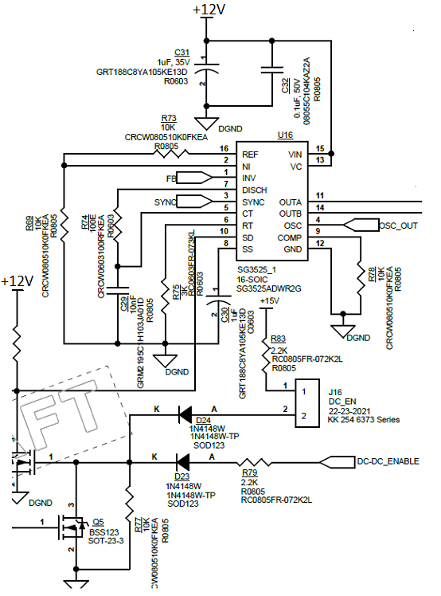
Figure 3: PWM controller Circuit

POWER MOSFET DRIVER
Output of PWM controller is given to Dual High speed MOSFET Driver IC(TC4427EOAA) to drive the push pull topology MOSFET’s.
TC4427EOAA Gate driver is capable of peak output current 1.5A with Matched Rise, Fall and Delay Times.
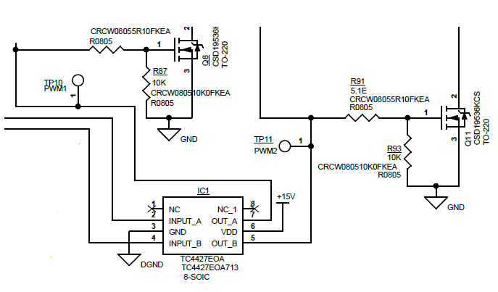

Figure 4: MOSFET DRIVER
Output of Driver IC is connected to the gate terminals of the MOSFET’s(CSD19536KCS). Whereas the MOSFET drain terminal are connected with the High frequency transformer secondary side.

HF TRANSFORMER
The 3.2KW transformer is used for stepping up the output to 380V level. Below are the specification details of the HF transformer.

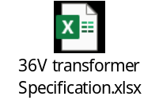

CURRENT SENSE
The current sense is done at the lower arm of MOSFET in terms of voltage drop across the shunt resistor connected at the Lower side of MOSFET. And that output is given to MUC through OPAMP(voltage follower).
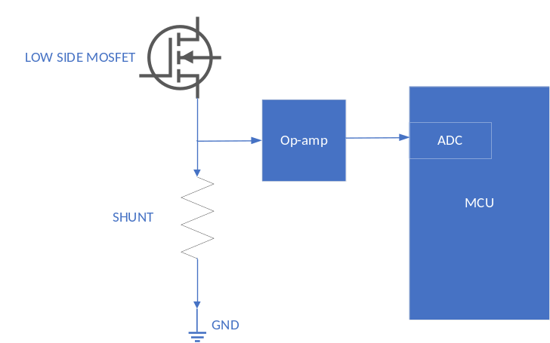

Figure 5: Current Sense

DC VOLTAGE SENSE
The rectifier output voltage is sensed by MCU through isolated opamp(AMC1302) followed by a voltage divider resistors.
A separate +3.3V supply is used for the opamp (mean-well).

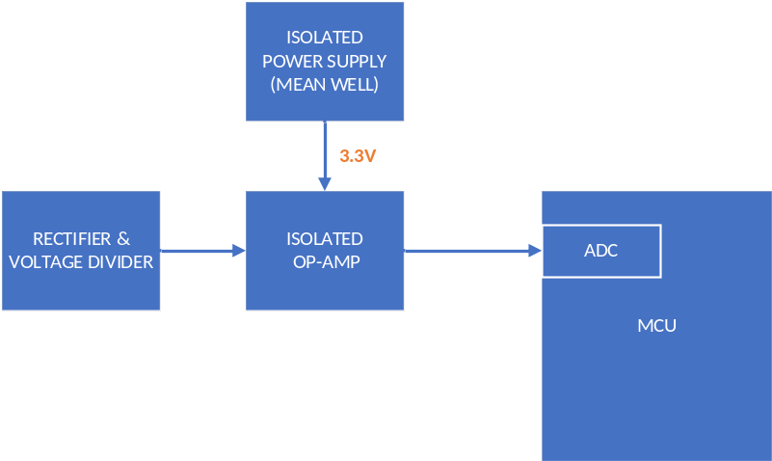

Figure 6: DC Voltage Sense

DC LOAD CUREENT SENSE
The load current is sensed and feedback to the MCU. Which is done based on the Hall effect sensor on the DC output(Load) side.
This output is given to ADC channel of MCU.

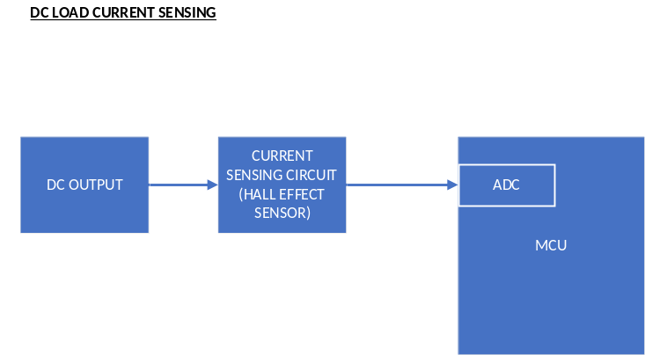

LCD DISPLAY-PARALLEL

This LCD used for setting parameters and to displays fault codes. And it operates at 3.3VThe LCD module uses the 8 bit for data communication from Micro controller. However this LCD module can also work with 4 bit data (upper bit:DB4-DB7) communication, hence in this PCBA 4 bit is used for data (upper bit:DB4-DB7) communication.
(5V Supply to be changed as 3.3V)
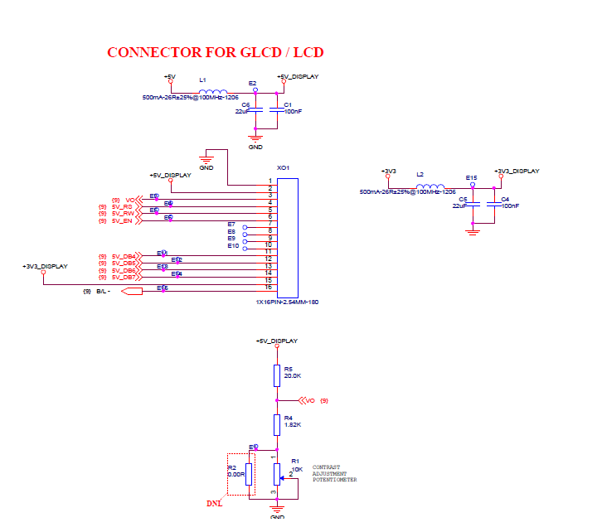
This LCD will be switch ON/OFF by using the MOSFET (Q11). Below the control signal circuit.
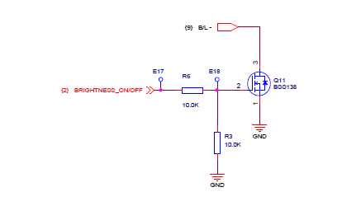

LCD SERIAL
The LCD interface is designed with serial communication for Future purpose. By using SPI channel the LCD interface can be done. For this purpose, SPI channel retained. SPI supported LCD with 3.3V supply to be used in this.

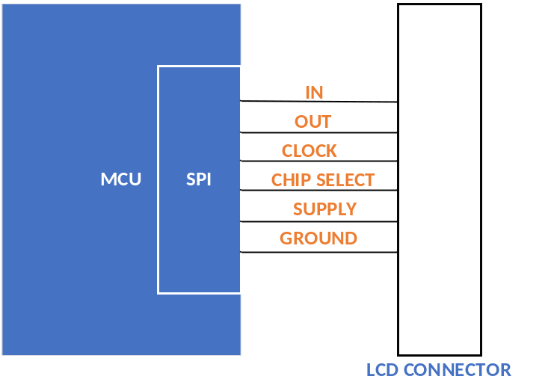

INVERTER/CHARGER PCBA INTERFACE
From DC-DC Converter PCBA, the RS-232 interface is used for communicating with Inverter and charger PCBA’s.
Below things are communicated for Inverter board
- Enable /Disable: This signal is output signal which is Enable/disable the Inverter PCBA.
- Inverter Failed/Change Board: This signal is input signal for this PCBA which is used to indicate the Inverter PCBA failure and inform to change the PCBA.
- Inverter Mode: This signal is input signal for this PCBA which is used to indicate the Inverter PCBA status.

Below things are communicated for charger board

  - From Inverter PCBA, the RS-485 interface for communicate with charger PCBA for Battery charging status, Battery condition and fault codes etc.

MAX3232 RS-232 Transceiver IC is used for this interface. This transceiver supports and capable of full-duplex mode and data transfer rate of 120Kbps.
Refer the circuit below for RS232 Interface Section.

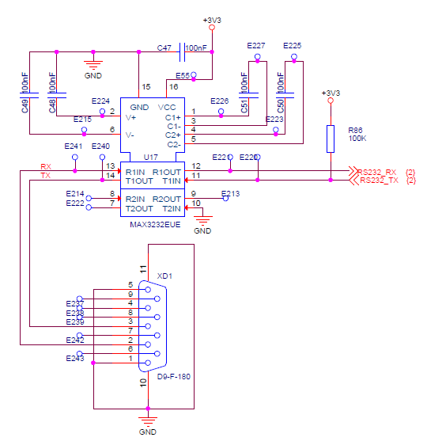

ELEVATOR CPU INTERFACE-PARALLEL
DC-DC board uses the below signals for CPU Controller communication,
- Mode: Mode of running which means, Main mode or rescue mode will communicate to CPU
- Device_Fault: This signal will communicate to CPU that this Device is fault.
- Bat_Low: This signal indicates when the Battery voltage is lower than 38V(YTD) the unit will not go to ERD mode.
- Remote_Test: this signal will communicate Remote test.
- Shutdown: This signal will go LOW and will make the unit come out of ERD mode
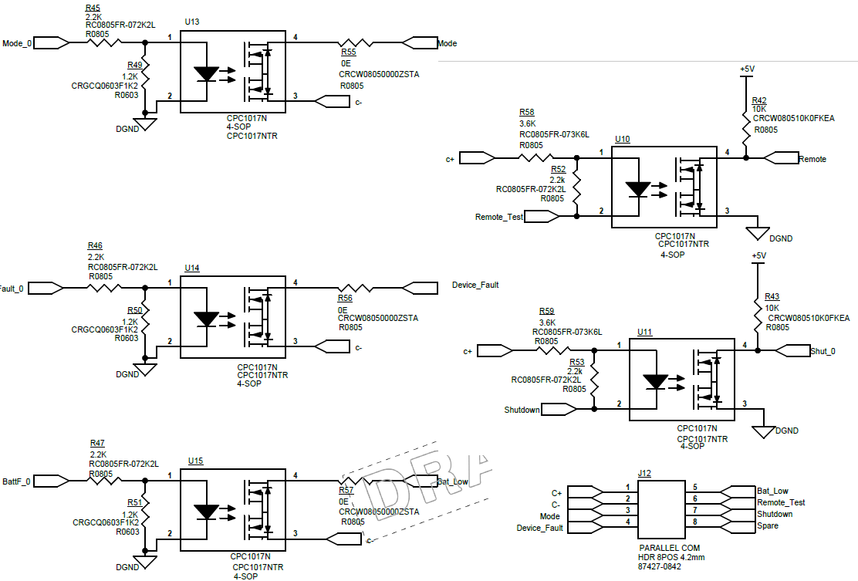

ELEVATOR CPU INTERFACE-SERIAL
This RS485 Interface used for DC-DC board to Communicate with CPU through serial for future purpose.

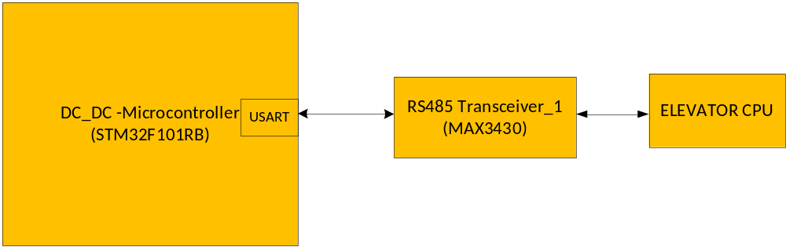
The MAX3430 fault-protected RS-485 transceiver features protection from over voltage signal faults on communication bus lines. Messages between DC TO DC CONVERTER, Elevator CPU shall be communicated to through RS 485 interface. Baud rate for this communication will be 115200kbps. It has,

- ±80V Fault Protection
- ±12kV ESD Protection
- 250kbps Data Rate
- Allows Up to 128 Transceivers on the Bus
- -7V to +12V Common-Mode Input Voltage Range

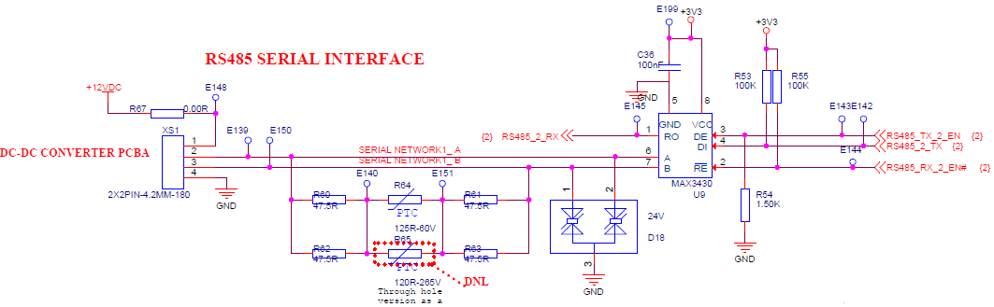

NTC’s and FAN’s
Two NTC’s used in this mode for monitoring Temperatures of MOSFET’s and rectifier diodes which are given to ADC channel of MCU.
These temperature sensors are mounted on the heatsinks of MOSFET and Diode. These outputs will be used by MCU to trun ON the FAN’s when heats up.

Below the NTC Interface circuit diagram
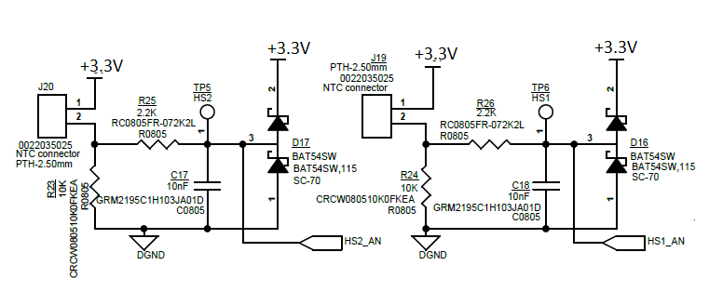
Below the FAN Interface circuit diagram

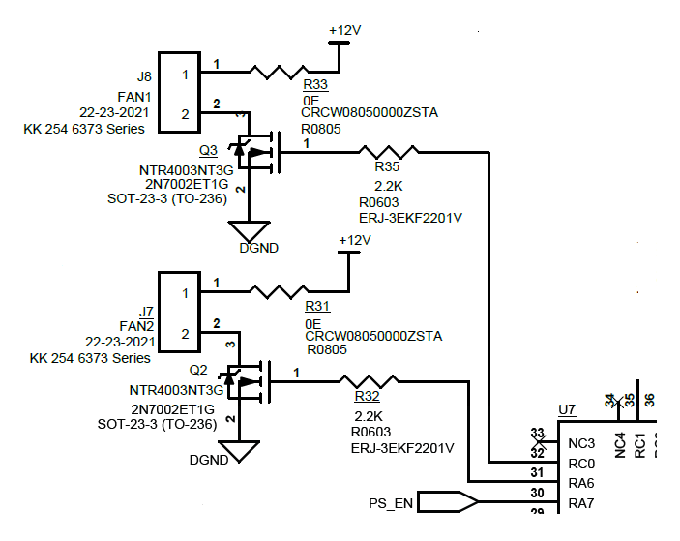

+36V MONITORING
The board Input voltage 36V is monitored in MCU. This is done opamp followed by voltage divider.
Here opamp is used as voltage follower and which is used for better output accuracy.
The output of opamp is given to the ADC channel of MCU.
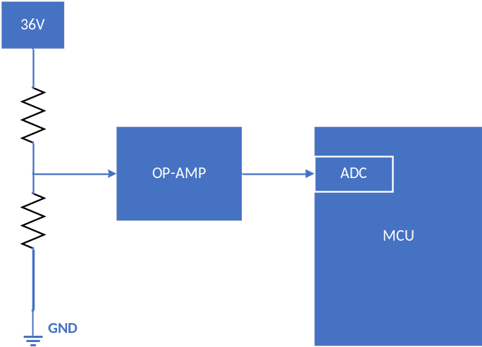

3-PHASE SENSING
3-phase sensing to be added for future purpose. This can be not assembled in current design.
Output of the 3-phase sensing circuit is given to one of ADC channel in MCU.

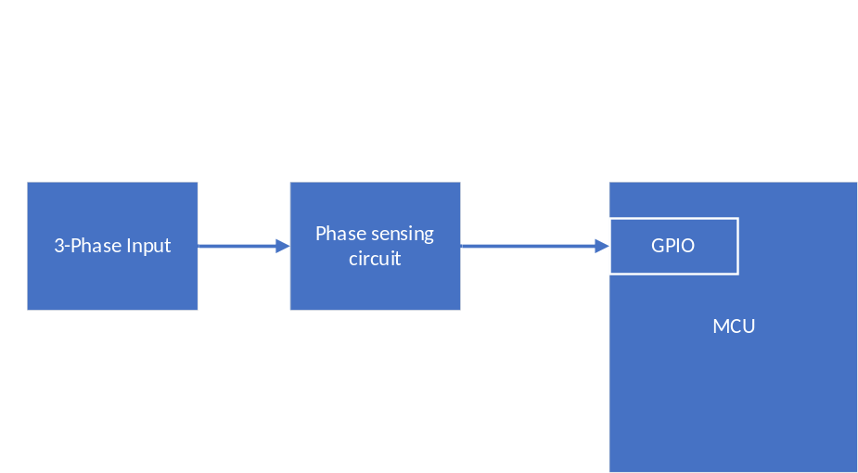

MICROCONTROLLER SECTION
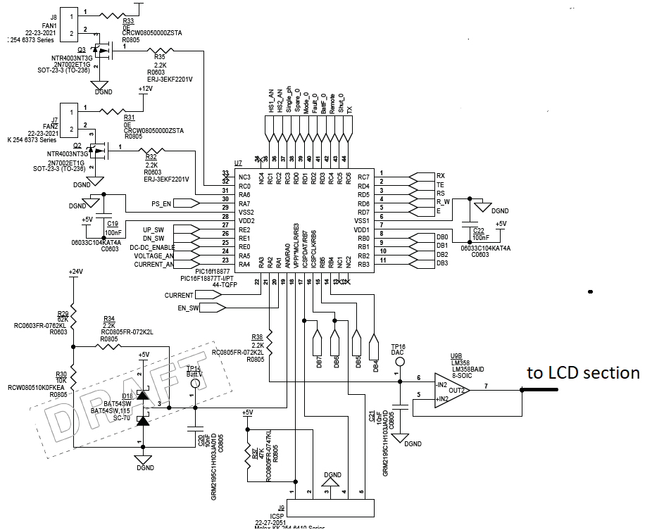

(Above image has PIC MCU these signals to be maintained and MCU to be changed as STM).

The STM32F101RB(medium-density access line family incorporates the High-performance ARM Cortex™-M3 32-bit RISC core operating at a 36 MHz frequency, High-speed embedded memories (Flash memory up to 128 Kbytes and SRAM up to 16 Kbytes), and an extensive range of enhanced peripherals and I/Os connected to two APB buses. All devices offer standard communication interfaces (two I2Cs, two SPIs, and up to three USARTs), one 12-bit ADC and three general-purpose 16-bit timers. The STM32F101xx medium-density access line family operates in the –40 to +85 °C

TIMERS
There are three synchronically general-purpose timers embedded in the STM32F101xx Medium-density access line devices. These timers are based on a 16-bit auto-reload Up/down counter, a 16-bit presale and feature 4 independent channels each for input capture, output compare, PWM or one pulse mode output. This gives up to 12 input captures / output compares / PWMs on the largest packages. The general-purpose timers can work together via the Timer Link feature for synchronization or event chaining. Their counter can be frozen in debug mode. Any of the general-purpose timers can be used to generate PWM outputs. They all have independent DMA request generation. These timers are capable of handling quadrature (incremental) encoder signals and the digital outputs from 1 to 3 hall-effect sensors.

INTERNAL MEMORY
EMBEDDED FLASH AND SRAM

The ARM Cortex™-M3 processor is the latest generation of ARM processors for embedded systems. It has been developed to provide a low-cost platform that meets the needs of MCU implementation, with reduced pin count and low-power consumption, while delivering outstanding computational performance and an advanced system response to interrupts. The ARM Cortex™-M3 32-bit RISC processor features exceptional code-efficiency, delivering the high-performance expected from an ARM core in the memory size usually associated with 8- and 16-bit devices. The STM32F103xx performance line family having an embedded ARM core is therefore compatible with all ARM tools and software.

EMBEDDED FLASH MEMORY
128 Kbytes of embedded Flash is available for storing programs and data.

EMBEDDED SRAM
16 Kbytes of embedded SRAM accessed (read/write) at CPU clock speed with 0 wait states.

INTERNAL WATCHDOG
INDEPENDENT WATCHDOG
The independent watchdog is based on a 12-bit down counter and 8-bit prescaler. It is clocked from an independent 40 kHz internal RC and as it operates independently of the main clock, it can operate in Stop and Standby modes. It can be used either as a watchdog to reset the device when a problem occurs, or as a free-running timer for application timeout management. It is hardware- or software-configurable through the option bytes. The counter can be frozen in debug mode.

WINDOW WATCHDOG
The window watchdog is based on a 7-bit down counter that can be set as free-running. It can be used as a watchdog to reset the device when a problem occurs. It is clocked from the main clock. It has an early warning interrupt capability and the counter can be frozen in debug mode.

IO MAPPING(TBD)
Pin no | Pin function | Type | Assigned net | Default /programmed state
1 | VBAT | Supply | 3.3V
2 | PC13 | Output
3 | PC14 | Output
4 | PC15 | Input
5 | PD0 | Input | OSC _IN
6 | PD1 | Output | OSC_OUT
7 | NRST | Input | RESET BY JTAG
8 | PC0 | Output
9 | PC1 | Output
10 | PC2 | Input
11 | PC3 | Input
12 | VSSA | Supply | ANALOG GND
13 | VDDA | Supply | 3.3V ANALOG
14 | PA0/WKUP | Input
15 | PA1 | Input
16 | PA2 | Output
17 | PA3 | Input
18 | VSS_4 | Supply | GND
19 | VDD_4 | Supply | 3.3V
20 | PA4 | Output
21 | PA5 | Output
22 | PA6 | Output
23 | PA7 | Input
24 | PC4 | Output
25 | PC5 | Output
26 | PB0 | Output
27 | PB1 | Output
28 | PB2 | Output
29 | PB10 | Input
30 | PB11 | Input
31 | VSS_1 | Supply | GND
32 | VDD_1 | Supply | 3.3V
33 | PB12 | Output
34 | PB13 | Output
35 | PB14 | Output
36 | PB15 | Output
37 | PC6 | Output
38 | PC7 | Output
39 | PC8 | Output
40 | PC9 | Output
41 | PA8 | Output
42 | PA9 | Output
43 | PA10 | Input
44 | PA11 | Input
45 | PA12 | Input
46 | PA13 | Bidirectional | JTMS
47 | VSS_2 | Supply | GND
48 | VDD_2 | Supply | 3.3V
49 | PA14 | Output | JTCK
50 | PA15 | Input
51 | PC10 | Output
52 | PC11 | Input
53 | PC12 | Output
54 | PD2 | Input
55 | PB3 | Output
56 | PB4 | Output
57 | PB5 | Output
58 | PB6 | Output
59 | PB7 | Output
60 | BOOT0 | Input
61 | PB8 | Output
62 | PB9 | Input
63 | VSS_3 | Supply | GND
64 | VDD_3 | Supply | 3.3V

MAIN CRYSTAL
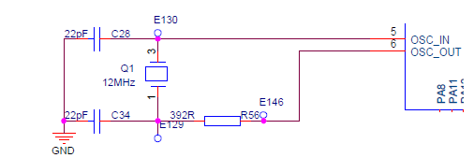
12 MHz crystal is used to generate clock signals.

CRYSTAL FOR RTC
32.768KHz is used for the real time clock purpose.
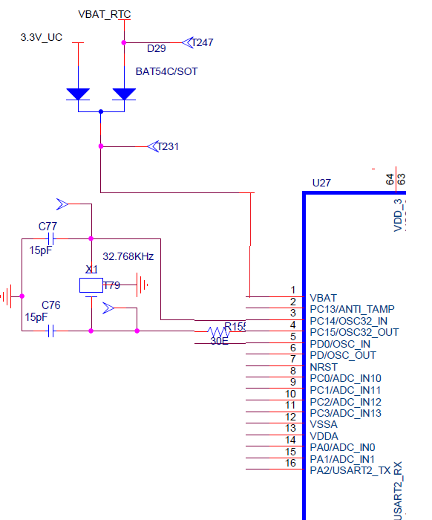

JTAG INTERFACE
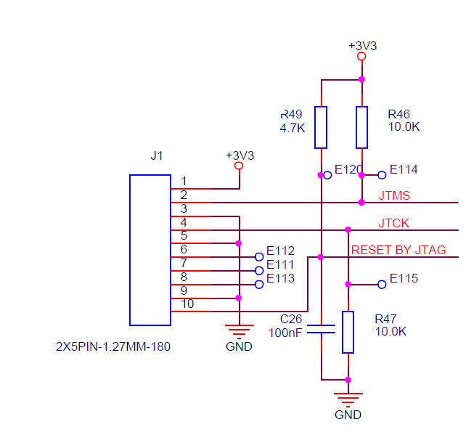

The ARM SWJ-DP Interface is embedded and is a combined JTAG and serial wire debug port that enables either a serial wire debug or a JTAG probe to be connected to the target. The JTAG TMS and TCK pins are shared with SWDIO and SWCLK, respectively, and a specific sequence on the TMS pin is used to switch between JTAG-DP and SW-DP.

DEBUG -RS232 SERIAL INTERFACE
The Debug Unit (DBGU) provides a single entry point from the processor for access to all the debug capabilities of the processor. Port details are shown in below table

Signal | I/O Line | Peripheral
RS232_RX | PA3 | USART2
RS232_TX | PA2 | USART2

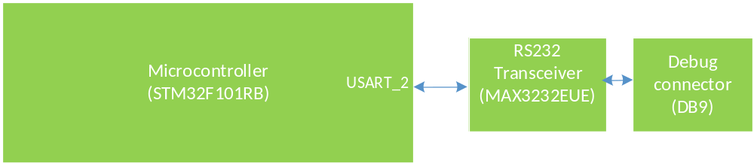

MAX3232 RS-232 Transceiver IC is used for this debug interface. this transceiver is supports and capable of full-duplex mode and data transfer rate of 120Kbps.
Refer the circuit below for RS232 Debug Interface Section.

SD CARD INTERFACE
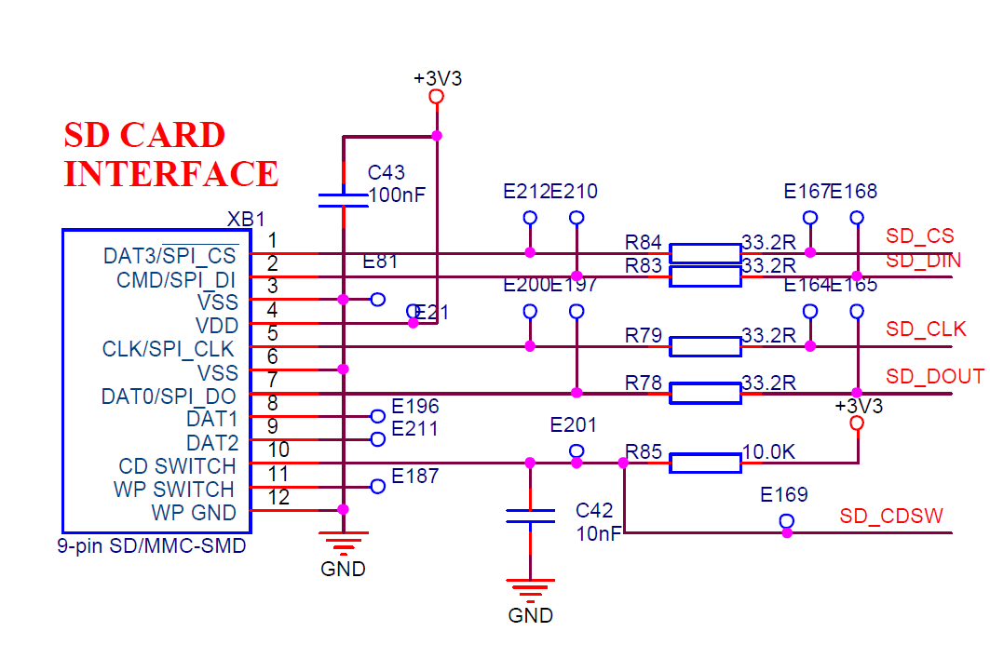

SD card interface used to load the application software in the field.

POWER SUPPLY
Input for DC-DC converter Board is +36VDC from battery, which is given @ J13,J14 Connectors.
This 36V will be converted to +12V by a Switching regulator (LM5085_DGK_8).
Then +12V will be converted into +3.3V using another switching regulator (LM2596S-3.3).

A separate 3.3V power supply module(mean well or similar TBD) is used for the voltage sense opamp.
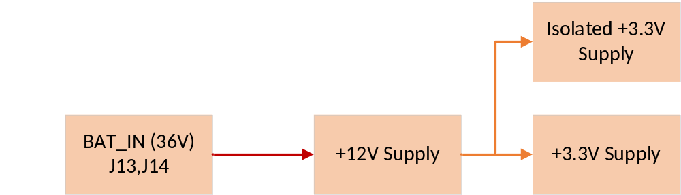

The power section will have to meet the below requirements.
- Input voltage min/max 36V/42V
- Input current min/max ?
- Output current min/max ?
- Protection→ Over Temperature, Short circuit, over current.

+12V POWER SUPPLY
Below +12V section reference circuit, Values are mentioned for 24V input and 15V out, that all to be changed for 36V input and 12V output
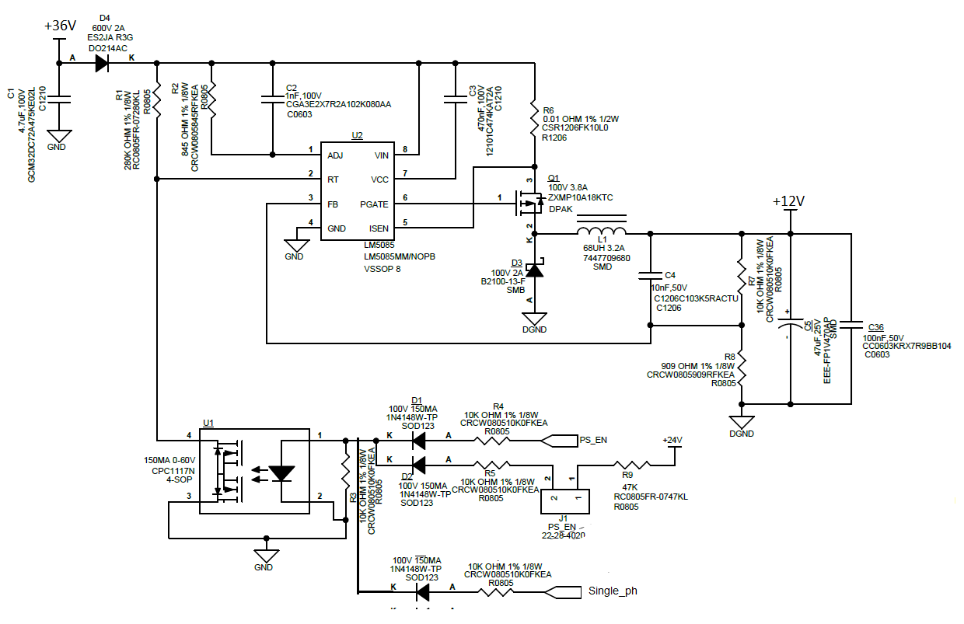

+3.3V POWER SUPPLY
Below +3.3V section reference circuit, this 3.3V is used as supply for MCU,LCD,MAX IC’s and OP-AMPs
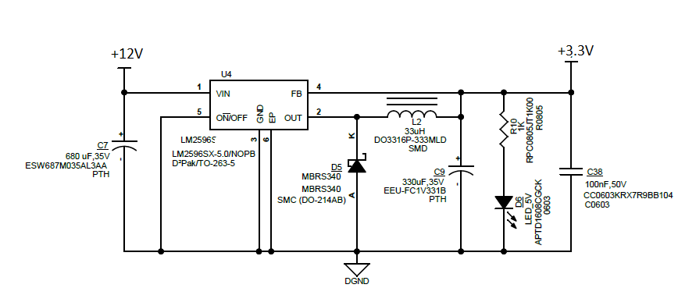

+3.3V POWER SUPPLY MODULE
SPAN02A-03 Power supply model is used to supply the isolated error amplifiers in the board.
SPAN02-03 is 2W isolated and regulated module type DC-DC converter with SIP8 package. It features high temperature range -40 to +90 high isolation voltage and short circuit protection. Which support 12V input and can deliver 3.3V output with low leakage current.

Below table shows the pin out of the power supply model
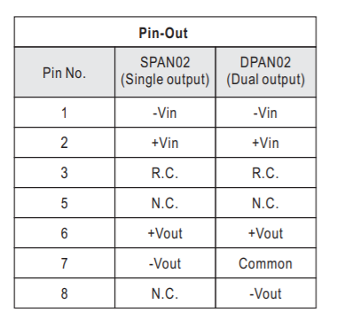

POWER OK INDICATORS

The green LEDs are connected to the +3.3V, power outputs to indicate the state of the power
supply .

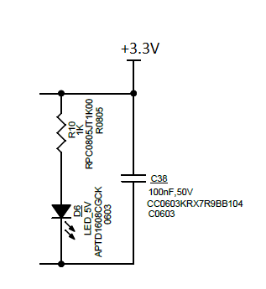

INTERFACES

ELECTRICAL INTERFACE

Position number |  | J13 |  |  |  | Pin 1  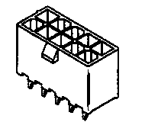  Note: Pin number is not same
Connector type |  | 9 Pin Shank Terminal Through Hole
Name |  | DC Input
From/To |  | Battery /DC-DC board
Pin | Signal name | Type | Voltage  Min | Voltage  Max | Current  Min | Current  Max | Low max  High min | Notes
1 | 36VDC | Power | 36V DC | 42 V DC

Position number |  | J14 |  |  |  | Pin 1  Note: Pin number is not same
Connector type |  | 9 Pin Shank Terminal Through Hole
Name |  | DC Input
From/To |  | Battery /DC-DC
Pin | Signal name | Type | Voltage  Min | Voltage  Max | Current  Min | Current  Max | Low max  High min | Notes
1 | Bat-0V DC | Power |  | 0V DC

Position number |  | J15 |  |  |  | Pin 1  Note: Pin number is not same
Connector type |  | 9 Pin Shank Terminal Through Hole
Name |  | Transformer Input connector
From/To |  | Centre tap of Transformer
Pin | Signal name | Type | Voltage  Min | Voltage  Max | Current  Min | Current  Max | Low max  High min | Notes
1 | 0VDC | Power |  | 24 V DC

Position number |  | J17 |  |  |  | Pin 1  Note: Pin number is not same
Connector type |  | 9 Pin Shank Terminal Through Hole
Name |  | Transformer Input connector
From/To |  | Centre tap of Transformer
Pin | Signal name | Type | Voltage  Min | Voltage  Max | Current  Min | Current  Max | Low max  High min | Notes
1 | 24VAC | Power |  | 24 V AC

Position number |  | J18 |  |  |  | Pin 1  Note: Pin number is not same
Connector type |  | 9 Pin Shank Terminal Through Hole
Name |  | Transformer Input connector
From/To |  | Centre tap of Transformer
Pin | Signal name | Type | Voltage  Min | Voltage  Max | Current  Min | Current  Max | Low max  High min | Notes
1 | 24VAC | Power |  | 24 V AC

Position number |  | J4 |  |  |  | Pin 1  Note: Pin number is not same
Connector type |  | TERM BLOCK HDR 3POS VERT 5.08MM
Name |  | DC Output
From/To |  | DC-DC Board /Load
Pin | Signal name | Type | Voltage  Min | Voltage Max | Current  Min | Current  Max | Low max  High min | Notes
1 | 380VDC |  |  | 380VDC
2 | GND

Position number |  | J16 |  |  |  | Pin 1  Note: Pin number is not same
Connector type |  | CONN HEADER VERT 2POS 2.54MM
Name |  | DC_EN
From/To |  | PWM CONTROLLER ENABLE/DISABLE
Pin | Signal name | Type | Voltage  Min | Voltage Max | Current  Min | Current  Max | Low max  High min | Notes
1 | 12V |  |  | 12VDC
2 | GND

Position number |  | XS1 |  |  |  | Pin 1  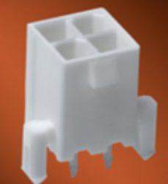  Note: Pin number is not same
Connector type |  | MINI FIT CONNECTOR 2X2PIN-4.2MM-180 (KM261998)
Name |  | RS485 CONNECTOR
From/To |  | DC-DC CONVERTER TO INVERTER/CHARGER
Pin | Signal name | Type | Voltage  Min | Voltage  Max | Current  Min | Current  Max | Low max  High min | Notes
1 | +12VDC | Supply |  | 12VDC | 500mA
2 | Serial network A | In/Out | 0VDC | 3.3VDC | 6mA | 10mA
3 | Serial network B | In/Out | 0VDC | 3.3VDC | 6mA | 10mA
4 | GND | Supply | 0VDC |  | 500mA

Position number |  | XS2 |  |  |  | Pin 1  Note: Pin number is not same
Connector type |  | MINI FIT CONNECTOR 2X2PIN-4.2MM-180 (KM261998)
Name |  | RS485 CONNECTOR
From/To |  | RS485 SPARE CONNECTOR
Pin | Signal name | Type | Voltage  Min | Voltage  Max | Current  Min | Current  Max | Low max  High min | Notes
1 | +12VDC | Supply |  | 12VDC | 500mA
2 | Serial network A | In/Out | 0VDC | 3.3VDC | 6mA | 10mA
3 | Serial network B | In/Out | 0VDC | 3.3VDC | 6mA | 10mA
4 | GND | Supply | 0VDC |  | 500mA

Position number |  | J16 |  |  |  |  | 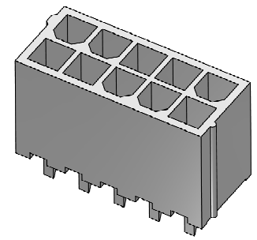  Pin 1  Note: Pin number is not same
Connector type |  | MINIFIT CONNECTOR 2X4PIN-4.2MM-180
Name |  | CPU CONTROLLER SIGNALS
From/To |  | From CPU to DC-DC
Pin | Signal name | Type | Voltage  Min | Voltage  Max | Current  Min | Current  Max |  | Low max  High min | Notes
1 | Common + (12V) | Power |  | 12VDC |  | 10 mA
2 | Common - | Gnd |  | 12VDC |  | 10 mA
3 | Mode | Input |  | 12VDC |  | 10 mA
4 | Device_Fault | Input |  | 24VDC |  | 10 mA
5 | Battery Low | Gnd |  | 24VDC |  | 10 mA
6 | Remote Test | Input |  | 24VDC |  | 10 mA
7 | Shutdown | Input |  | 24VDC |  | 10 mA
8 | NC

Position number |  | J1 |  |  |  |  | 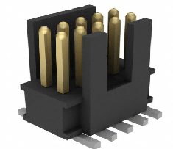  Pin 1
Connector type |  | SMD PIN HEADER 2X5PIN-1.27MM-180 (KM51215624)
Name |  | JTAG Interface
From/To |  | From System to DC-DC
Pin | Signal name | Type | Voltage  Min | Voltage  Max | Current  Min | Current  Max |  | Low max  High min | Notes
1 | 3.3V | Power |  | 3.3VDC |  | <0.5mA
2 | JTMS | Signal |  | 3.3VDC |  | <0.5mA
3 | GND | Power |  | 3.3VDC |  | <0.5mA
4 | JTCK | Signal |  | 3.3VDC |  | <0.5mA
5 | GND | Power |  | 3.3VDC |  | <0.5mA
6 | NC
7 | NC
8 | NC
9 | GND | Power |  | 3.3VDC |  | <0.5mA
10 | RST | Signal |  | 3.3VDC |  | <0.5mA

Position number |  | XD1 |  |  |  | 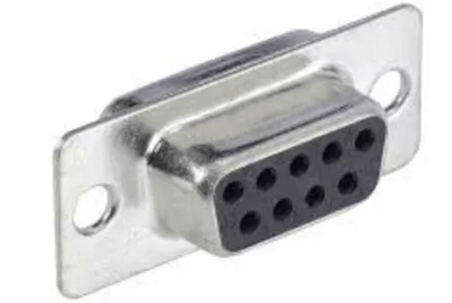  Pin 1  Note: Pin number is not same
Connector type |  | DB9 FEMALE CONNECTOR  (KM1334288)
Name |  | DEBUG CONEECTOR
From/To |  | RCU TO USB DEBUG CONNECTOR
Pin | Signal name | Type | Voltage  Min | Voltage  Max | Current  Min | Current  Max | Low max  High min | Notes
1 | GND | SUPPLY
2 | RXD | INPUT
3 | TXD | OUTPUT
4 | NC
5 | GND | SUPPLY
6 | NC
7 | NC
8 | NC
9 | NC

Position number |  | XO1 |  |  |  | Pin 1  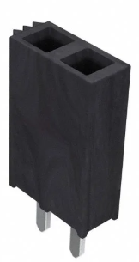Note: Pin number is not same
Connector type |  | FEMALE PIN HEADER 1X20PIN-2.54MM-180 (KM51621405)
Name |  | LCD DISPLAY CONNECTOR
From/To |  | DC-DC TO 2*16 DISPLAY MODULE
Pin | Signal name | Type | Voltage  Min | Voltage  Max | Current  Min | Current  Max | Low max  High min | Notes
1 | VSS | SUPPLY | 0VDC |  | 1mA | 1.5mA
2 | +3.3V_DISPLAY | SUPPLY |  | 3.3V | 1mA | 1.5mA
3 | VO | SUPPLY |  |  | 1mA | 1.5mA
4 | 3.3V_RS | OUTPUT |  | 3.3V | 1mA | 1.5mA
5 | 3.3V_RW | OUTPUT |  | 3.3V | 1mA | 1.5mA
6 | 3.3V_EN | OUTPUT |  | 3.3V | 1mA | 1.5mA
7 | NC
8 | NC
9 | NC
10 | NC
11 | 3.3V_DB4 | OUTPUT |  | 3.3V | 1mA | 1.5mA
12 | 3.3V_DB5 | OUTPUT |  | 3.3V | 1mA | 1.5mA
13 | 3.3V_DB6 | OUTPUT |  | 3.3V | 1mA | 1.5mA
14 | 3.3V_DB7 | OUTPUT |  | 3.3V | 1mA | 1.5mA
15 | +3V3_DISPLAY | SUPPLY |  | 3.3V |  | 40mA
16 | B/L - | SUPPLY |  | 3.3V |  | 40mA

MECHANICAL INTERFACE

PCB LAYOUT DRAWING
- Boar size 83.2 x 46 mm

ALLOWED FIXING METHOD

Allowed fixing method: | Symbol | Min |  | Typical |  | Max |  |  |  | Unit
Hole diameter (inner) | d |  |  | 3.2 |  |  |  |  |  | mm
Diameter of the fixing part (outer) | D |  |  |  |  | 7.5 |  |  |  | mm
Height from the bottom (to metal) | H_{B} | 6 |  |  |  |  |  |  |  | mm
Height from the top (to metal) | H_{T} | 6 |  |  |  |  |  |  |  | mm
Distance from the side (to metal) | H_{S1} | 2 |  |  |  |  |  |  |  | mm
Distance from the side (to metal) | H_{S2} | 2 |  |  |  |  |  |  |  | mm
Distance from the side (to metal) | H_{S3} | 2 |  |  |  |  |  |  |  | mm
Distance from the side (to metal) | H_{S4} | 2 |  |  |  |  |  |  |  | mm
Allowed material of the fixing part | - | Plastic or metal |  |  |  |  |  |  |  | -
Allowed mounting positions |  | Yes | Yes |  | Yes |  | Yes | Yes | No | -
Other limits
H_{S3}

H_{S4}
H_{S2}

H_{T}

d
D

H_{B}
H_{S1}

USER INTERFACE

LED’S
LED position number | Color | Name | Notes
D6 | Green | +3.3V OK
D* | Red | Change Board/Error

KEYPAD SWITCHES
DC-DC board is provided with 3 switches to navigate through the menu. SMD switches with 100mA and 42V rating is used. UP, DOWN, ENTER are the selections available to navigate with these switches.

FUSES

PARAMETERS
Not Applicable

DIAGNOSTICS
In DC-DC board below LED’s are used for Diagnostics

LED Position Number | Glowing | Not Glowing
D6 | 3.3V is present | 3.3V is not present
D* | Fault in board | No Fault in board

REQUIREMENTS FOR SOFTWARE
Not Applicable

DESIGN FOR TESTABILITY (DFT)
Not Applicable

INSTALLATION
Not Applicable

MAINTENANCE

MANUFACTURING PROCESS

PCB STRUCTURE AND COMPONENT TECHNOLOGY

Description | Method / Value | Note
Soldering process, top side | Reflow
Soldering process, bottom side | Wave
Component placement, top side | SMD + TH
Component placement, bottom side | No
Coating | Not needed
PCB material | FR4
Number of layers | 2 or 4 | Based on routing complexity
Resistor/Capacitor side | 0402,0603,0805
Logic family | HCMOS
Voltage levels | 380VDC,36V, 15V,12V 5V

Traditional FR4 processes (green recommended, red not recommended):

SMD TOP
THT TOP

REFLOW TOP
WAVE
BOTTOM ²⁾

1) When THT components will be soldered in reflow only, the components must be specified for reflow

2) Wave solder and reflow are alternative for each other

LAYOUT INSTRUCTIONS
Refer Section 5.2 STANDARDS AND REQUIREMENTS

SAFETY
- EN81-1, EN81-2: Safety rules for the construction and installation of lifts
- IEC 60950: Safety information technology equipment
- IEC 60664-1: Insulation coordination for equipment within low-voltage systems
- IEC 61558-1: Safety of power transformers, power supply units and similar
- CAN/CSA-B44.1-96 / ASME-A17.5-1996: Elevator and escalator electrical equipment, public safety
- Cross reference to clearances 853920D12

CLEARANCES AND CREEPAGE DISTANCES

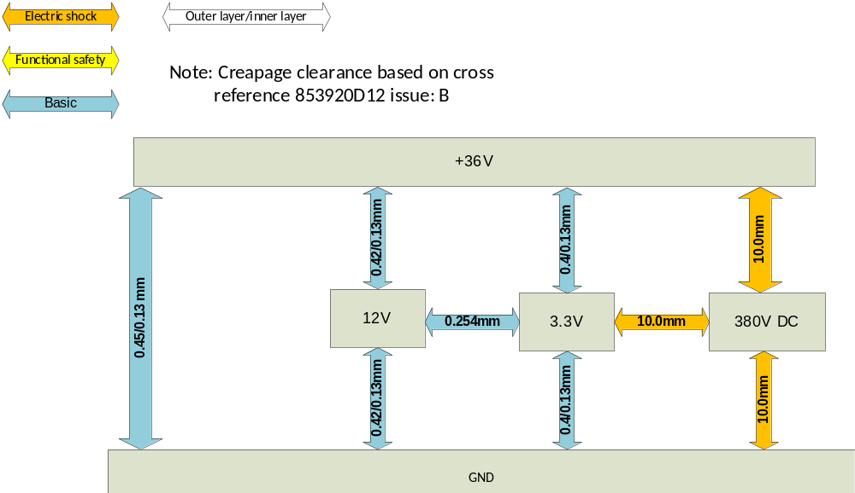

EMC
- Emission EN 12015
- Immunity EN 12016

ENVIRONMENTAL REQUIREMENTS
See LAB-01.01.021. If different requirement, list details here.

RELIABILITY
- Reliability at design lifetime
- Lifetime >15 years
- Probability to not fail during lifetime 0,9 (no maintenance during this time)
- Early Failure rate during warranty time <0,002 (probability to fail)

PROTECTION CATEGORY
- IP21 (with mechanics)

COMPATIBILITY
- spare parts / replacements

SECOND SOURCES
- Needed changes/actions due to second source components

OTHER RELATED ANALYSIS AND TEST RESULTS

ANALYSIS RESULTS
- Process and design FMEA found in 51674123D13 (TBD)
- Stress analysis found in 51674123D14 (TBD)

TEST RESULTS
- Test results found in 51674123D11 (TBD)

TECHNICAL DATA

Parameter | Min | Typical | Max | Unit
Supply voltage | 36 | 36 | 42 | VDC
Supply current |  |  |  | mA
AC supply voltage |  |  |  | VAC
AC supply frequency |  |  |  | Hz
Operating temperature | -20 |  | +66 | ºC
Storing temperature | -40 |  | +70 | ºC
Humidity |  |  | 36 | g/m³
Operating altitude (above sea level) |  |  | 4000 | M
Mechanical dimensions  Width  Height  Depth |  |  | 83.2  100  46 | mm  mm  mm
Weight |  | 400 |  | g

APPROVALS AND VERSION HISTORY

Compiled by: Praveen B
Checked by: Venkatesan S
Approved by: Rajkumar S

Issue | Date | Description of Change | Ref CR | Approved By
- | 2021-02-11 | First Draft | - | Rajkumar S
 |  |  | -

