With the growing need for new low-carbon energy sources, harnessing heat from abandoned flooded coal mines could be a very attractive solution. In the UK, a large proportion of the energy consumption is used for space heating, and around 70% of the heat demand is supplied by natural gas, largely contributing to the carbon emissions of the country.

A large proportion of the urban area in the UK was extensively mined for coal, and the resource that once contributed to the overall air pollution is now home to another valuable and easily accessible resource: a 12-20°C mine water. Using ground-source heat pump (GSHP) systems, heat energy can be extracted from this water and potentially be used for space heating. Mine water based GSHP schemes have already been implemented worldwide and one of the most successful projects is located at Herleen in the Netherlands. In Scotland, such a system has been used since 1999 in Shettleston to provide heat to 16 dwellings. Earlier this year, the Coal Authority (the non-departmental government body with the responsibility for managing the legacy of abandoned coal mines) has launched the first large scale mine-energy district heating scheme in the UK in South Seaham, where 18-20°C mine water will be used to provide heat to the 1500 residents of the new Garden Village.

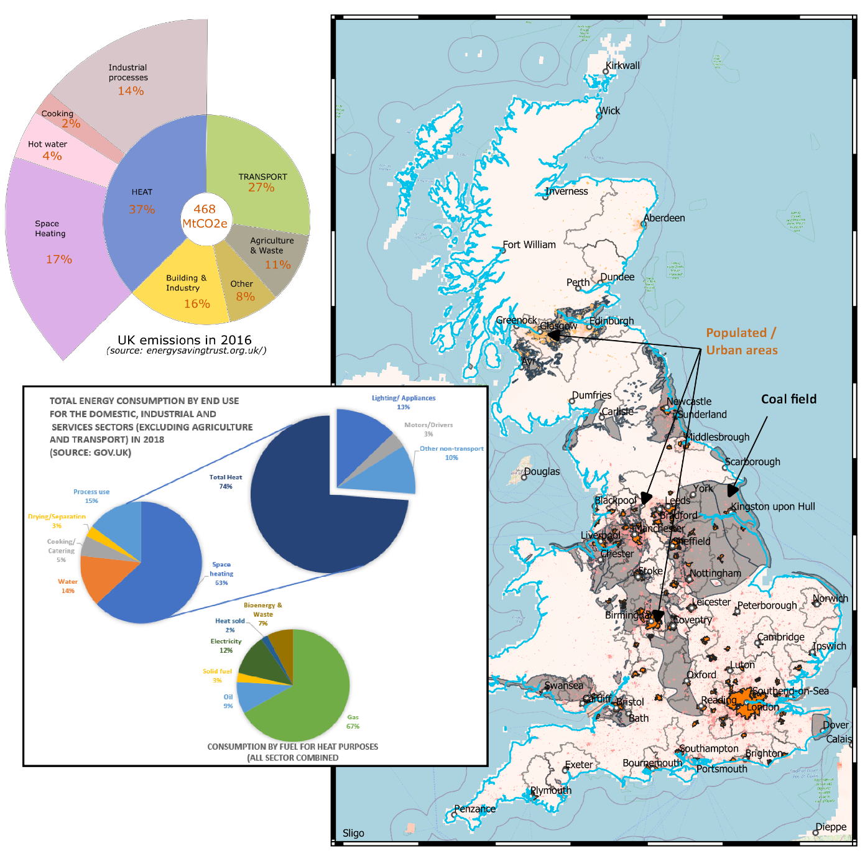

[Fig: Coal fields & urban areas- add % households underlain by coal mines (CA?) + chart showing how much domestic heat is of the energy mix]

*A great opportunity, but what is its potential?*

Mines have several benefits compared to conventional geothermal reservoirs. The existence of deep shafts offers a direct access to the mine water without needing to drill new boreholes, which can often be a large proportion of initial project investment costs. Geothermal projects can have a high risk of tapping into a non-existent resource, this is significantly reduced in mine water heat systems as the abandoned mines are generally well mapped and documented. Additionally, there is no need to transport this energy far away as the consumers are situated just above the mines. The schemes could, therefore, directly benefit the local population who often have a strong historical connection with the mine. The Coal Authority currently pumps and treats mine water at over 70 locations in the UK to control mine water discharge, it is envisioned that the operational costs of this could be offset by using the heat naturally contained within the water.

So if this is such a great opportunity why is it not already been capitalised upon? Well, there are several questions to be answered to avoid repeating mistakes from other schemes. Even if the resource is here and might be extensive, we don’t want to deplete it too fast. There is a great challenge in finding the right balance between the geological, technical and economic aspects - between what we need and what the Earth can really offer. To make the heat extraction sustainable, we need to assess the full extent of its potential, and understand how fast the energy we take from the mine water to heat our houses will be replenished within the mine system, and this is the purpose of my PhD: *Where does the heat come from?*

My research project is about trying to understand what the heat sources in mines are, their contribution to the total heat generation, and the heat recharge mechanisms that controls the mine water temperature over time. During the operation of a geothermal production system (i.e. mine water extraction), groundwater might enter the mine reservoir at a colder temperature, if not directly re-injected from the GSHP into the mined strata. The biggest issue would be that this water reaches the production well before warming up. Unfortunately, this “short-circuiting” effect is very likely in mines, where the interconnection of shafts, tunnels and galleries tends to enhance the reservoir permeability at very large scale, connecting hydrological systems that would have been naturally separated. If the inflowing water is hotter than the rock, the recharge potential of the mine might be guaranteed, but if it is colder, then the water might deplete the rock from its heat to fulfil our need. The key question will be to assess whether a sustainable heat extraction rate can be maintained over the long-term without mining the rock of all its energy.

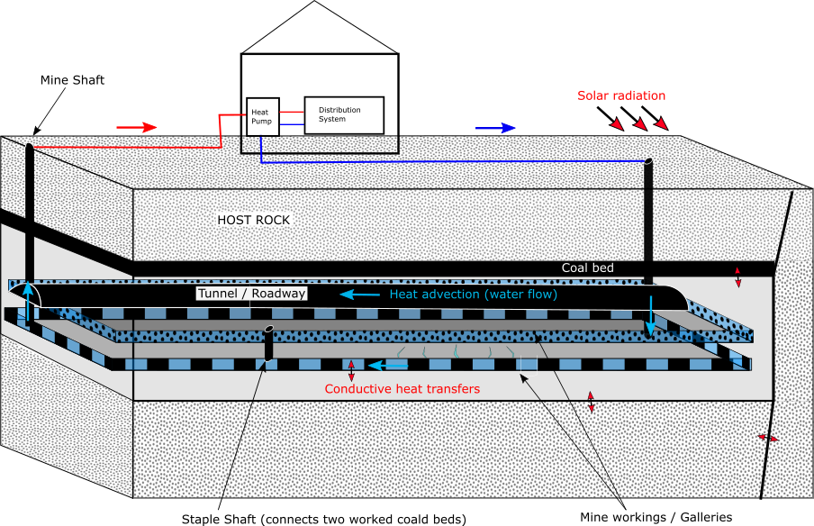

[Fig: Basic figures of mines + GSHP mine water heat system + generic mine plan showing details?]

*Mines, a complex geothermal system.*

Unfortunately, mine reservoirs are not simple. Their complex geometry, that result from a long mining history, make it difficult to predict the mine water flow path. And to cap it all, no matter how detailed mine plans can be (and they really are!), the amount of collapse that occurred after the mine closure and the current state of the galleries is quite uncertain. As a result, we don’t exactly know the volume and the shape of the residual voids, and thus the volume of accessible water. But more importantly, this might also indirectly affect our capacity to predict the nature of the heat fluxes in the mine, and thus its heat recharge potential. But actually, how important is it? One of the main points of my study will be to find a way to deal with those uncertainties, by assessing what parameter or geometrical feature does really matter when it comes to understand the key heat transfer processes controlling the temperature distribution at the scale of the mine.

The complexity of the mines is not limited to geometric aspects, but also to temporal aspects. During mining activities, pumping and ventilation were implemented in deep galleries to ensure good working conditions for the miners. Another line of investigation of my PhD will therefore to assess the possible long-term effect of such prolonged periods of cooling on the present-day temperature distribution in the mine and on the fluxes induced on the “disturbed” sub-surface. *How do I plan to do that?* Primarily by developingnumerical models, that will be calibrated and validated using temperature data acquired by the Coal Authority, who partly fund this research. Looking at the big picture, developing a numerical tool that could be used to evaluate the full extent of the heat available over the long term in a mine would be a valuable outcome of this study. It could first support the dimensioning of GSHP systems and then, help defining the footprint area of heat extraction, providing a scientific support to guide the licensing of heat.

*Cyclical production and mine stability*

Not only could mine systems be seen as a heat source, but also as a storage system; heat could be injected either seasonally by reversing the GSHP system, or from local buildings/infrastructures with excess heat (i.e. data centres, incinerators), in order to be used later in the year (i.e. winter time). Seasonal production/injection of heat and cold has been proven to increase the efficiency and the sustainability of GSHP system, by ensuring the artificial recharge of heat into the underground. However, the impact of such cooling-warming cycles on the stability of coal pillars, that have in some cases maintained structural stability of abandoned mines, is uncertain. If pillars collapse, subsidence of the ground, that generally occurred during or shortly after mining, could be resumed. This would have both a negative impact for the underground by reducing the rock permeability, but also for surface infrastructure. This is another area of research being undertaken at the University of Edinburgh by Fiona Todd whose PhD is aiming to evaluate the risk of pillar collapse through a full hydro-thermo-mechanical modelling study of cyclical mine water heat production.

*To conclude…* Recycling old coal mines into a renewable energy source could significantly contribute to the decarbonization of residential heat, an area targeted by the UK to help reach Net Zero emissions. Diversifying the range of energy sources is the key to a reduction of our impact on the environment, and it is legitimate to put mine water heat in the mix. But for that, we need to find the right balance, in terms of what is available rather than what we need, which requires an understanding of its potential over the long term. A *Final word? Be smart.* Antoine Lavoisier said “nothing is lost, nothing is created, everything is transformed”. What if we could make it true at the scale of our energy consumption? A giant interconnected loop, where all energy created is recycled, all waste is converted into usable energy source. Let’s think big. And the more brains involved, the more possible it can become.