With the growing need for new low-carbon energy sources, harnessing heat from abandoned and now flooded coal mines could be a very attractive solution. In the UK, about 47% of the energy consumption is used for space heating (*source: 2018 GOV.UK*), and around 70% of the heat demand is supplied by natural gas, largely contributing to the carbon emissions of the country.

A large proportion of the urban area in the UK was extensively mined for coal, and the resource that once contributed to harmful air pollution is now home to another valuable and easily accessible resource: a large volume of 12-20°C mine water. Using ground-source heat pump (GSHP) systems, heat energy can be extracted from this water and potentially be used for space heating. Mine water based GSHP schemes have already been implemented worldwide and one of the most successful projects is located at Heerlen in the Netherlands. Earlier this year, the Coal Authority (the non-departmental government body with the responsibility for managing the legacy of abandoned coal mines) has launched the first large scale mine-energy district heating scheme in the UK in South Seaham, North-East England, where 18-20°C mine water will be used to provide heat to the 1500 residents of the new Garden Village.

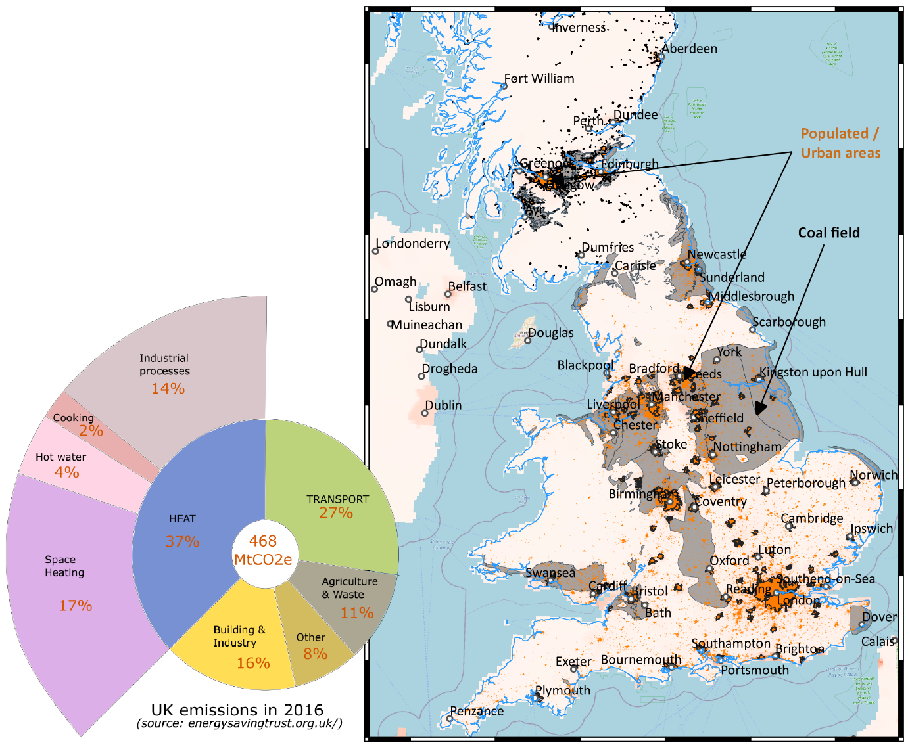

*UK coalfields (grey) with location of the main cities and urban areas (orange). In the UK, about 25 % of the population lives on former coalfields.*

*A great opportunity, but what is its potential?*

Mines have several benefits compared to conventional geothermal reservoirs. The existence of deep shafts, if not backfilled, might offer the possibility of direct access to the mine water without needing to drill new boreholes, which can often represent a large proportion of initial project investment costs. Geothermal projects can also have a high risk of tapping into a limited resource (i.e. low water flow), and this is significantly reduced in mine systems as the network of mine galleries, generally well mapped and documented, creates high conductivity pathways. Additionally, there is usually little need to transport this energy as the mines are situated immediately beneath the consumers. The schemes could, therefore, directly benefit the local population who often have a strong historical connection with former mines in their local area. The Coal Authority currently pumps and treats mine water at over 70 locations in the UK to control mine water discharge and it is envisioned that the operational costs of this could be offset by using the heat naturally contained within the water.

So if this is such a great opportunity, why has it not already been capitalised upon? Well, there are several questions to be answered to ensure that such project can be viable. Even if the resource is here and extensive, we don’t want to risk depleting it too fast. There are great challenges in striking the right balance between the geological, technical and economic aspects - between what energy we need and what a geological system can realistically deliver. To make the heat extraction sustainable, we need to assess the full extent of its potential, and understand how fast the energy we take from the mine water to heat our houses will be replenished within the mine system, and this is the focus of my PhD: *Where does the heat come from?*

My research project is about trying to understand what the heat sources in mines are, their relative contribution to the total heat generation, and the heat recharge mechanisms that control mine water temperature over time. These factors are critical to establishing the long-term health of mine water heat schemes, which highly depends on the system’s thermal dynamics. During the operation of the GSHP, groundwater might enter the system at a cooler temperature or abstracted mine water might be reinjected directly into the mined strata after being mined for heat. From an economic perspective, the biggest issue would be that this cooler water reaches the production well before warming up, reducing the ability of the scheme to provide the required heat. Unfortunately, “short-circuiting” effect is a real possibility in mines, where the interconnection of shafts, tunnels and galleries tends to enhance the subsurface permeability at very large scale, and can result in insufficient time for water to be replenished in heat via energy transfers from the host rock. From a resource perspective, if the inflowing water were hotter than the rock, the heat recharge of the mine would be guaranteed, but if it is colder, then the water might deplete the host rock from of the heat needed to fulfil our low-carbon heating needs. The key question will therefore be to assess whether a sustainable heat extraction rate can be maintained over the long-term.

*Mines, a complex geothermal system.*

Unfortunately, disused mine reservoirs are not simple. Their complex geometry resulting from a long mining history make it difficult to predict mine water flow paths. And to cap it all, no matter how detailed mine plans can be (and they really are!), the amount of collapse that occurred subsequent to mine closure and the current state of the galleries is uncertain. As a result, we can only make broad estimates of the volume and the shape of the residual voids, and thus the volume of accessible water. More importantly, this might also indirectly affect our capacity to predict the nature of the heat fluxes in the mine, and the potential to recharge the heat resource. However, we don’t actually know how important these factors are. One of the main points of my study will be to find a way to deal with those uncertainties, by assessing what parameter or geometrical feature does really matter when it comes to understand the key heat transfer processes controlling the temperature distribution at the scale of the mine.

The complexity of the mines is not limited to their geometry, but also to temporal aspects. During mining activities, pumping and ventilation were implemented in deep galleries to ensure acceptable working conditions for the miners. Another line of investigation of my PhD will be to assess the possible long-term effect of such prolonged periods of cooling on the present-day temperature distribution in the mine and on the fluxes induced on the “disturbed” sub-surface. *How do I plan to do that?* Primarily by developingnumerical models, using the open-source OpenGeoSys software. Models will be calibrated and validated using temperature data acquired by the Coal Authority, who partly fund this research. Looking at the big picture, developing a numerical tool that could be used to evaluate the full extent of the heat available over the long term in a mine would be a valuable outcome of this study. It could first support the dimensioning of GSHP systems and then, help defining the footprint area of heat extraction, providing a scientific support to guide the licensing of heat.

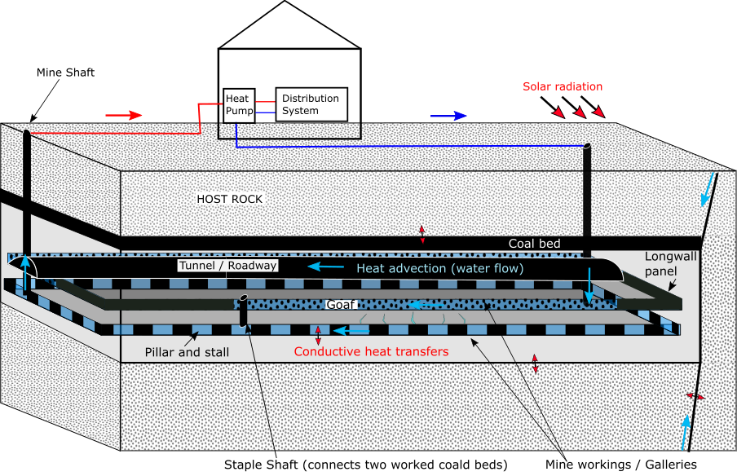

*Simplified sketch of a coal mine with GSHP mine water heat system. The arrows show the induced heat transfer processes and the direction of water flow. Two mining approaches are represented. In the “pillar and stall” approach, pillars of coal were left unmined to support the roof of the mine. In the “longwall” mining approach, coal panels (about 100 to 250 m wide) were mined between two parallel roadways and the roof was allowed to collapse, filling the galleries with “goaf” material (see Younger et al., 2002).*

*Cyclical production and mine stability*

Not only could mine systems be seen as a heat source, but also as a storage system; heat could be injected either seasonally by reversing the GSHP system, or from local buildings/infrastructures with excess heat (i.e. data centres, incinerators), in order to be used later in the year (i.e. winter time). Seasonal production/injection of heat and cold has been proven to increase the efficiency and the sustainability of GSHP system, by ensuring the artificial recharge of heat into the underground. However, the impact of such cooling-warming cycles on the stability of coal pillars, that have in some cases maintained structural stability of abandoned mines, is uncertain. If pillars collapse, subsidence of the ground, that generally occurred during or shortly after mining, could be resumed. This would have both a negative impact for the underground by reducing the rock permeability, but also for surface infrastructure. This is another area of research being undertaken at the University of Edinburgh by Fiona Todd whose PhD is aiming to evaluate the risk of pillar collapse through a full hydro-thermo-mechanical modelling study of cyclical mine water heat production.

*To conclude…* Reutilising old coal mines into a renewable energy source could significantly contribute to the decarbonization of residential heat, an area targeted by the UK to help reach Net Zero emissions. Diversifying the range of energy sources is the key to a reduction of our impact on the environment, and it is legitimate to put mine water heat in the mix. But for that, we need to find the right balance, in terms of what is available rather than what we need, which requires an understanding of its potential over the long term. A *Final word? Be smart.* Antoine Lavoisier said “nothing is lost, nothing is created, everything is transformed”. What if we could make it true at the scale of our energy consumption? A giant interconnected loop, where all wasted heat is recycled and converted into usable energy source. Let’s think big. And the more brains involved, the more possible it can become.