1. Introduction

Heat demand for domestic and industrial space heating account for about 50% of the energy consumption in the UK. Currently, around 85% of this energy is supplied by natural gas, contributing to about 34% of the Greenhouses Gas Emissions of the country (BEIS 2019 ECUK – end uses database). Following the Paris Agreement, the UK targeted through the 2019 Climate Change Act to reach net zero carbon emission by 2050. To achieve this goal, attention has been focused on the need to decarbonize residential heat, coming along with the requirements of replacing all gas boilers by new domestic low-carbon energy sources such as geothermal energy.

Low-temperature geothermal resources have been increasingly used in the UK since the 1980’s for cooling or heating applications. Using ground-source heat pump systems, low-grade heat can be extracted from the ground or from surface and groundwater and be raised to useful temperatures via heat pump systems. Closed-loop system configurations permit access to resources situated at different depth ranges in environments where no groundwater is available, via a working fluid circulating in a ground heat exchanger. Horizontal GHE are essentially solar thermal energy collectors (Banks, 2008). They are commonly installed at < 6 m depth, where the ground temperature varies accordingly to yearly changes in surface temperature (Banks, 2008). Alternatively, vertical borehole heat exchangers (BHE) can access resources situated down to 200 m depth, where the local geothermal gradient controls the ground temperature that remains stable though the year. Despite their higher costs of installations (i.e. drilling requirements), the higher temperatures accessed by vertical BHE allow a greater ΔT at the heat pump, which ensures higher performances relative to horizontal GHE (Chen *et al.,* 2019). Vertical BHE are also advantageous in areas of high land price due to the lower land surface requirements (Trillat-Berdal *et al.,* 2006). Deep Borehole Heat Exchangers (BHE) can also be drilled down to ~2 kilometres depth, where the heat collected offers good opportunities for district heating applications and/or power production (Alimonti *et al.,* 2021).

The performance and the sustainability aspects of BHE from an engineering perspective have been covered extensively in the literature using both analytical and numerical models (i.e. Rybach and Eugster, 2010; Signorelli *et al.,* 2005; Lyu *et al.,* 2017; Zhang *et al.,* 2016; Stylianou *et al.,* 2017; Zanchini *et al.,* 2010; Lazzari *et al.,* 2010). The long-term performances of such system are generally based on its coefficient of performance (COP), that corresponds to the ratio between the electrical energy provided to the heat pump and the energy delivered and is a function of the temperature contrast between the ground and the circulating fluid in the BHE. Although some authors showed that quasi steady-state outflow temperature can be reached at the BHE in some areas after a few years of heat extraction (i.e. Chen et al., 2019), Chen et al. (2020) warned that unbalanced heat extraction and injection from BHE in cold regions (i.e. due to greater needs in heating relative to cooling) could lead to an extensive cooling of the ground. More recently, Walsch *et al.,* (2021) quantified the regional scale thermal interferences caused by a dense deployment of individual shallow BHE for district heating in Switzerland, suggesting the importance of considering the areal impact of heat extraction for future applications of BHE-GSHP systems.

By regarding the sustainability issues of BHE from an engineering perspective (i.e. BHE performances), most of the published studies ignored the capacity of the shallow subsurface to replenished itself in areas of low heat flow. Considering the areal impact of heat extraction is however essential in a context where the number of GHE scheme is expected to increase in future years, together with the necessity to define heat ownership in the ground. Here, we investigate the capacity of the ground to provide the required heat load to an individual vertical BHE in the Midlothian area in Scotland, United Kingdom. We first use mathematical solutions to calculate the relative contribution of geothermal and solar heat recharge and the heat balance in the subsurface. Our analysis is based on the volume of rock required to provide the equivalent of a yearly average heat consumption to a single house in the UK. We then use numerical modelling approaches to determine the contribution of axial and radial heat fluxes during heat extraction and assess the areal thermal footprint induced by long-term heat extraction, considering a homogeneous purely diffusive porous medium. By treating the ground as a finite resource, we regard the sustainability issues of BHE from a geological perspective rather than from an engineering; we clarify the concept of “steady state” production temperature and show that geological conditions in the UK cannot sustainably provide heat to a shallow stand-alone vertical BHE.

1. Heat balance
   1. Energy requirements for a single UK house

We assess the impact of extracting heat from a shallow vertical BHE located in the Midland Valley of Scotland (MVS), a NNE-SSW trending Carboniferous Basin located in Scotland, United Kingdom (Browne *et al.,* 1999). In the UK, a large proportion of the population lives above legacy coal and shale mines that are today closed, with many of them located in rural areas that are likely to suffer from energy poverty. To comply with the heat demand whistle achieving the decarbonization of heating, small-scale ground-source heat pump (GSHP) systems have been growing in recent years. This technology permits providing low carbon water and space heating for individual houses while preventing from a number of disadvantages relative to large-scale systems, including the need for central heat pump system, heat losses in community distribution pipe networks, maintenance of heat interface units and high operating costs (Sayegh *et al.,* 2018).

In the UK, the average heat consumption for a single household is in the order of 15 000 kWh per year (ECUK, 2019). To satisfy this yearly demand, a heat pump would need to deliver an average heat load *H* = 1700 W. Part of this energy is actually supplied by the heat pump in the form of electrical heat to an amount that depends on the coefficient of performance (COP) of the system (Banks, 2008). Assuming a COP of 3.4, the energy extracted from the ground is reduced to G = H(1-1/COP) = 1200 W, which corresponds to a total energy Q = 3.81 × 1010J over a year.

We use the harmonic mean density and heat capacity for the Carboniferous rocks in the MVS to determine the volume of rock that would need to be cooled by ∆T = 5 °C every year to meet the heating demand (Eq. 1). Those were determined based on the thickness of the Carboniferous formations intersected by the Carrington-1 borehole, located in the MVS (XXX), the proportion of lithologies for each formation (XXX) and the rock properties given by XXX.

(1)

Considering a homogeneous rock with a porosity *φ* = 0*.*1, density = 2500 *kg/m*3 and specific heat capacity = 898 *J/kg°C* filled with a static water of density kg/m3 and heat capacity the volume of rock *V* required to provide this energy by cooling the rocks by ∆*T* = 5°*C* is about 3000 *m*3. Assuming that the heat is extracted radially from a 100-m long vertical borehole situated under the property, the surface area of the volume cooled would be ~30 *m*2 (i.e. cylinder with a radius *r* ~3 m). Over a 30-year operation period (*Q* = 1.14 × 1012*J*) and considering that no heat recharge is provided, an area of 900 *m*2 would be required (*r* = 17 m).

* 1. Geothermal flux

The thermal state of the Earth’s crust is controlled by the natural conductive heat flow and by the natural decay of radioactive heat producing elements, typically of the isotopes of uranium (U), thorium (Th) and potassium (K) (Pollack and Chapman, 1977, Sandiford, McLaren *et al.,* 2006). In the MVS, only granite intrusions would contain sufficient concentration of K, T and U elements to generate significant radiogenic heat (Gillespie *et al.,* 2013) and their contribution to the heat recharge is therefore neglected in this study. Using an average temperature gradient °C/km determined for Scottish coalfields (Farr et al., 2020) and an effective thermal conductivity of (i.e. calculated from the thickness of the Carboniferous formations in the Carrington-1 borehole and their heat conductivity values determined by Busby, 2019), the estimated steady state geothermal heat flux through a homogeneous rock volume is ~0.057 W/m2 (Eq. 3).

(3)

We use this value to calculate the contribution of the geothermal heat flux to the yearly heat recharge to the borehole. Considering the estimated footprint area of heat extraction from a single BHE after a year, a constant geothermal flux would only provide 0*.*057 W/m² × 30 m² ≈ 1.7 *W* of heat recharge to the borehole, that is 0.14% of the heat consumed by a single house in the UK in one year. Considering a median garden size for a house across Great Britain of 188 m², geothermal heat recharge could provide up to 10.7 W of heat to a single borehole, that is still < 1% of the heat consumed over a year. Alternatively, if we assume a yearly average geothermal heat flux of about 0.057 W/m2, the area required to provide a recharge of 1200 W to the BHE would be in the order of 21 000 *m*2, that is ~110 times the median garden size across Great Britain.

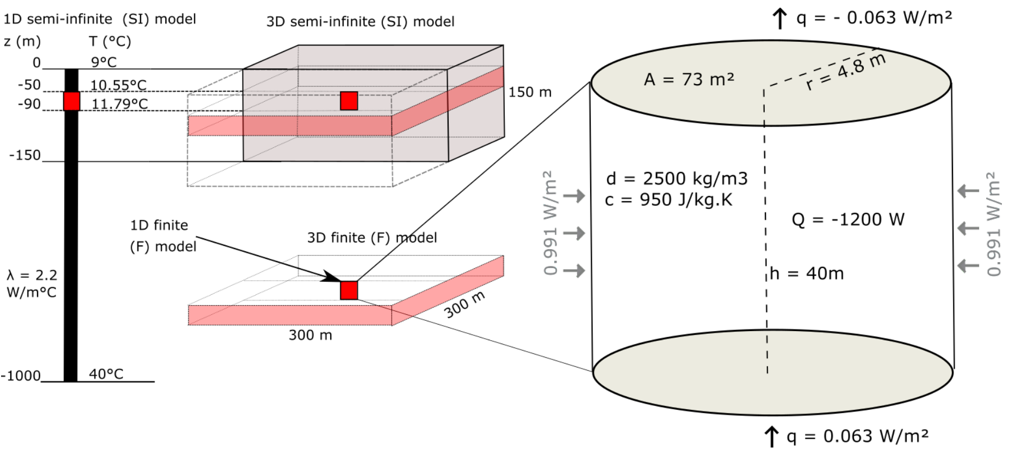

Figure 2: Conceptual models for the heat extraction model from vertical BHE. a) Sketch of the 1D and 3D numerical models developed in this study. b) Heat balance around the vertical BHE determined from mathematical models. The thermal state of the models is defined by an initial steady-state temperature gradient of 0.031°C/m and an average effective thermal conductivity of =2.2 *W/m*2. The heat flux entering the system from below equals the flux coming out at the surface through purely conductive heat transfers.

* 1. solar heat recharge

In the upper 10-25 m below the surface, the effective ground temperature highly depends on the surface climatic conditions such as the air temperature, the amount of solar radiation absorbed/reflected by the soil and the longwave radiation emitted from the ground, the wind velocity or the evapo-transpiration processes (Hein *et al.,* 2016). All of these factors tend to determine the amount of heat transmitted between the surface and sub-surface and warm/cool the ground down to a depth that mainly depends on the ground conductivity. In the considered scenario, the damping depth (i.e. depth of influence of yearly surface temperature variations) as defined in Ozgener *et al. (*2013) is:

(4)

Where is the period of oscillations and is the rock thermal diffusivity, with the effective density, J/Kg.°C the effective heat capacity and W/°C.m the effective thermal conductivity of the rock.

Although vertical BHEs are not directly harnessing solar energy in the same way as shallow horizontal BHE, we here attempt to quantify the impact of the fluctuating surface heat flux on the upper part of the geothermal gradient and thus on the available surface heat recharge to the BHE. In Edinburgh, the yearly average rate of insulation (i.e. amount of solar radiation per square meter) is about is about 94 W/m² (Whitlock *et al.,* 2000). Due to the low diffusivity of soil and all the processes mentioned above, it is expected that the net incoming shortwave radiation into the ground only equals 10s of *W/m*2 (Banks, 2008). Assuming that 60% of solar energy is reflected by the atmosphere, among the 40% absorbed by the Earth, 70% is reflected by the ground surface and 30% penetrate into the ground (XXX). Therefore, the actual solar recharge to the ground is reduced to per day, in accordance with the amplitude of conductive heat flux values calculated by Larwa (2018). However, unlike the geothermal flux, solar flux is not continuous over time and highly depends on the relative temperature difference between the ground and the air. Additionally, due to the delayed response of the sub-surface to a heat pulse at the surface, the ground will tend to be warmer than the air in winter and colder than the air in summer, impacting the direction of the heat fluxes down to the depth of influence of these seasonal fluctuations. To account for the effects of cyclical heat recharge and possible energy losses at the surface during cold periods, we scale up the solar recharge to the ground based on the average sunshine hours of 1380 h per year in Edinburgh (i.e. 16% of the time), leading to a scaled solar flux of 1.8 W/m². Based on the areal thermal footprint of a single BHE after a year, solar energy could only directly provide 1.8 W/m² 30 m² 54 W of heat recharge, which represent 4.5% of the yearly energy consumption. Using the median garden size of houses in Great Britain (i.e. 188 m²), the yearly solar recharge would equal 338 W, that is 28% of the energy extracted by a single borehole.

We quantify the amplitude of the variations of the surface heat flux required to reproduce the yearly change in the soil temperature measured in Scotland, using simple 1D models whose properties are defined accordingly to Equations 3 and 4. The daily heat flux values are calculated for a series of signal amplitudes, used as a surface boundary condition to the model of initial surface temperature T0 = 9°C corresponding to the yearly average air temperature in the UK.

(8)

where Q is the average daily heat flux, t the period of fluctuation (366 days), ∆*t* the time increment (86400 secs), A the amplitude of the variations and the geothermal heat flux set as bottom boundary condition. The best-fit surface temperatures, calculated for a period of 100 years to ensure stable conditions, are obtained for A = 8.4 W/m². The results moreover indicates that the fluctuating surface heat flux tends to disturb the upper part of the temperature gradient. The depth of influence of the yearly surface temperature variations is at about 26 m, in accordance with the results predicted by Eq (4). At that depth, the ground temperature is about 10°C, that is about 1°C higher than the modelled yearly average surface temperature (e.g. Rybach and Sanner, 2000). Below that depth, results indicate a slight shift in the initial linear temperature gradient toward higher temperatures down to 150 m depth.

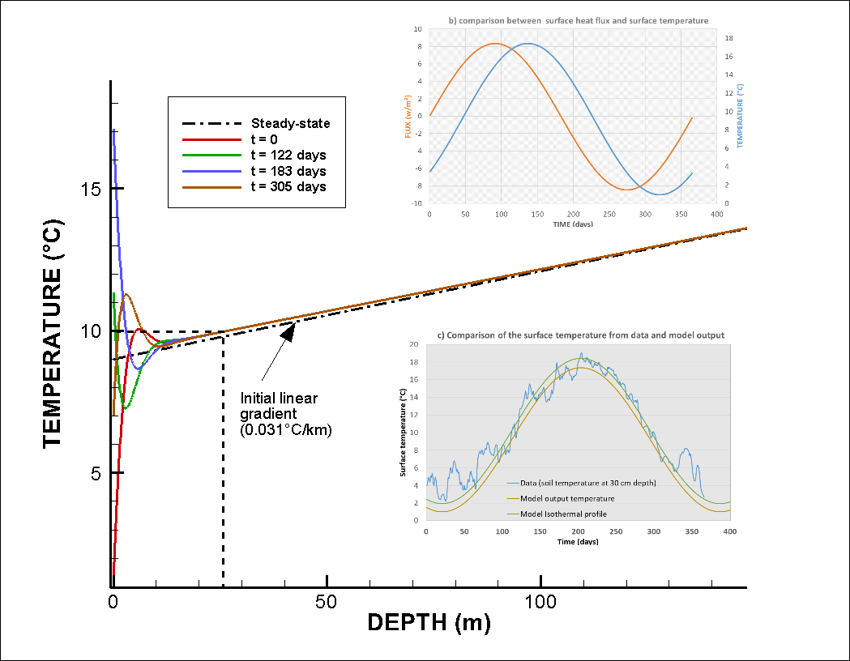

Figure 3: a) Input surface heat flux for the time-varying surface boundary conditions (black line) and output surface temperature time series (z = 0 m) for A = 8.4 *W/m*2. b) comparison between surface heat flux and surface temperature. The temperature change is delayed compared to the heat pulse imposed at the surface. c) Comparison between the data and model output surface temperature. The data used correspond to daily soil temperature measured in 2000 at 30 cm depth at the Paisley station, Glasgow (source: UK Meteorological Office). Results show a better match for the summer data compared to the low winter temperatures.

### Footprint of heat extraction

Results from our mathematical model suggests that a geothermal heat flux of 0.057 W/m² together with a solar flux of 1.8 W/m² cannot provide a direct heat recharge of more than 4.5% of the energy extracted for an individual UK house over a year, considering a footprint area of 29 m² around the 100-m long BHE (Fig. 2). Using the average area available for a UK property (i.e. 188 m²), geothermal and solar heat recharge could provide up to 29% of the heat extracted. This shows that heat balance cannot be naturally reached in the ground considering the geological and climatic conditions in the UK, and thus additional heat needs to be mined from the rock surrounding the borehole. Over time, the imbalance between heat recharge and heat extraction is likely to cause 1) extensive cooling of the ground at the near-surface that might not be compensated by an increase in the surface heat flux, and 2) the expansion of the thermal footprint around the BHE beyond the limit of the property.

Assuming that recharge is only provided by a geothermal flux of 0.057 W/m², the heat balance suggests that ~1198 W needs to be mined from surrounding rocks. After a year, the radial heat flux at a distance r = 3-m from the BHE (i.e. at the boundary of the 29-m² footprint area) of length h = 100-m would be in the order of *W/m*2 (Fig. 2.4). Adding solar recharge, the lateral flux would be reduced to m². This is about half the solar heat recharge but 10 times the geothermal recharge, which may have a major impact on the areal footprint of heat extraction. However, this heat balance approximation ignores the contribution from axial recharge (i.e. from above and below the borehole depth interval) as well as the potential increase in the heat flow at the surface due to cooling of the ground. Although the later contribution might be important in the long-term as the effects of heat extraction reach the surface, it is only trivial for this one-year heat balance approximation.

We use the OpenGeosys finite element modelling software (i.e. Kolditz et al., 2012; Chen et al., 2019) to simulate temperature change and calculate the heat fluxes induced in the subsurface due to heat extraction from the BHE. The relative contribution of solar and geothermal recharge is described using 1D models and lateral heat fluxes are quantified using 3D diffusion models. In both models, the BHE is simplified to a vertical line source embedded in a homogeneous porous medium whose properties are those defined in Eq. 3. Results are used to validate the mathematical models against the volume of accessible rock and quantify the footprint area of heat extraction over 30 years, assuming that heat transfers in the ground occur only by conduction.

1. Axial recharge

Fig. XXX a and b shows the temperature profiles after 1 and 30 years of heat extraction from a 1D vertical 1000-m long model and from a 100-m long model representing the BHE interval situated between 10 and 110-m depth. The scenario presented include 1) constant surface temperature and bottom heat flux of 0.057 W/m², 2) surface and bottom heat flux boundaries of ±0.057 W/m², used to maintain the geothermal gradient of 25°C/km (with *T*0 = 9°C),and 3) constant bottom heat flux of 0.057 W/m² and the fluctuating surface heat flux boundary described above. For each scenario, heat is extracted at a constant rate of -1200W equally distributed along the 100-m BHE after ensuring stable initial conditions.

Based on model areas of 29m² and 872 m², results of heat extraction from the 100-m long model (dark blue line) with constant heat flux boundaries for periods of 1 year and 30 year, respectively, confirm a uniform temperature decline of 5°C along the BHE, in accordance with the mathematical model. We therefore use the relative energy change in the BHE interval and in the surrounding rocks in the 1000-m long model (light blue line) to quantify the contribution of axial heat recharge (i.e. heat recharge from rocks located above/below the borehole via diffusion). Results suggests that although axial recharge is limited to <5% within the first year (using the 29 m² model), this effect increases up to ~18% after 30 years of heat extraction (872 m² model), reducing the temperature drop at the borehole predicted by the finite BHE model.

Although 1D models can be used to calculate steady-state conditions using a given heat extraction rate and model area, they cannot give insights on the actual extent of the temperature drawdown around the borehole. We therefore use 3D models to determine the footprint area of heat extraction over time and quantify the amplitude of lateral heat fluxes (i.e. lateral heat mining).

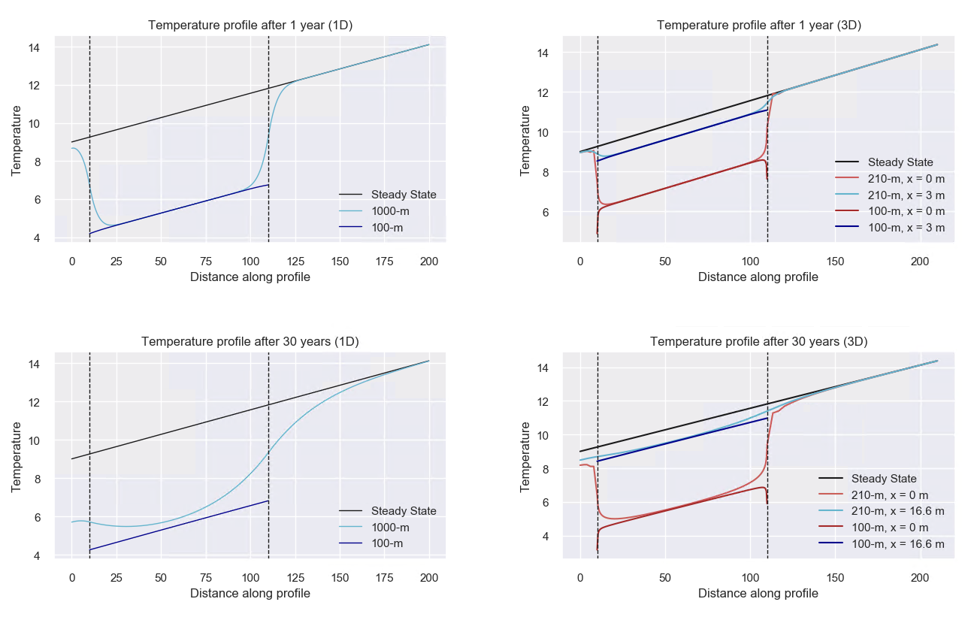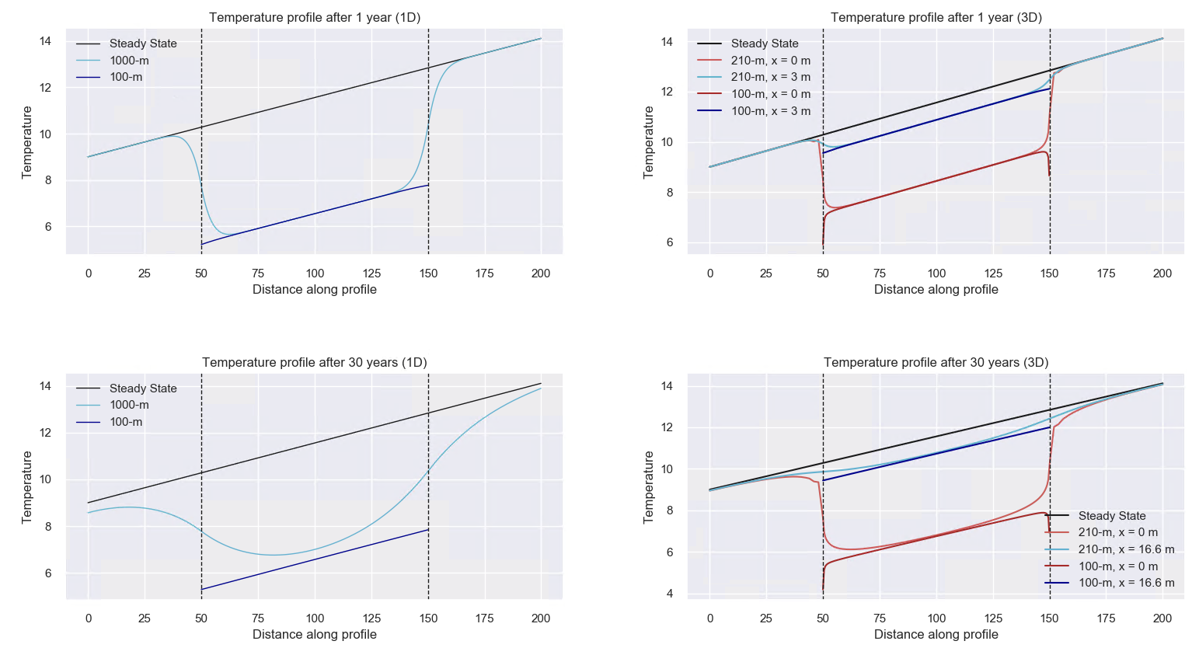

1. Footprint area

As for the 1D models, two 3D models are developed in order to quantify the contribution of radial recharge and the extent of thermal footprint caused by heat extraction from the BHE over time. The models consist of a 210-m deep and a 100-m thick 300 x 300 m homogeneous porous medium composed of xxx and xxx prismatic elements, respectively (Fig.2). In both models, the borehole is situated between 10 and 100 m depth, in the centre of two nested cylindrical volume with radii of 3-m and 16.6-m (i.e. radius of the area required for a 1-year and 30-year extraction periods, as calculated in section 2.3.1), that define a zone with a high-resolution mesh.

Fig xxx c and d shows the temperature profiles extracted from the 3D models at the borehole location and at distances x = 3 m and x = 16.6 m after 1 and 30 years of heat extraction, respectively, using surface and bottom heat fluxes of ±0.057 W/m². Those distances correspond to the radii of the areas required for BHE utilisation after 1 and 30 years. Assuming that 1D models represents far field conditions, those profiles are compared to the temperature distribution in the 1D 29 m² and 872 m² models after 1 and 30 years, respectively.

We calculate the energy change within the finite volume of rocks situated at distances x < 3 m, 3 m < x < 16.6 m and x > 16.6 m from the borehole (Fig. 6) to determine the relative contribution from radial heat recharge to the borehole. Results indicate that ~20% of the heat is mined from the area surrounding the borehole (x < 3 m) within the first year, with 90% of the energy being mined from the area comprised at x < 16.6 m when not axial recharge is allowed. After 30 years, more than 90% of the recharge is provided by the volume of rock located at x > 16.6 m. At x = 3 m, the radial heat fluxes are of ~0.93 W/m² during the first year and reach a steady rate of ~1.6 W/m² after ~10 years (Fig. 6).

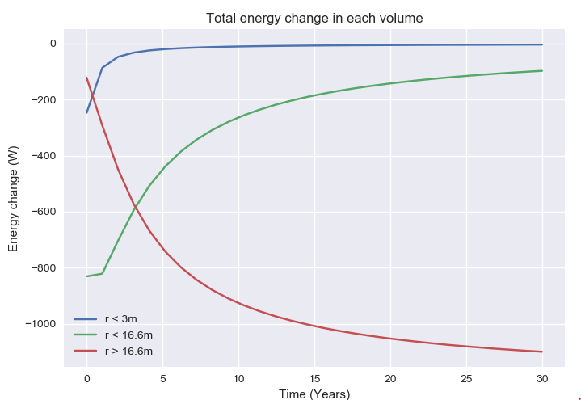 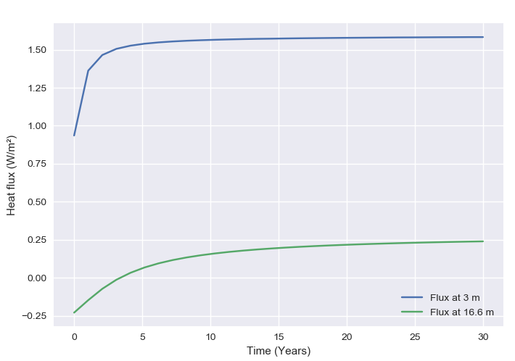 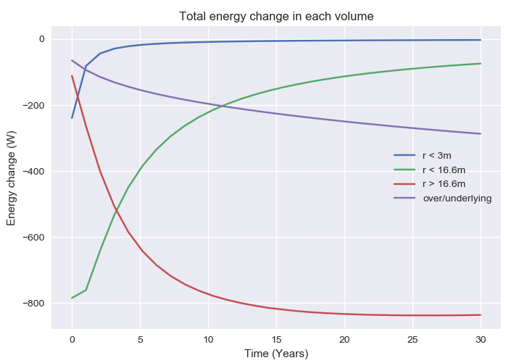 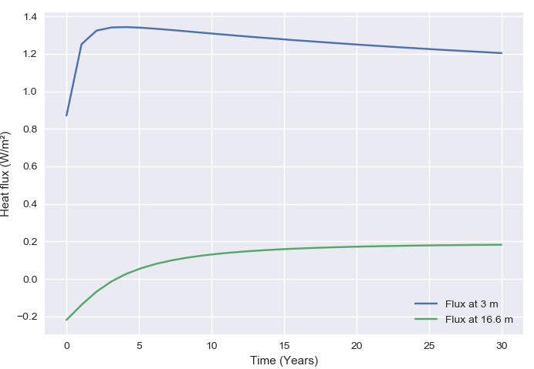

The contribution from radial heat recharge explains the relative temperature differences between the profiles extracted from the finite 3D model at x = 3 m and x = 16.6 and the corresponding finite 1D models after 1 year (29-m² model) and 30 years (872-m² model).

Fig. XXX shows the vertical and radial heat fluxes across a 2D temperature profile extracted at different time steps from the 3D 210-m deep model. It suggests that as the production time increases, the 3D model allows the mining of heat further away from the borehole though an expansion of radial heat transfers. Although the amplitude of the radial heat fluxes stabilizes at about 10 years of production, the lateral expansion of the volume of rock depleted in heat participates to an increase in the vertical temperature contrasts away from the borehole, enhancing the axial fluxes. Fig. 7 shows that the area contributing to the downward heat fluxes induced by heat extraction keeps expanding over time above the borehole, suggesting a lack of recharge at the surface and an insufficient upward geothermal heat flux. This heat mining effect at the near-surface is amplified by the proximity of the borehole to the top boundary of the model, that restrict axial heat recharge to the borehole and makes it sensitive to the boundary condition used (i.e. constant heat flux).

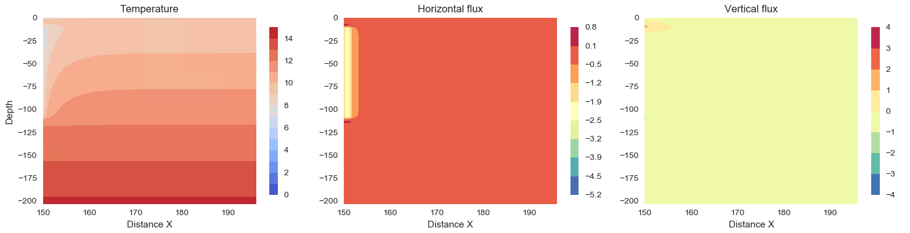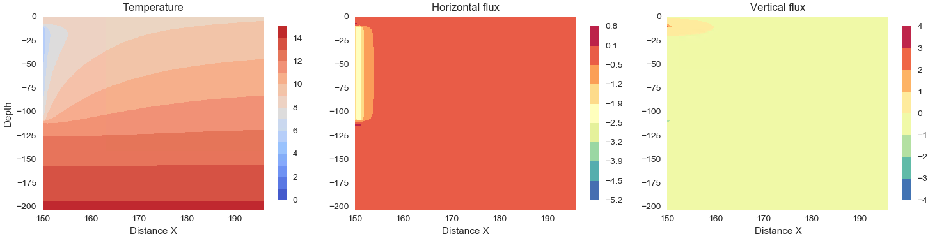

TO ADD ???

Using surface heat flux boundary conditions (e.g. Saadi and Gomri, 2017; Erol et al., 2015) rather than a constant temperature boundary (e.g. Zhao *et al.,* 2020) when simulating heat extraction from shallow BHE permits to account for potential temperature decline at the surface and avoid overestimating the available recharge.

Erol et al. (2015) indeed suggested that during production, the temperature distribution around BHEs is not equal to the undisturbed ground temperature from the surface to the bottom, and axial effects (i.e. vertical heat transfers) become important at both ends of the borehole.

Although the models presented use heat flux boundary conditions, here we neglect the increase in surface heat flux from the atmosphere to the ground induced by cooling at the ground surface. We use these results to quantify the relative contributions from vertical and lateral conductive heat fluxes providing heat to the borehole over a 30-year extraction period, through heat mining of the surrounding rock. A sensitivity analysis was performed to assess the key parameters controlling the extent of the drawdown caused by heat extraction as well as the maximal temperature drop at the borehole. Our results confirm that the areal impact of heat extraction on the ground depends on the ground thermal conductivity and is inversely correlated to the temperature decline at the borehole.

The effective thermal conductivity was (2.2 *W/°K.m*) and a pore-water thermal conductivity λw= 0.6 W/°K.m.

(3)