# ABSTRACT

In the UK, low-temperature geothermal energy is seen as a renewable resource able to contribute to the decarbonization of residential heating. Using vertical borehole heat exchanger (BHE) systems, heat can be extracted from the shallow ground sub-surface and be used for hot water or space heating. Although the potential of vertical BHE has been well studied, we here investigate the potential of the ground to provide an individual BHE with the heat load required on a yearly average by a single house in Scotland. 1D heat balance performed for a heat consumption of 1700 W suggests that a geothermal flux of 0.65 W/m² alone would require ~20 000 m² to recharge the system, while solar energy (~1.8 W/m²) can contribute up to 11% of the heat recharge. 1D and 3D numerical models are used to calculate the contribution from axial and radial heat recharge together with the footprint area of a 30-year long heat extraction period from a BHE embedded in a homogeneous purely diffusive medium. Although temperature equilibrium is reached at the BHE after a few years of heat extraction, the areal footprint of heat depletion increases beyond the average area of a UK property (70 m²). The ground conductivity fixes the amplitude of the lateral heat fluxes that reach a constant rate after one year of heat extraction. As the areal footprint expands, axial fluxes are induced further away from the borehole to an extent that depends on the BHE depth. The footprint area increases as the BHE length decreases and is inversely proportional to the temperature decline at the borehole. This study shows that although sustainability of BHE exists from an engineering point of view, it cannot be reach from the UK resource perspective. In a context where an increase in the number of geothermal heat schemes is expected and delineating/licensing heat resource becomes necessary, cyclical heat production and/or artificial heat recharge must be considered to constrained the area of heat depletion around BHE.

# Introduction

Heat demand for domestic and industrial space heating account for about 50% of the energy consumption in the UK. Currently, around 85% of this energy is supplied by natural gas, contributing to about 34% of the Greenhouses Gas Emissions of the country (BEIS 2019 ECUK – end uses database). Following the Paris Agreement, the UK targeted through the 2019 Climate Change Act to reach net zero carbon emission by 2050. To achieve this goal, attentions have been focused on the need to decarbonize residential heat and on the development of new low-carbon energy sources such as geothermal energy.

Geothermal energy characterizes the heat energy contained in rocks of the Earth’s crust and that can be either used as an energy source for space or water heating, or converted into electricity. Different technologies have been developed to access this energy resource, depending on the temperature and depth, on the presence of groundwater and on the purpose of utilization. Rocks generally get hotter with depth following the geothermal gradient, and although accessible high-temperature geothermal resources used to generate electricity and/or heat are limited to only a few geographical areas, shallow low temperature geothermal resources have been harnessed increasingly since the 1980’s to provide domestic space heating and cooling services. Using ground-source heat pump systems, low-grade heat can be extracted from the ground either via a working fluid circulating in a ground heat exchanger (GHE, in ‘closed-loop’ systems) or via pumping surface water and groundwater stored in aquifers (‘open-loop’ systems). After going through the heat exchanger, the water produced in open-loop systems can either be discharged at the surface of reinjected in the aquifer whereas the cold working fluid in GHE returns to the subsurface to be heated up again (Curtis et al., 2005). Different configurations for closed-loop systems permit to access resources situated at different depth range in environments where no groundwater is available. Horizontal GHE are essentially known as solar thermal energy collector (Banks, 2008). They are commonly installed at depth of ~2 meters below the surface where the ground temperature varies accordingly to the surface conditions (Banks, 2008). On the other hands, vertical borehole heat exchangers (BHE) can access resources situated down to 200 m depth, where the local geothermal gradient controls the ground temperature that remains stable though the year. Due to the higher temperatures accessed by vertical BHE (i.e. greater ΔT at the heat pump), vertical BHE are considered more performant than horizontals GHE (Chen et al., 2019). Despite of the higher costs of installations linked to the requirement for drilling technologies, such system is moreover advantageous in areas of high land price due to the lower land surface requirements (Trillat-Berdal et al., 2006). Deep Borehole Heat Exchangers (BHE) can also be drilled down to ~2 kilometres depth, where the higher temperatures accessed offers good opportunities for district heating applications and power production through ORC technology (Alimonti et al., 2021).

In this study, we focus on the impact on the ground temperature of shallow vertical BHE, a technology that can be used for hot water and space heating of individual houses (Fig. 1). We focus our study on the Midland Valley of Scotland in the UK, where a large proportion of the population lives over coal measured that have been mined until the 1990’. Today, all the underground mines are closed, in rural areas that are likely to suffer from energy poverty. In addition to the need to decarbonize heat sources, the interest in using small-scale ground-source heat pump has been growing in the past years. Unlike a large-scale system, small-scale ground-source heat pump technology would avoid a number of disadvantages, including the need for central heat pump system, heat losses in community distribution pipe networks, maintenance of heat interface units and high operating costs (Matthew Black, Online Conference).

To date, the performances and the sustainability aspects of BHE have been well studied. Many authors used both analytical and numerical models, ranging from one-dimensional BHE model to full 3D subsurface numerical models to assess the long-term performances of those systems (i.e. Rybach and Eugster, 2010; Signorelli et al., 2005; Lyu et al., 2017; Zhang et al., 2016; Stylianou et al., 2017; Zanchini et al., 2010; Lazzari et al., 2010). Those are generally expressed in terms of the system coefficient of performance (COP), the ratio between the electrical energy provided to the heat pump and the energy delivered, which is a function of the temperature contrast between the ground and the circulating fluid in the BHE. While Chen et al. (2019) showed that quasi steady-state outflow temperature could be reached after 20 years of production from a BHE in China using a specific heat extraction rate of 100 W/m, XXX warned that unbalanced heat extraction and injection from BHE in cold regions (i.e. due to greater needs in heating relative to cooling) could lead to an extensive cooling of the ground. The efficiency of heat extraction mostly depends on the heat transfer process between the BHEs and the ground. In a purely diffusive medium, this is mainly control by the thermal conductivity and diffusivity of the ground (i.e. Stylianou et al., 2017; Chen et al., 2019; Choi and Ooka, 2015). The presence of groundwater is suggested to improve the long-term performance of BHE both by increasing the heat exchange rate during production (Zanchini et al., 2010; Stylianou et al., 2017; Wang et al., 2013) and by favouring heat recovery during periods of no production (Hein et al., 2016; Erol et al., 2015). In such scenario, analysis showed that the soil heat capacity and thermal conductivity only have minor impact on the sustainability of a GSHP systems and that dispersion tends to increase the area of impact of heat extraction. However, by regarding the sustainability issues of BHE from an engineering perspective (i.e. production temperature), only a few studies treated the ground as a finite heat resource. Here, we investigate the capacity of the ground to provide the required heat load to an individual vertical BHE and simulate the extent of the heat depletion (i.e. thermal footprint) induced by long-term heat extraction considering a purely diffusive medium. By looking at the impact of heat extraction from a geological resource perspective rather than a BHE performance perspective, we clarify the concept of “steady state” production temperature and show that geological conditions in the UK cannot sustainably provide heat to shallow stand-alone vertical BHE.

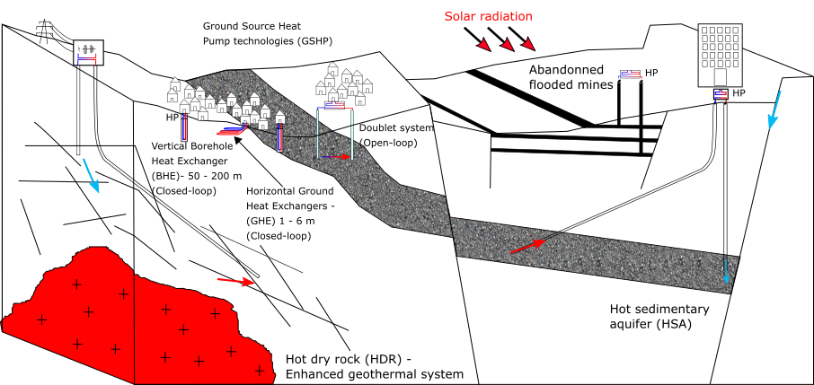

Figure 1: Type of geothermal energy available in the UK, including low-temperature resources (i.e. open-loop and closed-loop GSHP systems that comprise horizontal ground heat exchangers (GHE) and vertical borehole heat exchangers BHE), low-medium temperature resources (i.e. doublet systems, flooded mines) and high-temperature systems (i.e. Hot dry rock, Hot sedimentary aquifers). Open-loop systems are used to harness geothermal heat from in-situ water, by pumping/reinjecting groundwater from/to i.e. aquifers or legacy mine workings. Closed-loop systems use a working fluid to extract heat from the ground. The aim of this paper is to assess the long-term effects of heat extraction from vertical BHE on the subsurface.

Being able to discriminate between the energy sources through a detailed understanding of the heat fluxes induced during heat extraction (both axial and radial) is essential to get a better insight into the sustainability of heat extraction (i.e. Rivera et al., 2015). We first use mathematical solutions calculate the volume of rock required to provide the equivalent of a yearly average heat consumption to a single house in the UK, and quantify the amount of heat recharge available in the ground. We then verify the heat balance numerically by performing a series of 1D and 3D heat extraction simulations in a homogeneous porous medium. In order to neglect the engineering aspects, the BHE is simplified to a vertical line source extracting a constant heat load. Although the models presented use heat flux boundary conditions, we here ignore the increase in surface heat flux from the atmosphere to the ground induced by cooling at the ground surface. Results are used to quantify the relative contributions from vertical and lateral conductive heat fluxes providing heat to the borehole over a 30-year extraction period, through heat mining of surrounding rock. A sensitivity analysis performed to assess the key parameters controlling the extent of the drawdown caused by heat extraction as well as the maximal temperature drop at the borehole. Results confirms that the areal impact of heat extraction on the ground depends on the ground thermal conductivity and is inversely correlated to the temperature decline at the borehole.

# Conceptual model of heat extraction from vertical BHE

## Borehole Heat Exchanger

Vertical BHE are generally 40 to 200-m in length, drilled below the depth of influence of surface temperature variations to access deeper geothermal energy. Although the total heat content of a rock is intrinsically linked to its temperature, the amount of energy that can be extracted from cooling the rock depends on the temperature contrasts ∆*T* between the working fluid and the surrounding rocks. It is expressed as:

(2.1)

where *φ* is the porosity of the rock of volume *V, ρc refers* to the volumetric heat capacity of the rock and of the water (subscript r and w, respectively), *with the density and c* the heat capacity. In GSHP systems, ∆*T* often represents the difference between the inflow and outflow temperature through the heat pump (~ 5°C).

In this study, we assume that heat is extracted from a purely diffusive homogeneous porous medium without groundwater flow (i.e. static water only). Hydraulic and thermal properties for the medium are attributed accordingly to the average values of rocks in the MVS. The effect of heat recharge due to advective groundwater flow are here ignored to concentrate on the thermal footprint caused by conductive heat flow to the borehole only. Although ignoring disturbances of the thermal plume by groundwater flow might be not be realistic in most cases, this is done to get firsts insights into the spatial effect of imbalances between the heat load extracted and the heat capacity of the ground. Assessing the footprint area is an important issue in a context where the number of geothermal heat schemes is expected to increase drastically in the next decades, coming along with a need to delineate/license heat resources.

## Heat load

We first suggest to calculate the volume of rock that would be required to provide the space and waterheating requirements for a single house in the UK, which is in the order of 15 000 kWh on average per year (ECUK, 2019). To satisfy this yearly demand, a heat pump would need to deliver an average heat load *H* = 1700 W by extracting heat from the subsurface. In reality, part of the heat load is supplied by the heat pump in the form of electrical heat *E* that is required for air compression, reducing the energy that needs to be extracted from the ground *G* by an amount that depends on the coefficient of performances (COP) of the heat pump (Banks, 2008).

*G* = *H* (1− 1/COP) (2.2)

Using a COP of 3.4, the average heat that would need to be extracted from the ground to satisfy a total heat demand H = 1700 W is therefore reduced to G = 1200 W. This corresponds to a total energy Q = 3*.81*×1010*J* over a year. Considering a rock with a porosity *φ* = 0*.*1, a density of = 2500 *kg/m*3 and a specific heat capacity of = 950 *J/kg.°C*, filled with a static water of density kg/m3 and heat capacity the volume of rock *V* required to provide this energy by cooling the rocks by ∆*T* = 5◦*C* is about 2900 *m*3, according to Eq. 2.1. Assuming that the heat is extracted radially from a borehole with a length h = 40 m situated in the centre of a cylinder, the radius of this cylinder would be 4.8 m, corresponding to a surface area of about 73 *m*2. The specific heat absorption from the rock, as defined by Banks, 2008 would therefore be  = 25 W/m. Over a 30-year operation period (*Q* = 1.14×1012*J*) and considering that no recharge occurs, an area of 2200 *m*2 would be required (r= 26.5 m), corresponding to a rock volume *V* = 8*.*8×104 *m*3.

Choosing the ∆*T* at the heat pump to calculate the required volume however neglects what the actual temperature of the rock is. To account for the heat content of rock sections, Raymond and Therrien (2008) suggested to define in Eq. 2.1 according to the initial rock temperature , with *z* the average depth of the considered rock section and the mean geothermal gradient. In such scenario, , ∆*T* would be reduced to 2°C. Assuming an average borehole depth z = 70 m and a geothermal gradient *α* = 31 ◦*C/km*, the volume of rock required for cooling would be increased to an area of 180 *m*2 for 1 year and 5500 m² for 30 years. In that case, considering a lower geothermal gradient and thus a lower at the borehole would require greater rock volume to provide the necessary heat load.

## Heat recharge

Sustainable heat production from BHE is achieved when the heat load extracted is balanced by heat recharge in the subsurface. We therefore here attempt to quantify the rate of heat production in the subsurface as well as the potential recovery rate from solar and geothermal heat flux, based on a typical temperature and geological profile in the Midlothian Coalfield in Scotland.

### Geothermal heat flux

The Earth’s natural heat flow is broadly attributed to a contribution from the primordial heat inherited from the formation of Earth and from the natural decay of radioactive elements, typically of the isotopes of uranium (238U, 235U), Thorium (232Th) and potassium (40K) (Pollack and Chapman, 1977). Due to geochemical differentiation, partial melting and magma crystallization processes, the upper crust is generally enriched in heat producing elements (Beamish and Busby, 2016) and their distribution can provide an important control on the temperature distribution within the earth lithosphere (Sandiford, McLaren, et al., 2006). A combined determination of the conductive heat flow and radiogenic heat production (RHP) is therefore here suggested to better constrain the thermal field within the study area (i.e. Jaupart and Mareschal, 2005).

The Midlothian Coalfield is situated in the south east of the Midland Valley of Scotland (MVS), a 80 km wide, 150 km long WSW-ENE trending Carboniferous graben extending across Scotland (Browne et al., 1999; Underhill et al., 2008). It is located in a geologically stable part of Earth’s crust, where only granite intrusions would contain sufficient concentration of K,T and U elements to generate significant radiogenic heat (Gillespie et al., 2013). An analysis of the radiogenic heat production in the Midlothian Coalfield is suggested in Supplementary Material XXX and show that, assuming a homogeneous 2800 *m*3 rock volume with an average RHP of 1.217 µW/m3, the total heat generated would equal 3*.*41×10−3 W, representing about 0.0003 % of the yearly average heat requirements of 1200 W.

In 2013, Gillespie et al. used a compilation of 35 heat flow data reported from the BGS Catalogue of Geothermal Data for the UK (Burley et al., 1984; Rollin, 1987) and Brereton et al. (1988) to map the heat flow in Scotland (Fig. 2.1). An average heat flow of 56 mW/m2 was calculated from values ranging from 29 to 82 mW/m2 mostly measured at depth < 400 m in onshore boreholes. Apparent ‘hot spots’ corresponding to granite intrusions were identified in the central part of the Midland Valley and in the East Grampians region, with heat flows of 60 mW/m2 and 70 mW/m2, respectively (Gillespie et al., 2013). In boreholes where no heat flow has been measured, geothermal gradients were calculated from the surface and bottom-hole temperatures measured in 61 boreholes, down to 1300 m depth (Burley et al., 1984). The average temperature gradient for all boreholes ranges from 3.7 to 45 ◦C/km, with a mean of 22.5 ◦C/km while plotted all together, the data indicate an average temperature gradient of 30.5 ◦C/km. Using 133 Bottom-Hole temperature (BHT) acquired from depth >1.5 km in 72 offshore wells in the North West Margin area (Gatliff et al., 1996 in Gillespie et al., 2013), the authors however noted the increase in the deep geothermal gradient from about 35.8◦C/km at 1 - 3.5 km to 46.7◦C/km at 3.5 - 5 km, relatively consistent across Scotland, and independent of the location (i.e. onshore or offshore) and the type of rock (i.e. sedimentary, crystalline basement) in which measurement were taken. Plotted together, onshore and offshore temperature measurements for the whole depth range (0-5km) indicated an average geothermal gradient of 31.9 ◦C/km.

Here, we chose the average linear geothermal gradient °C/m for depth < 1300 m depth (Gillespie et al., 2013) and an effective thermal conductivity to estimate the average upward heat flux through the homogeneous rock column from:

Where = . Using an average rock conductivity 2.2 *W/*◦*K*.m, calculated from the weight average the lithologies composing the upper 100 meters of the XXX Well log, situated in the Midlothian Coalfield (Appendix XXX), a pore-water heat conductivity .6 2.2 *W/*◦*K*.m and a rock porosity , we estimate the steady state flux to be about 0.063 *W/m*2. Based on the estimated 73 m2 footprint area required for a 40 m long BHE to access the necessary heat load by cooling rocks by 5°C, the geothermal heat flux would contribute up to 0*.*063 × 73 ≈ 5 *W* or to the total heat recharge over a year, assuming purely vertical heat transfers. This indicative study shows that the geothermal heat recharge would represent only less than 0.5 % of the heat consumed by a single house in the UK in one year. Alternatively, if we assume a yearly average geothermal heat flux of about 0.063 W/m2, the area required to provide the necessary recharge to the BHE (for G = 1200 W) is in the order of 19000 *m*2, or 260 times the surface area required for heat extraction in one year. Given that the average area of a house in the UK is 70-100 *m*2 (source: LABC Warranty, 2018), such required area is not realistic and vertical heat flux cannot contribute to recharge the subsurface in heat in a sustainable way.

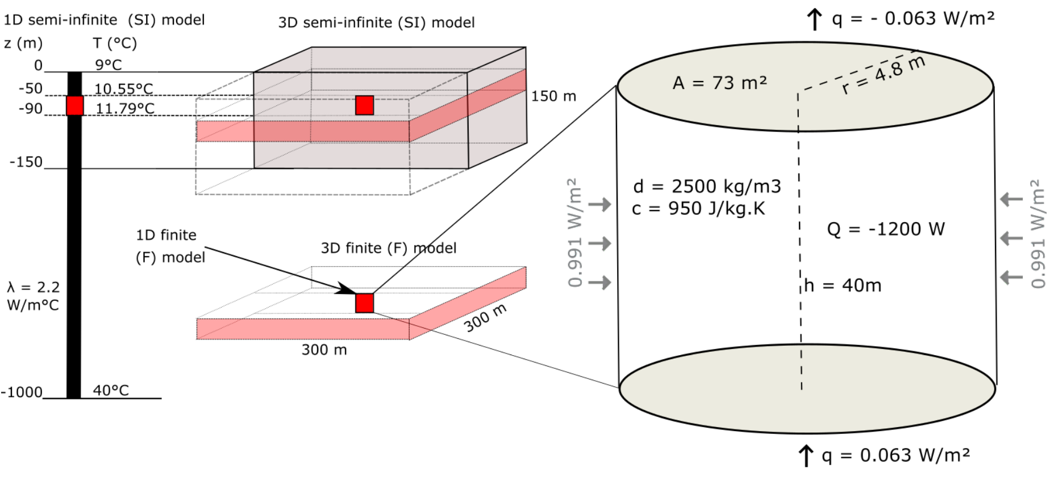

Figure 2: Conceptual models for the heat extraction model from vertical BHE. a) Sketch of the 1D and 3D numerical models developed in this study. b) Heat balance around the vertical BHE determined from mathematical models. The thermal state of the models is defined by an initial steady-state temperature gradient of 0.031°C/m and an average effective thermal conductivity of =2.2 *W/m*2. The heat flux entering the system from below equals the flux coming out at the surface through purely conductive heat transfers.

### Solar energy

In the upper 10-25 m below the surface, the ground temperature is mainly controlled by the yearly variations in air temperature and by the heat flux through the ground surface (Hein et al., 2016). The depth of influence mainly depends on the soil conductivity and on the local surface temperature and climatic conditions . The effective ground surface temperature depends on several factors (i.e. air temperature, solar radiations, longwave radiations emitted from the ground, wind velocity, evapo-transpiration processes) that controls the amount of heat transmitted via conduction or convection between the air and the ground. Due to the time necessary for a heat pulse at the surface to reach depth, the ground will tend to be warmer than the air in winter and colder than the air in summer, impacting the direction of the heat fluxes down to the depth of influence of these seasonal fluctuations. Below that depth, the ground temperature is mainly controlled by the upward geothermal heat flux and tends to follow the trend of the local geothermal gradient (Hein et al., 2016).

XXX suggested an interval of relatively constant temperature between 10-25 m and down to ~200 m depth due to a complex interaction between solar heat comping from the surface and geothermal heat coming from below. In that depth interval, the ground temperature is about 1°C higher than the yearly average surface temperature all year long (XXX), differing from the steady-state linear geothermal gradient displayed in Fig. 2. This is in that interval that BHE are generally installed. Although vertical BHE are not directly harnessing solar energy in the same way as shallow horizontal BHE, that are located in the depth of influence of the yearly variations in surface temperature (i.e. < 6 m), we here study the impact of the long-term downward surface heat flux on the upper part of the geothermal gradient (i.e. down to 200 m). This allows us to estimate the potential heat recharge from surface heat flux to the BHE.

In Edinburgh, the yearly average rate of insulation (i.e. amount of solar radiation per square meter) is about ~2.3 kWh/m² per day, that represents about 94 W/m² on a 24h basis. Over a 10-year average, a minimum insulation rate of 13 W/m² is reached in December and a maximum of 181 W/m² is reached in June (Whitlock et al., 2000). Due to the low diffusivity of soil, the reflection of solar radiation and all the processes mentioned above, it is expected that the net incoming shortwave radiation into the ground only equals 10s of *W/m*2 (Banks, 2008). Assuming that of 40% of the solar energy absorbed by the Earth, 70% is reflected by the ground surface, the average solar recharge to the ground is reduced to per day, in accordance with the amplitude of conductive heat flux values calculated by Larwa (2018). However, unlike the geothermal flux, solar flux is not continuous over time highly .To account for the effects of cyclical heat recharge and possible energy losses at the surface during cold periods, we scale up the solar recharge to the ground based on the sunshine hours in Edinburgh. Using an average of 1380 h of sunshine per year, that is about 16% of the time (i.e.), solar flux can be scaled up to 1.8 W/m². Considering a surface area of 73 m², this indicative study shows that the total solar energy recharging the ground over the considered area equals represents a heat recharge of ~ 4.1 x 109 J, that is less than 11% of the energy of consumed by a single house in the UK in one year.

Recent studies moreover highlighted the ‘heat island effect’ in urban areas (XXX). This effects XXX… and might provide additional heat from the surface to BHE located in cities.

[…]

### Radial heat recharge

Results from our mathematical model suggests that a steady-state geothermal heat flux of 0.063 W/m² can provide only less than 0.5% of the energy consumed in one year, considering a 73 m² area around the borehole (Fig. 2). Adding solar heat recharge at a rate of 1.8 W/m² would contribute to recharging the system up to 11.5% of the heat extracted for an individual UK house over a year. For this indicative study, we assume that radioactive heat generation is negligible in the sedimentary system considered. This shows that heat balance cannot be naturally reached in the ground considering those geological and climatic conditions, and thus additional heat is to be mined from the rock surrounding the borehole, inducing lateral heat fluxes.

To quantify the lateral heat flux, we first assume steady state conditions where 0.5% of the recharge in heat (i.e. 5 W) is provided by geothermal heat flux. That means that about 1195 W will be mined from surrounding rocks. Using a borehole length h = 40 m and , the lateral heat flux at a distance r = 4.8 m from the borehole would be in the order of *W/m*2 (Fig. 2.4). This is about 16 times the upward geothermal heat flux, suggesting that BHE systems extract heat laterally 16 times faster than vertically, which may have a major impact on areal footprint of heat extraction. In a case where the geothermal and solar heat flux contribute to recharge up to 11.5% of the heat extracted is recharged (i.e. 5 W geothermal + 132 W solar), the lateral flux would be reduced to m². This is still 14 times faster than the geothermal recharge but 2times slower than solar heat recharge. Although solar heat flux is an order of magnitude higher than the geothermal heat flux, it is expected to decrease exponentially with depth due to 1) an increase in temperature and 2) a dissipation of the effects of solar radiation and atmospheric condition with depth depending on the diffusivity of the soil (Ozgener et al., 2013). Therefore, the estimated solar recharge might be constrained to shallow depth and overestimate the heat recharge to the borehole. Additionally, energy losses might also occur at the surface in situations where the ground gets warmer than the surface.

We therefore perform numerical simulations to better assess the contribution from vertical and lateral heat recharge in the sub-surface using 1D and 3D models.

# Numerical model

We use the OpenGeosys finite element modelling software (i.e. Kolditz et al., 2012; Chen et al., 2019) to simulate temperature change and calculate the heat fluxes induced in the subsurface due to heat extraction. The relative contribution of solar and geothermal recharge is first described using a 1D model, and lateral heat fluxes are then quantified using 3D diffusion models. Results are used to validate the mathematical models against the volume of accessible rock. We finally use our analysis to quantify the footprint area affected by heat extraction and assess the optimal production scenarios leading to the minimum thermal impact on the ground.

## One-Dimensional Model

We first model the Borehole Heat Exchanger (BHE) as a vertical finite line source embedded within a 1D semi-infinite (SI) model composed of 10 000 elements, 0.1 m in length. To keep the problem simple, the profile is treated as a homogeneous porous medium with a specific heat capacity of 950 J/Kg°C, a density of 2500 *kg/m*3 and a thermal expansion coefficient of 1 × 10−5 °*C*−1. The initial steady-state temperature distribution along the model follows a gradient of 0.031°C/km, with a surface temperature of *T*0 = 9 ◦C corresponding to the average yearly air temperature in the Glasgow area in Scotland, and a bottom temperature *Tz* = 40 ◦C at z = 1000 m. Heat transfer in the ground is assumed to occur only by conduction, with an effective thermal conductivity 2.04 W/°K.m corresponding to the average conductivity of a typical column of dry rock in the Midlothian Coalfield filled with static pore-water (Appendix XXX). A preliminary analysis of the contribution of radiogenic heat generation on the geothermal profile indicated that for an average RHP production of 1.217 µW/m3, the total temperature increase is only 0.0004°C after 30 years. Due to this low contribution, we neglect RHP in the followings.

## Axial effects

Many studies involving the numerical modelling of heat transfer around vertical BHE have assumed isothermal boundary conditions, where the surface temperature represents the yearly average air temperature (i.e. Zhao *et al.,* 2020). Several authors however underlined the importance of setting heat flux (i.e. Neumann) boundaries rather than a constant temperature (i.e. Dirichlet boundary) at the surface (Saadi and Gomri, 2017). Erol et al. (2015) explained that during production, the temperature distribution around BHE is not equal to the undisturbed ground temperature from the surface to the bottom, and axial effects (i.e. vertical heat transfers) become important at both ends of the borehole. Setting a Neumann boundary condition would therefore enable temperature decline at the surface due to heat extraction from the ground, and therefore avoid overestimating available recharge.

To realistically assess the heat recharge through the ground surface, Singh and Sharma (2017) expressed heat conduction through the surface boundary as a general convective heat transfer boundary condition. An effective surface temperature accounting for both convective and conductive heat transfers between the ground surface and the air was calculated from the ambient air temperature, the solar radiation and the wind speed, and used to derive the time-variant first type boundary condition on an hourly basis. We here suggest to quantify the heat flux at the surface by finding the amplitude of the variations that reproduced the soil temperatures measured in Scotland under the ground characteristics defined by the 1D model described above without calculating the complex energy balance between the air and the ground surface. Using Eq. 3.1, we calculate a series of curves representing the daily heat flux values for different signal amplitudes, that are used as source terms for the Neumann surface boundary condition of the 1D heat model.

(3.1)

where Q is the average daily heat flux, t the period of fluctuation (366 days), ∆*t* the time increment (86400 sec, i.e. one day) and A the amplitude of the variations. The parameter q corresponds to the geothermal heat flux of 0.063 W/m² used as bottom boundary condition to the model, and is added to ensure that the yearly average energy balance is maintained over the long term. For each scenario (i.e. values of A), we simulate the change in temperature in the model for a period of 100 years.

By comparing the measured soil temperatures with the surface temperatures obtained from the different modelling scenarios (Fig. 3.), we show that the yearly temperature change in Scotland can be best simulated for a heat flux input of amplitude A = 8.4 *W/m²*, using 2.04W/°K.m,which corresponds to the amplitude of the variations of the recorded soil temperatures at the Paisley station.

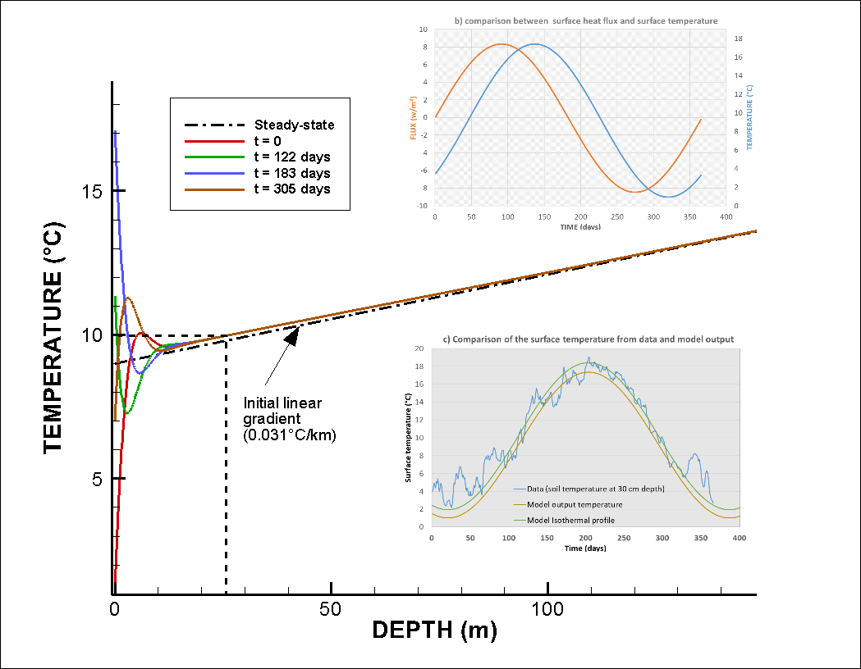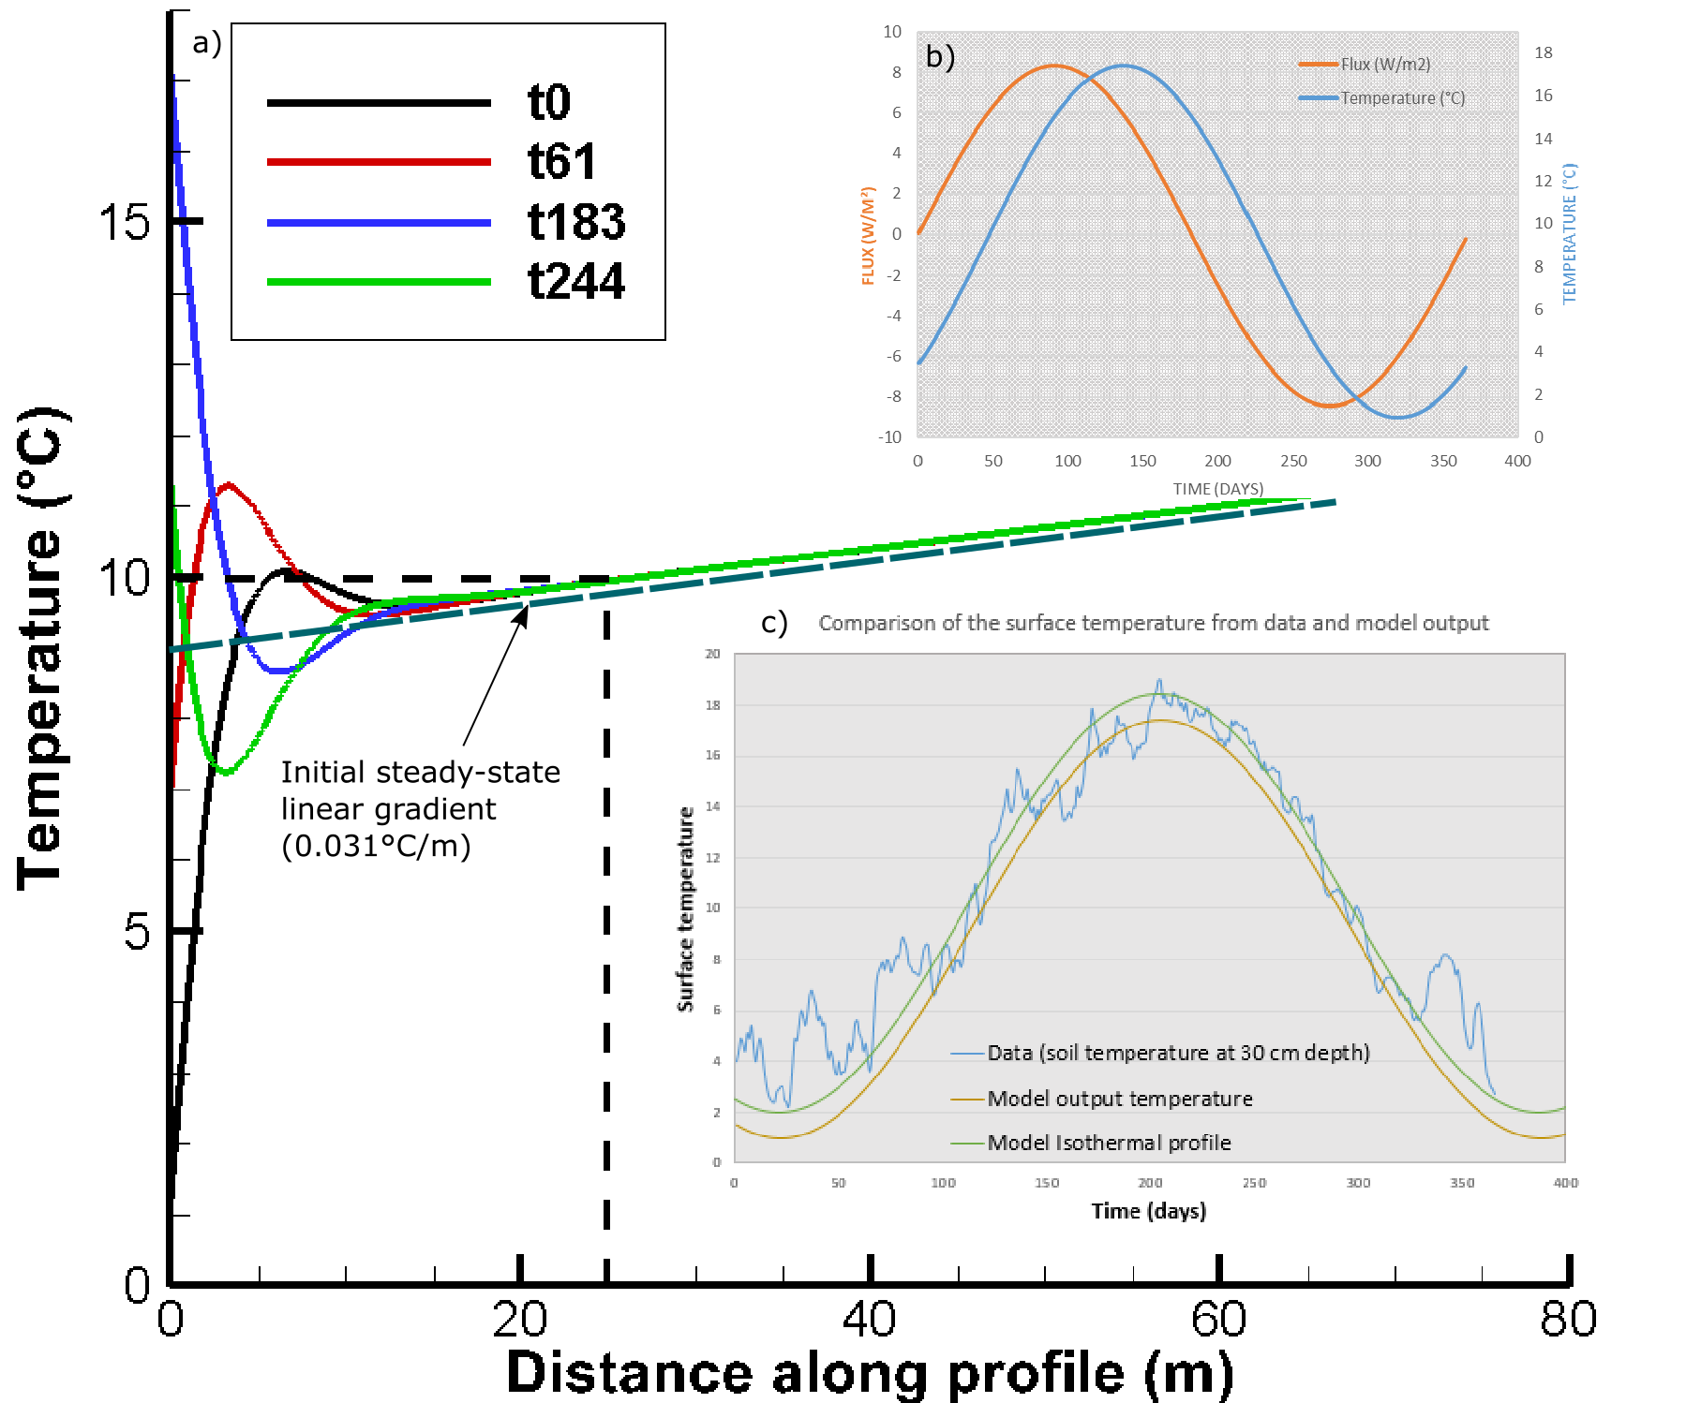

Figure 3: a) Input surface heat flux for the time-varying surface boundary conditions (black line) and output surface temperature time series (z = 0 m) for A = 8.4 *W/m*2. b) comparison between surface heat flux and surface temperature. The temperature change is delayed compared to the heat pulse imposed at the surface. c) Comparison between the data and model output surface temperature. The data used correspond to daily soil temperature measured at 30 cm depth at the Paisley station, Glasgow area, in 2000 and downloaded from the UK Meteorological Office website. Results show a better match for the summer data compared to the low winter temperatures – as shift that can explained by the effects of the geothermal gradient.

Results of a 100-year simulation period with no heat extraction moreover indicates that the fluctuating surface heat flux tends to disturb the upper part of the temperature gradient below the depth of influence of the seasonal variations. After about 80 years, a new fluctuating steady-state temperature profile is reached, showing a shift of the initial linear temperature gradient toward higher temperatures down to 150 m depth (see difference between dashed black line and solid lines in Fig. 4.c). There, the yearly average surface temperature equals 9.2°C, which is close to the average air temperature measured at Paisley (~9.4°C) and reaches 10°C at 25 m depth, in accordance with XXX.

We then simulate heat extraction along the 50-m long BHE situated between 40 and 90 m depth in the 1000-m long 1D semi-infinite medium. Different scenarios aiming at quantifying the relative contribution of solar and geothermal heat flux on the recharge potential are simulated, using 1) constant boundary conditions, 2) constant surface and bottom heat flux boundaries of −0*.*063 *W/m*2 and 0*.*063 *W/m*2, and 3) constant bottom heat flux of 0.063 W/m² and the fluctuating surface heat flux boundary described above. After verifying that the steady state gradient used as initial condition remains stable when using Neumann boundary conditions in a case without heat extraction, temperature change due to heat extraction is simulated for periods of 1 and 30 years, using line source areas of 73 *m*2 and 2200 *m*2, respectively. For each scenario, a constant source term of -1200 W, equally distributed along the 40 m long BHE section of the 1D profile is added.

In addition, we simulate heat extraction within a 40-m long finite (F) line source model. This model corresponds to the finite section of the 1200-m long BHE model situated between 50 and 90m depth, where the temperature is initially at XXX and XXX °C, respectively. This is done to isolate the borehole from potential axial (vertical) diffusive heat recharge from rocks situated above/below, and verify the temperature change predicted by the analytical solutions.3D model and lateral heat flux

Line source models can be used to study in an efficient way steady state conditions (i.e. the overall temperature change in the system) and one-dimensional (1D) heat transfers (i.e. vertical or axial heat fluxes). However, 1D models only give a few insights on the temperature distribution around the borehole, which is assumed to vary uniformly, and for each element the temperature change will be highly dependent on the model area. To study lateral heat fluxes induced by the heat extraction from the 40 m long BHE and the extent of the effect of heat extraction, we therefore set up a three-dimensional model whose properties and thermal state are equivalent to the 1D model previously described.

The 3D models consist of a 300 m large, 300 m long and 150 m deep block composed of 5000 prismatic elements. The borehole is situated in the centre of a cylindrical volume between 50 and 90 m depth. This cylinder has a radius of 26.5 m (i.e. radius of the area required for a 30-year extraction period, as calculated in section XXX) and defines a zone with a high-resolution mesh. The size of the elements increases from 2 m inside the cylinder and up to 20m at the lateral boundaries of the 3D block. The vertical resolution of the model is of 1 m within the borehole depth interval and of 4 m elsewhere.

Assuming that 1D models represent the far field conditions in a three-dimensional scenario, we compare the temperature profiles at 4.8 m and 26.5 m from the borehole (a line source embedded in a 3D model) to those from the 73 m² and 2200 m² 1D line source model. Any difference between the equivalent temperature profiles in the 1D and 3D model would therefore indicate the effects of radial heat recharge.

# Results

## Axial recharge

We first attempt to quantify the axial affects induced by heat extraction from the 40-m long borehole over time by comparing the temperature profiles obtained from the 1D finite (F) and semi-infinite (SI) models. In both scenarios, a total heat load of 1200 W regularly distributed along the line source of finite length is abstracted from the 70 m² and 2200 m² models for durations of 1 year and 30 years, respectively, according to the analytical model described in part XXX. The profiles obtained for both models are displayed in Fig. 4 together with the profiles extracted from the 3D models, at distance x = 0 m, x = 4.5 and x = 26.5 from the semi-infinite and finite line-sources (see Section XXX).

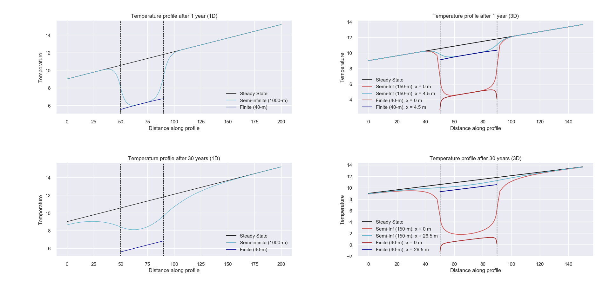

Figure 4. Temperature profile obtained a) for the 1D 70m² models and b) for the 3D models after 1 year of heat extraction, and c) for the 1D 2200m² models and d) for the 3D models after 30 years of heat extraction. In the legend, F refers to the 40-m long finite model (dark blue profile) and SI refers to the 1000-m long (1D) or 150-m thick (3D) semi-infinite models. Those distances correspond to the radius of the corresponding 1D model. The black dashed profile corresponds to the initial temperature profile for the model with fluctuating surface heat flux (green profile). All other models are calculated for constant heat flux boundaries of -0.063 and 0.063 W/m² at the surface and bottom, respectively, associated to a steady state temperature gradient of 0.031 °C/km (black dashed profile).

Results from the 1D 40-m long finite model with constant heat flux boundaries (dark blue line) first confirm that the extraction of a heat load of 1200 W induces a uniform temperature decline of 5°C along the borehole for both simulation periods (i.e. the temperature at the mid-borehole = 6.2°C), in accordance with the mathematical model. Our model also shows that after the same production period, the overall energy change in the 40-m and 1000-m long 1D models is consistent (i.e. ΔE = 1.14 × 1012 J (3.16 × 105 kWh) after 30 years). The Gaussian-type temperature distribution along the semi-infinite model (light blue line) however suggests that part of the heat is sourced from the areas situated above and below the borehole. This effect is prominent after 30 years of heat extraction (2200 m² model), where the temperature decline at the mid-borehole in the 1000-m model is only half of the temperature decline in the corresponding 40-m model (). Although most of the heat is mined at the borehole location in the first year, this indicates that the contribution of axial recharge becomes essential in the following years.

We therefore calculate the integrated temperature difference in the borehole depth interval between the finite and semi-infinite models for both time periods in order to evaluate the effects of axial heat recharge on the observed temperature profile. This is done based on the following equation:

## Where subscript F and SI refers to the finite 40-m long model and 1000-m long semi-infinite model, respectively, and the integrand limits represent the depths. Results indicate that after 1 year (73m² model), about 10% of the heat extracted in the semi-infinite model is sourced from the area available above and below the borehole. Over 30 years (i.e. 2200 *m*2 model), the temperature drop within the borehole depth interval is considerably reduced, with the rocks situated above and below providing up to ~50% of the heat required by the borehole. With increasing production time, the amplification of axial effects therefore allows decreasing the peak in temperature decline at the borehole. The importance of axial effects had already been noted by Marcotte et al. (2010). In their study, the authors examined the axial effects in in vertical BHE by comparing numerical results obtained using the finite and infinite line source methods. The main different between those models is the consideration of axial conduction effects by the finite line source, in which a constant temperature boundary condition is considered at the surface (Zeng et al., 2002). Results showed that axial effects tend to be important, especially for short boreholes and that considering axial conduction effects would permit downsizing of BHE. Although 1D models allow a simple estimation of the average temperature change in a given volume of rock, they cannot inform on the temperature distribution around the borehole, and thus on the area of impact in the long term. We therefore use 3D models to get a better insight on the area of impact of heat extraction over time, considering a homogeneous porous medium with no water flow.Three-dimensional study of radial recharge

From the 1D analysis, we have shown that axial effects tend to provide additional recharge to the system, by reducing the maximum temperature decline at the borehole while increasing the vertical footprint. To account for the potential heat recharge from lateral areas, we extend our analysis to three dimensions. Similarly to our 1D quantification of axial fluxes, we create a 40-m thick 3D model consisting of a finite vertical line source embedded in a 300-m wide and 300-m large volume (Fig. XXX). We simulate heat extraction at the borehole at a rate of -1200 W for a period of 30 years with yearly time steps, considering constant heat flux of +/- 0.063 W/m² at the upper and lower boundaries and no-flow laterally. Results show that for both 3D models, the total energy change is similar to the one calculated from 1D models (i.e. about 1.14 × 1012 J (3.16 × 105 kWh) after 30 years). We extract data along vertical profiles situated at distances x = 4.5 m and x = 26.5 m from the borehole location (i.e. x = 0 m), which correspond to the radii of the 73 m² ad 2200 m² 1D models, respectively. Assuming that 1D models represent far field condition, those data will be used to compare the amount of axial recharge obtained from the 1D and 3D models and quantify the lateral (radial) heat flow to the borehole (Fig. XXX)Based on Eq. XXX, we first calculate the axial heat fluxes induced at the borehole location (x = 0 m) and at x = 4.5 m (1-year model) or x = 26.5 m (30-year model) from the borehole in the 3D models. Although Fig. 4 shows that the 3D models see less thermal drawdown than in the corresponding 1D model (i.e. when comparing profiles at x = 4.5 m with the 1D 73m² model and profiles at x = 26.5 m with the 1D 2200m² model), results from the calculations indicate that at those distances from the line source, the contribution from axial flux is in the order of those estimated from 1D scenarios, that is about 10% after one year and ~50% after 30 years, respectively. On the contrary, a greater temperature decline is observed at the borehole location (x = 0 m). In the semi-infinite models, temperature at the mid-borehole declines by 6.2°C after 1 year (5 °C) and by 9.6°C after 30 years (1.35 °C). Although the 3D finite model sees the same temperature drop at the mid-borehole after 1 year, a temperature decline of 10.8°C is measured after 30 years (.35 °C). Applying Eq. XXX at x = 0 m shows that axial effects only contribute to less than 5 % of the recharge after 1 year and up 17 % after 30 years. This seems to indicate that although axial fluxes also allow reducing the temperature drop in the borehole depth interval in the 3D model, they are not sufficient at the borehole location, where the high energy reduction prevents sufficient recharge.

Fig. XXX shows the temperature time-series extracted at the mid-borehole location from the XXX 1D and 3D models. Results show that while the temperature declines a linear rate ~-0.08°C/year from the onset of production in the 1D models, the temperature at the borehole location in the 3D models tends to decrease exponentially, with a total temperature change ΔT of 6.2°C recorded within the first year and an additional temperature drop of 4.6°C recorded in the following 29 years (i.e. finite 3D model). This suggests that in 3D models, most of the heat extracted during the first year is mined from the area close to the borehole (see Fig. XXX). There, a quasi-steady state situation after about 12 years, where the decline in temperature is reduced to a linear rate of 0.01°C/year. The large temperature decline at the borehole i.e. ΔT = 10.8°C in the finite model) relative to the one observed at distance x = 4.5 m after 1 year (ΔT = 1.1 °C) after 1 year or at x = 26. 5 m after 30 years (ΔT = 1.3 °C) suggests the presence of a cone of thermal drawdown, where the effects of heat extraction are damped and delayed with distance from the borehole. At x = 26.5 m, temperature starts decline after a year and a quasi-constant rate of temperature decline of ~0.02°C/year is reached after about 20 years. This opposes to the 1D model, where the temperature drawdown is spread over a same volume at each time step, resulting in a homogeneous temperature drop over the surface area covered by the 1D model element. This suggests that although a quasi-steady-state temperature tends to be reached at the borehole, this does not correspond to the spatial steady-state temperature conditions due to the poor heat generation and recharge potential of this system.

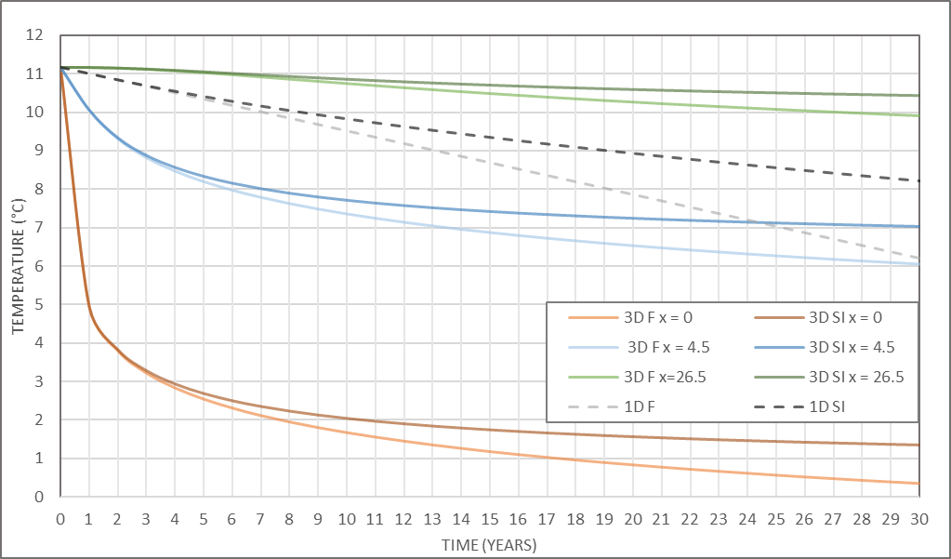

Fig 5. Temperature time series extracted at 70 m depth (mid-borehole location) from the 1D and 3D models. Results indicate more drawdown at the borehole location in the 3D model compared to the 1D 2200 m² model. The drawdown is linear in the 1D finite model. In both the semi-infinite 1D model and in the 3D models, where lateral and/or axial recharge is allowed, a quasi-steady-state temperature decline is reached after ~20 years (dotted lines). At 26.5 m from the borehole, the temperature at the mid-borehole depth only decreased by 0.4 °C (T = 10.6°C) after 30 years of extraction, against 2.4°C in the 1D model (T= 8.6°C). In the 3D model, the temperature decreases exponentially at the borehole location, with a temperature drop of ~5.5°C within the first year. A quasi-steady state temperature decline is reached after 12-15 years of heat production.

We therefore quantify the relative contribution of radial heat fluxes to the heat recharge to the borehole over time, using the relative temperature difference between data extracted at distances x = 4.5 m and x = 26.5 from the 3D finite model and the corresponding 1D finite temperature (Eq. XXX). Results indicate that when no axial recharge is allowed, radial heat fluxes contribute up to 70% of the recharge at the model boundary (i.e. 4.5 m for the 1-year model and 26.5 m for the 30-year model). In a case with axial recharge, they would contribute up to 63% of the recharge after 1 year and 35% after 30 years.

Both vertical (axial) and radial (horizontal) heat fluxes are calculated along vertical 2D profiles across the finite and semi-infinite 3D models for t = 1 year, 30 years and 100 years of heat extraction. Results displayed in Fig. XXX indicate that after 1 year (x = 4.8 m), the horizontal heat flux reaches 0.991 W/m² at the mid-borehole depth (i.e. -70 m), in accordance with the analytical model presented in section XXX, and reaches 1.06 W/m² at the BHE ends. After 30 years, our analysis shows that a constant horizontal heat flux is reached across the model (i.e. 0.16 W/m at x = 26.5 m), indicating that temperature will tend to decline at a constant rate at a given location while the area of impact will keep expanding, if no additional heat recharge is provided.

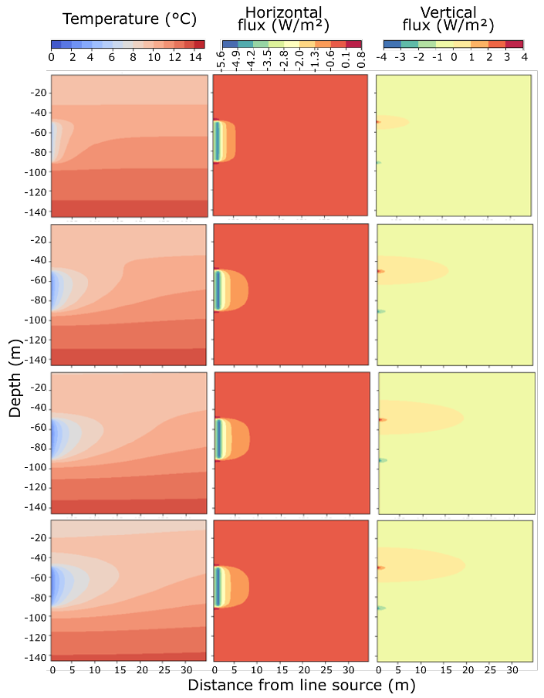

Figure 7: 2D section in the central part of the 3D model showing the vertical and horizontal fluxes after (a) one year (b) 10 years, (c) 30 years and (d)100 years

As the production time increases, the 3D model allows radial heat transfers that permit the mining of heat further away from the borehole. The lateral expansion of the volume of rock depleted in heat over time also participates to an increase in the vertical temperature contrasts, and thus in the contribution from axial fluxes. Fig. XXX shows the axial fluxes keep expanding over time at the borehole top, suggesting a lack of recharge in the upper part of the model. Although the upward geothermal heat flux represents a constant heat source at the bottom of the borehole, the lack of recharge at the surface together with the effects of heat extraction (i.e. downward heat flux above the borehole) indeed induces the mining of heat. This effect is amplified by the proximity of the borehole to the surface makes it relatively sensitive to the condition at the boundary. As no heat can be source from outside the model, downward fluxes tend to expand over time as the area depleted in heat expands laterally.

We finally use the 3D full extent model to measure the radius of the area impacted by heat extraction around the borehole over time. The drawdown is measured after 30 years along two horizontal profiles situated at the surface (z = 0 m) and at the mid-borehole (z= - 70 m) based on a threshold of XXX°C. Fig XXX shows that for both depths, the radius of influence reaches about 80 m around the borehole, with a total temperature drop of 8°C at the mid-borehole (red horizontal line) and of 0.1°C at the surface. After 30 years, the footprint area of heat mining in the volume with a thermal conductivity of 2.04 W/°C.m is in the order of 20 000 m², that is an order of magnitude higher than the area calculated from the analytical approach.

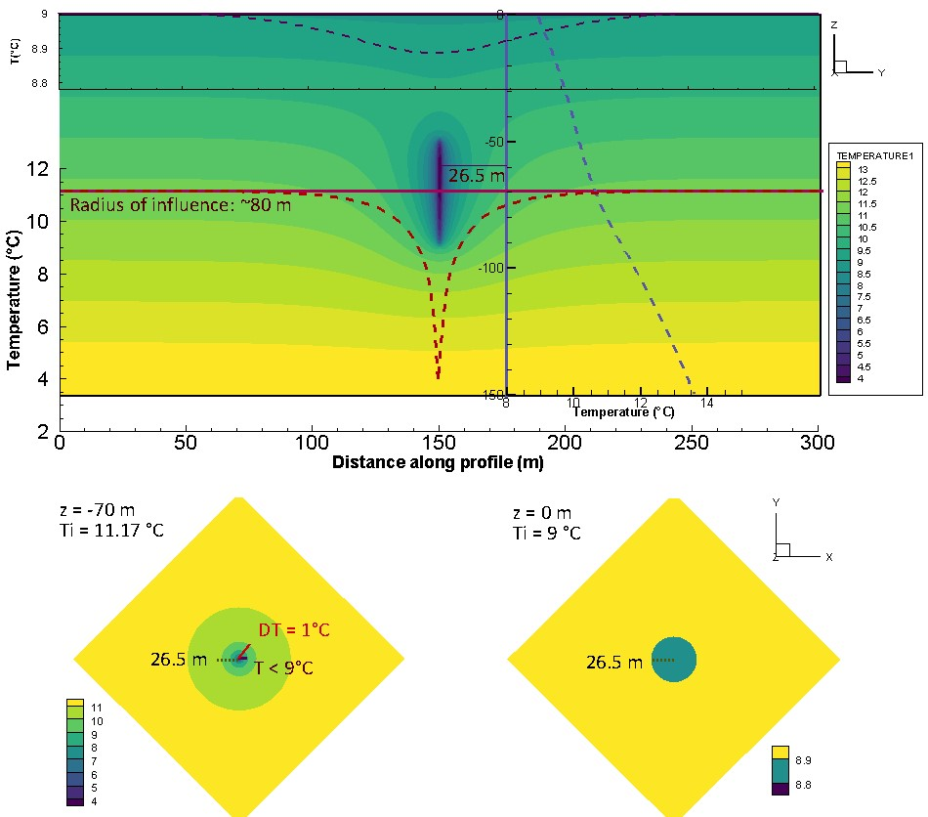

Figure 6: XZ temperature profiles obtained from the full extent 3D model after 30 years of heat extraction. The vertical light blue profile shows the temperature distribution at x = 26.5 m and the dark blue and red profiles represent the temperature distribution at y = 0 and y = -70 m.

## Solar variations effects

It has been shown from previous studies that solar effects are particularly important when studying the efficiency of borehole heat exchanger when those extract heat from shallow depth, i.e. in the zone of influence of the yearly fluctuation in solar flux (XXX). In our example, the effects of yearly oscillations in the surface heat flux reached about 25 m depth, modifying the direction of the heat flux at a yearly scale in the shallow sub-surface. Below that depth, the complex interaction between the surface and geothermal heat fluxes tend to disturb the steady-state linear geothermal gradient, creating a new equilibrium where the upper part of the geothermal gradient is shifted toward higher temperatures down to 150 m depth (Fig XXX). This suggests a decrease in the upward heat flux that might favour recharge from above.

To avoid overestimating the recharge due to the transient state of the geothermal gradient seen when using fluctuating heat flux (Fig. 3), we use the profile obtained after 100 years without heat production as initial state to the heat extraction model. As production time increases, our analysis showed that the layer of rock depleted in heat expands vertically, amplifying axial fluxes. After about 6 years, temperature time-series indicate the onset of the temperature decline at the surface, showing that the effects of heat extraction reached the surface. We therefore compare the temperature profiles below 25 m depth to assess the energy change in the system after 30 years of heat extraction using constant and fluctuating surface heat flux. This is done to assess the effects of heat extraction from the zone of transient temperature as well as the effects of fluctuating surface heat flux on the recharge to the system.

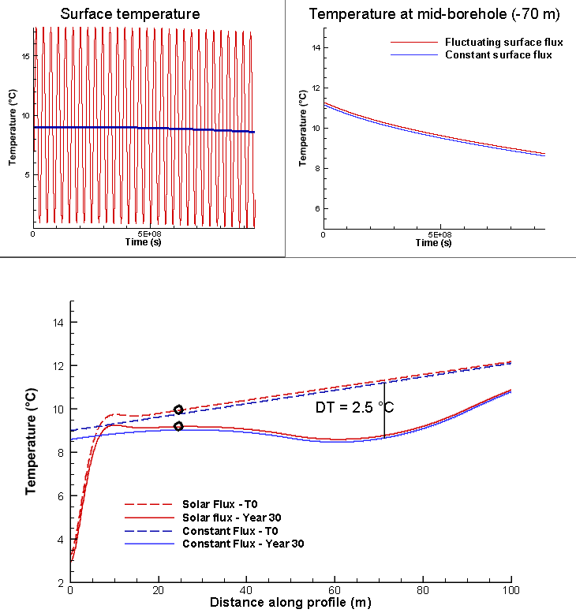

Fig. 8. Results show that after 30 years, the overall change in energy content in the system is only of a few tens of degrees (taking the integrated difference between the constant and fluctuating surface heat flux model between 25 and 150 m depth).

# Discussion

In the previous sections, we have calculated the volume of rock required to provide energy to a typical average UK house for periods of 1 and 30 years, based on analytical equations allowing a temperature change of 5°C in the system. The required heat load was compared to the available natural recharge in the system (i.e. radioactive heat, geothermal and solar heat flux) for a case study located in the Midlothian Coalfield, Scotland. We then used 1D and 3D numerical models to verify the mathematical model and calculate the amplitude of vertical and horizontal flux around the borehole. In addition, we evaluated the footprint area of heat extraction at the mid-borehole and at the surface, in a homogeneous system with a thermal conductivity of 2.2 W/°C.m².

While analytical models suggested that natural recharge can only contribute up to 13% of the heat extracted, numerical models confirmed that most of the heat is actually mined from the rock surrounding the borehole. Results from the 3D analysis show that if that heat transfers are not affected by the conditions at the boundaries, steady state flux can be reached after one year. This means that at a specific point, temperature will start declining at a constant rate from at a time t that depends on its distance from the line source (Fig. XXX). In response to the expansion of the volume depleted in heat with time, 3D models also showed the expansion of the downward heat flux above the borehole, allowing greater recharge to the borehole. As the extension of the layer impacted by downward fluxes reach the surface, the lack of input of heat at the surface (i.e. -0.063 W/m²) would explain that steady state flux at the surface cannot be reached as fast as lateral fluxes. In 1D models, where the amount of heat available is constrained by the model area and no recharge is provided from lateral areas, this effect led to an important drop in temperature above the borehole due to the lack of recharge from the surface (i.e. scenario with constant heat flux). This suggests that as the borehole depth increases, allowing more axial recharge, the areal impact of heat mining would decrease. Using a fluctuating surface heat flux, numerical results show that recharge from the surface can be increased by XXX%.

The model described in this study represents a specific scenario that highly depends on the choice of the geometrical parameters and medium properties. Further analysis aiming at assessing the contribution from 1) the thermal conductivity, 2) model area, 3) borehole depth (i.e. distance from the upper boundary), 4) borehole length (i.e. specific heat absorption rate), 5) production time and 6) thermal conductivity on axial recharge and extent of temperature change in the system is presented in SM XXX.

Results presented in SM XXX show that for a given production time the areal impact of heat extraction mostly depends on the thermal conductivity of the rock and on the borehole length, which are inversely proportional to the temperature decline at the borehole. Although increasing the borehole depth favours axial recharge and restrain the drop in temperature at the borehole, it only has a few effects on the areal impact of heat extraction. Therefore, considering axial effect would allow reducing the initial area in 1D model to reach a total temperature drop ΔT = 5°C at the mid-borehole. 3D analysis however showed that after 30 years of heat extraction, the radius of the impact area is only 10-m lower than in the 1000-m thick model. Increasing the borehole length allows decreasing the specific heat extraction rate from 25 W/m for a 40-m long borehole to 5 W/m for a 200 m long borehole. As increasing the borehole length generally represents important investment costs, improving the thermal conductivity of the medium around the heat exchanger is often seen as of primary interest to ensure long-term production and avoid engineering issue due to the accumulation of cold at the borehole (XXX). By confronting the need to ensure the BHE efficiency against that of ensuring the sustainability of the geological resource while constraining the area of impact, we come up against a conflict of interest… Here, we therefore perform simple heat balance analysis to evaluate the amount of annual recharge that would allow constraining the area of impact to 70-100 m² over 30 years. We then verify our model through different cyclical injection/production scenario using the 3D full-extent model.

## Heat balance analysis

The analysis presented in Fig. XXX suggested that although a steady-state temperature can be obtained at the borehole, often interpreted by previous studies as an indication of efficient system, this steady state situation can hardly be reached away from it. The area of impact of heat extraction will expand over time if no heat recovery schemes are planned.

We suggested earlier that radioactive heat production, solar recharge and geothermal heat cannot compensate for the heat extracted on a yearly average under the considered geological and climatic context, without considering an unrealistically large volume of rock. For a defined heat extraction rate and production period, the footprint area of mined heat is highly dependents on the conductivity of the medium. Our analysis shows that lateral heat flux, which defines the rate at which heat is provided to the borehole by the surrounding area, can reach steady state after a year in a homogeneous system. Axial fluxes tend to increase over time, depleting the volume of rock available above the borehole in heat while expanding the zone of influence below and around it, to an extent that depends on the conductivity of the ground.

Vertical heat exchanger coupled ground source heat pump systems use the shallow geothermal energy as a heat source or sink for space heating or cooling. In opposition to horizontal ground heat exchangers, they present the advantage of occupying less land surface area that horizontal ground heat exchanger. However, studies in China (i.e. Li and Lai, 2015; Wang et al., 2012) warned on the irreversible cooling of the ground caused by yearly imbalances in heat extraction/injection from ground source heat pump, especially in cold areas where the cooling needs are low and for large-scale systems with long operational periods (Gao et al., 2015). Some studies showed that other ways to achieve sustainable heat extraction and eliminate the cooling load accumulated into the ground is to perform cyclic production or provide additional artificial heat recharge during the non-heating season, such as solar thermal energy and industrial waste heat recharge (Cui et al., 2015; Cruickshank and Baldwin, 2016). Experimental studies conducted by Trillat-Berdal et al. (2006) showed that the ground thermal loads could be balanced by a system combining geothermal coupled heat pump and thermal solar collector, when the excess heat not used for hot water heating is injected into the ground, and the heat pump either used in cooling or heating mode. Cui et al. (2015) performed similar analysis on the performances of seasonal storage of industrial waste heat, by developing a heat transfer model for vertical GHE boreholes with multi-stage series connections.

# Conclusion

The aim of this study was to assess the spatial impact of heat extraction from BHE systems and the renewability of low-grade geothermal resources. We used simple analytical models to calculate subsurface energy balances in the Midlothian Coalfield in Scotland, considering heat extraction from a 50-m long vertical BHE. One-dimensional numerical models were used to verify the analytical solution and calculate axial recharge. We also extended the models in 3D to assess the effect of lateral recharge and the area of impact of heat extraction. Although previous studies aiming at assessing the long-term performances of BHE systems showed that steady-state production temperature can be reached after a few years of production, we here show that energy balance in the shallow sub-surface (i.e. < 100 m) cannot be naturally reached over the long term and thus steady-state conditions cannot be reached away from the borehole. For a fixed GSHP set up and production period, our study show that the areal impact mostly depends on the conductivity of the ground. Although high conductivity rocks are generally preferred to avoid a fast cooling at the borehole location and ensure sustainable BHE, it also considerably impacts the extent of heat depletion. In a context where geothermal energy becomes of real interest, constraining the footprint area of heat extraction is nevertheless essential to avoid interferences.

By calculating the relative contribution from axial and lateral heat flux, we showed that the initial recharge in the system depends on the long-term energy balance between surface and deep geothermal flux (i.e. initial temperature gradient). As the production time increase, the heat is mined further away from the borehole as the heat generated from radiogenic elements and recharged from solar and geothermal flux does not compensate for the heat extracted. Although steady-state radial flux can be reached after a year of production (i.e. constant rate of temperature decline), axial flux tends to increase with depth, with a maximal amplitude at the borehole ends. This effect is amplified as they reach the upper boundary, where the Neumann (i.e. constant flux) boundary condition prevents from maintaining a fixed temperature at the surface (i.e. this differs from the finite line source model of Zeng et al., 2002).

In addition, this study showed that in geographical areas with low geothermal heat flux and low in-situ heat production, artificial heat recharge is required to ensure sustainable heat extraction and constrain the footprint area impacted by heat mining. 3D analysis showed that the areal impact of heat mining can be minimized by performing cyclical production with periods of no production, while adding cyclical recharge allow ensuring heat balance in the system, decrease the peak in temperature drop at the borehole and ensure sustainability from the heat resource perspective.

Next step will be to assess the relative contribution from heat convection and conduction through the porous medium, using 2D advection-diffusion models (i.e. with groundwater flow). We will also extend this study by using mine-water heat source as a way to disperse heat injected from artificial sources.