# ABSTRACT

In the UK, low-temperature geothermal energy is seen as a renewable resource able to contribute to the decarbonization of residential heating. Using vertical borehole heat exchanger (BHE) systems, heat can be extracted from the shallow ground sub-surface and be used for hot water or space heating. Although the potential of vertical BHE has been well studied, we here investigate the potential of the ground to provide an individual BHE with the heat load required on a yearly average by a single house in Scotland. A 1D heat balance performed for a heat consumption of 1200 W suggests that a geothermal flux of 0.63 W/m² alone would require ~15 000 m² to recharge the system, while solar energy (~1.8 W/m²) can contribute up to 11% of the heat recharge. 1D and 3D numerical models are used to calculate the contribution from axial and radial heat recharge together with the footprint area of a 30-year long heat extraction period from a BHE embedded in a homogeneous purely diffusive medium. Although temperature equilibrium is reached at the BHE after a few years of heat extraction, the areal footprint of heat depletion increases beyond the average area of a UK property (70 m²). The ground conductivity fixes the amplitude of the lateral heat fluxes that reach a constant rate after one year of heat extraction. As the areal footprint expands, axial fluxes are induced further away from the borehole to an extent that depends on the BHE depth. The footprint area increases as the BHE length decreases and is inversely proportional to the temperature decline at the borehole. This study shows that although sustainability of BHE exists from an engineering point of view, the extension of the BHE footprint area over time means that sustainability cannot be reached from a UK resource perspective. As an increase in the number of geothermal heat schemes is expected in the UK, increasing the necessity for delineating/licensing heat resources, cyclical heat production and/or artificial heat recharge must be considered to constrain the area of heat depletion around the BHE.

# Introduction

Heat demand for domestic and industrial space heating account for about 50% of the energy consumption in the UK. Currently, around 85% of this energy is supplied by natural gas, contributing to about 34% of the Greenhouses Gas Emissions of the country (BEIS 2019 ECUK – end uses database). Following the Paris Agreement, the UK targeted through the 2019 Climate Change Act to reach net zero carbon emission by 2050. To achieve this goal, attention has been focused on the need to decarbonize residential heat and on the development of new low-carbon energy sources such as geothermal energy.

Geothermal energy characterizes the heat energy contained in rocks of the Earth’s crust, that can be used for heating/cooling applications or electricity generation, depending on the resource temperature. Rocks generally get hotter with depth following the geothermal gradient, and although accessible high-temperature geothermal resources used to generate electricity and/or heat are limited to only a few geographical areas, shallow low temperature geothermal resources have been harnessed increasingly since the 1980’s to provide domestic space heating and cooling services. Using ground-source heat pump systems, low-grade heat can be extracted from the ground either via a working fluid circulating in a ground heat exchanger (GHE, in ‘closed-loop’ systems) or via pumping surface water and groundwater stored in aquifers (‘open-loop’ systems). After going through the heat exchanger, the water produced in open-loop systems can either be discharged at the surface or reinjected in the aquifer whereas the cold working fluid in GHE returns to the subsurface to be heated up again (Curtis *et al.,* 2005).

Different closed-loop system configurations permit to access resources situated at different depth range in environments where no groundwater is available. Horizontal GHE are essentially solar thermal energy collectors (Banks, 2008). They are commonly installed at < 6 m depth, where the ground temperature varies accordingly to yearly changes in surface temperature (Banks, 2008). Alternatively, vertical borehole heat exchangers (BHE) can access resources situated down to 200 m depth, where the local geothermal gradient controls the ground temperature that remains stable though the year. Despite of their higher costs of installations (i.e. drilling requirements), the higher temperatures accessed by vertical BHE allow a greater ΔT at the heat pump, which ensures higher performances relative to horizontals GHE (Chen *et al.,* 2019). This is advantageous in areas of high land price due to the lower land surface requirements (Trillat-Berdal *et al.,* 2006). Deep Borehole Heat Exchangers (BHE) can also be drilled down to ~2 kilometres depth, where the heat collected offers good opportunities for district heating applications and/or power production (Alimonti *et al.,* 2021).

In this study, we focus on the impact on the ground temperature of shallow vertical BHE, a technology that can be used for hot water and space heating of individual houses (Fig. 1). We base our study on the Midland Valley of Scotland in the UK, where a large proportion of the population lives above coal mines. Today, all the underground mines are closed, with many located in rural areas that are likely to suffer from energy poverty. In addition to the need to decarbonize heat sources, the interest in using small-scale ground-source heat pump (GSHP) has been growing in recent years as they avoid a number of disadvantages relative to large-scale systems. These include the need for central heat pump system, heat losses in community distribution pipe networks, maintenance of heat interface units and high operating costs (i.e. Sayegh *et al.,* 2018).

The performance and the sustainability aspects of BHE from an engineering perspective have been covered extensively in the literature. Previous works have used both analytical and numerical models, ranging from one-dimensional BHE model to full 3D subsurface numerical models to assess the long-term performances of those systems (i.e. Rybach and Eugster, 2010; Signorelli *et al.,* 2005; Lyu *et al.,* 2017; Zhang *et al.,* 2016; Stylianou *et al.,* 2017; Zanchini *et al.,* 2010; Lazzari *et al.,* 2010). These are generally expressed in terms of the system coefficient of performance (COP), the ratio between the electrical energy provided to the heat pump and the energy delivered, which is a function of the temperature contrast between the ground and the circulating fluid in the BHE. While Chen et al. (2019) showed that quasi steady-state outflow temperature could be reached after 20 years of production from a BHE in China using a specific heat extraction rate of 100 W/m, Chen et al. (2020) warned that unbalanced heat extraction and injection from BHE in cold regions (i.e. due to greater needs in heating relative to cooling) could lead to an extensive cooling of the ground. The efficiency of heat extraction mostly depends on the heat transfer process between the BHEs and the ground. In a purely diffusive medium, this is mainly control by the thermal conductivity and diffusivity of the ground (i.e. Stylianou *et al.,* 2017; Chen *et al.,* 2019; Choi and Ooka, 2015). The presence of groundwater is suggested to improve the long-term performance of BHE both by increasing the heat exchange rate during production (Zanchini *et al.,* 2010; Stylianou *et al.,* 2017; Wang *et al.,* 2013) and by favouring heat recovery during periods of no production (Hein *et al.,* 2016; Erol *et al.,* 2015). In such a scenario, analysis showed that the soil heat capacity and thermal conductivity only have minor impact on the sustainability of a GSHP systems and that dispersion tends to increase the area of impact of heat extraction. However, by regarding the sustainability issues of BHE from an engineering perspective (i.e. production temperature), only a few studies treated the ground as a finite heat resource. More recently, Walsch *et al.,* (2021) quantified the regional scale thermal interferences caused by a dense deployment of individual shallow BHE for district heating in Switzerland, suggesting the importance of considering the areal impact of heat extraction for future applications of BHE-GSHP systems. Here, we investigate the capacity of the ground to provide the required heat load to an individual vertical BHE in the UK and simulate the extent of the heat depletion (i.e. thermal footprint) induced by long-term heat extraction considering a purely diffusive medium. By looking at the impact of heat extraction from a geological resource perspective rather than a BHE performance perspective, we clarify the concept of “steady state” production temperature and show that geological conditions in the UK cannot sustainably provide heat to a shallow stand-alone vertical BHE.

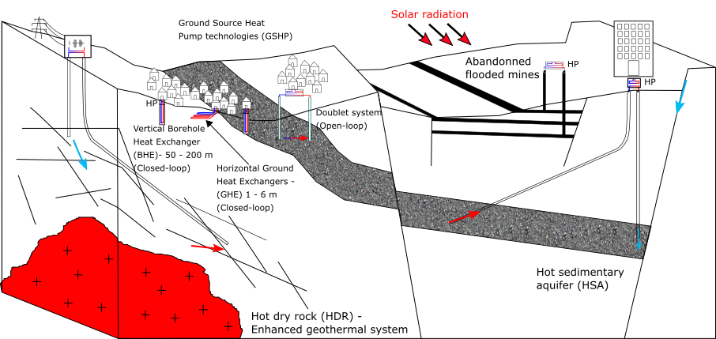

Figure 1: Type of geothermal energy available in the UK, including low-temperature resources (i.e. open-loop and closed-loop GSHP systems that comprise horizontal ground heat exchangers (GHE) and vertical borehole heat exchangers BHE), low-medium temperature resources (i.e. doublet systems, flooded mines) and high-temperature systems (i.e. Hot dry rock, Hot sedimentary aquifers). Open-loop systems are used to harness geothermal heat from in-situ water, by pumping/reinjecting groundwater from/to i.e. aquifers or legacy mine workings. Closed-loop systems use a working fluid to extract heat from the ground. The aim of this paper is to assess the long-term effects of heat extraction from vertical BHE on the subsurface.

The ability to discriminate between the energy sources through a detailed understanding of the heat fluxes induced during heat extraction (both axial and radial) is essential to fully understand the true sustainability of heat extraction (i.e. Rivera *et al.,* 2015). Here, we first use mathematical solutions calculate the volume of rock required to provide the equivalent of a yearly average heat consumption to a single house in the UK, and quantify the amount of heat recharge available in the ground. We then verify the heat balance numerically by performing a series of 1D and 3D heat extraction simulations in a homogeneous porous medium. In order to focus on the evolution of the heat extraction footprint, the BHE is simplified to a vertical line source extracting a constant heat load. Although the models presented use heat flux boundary conditions, here we neglect the increase in surface heat flux from the atmosphere to the ground induced by cooling at the ground surface. We use these results to quantify the relative contributions from vertical and lateral conductive heat fluxes providing heat to the borehole over a 30-year extraction period, through heat mining of surrounding rock. A sensitivity analysis was performed to assess the key parameters controlling the extent of the drawdown caused by heat extraction as well as the maximal temperature drop at the borehole. Our results confirm that the areal impact of heat extraction on the ground depends on the ground thermal conductivity and is inversely correlated to the temperature decline at the borehole.

# Conceptual model of heat extraction from vertical BHE

## Borehole Heat Exchanger

Vertical BHE are generally 40 to 200m in length, drilled below the depth of influence of surface temperature variations to access deeper geothermal energy. Although the total heat content of a rock is intrinsically linked to its temperature, the amount of energy that can be extracted from cooling the rock depends on the temperature contrasts ∆*T* between the working fluid and the surrounding rocks. It is expressed as:

(1)

where φ is the porosity of the rock of volume V, *ρc* refers to the volumetric heat capacity of the rock and of the water (subscript *r* and *w*, respectively), with the density and c the heat capacity. In GSHP systems, ∆T often represents the difference between the inflow and outflow temperature through the heat pump (~ 5°C).

In this study, we assume that heat is extracted from a purely diffusive homogeneous porous medium without groundwater flow (i.e. static water only). Hydraulic and thermal properties for the medium are attributed accordingly to the average values of rocks in the MVS. The effect of heat recharge due to advective groundwater flow are here ignored to concentrate on the thermal footprint caused by conductive heat flow to the borehole only. Whilst negating the influence of the thermal plume by groundwater flow is unrealistic in most cases, we take this approach to undertake a first pass assessment of the spatial effect of imbalances between the heat load extracted and the heat capacity of the ground. Assessing the footprint area is an important issue given that the number of geothermal heat schemes is expected to increase dramatically over the next decades, which is likely to pose heat extraction interference issues), along with a corresponding need to roll-out a practicable means to license heat resources.

## Heat load

We first calculate the volume of rock that would be required to provide the space and water heating requirements for a single house in the UK, in accordance with Eq. 1. The average heat consumption for a single household is in the order of 15 000 kWh per year (ECUK, 2019). To satisfy this yearly demand, a heat pump would need to deliver an average heat load *H* = 1700 W by extracting heat from the subsurface. In reality, part of the heat load is supplied by the heat pump in the form of electrical heat *E* that is required for air compression, reducing the energy that needs to be extracted from the ground *G* by an amount that depends on the coefficient of performances (COP) of the heat pump (Banks, 2008).

*G* = *H* (1− 1/COP) (2)

Using a COP of 3.4, the average heat that would need to be extracted from the ground to satisfy a total heat demand H = 1700 W is therefore reduced to G = 1200 W. This corresponds to a total energy Q = 3.81 × 1010J over a year. Considering a rock with a porosity *φ* = 0*.*1, density = 2500 *kg/m*3 and specific heat capacity = 950 *J/kg°C* filled with a static water of density kg/m3 and heat capacity the volume of rock *V* required to provide this energy by cooling the rocks by ∆*T* = 5◦*C* is about 2900 *m*3 (Eq. 1). Assuming that the heat is extracted radially from a borehole with a finite length h = 40 m situated in the centre of a cylinder, the radius of this cylinder would be ~4.8 m, corresponding to a surface area of about 73 *m*2. This value corresponds to the average surface area occupied by a single property in the UK. The specific heat absorption from the rock, as defined by Banks (2008) would therefore be 1200 W / 40 m = 30 W/m. Over a 30-year operation period (*Q* = 1.14 × 1012*J*) and considering that no heat recharge is provided, an area of 2200 *m*2 would be required (r= 26.5 m), corresponding to a rock volume *V* = 8*.*8 × 104 *m*3. Although this simple mathematical model neglects the actual rock temperature and the existence of axial heat recharge, it highlights the worst-case surface area requirements for BHE systems and set the initial conditions for the energy balance presented in this study.

## Heat recharge

Sustainable heat production from BHE is achieved when the heat load extracted is balanced by heat recharge in the subsurface. In the early stage of production, heat extraction from the ground is expected to create a zone of depressed temperature around the borehole, leading to radial conduction of the heat stored in surrounding rocks toward the BHE (Banks, 2008). As the production time increases, the radial and axial heat fluxes induced by heat extraction would ideally balance the heat extracted, leading to a constant production temperature (i.e. thermal steady-state). To verify this hypothesis, we quantify the amount of heat production and of solar and geothermal recharge to calculate the yearly heat balance within a finite rock volume of 2900m² (i.e. estimated volume of rock required for a 1-year heat production).

### Geothermal heat flux

The Earth’s natural heat flow is broadly attributed to a contribution from the primordial heat inherited from the formation of Earth and from the natural decay of radioactive elements, typically of the isotopes of uranium (238U, 235U), Thorium (232Th) and potassium (40K) (Pollack and Chapman, 1977). Due to geochemical differentiation, partial melting and magma crystallization processes, the upper crust is generally enriched in heat producing elements (Beamish and Busby, 2016) and their distribution can provide an important control on the temperature distribution within the earth lithosphere (Sandiford, McLaren *et al.,* 2006). A combined determination of the conductive heat flow and radiogenic heat production (RHP) therefore allows to better constrain the thermal field within the study area (i.e. Jaupart and Mareschal, 2005).

The Midlothian Coalfield is situated in the south east of the Midland Valley of Scotland (MVS), a 80 km wide, 150 km long WSW-ENE trending Carboniferous graben extending across Scotland (Browne *et al.,* 1999; Underhill *et al.,* 2008). It is located in a geologically stable part of Earth’s crust, where only granite intrusions would contain sufficient concentration of K, T and U elements to generate significant radiogenic heat (Gillespie *et al.,* 2013). An analysis of the radiogenic heat production in the Midlothian Coalfield is suggested in Supplementary Material SM 1 and show that, assuming a homogeneous 2900 *m*3 rock volume with an average RHP of 1.217 µW/m3, the total heat generated would equal 3*.*41×10−3 W, representing an insignificant part of 0.0003 % of the 1200 W required annual for heat consumption.

In 2013, Gillespie *et al.* used a compilation of 35 heat flow data reported from the BGS Catalogue of Geothermal Data for the UK (Burley *et al.,* 1984; Rollin, 1987) and Brereton et al. (1988) to map the heat flow in Scotland. An average heat flow of 56 mW/m² was calculated from values ranging from 29 to 82 mW/m² measured at depth < 400 m in onshore boreholes. Apparent ‘hot spots’ corresponding to granite intrusions were identified in the central part of the Midland Valley and in the East Grampians region, with heat flows of 60 mW/m² and 70 mW/m², respectively (Gillespie *et al.,* 2013). In boreholes where no heat flow was measured, geothermal gradients were calculated from the surface and bottom-hole temperatures measured in 61 boreholes, down to 1300 m depth (Burley *et al.,* 1984). The average temperature gradient for all boreholes ranges from 3.7 to 45°C/km, with a mean of 22.5 ◦C/km. Plotted all together, the data indicate an average temperature gradient C/km.

We use the average linear geothermal gradient of °C/m and the effective thermal conductivity = calculated from of a typical stratigraphic column in the MVS to estimate the average upward heat flow through the homogeneous rock volume, as followed:

(3)

An average rock conductivity of 2.2 *W/°K.m* was calculated for the MVS based on the thickness of the Carboniferous formations intersected by the Carrington-1 borehole and their average thermal conductivity, as given by Busby (2019). Considering a pore-water heat conductivity .6 *W/*°*K*.m and an average rock porosity (Gillespie, 2013), we find that W/°K.m, resulting in a steady state flux to be about 0.063 W/m2. Using the average local temperature gradient of 0.025°C/km predicted by Farr et al. (2020) in Scottish Coalfields, a heat flux of 0.053 W/m² is calculated, in accordance with Gillespie (2013).

We use the conservative value of 63 mW/m² to calculate the yearly contribution of the geothermal heat flux, assumed to provide heat recharge to the borehole from below only. Based on the estimated 73 m2 footprint area of heat extraction, a constant geothermal heat flux would contribute up to 0*.*063 × 73 ≈ 5 *W* or to the total heat recharge over a year. In this indicative scenario, geothermal heat recharge would represent only less than 0.5 % of the heat consumed by a single house in the UK in one year. Alternatively, if we assume a yearly average geothermal heat flux of about 0.063 W/m2, the area required to provide the necessary recharge to the BHE (for G = 1200 W) is in the order of 19000 *m*2, or 260 times the surface area required for heat extraction in one year. Given that the average area of a house in the UK is 70-100 *m*2 (source: LABC Warranty, 2018), such required area is not realistic and vertical heat flux cannot contribute to recharge the subsurface in heat in a sustainable way.

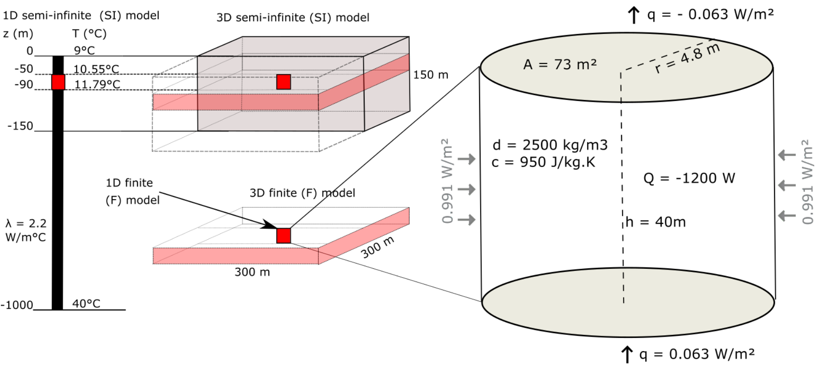

Figure 2: Conceptual models for the heat extraction model from vertical BHE. a) Sketch of the 1D and 3D numerical models developed in this study. b) Heat balance around the vertical BHE determined from mathematical models. The thermal state of the models is defined by an initial steady-state temperature gradient of 0.031°C/m and an average effective thermal conductivity of =2.2 *W/m*2. The heat flux entering the system from below equals the flux coming out at the surface through purely conductive heat transfers.

### Solar energy

In the upper 10-25 m below the surface, the effective ground temperature highly depends on the surface climatic conditions such as the air temperature, the amount of solar radiation absorbed by the soil and the longwave radiation emitted from the ground, the wind velocity or the evapo-transpiration processes (Hein *et al.,* 2016). All of these factors tend to determine the amount of heat transmitted between the surface and sub-surface and warm/cool the ground down to a depth that mainly depends on the ground conductivity. Due to the delayed response of the sub-surface to a heat pulse at the surface, the ground will tend to be warmer than the air in winter and colder than the air in summer, impacting the direction of the heat fluxes down to the depth of influence of these seasonal fluctuations.

The damping depth (i.e. depth of influence of yearly surface temperature variations can be calculated as followed (Ozgener *et al.,* 2013):

(4)

Where is the period of oscillations and is the rock thermal diffusivity, with:

(5)

(6)

(7)

In this interval, the ground temperature is about 1°C higher than the yearly average surface temperature (Rybach and Sanner, 2000). Such effect has also been described by e.g. Westaway and Younger (2013) and Busby et al. (2015) as a potential response of the ground to long-term and high-amplitude perturbations caused by paleo-climatic warming and cooling cycles. In such a scenario, the temperature gradient might not have reached equilibrium since the last Ice Age (Baltrami *et al.,* 2017). Although vertical BHEs are not directly harnessing solar energy in the same way as shallow horizontal BHE, here we attempt to quantify the impact of downward surface heat flux on the upper part of the geothermal gradient and thus on the available surface heat recharge to the BHE.

In Edinburgh, the yearly average rate of insulation (i.e. amount of solar radiation per square meter) is about ~2.3 kWh/m² per day, which is about 94 W/m². The minimum and maximum insulation rates obtained from a 10-year average were obtained in December and June, with values of 13 W/m² and 181 W/m², respectively (Whitlock *et al.,* 2000). Due to the low diffusivity of soil, the reflection of solar radiation and all the processes mentioned above, it is expected that the net incoming shortwave radiation into the ground only equals 10s of *W/m*2 (Banks, 2008). Assuming that among the 40% of the solar energy absorbed by the Earth (i.e. with 60% being reflected by the atmosphere), 70% is reflected by the ground surface and 30% penetrate in the ground surface. The average solar recharge to the ground is therefore reduced to per day, in accordance with the amplitude of conductive heat flux values calculated by Larwa (2018). However, unlike the geothermal flux, solar flux is not continuous over time and highly depends on the relative temperature difference between the ground and the air (i.e. Larwa, 2018). To account for the effects of cyclical heat recharge and possible energy losses at the surface during cold periods, we scale up the solar recharge to the ground based on the sunshine hours in Edinburgh. Using an average of 1380 h of sunshine per year, that is about 16% of the time (i.e. ), solar flux can be scaled up to 1.8 W/m². Considering a surface area of 73 m², this indicative study shows that the total solar energy recharging the ground over the considered area equals represents a heat recharge of ~ 4.1 x 109 J, that is less than 11% of the energy of consumed by a single house in the UK in one year.

In cities, the Urban Heat Island (UHI) effect responsible for higher temperatures in city centre is becoming more significant in the UK with increasing mean air temperature and heat waves (Hathway and Sharples, 2012). Such effects include the increase in solar absorption caused by the presence of dark surfaces with low albedo and the reduced cooling of the ground via evapotranspiration from vegetation and porous ground. UHI results from the increased use of manmade materials and anthropogenic heat production (Mohajerani *et al.,* 2017). In summer, black asphalt pavements that have low albedo and high thermal absorption and conductivity have temperatures above 60°C (Hathway and Sharples, 2012). Using land-surface temperature calculations from Landsat satellite image acquired in June 2019, we show that the average temperature in Edinburgh/Glasgow is about 6°C higher than the average countryside temperature (~18°C). In cities, UHI effect is therefore likely to provide a constant additional surface heat recharge to BHE.

### Radial heat recharge

Results from our mathematical model suggests that a steady-state geothermal heat flux of 0.063 W/m² can provide only less than 0.5% of the energy consumed in one year, considering a 73 m² area around the borehole (Fig. 2). Adding solar heat recharge at a rate of 1.8 W/m² would contribute to recharging the system up to 11.5% of the heat extracted for an individual UK house over a year. For this indicative study, we assume that radioactive heat generation is negligible in the sedimentary system considered. This shows that heat balance cannot be naturally reached in the ground considering those geological and climatic conditions, and thus additional heat is to be mined from the rock surrounding the borehole, inducing lateral heat fluxes.

We first quantify the lateral heat flux for a scenario where heat recharge is provided by the geothermal heat flux only. Over 1200 W required by the BHE, the heat balance suggests that 1195 W needs to be mined from surrounding rocks. Using a borehole length h = 40 m, the lateral heat flux at a distance r = 4.8 m from the borehole would be in the order of *W/m*2 (Fig. 2.4). This radial heat flux is about 16 times the estimated geothermal heat flux and, which may have a major impact on the areal footprint of heat extraction. It is however important to note that this model ignore the contribution from axial recharge (i.e. from above and below the borehole depth interval) and therefore represent a conservative value. In a case where the geothermal and solar heat flux contribute to recharge up to 11.5% of the heat extracted is recharged (i.e. 5 W geothermal and 131 W solar), the lateral flux would be reduced to m². This is still 14 times the geothermal recharge but half the solar heat recharge. However, this first approximation of the heat balance ignores the potential increase in the heat flow at the atmosphere-ground surface interface due to cooling of the area. Although such contribution might be important within the long-term as the effects of heat extraction reach the surface, it depends on a number of parameters (i.e. depth of the borehole, ground conductivity) described in further details in Supplementary Material SM 2 and are only trivial for this one-year heat balance approximation.

We therefore perform numerical simulations to better assess the contribution from vertical and lateral heat recharge in the sub-surface using 1D and 3D models.

# Numerical model

We use the OpenGeosys finite element modelling software (i.e. Kolditz *et al.,* 2012; Chen *et al.,* 2019) to simulate temperature change and calculate the heat fluxes induced in the subsurface due to heat extraction from a 40-m long BHE. The relative contribution of solar and geothermal recharge is first described using a 1D model, and lateral heat fluxes are then quantified using 3D diffusion models. Results are used to validate the mathematical models against the volume of accessible rock. We finally use our analysis to quantify the footprint area affected by heat extraction and assess the optimal production scenarios leading to the minimum thermal impact on the ground.

## One-Dimensional Model

We first model the Borehole Heat Exchanger (BHE) as a vertical finite line source embedded within a 1D semi-infinite (SI) model composed of 10 000 elements, 0.1 m in length. To keep the problem simple, the profile is treated as a homogeneous porous medium with a specific heat capacity of 950 J/Kg°C, a density of 2500 *kg/m*3 and a thermal expansion coefficient of 1 × 10−5 °*C*−1. The initial steady-state temperature distribution along the model follows a gradient of 0.031°C/km, with a surface temperature of *T*0 = 9 ◦C corresponding to the average yearly air temperature in the Glasgow area in Scotland, and a bottom temperature *Tz* = 40 ◦C at z = 1000 m. Heat transfer in the ground is assumed to occur only by conduction, with an effective thermal conductivity 2.04 W/°K.m corresponding to the average conductivity of a typical column of dry rock in the Midlothian Coalfield filled with static pore-water (SM 1). A preliminary analysis of the contribution of radiogenic heat generation on the geothermal profile indicated that for an average RHP production of 1.217 µW/m3, the total temperature increase is only 0.0004°C after 30 years. Due to this low contribution, we neglect RHP in the followings.

## Axial effects

Many studies involving the numerical modelling of heat transfer around vertical BHE have assumed isothermal boundary conditions, where the surface temperature represents the yearly average air temperature (i.e. Zhao *et al.,* 2020). Some authors however underlined the importance of setting heat flux (i.e. Neumann) boundary conditions rather than a constant temperature (i.e. Dirichlet boundary) at the surface (Saadi and Gomri, 2017). Erol et al. (2015) explained that during production, the temperature distribution around BHE is not equal to the undisturbed ground temperature from the surface to the bottom, and axial effects (i.e. vertical heat transfers) become important at both ends of the borehole. Setting a Neumann boundary condition would therefore enable temperature decline at the surface due to heat extraction from the ground, and therefore avoid overestimating available recharge.

To realistically assess the heat recharge through the ground surface, Singh and Sharma (2017) expressed heat conduction through the surface boundary as a general convective heat transfer boundary condition. An effective surface temperature accounting for both convective and conductive heat transfers between the ground surface and the air was calculated from the ambient air temperature, the solar radiation and the wind speed, and used to derive the time-variant first type boundary condition on an hourly basis. We here suggest to quantify the heat flux at the surface by finding the amplitude of the variations that reproduced the soil temperatures measured in Scotland under the ground characteristics defined by the 1D model described above without calculating the complex energy balance between the air and the ground surface. Using Eq. 8, we calculate a series of curves representing the daily heat flux values for different signal amplitudes, that are used as source terms for the Neumann surface boundary condition of the 1D heat model.

(8)

where Q is the average daily heat flux, t the period of fluctuation (366 days), ∆*t* the time increment (86400 seconds, i.e. one day) and A the amplitude of the variations. The parameter q corresponds to the geothermal heat flux of 0.063 W/m² used as bottom boundary condition to the model, and is added to ensure that the yearly average energy balance is maintained over the long term. For each scenario (i.e. values of A), we simulate the change in temperature in the model for a period of 100 years.

By comparing the measured soil temperatures with the surface temperatures obtained from the different modelling scenarios (Fig. 3.), we show that the yearly temperature change in Scotland can be best simulated for a heat flux input of amplitude A = 8.4 *W/m²*, using 2.04 W/°K.m, which corresponds to the amplitude of the variations of the recorded soil temperatures at the Paisley station.

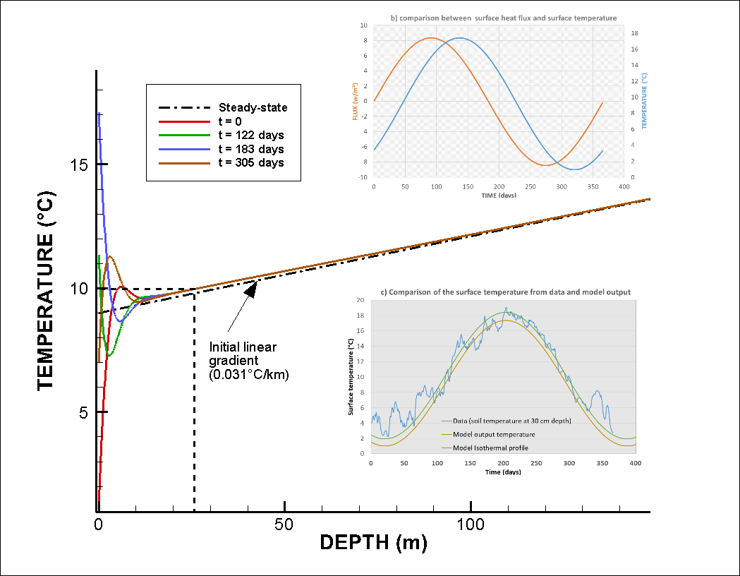

Figure 3: a) Input surface heat flux for the time-varying surface boundary conditions (black line) and output surface temperature time series (z = 0 m) for A = 8.4 *W/m*2. b) comparison between surface heat flux and surface temperature. The temperature change is delayed compared to the heat pulse imposed at the surface. c) Comparison between the data and model output surface temperature. The data used correspond to daily soil temperature measured in 2000 at 30 cm depth at the Paisley station, Glasgow (source: UK Meteorological Office). Results show a better match for the summer data compared to the low winter temperatures.

Results of a 100-year simulation period with no heat extraction moreover indicates that the fluctuating surface heat flux tends to disturb the upper part of the temperature gradient. The depth of influence of the yearly surface temperature variations is at about 27 m, in accordance with the damping depth predicted by the equations given in Ozgener (2013). At that depth, the ground temperature is about 10°C, that is about 1°C higher than the modelled yearly average surface temperature of 9.2°C (i.e. reflects the average air temperature of 9.4°C measured at Paisley). Below that depth, results indicate a slight shift in the initial linear temperature gradient toward higher temperatures down to 150 m depth (see difference between dashed black line and solid lines in Fig. 4.c). A new equilibrium between the fluctuating surface heat flux and the geothermal heat flux is reached after ~80 years of simulation.

We then simulate heat extraction along the 50-m long BHE situated between 40 and 90 m depth in the 1000-m long 1D semi-infinite medium. Different scenarios aiming at quantifying the relative contribution of solar and geothermal heat flux on the recharge potential are simulated, using 1) constant surface temperature and bottom heat flux of 0.063 W/m², 2) constant surface and bottom heat flux boundaries of −0*.*063 *W/m*2 and 0*.*063 *W/m*2, and 3) constant bottom heat flux of 0.063 W/m² and the fluctuating surface heat flux boundary described above. After verifying that steady-state conditions are maintained for each scenario (i.e. simulations without heat extraction), we simulate temperature change due to a 1-year and a 30-year period of heat extraction from a line source with areas of 73 *m*2 and 2200 *m*2, respectively. For each scenario, the heat load corresponds to a constant source term of -1200 W equally distributed along the 40-m long BHE section.

In addition, we simulate heat extraction within a 40-m long finite (F) line source model. This model corresponds to the finite section of the 1200-m long BHE model situated between 50 and 90m depth, where the temperature is initially at 10.2 and 11.8 °C, respectively. This is done to isolate the borehole from potential axial (vertical) diffusive heat recharge from rocks situated above/below, and verify the temperature change predicted by the analytical solutions.3D model and lateral heat flux

Line source models can be used to study in an efficient way steady state conditions (i.e. the overall temperature change in the system) and one-dimensional (1D) heat transfers (i.e. vertical or axial heat fluxes). However, 1D models only give a few insights on the temperature distribution around the borehole, which is assumed to vary uniformly, and for each element the temperature change will be highly dependent on the model area. To study lateral heat fluxes induced by the heat extraction from the 40 m long BHE and the extent of the effect of heat extraction, we therefore set up a three-dimensional model whose properties and thermal state are equivalent to the 1D model previously described.

The 3D models consist of a 300 m large, 300 m long and 150 m deep block composed of 5000 prismatic elements. The borehole is situated in the centre of a cylindrical volume between 50 and 90 m depth. This cylinder has a radius of 26.5 m (i.e. radius of the area required for a 30-year extraction period, as calculated in section 2.3.1) and defines a zone with a high-resolution mesh. The size of the elements increases from 2 m inside the cylinder and up to 20m at the lateral boundaries of the 3D block. The vertical resolution of the model is of 1 m within the borehole depth interval and of 4 m elsewhere. As for the 1D models, we create a 40-m thick 3D model consisting of a finite vertical line source embedded in a 300-m wide and 300-m large volume (Fig. 2), in order to estimate the radial heat fluxes to the borehole. In the 3D models, we simulate heat extraction at the borehole at a rate of -1200 W for a period of 30 years with yearly time steps, considering constant heat flux of +/- 0.063 W/m² at the upper and lower boundaries and no-flow laterally.

# Results

## Temperature profiles and time-series

Results from the 30-year simulations of heat extraction in both 1D and 3D models indicate an overall energy change of ~ ΔE = 1.14 × 1012 J that equals the heat load of -1200 W extracted constantly from the BHE for 30 years, suggesting the lack of recharge from the geothermal heat flux (0.063 W/m²) during that time interval. Fig. 4 shows the temperature profiles extracted from the 1D and 3D models after 1 year and 30 years of heat extraction. Assuming that 1D models represent the far field conditions, we compare the temperature profiles extracted at distances x = 4.5 m and x = 26.5 m from the BHE in the 3D models to the temperature distribution in the 1D 73-m² and 2200-m² models after 1 and 30 years of heat extraction, respectively.

The temperatures profiles from the 1D 40-m long finite model with constant heat flux boundaries (dark blue line) first confirm that the extraction of a heat load of 1200 W induces a uniform temperature decline of 5°C along the borehole for both simulation periods, in accordance with the mathematical model. The Gaussian-type temperature distribution along the semi-infinite model (light blue line) however suggests that part of the heat is sourced from the areas situated above and below the borehole. Although axial recharge to the borehole is limited to a ~15% within the first year (i.e. comparison between the difference in temperature at the mid-borehole depth in the 73m² finite and semi-infinite 1D models), this effect is prominent after 30 years of heat extraction (2200 m² model), where the temperature decline at the mid-borehole in the semi-infinite model () is only ~60% of the temperature decline in the corresponding finite model (= 6.2°C).

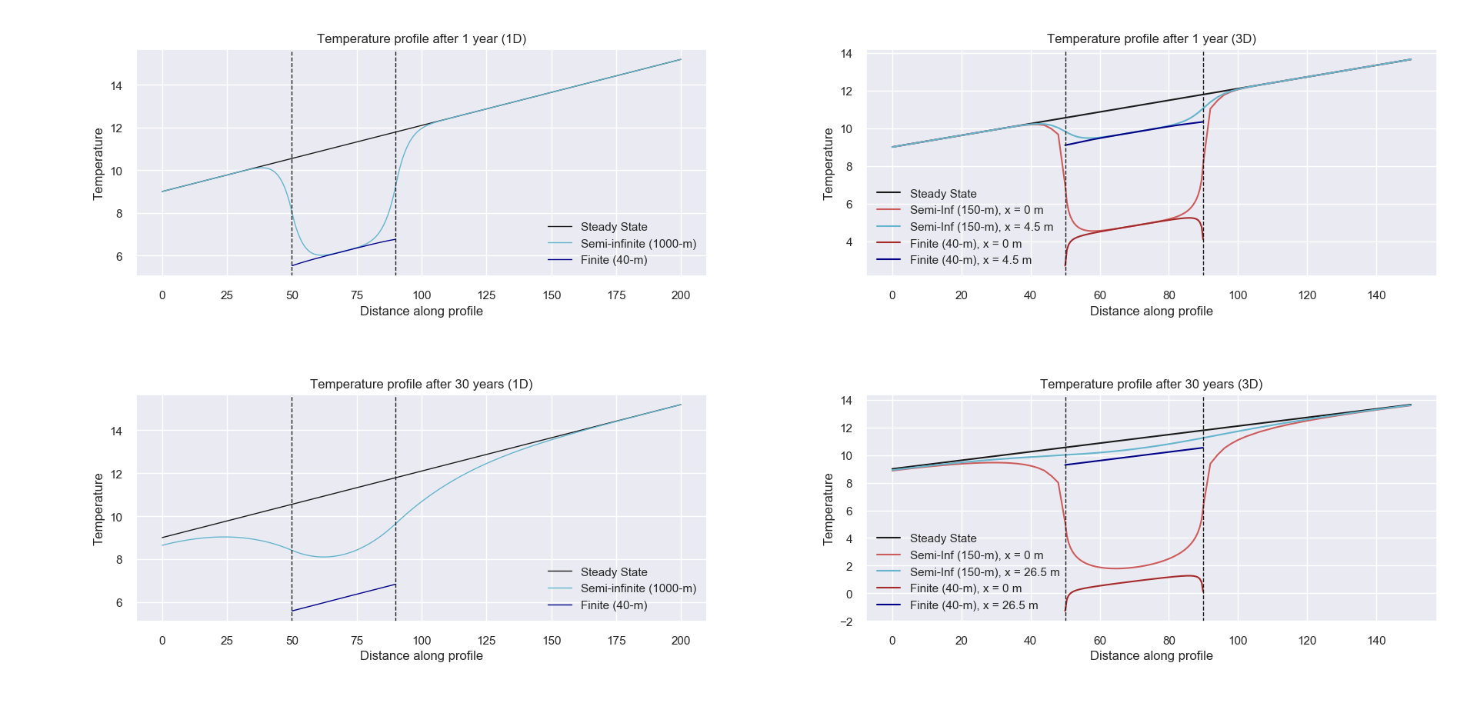

Figure 4. Temperature profile obtained for a) the 1D 73-m² models and b) the 3D models after 1 year of heat extraction, and for c) the 1D 2200m² models and d) the 3D models after 30 years of heat extraction. In the 3D models, the data are extracted from vertical profiles situated at the borehole location x=0 (red profile) and at a distance x=4.5-m (1-year) and 26.5-m (30-year) away from the borehole (light blue profile). Those distances correspond to the radius of the area for the corresponding 1D model (73-m² and 2200-m²). The black profile corresponds to the initial temperature gradient of 0.031°C/km.

In the 1D finite model, energy is extracted from all the model elements at a constant rate throughout the simulation period. Due to the absence of axial recharge and lateral special discretisation, this results in a linear temperature drop from the onset of production (-0.17°C/yr), displayed in the temperature time-series plots in Fig. 5. In the 1D semi-infinite model, although the lack of lateral discretisation also results in a homogenous temperature decline over the model area, the axial effects permit a progressive reduction in the drawdown rate (i.e. down to about -0.07°C/yr after 20 years) that explain the lower temperature drop observed at the borehole location after 30 years. This suggests that although most of the heat is mined at the borehole location in the first year, the contribution of axial recharge becomes essential in the following years.

On the contrary, time-series extracted from the 3D models demonstrate a logarithmic decrease in temperature in the early stage of production. At the borehole location, the temperature decreases by -6.2°C during the first year, followed by additional of -4.6°C (finite model) and -3.6°C (semi-infinite model) in the 29 following years. The reduction of the drawdown rate over time (Fig. 5) suggests contributions from radial and/or axial recharge (i.e. semi-infinite model only) as the production time increases. After ~10 to 20 years, depending on the distance to the borehole, the temperature in the 3D models decreases at a quasi-linear rate of -0.035°C/yr ± 0.015°C/yr near the borehole (x < 4.5 m) and -0.028 ± 0.012 at x = 26.5m.

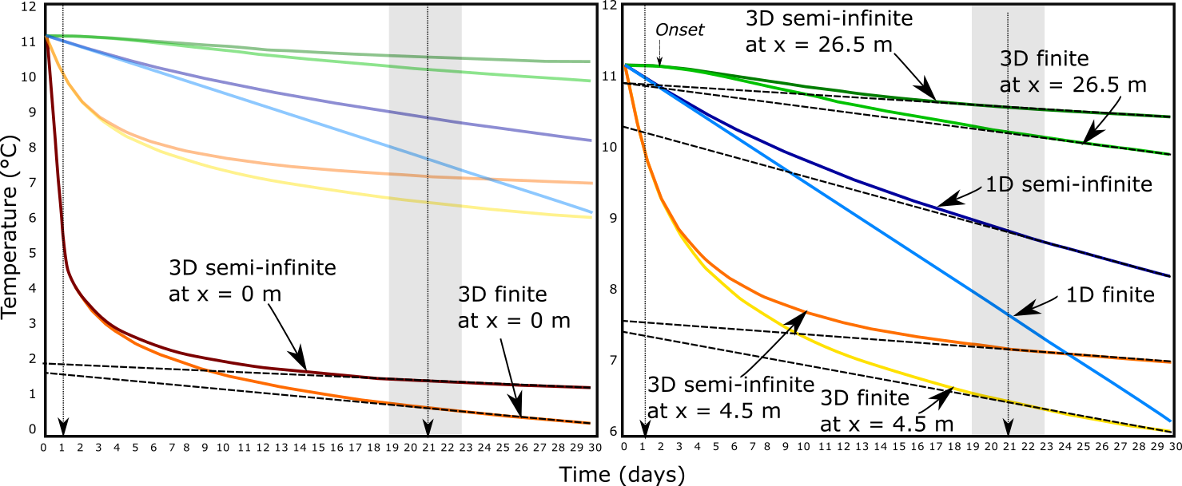

Fig 5. a) Temperature time-series extracted at 70 m depth (mid-borehole location) from the 1D 2200-m² and from the 3D models. The vertical dashed arrow and surrounding shaded area represents the onset of the constant rate of temperature decline for the 3D model and the interval of uncertainty. Lateral discretisation in the 3D model results in a delayed drawdown at 26.5 m, observed after 2 years of production.

Although the high extraction rate at the borehole location prevents efficient axial recharge at x = 0 m (i.e. only ~10% after 30 years, where a temperature difference of only ~1°C is measured between the finite and semi-infinite profiles at the mid borehole depth), the difference in the mid-borehole temperature measured at x = 4.5 m and 26.5 m in the finite and semi-infinite 3D models indicate that the axial recharge is in the range of those observed in the corresponding 73-m² and 2200-m² 1D models after 1 and 30 years of production, respectively (i.e. ~15% after one year and ~60% after 30 years, respectively).

The early high-amplitude drawdown at x = 0 m in the 3D models suggests that most of the heat required by the BHE is mined from the area close to the borehole during the first year. After 30 years of production from the semi-infinite 3D model, the high amplitude of the drawdown at the borehole location (ΔT = 9.8°C) relative to the drawdown at x = 4.5 m (ΔT = 4.1°C) and x = 26.5 m (ΔT = 0.7°C) suggest the existence of a depression cone resulting from the effects of lateral discretisation.

## Axial recharge

We calculate the difference between the relative energy change in the BHE interval and the surrounding rock volume at each time step to determine the relative contribution of axial recharge in the 1D SI models. Results displayed in Fig. 6 confirms that within the first year of production, only ~15% of the energy is source from the area situated above and below the BHE, for both 73-m² and 2200-m² models. After 30 years, the axial effects in the 2200-m² model contribute to ~60% of the heat recharge to the borehole. This shows that the amplification of axial effects over time allows reducing the temperature drop at the borehole predicted by the finite BHE model, depending on the heat available within the borehole depth interval.

The importance of axial effects had already been noted by Marcotte et al. (2010). In their study, the authors examined the axial effects in vertical BHE by comparing numerical results obtained from the finite and infinite line source methods. In the finite line source model, a constant temperature boundary condition is applied at the surface to account for axial conduction effects (Zeng *et al.,* 2002; Bandos *et al.,* 2009). Axial effects were suggested to be important for short boreholes, permitting downsizing of BHE.

Although 1D models allow a simple estimation of the average temperature change in a given volume of rock, they cannot inform on the temperature distribution around the borehole, and thus on the area of impact in the long term. We therefore use 3D models to get a better insight on the areal impact of heat extraction.

## Three-dimensional study of radial recharge

From the 1D analysis, we have shown that axial effects tend to provide additional recharge to the system, reducing the temperature drop at the borehole predicted by mathematical analysis by increasing the vertical footprint of heat extraction (i.e. semi-infinite line source). We here use the 3D finite model to account for the effects of radial heat recharge and quantify the areal impact of heat extraction from vertical BHE over time, considering a homogeneous porous medium with no water flow. Assuming that 1D models represent far field conditions, we calculate the energy change within the finite volume of rocks situated at distances x < 4.5 m, 4.5 m < x < 26.5m and x > 26.5 m from the borehole (Fig. 6) to determine the relative contribution from radial heat recharge to the borehole. Those distances correspond to the radii of the areas required for BHE utilisation after 1 and 30 years of heat extraction (73-m² and 2200-m²), respectively, and used in the 1D analysis.

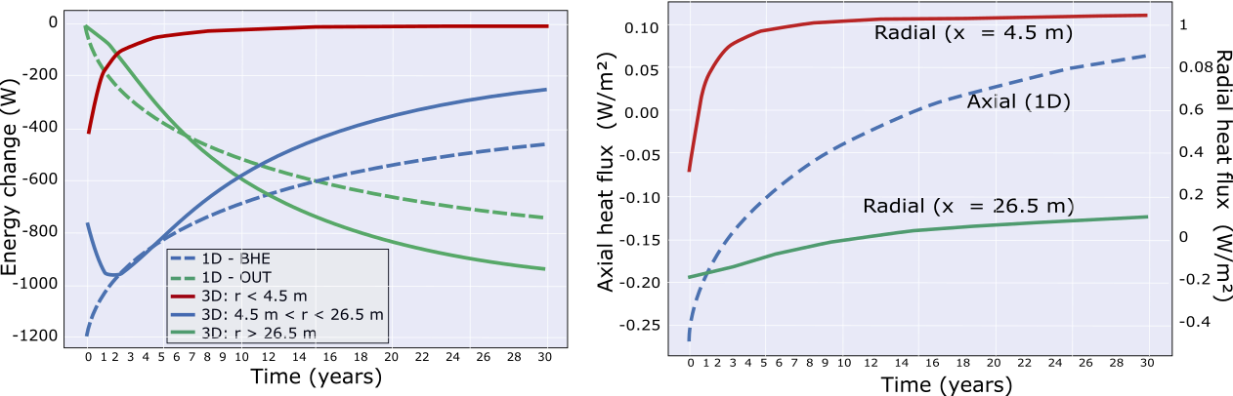

Fig. 6. a) Time-series of energy change showing the relative contribution from the different parts of the 1D semi-infinite (dashed lines) and 3D finite models to the heat mined from the borehole. b) Axial and radial heat fluxes at the volume interfaces from the 1D and 3D models, respectively, calculated from the relative energy change in each volume and the surface area of the interfaces.

Results indicate that when no axial recharge is allowed (finite model), ~30% of the heat is mined from the area surrounding the borehole (x < 4.5m) within the first year, suggesting a recharge from lateral areas of ~70%. About 95% of the energy is mined from the area comprised in x < 26.5 m. After 30 years, about 75% of the recharge is provided by the volume of rock located at x > 26.5 m. At x = 4.5 m, the radial heat fluxes are reach a steady rate of ~1.00 W/m² after ~10 years (Fig. 6), in accordance with the analytical solution presented in section 2.3.3. The contribution from radial heat recharge moreover explains the relative temperature differences between the profiles extracted from the finite 3D model at x = 4.5 m and x = 26.5 and the corresponding finite 1D models after 1 year (73-m² model) and 30 years (2200-m² model). Based on the contribution from axial fluxes calculated numerically in section 4.2, we finally calculate that in a semi-infinite volume, axial and radial heat fluxes account for 15% and 60% of the recharge during the first year (i.e. within a 73 m² area), and for 60% and 30% after 30 years (i.e. within a 2200 m² area), respectively. This suggests that although the footprint area keeps expanding after 30 years, most of the heat is mined through axial (vertical) heat recharge.

## Heat fluxes and footprint area

To verify this hypothesis, we calculate the absolute vertical and horizontal heat fluxes across a 2D temperature profile extracted at different time steps from the 3D semi-infinite model (Fig. 7).

Results indicate that as the production time increases, the 3D model allows the mining of heat further away from the borehole though an expansion of radial heat transfers. Although the amplitude of the radial heat fluxes stabilizes at about 10 years of production, the lateral expansion of the volume of rock depleted in heat participates to an increase in the vertical temperature contrasts away from the borehole, enhancing the axial fluxes. Fig. 7 shows that the area contributing to the downward heat fluxes induced by heat extraction keeps expanding over time above the borehole, suggesting a lack of recharge at the surface and an insufficient upward geothermal heat flux. This heat mining effect at the near-surface is amplified by the proximity of the borehole to the top boundary of the model, that restrict axial heat recharge to the borehole and makes it sensitive to the boundary condition used (i.e. constant heat flux).

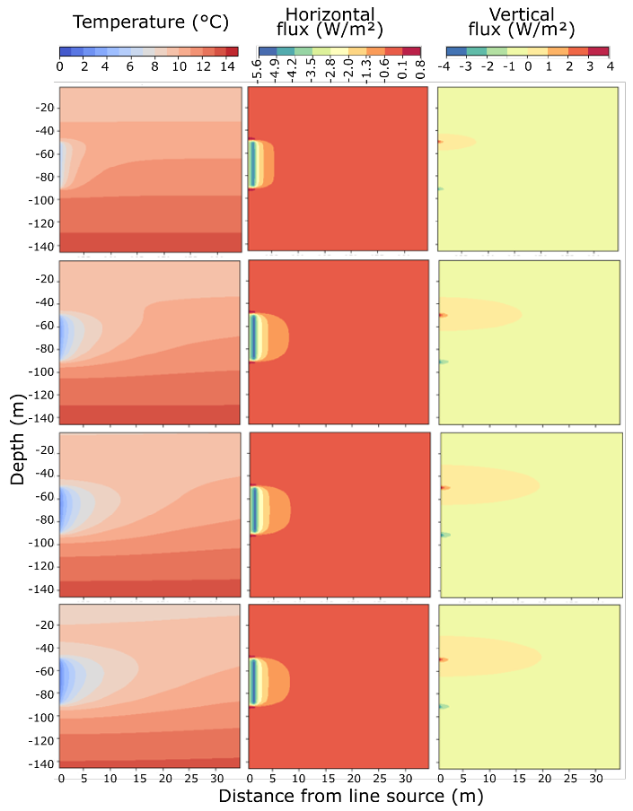

Figure 7: 2D section in the central part of the 3D model showing the vertical and horizontal fluxes after (a) one year (b) 10 years, (c) 30 years and (d)100 years

We use results from the 3D models to measure the radius of the area impacted by heat extraction around the borehole over time. The drawdown is measured after 1 and 30 years of heat extraction along two horizontal profiles situated at the near-surface (z = -1 m) and at the mid-borehole (z = - 70 m). For both profiles, the assessment of the lateral extent of the drawdown is based on a temperature decline of 0.1°C relative to the undisturbed temperature at the same depth. Fig 8 shows that for both finite and semi-infinite models, heat extraction from the BHE in a homogeneous medium with heat conductivity of 2.04 W/°C.m reaches a radius of influence at the mid-borehole depth of ~13 m after 1 year and of ~64 m after 30 years. This represents a total footprint area of ~15 000 m², that is in the order of magnitude higher that the required area calculated from analytical approaches. At the near-surface (z = -1 m), the areal impact of heat extraction from the SI model is ~20 m after 30 years (i.e. 1200 m²). However, the temperature there does not decline by more than 0.2°C.

This larger footprint area in the 3D models relative to the footprint predicted by 1D models after 30 years (i.e. shaded green area in Fig. 8) results from the combination of the discretisation effects (i.e. delayed propagation of the heat pulse away from the line source) and from the small threshold used to delineate the cone of depression (i.e. 0.1°C rather than 5°C in the 1D models). However, results suggests that constant heat extraction from BHE with limited geothermal heat recharge such as the UK can lead over the long term to ground temperature disturbances over large areas (i.e. about 20 times the surficial area of a single UK house at the surface and 200 times at depth), which can cause both environmental and engineering issues (i.e. interferences)

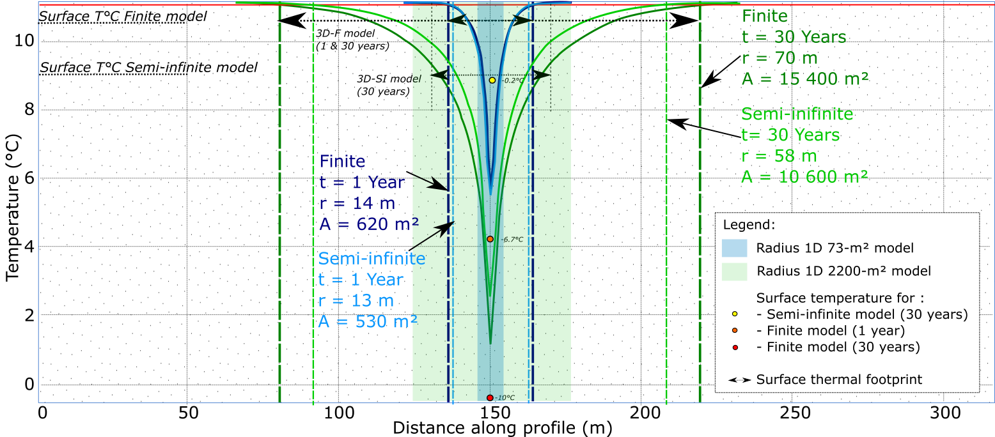

Figure 8: XZ temperature profiles obtained from the full extent 3D model after 30 years of heat extraction. The vertical light blue profile shows the temperature distribution at x = 26.5 m and the dark blue and red profiles represent the temperature distribution at y = 0 and y = -70 m.

## Solar variations effects

It has been shown from previous studies that solar effects are particularly important when studying the efficiency of borehole heat exchanger when those extract heat from shallow depth, i.e. in the zone of influence of the yearly fluctuation in solar flux (Fig. 3). In our example, the effects of yearly oscillations in the surface heat flux reached ~25 m depth and therefore do not directly impact the BHE. Below that depth, the interaction between the surface and geothermal heat fluxes however tend to disturb the steady-state temperature profile (i.e. Baltrami *et al.,* 2017), creating a new equilibrium where the upper part of the geothermal gradient is shifted toward higher temperatures down to 150 m depth (Fig. 3). This suggests a decrease in the geothermal heat flux in the borehole depth interval (50 – 90 m) that might favour recharge from above.

As production time increases, our previous 1D modelling analysis showed that the layer of rock depleted in heat expands vertically from the BHE depth interval, amplifying axial fluxes. The effects of axial recharge reached the surface after ~6 years (Fig. 3d), where the surface temperature started declining. We therefore compare the temperature profiles below 25 m depth and calculate the energy change in the system after 30 years of heat extraction using constant and fluctuating surface heat flux to assess the potential effects of fluctuating surface heat flux on the recharge to the system. To avoid overestimating the recharge due to the transient state of the geothermal gradient seen when using fluctuating heat flux, we use the profile obtained after 100 years without heat production as initial state to the heat extraction model.

Results from a 30-year simulation of heat extraction from the 1D 2200-m² semi-infinite model shows that the overall decrease in the energy content in the system is reduced by 10% when using a fluctuating surface heat flux boundary (i.e. after correction for the effects of solar fluctuation on the energy content). In a scenario with constant surface heat flux, the average rate of energy decline over 30 years is 4.8 kWh/yr, against 4.3 kWh/yr for a scenario with a fluctuating surface heat flux. Although the temperature at the mid-borehole is only slightly affected by the choice of the surface boundary condition (Fig. 8e), the additional heat provided at the surface represents an input available for axial recharge that slightly reduce the amount of mined heat above the borehole (Fig. 8d).

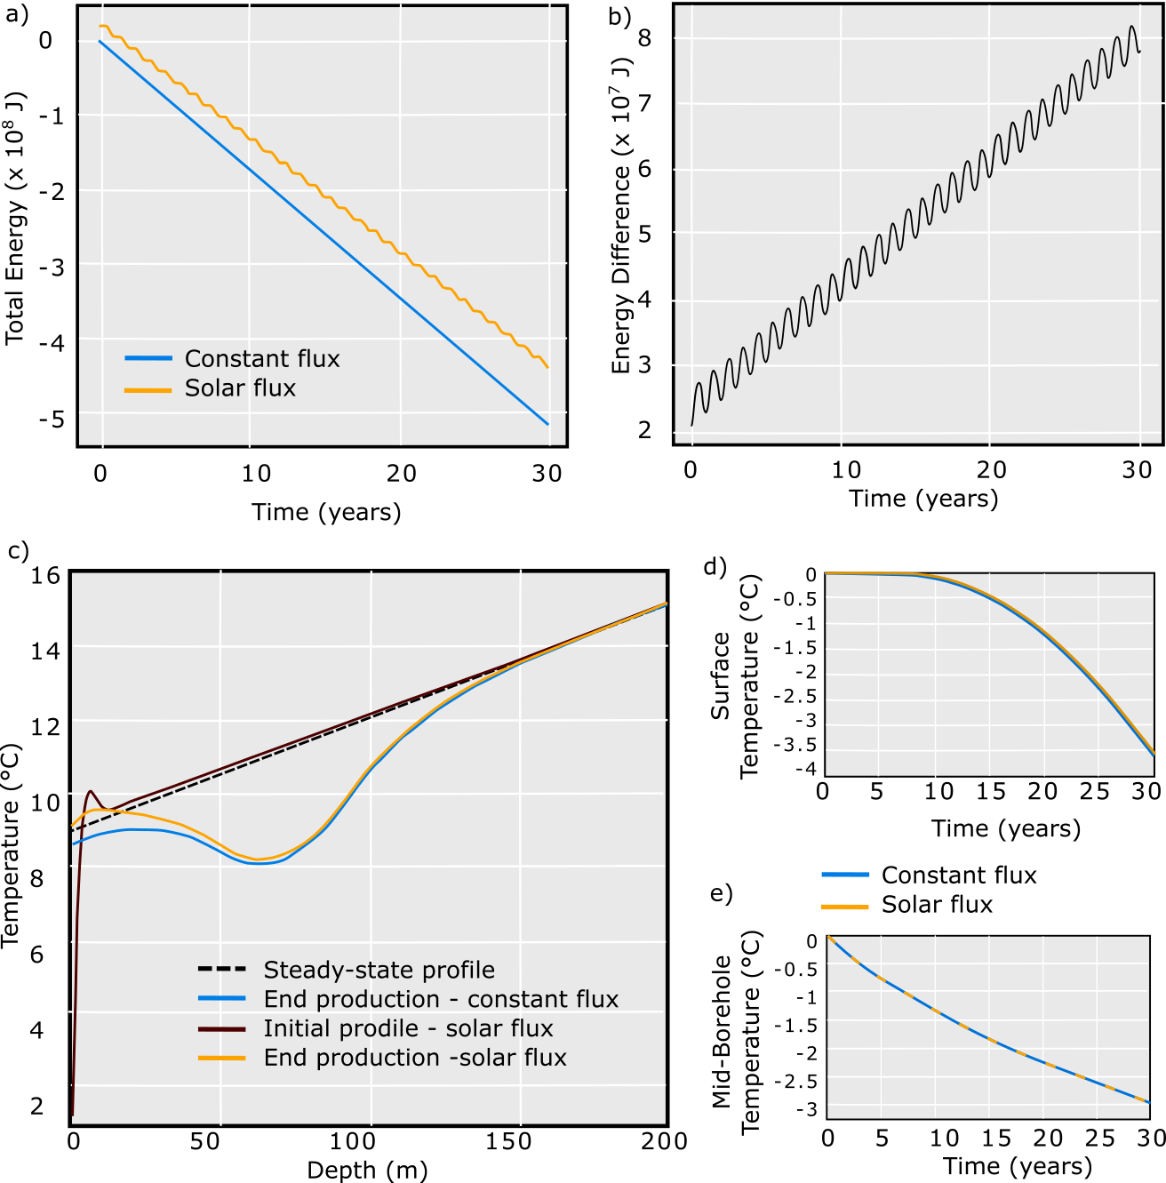

Fig. 9. a) Time-series of energy change from the 1D 2200-m² semi-infinite model with constant and fluctuating surface heat flux, b) difference in energy change between the two models, c) initial and final temperature profiles and surface temperature (d) and temperature at the mid-borehole corrected for the effects of solar fluctuations (i.e. fluctuating surface heat flux model) after 30 years of heat extraction.

Here, the effects of surface heat flux variations tend to disturb the geothermal gradient, that might not have reached steady-state after the 100-year long simulation without heat extraction, used as initial condition to the production scenario. Therefore, the input of heat at the surface would mostly relate to long-term transient warming (i.e. climate warming) rather than to the effect of yearly fluctuations of solar heat flux. Such effect has already been described for the UK as a source of perturbation for the steady-state geothermal gradient (i.e. Westaway and younger, 2013) . However, further work would be required to properly quantify the amount of recharge provided at the surface due to climate warming, which is beyond the extent of this study.

# Discussion

In the previous sections, we have calculated the volume of rock required to provide energy to a typical average UK house for periods of 1 and 30 years, based on analytical equations allowing a temperature change of 5°C in the system. The required heat load was compared to the available natural recharge in the system (i.e. radioactive heat, geothermal and solar heat flux) for a case study located in the Midlothian Coalfield, Scotland. We then used 1D and 3D numerical models to verify the mathematical model and calculate the amplitude of the axial (vertical) and radial (horizontal) heat flux around the borehole. In addition, we evaluated the footprint area of heat extraction at the mid-borehole and at the surface, in a homogeneous system with a rock heat conductivity of 2.2 W/°C.m.

Although analytical models suggested that natural recharge can only contribute up to maximum of 13% of the heat extracted, numerical models confirmed that most of the heat is mined from the rock surrounding the borehole during the first year. As the production time increases, axial heat fluxes become an essential contribution to the heat recharge (i.e. up to 60%). Results from the 3D analysis show that if heat transfers are not affected by the conditions at the boundaries, steady radial heat flux can be reached after ~10 years, meaning that the temperature will start declining at a constant rate in lateral areas, depending on their distance to the line source (Fig. 5). In response to the expansion of the volume depleted in heat with time, 3D models also showed the expansion of the downward heat flux above the borehole, allowing greater recharge to the borehole. As the extension of the layer impacted by downward fluxes reach the surface, the lack of recharge at the surface in a scenario with constant geothermal heat flux (i.e. -0.063 W/m²) implies that steady axial fluxes cannot be reached above the borehole, resulting in a greater temperature drop. This effect is particularly visible in the 1D models, where the amount of heat available is constrained by the model area and no recharge is provided from lateral areas (Fig. 5). This suggests that as the borehole depth increases, allowing more axial recharge, the areal impact of heat mining would decrease (SM 2). Using a fluctuating surface heat flux representing the yearly fluctuations in the surface temperature, numerical results show that recharge from the surface can be increased by 10%, in accordance with the analytical model presented in section 2.3.2. Such effect was also suggested to result from the transient nature of the temperature profile (i.e. long-term warming).

The model described in this study represents a specific scenario that highly depends on the choice of the geometrical parameters and medium properties. Further analysis aimed at assessing the contribution from 1) the thermal conductivity, 2) model area, 3) borehole depth (i.e. distance from the upper boundary), 4) borehole length (i.e. specific heat absorption rate), 5) production time and 6) thermal conductivity on axial recharge and extent of temperature change in the system is presented in SM 2. A comprehensive dimensionless analysis of the line heat source models in purely conductive media was also performed by Conti et al (2016). The result of the sensitivity analysis presented in SM 2 show that for a given production time the areal impact of heat extraction mostly depends on the thermal conductivity of the rock and on the borehole length, which are inversely proportional to the temperature decline at the borehole. Although increasing the borehole depth favours axial recharge and restrain the drop in temperature at the borehole, this has a limited effect on the areal impact of heat extraction, with a decrease in the radius of the impact area of only 10-m after 30 years (3D analysis). Therefore, considering the axial effect would allow reducing the initial area in 1D model to reach a total temperature drop ΔT = 5°C at the mid-borehole. This is in accordance with the finite line-source analytical approach described in Zeng et al. (2002) and Marcotte et al. (2013).

Increasing the borehole length allows decreasing the specific heat extraction rate from 25 W/m for a 40-m long borehole to 5 W/m for a 200 m long borehole. However, a deep borehole generally represents important investment costs, and therefore improving the thermal conductivity of the medium around the heat exchanger is often seen as a more effective means to access the energy required over the long term and prevent from the accumulation of cold at the borehole (Chen *et al.,* 2020). However, this study highlights the antagonism between the need to ensure the BHE efficiency and the sustainability of a geological resource within a constrained footprint area.

Vertical heat exchanger coupled ground source heat pump systems use the shallow geothermal energy as a heat source or sink for space heating or cooling. As opposed to horizontal ground heat exchangers, they offer an advantage of occupying less land surface area than that of a horizontal ground heat exchanger. However, studies in China (i.e. Li and Lai, 2015; Wang *et al.,* 2012) have warned on the irreversible cooling of the ground caused by yearly imbalances in heat extraction/injection from the ground source heat pump, especially in cold areas where the cooling needs are low and for large-scale systems with long operational periods (Gao *et al.,* 2015). Several studies have showed that sustainable heat extraction and elimination of the cooling load accumulated into the ground can be achieved by cyclic production or through the provision of additional artificial heat recharge during the non-heating season, such as solar thermal energy and industrial waste heat recharge (Cui *et al.,* 2015; Cruickshank and Baldwin, 2016). Experimental studies conducted by Trillat-Berdal *et al.* (2006) showed that the ground thermal loads could be balanced by a system combining a geothermal coupled heat pump and thermal solar collector, when the excess heat not used for hot water heating is injected into the ground, and the heat pump is used in either cooling or heating mode. Cui et al. (2015) performed similar analysis on the performances of seasonal storage of industrial waste heat, by developing a heat transfer model for vertical GHE boreholes with multi-stage series connections.

The analysis presented in Fig. 5 confirmed that although a steady-state temperature can be obtained at the borehole, often interpreted by previous studies as an indication of sustainable system, this steady state situation can hardly be reached away from it in the short-term (< 30 years) given the considered geological conditions (i.e. low geothermal heat flux, cold climate) and production scenario (i.e. constant heat extraction for 30 years). This will result in a high areal impact of heat extraction, that will expand over time if no heat recovery periods and/or cyclical production with periods of injection are performed, causing some interferences and environmental issues.

# Conclusion

The aim of this study was to assess the spatial impact of heat extraction from BHE systems and the sustainability of low-grade geothermal resources. We used simple analytical models to calculate subsurface energy balances in the Midlothian Coalfield in Scotland, considering heat extraction from a 50-m long vertical BHE. One-dimensional numerical models were used to verify the analytical solution and calculate axial recharge. We also extended the models in 3D to assess the effect of lateral recharge and the area of impact of heat extraction. Although previous studies aiming at assessing the long-term performances of BHE systems showed that steady-state production temperature can be reached after a few years of production, we here show that energy balance in the shallow sub-surface (i.e. < 100 m) cannot be naturally reached over the long term and thus steady-state temperature conditions cannot be reached away from the borehole. For a fixed GSHP set up and production period, our study shows that the areal impact mostly depends on the conductivity of the ground. Although high conductivity rocks are generally preferred to avoid a fast cooling at the borehole location and ensure sustainable BHE, it also considerably impacts the extent of heat depletion. In a context where geothermal energy becomes of real interest, constraining the footprint area of heat extraction is essential to avoid interferences.

Through the calculation of the relative contribution from axial and lateral heat flux, we showed that the initial recharge in the system depends on the long-term energy balance between surface and deep geothermal flux (i.e. initial temperature gradient). As the production time increase, the heat is mined further away from the borehole as the heat generated from radiogenic elements and recharged from solar and geothermal flux does not compensate for the heat extracted. Although steady radial flux can be reached after ~ 10 years of production (i.e. constant rate of temperature decline), axial flux tends to increase with depth, with a maximal amplitude at the borehole ends. This effect is amplified as they reach the upper boundary, where the lack of heat input prevents from providing a constant heat recharge to the BHE.

This study confirms that in geographical areas with low geothermal heat flux and low in-situ heat production, cyclical production and/or artificial heat recharge is required to ensure sustainable heat extraction and constrain the footprint area impacted by heat mining. Further work is required to determine the best production scenario required to constrain the footprint area of heat extraction. We will also assess the relative contribution from heat diffusion and convection through the porous medium, using 2D advection-diffusion models with groundwater flow.