# Introduction

Heat demand for domestic and industrial space heating account for about 50% of the energy consumption in the UK. Currently, around 70% of this energy is supplied by natural gas, contributing to about 34% of the Greenhouses Gas Emissions of the country (XXX). Following the Paris Agreement, the UK targeted to reach net zero carbon emission by 2050 through the 2019 Climate Change Act. To achieve this goal, attentions have been focused on the need to decarbonize residential heat and the development of new low-carbon energy sources such as geothermal energy.

Low temperature geothermal heat resources can be accessed and used for domestic space heating and cooling purposes thanks to borehole heat exchanger (BHE) systems (Chen et al., 2019). Different types of closed-loop technologies have been developed to extract the resource from different depth range in environments where no groundwater is available. Among them, horizontal heat exchangers allow accessing the heat down to a ~2 meters below the surface, where the ground temperature mainly depends on the surface conditions (i.e. air temperature, solar radiations). Alternatively, deep vertical BHE can access depth of ~2 kilometres, where the sub-surface temperature profile is mainly controlled by the local geothermal gradient. Deep BHE have been proven to be more performant, as greater and more stable heat energy can be extracted throughout the year, and used to provide heat to district heating network (i.e. XXX). In this study, we focus on shallow vertical BHE, a technology that can be used for hot water and space heating of individual houses (Fig. 1). Those boreholes are usually between 40 and 200 m long and present the advantage of requiring a smaller area compared to horizontal heat exchangers. At that depth, the temperature is assumed to be relatively constant as a result of complex interactions between the solar heat flow coming from the ground surface and the deep geothermal flux, and tends to equal the average yearly air temperature (XXX).

To date, the performances and the sustainability aspects of BHE have been well studied. Many authors used both analytical and numerical models, ranging from one-dimensional BHE model to full 3D subsurface numerical models to assess the long-term performances of such system (i.e. Rybach and Eugster, 2010; Signorelli et al., 2005; Lyu et al., 2017; Zhang et al., 2016; Stylianou et al., 2017; Zanchini et al., 2010; Lazzari et al., 2010). The efficiency of BHE is generally expressed by the system COP that mainly depends on the temperature contrast between the ground and the circulating fluid in the BHE. While XXX and XXX, for example, showed that steady state production temperature can be reached after a few years of heat extraction, XXX warned that unbalanced heat extraction and injection from BHE in cold regions (i.e. due to greater needs in heating relative to cooling) might lead to an extensive cooling of the ground. Injecting excess solar heat energy collected from solar panels in summer into the ground was view by the authors as a potential solution to compensate for the geothermal heat extracted in winter and guarantee the long-term viability of such installations. However, there is still a lack of investigation regarding the extent of the heat accessed by shallow vertical BHE over the long term. This is an important issue in a context where the number of geothermal heat schemes is expected to increase drastically in the next decades, coming along with a need to delineate/license heat resources.

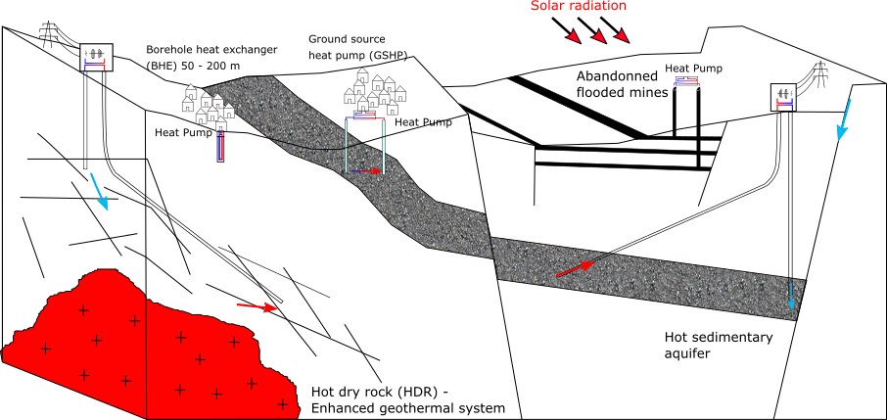

Figure 1: Type of geothermal energy available in the UK. The aim of this paper is to assess the long-term heat potential of the shallow subsurface, based on heat extraction from vertical borehole heat exchanger (BHE). The conceptual model here assumes conductive heat transfers in a dry porous rock without groundwater flow

The objective of this paper is therefore to investigate the footprint area of heat extraction from an individual vertical BHE in the UK, based on different production scenarios. By looking at the impact of heat extraction from a geological resource perspective rather than a BHE performance perspective, we clarify the concept of “steady state” production temperature and show that geological conditions in the UK cannot sustainably provide heat to shallow vertical BHE. Mathematical solutions are used to calculate the volume of rock required to provide the equivalent of a yearly average heat consumption to a single house in the UK, and quantify the amount of heat recharge available in the ground. Heat balance are then verified numerically by performing a series of 1D and 3D heat extraction simulations in a homogeneous porous medium. Results are used to quantify the relative contributions from vertical and lateral conductive heat fluxes providing heat to the borehole over a 30-year extraction period, through heat mining of surrounding rock. A sensitivity analysis performed to assess the key parameters controlling the extent of the heat depletion caused by constant/cyclical production as well as the maximal temperature drop at the borehole. We finally investigate how cyclical production and heat recharge contribute to reduce the impact on the ground. Results indicate that cyclical production with period of artificial heat recharge to the ground is mandatory to both constrain the areal impact of heat extraction on the ground and reduce the temperature decline at the borehole, both inversely correlated depending on the thermal conductivity of the ground.

# Mathematical model

## Borehole Heat Exchanger

Geothermal energy characterizes the heat energy contained in rocks of the Earth’s crust and that can be either used as an energy source for space or water heating, or converted into electricity. Different technologies have been developed to access this energy resource, depending on its depth, on the presence of groundwater, and on the purpose of utilization. Rocks generally get hotter with depth according to the geothermal gradient, and although accessible high-temperature geothermal resources are limited to only a few geographical areas, harnessing the shallow low temperature geothermal resources available worldwide has been of growing interest since the 1980’s. In areas with no available groundwater, the energy contained in the shallow-subsurface can be accessed using vertical Borehole Heat Exchangers. As the total heat content of a rock is intrinsically linked to its temperature, the amount of energy that can be extracted from cooling the rock is expressed as:

*Q* = ∆*T V*(1−*φ*) *ρc* (2.1)

where ∆*T* is the amount of cooling, *ρc* is the volumetric heat capacity of the rock of volume *V* and porosity *φ, c* is the heat capacity, *λ* the heat conductivity, and *ρ* the densityof the material. ∆*T* is generally in the order of 5°C, either representing the temperature difference between the abstracted and injected water in a doublet system or the difference between the inflow and outflow temperature through a Heat Pump in a BHE system. Alternatively, Raymond and Therrien (2008) suggested to use Eq. 2.1 to calculate the heat content of rock sections along a vertical profile, where ∆*T* = *dTdz* ×*z*, with *z* the average depth of the considered rock section and *dTdz* the mean geothermal gradient.

Previous studies aiming at assessing the performances of BHE and Ground-Source Heat Pump systems showed that the efficiency of heat extraction mostly depends on the heat transfer process between the BHEs and the ground. In a purely diffusive medium, it mainly depends over the long term on the thermal conductivity and diffusivity of the ground (i.e. Stylianou et al., 2017; Chen et al., 2019; Choi and Ooka, 2015). The presence of groundwater was suggested to improve the long-term performance of BHE both by increasing the heat exchange rate during production (Zanchini et al., 2010; Stylianou et al., 2017; Wang et al., 2013) and by favouring heat recovery during periods of no production (Hein et al., 2016; Erol et al., 2015). In medium with groundwater circulation, analysis showed that soil heat capacity and thermal conductivity only have minor impact on the sustainability of a GSHP system and that dispersion tends to increase the area of impact of heat extraction. In this study, we want to understand the capacity of the ground to provide and regenerate the heat load required by a single house in the UK, rather than evaluating the performances of extraction of BHE. We will therefore ignore the engineering aspects first by simplifying the BHE to a vertical line source. We will moreover consider that heat is extracted from a purely diffusive homogeneous porous medium, whose characteristics are defined accordingly by a typical geological profile in the Midlothian Coalfield, Scotland.

## Heat load

We first suggest to calculate the volume of rock that would be required to provide the energy requirements for a single house in the UK, which is in the order of 12 400 kWh on average per year, with a maximum of 18 000 kWh in winter and 8 000 kWh in summer (XXX). To satisfy this yearly demand, a heat pump would need to deliver an average heat load *H* = 1415 W by extracting heat from the subsurface. In reality, part of the heat load is supplied by the heat pump in the form of electrical heat *E* that is required for air compression, reducing the energy that needs to be extracted from the ground *G* by an amount that depends on the coefficient of performances (COP) of the heat pump (Banks, 2008).

*G* = *H* (1− 1/COP) (2.2)

Using a COP of 3.4, the average heat that would need to be extracted from the ground to satisfy a total heat demand H = 1415 W is therefore reduced to G = 1000 W. This corresponds to a total energy Q = 3*.*15×1010*J* over a year. Considering a dry solid rock mass with a porosity *φ* = 0*.*1, a density of *ρ* = 2500 *kg/m*3 and a specific heat capacity of c = 950 *J/kg.°C*, the volume of rock *V* = *V*(1−*φ*) required to provide this energy by cooling the rocks by ∆*T* = 5◦*C* is about 2800 *m*3, according to Eq. 2.1. Assuming that the heat is extracted radially from a borehole with a length h = 40 m situated in the centre of a cylinder, the radius of this cylinder would be 4.8 m, corresponding to a surface area of about 70 *m*2. The specific heat absorption from the rock, as defined by Banks, (2008) would therefore be  = 25 W/m. Over a 30-year operation period (*Q* = 9*.*47×1011*J*) and considering that no recharge occurs, an area of 2200 *m*2 would be required (r= 26.5 m), corresponding to a rock volume *V* = 8*.*9×104 *m*3.

## Heat recharge

Sustainable heat production from BHE is achieved when the heat load extracted is balanced by heat recharge in the subsurface. We therefore here attempt to quantify the rate of heat production in the subsurface as well as the potential recovery rate from solar and geothermal heat flux, based on a typical temperature and geological profile in the Midlothian Coalfield in Scotland.

### Geothermal heat flux

The Earth’s natural heat flow is broadly attributed to a contribution from the primordial heat inherited from the formation of Earth and from the natural decay of radioactive element, typically of the isotopes of uranium (238U, 235U), Thorium (232Th) and potassium (40K) (Pollack and Chapman, 1977). Due to geochemical differentiation, partial melting and magma crystallization processes, the upper crust is generally enriched in heat producing elements (Beamish and Busby, 2016) and their distribution can provide an important control on the temperature distribution within the earth lithosphere (Sandiford, McLaren, et al., 2006). A combined determination of the conductive heat flow and radiogenic heat production (RHP) is therefore here suggested to better constrain the thermal field within the study area (i.e. Jaupart and Mareschal, 2005).

The Midlothian Coalfield is situated in the south east of the Midland Valley of Scotland (MVS), a 80 km wide, 150 km long WSW-ENE trending Carboniferous graben extending across Scotland (Browne et al., 1999; Underhill et al., 2008). It is located in a geologically stable part of Earth’s crust, where only granite intrusions would contain sufficient concentration of K,T and U elements to generate significant radiogenic heat (Gillespie et al., 2013). An analysis of the radiogenic heat production in the Midlothian Coalfield is suggested in Appendix XXX and show that, assuming a homogeneous 2800 *m*3 rock volume with an average RHP of 1.217 uW/m3, the total heat generated would equal 3*.*41×10−3 W, representing about 0.0003 % of the yearly average heat requirements of 1000 W.

In 2013, Gillespie et al. used a compilation of 35 heat flow data reported from the BGS Catalogue of Geothermal Data for the UK (Burley et al., 1984; Rollin, 1987) and Brereton et al. (1988) to map the heat flow in Scotland (Fig. 2.1). An average heat flow of 56 mW/m2 was calculated from values ranging from 29 to 82 mW/m2 mostly measured at depth < 400 m in onshore boreholes. Apparent ‘hot spots’ corresponding to granite intrusions were identified in the central part of the Midland Valley and in the East Grampians region, with heat flows of 60 mW/m2 and 70 mW/m2, respectively (Gillespie et al., 2013). In boreholes where no heat flow has been measured, geothermal gradients were calculated from the surface and bottom-hole temperatures measured in 61 boreholes, down to 1300 m depth (Burley et al., 1984). The average temperature gradient for all boreholes ranges from 3.7 to 45 ◦C/km, with a mean of 22.5 ◦C/km while plotted all together, the data indicate an average of 30.5 ◦C/km. Using 133 BHT acquired from depth >1.5 km in 72 offshore wells in the North West Margin area (Gatliff et al., 1996 in Gillespie et al., 2013), the authors however noted the increase in the deep geothermal gradient from about 35.8◦C/km at 1 - 3.5 km to 46.7◦C/km at 3.5 - 5 km, relatively consistent across Scotland, and independent of the location (i.e. onshore or offshore) and the type of rock (i.e. sedimentary, crystalline basement) in which measurement were taken. Plotted together, onshore and offshore temperature measurements indicated an average geothermal gradient of 31.9 ◦C/km.

Based on a linear geothermal gradient °C/m and on the weighted average thermal conductivity of the lithologies composing the upper 100 meters of the XXX Well log, situated in the Midlothian Coalfield (Appendix XXX), we estimated the average upward heat flux through the homogeneous rock column from . With = 2.2 *W/*◦*C*.m, we estimate the steady state flux to be 0.068 *W/m*2. Based on the estimated 70 m2 footprint area required for a 40 m long BHE to access the necessary heat load by cooling rocks by 5°C, the geothermal heat flux would contribute up to 0*.*068 × 70 ≈ 5*W* to the total heat recharge, representing 0.5 % of the heat consumed by a single house in the UK in one year. Alternatively, if we assume a yearly average geothermal heat flux of about 0.068 W/m2, the area required to provide the necessary recharge to the BHE (for G = 1000 W) is in the order of 14300 *m*2, or 200 times the surface area required for heat extraction in one year. Given that the average area of a house in the UK is 70-100 *m*2 (source: LABC Warranty, 2018), such required area is not realistic and vertical heat flux only can not contribute to recharge the subsurface in heat in a sustainable way.

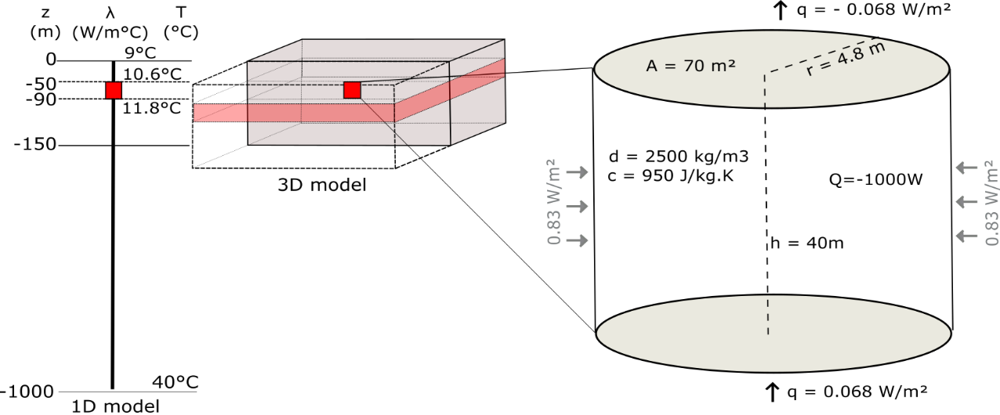

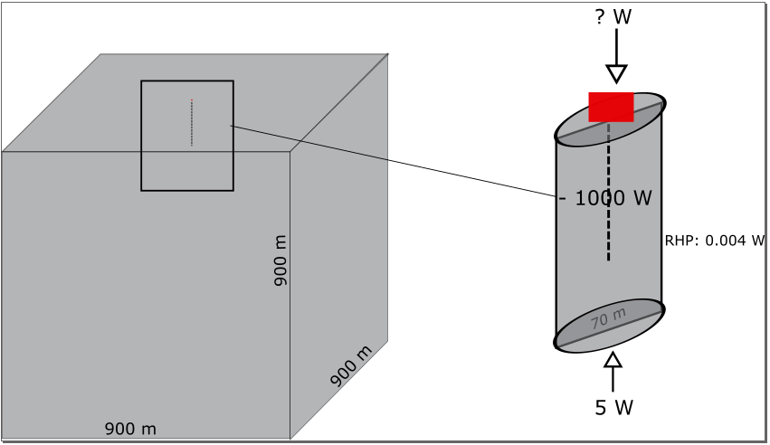

Figure 2: Conceptual, mathematical and numerical models for the heat extraction model from vertical BHE. The left part represents the 1D and 3D numerical models developed in this study. The thermal state of the models is defined by an initial temperature gradient of 0.031 ◦C/m and an average effective thermal conductivity of 2.2 *W/m*2. Details of the heat balance around the vertical BHE (red rectangle) determined from mathematical estimates is shown on the conceptual figure on the right. // Energy imbalance

### Solar energy

In the upper 10-25 m below the surface, the ground temperature is mainly controlled by the yearly variations in air temperature and by the heat flux through the ground surface. The effective ground surface temperature depends on several factors (i.e. air temperature, solar radiations, longwave radiations emitted from the ground, wind velocity, evapo-transpiration processes) that controls the amount of heat transmitted via conduction or convection between the air and the ground. Due to the time necessary for a heat pulse at the surface to reach depth, the ground will tend to be warmer than the air in winter and colder than the air in summer, impacting the direction of the heat fluxes down to the depth of influence of these seasonal fluctuations. At about 15 m depth, the ground temperature is relatively stable all year long, about 1°C higher than the yearly average surface temperature (XXX). Below that depth, the ground temperature is mainly controlled by the geothermal heat flux and tends to follow the trend of the local geothermal gradient.

XXX suggested that between 15 and 150 m depth, where vertical BHE are generally located, the temperature of the ground is relatively constant as a result of a complex interaction between the heat coming from the surface and that coming from the depths of the Earth. This differs from the steady state gradient assumed in the previous section. Although vertical BHE are not directly harnessing solar energy in the same way as shallow horizontal BHE that are located in the depth of influence of seasonal variations, we here study the impact of a downward surface solar heat flux on the upper part of the geothermal gradient (i.e. down to 200 m). This allows us to estimate the potential additional heat recharge provided by solar heat flux.

In Edinburgh, the average annual rate of insulation is in the order of 94 W/m2, with a minimum of 13 W/m2 in December and 181 W/m2 in July (Whitlock et al., 200). Due to the low diffusivity of soil, the refraction of solar radiation and all the processes mentioned above, it is assumed that the net incoming shortwave radiation into the ground only equals 10s of *W/m*2 (Banks, 2008). If we assume that the average yearly solar radiation recharging the ground is in the order of 8 W/m² (or 8 x 70 m² = 560 W) and that the average yearly sun hours in Edinburgh is 1380 h (4.968 x 106 s), then the total energy recharging the ground on the area of impact of heat extraction equals 2.78 x 109 J (770 kWh), that is 9% of the energy extracted.

### Lateral heat recharge

Results from our mathematical model suggests that geothermal heat flux can provide only 0.5% of the energy consumed in one year, considering a 70 m² area around the borehole and a steady state situation (Fig. 2). Adding solar heat recharge at a rate of 8 W/m² would contribute to recharging the system up to 10% of the heat extracted for an individual UK house over a year, while radioactive heat generation is negligible in the sedimentary system considered. This shows that heat balance cannot be naturally reached in the ground considering those geological and climatic conditions, and thus additional heat is to be mined from the rock surrounding the borehole, inducing lateral heat fluxes.

To quantify the lateral heat flux, we first assume steady state conditions where 5W is provided by geothermal heat flux. That means that about 995 W will be mined from surrounding rocks. Using h = 40 m and a perimeter of 30 m (2*π*r with r =4.8 m), the lateral heat flux would be in the order of 995*/*(40×30) = 0*.*83 *W/m*2 (Fig. 2.4). In a case with solar recharge (total recharge of 560 W), the lateral flux would be reduced to 0.37 W/m2.

# Numerical model

We use the OpenGeosys finite element modelling software (i.e. Kolditz et al., 2012; Chen et al., 2019) to simulate temperature change and calculate the heat fluxes induced in the subsurface due to heat extraction. The relative contribution of solar and geothermal recharge is first described using a 1D model, and lateral heat fluxes are then quantified using 3D diffusion models. Results are used to validate the mathematical models against the volume of accessible rock. We finally use our analysis to quantify the footprint area affected by heat extraction and assess the optimal production scenarios leading to the minimum thermal impact on the ground.

## One-Dimensional Model

We first model the Borehole Heat Exchanger (BHE) as a vertical line source embedded within a 1D model composed of 10 000 elements, 0.1 m in length. To keep the problem simple, the profile is treated as a homogeneous porous medium with a specific heat capacity of 950 J/Kg°C, a density of 2500 *kg/m*3 and a thermal expansion coefficient of 1 × 10−5 ◦*C*−1. The initial steady-state temperature distribution along the model follows a gradient of 0.031°C/km, with a surface temperature of *T*0 = 9 ◦C corresponding to the average yearly air temperature in the Glasgow area in Scotland, and a bottom temperature *Tz* = 40 ◦C at z = 1000 m. Heat transfer in the ground is assumed to occur only by conduction, with an effective thermal conductivity of 2.2 W/°C.m corresponding to the average conductivity of a typical column of dry rock in the Midlothian Coalfield (Appendix XXX).

## Axial effects

Many studies involving the numerical modelling of heat transfer around vertical BHE have assumed isothermal boundary conditions, where the surface temperature represents the yearly average air temperature (i.e. Zhao *et al.,* 2020). Several authors however underlined the importance of setting heat flux (i.e. Neumann) boundaries rather than a constant temperature (i.e. Dirichlet boundary) at the surface (Saadi and Gomri, 2017). Erol et al. (2015) explained that during production, the temperature distribution around BHE is not equal to the undisturbed ground temperature from the surface to the bottom, and axial effects (i.e. vertical heat transfers) become important at both ends of the borehole. Setting a Neumann boundary condition would therefore enable temperature decline at the surface due to heat extraction from the ground, and therefore avoid overestimating available recharge.

To realistically assess the heat recharge through the ground surface, Singh and Sharma (2017) expressed heat conduction through the surface boundary as a general convective heat transfer boundary condition. An effective surface temperature accounting for both convective and conductive heat transfers between the ground surface and the air was calculated from the ambient air temperature, the solar radiation and the wind speed, and used to derive the time-variant first type boundary condition on an hourly basis. We here suggest to quantify the heat flux at the surface by finding the amplitude of the variations that reproduced the soil temperatures measured in Scotland under the ground characteristics defined by the 1D model described above without calculating the complex energy balance between the air and the ground surface. Using Eq. 3.1, we calculate a series of curves representing the daily heat flux values for different signal amplitudes, that are used as source terms for the Neumann surface boundary condition of the 1D heat model.

∆*t*

*Q* = −*A sin*(2*π*∗ ) − *q* (3.1)

*t*

where Q is the average daily heat flux, ∆*t* the time increment (days), t the period of fluctuation (366 days), ∆*t*

the time increment (86400 sec, i.e. one day) and A the amplitude of the variations. The parameter q corresponds to the geothermal heat flux of 0.068 W/m² used as bottom boundary condition to the model, and is added to ensure that the yearly average energy balance is maintained over the long term. For each scenario (i.e. values of A), we simulate the change in temperature in the model for a period of 50 years.

By comparing the measured soil temperatures with the surface temperatures obtained from the different modelling scenarios (Fig. 3.), we show that the yearly temperature change in Scotland can be best simulated for a heat flux input of amplitude A = 8.4 *W/m²*, considering an average thermal conductivity of 2.2 W/°C.m and a gradient of 0.031 °C/m.

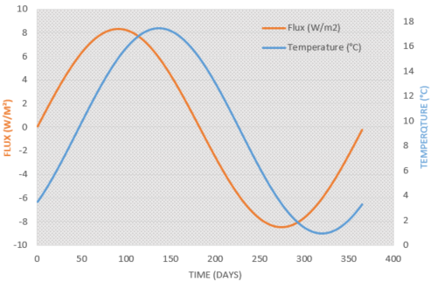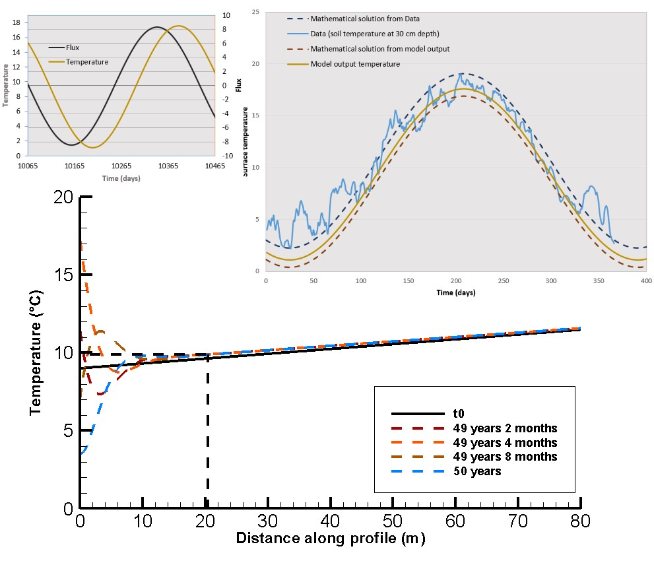

Figure 3: a) Input surface heat flux for the time-varying surface boundary conditions (black line) and output surface temperature time series (z = 0 m) for A = 8 *W/m*2. b) Comparison between the data, mathematical solutions and model output for the surface temperature. The data used correspond to daily soil temperature measured at 30 cm depth at the Paisley station, Glasgow area, in 2000 and downloaded from the UK Meteorological Office website.

Results of a 50-year simulation period with no heat extraction shown in Fig. 3 indicate that the fluctuating heat flux at the surface tends to disturb the initial steady state temperature profile. A shift toward higher temperatures can be seen down to 150 m depth, where the ground temperature starts following the local geothermal gradient. Further analysis show that a new fluctuating steady state is reached after 80 years. There the average surface temperature is 9.2 °C and reaches 10°C at 25 m depth. This is 1°C higher than the average air temperature of 9.4°C measured in Paisley, in accordance with XXX.

We then simulate heat extraction along the BHE situated between 40 and 90 m depth in the 1000-m long 1D model representing a semi-infinite vertical homogeneous line source. Different scenarios aiming at quantifying the relative contribution of solar and geothermal heat flux on the recharge potential are simulated, using 1) constant boundary conditions, 2) constant surface and bottom heat flux boundaries of −0*.*068*W/m*2 and 0*.*068*W/m*2, and 3) constant bottom heat flux of 0.068 W/m2 and the fluctuating surface heat flux boundary described above. After verifying that the steady state gradient used as initial condition remains stable when using Neumann boundary conditions in a case without heat extraction, temperature change due to heat extraction is simulated for periods of 1 and 30 years, using line source areas of 70 *m*2 and 2200 *m*2, respectively. For each scenario, a constant source term of -1000 W, equally distributed along the 40 m long BHE section of the 1D profile is added.

In addition, we simulate heat extraction within a 40m long line source model. This model corresponds to a finite section of the 1000-m long BHE model situated between 50 and 90m depth, where the temperature is initially at XXX and XXX °C, respectively. This is done to validate the analytical solutions described in the previous section, using purely diffusive heat transfer, and to assess the effect of axial heat fluxes when a layer of rock is situated below/above the BHE.

## 3D model and lateral heat flux

Line source models can be used to study in an efficient way steady state conditions (i.e. the overall temperature change in the system) and one-dimensional (1D) heat transfers (i.e. vertical or axial heat fluxes). However, 1D models only give a few insights on the temperature distribution around the borehole, which is assumed to vary uniformly, and for each element the temperature change will be highly dependent on the model area. To study lateral heat fluxes induced by the heat extraction from the 40 m long BHE and the extent of the effect of heat extraction, we therefore set up a three-dimensional model whose properties and thermal state are equivalent to the 1D model previously described.

The 3D models consist of a 300 m large, 300 m long and 150 m deep block composed of 5000 prismatic elements. The borehole is situated in the centre of a cylindrical volume between 50 and 90 m depth. This cylinder has a radius of 26.5 m (i.e. radius of the area required for a 30-year extraction period, as calculated in section XXX) and defines a zone with a high-resolution mesh. The size of the elements increases from 2 m inside the cylinder and up to 20m at the lateral boundaries of the 3D block. The vertical resolution of the model is of 1 m within the borehole depth interval and of 4 m elsewhere.

Assuming that 1D models represent the far field conditions in a three-dimensional scenario, we compare the temperature profiles at 4.7 m and 26.5 m from the borehole (from a line source embedded in a 3D model) to those from the 70 m² and 2200 m² 1D line source model. Any difference between the equivalent temperature profiles in the 1D and 3D model would therefore indicate the effects of lateral heat recharge.

# Results

## Axial recharge

We first attempt to quantify the axial affects induced by heat extraction from the 40-m long borehole over time by comparing the temperature profiles obtained from the 1D finite and semi-infinite models. In both scenarios, a total heat load of 1000 W regularly distributed along the borehole is abstracted from the 70m² and 2200m² for durations of 1 year and 30 years, respectively, according to the mathematical model described in part XXX. The profiles obtained for both models are displayed in Fig. 4 together with results from the 3D models (see Section XXX).

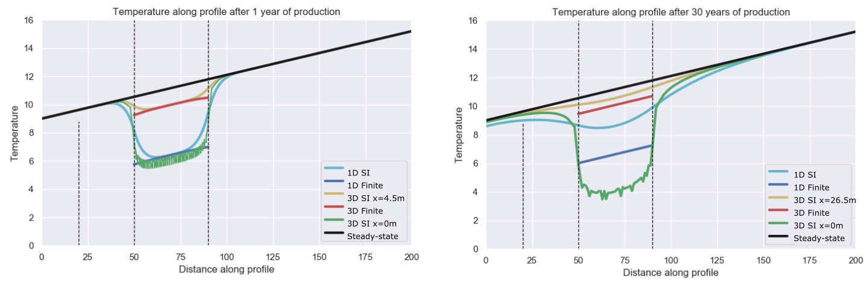

Figure 4. Temperature profile obtained after 1 year (left) and 30 years (right) of heat extraction from the 1D and 3D finite and semi-infinite models for constant heat flux boundaries of -0.068 and 0.068 W/m² associated with a steady state temperature gradient of 0.031 °C/km (black profile). In the 3D models, the data are extracted from vertical profiles situated at the borehole location (x=0) and at a distance x=4.5-m (1-year) and 26.5-m (30-year) away from the borehole.

Results from the 40-m long finite BHE model with constant heat flux boundaries (yellow line) first confirm that the extraction of a heat load of 1000 W induces a uniform temperature decline of 5°C along the borehole for both simulation periods, in accordance with the mathematical model. By integrating the temperature difference between the final and initial states, we also show that after the same production period, the overall changes in temperature in the 40-m and 1000-m long models are consistent (i.e. ΔT = 1820°C after 30 years). However, the Gaussian-type temperature distribution along the semi-infinite model reveals that part of the heat is sourced from the areas situated above and below the borehole. This effect is particularly visible after 30 years, where the decline in temperature is maximal at the mid-borehole (light blue line in Figure 4B).

We therefore suggest to calculate the integrated temperature difference between both models in the borehole depth interval in order to evaluate the effects of axial heat recharge on the temperature profile, according to Eq. XXX:

; (

Where subscript F refers to the finite 40-m long model and SI to the 1000-m long semi-infinite model. Results indicate that after 1 year (70m² model), about 10% of the heat extracted in the semi-infinite model is sourced from the area available above and below the borehole. Over 30 years (i.e. 2200 *m*2 model), the temperature drop within the borehole depth interval is considerably reduced -black curve), with the rocks situated above and below providing up to 50% of the heat required by the borehole. With increasing production time, the amplification of axial effects therefore allows decreasing the peak in temperature decline at the borehole. This observation is in agreement with Marcotte et al. (2010). Further analysis aiming at assessing the impact of 1) the thermal conductivity, 2) production time, 3) borehole depth (i.e. distance from the upper boundary) and 4) borehole length (i.e. specific heat absorption rate) on the contribution of axial effects on the recharge to the borehole is presented in Appendix XXX.

## Three-dimensional study of lateral recharge

From the 1D analysis, we have shown that axial effects tend to provide additional recharge to the system, by reducing the maximum temperature decline at the borehole. To account for the potential heat recharge from lateral areas, we extend our analysis to three dimensions. Similarly to our 1D quantification of axial fluxes, we create a 40-m thick 3D model consisting of a finite vertical line source embedded in a 300-m wide and 300-m large volume aiming at quantifying the lateral fluxes. We simulate heat extraction at the borehole at a rate of -1000 W for a period of 30 years with yearly time steps, considering constant heat flux of +/- 0.068 W/m² at the upper and lower boundaries and no-flow laterally.

Based on Eq. XXX, we first calculate the axial heat fluxes induced at x = 4.5 m and x = 26. 5m, using results from the finite and full-extent 3D models. Results indicate that at those distances from the line source, the contribution from axial flux is in the order of those estimated from 1D scenarios, that is about 10% after one year and 50% after 30 years, respectively. Although the overall temperature change in the models remains the same (i.e. about 3.98 x 105 °C over 30 years), extending the model in the vertical direction appears to reduce the temperature drop in the borehole depth interval by providing additional recharge (see dark blue and light blue profiles).

Assuming that 1D models aim at representing far field conditions, we then use the relative difference between temperatures profiles extracted at distance x=4.5 m and x = 26.5 m from the line source in the finite 3D model to the corresponding 1D finite temperature profile to quantify the effects of lateral heat recharge over time. Results show that after 1 year, the temperature at x = 4.5 m has declined by ~ 1.2°C. Similarly, after 30 years of heat extraction, the temperature at x = 26. 5 m has declined by ~ 1.1 °C. Those represent about 20% of the temperature change of 5°C permitted at the borehole and verified by the corresponding 1D models. Alternatively, results indicate that the temperature at the borehole location in the 3D model is significantly higher than in the corresponding 1D finite 1D model, with the temperature change ΔT increasing from ~5.5°C after one year an ΔT ~ 8.4° after 30 years (i.e. temperature of reaching 2.7°C).

Although 1D models allow a simple estimation of the average temperature change in a given volume of rock, this comparison shows that they cannot inform on the temperature distribution around the borehole, and thus on the area of impact in the long term. Temperature time-series extracted from the 1D and 3D models show that in contrast to 1D models, where the temperature declines a linear rate ~-0.08°C/year from the onset of production, temperature at the borehole location tends to decrease exponentially in the first years of heat extraction in a 3D scenario. After about 13 years, temperature near the borehole approaches steady state conditions with a quasi-linear rate of decrease of ~-0.01°C/year. Away from the borehole, the effects of heat extractions are delayed. At x = 26.5 m, temperature starts decline after a year and a quasi-constant rate of temperature decline of ~0.02°C/year is reached after about 20 years. Further away from the borehole, the rate of temperature decline starts to linearize from the onset of temperature decline. This suggests that although steady state temperature tends to be reached at the borehole, this does not correspond to spatial steady-state temperature conditions due to the poor heat generation and recharge potential of this system.

We use the 3D full extent model to measure the radius of the area impacted by heat extraction around the borehole after 30 years. The drawdown is measured along two horizontal profiles situated at the surface (z = 0 m) and at the mid-borehole (z= - 70 m). Fig XXX shows that for both depths, the radius of influence reaches about 80 m around the borehole, with a total temperature drop of 8°C at the mid-borehole (red horizontal line) and of 0.1°C at the surface. After 30 years, the footprint area of heat mining in the volume with a thermal conductivity of 2.2 W/°C.m is in the order of 20 000 m², that is an order of magnitude higher than the area calculated from a mathematical approach.

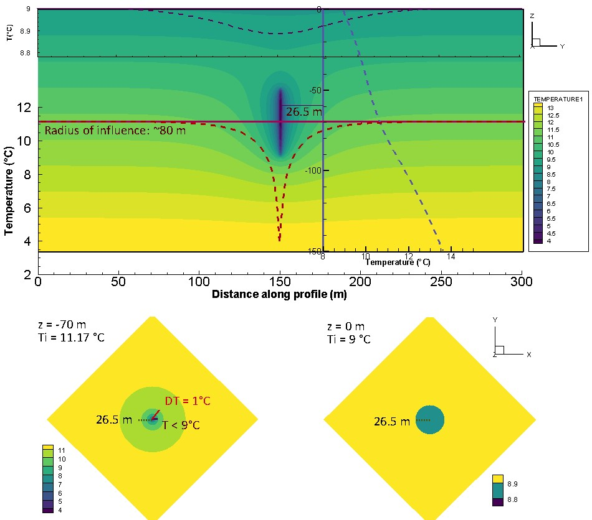

Figure 6: XZ temperature profiles obtained from the full extent 3D model after 30 years of heat extraction.

To appreciate better the expansion rate of the area impacted by heat extraction, we calculate the axial (vertical) and lateral (horizontal) heat fluxes at t = 1, t = 30 and t = 100 years of heat extraction. Results displayed in Fig. XXX indicate that horizontal heat flux reaches steady state conditions after a year only, stabilizing at a rate of 0.8 W/m² (0.74) in the middle of the borehole, in accordance with the mathematical model presented in section XXX, and reaching 0.42 W/m² at the BHE ends. Those constant fluxes indicate that the temperature will decline at a constant rate, and that the area of impact will keep expanding if no additional heat recharge is provided. It can be expected that the lateral expansion of the volume of rock depleted in heat overtime will also participate to an increase in the vertical temperature contrasts, and thus in the contribution from axial fluxes. Fig. XXX shows the axial fluxes keep expanding over time, suggesting a lack of recharge in the upper part of the model. While the upward geothermal heat flux represents a constant heat source at the bottom of the borehole, the net heat recharge above the borehole is indeed negative, both due to the effects of the geothermal gradient and to the downward fluxes induced by heat extraction. In addition, the proximity of the borehole to the surface makes it relatively sensitive to the condition at the boundary. As no heat can be source from outside the model, downward fluxes tend to expand over time as the area depleted in heat expands laterally.

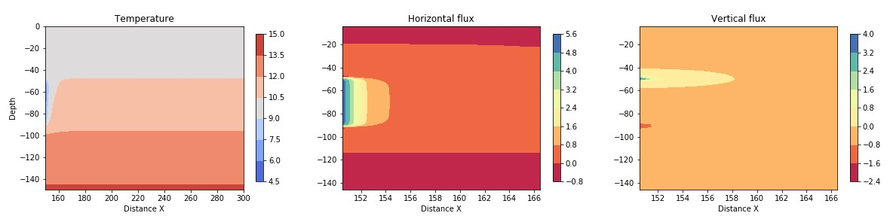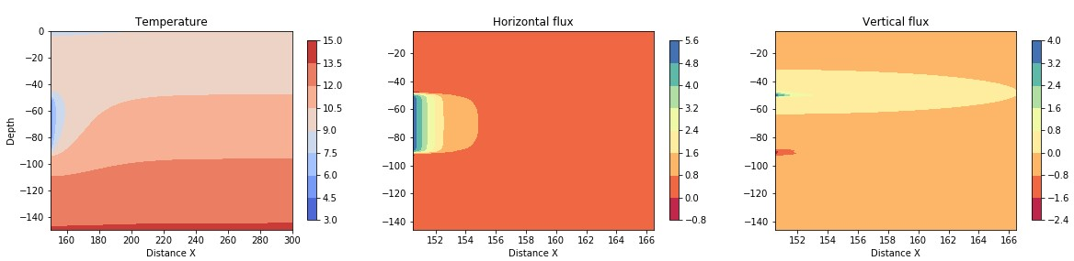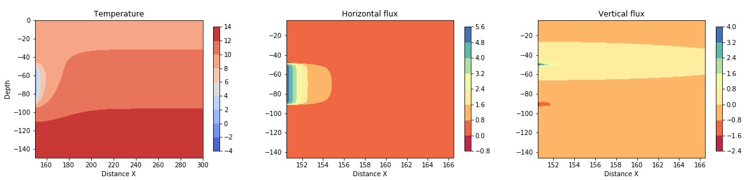

Figure 7: 2D section in the central part of the 3D model showing the vertical and horizontal fluxes after one year (a) 30 years (b), and 100 years (c)

## Solar variations effects

As production time increases, the layer of rock depleted in heat tends to expand vertically. Time series of temperature showed that the effects of heat extraction reaches the surface after 6 years, from when the surface temperature starts decreasing. In section XXX, we showed that over a year, the effects of fluctuating heat flux reach only 25m depth. However, over the long term, the complex interaction between the surface and geothermal heat flux tend to disturb the steady state linear geothermal gradient by creating an isothermal zone. This suggests that additional recharge is provided from above.

We therefore compare the temperature change in the system over 30 years of heat extraction, using constant and fluctuating surface heat flux. To avoid overestimating the recharge due to the transient state of the geothermal gradient seen when using fluctuating heat flux (Fig. 3), we use the profile obtained after 100 years without heat production as initial state to the heat extraction model.

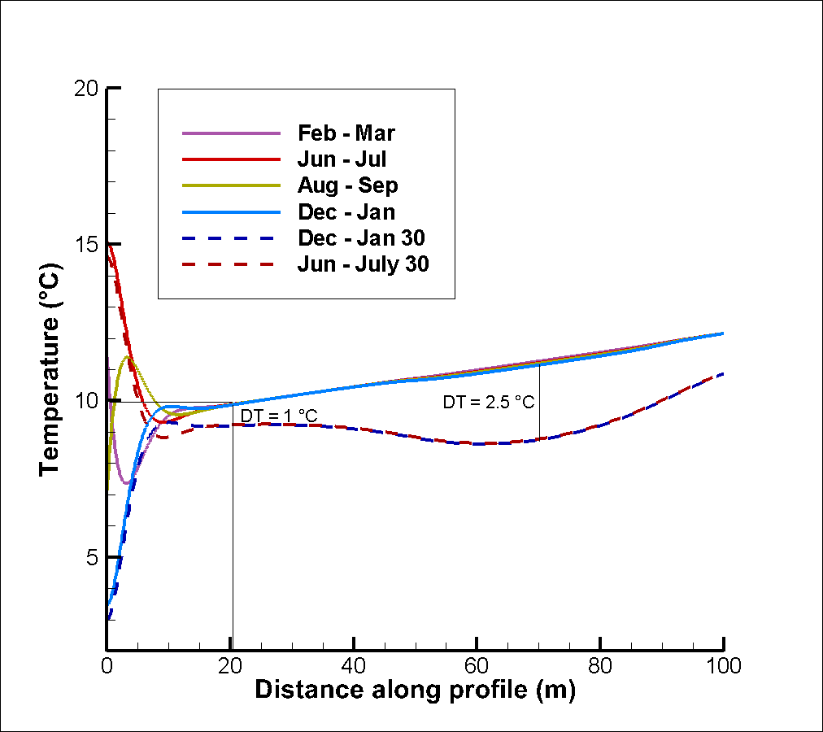

# Discussion

In the previous sections, we have calculated the volume of rock required to provide energy to a typical average UK house for periods of 1 and 30 years, based on mathematical equations allowing a temperature change of 5°C in the system. The required heat load was compared to the available natural recharge in the system (i.e. radioactive heat, geothermal and solar heat flux) for a case study located in the Midlothian Coalfield, Scotland. We then used 1D and 3D numerical models to verify the mathematical model and calculate the amplitude of vertical and horizontal flux around the borehole. In addition, we evaluated the footprint area of heat extraction at the mid-borehole and at the surface, in a homogeneous system with a thermal conductivity of 2.2 W/°C.m².

While analytical models suggested that natural recharge can only contribute up to 5% of the heat extracted, numerical models confirmed that most of the heat is actually mined from the rock surrounding the borehole. Results from the 3D analysis show that if that heat transfers are not affected by the conditions at the boundaries, steady state flux can be reached after one year. This means that at a specific point, temperature will start declining at a constant rate from at a time t that depends on the distance from the line source. In response to the expansion of the volume depleted in heat with time, 3D models also showed the expansion of the downward heat flux above the borehole, allowing greater recharge to the borehole. In 1D models, where the amount of heat available is constrained by the model area and no recharge is provided from lateral areas, this effect led to an important drop in temperature above the borehole due to the lack of recharge from the surface (i.e. scenario with constant heat flux). This suggests that as the borehole depth increases, allowing more axial recharge, the areal impact of heat mining would decrease.

Using a fluctuating surface heat flux, numerical results show that recharge from the surface can be increased by XXX%. This result is however highly dependent on the transient situation of the model, that results from the interaction between fluctuating heat flux on the surface and geothermal heat coming from below.

The model described in this study represents a specific scenario that highly depends on the choice of the geometrical parameters and medium properties. We therefore perform a sensitivity analysis on the borehole depth, borehole length, available area, production time and rock conductivity to evaluate the contribution of different parameters on the extent of the temperature change in the system and support the use of dimensionless parameters in future analysis. Results presented in appendix XXX show that for a given production time the areal impact of heat extraction mostly depends on the thermal conductivity of the rock and on the borehole length, which are inversely proportional to the temperature decline at the borehole. Although increasing the borehole depth favours axial recharge and restrains the drop in temperature at the borehole, it only has a few effects on the areal impact of heat extraction. As increasing the borehole length generally represents important investment costs, improving the thermal conductivity of the medium around the heat exchanger is often seen as of primary interest to ensure long-term production and avoid engineering issue due to the accumulation of cold at the borehole (XXX). By confronting the need to ensure the BHE efficiency against that of ensuring the sustainability of the geological resource while constraining the area of impact, we come up against a conflict of interest… Here, we therefore perform simple heat balance analysis to evaluate the amount of annual recharge that would allow constraining the area of impact to 70-100 m² over 30 years. We then verify our model through different cyclical injection/production scenario using the 3D full-extent model.

## Heat balance analysis

The analysis presented in Fig. XXX suggested that although a steady-state temperature can be obtained at the borehole, often interpreted by previous studies as an indication of efficient system, this steady state situation can hardly be reached away from it. The area of impact of heat extraction will expand over time if no heat recovery schemes are planned.

We suggested earlier that radioactive heat production, solar recharge and geothermal heat cannot compensate for the heat extracted on a yearly average under the considered geological and climatic context, without considering an unrealistically large volume of rock. For a defined heat extraction rate and production period, the footprint area of mined heat is highly dependent on the conductivity of the medium. Our analysis shows that lateral heat flux, which defines the rate at which heat is provided to the borehole by the surrounding area, can reach steady state after a year in a homogeneous system. Axial fluxes tend to increase over time, depleting the volume of rock available above the borehole in heat while expanding the zone of influence below and around it, to an extent that depends on the conductivity of the ground.

Vertical heat exchanger coupled ground source heat pump systems use the shallow geothermal energy as a heat source or sink for space heating or cooling. In opposition to horizontal heat exchangers, vertical boreholes present the advantage of requiring less land area. However, yearly imbalance in heat extraction and injection into the ground, especially in cold areas and for large-scale systems with long operational periods, can cause irreversible drop in temperature into the ground, resulting in a decrease in the HP performances. Some studies showed that other ways to achieve sustainable heat extraction and eliminate the cooling load accumulated into the ground is to perform cyclic production or provide additional artificial heat recharge during the non-heating season, such as solar thermal energy and industrial waste heat recharge (Cui et al., 2015; Cruickshank and Baldwin, 2016). Experimental studies conducted by Trillat-Berdal et al. (2006) showed that the ground thermal loads could be balanced by a system combining geothermal coupled heat pump and thermal solar collector, when the excess heat not used for hot water heating is injected into the ground, and the heat pump either used in cooling or heating mode. Cui et al. (2015) performed similar analysis on the performances of seasonal storage of industrial waste heat, by developing a heat transfer model for vertical GHE boreholes with multi-stage series connections.

## Cyclical production

To compensate for the heat extracted, we evaluate the capacity of different scenarios to 1) recharge the ground in heat by decreasing the yearly average temperature decline in the system and 2) limit the impact area of heat extraction. Those scenarios involve cyclical production with periods of natural recovery, cyclical production with injections of artificial heat and continuous production with constant heat source below the borehole. The objective is to assess the optimal scenario and the recharge in heat required to constrain the area of impact to 70-100 m², which corresponds to the average surface for a property in the UK (i.e. house and garden), over the long term. We will finally compare the heat load required to recharge the system annually to the amount of waste heat or artificial heat available in the Midlothian area.

The first heat extraction scenario considers seasonal heat extraction, with a minimum of -1294 W in winter and a maximum of -706 W in summer, distributed along the 40-m long BHE. The fluctuating heat load is calculated using Eq. 3.1, with *A* = 294 W, the amplitude of the variations and *q* = -1000 W the average year heat load. After 30 years of production, similar temperature profiles are obtained (Fig. 5.2), indicating that average yearly extraction rate is representative of a fluctuating extraction rate around this average.

The second scenario considers cyclical production with periods of no production. Over a year, 2000 W are extracted for 6 month and recovery is allowed for the six following months. This results in a temperature decrease of XXX rather than XXX at the mid-borehole. The overall temperature change in the model after 30 years is of XXX instead of XXX. The area of impact…

Finally, the third scenario considers cyclical production with period of recharge. Over a year, 2000 W are extracted for 6 month and 1000 W are reinjected for 6 months.

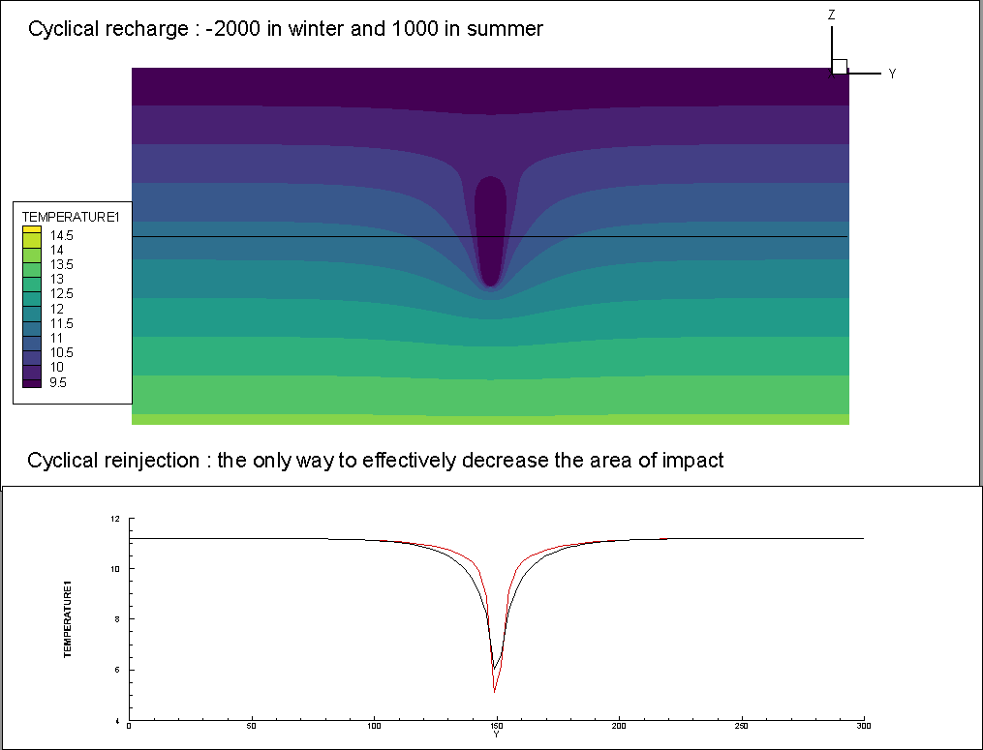

Figure 16: 2D temperature profiles after 30 years of heat extraction/injection for different scenarios.

# Conclusion

Using simple energy balance calculations validated using numerical models, we showed that in geographical areas with low geothermal heat flux and low in-situ heat production such as in the Midlothian Coalfield in Scotland, artificial heat recharge through cyclical heat extraction/injection is required to ensure sustainable heat extraction and constrain the footprint area impacted by heat mining. Such scenario could be achieved by injecting excess heat from unreliable renewable energy sources (i.e. solar, wind farms) or "waste heat" produced in cities (i.e. here we use the example of data centres from Edinburgh). Although this study focuses on the energy consumption for a single house in the UK, we suggest that it confirms that the integration of renewable heat sources combined with i.e. industrial waste heat or solar recharge might be essential for a sustainable and low-carbon heat supply at the scale of a district heating network (Köfinger et al., 2018).

By calculating the relative contribution from axial and lateral heat flux, we also showed that the initial recharge in the system depends on the long-term energy balance between surface and deep geothermal flux. This is due to the fact that the temperature gradient might not have reached equilibrium since the last Ice Age. While previous studies mentioned that steady-state production temperature can be reached after a few years of production, we hear show that this only applies at the borehole location. In terms of spatial analysis, the models indicate that although steady state radial flux can be reached in the sub-surface over the production period, the recharge from solar or geothermal gradient does not compensate for the heat extracted and thus, the heat extracted is mined from further and further away from the borehole (extension of the temperature gradient laterally). This effect is even more important with the effect of the upper boundary on the axial heat flux which tends to increase the ratio DT/C above the borehole. In a context where geothermal energy becomes of real interest, putting a constraint of the footprint area of heat extraction is required to avoid superimposition effects of heat extraction and interference.

We therefore show that the area of impact can be decreased by performing cyclical production with periods of no production, while adding cyclical recharge allow ensuring heat balance in the system and decrease the peak in temperature drop at the borehole. The amount of recharge available from solar collectors was calculated and used as input to the 3D model. Results indicated that adding XXX W of recharge would permit a reduction of the area of impact by XXX, showing that a combination of diverse energy sources (i.e. combination of solar or IWH for district heating, and geothermal) is essential to guarantee heat balance and decrease the areal impact of heat extraction.

Next step will be to assess the relative contribution from heat convection and conduction through the porous medium, using 2D advection-diffusion models (i.e. with groundwater flow). We will also extend this study by using mine-water heat source as a way to disperse heat injected from artificial sources.