# ABSTRACT

The objective of this paper is therefore to investigate the capacity of the ground to provide the required heat load to an individual vertical BHE in the Midlothian Coalfield, Scotland as well as the footprint area of heat extraction considering a purely diffusive medium. Assessing the footprint area is an important issue in a context where the number of geothermal heat schemes is expected to increase drastically in the next decades, coming along with a need to delineate/license heat resources. Using 1D and 3D numerical model, we evaluated the extent of heat depletion caused by a constant heat load extraction from a simple homogeneous system without groundwater flow for 30 years. We confirm that despite steady state fluxes and temperature equilibrium are reached at the BHE after a few years of heat extraction, the extent of the temperature keeps increasing with time, to an area that is far beyond the average area of a single house (70m²). Results from the sensitivity analysis showed that the footprint area of heat extraction mainly depends on the conductivity of the ground, to the yearly average heat extraction rate and to a lesser extent to the borehole length, and is inversely proportional to the temperature decline at the borehole. Different heat extraction scenarios are finally simulated in order to investigate how to optimize heat recharge. Discontinue heat extraction (i.e. with periods of total recovery allowed) allows reducing up to XXX the footprint area, while providing artificial recharge contribute to both reducing the temperature decline in the system, and to a lesser extent to the footprint area of heat extraction.

# Introduction

Heat demand for domestic and industrial space heating account for about 50% of the energy consumption in the UK. Currently, around 85% of this energy is supplied by natural gas, contributing to about 34% of the Greenhouses Gas Emissions of the country (BEIS 2019 ECUK – end uses database). Following the Paris Agreement, the UK targeted to reach net zero carbon emission by 2050 through the 2019 Climate Change Act. To achieve this goal, attentions have been focused on the need to decarbonize residential heat and the development of new low-carbon energy sources such as geothermal energy.

Ground-source heat pump (GSHP) technologies have been widely used worldwide to provide domestic space heating and cooling services by accessing the low temperature geothermal resources. In opposition to high-temperature systems, from which steam can be extracted and used to generate electrical power (i.e. Enhanced geothermal systems, such as in Cornwall, UK), low grade geothermal systems can be found everywhere and therefore represent an important resource. GSHP technologies consists of a heat pump unit coupled with a ground heat exchanger (GHE), usually a vertical borehole heat exchanger (BHE) or, less commonly, horizontal loops (XXX). Those closed-loop technologies have been developed to extract heat energy from resources situated at different depth range in environments where no groundwater is available. Horizontal ground heat exchangers are generally installed at depth of ~2 meters below the surface, where the ground temperature is mainly controlled by the surface conditions (i.e. air temperature, solar radiations), and are essentially known as solar thermal energy collectors (Banks, 2008). On the other hands, heat exchanger can be installed within vertical boreholes that allow accessing greater depth. Deep Borehole Heat Exchangers (BHE) can be drilled down to ~2 kilometres depth, where the sub-surface temperature profile is mainly controlled by the local geothermal gradient. Deep BHE have been proven to be more performant, as greater and more stable heat energy can be extracted throughout the year (Chen et al., 2019). Due to the greater temperature accessed, the energy can be used to provide heat to district heating network (i.e. XXX). In this study, we focus on shallow vertical BHE, a technology that can be used for hot water and space heating of individual houses (Fig. 1). Those boreholes are usually below the depth of influence of seasonal variations and are generally 40 to 200 m long. This design is expected to ensure good performances through the year as the temperature is not affected by the surface weather conditions (XXX). At that depth, the temperature is assumed to be relatively constant as a result of complex interactions between the solar heat flow coming from the ground surface and the deep geothermal flux, and tends to equal the average yearly air temperature (XXX). Despite of the high installation costs of vertical BHE that require drilling technologies, they present the advantage of occupying less land surface area than horizontal ground heat exchangers, which represents an advantages in areas of high land price (Trillat-Berdal et al., 2006). To date, the performances and the sustainability aspects of BHE have been well studied. Many authors used both analytical and numerical models, ranging from one-dimensional BHE model to full 3D subsurface numerical models to assess the long-term performances of GSHP system (i.e. Rybach and Eugster, 2010; Signorelli et al., 2005; Lyu et al., 2017; Zhang et al., 2016; Stylianou et al., 2017; Zanchini et al., 2010; Lazzari et al., 2010). In most of the studies, the efficiency of BHE is expressed in terms of the system coefficient of performance (COP). The COP, which represents the ratio between the electrical energy provided to the heat pump and the energy delivered, which is a function of the temperature contrast between the ground and the circulating fluid in the BHE. As suggested by Banks (2008), heat extraction from the ground in the early stage of production is expected to create a zone of depressed temperature around the borehole, leading to radial conduction of the heat stored in surrounding rocks toward the BHE. Cooling of the area would then induce an increasing heat flow of solar energy from the surface that will eventually balance the heat abstracted. Ideally, the production temperature will stabilize as the production time increase, indicating that the geothermal system has reached a new thermal steady-state conditions and ensuring a stable COP of the GSHP. While Chen et al., 2019 showed that using a specific heat extraction rate of 100 W/m, quasi steady-state outflow temperature could be reached after 20 years of production from a BHE in China, considering a geothermal gradient of 0.03 ◦C/m, XXX warned that unbalanced heat extraction and injection from BHE in cold regions (i.e. due to greater needs in heating relative to cooling) might lead to an extensive cooling of the ground. Injecting excess solar heat energy collected from solar panels in summer into the ground was view by the authors as a potential solution to compensate for the geothermal heat extracted in winter and guarantee the long-term viability of such installations.

Several studies showed that the efficiency of heat extraction mostly depends on the heat transfer process between the BHEs and the ground. In a purely diffusive medium, it mainly depends over the long term on the thermal conductivity and diffusivity of the ground (i.e. Stylianou et al., 2017; Chen et al., 2019; Choi and Ooka, 2015). The presence of groundwater was suggested to improve the long-term performance of BHE both by increasing the heat exchange rate during production (Zanchini et al., 2010; Stylianou et al., 2017; Wang et al., 2013) and by favouring heat recovery during periods of no production (Hein et al., 2016; Erol et al., 2015). In medium with groundwater circulation, analysis however showed that soil heat capacity and thermal conductivity only have minor impact on the sustainability of a GSHP system and that dispersion tends to increase the area of impact of heat extraction. However, there is still a lack of investigation regarding the extent of the heat accessed by shallow vertical BHE over the long term. The favourable contribution of advective recharge to the BHE performances makes BHEs another site-specific geothermal resource that is out of the scope of this study. Here, we investigate a case with no advection by focusing solely on diffusive heat transfers.

Most of the previous research papers tend to focus on production temperatures, treating the sustainability issue from an engineering point of view but not seeing the ground as a finite resource. Only a few studies considered the footprint area of the heat extracted as a limitation of the long-term efficiency of BHE. [Develop on boundary conditions / model accuracies] Being able to discriminate between the energy sources through a detailed understanding of the heat fluxes induced during heat extraction (both axial and radial) is therefore essential to get a better insight on the sustainability of heat extraction (i.e. Rivera et al., 2015). The objective of this paper is therefore to investigate the capacity of the ground to provide the required heat load to an individual vertical BHE as well as the footprint area of heat extraction considering a purely diffusive medium. We focus our study on the sub-surface of the Midlothian Coalfield in Scotland. Much of the population density in Scotland is situated in the Midland Valley and over coal measured that have been mined until the 1990’. Today, all the underground mines are closed, in rural areas that are likely to suffer from energy poverty. In addition to the need to decarbonize heat sources, the interest in using small-scale ground-source heat pump has been growing in the past years. Unlike a large-scale system, small-scale ground-source heat pump technology would avoid a number of disadvantages, including the need for central heat pump system, heat losses in community distribution pipe networks, maintenance of heat interface units and high operating costs (Matthew Black, Online Conference). By looking at the impact of heat extraction from a geological resource perspective rather than a BHE performance perspective, we clarify the concept of “steady state” production temperature and show that geological conditions in the UK cannot sustainably provide heat to shallow stand-alone vertical BHE. Assessing the footprint area is an important issue in a context where the number of geothermal heat schemes is expected to increase drastically in the next decades, coming along with a need to delineate/license heat resources.

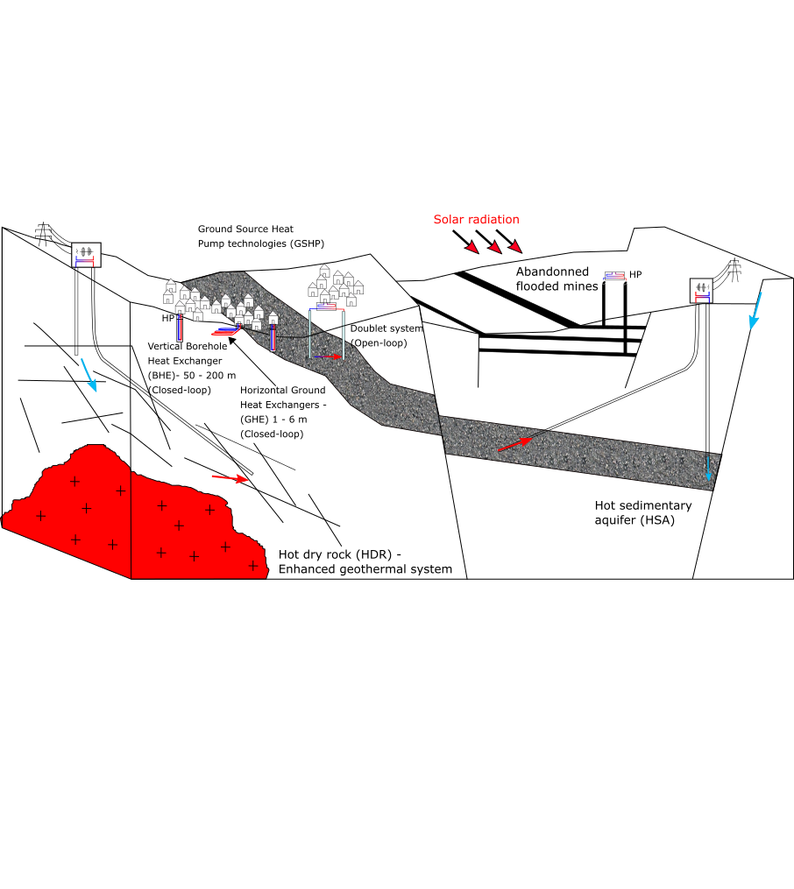

Figure 1: Type of geothermal energy available in the UK, including low-temperature resources (i.e. open-loop and closed-loop GSHP systems that comprise horizontal ground heat exchangers (GHE) and vertical borehole heat exchangers BHE), low-medium temperature resources (i.e. doublet systems, flooded mines) and high-temperature systems (i.e. Hot dry rock, Hot sedimentary aquifers). Open-loop systems are used to harness geothermal heat from in-situ water, by pumping/reinjecting groundwater from/to i.e. aquifers or legacy mine workings. Closed-loop systems use a working fluid to extract heat from the ground. The aim of this paper is to assess the long-term effects of heat extraction from vertical BHE on the subsurface.

Mathematical solutions are used to calculate the volume of rock required to provide the equivalent of a yearly average heat consumption to a single house in the UK, and quantify the amount of heat recharge available in the ground. Heat balance is then verified numerically by performing a series of 1D and 3D heat extraction simulations in a homogeneous porous medium, simplifying the BHE to a vertical line source to ignore the engineering aspects of the problem. Results are used to quantify the relative contributions from vertical and lateral conductive heat fluxes providing heat to the borehole over a 30-year extraction period, through heat mining of surrounding rock. A sensitivity analysis performed to assess the key parameters controlling the extent of the heat depletion caused by constant/cyclical production as well as the maximal temperature drop at the borehole. We finally investigate how cyclical production and heat recharge contribute to reduce the areal thermal drawdown on the ground. Results indicate that cyclical production with period of artificial heat recharge to the ground is mandatory to both constrain the areal impact of heat extraction on the ground and reduce the temperature decline at the borehole, both inversely correlated and dependent on the thermal conductivity of the ground.

# Conceptual model of heat extraction from vertical BHE

## Borehole Heat Exchanger

Geothermal energy characterizes the heat energy contained in rocks of the Earth’s crust and that can be either used as an energy source for space or water heating, or converted into electricity. Different technologies have been developed to access this energy resource, depending on its depth, on the presence of groundwater and on the purpose of utilization. Rocks generally get hotter with depth following the geothermal gradient, and although accessible high-temperature geothermal resources are limited to only a few geographical areas, harnessing the shallow low temperature geothermal resources available worldwide has been of growing interest since the 1980’s. As the total heat content of a rock is intrinsically linked to its temperature, the amount of energy that can be extracted from cooling the rock is expressed as:

*Q* = ∆*T V*(1−*φ*) *ρc* (2.1)

where ∆*T* is the amount of cooling, *ρc* is the volumetric heat capacity of the rock of volume *V* and porosity *φ, c* is the heat capacity, *λ* the heat conductivity, and *ρ* the densityof the material. ∆*T* is generally in the order of 5°C, either representing the temperature difference between the abstracted and injected water in a doublet system or the difference between the inflow and outflow temperature through a Heat Pump in a BHE system. Alternatively, Raymond and Therrien (2008) suggested to use Eq. 2.1 to calculate the heat content of rock sections along a vertical profile, where , with *z* the average depth of the considered rock section and the mean geothermal gradient.

Explain why focusing on footprint of impact and assuming conductive heat flux

We will moreover consider that heat is extracted from a purely diffusive homogeneous porous medium, whose characteristics are defined accordingly by a typical geological profile in the Midlothian Coalfield, Scotland.

## Heat load

We first suggest to calculate the volume of rock that would be required to provide the energy requirements for a single house in the UK, which is in the order of 12 400 kWh on average per year, with a maximum of 18 000 kWh in winter and 8 000 kWh in summer (XXX). To satisfy this yearly demand, a heat pump would need to deliver an average heat load *H* = 1415 W by extracting heat from the subsurface. In reality, part of the heat load is supplied by the heat pump in the form of electrical heat *E* that is required for air compression, reducing the energy that needs to be extracted from the ground *G* by an amount that depends on the coefficient of performances (COP) of the heat pump (Banks, 2008).

*G* = *H* (1− 1/COP) (2.2)

Using a COP of 3.4, the average heat that would need to be extracted from the ground to satisfy a total heat demand H = 1415 W is therefore reduced to G = 1000 W. This corresponds to a total energy Q = 3*.*15×1010*J* over a year. Considering a dry solid rock mass with a porosity *φ* = 0*.*1, a density of *ρ* = 2500 *kg/m*3 and a specific heat capacity of c = 950 *J/kg.°C*, the volume of rock *V* = *V*(1−*φ*) required to provide this energy by cooling the rocks by ∆*T* = 5◦*C* is about 2800 *m*3, according to Eq. 2.1. Assuming that the heat is extracted radially from a borehole with a length h = 40 m situated in the centre of a cylinder, the radius of this cylinder would be 4.8 m, corresponding to a surface area of about 70 *m*2. The specific heat absorption from the rock, as defined by Banks, 2008 would therefore be  = 25 W/m. Over a 30-year operation period (*Q* = 9*.*47×1011*J*) and considering that no recharge occurs, an area of 2200 *m*2 would be required (r= 26.5 m), corresponding to a rock volume *V* = 8*.*9×104 *m*3. In a case where we use as defined by Raymond and Therrien (2008), the volume of rock required for cooling highly depends on the initial rock temperature. In that case, assuming an average borehole depth z = 70 m and a geothermal gradient *α* = 31 ◦*C/km*, ∆*T* would be reduced to 2°C, increasing the required area for 1 year to 180 *m*2. This shows that by choosing the ∆*T* at the heat pump, the calculation of the required volume neglect what the actual temperature of the rock is. Considering a low geothermal gradient and thus a low at the borehole would require greater rock volume to provide the necessary heat load.

## Heat recharge

Sustainable heat production from BHE is achieved when the heat load extracted is balanced by heat recharge in the subsurface. We therefore here attempt to quantify the rate of heat production in the subsurface as well as the potential recovery rate from solar and geothermal heat flux, based on a typical temperature and geological profile in the Midlothian Coalfield in Scotland.

### Geothermal heat flux

The Earth’s natural heat flow is broadly attributed to a contribution from the primordial heat inherited from the formation of Earth and from the natural decay of radioactive elements, typically of the isotopes of uranium (238U, 235U), Thorium (232Th) and potassium (40K) (Pollack and Chapman, 1977). Due to geochemical differentiation, partial melting and magma crystallization processes, the upper crust is generally enriched in heat producing elements (Beamish and Busby, 2016) and their distribution can provide an important control on the temperature distribution within the earth lithosphere (Sandiford, McLaren, et al., 2006). A combined determination of the conductive heat flow and radiogenic heat production (RHP) is therefore here suggested to better constrain the thermal field within the study area (i.e. Jaupart and Mareschal, 2005).

The Midlothian Coalfield is situated in the south east of the Midland Valley of Scotland (MVS), a 80 km wide, 150 km long WSW-ENE trending Carboniferous graben extending across Scotland (Browne et al., 1999; Underhill et al., 2008). It is located in a geologically stable part of Earth’s crust, where only granite intrusions would contain sufficient concentration of K,T and U elements to generate significant radiogenic heat (Gillespie et al., 2013). An analysis of the radiogenic heat production in the Midlothian Coalfield is suggested in Supplementary Material XXX and show that, assuming a homogeneous 2800 *m*3 rock volume with an average RHP of 1.217 uW/m3, the total heat generated would equal 3*.*41×10−3 W, representing about 0.0003 % of the yearly average heat requirements of 1000 W.

In 2013, Gillespie et al. used a compilation of 35 heat flow data reported from the BGS Catalogue of Geothermal Data for the UK (Burley et al., 1984; Rollin, 1987) and Brereton et al. (1988) to map the heat flow in Scotland (Fig. 2.1). An average heat flow of 56 mW/m2 was calculated from values ranging from 29 to 82 mW/m2 mostly measured at depth < 400 m in onshore boreholes. Apparent ‘hot spots’ corresponding to granite intrusions were identified in the central part of the Midland Valley and in the East Grampians region, with heat flows of 60 mW/m2 and 70 mW/m2, respectively (Gillespie et al., 2013). In boreholes where no heat flow has been measured, geothermal gradients were calculated from the surface and bottom-hole temperatures measured in 61 boreholes, down to 1300 m depth (Burley et al., 1984). The average temperature gradient for all boreholes ranges from 3.7 to 45 ◦C/km, with a mean of 22.5 ◦C/km while plotted all together, the data indicate an average temperature gradient of 30.5 ◦C/km. Using 133 Bottom-Hole temperature (BHT) acquired from depth >1.5 km in 72 offshore wells in the North West Margin area (Gatliff et al., 1996 in Gillespie et al., 2013), the authors however noted the increase in the deep geothermal gradient from about 35.8◦C/km at 1 - 3.5 km to 46.7◦C/km at 3.5 - 5 km, relatively consistent across Scotland, and independent of the location (i.e. onshore or offshore) and the type of rock (i.e. sedimentary, crystalline basement) in which measurement were taken. Plotted together, onshore and offshore temperature measurements for the whole depth range (0-5km) indicated an average geothermal gradient of 31.9 ◦C/km.

Here, we chose the average linear geothermal gradient °C/m for depth < 1300 m depth (Gillespie et al., 2013) and an average thermal conductivity to estimate the average upward heat flux through the homogeneous rock column from:

With = 2.2 *W/*◦*K*.m, calculated from the weight average the lithologies composing the upper 100 meters of the XXX Well log, situated in the Midlothian Coalfield (Appendix XXX), we estimate the steady state flux to be about 0.068 *W/m*2. Based on the estimated 70 m2 footprint area required for a 40 m long BHE to access the necessary heat load by cooling rocks by 5°C, the geothermal heat flux would contribute up to 0*.*068 × 70 ≈ 5*W* or to the total heat recharge, representing 0.5 % of the heat consumed by a single house in the UK in one year. Alternatively, if we assume a yearly average geothermal heat flux of about 0.068 W/m2, the area required to provide the necessary recharge to the BHE (for G = 1000 W) is in the order of 14300 *m*2, or 200 times the surface area required for heat extraction in one year. Given that the average area of a house in the UK is 70-100 *m*2 (source: LABC Warranty, 2018), such required area is not realistic and vertical heat flux cannot contribute to recharge the subsurface in heat in a sustainable way.

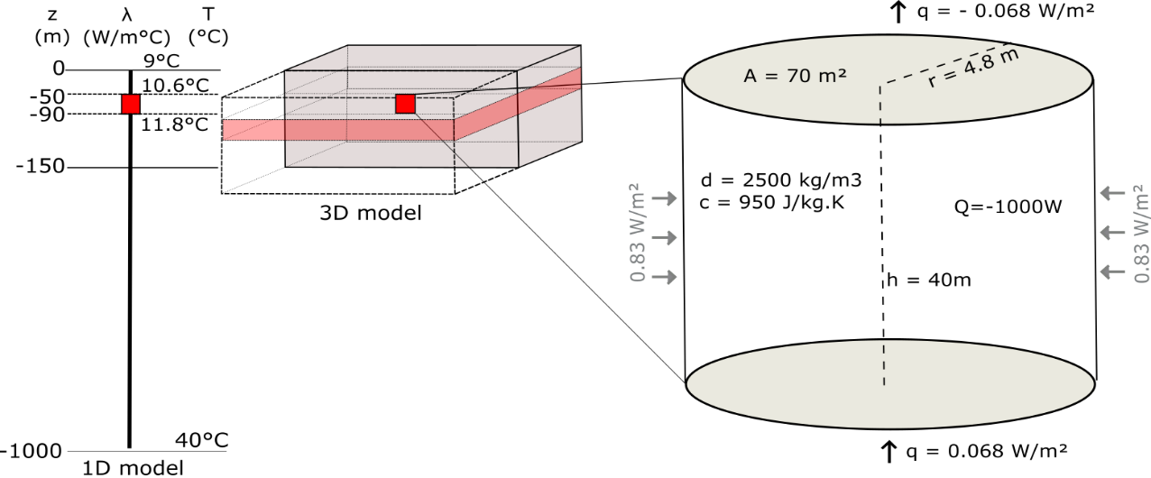

Figure 2: Conceptual models for the heat extraction model from vertical BHE. a) Sketch of the 1D and 3D numerical models developed in this study. b) Heat balance around the vertical BHE determined from mathematical models. The thermal state of the models is defined by an initial steady-state temperature gradient of 0.031°C/m and an average effective thermal conductivity of =2.2 *W/m*2. The heat flux entering the system from below equals the flux coming out at the surface through purely conductive heat transfers.

### Solar energy

In the upper 10-25 m below the surface, the ground temperature is mainly controlled by the yearly variations in air temperature and by the heat flux through the ground surface (Hein et al., 2016). The depth of influence mainly depends on the soil conductivity and on the local surface temperature and climatic conditions . The effective ground surface temperature depends on several factors (i.e. air temperature, solar radiations, longwave radiations emitted from the ground, wind velocity, evapo-transpiration processes) that controls the amount of heat transmitted via conduction or convection between the air and the ground. Due to the time necessary for a heat pulse at the surface to reach depth, the ground will tend to be warmer than the air in winter and colder than the air in summer, impacting the direction of the heat fluxes down to the depth of influence of these seasonal fluctuations. Below that depth, the ground temperature is mainly controlled by the upward geothermal heat flux and tends to follow the trend of the local geothermal gradient (Hein et al., 2016).

XXX suggested an interval of relatively constant temperature between 10-25 m and down to ~200 m depth due to a complex interaction between solar heat comping from the surface and geothermal heat coming from below. In that depth interval, the ground temperature is about 1°C higher than the yearly average surface temperature all year long (XXX), differing from the steady-state linear geothermal gradient displayed in Fig. 2. This is in that interval that BHE are generally installed. Although vertical BHE are not directly harnessing solar energy in the same way as shallow horizontal BHE, that are located in the depth of influence of the yearly variations in surface temperature (i.e. < 6 m), we here study the impact of the long-term downward surface heat flux on the upper part of the geothermal gradient (i.e. down to 200 m). This allows us to estimate the potential heat recharge from surface heat flux to the BHE.

In Edinburgh, the average annual rate of insulation (i.e. amount of solar radiation per square meter) is in the order of 94 W/m², with a minimum of 13 W/m² in December and 181 W/m² in July (Whitlock et al., 2000). Due to the low diffusivity of soil, the reflection of solar radiation and all the processes mentioned above, it is assumed that the net incoming shortwave radiation into the ground only equals 10s of *W/m*2 (Banks, 2008). Although the amount of recharge is cyclical and depends on the relative temperature difference between the ground and the air (i.e. Larwa, 2018), we here assume that over 40% of the solar energy absorbed by the Earth, 70% is reflected by the surface. Therefore, the average solar recharge to the ground is , in accordance with the amplitude of conductive heat flux values calculated by Larwa (2018). Considering a surface area of 70 m², the total energy recharging the ground equals . However, unlike the geothermal flux, solar flux is not continuous over time. Relative to the 1380 h of sunshine per year in Edinburgh (i.e. = 16% of the time), solar flux can be scaled up to 1.84 W/m², representing a heat recharge of ~ 4 x 109 J, that is 12.5% of the energy of consumed by a single house in the UK in one year.

Recent studies moreover highlighted the ‘island effect’ in cities (XXX). This effects XXX… and might provide additional heat from the surface to BHE located in cities.

[…]

### Radial heat recharge

Results from our mathematical model suggests that geothermal heat flux can provide only 0.5% of the energy consumed in one year, considering a 70 m² area around the borehole and a steady state situation (Fig. 2). Adding solar heat recharge at a rate of 11.5 W/m² would contribute to recharging the system up to 12.5% of the heat extracted for an individual UK house over a year, while radioactive heat generation is negligible in the sedimentary system considered. This shows that heat balance cannot be naturally reached in the ground considering those geological and climatic conditions, and thus additional heat is to be mined from the rock surrounding the borehole, inducing lateral heat fluxes.

To quantify the lateral heat flux, we first assume steady state conditions where 0.5% of the recharge in heat is provided by geothermal heat flux. That means that about 995 W will be mined from surrounding rocks. Using h = 40 m and a perimeter of 30 m (2*π*r with r =4.8 m), the lateral heat flux would be in the order of *W/m*2 (Fig. 2.4). This is more than 10 times the estimated upward geothermal heat flux (i.e. 0.068 W/m²), suggesting that BHE systems extract heat laterally 10 times faster than vertically, which may have a major impact on areal footprint of heat extraction. In a case with a total solar recharge, i.e. 13% of the heat extracted is recharged, the lateral flux would be reduced to W/m². This is still 10x faster than the geothermal recharge but 2.5 times lower than solar heat. Although solar heat flux is an order of magnitude higher than the geothermal heat flux, it is expected to decrease exponentially with depth due to 1) an increase in temperature and 2) a dissipation of the effects of solar radiation and atmospheric condition with depth depending on the diffusivity of the soil (Ozgener et al., 2013). Therefore, the estimated solar recharge might be constrained to shallow depth and overestimate the heat recharge to the borehole. Additionally, energy losses might also occur at the surface in situations where the ground gets warmer than the surface.

We therefore perform numerical simulations to better assess the contribution from vertical and lateral heat recharge in the sub-surface using 1D and 3D models.

# Numerical model

We use the OpenGeosys finite element modelling software (i.e. Kolditz et al., 2012; Chen et al., 2019) to simulate temperature change and calculate the heat fluxes induced in the subsurface due to heat extraction. The relative contribution of solar and geothermal recharge is first described using a 1D model, and lateral heat fluxes are then quantified using 3D diffusion models. Results are used to validate the mathematical models against the volume of accessible rock. We finally use our analysis to quantify the footprint area affected by heat extraction and assess the optimal production scenarios leading to the minimum thermal impact on the ground.

## One-Dimensional Model

We first model the Borehole Heat Exchanger (BHE) as a vertical finite line source embedded within a 1D semi-infinite model composed of 10 000 elements, 0.1 m in length. To keep the problem simple, the profile is treated as a homogeneous porous medium with a specific heat capacity of 950 J/Kg°C, a density of 2500 *kg/m*3 and a thermal expansion coefficient of 1 × 10−5 ◦*C*−1. The initial steady-state temperature distribution along the model follows a gradient of 0.031°C/km, with a surface temperature of *T*0 = 9 ◦C corresponding to the average yearly air temperature in the Glasgow area in Scotland, and a bottom temperature *Tz* = 40 ◦C at z = 1000 m. Heat transfer in the ground is assumed to occur only by conduction, with an effective thermal conductivity of 2.2 W/°C.m corresponding to the average conductivity of a typical column of dry rock in the Midlothian Coalfield (Appendix XXX). A preliminary analysis of the contribution of radiogenic heat generation on the geothermal profile indicated that for an average RHP production of 1.217 µW/m3, the total temperature increase is only 0.0004°C after 30 years. Due to this low contribution, we neglect RHP in the followings.

## Axial effects

Many studies involving the numerical modelling of heat transfer around vertical BHE have assumed isothermal boundary conditions, where the surface temperature represents the yearly average air temperature (i.e. Zhao *et al.,* 2020). Several authors however underlined the importance of setting heat flux (i.e. Neumann) boundaries rather than a constant temperature (i.e. Dirichlet boundary) at the surface (Saadi and Gomri, 2017). Erol et al. (2015) explained that during production, the temperature distribution around BHE is not equal to the undisturbed ground temperature from the surface to the bottom, and axial effects (i.e. vertical heat transfers) become important at both ends of the borehole. Setting a Neumann boundary condition would therefore enable temperature decline at the surface due to heat extraction from the ground, and therefore avoid overestimating available recharge.

To realistically assess the heat recharge through the ground surface, Singh and Sharma (2017) expressed heat conduction through the surface boundary as a general convective heat transfer boundary condition. An effective surface temperature accounting for both convective and conductive heat transfers between the ground surface and the air was calculated from the ambient air temperature, the solar radiation and the wind speed, and used to derive the time-variant first type boundary condition on an hourly basis. We here suggest to quantify the heat flux at the surface by finding the amplitude of the variations that reproduced the soil temperatures measured in Scotland under the ground characteristics defined by the 1D model described above without calculating the complex energy balance between the air and the ground surface. Using Eq. 3.1, we calculate a series of curves representing the daily heat flux values for different signal amplitudes, that are used as source terms for the Neumann surface boundary condition of the 1D heat model.

(3.1)

where Q is the average daily heat flux, t the period of fluctuation (366 days), ∆*t* the time increment (86400 sec, i.e. one day) and A the amplitude of the variations. The parameter q corresponds to the geothermal heat flux of 0.068 W/m² used as bottom boundary condition to the model, and is added to ensure that the yearly average energy balance is maintained over the long term. For each scenario (i.e. values of A), we simulate the change in temperature in the model for a period of 50 years.

By comparing the measured soil temperatures with the surface temperatures obtained from the different modelling scenarios (Fig. 3.), we show that the yearly temperature change in Scotland can be best simulated for a heat flux input of amplitude A = 8.4 *W/m²*, considering an average thermal conductivity of 2.2 W/°C.m and a gradient of 0.031 °C/m.

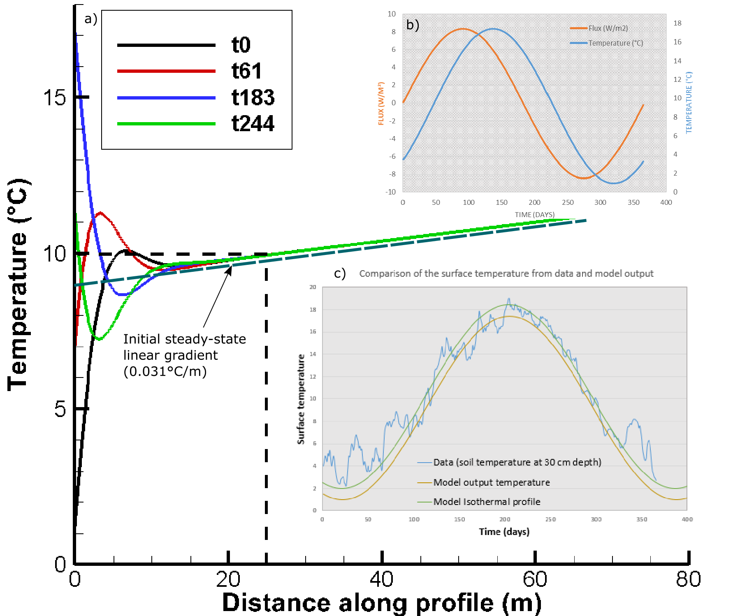

Figure 3: a) Input surface heat flux for the time-varying surface boundary conditions (black line) and output surface temperature time series (z = 0 m) for A = 8.4 *W/m*2. b) comparison between surface heat flux and surface temperature. The temperature change is delayed compared to the heat pulse imposed at the surface. c) Comparison between the data and model output surface temperature. The data used correspond to daily soil temperature measured at 30 cm depth at the Paisley station, Glasgow area, in 2000 and downloaded from the UK Meteorological Office website. Results show a better match for the summer data compared to the low winter temperatures – as shift that can explained by the effects of the geothermal gradient.

Results of a 100-year simulation period with no heat extraction moreover indicates that the fluctuating surface heat flux tends to disturb the upper part of the temperature gradient below the depth of influence of the seasonal variations. After about 80 years, a new fluctuating steady-state temperature profile is reached, showing a shift of the initial linear temperature gradient toward higher temperatures down to 150 m depth (see difference between dashed and solid black line in Fig. 4.c). There, the yearly average surface temperature equals the average air temperature measured at Paisley (~9.4°C) and reaches 10°C at 25 m depth, in accordance with XXX.

We then simulate heat extraction along the 50-m long BHE situated between 40 and 90 m depth in the 1000-m long 1D semi-infinite medium. Different scenarios aiming at quantifying the relative contribution of solar and geothermal heat flux on the recharge potential are simulated, using 1) constant boundary conditions, 2) constant surface and bottom heat flux boundaries of −0*.*068*W/m*2 and 0*.*068*W/m*2, and 3) constant bottom heat flux of 0.068 W/m² and the fluctuating surface heat flux boundary described above. After verifying that the steady state gradient used as initial condition remains stable when using Neumann boundary conditions in a case without heat extraction, temperature change due to heat extraction is simulated for periods of 1 and 30 years, using line source areas of 70 *m*2 and 2200 *m*2, respectively. For each scenario, a constant source term of -1000 W, equally distributed along the 40 m long BHE section of the 1D profile is added.

In addition, we simulate heat extraction within a 40-m long line source model. This model corresponds to the finite section of the 1000-m long BHE model situated between 50 and 90m depth, where the temperature is initially at XXX and XXX °C, respectively. This is done to validate the analytical solutions described in the previous section, using purely diffusive heat transfer, and to assess the effect of axial heat fluxes when a layer of rock is situated below/above the BHE.

## 3D model and lateral heat flux

Line source models can be used to study in an efficient way steady state conditions (i.e. the overall temperature change in the system) and one-dimensional (1D) heat transfers (i.e. vertical or axial heat fluxes). However, 1D models only give a few insights on the temperature distribution around the borehole, which is assumed to vary uniformly, and for each element the temperature change will be highly dependent on the model area. To study lateral heat fluxes induced by the heat extraction from the 40 m long BHE and the extent of the effect of heat extraction, we therefore set up a three-dimensional model whose properties and thermal state are equivalent to the 1D model previously described.

The 3D models consist of a 300 m large, 300 m long and 150 m deep block composed of 5000 prismatic elements. The borehole is situated in the centre of a cylindrical volume between 50 and 90 m depth. This cylinder has a radius of 26.5 m (i.e. radius of the area required for a 30-year extraction period, as calculated in section XXX) and defines a zone with a high-resolution mesh. The size of the elements increases from 2 m inside the cylinder and up to 20m at the lateral boundaries of the 3D block. The vertical resolution of the model is of 1 m within the borehole depth interval and of 4 m elsewhere.

Assuming that 1D models represent the far field conditions in a three-dimensional scenario, we compare the temperature profiles at 4.7 m and 26.5 m from the borehole (a line source embedded in a 3D model) to those from the 70 m² and 2200 m² 1D line source model. Any difference between the equivalent temperature profiles in the 1D and 3D model would therefore indicate the effects of radial heat recharge.

# Results

## Axial recharge

We first attempt to quantify the axial affects induced by heat extraction from the 40-m long borehole over time by comparing the temperature profiles obtained from the 1D finite and semi-infinite models. In both scenarios, a total heat load of 1000 W regularly distributed along the line source of finite length is abstracted from the 70 m² and 2200 m² models for durations of 1 year and 30 years, respectively, according to the analytical model described in part XXX. The profiles obtained for both models are displayed in Fig. 4 together with results from the 3D models (see Section XXX).

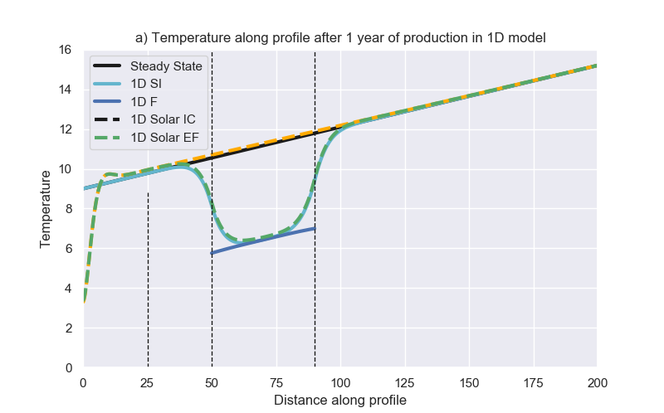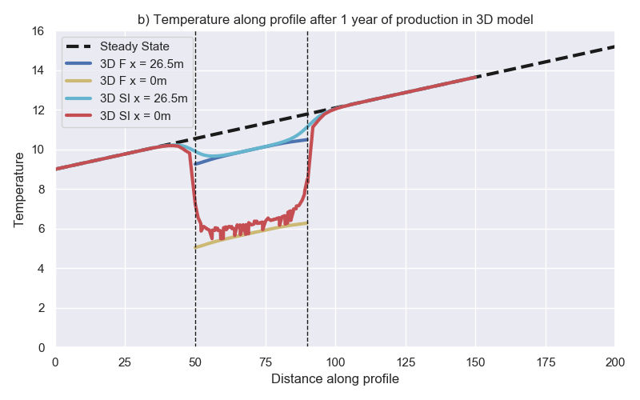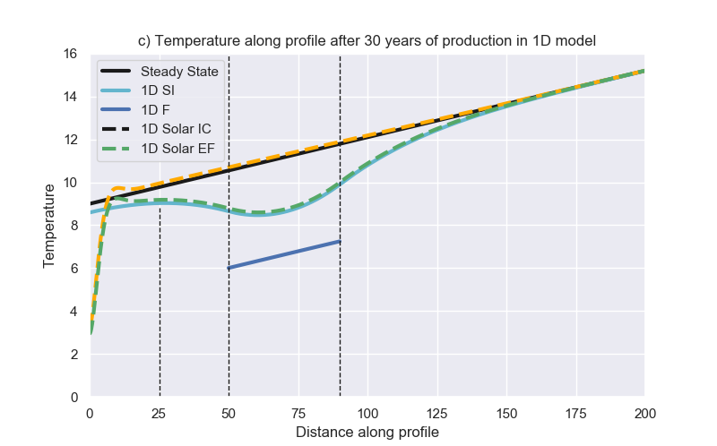 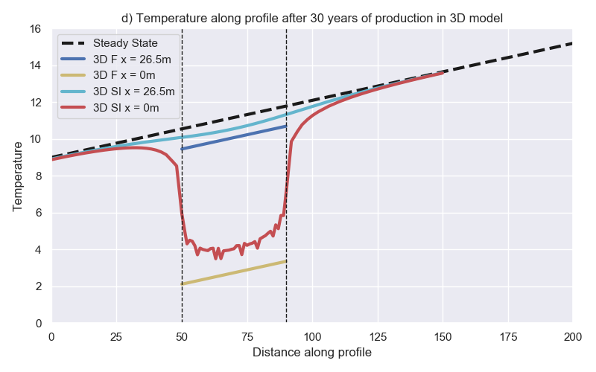

Figure 4. Temperature profile obtained after 1 year of heat extraction a) for the 1D 70m² models and b) for the 3D models and after 30 years of heat extraction c) for the 1D 2200m² models and d) for the 3D models. In the legend, F refers to the 40-m long finite model (dark blue profile) and SI refers to the 1000-m long (1D) or 150-m thick (3D) semi-infinite models. The black dashed profile corresponds to the initial temperature profile for the model with fluctuating surface heat flux (green profile). All other models are calculated for constant heat flux boundaries of -0.068 and 0.068 W/m² at the surface and bottom, respectively, associated to a steady state temperature gradient of 0.031 °C/km (black dashed profile). In the 3D models, the data are extracted from vertical profiles situated at the borehole location x=0 (red profile) and at a distance x=4.5-m (1-year) and 26.5-m (30-year) away from the borehole (light blue profile).

Results from the 1D 40-m long finite model with constant heat flux boundaries (dark blue line) first confirm that the extraction of a heat load of 1000 W induces a uniform temperature decline of 5°C along the borehole for both simulation periods, in accordance with the mathematical model. By integrating the temperature change difference between the final and initial states, we also show that after the same production period, the overall changes in temperature in the 40-m and 1000-m long models are consistent (i.e. ΔT = 1820°C after 30 years). The Gaussian-type temperature distribution along the semi-infinite model however reveals that part of the heat is sourced from the areas situated above and below the borehole. This effect is prominent after 30 years of heat extraction and show that although most of the heat is mined at the borehole location in the first year, the contribution of axial recharge is essential in the following years.

We therefore suggest to calculate the integrated temperature difference between both models in the borehole depth interval in order to evaluate the effects of axial heat recharge on the temperature profile, according to Eq. XXX:

Where subscript F refers to the finite 40-m long model and SI to the 1000-m long semi-infinite model. Results indicate that after 1 year (70m² model), about 10% of the heat extracted in the semi-infinite model is sourced from the area available above and below the borehole. Over 30 years (i.e. 2200 *m*2 model), the temperature drop within the borehole depth interval is considerably reduced (light blue profile), with the rocks situated above and below providing up to 50% of the heat required by the borehole. With increasing production time, the amplification of axial effects therefore allows decreasing the peak in temperature decline at the borehole. The importance of axial effects had already been noted by Marcotte et al. (2010). In their study, the authors examined the axial effects in in vertical BHE by comparing numerical results obtained using the finite and infinite line source methods. The main different between those models is the consideration of axial conduction effects by the finite line source, in which a constant temperature boundary condition is considered at the surface (Zeng et al., 2002). Results showed that axial effects tend to be important, especially for short boreholes and that considering axial conduction effects would permit downsizing of BHE.

## Three-dimensional study of radial recharge

From the 1D analysis, we have shown that axial effects tend to provide additional recharge to the system, by reducing the maximum temperature decline at the borehole. To account for the potential heat recharge from lateral areas, we extend our analysis to three dimensions. Similarly to our 1D quantification of axial fluxes, we create a 40-m thick 3D model consisting of a finite vertical line source embedded in a 300-m wide and 300-m large volume aiming at quantifying the lateral fluxes. We simulate heat extraction at the borehole at a rate of -1000 W for a period of 30 years with yearly time steps, considering constant heat flux of +/- 0.068 W/m² at the upper and lower boundaries and no-flow laterally.

Based on Eq. XXX, we first calculate the axial heat fluxes induced at x = 4.5 m and x = 26.5 m, using results from the finite and semi-infinite 3D models. Although Fig. 4 shows that the 3D semi-infinite model (light blue profile) sees less thermal drawdown as in the corresponding 1D model (i.e. when comparing the profile at x = 4.5 m with the 1D 70m² model and the profile at x = 26.5m with the 1D 2200m² model), results from the calculations indicate that at those distances from the line source, the contribution from axial flux is in the order of those estimated from 1D scenarios, that is about 10% after one year and 50% after 30 years, respectively. Extending the 3D model in the vertical direction also appears to reduce the temperature drop at the borehole location by providing additional recharge in the order of ~25% i.e. the temperature at the mid-borehole is increased from 3.6°C after 30 years instead of 2.7°C (see Fig. 5). This means that about 25% of the heat is directly mined from the area surrounding the borehole. For the 1-year model, the temperature change in the 1D 70m² semi-infinite model equals the temperature change at borehole in the corresponding 3D model (= 6°C). For the 30-year model however, in the 1D 2200m² semi-infinite model is 8.4°C, which is half the drawdown observed at the borehole in the corresponding 3D model ( = 4°C). This seems to show that the axial fluxes are not sufficient at the borehole location, or that after 30 years the energy reduction prevents sufficient recharge at the borehole.

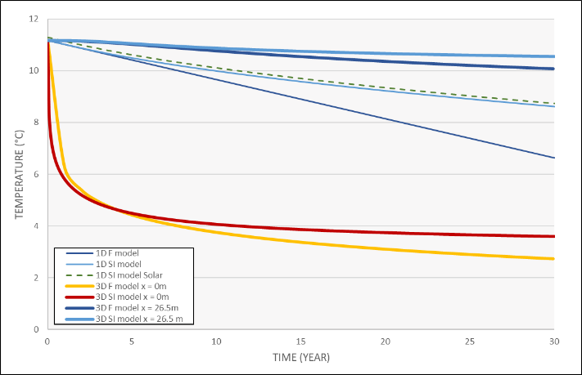 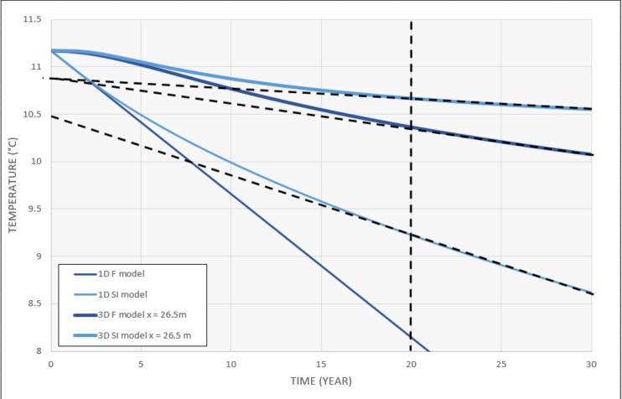

Fig 5. Temperature time series extracted at 70 m depth (mid-borehole location) from the 1D and 3D models. Results indicate more drawdown at the borehole location in the 3D model compared to the 1D model. The drawdown is linear in the 1D finite model. In both the semi-infinite 1D model and in the 3D models, where lateral and/or axial recharge is allowed, a quasi-steady-state temperature decline is reached after ~20 years (dotted lines). At 26.5 m from the borehole, the temperature at the mid-borehole depth only decreased by 0.4 °C (T = 10.6°C) after 30 years of extraction, against 2.4°C in the 1D model (T= 8.6°C). In the 3D model, the temperature decreases exponentially at the borehole location, with a temperature drop of ~5.5°C within the first year. A quasi-steady state temperature decline is reached after 12-15 years of heat production. The right plot is a zoom of the left plot for higher temperatures.

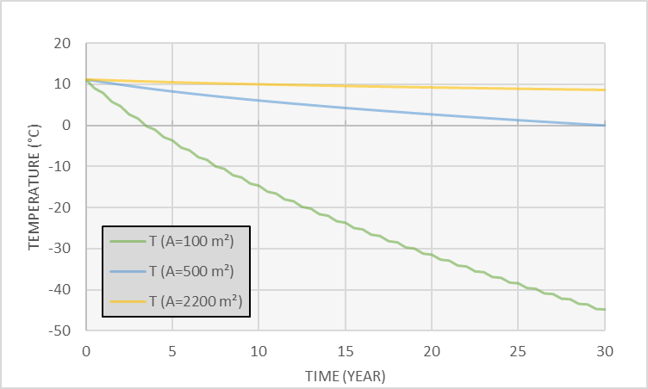

Drawdown for different model area showing the impact of heat drawdown across different volume. In 1D, when moving the volume boundary away from the borehole, heat is sourced from a larger volume, decreasing the amplitude of the drawdown at a specific point.

For both 3D models, the overall temperature change in the models is the same (i.e. about 3.98 x 105 °C over 30 years), which is XXX compared to 1D model. Assuming that 1D models aim at representing far field conditions, we then use the relative difference between temperatures profiles extracted at distance x=4.5 m and x = 26.5 m from the line source in the finite 3D model to the corresponding 1D finite temperature profile to quantify the effects of lateral heat recharge over time. Results show that after 1 year, the temperature at x = 4.5 m has declined by ~ 1.2°C. Similarly, after 30 years of heat extraction, the temperature at x = 26. 5 m has declined by ~ 1.1 °C. Those represent about 20% of the temperature change of 5°C permitted at the borehole and verified by the corresponding finite 1D models. This indicates the presence of a cone of thermal drawdown around the borehole, where the temperature decline is spread over the volume of rock around the borehole. However, results from the 3D models indicate a greater decline at the borehole location than in the corresponding 1D finite model, with a drawdown of ΔT~5.5°C after one year an ΔT ~ 8.4° after 30 years (i.e. temperature of reaching 2.7°C). This suggests that although the temperature decline is spread over a larger volume, reducing the maximal drawdown away from the borehole, most of the heat extracted during the first year is mined from the area close to the borehole, inducing a fast and large drawdown at the borehole location. This opposes to the 1D model, where the temperature drawdown is spread over a same volume at each time step, resulting in a homogeneous temperature drop over the surface area covered by the 1D model element. As the production time increase in 3D models, radial heat transfers allow extracting heat further away from the borehole. Although 1D models allow a simple estimation of the average temperature change in a given volume of rock, this comparison shows that they cannot inform on the temperature distribution around the borehole, and thus on the area of impact in the long term.

We verify this hypothesis by looking at the temperature time series extracted from the mid-borehole location in the 1D and 3D semi-infinite models (Fig.5). Results show that in contrast to 1D models, where the temperature declines a linear rate ~-0.08°C/year from the onset of production, temperature at the borehole location tends to decrease exponentially in the first years of heat extraction in a 3D scenario. After about 12 years, temperature near the borehole approaches steady state conditions with a quasi-linear rate of decrease of ~-0.01°C/year (Fig.XXX). Away from the borehole, the effects of heat extractions are delayed. At x = 26.5 m, temperature starts decline after a year and a quasi-constant rate of temperature decline of ~0.02°C/year is reached after about 20 years. Further away from the borehole, the rate of temperature decline starts to linearize from the onset of temperature decline. This suggests that although steady state temperature tends to be reached at the borehole, this does not correspond to the spatial steady-state temperature conditions due to the poor heat generation and recharge potential of this system.

We then use the 3D full extent model to measure the radius of the area impacted by heat extraction around the borehole over time. The drawdown is measured after 30 years along two horizontal profiles situated at the surface (z = 0 m) and at the mid-borehole (z= - 70 m). Fig XXX shows that for both depths, the radius of influence reaches about 80 m around the borehole, with a total temperature drop of 8°C at the mid-borehole (red horizontal line) and of 0.1°C at the surface. After 30 years, the footprint area of heat mining in the volume with a thermal conductivity of 2.2 W/°C.m is in the order of 20 000 m², that is an order of magnitude higher than the area calculated from the analytical approach.

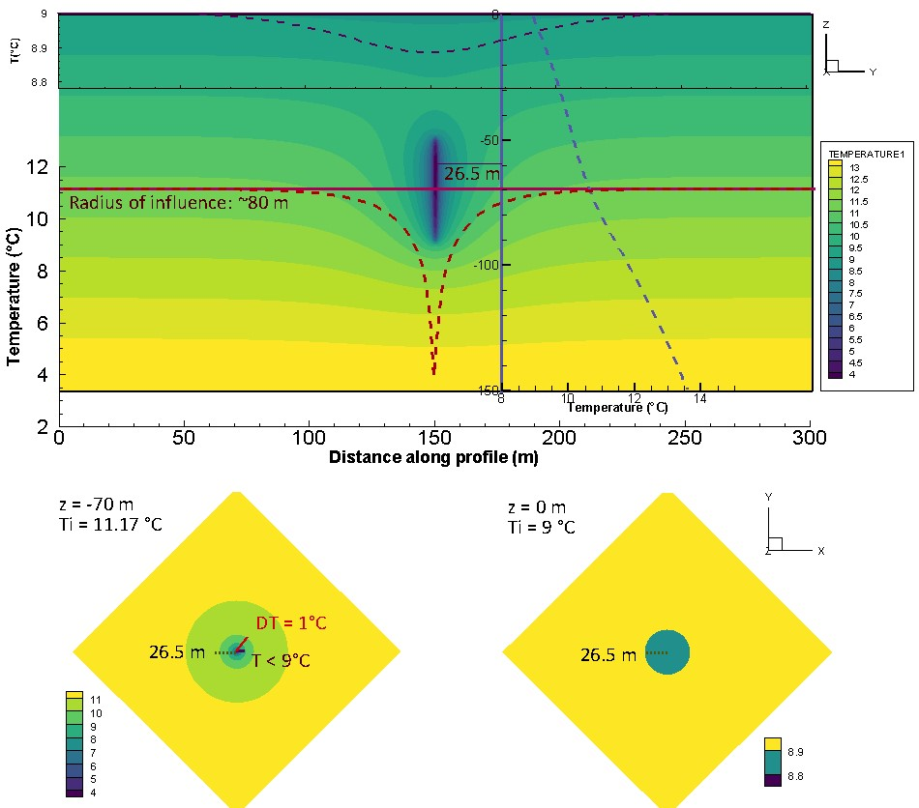

Figure 6: XZ temperature profiles obtained from the full extent 3D model after 30 years of heat extraction. The vertical light blue profile shows the temperature distribution at x = 26.5 m and the dark blue and red profiles represent the temperature distribution at y = 0 and y = -70 m.

To appreciate better the expansion rate of the area impacted by heat extraction, we calculate the axial (vertical) and lateral (horizontal) heat fluxes at t = 1, t = 30 and t = 100 years of heat extraction. Results displayed in Fig. XXX indicate that horizontal heat flux reaches steady state conditions after a year only, stabilizing at a rate of 0.8 W/m² (0.74) in the middle of the borehole, in accordance with the analytical model presented in section XXX, and reaching 0.42 W/m² at the BHE ends. Those constant fluxes indicate that the temperature will decline at a constant rate, and that the area of impact will keep expanding if no additional heat recharge is provided. It can be expected that the lateral expansion of the volume of rock depleted in heat overtime will also participate to an increase in the vertical temperature contrasts, and thus in the contribution from axial fluxes. Fig. XXX shows the axial fluxes keep expanding over time, suggesting a lack of recharge in the upper part of the model. While the upward geothermal heat flux represents a constant heat source at the bottom of the borehole, the net heat recharge above the borehole is indeed negative, both due to the effects of the geothermal gradient and to the downward fluxes induced by heat extraction. In addition, the proximity of the borehole to the surface makes it relatively sensitive to the condition at the boundary. As no heat can be source from outside the model, downward fluxes tend to expand over time as the area depleted in heat expands laterally.

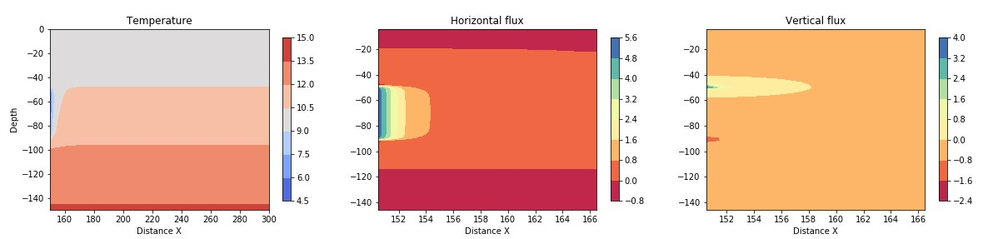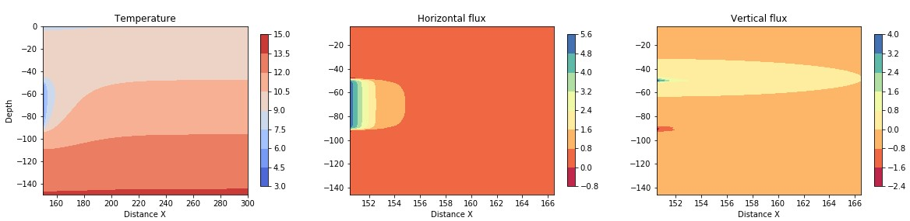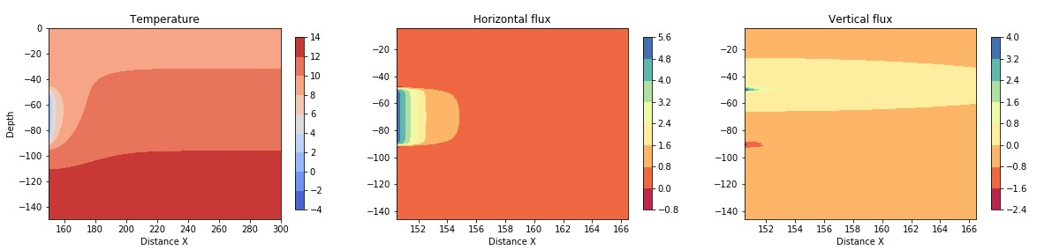

Figure 7: 2D section in the central part of the 3D model showing the vertical and horizontal fluxes after one year (a) 30 years (b), and 100 years (c)

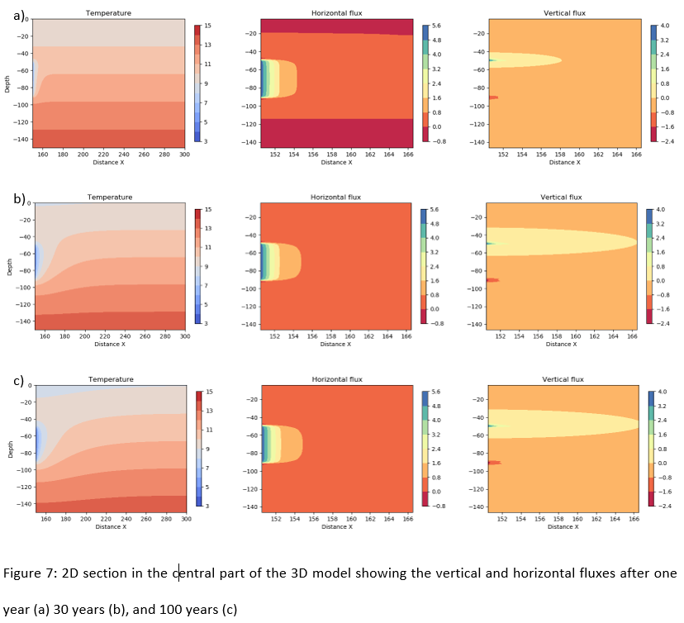

## Solar variations effects

It has been shown from previous studies that solar effects are particularly important when studying the efficiency of borehole heat exchanger when those extract heat from shallow depth, i.e. in the zone of influence of the yearly fluctuation in solar flux (XXX). In our example, the effects of yearly oscillations in the surface heat flux reached about 25 m depth, modifying the direction of the heat flux at a yearly scale in the shallow sub-surface. Below that depth, the complex interaction between the surface and geothermal heat fluxes tend to disturb the steady-state linear geothermal gradient, creating a new equilibrium where the upper part of the geothermal gradient is shifted toward higher temperatures down to 150 m depth (Fig XXX). This suggests a decrease in the upward heat flux that might favour recharge from above.

To avoid overestimating the recharge due to the transient state of the geothermal gradient seen when using fluctuating heat flux (Fig. 3), we use the profile obtained after 100 years without heat production as initial state to the heat extraction model. As production time increases, our analysis showed that the layer of rock depleted in heat expands vertically, amplifying axial fluxes. After about 6 years, temperature time-series indicate the onset of the temperature decline at the surface, showing that the effects of heat extraction reached the surface. We therefore compare the temperature profiles below 25 m depth to assess the energy change in the system after 30 years of heat extraction using constant and fluctuating surface heat flux. This is done to assess the effects of heat extraction from the zone of transient temperature as well as the effects of fluctuating surface heat flux on the recharge to the system.

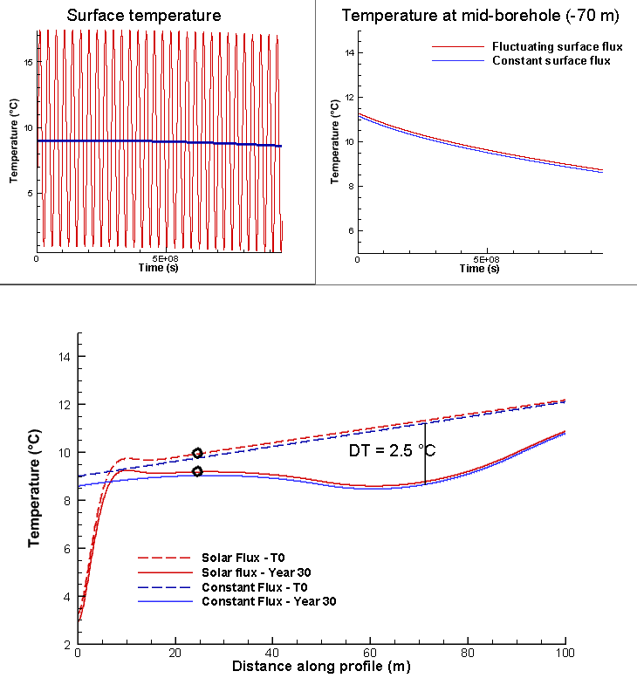

Fig. 8. Results show that after 30 years, the overall change in energy content in the system is only of a few tens of degrees (taking the integrated difference between the constant and fluctuating surface heat flux model between 25 and 150 m depth).

# Discussion

In the previous sections, we have calculated the volume of rock required to provide energy to a typical average UK house for periods of 1 and 30 years, based on analytical equations allowing a temperature change of 5°C in the system. The required heat load was compared to the available natural recharge in the system (i.e. radioactive heat, geothermal and solar heat flux) for a case study located in the Midlothian Coalfield, Scotland. We then used 1D and 3D numerical models to verify the mathematical model and calculate the amplitude of vertical and horizontal flux around the borehole. In addition, we evaluated the footprint area of heat extraction at the mid-borehole and at the surface, in a homogeneous system with a thermal conductivity of 2.2 W/°C.m².

While analytical models suggested that natural recharge can only contribute up to 13% of the heat extracted, numerical models confirmed that most of the heat is actually mined from the rock surrounding the borehole. Results from the 3D analysis show that if that heat transfers are not affected by the conditions at the boundaries, steady state flux can be reached after one year. This means that at a specific point, temperature will start declining at a constant rate from at a time t that depends on its distance from the line source (Fig. XXX). In response to the expansion of the volume depleted in heat with time, 3D models also showed the expansion of the downward heat flux above the borehole, allowing greater recharge to the borehole. As the extension of the layer impacted by downward fluxes reach the surface, the lack of input of heat at the surface (i.e. -0.068 W/m²) would explain that steady state flux at the surface cannot be reached as fast as lateral fluxes. In 1D models, where the amount of heat available is constrained by the model area and no recharge is provided from lateral areas, this effect led to an important drop in temperature above the borehole due to the lack of recharge from the surface (i.e. scenario with constant heat flux). This suggests that as the borehole depth increases, allowing more axial recharge, the areal impact of heat mining would decrease. Using a fluctuating surface heat flux, numerical results show that recharge from the surface can be increased by XXX%.

The model described in this study represents a specific scenario that highly depends on the choice of the geometrical parameters and medium properties. Further analysis aiming at assessing the contribution from 1) the thermal conductivity, 2) model area, 3) borehole depth (i.e. distance from the upper boundary), 4) borehole length (i.e. specific heat absorption rate), 5) production time and 6) thermal conductivity on axial recharge and extent of temperature change in the system is presented in SM XXX.

Results presented in SM XXX show that for a given production time the areal impact of heat extraction mostly depends on the thermal conductivity of the rock and on the borehole length, which are inversely proportional to the temperature decline at the borehole. Although increasing the borehole depth favours axial recharge and restrain the drop in temperature at the borehole, it only has a few effects on the areal impact of heat extraction. Therefore, considering axial effect would allow reducing the initial area in 1D model to reach a total temperature drop ΔT = 5°C at the mid-borehole. 3D analysis however showed that after 30 years of heat extraction, the radius of the impact area is only 10-m lower than in the 1000-m thick model. Increasing the borehole length allows decreasing the specific heat extraction rate from 25 W/m for a 40-m long borehole to 5 W/m for a 200 m long borehole. As increasing the borehole length generally represents important investment costs, improving the thermal conductivity of the medium around the heat exchanger is often seen as of primary interest to ensure long-term production and avoid engineering issue due to the accumulation of cold at the borehole (XXX). By confronting the need to ensure the BHE efficiency against that of ensuring the sustainability of the geological resource while constraining the area of impact, we come up against a conflict of interest… Here, we therefore perform simple heat balance analysis to evaluate the amount of annual recharge that would allow constraining the area of impact to 70-100 m² over 30 years. We then verify our model through different cyclical injection/production scenario using the 3D full-extent model.

## Heat balance analysis

The analysis presented in Fig. XXX suggested that although a steady-state temperature can be obtained at the borehole, often interpreted by previous studies as an indication of efficient system, this steady state situation can hardly be reached away from it. The area of impact of heat extraction will expand over time if no heat recovery schemes are planned.

We suggested earlier that radioactive heat production, solar recharge and geothermal heat cannot compensate for the heat extracted on a yearly average under the considered geological and climatic context, without considering an unrealistically large volume of rock. For a defined heat extraction rate and production period, the footprint area of mined heat is highly dependents on the conductivity of the medium. Our analysis shows that lateral heat flux, which defines the rate at which heat is provided to the borehole by the surrounding area, can reach steady state after a year in a homogeneous system. Axial fluxes tend to increase over time, depleting the volume of rock available above the borehole in heat while expanding the zone of influence below and around it, to an extent that depends on the conductivity of the ground.

Vertical heat exchanger coupled ground source heat pump systems use the shallow geothermal energy as a heat source or sink for space heating or cooling. In opposition to horizontal ground heat exchangers, they present the advantage of occupying less land surface area that horizontal ground heat exchanger. However, studies in China (i.e. Li and Lai, 2015; Wang et al., 2012) warned on the irreversible cooling of the ground caused by yearly imbalances in heat extraction/injection from ground source heat pump, especially in cold areas where the cooling needs are low and for large-scale systems with long operational periods (Gao et al., 2015). Some studies showed that other ways to achieve sustainable heat extraction and eliminate the cooling load accumulated into the ground is to perform cyclic production or provide additional artificial heat recharge during the non-heating season, such as solar thermal energy and industrial waste heat recharge (Cui et al., 2015; Cruickshank and Baldwin, 2016). Experimental studies conducted by Trillat-Berdal et al. (2006) showed that the ground thermal loads could be balanced by a system combining geothermal coupled heat pump and thermal solar collector, when the excess heat not used for hot water heating is injected into the ground, and the heat pump either used in cooling or heating mode. Cui et al. (2015) performed similar analysis on the performances of seasonal storage of industrial waste heat, by developing a heat transfer model for vertical GHE boreholes with multi-stage series connections.

## Cyclical production

To compensate for the heat extracted, we evaluate the capacity of different scenarios 1) to decrease the yearly average temperature drop at the borehole and 2) limit the impact area of heat extraction. Those scenarios involve cyclical production with periods of natural recovery, cyclical production with injections of artificial heat and continuous production with constant heat source below the borehole. The objective is to assess the optimal scenario and the recharge in heat required to constrain the area of impact to 70-100 m², which corresponds to the average surface for a property in the UK (i.e. house and garden), over the long term. We will finally compare the heat load required to recharge the system annually to the amount of waste heat or artificial heat available in the Midlothian area.

The first heat extraction scenario considers seasonal heat extraction, with a minimum of -1294 W in winter and a maximum of -706 W in summer, distributed along the 40-m long BHE. The fluctuating heat load is calculated using Eq. 3.1, with *A* = 294 W, the amplitude of the variations and *q* = -1000 W the average year heat load. After 30 years of production from the 3D model, a similar temperature profile to the one with constant extraction rate is obtained (Fig.4), indicating that average yearly extraction rate is representative of a fluctuating extraction rate around this average.

The second scenario considers cyclical production with periods of no production. Over a year, 2000 W are extracted for 6 month and recovery is allowed for the six following months. This results in a temperature decrease of XXX rather than XXX at the mid-borehole. The overall temperature change in the model after 30 years is of XXX instead of XXX. The area of impact….

Finally, the third scenario considers cyclical production with period of recharge. Over a year, 2000 W are extracted for 6 month and 1000 W are reinjected for 6 months. Results… (Fig.9).

# Conclusion

The aim of this study was to assess the spatial impact of heat extraction from BHE systems and the renewability of low-grade geothermal resources. We used simple analytical models to calculate subsurface energy balances in the Midlothian Coalfield in Scotland, considering heat extraction from a 50-m long vertical BHE. One-dimensional numerical models were used to verify the analytical solution and calculate axial recharge. We also extended the models in 3D to assess the effect of lateral recharge and the area of impact of heat extraction. Although previous studies aiming at assessing the long-term performances of BHE systems showed that steady-state production temperature can be reached after a few years of production, we here show that energy balance in the shallow sub-surface (i.e. < 100 m) cannot be naturally reached over the long term and thus steady-state conditions cannot be reached away from the borehole. For a fixed GSHP set up and production period, our study show that the areal impact mostly depends on the conductivity of the ground. Although high conductivity rocks are generally preferred to avoid a fast cooling at the borehole location and ensure sustainable BHE, it also considerably impacts the extent of heat depletion. In a context where geothermal energy becomes of real interest, constraining the footprint area of heat extraction is nevertheless essential to avoid interferences.

By calculating the relative contribution from axial and lateral heat flux, we showed that the initial recharge in the system depends on the long-term energy balance between surface and deep geothermal flux (i.e. initial temperature gradient). As the production time increase, the heat is mined further away from the borehole as the heat generated from radiogenic elements and recharged from solar and geothermal flux does not compensate for the heat extracted. Although steady-state radial flux can be reached after a year of production (i.e. constant rate of temperature decline), axial flux tends to increase with depth, with a maximal amplitude at the borehole ends. This effect is amplified as they reach the upper boundary, where the Neumann (i.e. constant flux) boundary condition prevents from maintaining a fixed temperature at the surface (i.e. this differs from the finite line source model of Zeng et al., 2002).

In addition, this study showed that in geographical areas with low geothermal heat flux and low in-situ heat production, artificial heat recharge is required to ensure sustainable heat extraction and constrain the footprint area impacted by heat mining. 3D analysis showed that the areal impact of heat mining can be minimized by performing cyclical production with periods of no production, while adding cyclical recharge allow ensuring heat balance in the system, decrease the peak in temperature drop at the borehole and ensure sustainability from the heat resource perspective.

Next step will be to assess the relative contribution from heat convection and conduction through the porous medium, using 2D advection-diffusion models (i.e. with groundwater flow). We will also extend this study by using mine-water heat source as a way to disperse heat injected from artificial sources.