# SUPPLEMENTARY MATERIAL

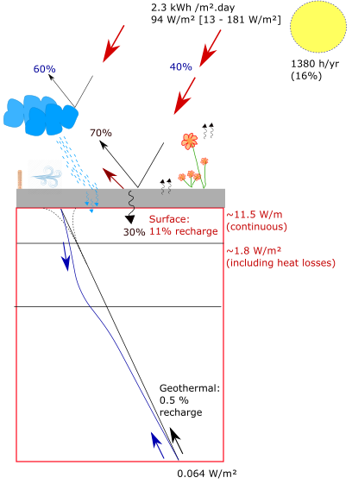

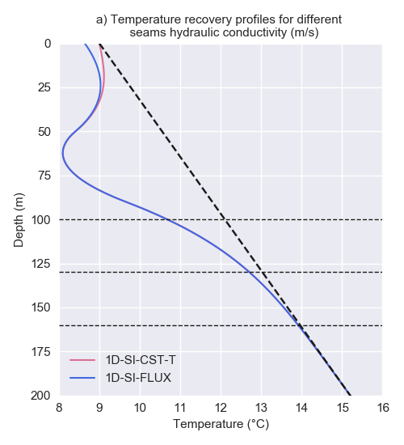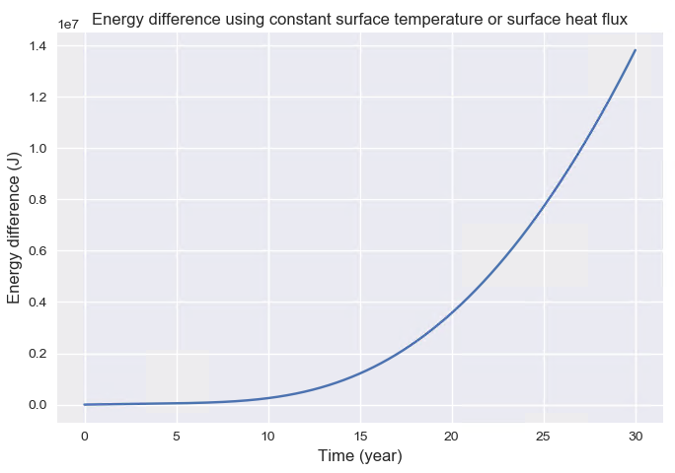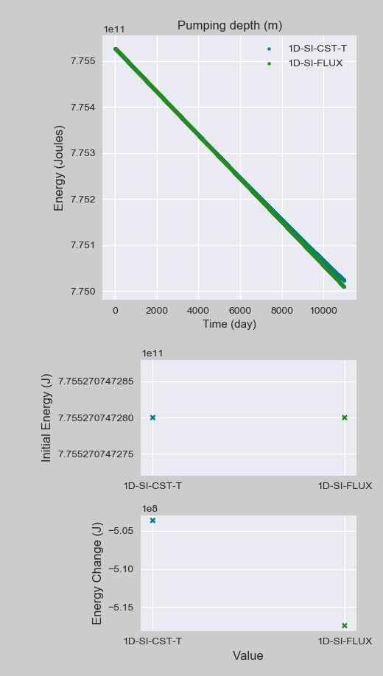

## A1. Radiogenic heat production

The Midlothian Coalfield is located on a geologically stable part of Earth’s crust, where only granite intrusions would contain sufficient concentration of K,T and U element to generate significant radiogenic heat (Gillespie et al., 2013). However, intrusions dated from the Carboniferous to Permian can be found in Scotland in high concentration in the block of crystalline rocks bounded by the Highland Boundary Fault and the Great Glen Fault. Some are located south of Inverness and near Aberdeen but only have small heat producing (HP) values (0.6–2.2 uW/m3), in the Grampian Highlands and in the Northern Highlands (HP of 2.2 to 7.3 uW/m3). Two large intrusions (Fleet and Criffel), with HP values of 3 and 2.2 uW/m3, respectively, were emplaced in Southern Scotland at the end of the Caledonian Orogeny (410–390 Ma). Only one intrusion of significant size, the Distinkhorn intrusion, can be found in the MVS and consists of diorite and granodiorite with relatively low HP capacity (2.0 uW/m3).

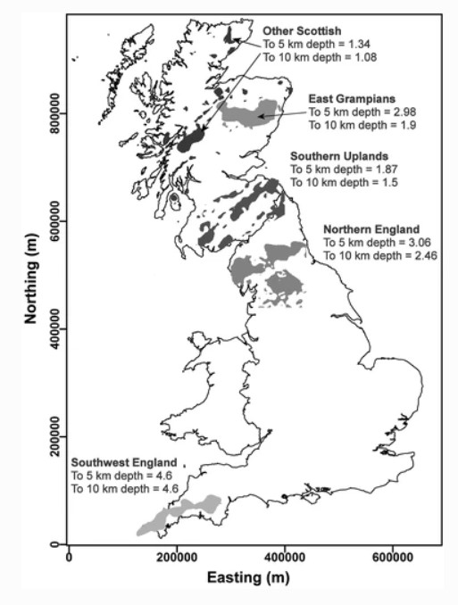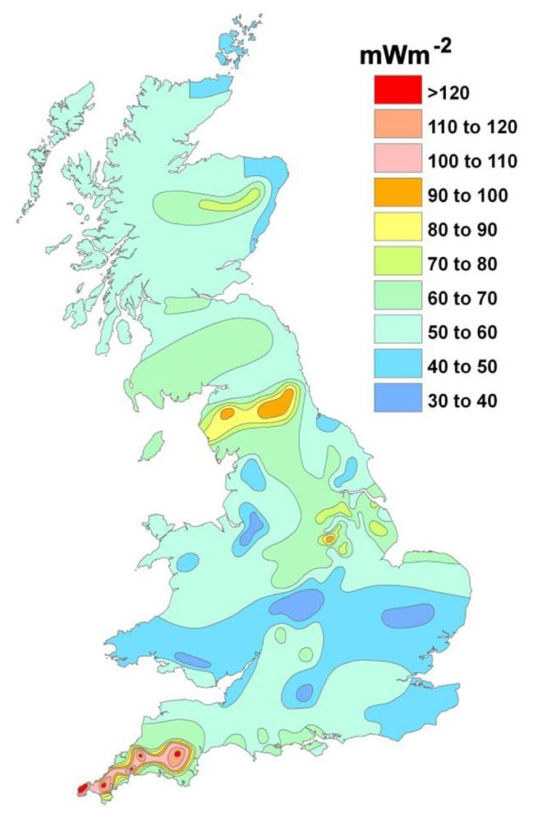

Figure 2.2: a) Locations in Great Britain with significant quantities of heat producing granites within the upper crust. Quantitative figures of average heat production in, uW/m3 (Busby, 2017) b) Heat flow map for the UK (Busby, 2011).

According to XXX, isotopes of U, Th and K can be found in minerals in most crustal lithologies. We therefore attempt to calculate the average radiogenic heat produced in a typical Carboniferous sedimentary succession of the Midlothian Coalfield to evaluate if this could represent an additional source of in-situ heat (Fig. 2.3). Our estimates are based on the thickness of each Carboniferous formation identified the Carrington-1 well (Monaghan, 2014), on the average proportion of lithologies in each group (Entwisle, 2019; Vincent et al., 2010) and on typical RHP values for those lithologies obtained from the literature (Vila et al., 2010; Osimobi et al., 2018). In the Midlothian Coalfield, the sedimentary succession consists of 10-m thick cycles of non-metamorphized sandstones, siltstones and mudstones with beds of limestone, coal, fireclay, ironstone and oil-shale, intersected by andesitic/basaltic lava flows and pyroclastic rocks (Cameron and Stephenson, 1985). This succession, typical of the one found in Scotland, can be subdivided into the Inverclyde group, the Strathclyde group, the Clackmannan (i.e. Upper Limestone Formation (ULGS), Limestone Coal Formation (LSC) and Lower Limestone Formation (LLGS)) and of the Scottish Coal Measures group (i.e. Lower (LCMS), Middle (MCMS) and Upper Coal Measures formations (UCMS)) (Browne et al., 1999). The Upper Limestone Coal Formation is separated from the overlying Coal Measures Group by the Passage Formation (PGP), dominated by relatively coarse-grained sandstone (Browne et al., 1999) (Fig. ??). Using an area of about 82 *km*2 corresponding to the zone covered by the outcrops of the Coal Measures Formation, we find that the total radiogenic heat produced in the Midlothian Coalfield would be in the order of about 86 kW.

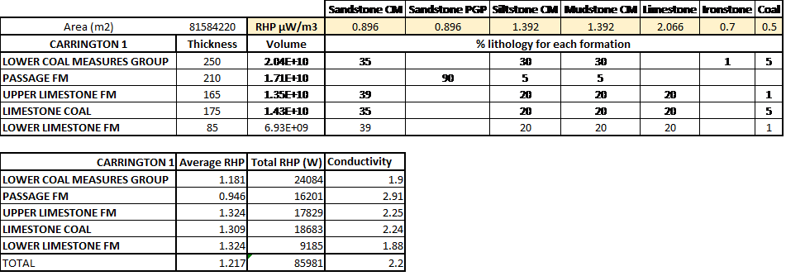

Figure 2.3: Estimates of total radiogenic heat produced in the Midlothian Coalfield based on the thickness of each Carboniferous formation in the Carrington 1 well and on the percentage of lithologies for each formation of the MVS. Data for the Lower (LCMS) and Middle (MCMS) Coal Measures are from the BGS Open Report OR19019 (Entwisle, 2019). Data for the Upper Coal Measures (UCMS), Limestone Coal (LSC) to Passage (PGP) Formations were determined from 9 boreholes logs in Vincent et al., 2010. The average thermal conductivity were estimated from the Maryhill, Hurlet House, Clachie Bridge, Barnhill, Kipperoch (Oxburgh, 1982), Boreland (Anderson, 1940) and Glenrothes (Gebski et al., 1987) borehole logs by Busby, 2019).

Based on the BHE geometry discussed in the previous section, we then calculate the amount of radiogenic heat that would be produced in an homogeneous rock volume with an average RHP of 1.217 uW/m3. Considering a rock volume V = 2800 *m*3, the total heat generated would equal 3*.*41×10−3 W, representing about 0.0003 % of the yearly average heat requirements of 1000 W, which is insufficient to regenerate the heat extracted. With such low RHP, a volume of 0.8 *km*3 would be required to regenerate the heat extracted from decay of radioactive elements.

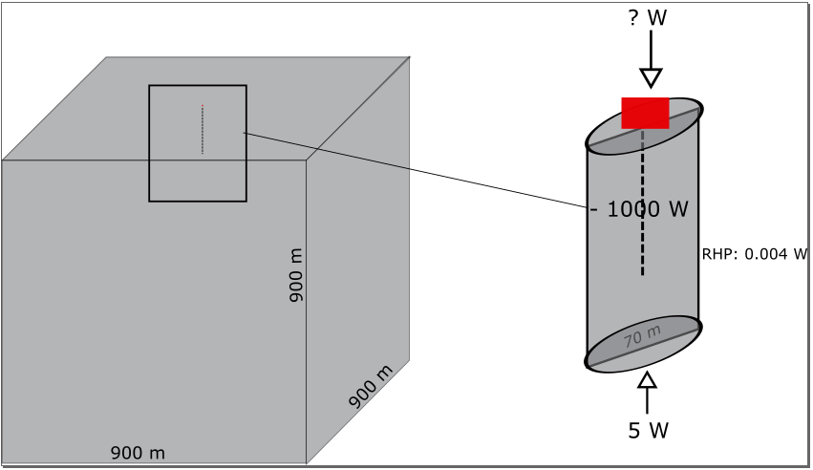

Fig. Sketch of the volume of rock required to regenerate heat from RHP relative to geothermal heat flux.

Radioactive heat generation is then simulated based on 1D numerical models. RHP source terms are added to evaluate their contribution on the steady state temperature profile. After 30 years, results indicate that temperature increases linearly by 0.0004°C only.

## A2. Sensitivity analysis

When production starts, the heat balance in the system is lost as the geothermal flux cannot compensate for the heat abstracted. As the production time increases, axial effects become dominant to provide the BHE with the required heat load by depleting the rock from its heat. In the scenario with constant heat flux boundaries, the absence of heat recharge at the surface and the abstraction of the geothermal heat will lead to a progressive decline sub-surface temperature above the borehole. After 6 years, the propagation of the effects of heat extraction (i.e. downward fluxes) reach the surface, inducing a decline in the ground surface temperature that reaches 8.6 ◦C after 30 years (Fig. 4.3.b). Fig XXX show that the axial fluxes, calculated from 1D model as a function of depth after 1 year and 30 years of heat extraction, are maximal at the top/bottom of the BH. As production continues, their effects become more important and temperature starts decreasing further below and above the borehole.

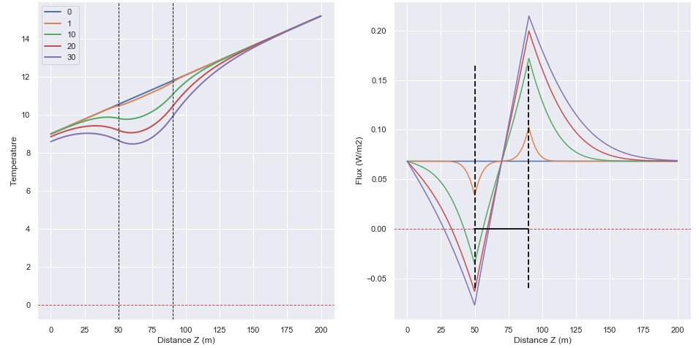

Figure 4.4: Temperature profile and vertical flux profile in the shallow part (< 200-m) of the 1000-m long 1D model (2200 *m*2) after a 30-year production period with constant heat extraction and constant heat flux boundary conditions.

### Available area

We evaluate the impact of the available stored energy on the temperature decrease in the system, using line source areas of 200, 350 and 600 m2 and yearly fluctuating surface heat flux. For each case, the solar and geothermal heat flux are scaled up appropriately and simulations are performed for constant extraction. With a higher constrain of the available area (i.e. 500 *m*2), the temperature decline after 30 years reaches 0°C at the borehole location, as recharge flux are similar to those previously described. The overall temperature change in the system is increased and the temperature change at the surface is in the order of 1.9 ◦C. At the BHE ends, the fluxes are increased from 0.2 W/m (Fig. 4.4) to 0.6 W/m after 30 years.

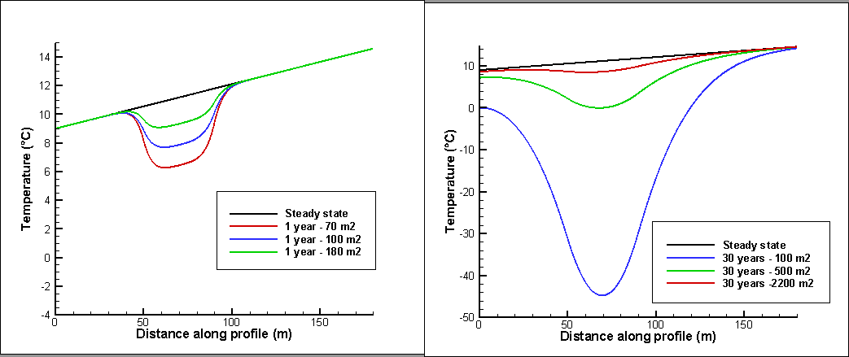

Figure 8: Temperature profiles after a) 1 year and b) 30 years, for a constant extraction rate of -1000W

Just as increasing the area in 1D models tends to decrease the axial fluxes at the borehole ends (by about 95% for an example comparing results after a year for the 70 m² and 2200 m² models), three dimensionality tends to reduce axial fluxes from 75%at the top and 80% at the bottom relative to 1D models (for a profile taken at 4.5 m away from the borehole in the 3D model) after a year of production. After 30 years, 3D effects reduce by 22% the axial fluxes at the top and by 65% the flux at the bottom of the borehole, for a profile taken at 26.5 m away from the borehole. Dividing the BHE length by two doubles the axial fluxes, while decreasing the borehole depth decrease the fluxes. In addition, reducing the conductivity reduces both axial and lateral flux, reducing the recharge to the borehole and increasing and the areal impact of heat extraction, but increase the temperature drop at the borehole.

### Borehole length

We assess the impact of the length of the BHE on the final temperature and the temperature distribution within the line source. By dividing the borehole size by two (i.e. 60 to 80 m depth), the specific heat absorption of the BHE is doubled (i.e. from 25 to 50 W/m). Results from the numerical simulation show that over a year, the drop in temperature at the mid-BHE (70 m²) and the heat flux at the BHE ends are twice the values for a 40-m long BHE, as expected from the mathematical model. However, the 30-year long simulation with the 2200 m² model indicates a maximum temperature drop at the mid-BHE only 0.4°C lower than for the 40-m long BHE. Steady state fluxes tend to be reached faster at the BHE ends, with a rate of about 0.25 W/m², which is only ~5W/m² more than for a the 40-m long BHE. This suggests that the dependence of the temperature distribution on the length of the line source reduces as the model area increases. In addition, the absolute temperature change in the system (∆*T* = 1820◦*C*), the temperature drop at the surface (-0.4 ◦C) and the thickness of the layer affected by heat mining are not dependent on the BHE length. Further analysis showed that while lateral heat fluxes remain the same, contributing up to 76% of the recharge, axial effects at the BHE ends increase to account for the smaller borehole length, reaching up to 69% of the total heat extracted.

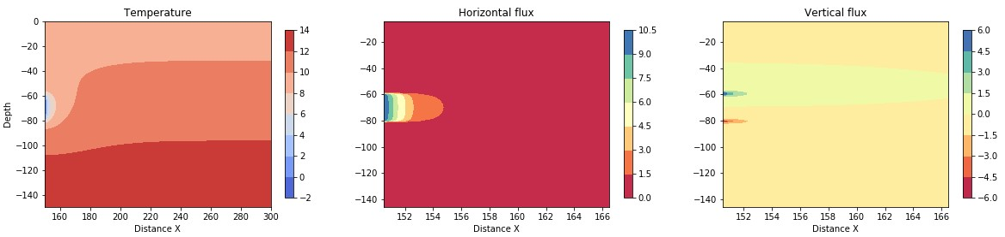

7

### Borehole depth

As suggested earlier, the effects of the boundary condition on the resulting temperature change and thus on the footprint area of heat extraction over 30 years can be critical for shallow borehole. For a BHE situated between 50 and 90 m depth, we showed that the induced downward fluxes reach the surface after about 6 years. A new model placing the BHE between 10 and 50 m depth showed that for such depth, the heat extracted directly originates from the surface and thus temperature starts decreasing on the surface after a year only. Choosing a Neumann boundary condition (i.e. surface heat flux) is in that case generally preferred as it allows the decrease in temperature at the surface avoids the overestimation of the recharge into the system cause by a constant surface temperature. This cause a decrease in axial recharge down to 40%. In this case, we show that the surface temperature decreases by 2.6°C (e.g. against 0.4°C for the deep borehole scenario). The overall temperature change in the system is therefore of ~570°C, about 100°C higher than the case with constant surface temperature, meaning that a constant temperature boundary would over-estimate the heat depletion by 30%. In addition, the rate of temperature decline for shallow BHE is higher than deeper borehole. The analysis of the heat flux from the 1D model indeed indicates that axial recharge is reduced to 40% over 30 years. This is interpreted as a result of the reduction of the volume, and therefore of heat recharge available above the borehole.

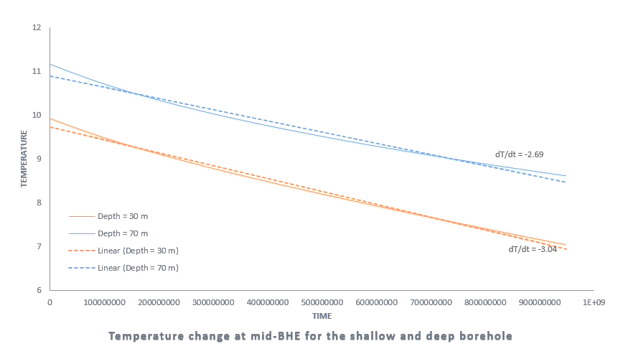

Figure 11: Rate of temperature decrease at the borehole mid-depth for the shallow and deep boreholes

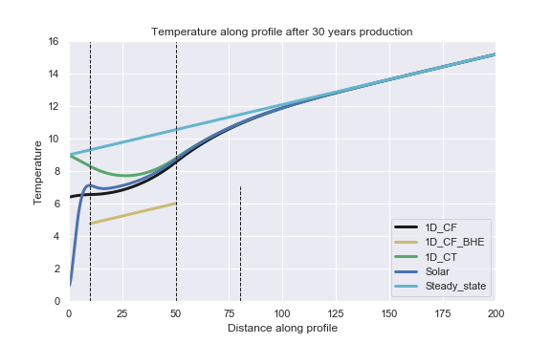

Profiles after 30 years of heat extraction for a shallow borehole

### Production time

Similarly to the reduction of the borehole depth, an increase in the production time is expected to increase the temperature drop in the model. Results from 1D numerical simulation showed that the contribution from axial recharge increases from 50% to 65% while lateral flux remains relatively stable, mining heat laterally at a constant rate. This is due to the increase in the thickness of the layer of rock affected by cooling above and below the borehole.

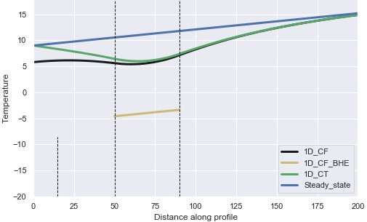

Figure 12: Temperature profile for a constant heat extraction rate from a 2200 m2 area after 100 years of production.

### Rock heat conductivity

We use the mathematic approach used in section XXX to evaluate the amplitude of the heat fluxes that would be induced by the extraction of heat in a medium with reduced heat conductivity. Eq. XXX indicates that with a conductivity of 1.2 W/°C.m, heat fluxes are reduced down to 0.037 W/m² (instead of 0.068 W/m²), reducing the geothermal recharge. Numerical simulations show that using a low conductivity tends to reduce both the distance and the thickness of the rock layer depleted in heat, but also the depth of impact of yearly solar fluctuations. Lower conductivity (i.e. 1.2 instead of 2.2 W/◦C.m) results in a reduced lateral recharge by 4% (73% instead of 76%) and of vertical recharge by 20% (40% instead of 50%) after 30 years, resulting in a smaller temperature decline at the surface (only 0.2 ◦C). The reduced recharge therefore results in a higher temperature drop in the borehole section.

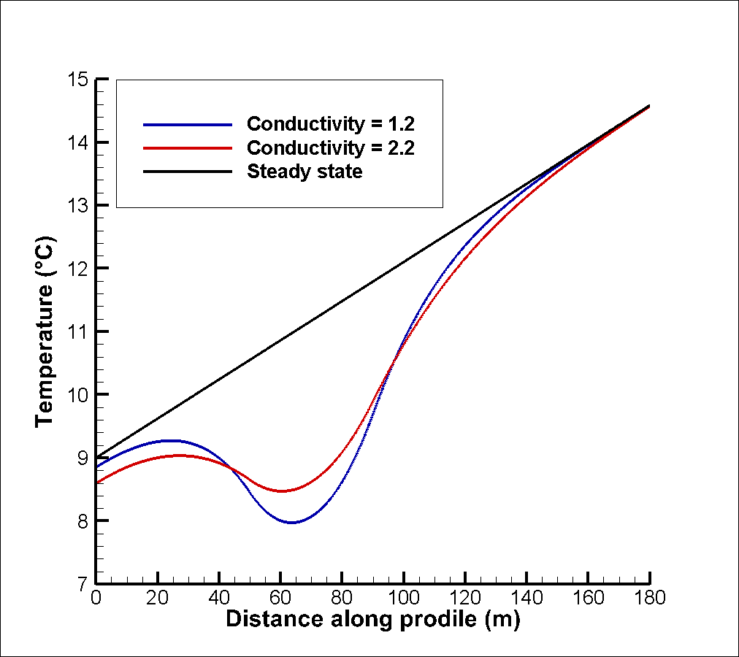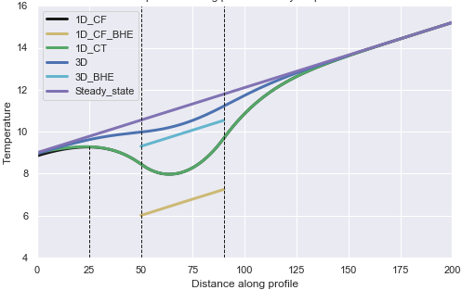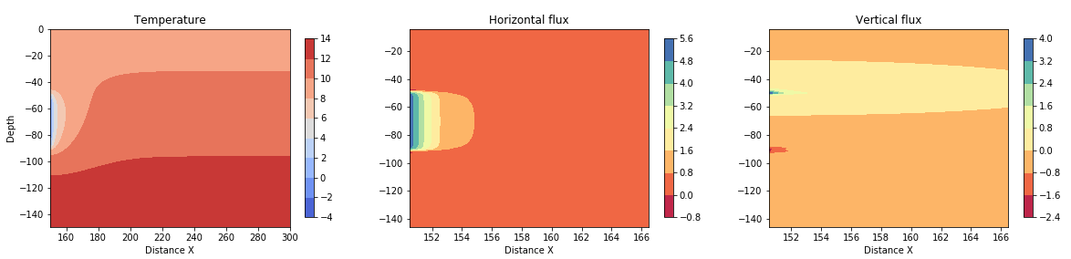

Figure 8: Profile after 30 years with a rock conductivity of 1.2 W/°C.m

### Temperature gradient

### 

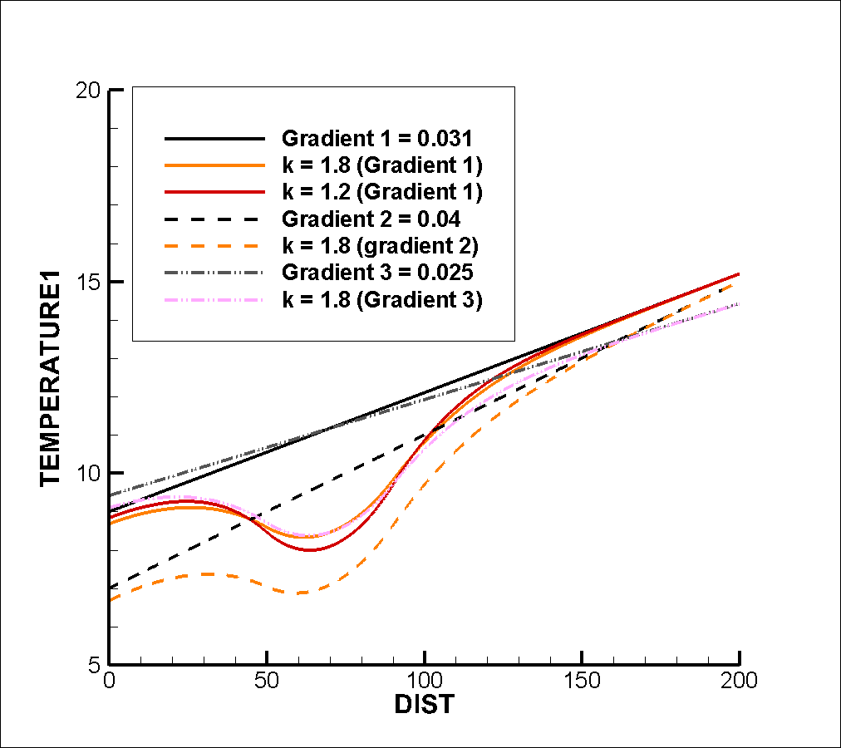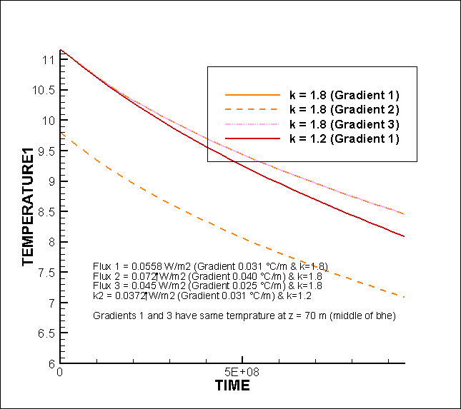

## A3. Constant temperature boundary condition

By comparing the profiles obtained after 30 years of heat extraction from the 2200 *m*2 semi-infinite models using a constant heat flux of -0.068 W/m² or constant temperature of 9°C at the surface, we suggest to assess the effects of the upper boundary condition on the recharge to the system. Fig. 4.2 shows that over 30 years and for a conductivity of 2.2 W/°C.m, the effects of the upper boundary condition propagate down to about 80m depth, where the temperature difference between the profile with constant surface heat flux is only 1×10-3 °C. The greatest difference is observed at the surface, where the temperature decline enabled by heat flux boundary conditions reaches 0.4°C after 30 years of heat extraction. However, the total temperature change in the models only differ by 70°C or 0.02%.

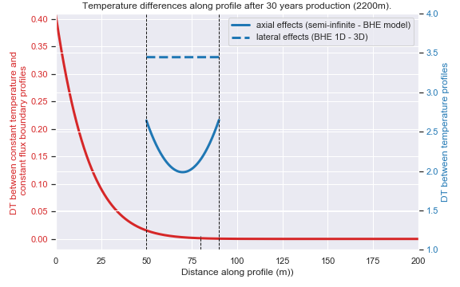

Figure 5: Difference in temperature profiles after 30 years of heat extraction obtained from different scenarios. The red curve show the impact of the upper boundary condition reached about 80 m depth after 30 years. This is also the depth at with the oscillations of the fluctuating surface heat flux totally dissipate. Further analysis described in appendix XXX and also demonstrated by Eq. XXX show that the propagation depth mostly depends on the conductivity of the ground.

## A3. Transient temperature profile

Despite temperature measured below 1.5 km depth are assumed to be only little affected by surface perturbations, Westaway and Younger (2013) suggested that near-surface temperatures in Scotland might have been disturbed by climate warming since the last prolonged glaciation (i.e Ice Age), accounting for the lower geothermal gradient near the surface. When extrapolated to the surface, the best-fit shallow geothermal gradient estimated from boreholes < 400 m depth indeed indicates a surface temperature of 4.0 ◦C, which is lower than the current yearly average surface temperature in Scotland of about 9◦C (Gillespie et al., 2013). Several studies already mentioned the importance of considering the effects of past climatic variations on the shallow geothermal gradient, especially at high latitudes (i.e. Carslaw and Jaeger, 1959; Majorowicz et al., 2012; Raymond, 2018; Beltrami et al., 2017; Gosnold et al., 2011). Paleo-climate signals have been described as a series of mean surface temperature change before present day, that propagates downward by conduction and tends to superimpose to the quasi-steady state thermal field associated to the Earth’s internal heat (Beltrami et al., 2017). While the extent of the perturbations mainly depends on the magnitude and time scale of the past variations, the amplitude of the temperature change due to surface disturbances will tend to decrease exponentially with depth depending on the thermal conductivity of the ground, and with a time lag since the onset of the perturbation at the surface (Westaway and Younger, 2013; Beamish and Busby, 2016; Busby et al., 2015). In the UK, Wheildon and Rollin, 1986 suggested that boreholes < 100 m depth are sensitive to surface temperature variations over the past 500 years, while Beltrami et al., 2017 showed that past climatic signals > 1000 years B.P are still contributing to the thermal state of the subsurface down to 500 m depth. Using individual temperature measurements from shallow depth (< 400m) would therefore tend to underestimated the true "steady-state" background geothermal gradient and thus the extent of the geothermal resource at depth. New interests in re-evaluating the heat flow including paleo-climate corrections have recently grown in the UK. Westaway and Younger, 2013 suggested that heat fluxes measured in shallow boreholes in Scotland would need to be increased by 18 mW/m2 to account for the effects of palaeoclimate. The correction would be reduce to 8.8-13.5 mW/m2 for 1 km deep boreholes and 0.2-9.1 mW/m2 for

1.5 km deep boreholes.

Assuming steady state conditions, the energy that comes in from below is equal to the flux that comes out of the model above (flux through the vertical column is initially constant) and therefore, the recharge only comes from the geothermal heat flux. We suggest to evaluate the impact of the initial temperature profile on the recharge heat flux on the system. We simulate the effects of long-term surface warming (i.e. 1000 years) on the shallow temperature gradient by using a transient simulation, where the initial gradient of 40 ◦C/km is disturbed by a constant surface temperature of 9 ◦C. The significant difference in the profiles obtained from steady state and transient simulation show that for ∆*T* = 9◦*C* on surface, 1000 years is not sufficient for the gradient to reach its undisturbed steady state, with perturbations visible down to 180 m depth.

Unsteady temperature gradients results in different heat fluxes compared to a steady-state scenarios. In our model, a flux of -0.012 is set on the surface against 0.092 on the bottom of the model, allowing a recharge from the surface of about 0.08 W/m2. If no production is performed, this leads to a increase in temperature at the surface of about 3e-5 ◦C in one year. This flux, which allows greater recharge both from below (geothermal flux) and above (solar flux) participates to the return to steady state condition of the geothermal gradient.

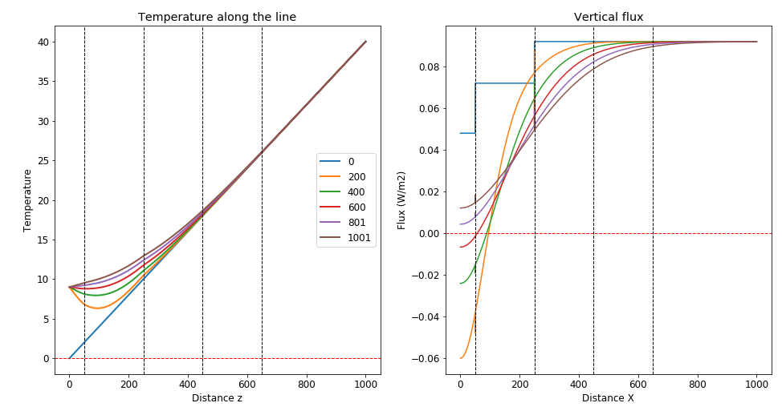

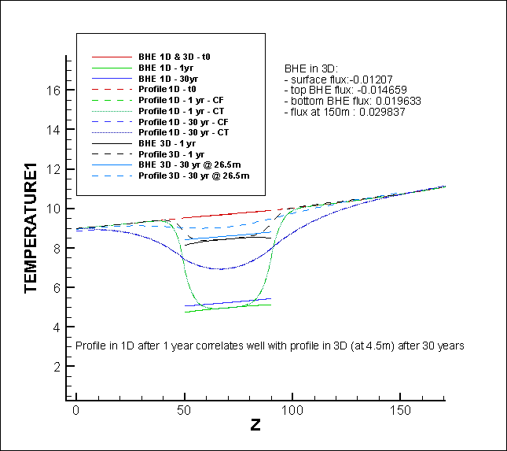

## A4. Recharge

Such scenario could be achieved by injecting excess heat from other renewable energy sources (i.e. solar, wind farms) or "waste heat" produced in cities (i.e. here we use the example of data centres from Edinburgh). The amount of recharge available from solar collectors was calculated and used as input to the 3D model. Results indicated that adding XXX W of recharge would permit a reduction of the area of impact by XXX, showing that a combination of diverse energy sources (i.e. combination of solar or IWH for district heating, and geothermal) is essential to guarantee heat balance and decrease the areal impact of heat extraction.

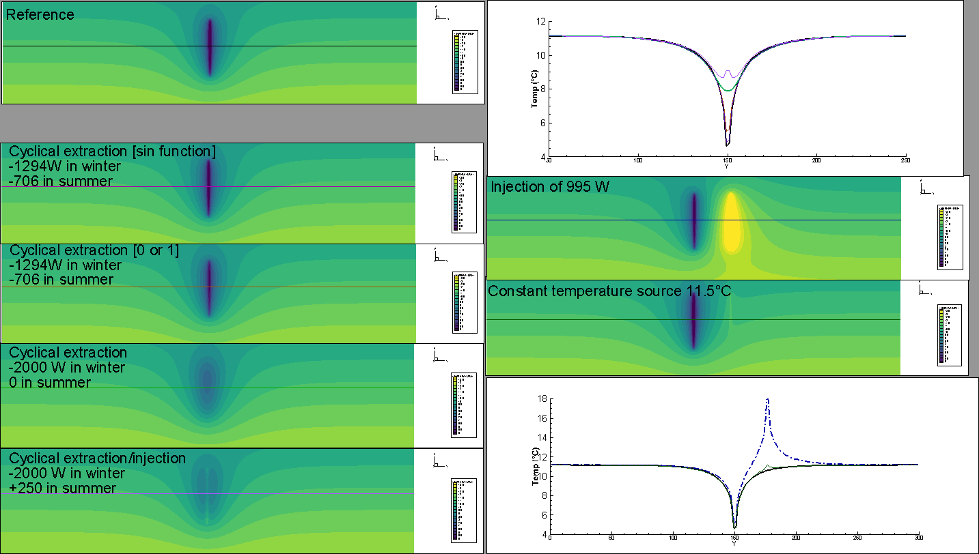

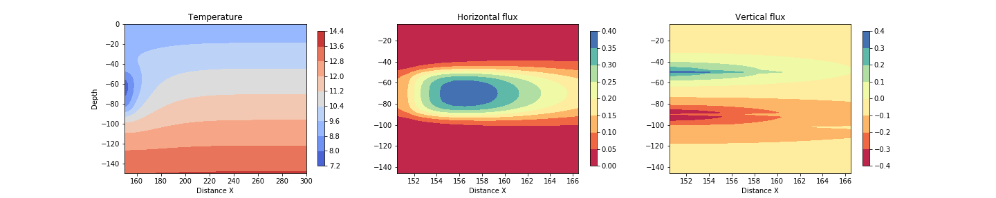

Figure 17: Flux Cyclical production after 30 years

### Mine-water heat Recharge

We first assume that mine water is recharging the system constantly with a constant temperature of 12°C. Using 1D numerical model, we show that this heat recharge allows decreasing the temperature decline at the borehole by a few degrees. Recharge create a temperature source that maintain the overall energy contend of the system, by high conductivity would be required so it can be effectively transmitted to the BHE.

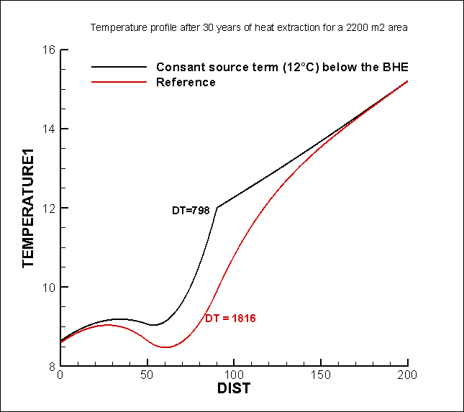

Figure 14: profile with constant temperature

### Solar Recharge

XXX suggested that a way to counteract the imbalance caused by ground heat extraction would be to use hybrid system, and re-inject the excess heat collected by solar panels. In Scotland, solar radiations are about 1000 kwh/year, that is about 2.5 kwh/day. Solar collectors for a single-family house of 4 persons are typically 3-4 m2, allowing to generate 3 to 4 kWh/day of heat (i.e. 150 W, assuming 24h consumption) that can be used for hot water heating. On a yearly average, it is assumed that recharging the ground with solar heat (i.e. if all produced heat is re-injecting, i.e. would include heat for hot water heating purpose and excess heat) would therefore allow reducing the heat extraction from the ground by 15%.

### Waste heat

Recent reports published by the Scottish Government revealed that over 50% of the total energy consumption in Scotland is for heating purposes. In addition to finding new low-carbon energy sources, increasing the efficiency in the energy production and distribution systems appears to be essential. In XXX, the Scottish District Heat Network Investment opportunity proposed the integration of renewable energy from diverse sources, including geothermal energy, industrial waste heat, energy from waste (EfW), biomass boilers, heat from waste water into district heating. Energy recovery from waste heat has been seen as a key factor to meet the challenging ambitions of reaching net zero targets by 2045. In 2018, biomass accounted for the largest proportion of renewable heat generated in Scotland. Heat pumps and solar thermal installations accounted for 6% (340 GWh) and less than 1% (18 GWh) of the total renewable heat output, respectively, while the remaining 20% (1,027 GWh) were generated from energy from waste sources.

Most of industrial processes generate heat as a by-product that is generally wasted through venting into the atmosphere. A few heat recovery technologies based on heat exchanger or water source heat pump systems have been deployed in industries order to recover heat from industrial/cooling processes (i.e. effluent streams) but also from waste water in sewers or from water treatment facilities. Most of them are located in Nordic countries, where industrial waste heat is utilized to provide district heating. In the UK, the first heat from waste water scheme has been implemented in XXX at Borders College, Galashiels, generating XXX W. More recently, a combined heat and power engine has been implemented in Stirling to provide low carbon heat to a city community through a district heating network (source: Scottish Water).

Additionally, Scotland is looking to transform residual waste (i.e. waste that cannot be recycled and generally placed in landfills) into energy. New technologies are being developed to allow the recovery of heat and electricity from the incineration of residual waste or from landfill gas (i.e. EfW operations). According to SEPA, EfW could contribute up to 31% of Scotland’s renewable heat target and to 4.3% of the renewable electricity target set by the Scottish Climate Change Act 2009. Currently, several EfW sites exist in Scotland (i.e. Polmadie Combined Heat and Power plant) and some heat recovery feasibility studies are being conducted by Zero Waste Scotland (i.e. Alloa glassworks). In Edinburgh, the Millerhill recycling and energy recovery centre RERC opened in 2019 is a thermal treatment plant aiming at diverting 155 kT of residual waste from landfill to generate electricity, that would power 32 000 households and business in the Midlothian.

The Midlothian area is moreover host to several data centres (DCs), with five of them located in the Edinburgh area. DCs are facilities that require a vast amount of cooling energy in addition to the energy directly consumed by the IT equipment. Each Watt of power consumed by the IT units indeed produces heat that is dissipated into the air. Air conditioning units are generally used to provide the appropriate cooling and avoid extreme rise in temperature in the facilities. The total heat load (cooling density) of a typical data centre is in the order of 50-150 *W/ft*2. Taking Pulsant Edinburgh data centres in South Gyle and Medway, which are 31000 and 182986 *ft*2and have capacities of 12.85 and 4.20 MW, respectively, the cooling load would be 290 and 16 *W/ft*2, assuming 70% of the IT power need.

Today, only few data centres implemented heat recovery systems. A few authors assessed the possibility of reusing waste heat from DCs on an economical and technological aspects, though efficient cooling systems. Wahlroos et al. (2018) performed a review of the different solution for waste heat utilization. The authors showed that depending on the cooling system, waste heat could be captured at a temperature ranging from 25-35°C for air cooled DCs to 50-60°C for liquid cooling DCs, allowing to recover from 20 GWh/a (Mantsala DC, Finland - 10 MW) to 200 GWh/a (Helsinki DC -24MW) of waste heat. Ebrahimi et al. (2015) and Linna (2016) however showed that many barriers tend to limit the development of heat recovery system for district heating (DC) purposed. Those includes the lack of heat demand (i.e. consumers far from the DCs), the low quality of heat (e.g. low temperature or unstable source of heat) as well as profitability issues (i.e high investment costs, divergent interests between the CC and District Heating operators)

Waste heat can be harnessed for different purpose, ranging from small scale and site-specific utilization (i.e. swimming pool) to large scale district space and water heating, providing an environmentally-friendly alternative to gas heating. In opposition to natural sources, excess heat from human activities (i.e. DCs, EfW, sewage and waste-water ground source heat, industrial waste heat…) generally allows accessing higher temperature (Wahlroos et al., 2018). However, just as solar collectors, the instability of the source of heat is an important barrier to the development of heat recovery system for district heating purpose.

### Sub-surface energy storage

To deal with some of the unstable source of heat provided by waste heat or solar radiations, we suggest to use those heat sources as an artificial heat recharge to the ground. Thermal energy storage (TES) is a technology that can solve for possible mismatch between offer and heat demand by recovering industrial water heat or solar energy and storing it into the ground for a later use (Gao et al., 2015; Köfinger et al., 2018; Moser et al., 2018, Miró et al., 2016). Different methods and storage systems have been developed depending on the resource and medium available, including hot-water TES (water tanks, solar ponds), aquifer stores (ATES), gravel-water TES or borehole TES (Pinel et al., 2011). Theoretical studies have been made on techno-economic aspects of large scale or seasonal energy storage systems with either industrial waste heat or solar thermal energy integration for small district heating in Germany, Denmark and Sweden (i.e. Miró et al., 2016; Cui et al. 2015; Fisch et al., 1998; Hirvonen et al., 2018; Pinel et al., 2011; Bauer et al., 2016; Schmidt et al., 2004; Gao et al., 2015). Using a series of 400 80-m deep borehole stores acting like geothermal BHE, Guo et al (2017) moreover showed that thermal energy storage combining a 20 MW IWH recovery system and solar collectors could ensure stable energy output and supply in a case study located in China. To date, solar-IWH heating system are still on a demonstration stage

Pinel et al. (2011) noted that despite seasonal storage is more economically competitive at the community scale, single detached housing tends to represent a large proportion of the building stock. Small scale TES systems have particularly been developed US and Canada (i.e. Providence House, Hooper, XXX) and are mostly based on solar tanks and rock beds. Alternatively, experimental set up and demonstration projects showed that hybrid systems combining solar collectors and GSHP with seasonal thermal storage could help meeting heating and cooling demand (i.e. example of a residential heating in Turkey by Bakirci et al., 2011). The idea of combining solar collectors and borehole heat exchangers to store heat underground was first suggested in 1956 by Penrod (Gao et al., 2015). Recharging the ground with solar heat is particularly interesting when BHE are too shallow or undersized to collect the necessary heat load. In addition to compensating for the lack of natural recharge, this technology could also enable the reduction of the thermal load of the borehole and thus its length, in the order of 4.5 to 7.7 m per m² of solar collector area (Chiasson, XXX). However, unknown geological conditions and lack of land still represents the main barrier of the development of borehole seasonal solar thermal recharge.

In 2018, 47% of renewable heat generated in Scotland in 2018 came from large size installations (i.e. generally biomass and energy from waste technologies). In opposition to large scale installations, that have the capacity to provide heat all year, small installations (i.e. 45 kW – 1 MW) generally have seasonal demands, mostly depending on space and water heating demand. Most of the heat is provided by heat pump and solar thermal technologies is generated from micro installations (lower than 45 kW), while energy from waste and biomass comes from large installations (more than 1 MW).

APPENDIX

## Equations

The transient heat diffusion equation can be written as follow.

*dT dT*

*ρc*  = −*ρwcwvw*  +∇(*λ*∇*T*) *dt dx*

The first term on the right side represents the advective term, with the mass flow being characterized by the product of the water density *ρw* (*kg/m*3) and velocity *v*, and the second term is the conductive heat transfer, with the medium heat conductivity *λm* (W/m.◦C) and heat capacity of the wet rock *ρc*, *c* the specific heat capacity (J/kg.◦C) and *ρ* the density (*kg/m*3). In a porous rock, the total energy extractable from cooling can be calculated as follow:

*E* = *mr*∆*Tcr*

with E the total energy (J) extracted from cooling rocks of volume V, *mr* = *V*(1−*φ*)*ρr* the mass of rock and ∆*T* the change in rock temperature. ∆*T* can in some cases relates to the maximum temperature change allowed across the heat exchanger.Raymond and Therrien, 2008 estimated that the total geothermal energy content in mines from the sum of the energy associated with each flooded underground section, as:

*Er* =*Vzαρc*

where *Er* is the energy of a given section, V the volume of water in the mine section, z its average depth and *α* the measured geothermal gradient. The rate *Ehp* at which geothermal energy can be extracted from water using heat pumps was calculated as followed:

*Ehp* = *Qw*(*Tp* −*Tr*)*ρwcw*

with *Qw* the average flow rate, *Tp* the pumped water temperature and *Tr* the exchanger return temperature. Assuming that the energy is extracted from water flowing at a rate *Qw*(*m*3*/s*), recharging the system at a temperature *Ti* and extracted at a temperature *Tout*, the rate of cooling of the reservoir ∆*Tr*(◦*C/s*) can be expressed as follow:

*Qwρwcw*

∆*Tr* = ∆*Tw*

*Vφρc*

with ∆*Tw* = *Tout* −*Ti*. The heat fluxes induced by water advection *q*(*W/m*2) can be expressed through the coefficient of heat transfer *h*(*W/m*2*.K*) as *q* = *h*×(*Tr* −*Tw*).

#### Periodic heating

The analytical solution for temperature change in a semi-infinite half space under periodic heating/seasonal change in temperature *Ts* = *T*0+∆*Tcos*(*ωt*) given by Turcotte and Schubert, 2002 is:

*T* 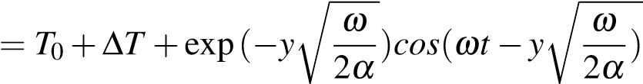

where *ω* = , with *τ* the period of the oscillations. A sinusoidal temperature model representing the variations in heat transferred to the soil at the surface was derived by Hillel (1982) using a sinusoidal forcing function (Ozgener et al., 2013), describing the soil temperature at time t and depth z as:

*T*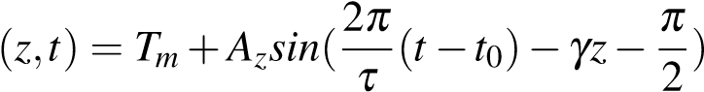

Here, 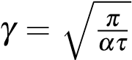 is the inverse damping depth, with *α* the thermal diffusivity (m2/s), defined as *α* = *λρmc*. *Tm* is the mean surface temperature, *t*0 the time lag needed for the surface soil temperature to reach *Tm*, and *Az* = *A*0exp(−*γt*) the amplitude of temperature wave at depth z, time t, which decay exponentially with depth. The undisturbed temperature at depth z and time t taking into account daily and annual temperature variations was expressed in Radioti et al., 2017 as followed:

*T*(*z,t*) = *Tm* 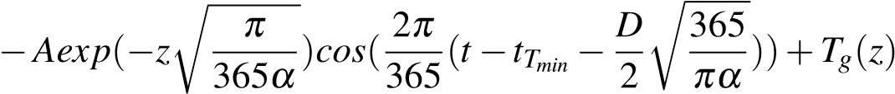

where A is the amplitude of air temperature oscillations, *tTmin* the day number corresponding to the minimum temperature, *α* the equivalent ground daily thermal diffusivity and *Tg* the product of the geothermal gradient by the testing depth.

#### Seasonal production

Angelotti et al., 2018 modelled in 3D the temperature distribution (i.e. thermal plume) in porous aquifer under seasonal production from BHE, considering different groundwater velocity. The temperature response of the medium is here expressed as follow:

*q ux* Z *r*2*/*(4*αt*) 1 1 *u*2*r*2*ψ*

*T*(*x,y,t*) = *Tg*0+ *exp*( ) exp(− − 2 )*dψ*

## 4*πλ* 2*α* 0 *ψ ψ* 16*α*

with *u* = *vx ρρwccw* the effective water velocity. A steady state temperature might be reached for high simulation time and can be defined as follow: *q ux u*p*x*2+*y*2

*T*(*x,y,t*) = *Tg*0+ *exp*( )*K*0( )

2*πλ* 2*α* 2*αt*

#### Diffusion only

For a instantaneous cooling/heating of a semi-infinite half-space, where a constant temperature *T*0 is applied on the top boundary condition of a domain of initial temperature *T*1, the temperature profile can be calculated at a time *t* or distance *z* from the boundary using the following equation (Heat conduction - Dirichlet BC, with q = 0 on the other boundary):

*x*

*T* = *T*1+(*T*0−*T*1)*erfc*(~~√~~ ) (A.1)

4*αt*

with *α* = *ρλrcrr* or *α* = *λρmc*, for diffusion in a dry solid matrix or in a saturated porous medium, respectively. While this solution fits well the numerical time-dependent results, it has been slightly modified to fit the temperature profile at t = 10 000 s, as followed:

*x*

*T* = *T*0*erfc*(√ ) (A.2)

16*παt*

The analytical solution for an instantaneous heat pulse (pulse length = 1 sec) given below () has been tested, but do not fit properly the numerical results (see Fig. ??):

 *T* 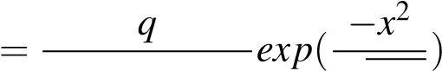 (A.3)

## Analytical solutions

Analytical solutions are necessary to benchmark (quasi-) linear problems and to verify numerical methods that will be used to solve for problems with greater geometrical complexity. Solutions of the partial differential equation for heat transport in porous media have been developed for scenarios with different boundary conditions. A general solution for the calculation of the residual heat dissipated by conduction after an instantaneous heat pulse of energy q in an infinite homogeneous and isotropic medium, derived by Carslaw and Jaeger, 1959, is given in Bauer et al., 2015:

(2.4) *ρ* (4*παt*) 2

∆

*T*

(

*r*

*,*

*t*

)=

*q*

*c*

*n*

+

1

*exp*

(

−

*r*

2

4

*α*

*t*

)

where ∆*T* is the temperature difference between the measured temperature and the background temperature at the time t elapsed since the heat pulse and at a radial distance r from the source (i.e. *r*2 = *x*2 +*y*2), and *n* is a factor accounting for the geometry of the heat source (*n*1*D*=0 for a plan, *n*2*D*=1 for a cylinder and *n*3*D*=2 for a point source). *α* = *λ/ρc* is the thermal diffusivity of the subsurface (*m*2*/s*), with *λ* the bulk ground thermal conductivity (W/m.◦C) and *ρc* =*φρwcw* +(1−*φ*)*ρscs* the volumetric heat capacity of the saturated porous media ), calculated from the weighted arithmetic mean of the solid matrix *ρscs* and water *ρwcw*.

The problem of heat diffusion in a porous media due to heat extraction/injection from BHE has first been described using the Infinite Line Source (ILS) model (Carslaw and Jaeger, 1959). For a constant heat injection *q* (W/m) along the vertical axis of a line source, the temperature distribution around a BHE can be solved using the following solution (Monzo, 2011; He et al., 2018):

*q r*2

∆*TILS*(*r,t*) = *E*1 (2.5)

4*πλ* 4*αt*

where *E*1 is the exponential integral function. This function can be approximated by *r* for large values of *αr*2*t* , with *γ* the Euler’s constant = 0.5772. In BHE models, a thermal resistance factor *Rb* is generally added in order to faithfully characterise the heat transfers between the borehole walls the circulating fluid (i.e. Monzo, 2011).

The ILS solution describes the temperature change at the borehole wall (r =quasi rb):

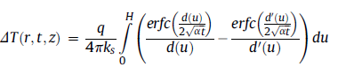

Extensions of infinite line source model have been made to better study the fluxes induced by heat extraction/injection whilst accounting for axial effects (Zeng et al., 2002; Molina-Giraldo, 2011) and for seasonal/cyclical effects (i.e. Rivera et al., 2015; Erol et al., 2015 in situations with or without groundwater flows. The solution derived by Zeng (2002) to evaluate the axial effects is based on a constant line-source with finite length H in a porous media, derived by applying the method of images (Eq. 2.6).

In Marcotte et al. (2010), analytical solutions allowed to verify that the importance of axial effects and the discrepancy between infinite and finite models increases with the Fourier number (αt/r² = 4.54 and 181.4 for these two cases). In opposition to finite line source model, both analytical and numerical analysis showed that temperature steady state can be reached using infinite line source model.

Finite line source model assumes a constant temperature at the ground surface equal to the undisturbed ground temperature. This hypothesis would more or less correspond to the case of geothermal boreholes located under a building slab (Marcotte et al., 2010)

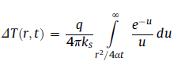

Salah Saadi and Gomri (2017) investigated thermal interferences under seasonal effects and a dynamic heat flux for a vertical coaxial borehole heat exchangers field. The authors suggested that physical phenomena such as axial effects, seasonal effects, underground water flow and BHE dynamic behaviour must be accounted for in order to reflect exactly the real physical situation before the design and parametrization of ground coupled heat pump systems as a heat source or sink.

*From the aforementioned discussion, it is clear that both effects combined, axial and groundwater flow, have a major influence on the thermal response of a BHE for Peclet numbers between 1.2 and 10. It has to be mentioned that the presented results are expressed based on a Peclet number, in which the characteristic length is set to be the borehole length (H). This is to emphasize that this parameter determines the finite length of a BHE, the focus of this work. The Peclet number is a common indicator to compare the role of convection to that of conduction, but as in our study the characteristic length is defined dependent on the scale of investigation. For instance, it is set the borehole spacing (Chiasson et al. 2000), the borehole radius (Sutton et al. 2003), and the radial distance (Diao et al. 2004). Chiasson et al. (2000) stated that advection has a significant effect on the GSHP system performance for Pe > 1. Sutton et al. (2003) showed that for Pe > 0.01, the ground temperature response when advection is considered highly differs from the response with only conduction. Finally, Diao et al. (2004) revealed that for Pe > 0.005 the impact of groundwater flow must be accounted for. Due to the different underlying characteristics lengths, these values, however, are not directly comparable. For the specific case of H = 50 m, when normalizing our results with respect to the aforementioned characteristic lengths, we obtain equivalent Pe = 0.11, 0.0013 and 0.002 for Chiasson et al. (2000), Sutton et al. (2003), and Diao et al. (2004), respectively (Molina Giraldo, 2011).*

*Notes from* Zhao et al., 2020

