<http://earthwise.bgs.ac.uk/index.php/British_regional_geology:_Midland_Valley_of_Scotland>

Busby, 2014

Rocks in Upper Palaeozoic are hard and compact with low porosities and intrinsic permeabilities less than 1×10–14 m2 and often less than 0.1×10–14 m2. Water flows that do occur are

often in fractures and fissures (i.e. upflow of warm water through fractures at Bath, Bristol and south Wales and in the Peak District around Buxton (Brassington 2007; Gallois 2007)). Temperatures as high as 46 °C were recorded in Bath where groundwater has risen relatively rapidly through fractured Carboniferous Limestone (Barker et al. 2000).

Westphalian Coal Measures:

* Most of the remaining Coal Measures within the UK occur at shallower depths where temperatures are unlikely to exceed 40 °C. Sandstones form significant thicknesses in places
* In the East Midlands, Coal Measures are up to 2,800 m deep. Sandstone porosities are around 12–15 % and intrinsic permeabilities for the Lower and Middle Coal Measures sandstones range from 0.006×10–14 to 3.7×10–14 m2 and for the Upper Coal Measures from 0.2×10–14 to 15.8×10–14 m2. Cumulative sandstone thicknesses are between 7 and 210 m resulting in low transmissivities. Little is known about these rocks at depth, but matrix permeabilities are anticipated to be low with any groundwater movement occurring along fractures (Downing and Gray 1986a).

Namurian rocks beneath the CoalMeasures : In northern England and Scotland, the lateral equivalents of the Carboniferous Limestone are rocks in which shales and sandstones dominate and limestone is of less importance. The mean porosity of the Fell Sandstone is 7.2 %, the mean horizontal intrinsic permeability is 2×10–14 m2 and the mean vertical intrinsic permeability is 7.2×10–14 m2. An intrinsic transmissivity of 1.2×10–12 m3 was calculated from the horizontal intrinsic permeability. Permeabilities are likely to be enhanced at depth by fissure flow. It has been suggested that major fault zones such as the southerly bounding fault (the Ninety Fathom-Stublick fault zone) of the Northumberland Trough may enable groundwater convection (Younger et al. 2012). In this case, the North Pennine granitic batholith (formerly known as the Weardale granite), which is a buried high heat-producing granite to the west southwest of Newcastle upon Tyne (Kimbell et al. 2010), could be the source of warmer water that then migrates eastwards. A borehole in the centre of Newcastle upon Tyne (Science Central) recently intersected 377 m of Fell Sandstone below a depth of 1,419 m and recorded a temperature of 73 °C at a depth of 1,767 m, indicating a geothermal gradient of 36 °C km–1. Figure 6 illustrates the position of the borehole on the southern margin of the Northumberland Trough.

Old Red Sandstone + associated volcanic rocks occur extensively beneath Carboniferous cover in the Midland Valley of Scotland. The sequence consists predominantly of sandstone with subordinate mudstone and is usually over 500 m thick, at depths of 500–4,000 m. Knox Pulpit Formation has porosity greater than 20 % and intrinsic permeability greater than 59×10–14 m2. This formation is not cemented, but despite the high permeability, 70 % of the transmissivity is derived from fracture flow. If the hydrogeological properties extend to depth, then the eastern Midland Valley offers the best potential for geothermal reservoirs within the Upper ORS. Lower ORS also attains great thicknesses within the Midland Valley but low permeability results in predicted intrinsic transmissivities of only 2.5×10–12 m3. In northern Scotland, the Orcadian Basin is known to have ORS thicknesses of around 4,000 m. Extremely high vitrinite reflectance values and spore colours developed over an extensive (∼300 km2) area of ORS rocks within the basin are inferred to result from contact metamorphism by a large, concealed Late Devonian pluton (the ‘Caithness Granite’; Gillespie 2009). Although no other evidence has been presented for a buried granite, if it was present and had high heat production, it could possibly lead to elevated heat flow and a high geothermal gradient.

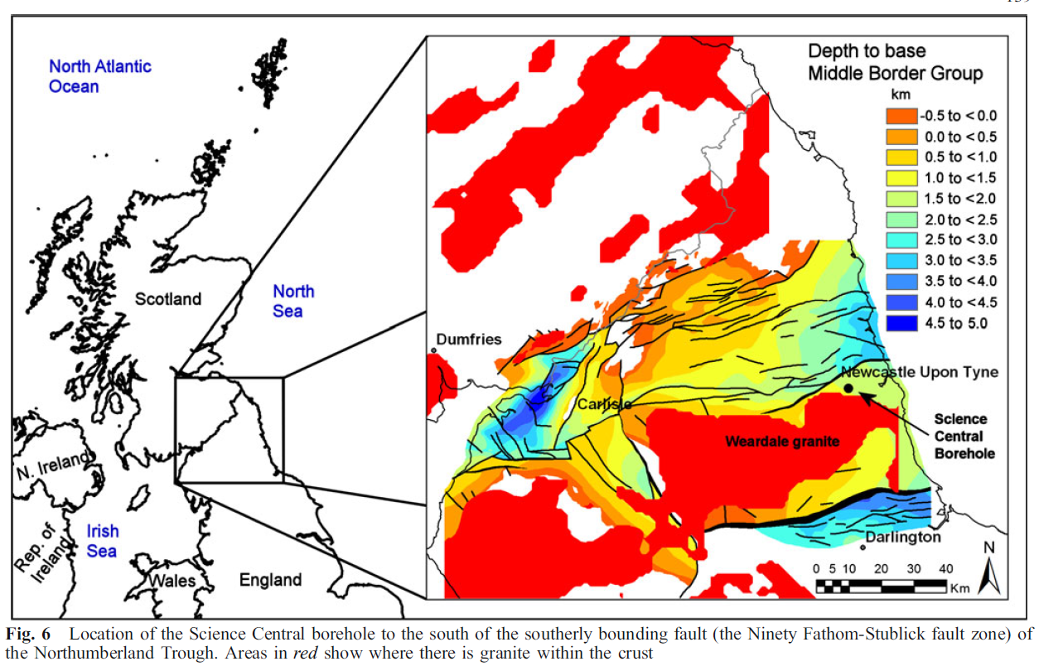

Gluyas, 2018

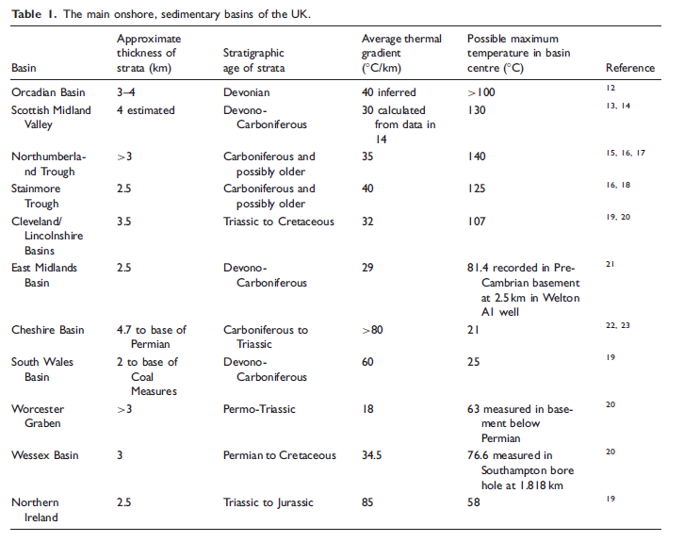

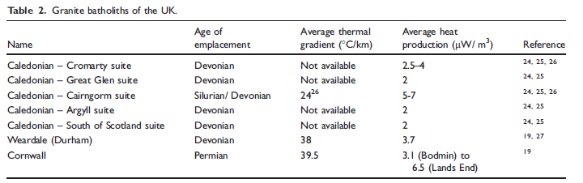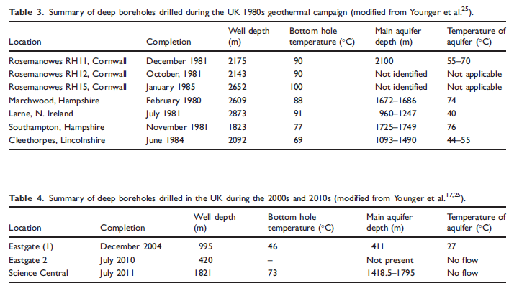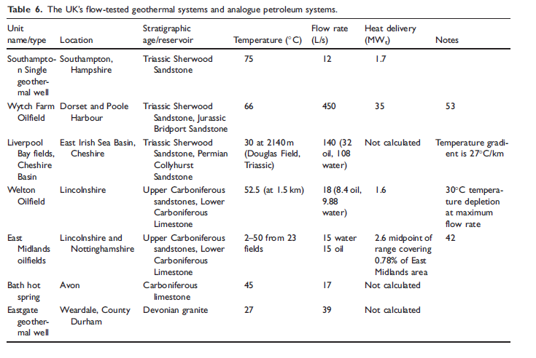Eastgate 1 : The Mid-deep part of the well encountered naturally fractured Weardale Granite- BHT = 46 _C and the well flowed saline water from a zone at 411m and at a temperature of 27 _C. Producing water at a rate of 140 m3/h (39 L/s) from per meter of drawdown and the heat flow was measured at 111 mW/m2.

Eastgate 2, drilled in 2010, 700m away from Eastgate 1. Showed that granite at Eastgate 2 has the same thermal gradient as Eastgate 1, but impermeable, confirming that the fracture (Slitt Vein) permeability in Eastgate 1 is local and associated with the bounding fault to the granite.

Newcastle Science Central: target same fracture as Eastgate 1, drilled down to 1.8km in the Lower Carboniferous Fell Sandstones, close to the Ninety Fathom Fault (equivalent to the Slitt Vein). The well proved the high thermal gradient but failed to flow water to surface.17

Downing and Gray19 provided the first comprehensive nationwide assessment of geothermal potential

for production of hot water from Permian and younger strata in the UK.

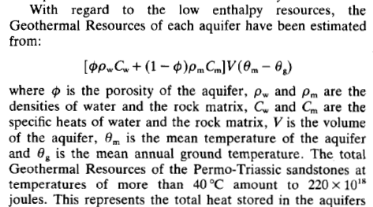

Busby, 2014

The change in surface temperature will propagate into the ground, but the amplitude of

the change will decrease exponentially with depth and there is a time lag between the

temperature perturbation at the surface and at depth. The rate of the exponential decrease and the time lag are both dependent on the thermal diffusivity of the geological strata.

Representing the surface temperature history as a series of step changes in temperature, Carslaw & Jaeger (1959) have shown that  where Tθ is the departure from original equilibrium temperature at depth z and time t after an instantaneous change in surface temperature of T0; κ is the average thermal diffusivity of the geological strata down to depth z and erfc(x) is the complementary error function.

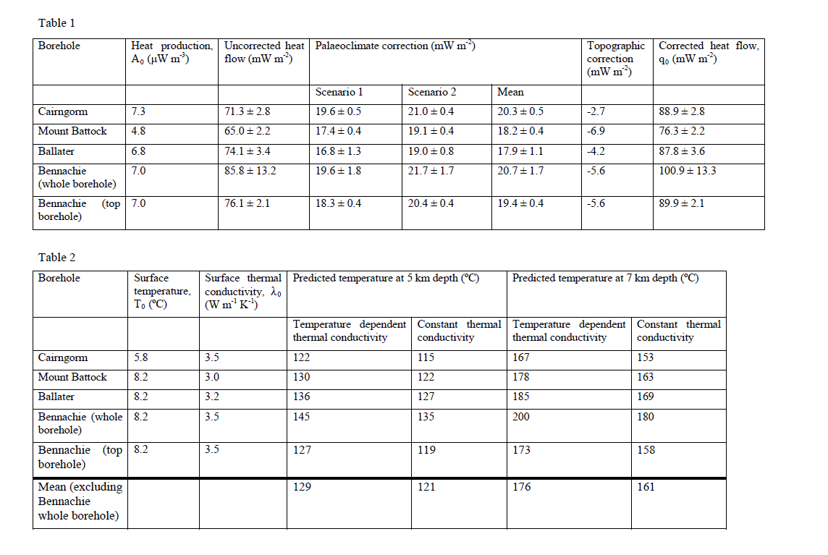

<http://earthwise.bgs.ac.uk/index.php/OR/17/001_The_distribution_of_natural_radioactivity_in_rocks>

High background radioactivity is principally associated with large granitic bodies, in particular the evolved potassium-rich alkaline granites, including, Cairngorm and Etive in northern Scotland; Caledonian granites of the Southern Uplands of Scotland and northeast England (e.g. Criffell Granodiorite and Cheviot Granite), and the Altanabreac Granite in Sutherland and Caithness, northeast Scotland. These granites contain high concentrations of uranium, thorium and potassium (Plant et al., 1983). Most of the uranium and thorium in these granitic rocks is hosted within primary igneous accessory minerals such as uraninite/pitchblende, thorite, thorianite, zircon, xenotime, monazite-cheralite, apatite, titanite, allanite and apatite.

High levels of background radioactivity are also associated to:

* interbedded lacustrine rocks of the Middle Old Red Sandstone (Devonian) of the Orcadian Basin of Caithness, Sutherland, Orkney and Shetland in northeast Scotland. These rocks contain significant uranium closely associated with organic-rich strata, phosphatic fossil-fish beds and localised carbonate-sulphide fracture mineralisation (where minor amounts of uranium minerals are often associated with residual bitumen related to hydrocarbon mobilisation (e.g. Milodowski et al., 1989).
* localised hydrothermal polymetallic vein mineralisation. i.e. Broubster, near Dounreay in Caithness (Gallagher et al., 1976; Ball and Milodowski, 1989[[16]](http://earthwise.bgs.ac.uk/index.php/OR/17/001_The_distribution_of_natural_radioactivity_in_rocks#cite_note-Ball_1989-16); Milodowski et al., 1989[[28]](http://earthwise.bgs.ac.uk/index.php/OR/17/001_The_distribution_of_natural_radioactivity_in_rocks#cite_note-Milodowski_1989-28)), and several other small vein deposits in Caithness and Orkney (Gallagher et al., 1976);
* Secondary oxidation, leaching and remobilisation of uranium from the primary vein mineralisation by percolating groundwater, locally re-concentrated by re-deposition in adjacent sediments, resulting in the formation of a wide range of secondary low-temperature uranyl minerals associated with many of these deposits (concentrations up to 1000 ppm, i.e. Basham et al., 1989; Ball and Milodowski, 1989; Milodowski et al., 1989).
* shale and volcanic lithologies of the Ordovician and Silurian of Wales and the Southern Uplands of Scotland, and the Devonian of southwest England. Some of these areas are associated with moderate-to-high radon risk (e.g. Environment Agency, 2007; Miles et al., 2007; Scheib et al, 2013), and petrographic analysis indicates that uranium is hosted largely within detrital heavy minerals (zircons etc.), iron-rich clays, goethite alteration products, and phosphatic (apatitic) cements (Hyslop and Pearce, 1999[[50]](http://earthwise.bgs.ac.uk/index.php/OR/17/001_The_distribution_of_natural_radioactivity_in_rocks#cite_note-Hyslop_1999-50); Hodgkinson et al., 2006[[47]](http://earthwise.bgs.ac.uk/index.php/OR/17/001_The_distribution_of_natural_radioactivity_in_rocks#cite_note-Hodgkinson_2006-47) and unpublished BGS data).

Moderately-high radioactivity is associated with localised sedimentary facies such as: phosphatic limestone horizons in the Lower Carboniferous Dinanian limestones, mostly in north England; organic-rich marine bands in Namurian and Westphalian mudrocks (e.g. Bowland Shale, Edale Shale); the ironstones and limestones within the Jurassic — i.e. Lias, Inferior Oolite Group (including the Northamptonshire Sand Formation, previously referred to as the Northamptonshire Ironstone) Great Oolite Group and Bridport Sand Formation (Plant et al., 1983[[40]](http://earthwise.bgs.ac.uk/index.php/OR/17/001_The_distribution_of_natural_radioactivity_in_rocks#cite_note-Plant_1983-40); Hodgkinson et al., 2006[[47]](http://earthwise.bgs.ac.uk/index.php/OR/17/001_The_distribution_of_natural_radioactivity_in_rocks#cite_note-Hodgkinson_2006-47); Schreib et al., 2013[[48]](http://earthwise.bgs.ac.uk/index.php/OR/17/001_The_distribution_of_natural_radioactivity_in_rocks#cite_note-Schreib_2013-48)).

The areas of lowest background radioactivity correspond to: the Cretaceous Chalk, Tertiary sedimentary rocks, and unmineralised Lower Carboniferous Limestones in England; granulite-facies Lewisian metamorphic rocks of northwest Scotland, and; areas underlain by mafic and ultramafic rocks in general (e.g. the lizard, Cornwall), Tertiary basalts of northwest Scotland, and mafic and ultramafic rocks of the Grampians and Aberdeenshire).

The Hunterston site is located on bedrock belonging to the Late Devonian Stratheden Group Group (Figure 7). Regionally, these rocks consist mainly of red-brown sandstones with subordinate conglomerates and mudstones (Browne et al., 2001[[61]](http://earthwise.bgs.ac.uk/index.php/OR/17/001_The_distribution_of_natural_radioactivity_in_rocks#cite_note-Browne_2001-61)). No specific rock data for uranium, thorium and potassium are available from this site. However, Figure 3 indicates that these rocks have a relatively high total background radioactivity. Petrographic analyses of this formation from elsewhere in the Midland Valley of Scotland (Milodowski and Rushton, 2008[[62]](http://earthwise.bgs.ac.uk/index.php/OR/17/001_The_distribution_of_natural_radioactivity_in_rocks#cite_note-Milodowski_2008-62); Monaghan et al., 2012[[63]](http://earthwise.bgs.ac.uk/index.php/OR/17/001_The_distribution_of_natural_radioactivity_in_rocks#cite_note-Monaghan_2012-63)) shows the sandstones are commonly subfeldspathic to sublithic arenites with detrital quartz and minor K-feldspar, albite, muscovite, biotite and chlorite. Mudstones and siltstones are commonly composed of illitic clay with minor quartz, muscovite, biotite and chlorite. Therefore, at least part of the radioactivity will be derived from potassium decay in these potassium-rich minerals. However, it is also possible that the enhanced radioactivity may be related to the presence of phosphatic fossil fish in this formation (Browne et al., 2001[[61]](http://earthwise.bgs.ac.uk/index.php/OR/17/001_The_distribution_of_natural_radioactivity_in_rocks#cite_note-Browne_2001-61)).

**Monaghan, A.A. 2014. *The Carboniferous shales of the Midland Valley of Scotland: geology and resource estimation*. British Geological Survey for Department of Energy and Climate Change, London, UK.**

Coals have been mined in Scotland since the 12th century. Of importance to this study is that methane was a serious problem for coal mining in Limestone Coal Formation strata in the western part of the Central Coalfield (e.g. the Bedlay and Cardowan colleries; HM Inspectorate of Mines and Quarries 1982). Oil seepages were also recorded close to large faults in the St Flannans (above the Kilsyth Coking Coal), Auchenreoch and Gartshore 11 collieries near Kirkintilloch, with 56 tonnes of oil recovered from St Flannans in 1905-06 (Robertson & Haldane 1937). Today, methane venting from coal mines takes place in some areas such as Chryston in North Lanarkshire. The coal-mine gas is generally assumed to be released from coal seams, no studies have been found that examine whether a component of the gas could be from mature organic-rich mudstones

The depths of the historic mine workings are commonly shallower than 500 m below Ordnance Datum, but a significant number are between 500 m to 1,030 m deep. Mineshafts can be deeper than the coal seams which were worked. The abandoned deep mined strata of the Limestone Coal Formation are much nearer the deeper prospective shale units within this same formation (e.g. Black Metals Member and Johnstone Shell Bed).

In order to quantify the volume of shale within the heterolithic Midland Valley of Scotland succession for the resource estimation, the percentage of shale was measured from natural gamma logs and from selected borehole records for each of the four prospective shale units. A cut-off at around 50% of the API range of the gamma log was used to determine the shale intervals. Igneous rocks (intrusive and extrusive) within the four shale units were included as a non-shale lithology, to give a realistic shale percentage in the rock volume at that locality. Selected borehole records were used for areas lacking in well data. This was done by taking the sum of mudstone, carbonaceous mudstone, muddy siltstone, siltstone etc. lithology thickness, compared to the overall thickness of that stratigraphic unit. The borehole shale values generally gave higher shale percentages than gamma logs due to the inclusion of siltstone. This was factored into contouring the maps. The percentage shale data points from wells and boreholes were geologist-contoured at regional scale using the basin palaeogeographies (Figures 27, 32, 33, 38) as a guide in areas of no measured data points. The contours were then interpolated to give the percentage shale maps shown below (Figures 28, 34, 36, 39). The thickness of shale units incorporated in the percentage shale maps varies from a few inches to tens of feet. Though the overall percentage shale in wells may be similar, the shale can be distributed through the succession in very different ways, largely dependent on the depositional environment. For example, in the Bargeddie 1 well (on the western side of the study area), shales over a hundred feet thick were interpreted as deposited in a relatively restricted setting, whereas in the Kilconquhar Mains borehole (on the eastern side of the study area), a heterolithic succession was deposited in an area interpreted as cut by meandering fluvio-deltaic systems, resulting in only a few shales >50 ft thick (Figure 26).

The palaeogeography for the Limestone Coal Formation (Figure 38) highlights growth on synsedimentary folds and faults, and the palaeocurrent directions of fluvial systems taken from Read (1988) and Hooper (2004). Eruption of lavas and tuffs occurred in the Bathgate and Saline hills. The percentage shale maps have high values in the north, north-west and western Central Coalfield, where the Black Metals Member is particularly thick (Figure 39). Relatively high percentages of shale are also shown in the Midlothian-Leven Syncline, though the number of shale units thicker than 50 ft (15 m) is relatively low due to the small scale of fluvio-deltaic cycles here (Figure 39).

The thermal effects of sill emplacement were found to be widespread around tholeiitic sills (Figure 58; see also Raymond & Murchison 1988, Murchison & Raymond 1989), but confined to the very close proximity around alkaline sills. This was explained by the intrusion of the tholeiitic sills into dry, consolidated sediments, whereas the alkaline sills were believed to have been intruded into wet, unlithified sediments that greatly restricted the thermal effects of the hightemperature magma. The tholeiitic Midland Valley Sill exerted a major influence on organic maturation within the lower Limestone Coal, Lower Limestone and upper West Lothian Oil-Shale formations in the central and eastern Midland Valley of Scotland.

During the Midland Valley of Scotland tholeiitic magmatic phase, ENE-to ESE-trending tholeiitic dykes and extensional faults cut across tightened and inverted Carboniferous basins (Cameron & Stephenson 1985, Rippon *et al.* 1996). Dykes were emplaced along approximately east–west trending fault planes and are also offset by them (Browne & Woodhall 1999, Stephenson *et al.* 2003). Subsequently, latest Carboniferous to Permian alkaline basaltic sills, vents, necks and dykes and one preserved lava succession (Mauchline Volcanic Formation) had an extension-related petrogenesis (Wallis 1989) and appear to be related to NNE- to NW-trending post-Carboniferous extensional fault systems (Anderson *et al.* 1995, Upton *et al.* 2004). Scotland has been subjected to regional uplift since the early Paleocene (Hillis *et al*. 1994) due to magmatic underplating from a mantle plume during the opening of the North Atlantic (White 1988). Thus, sedimentary deposition is likely to have ended at around 60 Ma, coeval with the start of North Atlantic magmatism, uplift and erosion. Vitrinite relectance data and thermal modelling of well data implies previous burial to depths of approximately 6,000-8,000 ft (2,000-3,000 m) prior to uplift of up to 6,230 ft (1,900 m) (e.g. Vincent *et al*. 2010).

The amount of uplift and erosion indicated by the observed burial-related maturity on selected boreholes is of the order of 6,000 ft. Vincent *et al.* (2010) calculated 6,000 ft (1.9 km) in the Midlothian- Leven Syncline and Vincent (2013) estimated 5,500 ft (1.7 km) of uplift from the Salsburgh 2 well using thermal basin modelling in BasinMod (Platte River Associates Inc. Software). Reach (2013) estimated between 5,900-6,000 ft (1.8-1.9 km) of uplift in the Central Coalfield using extrapolated depth-maturity plots. Vincent *et al*. (2010) examined aspects of basin thermal maturity and uplift in the Midlothian-Leven Syncline area of the eastern Midland Valley of Scotland, and deduced up to 1,900 m (6,230 ft) additional burial of Carboniferous strata compared to present day levels. This Basin Mod analysis suggested deeply buried Strathclyde Group strata had reached the gas window (Ro=1.3%; Vincent *et al*. 2010). A similar schematic burial and uplift history was used by Underhill *et al.* (2008) to explain the generation of hydrocarbons in the Midlothian-Leven Syncline. Given the complex variation in rank resulting from igneous intrusion plus differential burial, uplift and erosion (Raymond 1991, Chapter 5) the depth-maturity surfaces are a regional simplification. It was not possible to quantify the complex local effects of igneous intrusions throughout the succession at regional scale. Between the main Central Coalfield and Midlothian-Leven basins, the area north of the Forth Estuary shows complex variations in maturity relating to intrusion and small sub-basins (e.g. Westfield), and here the depth-maturity maps are poorly constrained. The West Lothian area to the south of the Forth Estuary is poorly constrained due to lack of data. In the Firth of Forth, it has been assumed that the maturity depth follows the burial depth. The depth-maturity maps (Figures 59, 60) show that: Depths of oil and gas maturity are shallower in the Central Coalfield basin than Midlothian-Leven Syncline. Areas at present day basin margins and between the Midlothian–Leven Syncline and Clackmannan Syncline are assumed to have experienced significantly more uplift than in the basin centre, resulting in shallower depths for oil and gas maturity.

The percentage of described strength are shown in Figure 49. The percentages of strength of the Scottish Lower and Middle Coal Measures formations are similar, mostly being weak to medium strong, whereas the Midland Valley Carboniferous to early Permian Alkaline Basic Sill Suite (MCPAS) rocks are mostly medium strong to extremely strong.

During mining activity, additional or incidental activities are possible. Also, during the elimination of excavations, it is possible to introduce alternative activities in some instances (Ostaficzuk, 2000). One such activity is the acquisition and utilization of the Earth's heat. Heat can be acquired from existing, decommissioned or partially decommissioned mine workings (mines and wells) in several ways. One category of methods involves open systems, such as the following:

* For operating underground mines, heat can be extracted from ventilation air.
* For operating underground or open pit mines, heat can be extracted from water during mine dewatering (Solik-Heliasz, 2002). For example, a total of about 416 m3/min of water is used for dewatering in hard coal mines in the Upper Silesian Basin, and the total heat rate potentially available is estimated at more than 220 MW (Solik-Heliasz, 2007, 2009).
* For closed coal mines, the underground water pumped out to protect neighboring mines can be used as a thermal energy source for heating purposes (Mutke, 2008).
* For closed underground mines, water from one shaft can be extracted and returned to another shaft. This water serves as a heat carrier, which can be used for heating. Underground flooded mines and pits/ excavations contain a reservoir of water

that is heated from the surrounding rocks and also is usable for heating. Example installations exist in Heerlen (The Netherlands), Edinburgh (Scotland) and Springhill (Nova Scotia, Canada), and are described elsewhere (Verhoeven et al., 2014; Burke, 2002; Jessop, 1995).

The second category of methods for extracting and exploiting the heat from underground mines involves the use closed systems. Such systems utilize heat exchangers (Hopkirk and Rybach, 1994), often in the form of closed helical pipes filled with a working fluid. Such systems can be installed in excavations before completing the backfill (before closing), and in excavations connected by vertical insulated pipes to heat consumers on the surface (Borkiewicz, 2002). Some other examples follow:

* For partially closed underground mines, heat carrier pipes can be installed in closed excavations before filling flooring

material. This heat can be used in other working parts of the mine (Gonet et al., 2015).

* For boreholes made for exploration for oil and gas and evaluation, geothermal water can be extracted for heating (Barbacki et al., 2000). The boreholes can be also used as injection wells, to disposal of spent geothermal waters.
* Boreholes that are scheduled for closing can be adapted to be borehole heat exchangers after partial closure. This can be accomplished by either sealing exhausted intervals using cement plugs, as described by Sliwa (2002), and Pająk and Bujakowski (2000), or restoring holes previously closed, as described by Sliwa and Gonet (2006).

