**Brunetti et al, 2017:**

* **develop more reliable and more robust approaches that can account for ground heterogeneities / groundwater flow aﬀecting ground heat exchange so that ground thermal properties may be more accurately estimated, using numerical models, that allow more detailed representations of the system and phenomena related to TRT**
* **Develop a numerically eﬃcient method that account for detailed saturated-unsaturated processes is essential in promoting a numerical data analysis of BHE as GSHP are strongly inﬂuenced by hydrological processes in the vadose zone**
* **OBJECTIVE: develop a computationally eﬃcient pseudo-3D model for the numerical analysis and interpretation of TRTs, combining 1D description of the heat transport in the BHE with a 2D description of the heat transfer in the surrounding subsurface soil, therefore reducing the dimensionality of the problem and the computational cost**

The Kelvin's source function assumes a system in cylindrical coordinates with an inﬁnitely long line heat source in the center. Under the assumptions that the heat ﬂux from the heat source is constant regardless of time or depth, the medium has uniform thermal characteristics, and the heat transfer in the vertical direction can be neglected, the following analytical solution is obtained by solving the heat conduction equation that describes the change in the ground temperature ΔT at a given time t and distance r. It is also assumed that temperature at inﬁnity is constant: 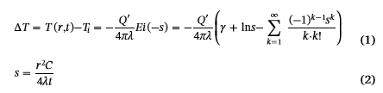

where Ei(−s) is the integral exponential function, Q′ is the heat per unit length of the line heat source [ML T−3], λ is the thermal conductivity [M L T−3K−1], C is the volumetric heat capacity [ML−1 T−2 K−1], and γ is the Euler constant, which has a value of 0.5772 [5,6]. When t is large and s sufficiently small (s < 0.05),Eq.(1) can be approximated using the thermal diﬀusivity parameter α (=λ/C) [L 2 T−1] by the following equation:

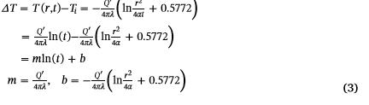

In practice, the average ﬂuid temperature between an inlet and an outlet of the U-tube during TRT is taken as T(0, t) in Eq. (3) to estimate λ. The most straightforward approach is to plot T(0, t) as a function of the natural logarithm of time. The thermal conductivity λ can then be estimated from the slope (depends on the selection of the temporal data section). By selecting the time period, during whichthere is an obvious linear relationship, early time data are discarded from the analysis. Also, since the volumetric heat capacity C (or thespeciﬁc heat c) that characterizes the heat storage in a substance is not estimated [7], C must be obtained by another method.

Liuzzo-Scorpo et al. [10] demonstrated that even very low groundwater ﬂow rates can signiﬁcantly reduce the Inﬂuence Length of the exchanger

Wang et al. [11] conducted a thermal performance experiment of a BHE under groundwater ﬂow in China and showed that the presence of groundwater ﬂow enhanced the thermal performances of the BHE and influenced the temperature proﬁle in the aquifer.

Numerical approaches:

Florides et al. applied a model that combined 3D conduction with 1D mass ﬂow and 1D convective heat transfer within the carrier ﬂuid. The resulting 3D model was implemented in FlexPDE® and used to investigate the performances of single and double U-tubes BHEin multiple-layer substrates. Neglected the effects of groundwater. Authors highlighted how the soil thermal conductivity plays a major role in dissipating heat into the ground + sensitivity starts increasing with time.

Ozudogru et al. Applied similar approach, by coupling COMSOL® for the description of the heat transfer in the borehole with a 1D description of heat and water transport in the pipe

Han et al. developed a 3D coupled Finite Element Model, which was then utilized to simulate steady-state and transient behaviors of a geothermal heat exchanger. They validated the model and used it to investigate the inﬂuence of several factors on the borehole behavior by carrying out a sensitivity analysis.

But high computational cost of 3D models. In TRT, different dimensionality to be accounted for in tube and ground.

Signorelli et al. [19] used the FEM code FRACTure to evaluate the eﬀect of factors not considered by analytical solutions since his code allowed one to use a combination of lower and higher dimension elements. 1D model was used for heat transport in tubes and 3D model was used to simulate heat transfer in the surrounding ground.

Bozzoli et al. took a similar modeling approach where both 1D and 3D equations were solved for diﬀerent domains to inversely estimate thermal properties of the soil and the grout. In their analysis, the heat transfer between the ﬂuid inside the tube and the solid phase (e.g., tube or grout) was modeled using the Robin boundary condition with the heat transfer coeﬃcient, which is a function of ﬂuid parameters.

Christodoulides et al. [22] used a source/sink term in the governing equation (instead of Robin BC) to account for the heat transfer between the ﬂuid and the tube, assuming the heat transfer within the tube body was instantaneous because the thickness of the tube was extremely thin.

Kim et al. [23] applied a Model Order Reduction (MOR) technique to develop a computationally eﬃcient model for the numerical analysis of a vertical BHE. They combined a vertical slice model with a Finite Element discretization of horizontal cross sections and validated it against analytical solutions. The authors reported a computational time reduction of 95% compared to a fully 3D model. However, the proposed model lacked a proper description of hydrological processes in the vadose zone, which proved to signiﬁcantly affect the **thermal performance of the BHE.**

The magnitude of natural convection depends on DT ﬂuid in the U tube - surrounding ground = f(injection rate). Gustafsson and Gehlin reported a decrease > 10% in the BHE thermal resistance with increase in heat injection rate from 40 W/m to 80 W/m. This process is signiﬁcant for groundwater-ﬁlled BHE (Spitler et al.) while it is less pronounced for cement-grouted BHE (Choi and Ooka [33]). Eﬀect of the natural convection in the BHE dominated by the hydrothermal properties of the surrounding soil, rather than the ﬁlling material (Choi and Ooka).

This study: same as Yavuzturk et al. [29] and Austin et al. [30] but use of the HYDRUS model. **Assumes that heat transfer in the soil domain occurs only in the horizontal plane + in vertical in 1D BHE:**

* **1D (solved using python): heat advection in tube + convective heat transfer between tube and fluid solved using semi-implicit approach (linearization of the temperature in BHE to avoid solving for 2D heat transfer in ground = explicit solution). Periodic Dirichlet BC on tubes.**



where dp is the inner diameter of the pipe [L] (Fig. 2). The convective heat transfer coeﬃcient can be estimated using the relation:

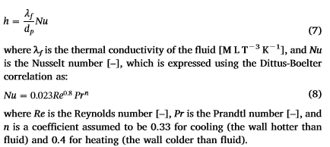n is a coeﬃcient assumed to be 0.33 for cooling (the wall hotter than ﬂuid) and 0.4 for heating (the wall colder than ﬂuid).

* **2D (solved using HYDRUS): In each plan (can have its own thermal/hydraulic properties to represent heterogeneous system), 2 nodes representing the BHE (convective heat transfer between the ﬂuid and the solid domain described using a Robin BC). Convective heat transfer between tube and fluid described by a source term.** Thus, ignores convection in BHE and other vertical fluxes (that might enhance heat exchanges)

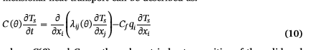

The ﬁrst term on the right-hand side represents the heat transfer by conduction in the soil, while the second term accounts for heat being transported by ﬂowing water.

* The apparent thermal conductivity λij(θ) combines the thermal conductivity λ0(θ) of the porous medium in the absence of flow and the macro dispersivity (linear function of the velocity)

where δij is the Kronecker delta function, and λL and λT are the longitudinal and transverse thermal dispersivities [L].

* Robin BC: 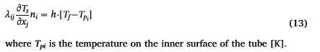where Tpi is the temperature on the inner surface of the tube
* Cauchy-type BC speciﬁed on the remaining boundaries of the domain = heat ﬂux along the boundary, in which T0 is the temperature of the incoming ﬂuid. When the boundary is impermeable or when water ﬂow is directed out of the region, Eq. (14) reduces to a Neumann type BC (Eq. 15)

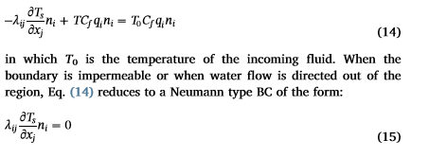

* Python script simultaneously solves the 1D advective heat transport in the tube, interacts with HYDRUS-2D, and exchanges data between the two models:
* A common time step is set for both models
* numerical discretization of the vertical domain for both legs of the U-tube.
* Python reads the temperatures on the border of the cross-sectional domains and solves for 1D equation in BHE+ update values of the ﬂuid temperature in diﬀerent nodes
* A for loop is used to iterate through diﬀerent horizontal cross-sections: at each iteration, the initial condition is updated and the calculated ﬂuid temperatures are passed to the HYDRUS solver for the computation of the Robin boundary condition.
* HYDRUS-2D is then executed and the resulting calculated solid temperatures are stored in a 2D matrix for the next time step. This matrix contains temperature distributions for all horizontal cross sections and is updated at each time step.

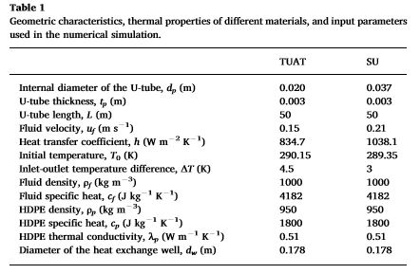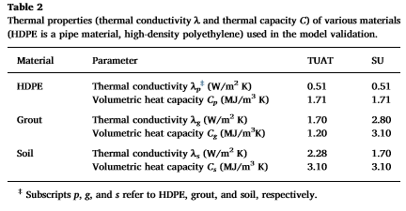

Limitation:

* groundwater ﬂow can aﬀect BHE when groundwater ﬂuxes are equal to or above 10−1 m/s (i.e. in aquifers or regions with high hydraulic gradients): groundwater can enhance the performance of the system by dissipating heat around boreholes faster than unsaturated soil + introduce nonlinearities in the measured temperatures (cannot be interpreted with simpliﬁed inﬁnite line source model) Signorelli et al.
* assumption of a homogeneous and isotropic medium may not be valid for particular geological settings. Heterogeneities in subsurface thermal properties can signiﬁcantly inﬂuence the heat transfer between BHE and soil [45]

Results sensitivity analysis:

* coarse vertical mesh generally only introduces a low bias in the numerical solution. Coarse vertical mesh can be used to test diﬀerent thermal properties of diﬀerent and to simulate the outlet temperature. When the analysis considers the effects of different layers, groundwater table depth + water ﬂow on the thermal behavior of the BHE, a ﬁner mesh should be used. In such cases, an additional preliminary mesh sensitivity analysis is required.
* The thermal properties of the grout had a signiﬁcant inﬂuence on the model’s response during the ﬁrst part of the simulation. This suggests that the thermal properties of the grout could be determined with reasonable accuracy by limiting the analysis to the ﬁrst few hours of the simulation, in which the eﬀect of the ground is rather limited.
* eﬀects of thermal properties of the ground on the model’s output increased with time. It is important to temporally extend the numerical simulation to identify the thermal properties of the ground and limit the inﬂuence of the grout and the pipe. A short simulation time could lead to a biased estimation of the thermal properties.
* aquifer thicknesses and groundwater ﬂuxes are negatively correlated with the outlet temperatures of the ﬂuid
* homogeneous proﬁle, which is composed of sand, dissipates more heat compared to the layered scenario. While the ﬂuid temperature profile for the homogeneous case is smooth but exhibits some nonlinearities for the layered scenario.